An Application Based Energy Efficient Management for Wireless Networks

*Vikas Gahlot ¹, Rajender Kumar ² and Anuj Goel ³

- Department of Electronics & Communication Engineering, U.I.E.T., Kurukshetra University, INDIA
- Department of Electronics & Communication Engineering, N.I.T., Kurukshetra, INDIA
- Department of Electronics & Communication Engineering, M.M.U., Mullana, INDIA
*vikasgahlot@gmail.com

Abstract: Energy management is one of the hot issues and the most important research topics in the fields of wireless networks. This paper introduces high performance architecture to demonstrate a triple play/Double play services delivery over Wireless converged networks. Applications including VoD (video on demand), VoIP and IPTV have been added to the emulated converged network. The methodology is tested on MICA and MICAZ Wireless Networks which provided a novel approach for energy efficient management for different type of applications. The main objective is to first identify the network resources viz. Received signal strength-RSS, Transmission power, different path loss, latency in transmission, offered throughput, etc. Further these metrics also gives an insight on the performance of an advanced wireless system when subjected to different channel impairments. Further it is severely dependent on type of service a user has been intended to i.e. whether a voice service or data or video type. Further some parameters will be identified, formulated, modeled and finally an analysis report will be developed which will help to characterize the optimization of resources for the emerging wireless standards like Wireless Sensor Network and WiMAX (Worldwide Interoperability for Microwave access) etc. [New York Science Journal 2010;3(9):128-133]. (ISSN: 1554-0200).

Keywords: Wireless networks, Voice over internet, wireless Fidelity, IEEE 802.11, Nodes, transmission power.

1. Introduction
Now a day’s wireless Networks are becoming very popular in indoor as well as outdoor applications, such as in conference halls where mobile users demand a high-speed wireless data access to the network and voice capabilities for telephone conversations. To deploy such a network, a simulation framework is very necessary to compare the parameters of the wireless networks with voice and data services in different scenarios. Wireless networks aim to provide ubiquitous, flexible communications mainly in community areas [1].
In the last decade, the market for wireless networks is increased rapidly while the prices of its devices are decreased. Because the medium in wireless networks is by nature shared among nodes in the spatial domain, media access control (MAC) plays an important role of coordinating medium access among nodes [2].Therefore, the development of wireless is crucial. As a consequence of the increased popularity of wireless local area networks (WLANs) based on IEEE 802.11 [3], the interest for adhoc networks has also increased. The energy-limited capacity of a wireless network as the maximum amount of data the network can deliver before the nodes run out of energy [4]. An adhoc network is an autonomous wireless network that can be formed without the need of any infrastructure or centralized administration. It is composed of stations, every station communicates with each other in a peer-to-peer fashion through single hop or multi-hop paths. Each node does not operate as a host only but also acts as a router, which forwards the packets on behalf of other nodes that may not be within the direct transmission range of their destination [8]. Wireless ad hoc networks enable devices to communicate with each other without pre-installed infrastructure. These networks have a wide range of applications such as environmental sensing, battlefield support and disaster relief [5], [6]. Therefore, station can route and forward the packets of others stations. The integration of wireless sensor networks with wireless local area network and the Internet is an important issue of future wireless networks [7]. This paper provides an analysis of the performance of an integrated voice and data for wireless LAN network that uses the MAC protocol for the voice and data packets.

2. Related Work
2.1 Triple-play/Double Play Services
In telecommunication, the triple play service is a term for the provisioning integration of two bandwidth-intensive services viz. high speed (internet & television), and less bandwidth demanding (but more latency sensitive) service, over a single broadband
connection, network infrastructures for Triple Play services is related with selection of advanced and perspective technologies fitting into ideology of NGN (next generation network) concept [9]. Generation network) concept. So a triple-play network is one in which voice; data and video are provisioned on a single access subscription. The most common applications are Telephony, community antenna television (CATV) and high-speed Internet service. The transmission medium may be fiber optics, conventional cable or satellite. Triple play focuses on a combined model rather than solving technical issues or a common standard.

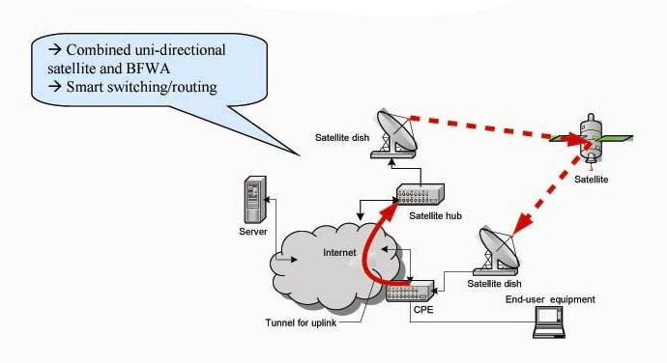

Figure 1.1 Architecture for Triple Play services

2.2 Types of Wireless networks
There are various wireless network technologies that offer Internet access to end-users. The technologies have been developed separately and thus offer different services, coverage areas, data rates, and so on. For example, second-generation (2G) cellular networks are designed to serve speech and low bit- rate data services to end-users while third-generation (3G) cellular networks are developed to provide higher data-rate services [10]. During the evolution from 2G to 3G, several wireless systems including IEEE 802.16 (WiMAX) [11], Wireless LAN (WLAN) [12], Bluetooth, and Hyper LAN have been developed. WLAN offers higher data rates up to 54Mbps, but it is only suitable for small office networks and public hotspot areas such as campus and airports, whereas 2G/3G cellular networks cover a larger area. Some wireless data networks run over wireless voice networks, such as mobile telephone networks. CPDP, HSCSD, PDC-P, and GPRS are examples. Other wireless networks run on their own physical layer networks, utilizing anything from antennas built into handheld devices to large antennas mounted on towers. 802.11, LMDS, and MMDS are examples. A few wireless networks are intended only
to connect small devices over short distances. Bluetooth is an example. Wireless networks which
run over other wireless networks often utilize the lower layer networks to provide security and encryption. Stand-alone wireless networks either provide their own security and encryptions features or rely upon VPN's (Virtual Private Networks) to provide those features. In many cases, multiple layers of security and encryption may be desirable. Some wireless networks are fixed, meaning that antennas do not move frequently. Just as the conventional video, voice, and data services will be replaced by these new services, the terms Triple Play and Quad Play will no longer be relevant [13]. WiMAX, meaning Worldwide Interoperability for Microwave Access, is a telecommunications technology that provides wireless transmission of data using a variety of transmission modes, from point-to-multipoint links to portable and fully mobile internet access. The technology provides up to 10 Mbps broadband speed without the need for cables. The technology is based on the IEEE 802.16 standard. In practical terms, WiMAX would operate similar to WiFi but at higher speeds, over greater distances and for a greater number of users. WiFi uses a single narrow-band radio channel on a public frequency.
Radio communications are typically multiplexed and based on some combination of space, frequency, time, and coding, WiFi exploits the first three [14]. WiMAX could potentially erase the suburban and rural blackout areas that currently have no broadband Internet access because phone and cable companies have not yet run the necessary wires to those remote locations.

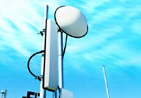

Figure1.2 WiMAX transmitting tower

  - Software Simulation framework using Qualnet

A network of nine nodes was assembled for simulation. Qualnet is chosen for the simulation work. It has so many advance features as compare to other available network simulator. It can be used for wireless networks and also for wireless sensor networks. Nodes were placed in the specified topology and signaled to run networking tasks initiated by the Base Station. The nodes are network configurable to set their distance, energy, routing protocol, and may be sent messages to emulate maintenance. Maintenance signals include messages to recharge a node, reset nodes, and configure analog-to-digital converter parameters. In this simulation we have use the mica mote and observe the parameters in transmission mode. The topology of network consist of 9 nodes. The transmission power is observed on each node . The maximum & minimum energy consumed in in Transmit mode at 2dBm transmission power contains value 0.47729 & 0.005786, at node 2 & node 5 respectively. The maximum & minimum energy consumed in in Transmit mode at 30dBm transmission power contain value 11.3354 & 0.130283, at node 8 & node 1 respectively.

Table1. Energy Consumed in Transmit mode for Mica Motes
Tx.  Power  (dBm) | Energy Consumed  (mjoule)  in Transmit mode at Node 1 | Energy Consumed (mjoule)  in Transmit mode at Node 2 | Energy Consumed (mjoule)  in Transmit mode at Node 3 | Energy Consumed (mjoule)  in Transmit mode at Node 4 | Energy Consumed (mjoule)  in Transmit mode at Node 5 | Energy Consumed (mjoule)  in Transmit mode at Node 6 | Energy Consumed (mjoule)  in Transmit mode at Node 7 | Energy Consumed (mjoule)  in Transmit mode at Node 8 | Energy Consumed (mjoule)  in Transmit mode at Node 9
2 | 0.041483 | 0.047729 | 0.016239 | 0.015239 | 0.005786 | 0.012613 | 0.042748 | 0.013275 | 0.041783
5 | 0.02924 | 0.335835 | 0.018831 | 0.023351 | 0.018159 | 0.023768 | 0.377921 | 0.009493 | 0.322506
10 | 0.33898 | 0.309694 | 0.02509 | 0.165884 | 0.308541 | 0.033138 | 0.277522 | 0.110613 | 0.768957
15 | 0.134637 | 0.133493 | 0.023572 | 0.188109 | 0.023426 | 0.023426 | 0.140949 | 0.161157 | 0.765136
20 | 0.132189 | 0.136972 | 0.064538 | 0.507379 | 0.064166 | 0.659927 | 0.139086 | 0.415333 | 0.56045
25 | 0.138345 | 0.128432 | 1.49133 | 1.38599 | 2.55002 | 0.218971 | 0.151253 | 2.67511 | 0.151692
30 | 0.130283 | 0.139048 | 0.595653 | 3.97956 | 0.596667 | 0.597395 | 0.143239 | 11.3354 | 0.149621

Table 2 Energy Consumed in Transmit mode for MicaZ
Tx. Power  (dBm) | Energy Consumed (mjoule)  in Transmit mode at Node 1 | Energy Consumed (mjoule)  in Transmit mode at Node 2 | Energy Consumed (mjoule)  in Transmit mode at Node 3 | Energy Consumed (mjoule)  in Transmit mode at Node 4 | Energy Consumed (mjoule)  in Transmit mode at Node 5 | Energy Consumed (mjoule)  in Transmit mode at Node 6 | Energy Consumed (mjoule)  in Transmit mode at Node 7 | Energy Consumed (mjoule)  in Transmit mode at Node 8 | Energy Consumed (mjoule)  in Transmit mode at Node 9
2 | 0.017053 | 0.19621 | 0.028256 | 0.026516 | 0.010067 | 0.021947 | 0.175736 | 0.023099 | 0.171768
5 | 0.120205 | 1.3806 | 0.035659 | 0.04422 | 0.034387 | 0.045008 | 1.55361 | 0.017976 | 1.3258
10 | 1.39353 | 1.27313 | 0.062062 | 0.410324 | 0.763195 | 0.081969 | 1.14088 | 0.273608 | 3.16114
15 | 0.553484 | 0.54878 | 0.096905 | 0.773304 | 0.096301 | 0.096301 | 0.579431 | 0.662508 | 3.14543
20 | 0.54342 | 0.563085 | 0.296587 | 2.33165 | 0.294877 | 3.03271 | 0.571776 | 1.90867 | 2.30398
25 | 0.568729 | 0.527975 | 7.13349 | 6.62959 | 12.1975 | 1.0474 | 0.621793 | 12.7098 | 0.623597
30 | 0.535585 | 0.571617 | 2.88712 | 19.2888 | 2.89204 | 2.89557 | 0.588846 | 54.9423 | 0.615083

The graph is plotted between transmission power versus energy consumed in transmit mode for MicaZ. The maximum & minimum energy consumed value in Transmit mode at 2dBm transmission power contains 0.19621 & 0.010067, at node 2 & at node 5 respectively. The maximum & minimum energy consumed in Transmit mode at 30dBm transmission power contains value 54.9423 & 0.535585, at node 8 & node 1 respectively.

- Result and Conclusion
The graph is plotted between Transmission Power vs energy consumed in transmit mode using nine node architecture.The maximum energy is consumed at a peak value of 0.956709 and the minimum energy is consumed having minimum value of 0.050675. In this work a study of the wireless network has been done in the software environment. Comparison of the Mac protocol can also be done to demonstrate the performance gains with use of a protocol that optimizes distance, available energy, throughput, jitter and delay.

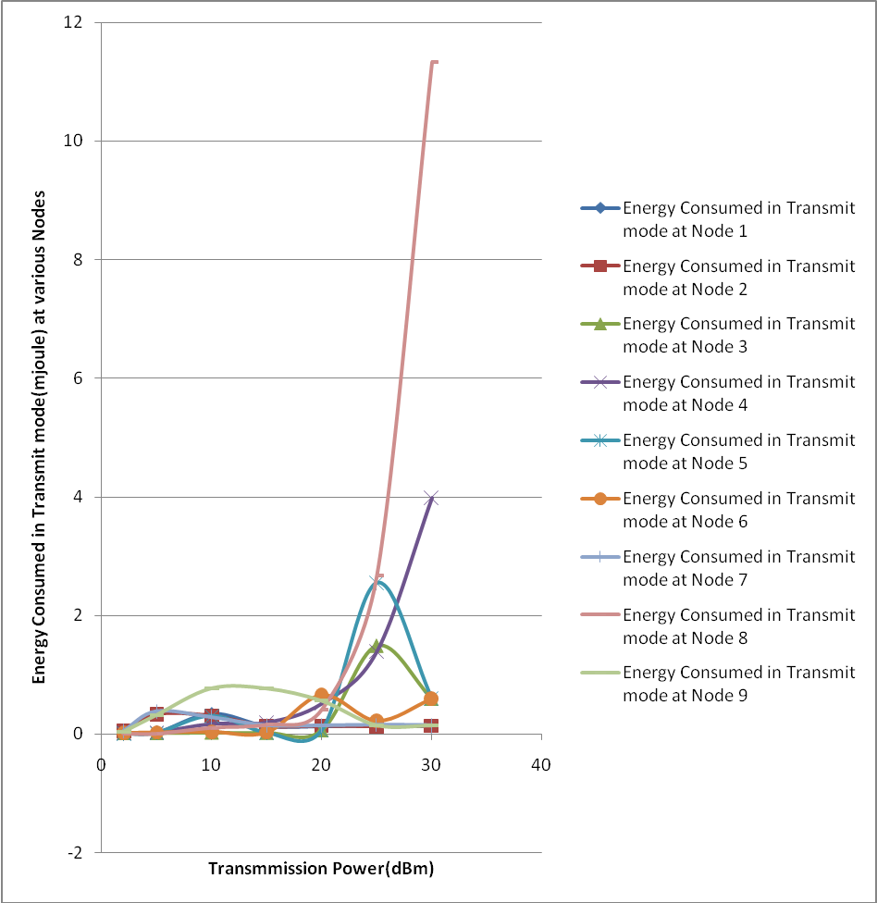
Fig 1.3 Graph Plotted between Transmission Power v/s Energy Consumed in Transmit mode for Mica Mote

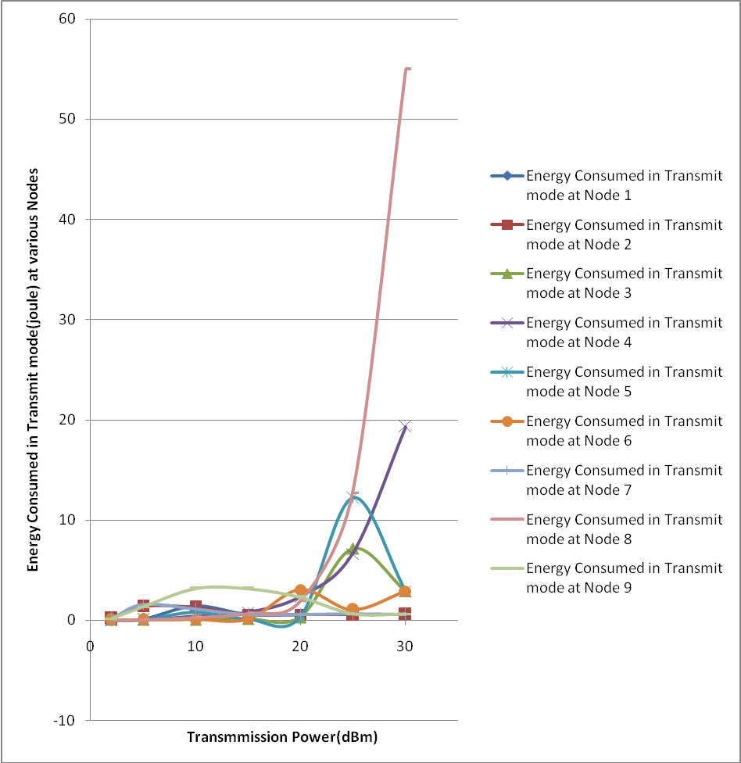

Fig 1.4 Graph Plotted between Transmission Power v/s Energy Consumed in Transmit mode for MicaZ

Future Scope
With the demand for rapid deployment of wireless connectivity to access Internet and multimedia services wireless networks is an easy and cost effective way of building communication networks. In this article we have evaluated so called triple play services over a wireless network based on modified and reconfigurable standard IEEE 802.11ab/g access points as well as on mica and micaz motes. Based on results presented n this paper, we can conclude that with today’s technology, WMN is far from being fully exploitable to support multimedia streaming over a large area (many hops). Rich multimedia applications require improved QoS functionality and higher performances at the MAC layer. By adding multiple input multiple output technology, signal processing and smart antennas, the upcoming IEEE 802.11n standard should guarantee up to five times the bandwidth and the double range.

Acknowledgement:
The authors are grateful to M.M. University, Mullana (Ambala) and N.I.T., Kurukshetra for providing assistance and laboratory facilities to carry out the work.

Correspondence to:
Vikas Gahlot
Electronics & Communication Engineering Department, U.I.E.T. Kurukshetra University Kurukshetra, 136119 (India)
Email:vikasgahlot@gmail.com

References
[1] Zeyu Zheng, Jianping Wang, and Jin Wang, A Study of Network Throughput Gain in Optical-Wireless Networks Subject to Peer-to-Peer Communications , IEEE International Conference on Communications, pp. 1-6, June 2009.
[2] Zheng Zeng, Yong Yang and Jennifer C. Hou, How Physical Carrier Sense Affects System Throughput in IEEE 802.11 Wireless Networks, The 27th IEEE Conference on Computer Communications , pp.1445 – 1453, April 2008.
[3]http://standards.ieee.org/getieee802/download/802.11-1999.pdf
[4] Wenrui Zhao, Mostafa Ammar, and Ellen Zegura, The Energy-Limited Capacity of Wireless Networks, First Annual IEEE Communications Society Conference on Sensor and Ad Hoc Communications and Networks, pp. 279 - 288, Oct. 2004.
[5] D. Johnson and D. Maltz, Dynamic source routing in ad-hoc wireless networks, In ACM SIGCOMM, pp. 183-191, August 1996.
[6] C. Perkins and P. Bhagwat, Highly dynamic destination-sequenced distance-vector routing (DSDV) for mobile computers. Computer Communication Review, vol.24, pp. 234-244, October 1994.
[7] Liang Cheng, Yuecheng Zhang, Tian Lin, and Qing Ye, Integration of Wireless Sensor Networks, Wireless Local Area Networks and the Internet, Proceedings of the 2004 IEEE International Conference and Networking, Sensing & Control , Vol.1, pp.462 – 467, March 2004
[8] Bhupendra Kumar Gupta and B.M.Acharya, Manoj Kumar Mishra, Optimization of Routing Algorithm in Wireless Mesh Networks, World Congress on Nature & Biologically Inspired Computing , pp. 1150 – 1155, Dec 2009.
[9] A. Nikitinl, V. Pyattaev, B. W. Kim, Technological aspects of the triple play service on fixed access networks, 11th International Conference on Advanced Communication Technology, ICACT 2009, pp. 1890 – 1893, Feb 2009.
[10] Yong-Sung Kim, Dong-Hee Kwon, and Young-Joo Suh, A Client-based Vertical Handoff Approach for Seamless Mobility in Next Generation Wireless Networks, 33rd IEEE conference on Local Computer Networks, LCN 2008, pp.419-426, 2008
[11] IEEE Std. 802.16-2001, IEEE Standard for Local and Metropolitan Area Networks, Part 16, 2001.
[12] IEEE Std. 802.11-1999, IEEE Standard for Local and Metropolitan Area Networks, Part 11, 1999.
[13] John Ulm, Motorola and Bill Weeks, Next Play Evolution, Beyond Triple Play & Quad Play, IEEE International Symposium on Consumer Electronics, ISCE 2007, pp.1-6, June 2007
[14] Marco Domenico Aime, Giorgio Calandriello, Antonio Lioy, Politecnico di Torino, Security & Privacy, IEEE transaction , Vol. 5, pp. 23 – 29, Jan. 2007.

08/16/2010

