Quality assessment of selected cereal – soybean mixtures in “ogi” production
Bolaji Oluwatosin Akanbi ¹, Olubunmi O Agarry ¹ , Samuel Alimi Garba^{1,2}
¹Department of Biological Sciences, Microbiology Unit, University of Abuja, P.M.B 117, Abuja, Nigeria.
² Department of Microbiology, Federal University of Technology, P.M.B 65 Minna, Nigeria.
tosinakanbi2@yahoo.co.uk
Abstract: To develop a protein rich weaning food in a country with high poverty rate, the effects of adding soybeans as a starting material for “ogi” production were evaluated. Simple spontaneous fermentation was carried out similar to traditional fermentation and proximate analysis and bioavailabity test using broiler chicks were performed to determine nutrient content and inactivation of protein inhibitors present in soybeans respectively. The Fermented soybean-cereal mixtures resulted in higher microbial densities, protein content and lactic acid than fermented cereals without soybeans (P <0.05). Chicks fed diets from the fermented mixtures showed better weight gain and food efficiency than those fed on fermented cereals without soybeans (P<0.05). Incorporation of soybeans in cereals did not result in any significant differences in microbial types. The inclusion of soybeans in as a starting material in the production of “ogi” improves the nutritional value and further research is needed to elucidate the contributions of the microbiota involved with respect to protein inhibitors inactivation and phytase degradation. [New York Science Journal 2010;3(10):17-26]. (ISSN: 1554-0200).
Key words: ogi, protein inhibitors, soybean, bioavailability,poverty, lactic acid.
- Introduction

In developing countries, one of the greatest problems affecting millions of people, particularly children are lack of adequate protein intake in term of quality and quantity. As cereals are generally low in protein, supplementation of cereals with locally available legume that is high in protein increases protein content of cereal-legume blends. Several traditional fermentations have been upgraded to high technology production systems and this has undoubtedly improved the general well being of the people as well as the economy (Achi, 2005).
‘Ogi’, an acid fermented gruel or porridge made from maize (Zea mays), sorghum (Sorghum bicolor) or millet (Pennisetum glaucum) is limited by its low protein content especially amino acids notably lysine and methionine. Several strategies have been used to increase the protein content and minimize nutrient loss (Inyang and Idoko, 2006). Fermentation of cereals and pulses is of great relevance in Africa especially as weaning foods. Various microorganisms can ferment various substrates resulting in the generation of different end products. Traditionally, microbes are used to prepare and preserve foods.
Fermentation of cereals is believed to increase protein and amino acid levels in the end product. Most foods including ‘ogi’ contain enough moisture to permit action by their own enzymes and microorganisms. Several microorganisms have been isolated from ‘ogi’ including molds in the genera Cephalosporium, Rhizopus, Ospora, Cercospora, Fusarium, Aspergillus and Penicillium, bacteria of the genera Corynebacterium, Enterobacter, Lactobacillus fermentum, Streptococcus lactis, Leuconostoc spp Clostridium bifermentans, Staphylococcus aureus and yeasts Saccharomyces cereviseae, Candida krusei, C. tropicalis, Geotrichum candidum, G. fermentans and Rhodotorola graminis (Odunfa, 1985; Ohenhen, 2002; Ijabadeniyi, 2004; Omemu et al., 2007).
‘Ogi’ in the form currently available to the consumers cannot be stored at home for any length of time without spoilage (Ohenhen and Ikenebomeh, 2007). The products formed after fermentation of foods e.g. lactic acid and bacteriocins by microorganisms in the fermenting substrates make them safe for consumption. Lactobacillus fermentum from ‘ogi’ produces bacteriocins which are active against common food borne pathogens, improving the shelf-life of ‘ jellied ogi’ by 10 days (Olasupo et al.,1997). There is, however, still a need for more information on the nutritional, microbiological and storage qualities of using soybeans in complementary food formulations. This paper reports on these parameters using three complementary blends in ‘ogi’ production.

MATERIALS AND METHODS
Preparation of “Ogi” slurry This was done using a modified method of Odunfa and Adeleye (1985). Maize (Zea mays, Linn), sorghum (Sorghum bicolor( L)Moench) and millet (Pennisetum glaucum, L) each in ratio 3:1(w/w) and soybeans (Glycine max, L) were used to prepare three complementary blends of cereal-soybean mixtures. Two hundred grams of each variety of the cereal grains serving as the control samples and the mixtures were steeped separately in 500ml cold sterile distilled water for 48 h at room temperature (27-30ºC). pH values of the liquor samples were taken at 0, 12, 24 , 48 and 72 h using pH meter model S204 . The water was decanted and the grains wet milled separately using clean blender (National Blender Model MX 795N). The resulting paste was sieved using different sterile muslin cloths.

Preparation of “Ogi” powder and storage
‘Ogi’ slurry from the different mixtures were dried in hot air oven at 50ºC for 24h, pulverized separately and stored at room temperature (25±2ºC).

MICROBIAL ANALYSIS
Microbial counts and types were made on selective media after decimal dilution of the samples using the spread plate method as described below:

Total Lactic Bacteria Counts: These were performed on Nutrient Agar and Man Rogosa Sharpe Agar. Plates were incubated at 37^{o.} The colonies which appeared after incubation period were counted as colony-forming units (c.f.u/g)sample. The colony characteristics and cell morphology were observed microscopically after Gram staining. All cultures were identified according to Holt (1986).

Coliform Count: This was made on MacConkey Agar, plates incubated at 37ºC.

Yeast and Mould Counts: These were made on Potato Dextrose Agar. Plates were incubated at room temperature (27-30ºC) for 3 to 5 days and isolates identified according to (Barnett et al., 2000).

NUTRITIONAL ANALYSIS
Proximate analysis: Moisture content, protein ( N x 6.25), fat, ash and crude fibre were determined by standard procedures (AOAC,1995). Digestible carbohydrate content of each sample was determined by difference.
Titratable acidity: The acidity was measured by titrating a mixture of 3 g of ogi slurrry and 27 ml of distilled water to pH 8.5 using 0.1 M sodium hydroxide solution (Kingamkono et al., 1994). The result was expressed as g lactic acid/100 g sample.

Chemical analysis: The digestion procedure of AOAC (1995) was adopted. Zn, Fe, Cu, Mn, Ca and Mg were analyzed by Atomic Absorption Spectrophotometry.

Bioavalaibity test using Broiler Chickens and Feed Treatments
Fermented cereals and cereal-soybean mixtures were air- dried after 48 h fermentation and hammer -milled. Studies were performed on 60 1-day-old broiler chickens randomly assigned to the six treatment diets in a completely randomized design (CRD) experiment. The birds were placed in 6pens (10 birds per pen). Heat was provided by electric bulbs , water was offered through drinkers and feed through tube feeders to allow for ad libitum consumption. The clean and disinfected concrete floor was covered with approximately three inches of clean wood shavings and the bird density was approximately (0.07 m2) per bird . All the recommended vaccinations and preventive medication were administered accordingly; the feeding trial lasted for 4 weeks Performance traits (body weight, weight gain, feed consumption, and feed efficiency) were measured at days1, 7, 14 and 28.

Statistical analysis: The data collected for each of the parameters were statistically analyzed using one-way Analysis of variance procedure using SPSS version 16. Differences between treatment means were separated using Duncan’s Multiple Range Test .
RESULTS
The results of the study showed that soybean that soybeans addition exerted effects on the microbiology and nutritional qualities of ogi. The proximate analysis is presented in Table 1.
Lactic acid yield is compared in Table 1.1. The content was found to be higher in fermented soybeans cereal mixture than fermented cereals without soybean (P<.05) (Table 1.1.)
Proximate analysis showed significant differences in protein content (Table 1.2) between grain types and also with the use of soybeans enrichment (P<.05).

Table 1 Proximate Analysis of Cereals and Cereals/Soya Blend Ogi
Parameters | Millet only | Millet/Soya | Sorgum only | Sorgum/Soya | Maize only | Maize/Soya
pH | 3.8 | 3.3 | 4.0 | 3.7 | 4.4 | 4.1
TTA (%lactic acid) | 0.69 | 0.89 | 0.58 | 0.74 | 0.47 | 0.64
Moisture % | 9.00 | 9.47 | 9.62 | 9.09 | 9.30 | 10.24
Ash % | 1.27 | 2.3 | 0.86 | 2.01 | 0.24 | 1.76
Crude fibre % | 2.01 | 2.37 | 2.02 | 2.34 | 3.04 | 3.21
Protein % | 12.12 | 17.75 | 11.7 | 15.9 | 10.3 | 15.3
Fat % | 6.21 | 8.31 | 5.3 | 7.5 | 6.7 | 8.23
Carbohydrate % | 68.71 | 59.8 | 70.5 | 61.35 | 70.42 | 61.76

Table 1.1. Comparison of % lactic acid from different Ogi
Ogi Substrate | Lactic acid %
Millet and Soybeans | 0.89ª
Sorghum and Soybeans | 0.74^{b}
Millet | 0.69^{c}
Maize and Soybeans | 0.64^{cd}
Sorghum | 0.58e
Maize | 0.47^{f}
Means in the same column followed by the same letter are not significantly different by Duncan’s new multiple range test at P= 0.05
Table 1.2 Comparison of % protein content from different Ogi
Ogi Substrate | Crude protien %
Millet and Soybeans | 17.75ª
Sorghum and Soybeans | 15.90^{b}
Millet | 15.30^{b}
Maize and Soybeans | 12.12^{c}
Sorghum | 11.70^{c}
Maize | 10.30^{d}
Means in the same column followed by the same letter are not significantly different by Duncan’s new multiple range test at P= 0.05
Table 2 The Mineral Content of Ogi Samples (mg/100g)
Elements | Ma | MaS | Mi | MiS | So | SoS
Cu | 14.6±1.02ª | 15.8±2.35^{b} | 19.8±3.06ª | 10.7±1.10^{c} | 4.3±1.32^{d} | 5.7±0.9e
Zn | 18.3±2.56ª | 19.2±2.34ª | 19.4±2.06ª | 10.3±1.4^{c} | 12.6±1.67^{b} | 8.3±1.50^{d}
Mg | 271.5±6.74^{d} | 340.6±8.45^{ab} | 278.0±7.54^{d} | 290.4±9.32^{c} | 325.7±5.82^{b} | 350.6±7.45ª
Ca | 73.5±1.34^{d} | 98.2±2.40^{c} | 109.7±2.58^{b} | 112.2±4.83ª | 56.3±0.95^{f} | 63.5±1.57e
Fe | 21.6±1.45^{bc} | 24.3±1.00^{b} | 48.6±2.82ª | 47.3±3.25ª | 18.7±1.90^{c} | 15.4±1.11^{c}
Key: Ma; maize only, MaS; Maiza/Soya, Mi; Millet only, MiS; Millet/Soya, So; Sorghum only, SoS; Sorghum/Soya
Values are means ± standard error of mean; n=5
Means in the same column followed by the same letter are not significantly different by Duncan’s new multiple range test at P= 0.05

Table 3 Performance of broiler chicken fed on fermented cereals and fermented cereals soybean mixture
Parameter | Period (week) | FSMi | FMi | FSMa | FMa | FSS | FS
Body weight (g) | Initial day  Wk1  Wk2  Wk3  Wk3 | 44.62±1.43  103.29±0.93  236.89±1.17  458.40±0.79  689.60±1.20 | 43.81±1.21  63.66±1.22  107.51±1.00  250.90±1.07  390.57±1.36 | 42.91±1.13  98.16±1.20  220.95±0.84  428.63±0.75  647.95±1.16 | 43.31±0.95  62.79±0.77  116.51±0.90  252.62±1.03  397.41±0.86 | 42.78±1.12  104.41±0.91  237.69±0.69  461.61±0.86  690.43±1.47 | 43.92±1.24  64.77±0.92  115.67±0.91  394.20±0.87  394.20±0.87
Feed intake (g) | Wk1  Wk2  Wk3  Wk4 | 64.73  54.87  285.86  302.50 | 63.62  148.67  283.50  307.81 | 63.21  152.97  285.63  310.46 | 65.89  153.65  282.90  302.75 | 62.76  151.27  283.82  301.56 | 63.74  151.45  280.76  303.36
Total feed intake (g) |  | 777.96 | 777.23 | 811.18 | 805.19 | 769.41 | 769.71
Feed efficiency (g) | Wk1  Wk2  Wk3  Wk4 | 1.10  1.15  1.29  1.31  1.12 | 3.26  3.39  1.97  2.20  1..99 | 1.14  1.25  1.38  1.41  1.23 | 3.38  2.86  2.07  2.09  2.02 | 1.01  1.13  1.27  1.32  1.11 | 3.05  2.96  1.82  2.16  1.95
Values are means of body weight (g) ± S;E and intake (g)
Feed efficiency = g of feed/g body wt gain

Keys;
FSMi fermented soybean millet mixture
FMi fermented millet only
FSMa fermented soybean maize mixture
FMa fermented maize only
FSS fermented sorghum soybean mixture
FS fermented sorghum

Table 3.1 Comparison of mean weight of broiler chicken fed different diets
Fermented Treatment | Bean weight (g)
Sorghum and soybeans | 690.43ª
Millet and soybeans | 689.60ª
Maize and soybeans | 647.95^{b}
Maize | 397.41^{c}
Sorghum | 394.20^{c}
Millet | 390.57^{c}
Means in the same column followed by the same letter are not significantly different by Duncan’s new multiple range test at P= 0.05
Table 4. Effect of storage on the quality of Ogi from different substrates
Table 4.4a Dry maize Ogi sample
 | pH | Flavor | Colour | Microbial counts | reconstitution
Month 1 | 4.9 | Sour | White | <10/g | +
Month 2 | 4.9 | Sour | White | <10/g | +
Month 3 | 4.9 | Sour | White | <10/g | +
Month 4 | 4.9 | Sour | White | <10/g | +
Month 5 | 4.9 | Sour | White | <10/g | +
Month 6 | 4.9 | Sour | White | <10/g | +

Table 4.4b Dry maize/soybean Ogi sample
 | pH | Flavor | Colour | Microbial counts | Reconstitution
Month 1 | 4.5 | Cream | White | <10/g | +
Month 2 | 4.5 | Cream | White | <10/g | +
Month 3 | 4.5 | Cream | White | <10/g | +
Month 4 | 4.5 | Cream | White | <10/g | +
Month 5 | 4.5 | Cream | White | <10/g | +
Month 6 | 4.5 | Cream | White | <10/g | +

Table 4.4c Dry sorghum Ogi sample
 | pH | Flavor | Colour | Microbial counts | Reconstitution
Month 1 | 4.5 | Sour | Light brown | <10/g | +
Month 2 | 4.5 | Sour | Light brown | <10/g | +
Month 3 | 4.5 | Sour | Light brown | <10/g | +
Month 4 | 4.5 | Sour | Light brown | <10/g | +
Month 5 | 4.5 | Sour | Light brown | <10/g | +
Month 6 | 4.5 | Sour | Light brown | <10/g | +

Table 4.4d Dry sorghum/soybean Ogi sample
 | pH | Flavor | Colour | Microbial counts | Reconstitution
Month 1 | 4.5 | Sour | Cream | <10/g | +
Month 2 | 4.5 | Sour | Cream | <10/g | +
Month 3 | 4.5 | Sour | Cream | <10/g | +
Month 4 | 4.5 | Sour | Cream | <10/g | +
Month 5 | 4.5 | Sour | Cream | <10/g | +
Month 6 | 4.5 | Sour | Cream | <10/g | +

Table 4.4e Dry millet Ogi sample
 | pH | Flavor | Colour | Microbial counts | Reconstitution
Month 1 | 4.7 | Sour | Grayish | <10/g | +
Month 2 | 4.7 | Sour | Grayish | <10/g | +
Month 3 | 4.7 | Sour | Grayish | <10/g | +
Month 4 | 4.7 | Sour | Grayish | <10/g | +
Month 5 | 4.7 | Sour | Grayish | <10/g | +
Month 6 | 4.7 | Sour | Grayish | <10/g | +

Table 4.4f Dry millet/soybean Ogi sample
 | pH | Flavor | Colour | Microbial counts | Reconstitution
Month 1 | 4.5 | Sour | Cream | <10/g | +
Month 2 | 4.5 | Sour | Cream | <10/g | +
Month 3 | 4.5 | Sour | Cream | <10/g | +
Month 4 | 4.5 | Sour | Cream | <10/g | +
sMonth 5 | 4.5 | Sour | Cream | <10/g | +
Month 6 | 4.5 | Sour | Cream | <10/g | +

The results for mineral contents show that the relative proportion of these elements depends primarily on the type of grain (Table 2). The results were variable for the different elements. The amount in copper in ogi was unaffected by the addition of soybeans (p<0.05). A similar trend was also obtained in zinc. The magnesium content showed significant increases in ogi blended with soybeans (p<0.05).
The results of animal feeding experiment are summarized in Table 3. These results show that chicks fed the co fermented mixtures showed better weight gain and food efficiency than those fed on fermented cereals without soybeans (P<.05). In terms of feed intake there was a significant difference in consumption of maize based fermented feeds than others (P<.05) though no significant difference were noted between fermented soybean cereal mixtures and fermented cereals (P >0.05). Microbial isolates were similar in all groups. The mean weight gain at the end of four weeks show that co fermented sorghum soybeans mixture and co fermented millet soybeans mixture showed the best result and there was no significant statistical difference between the 2 (p<0.05). Co fermented maize soybeans ranked second while no significant difference was found among other treatments. Soybeans cereal mixtures showed a better result compared to with unblended cereals.
pH values of all samples did not change over the six month period (Table 4. a-f) . The samples had similar pH values for dry maize/soybeans, sorghum only, sorghum/soybeans and millet/soybeans mixture. These had a pH value of 4.5 which was also the lowest value obtainable. The pH values for dry samples were generally higher than in the fresh samples and the difference was significant (p<0.05.). The colour of the dried samples differed according to the grain type: greyish, brown and white for millet, sorghum and maize respectively. The addition of soybeans imparted a creamy colour on all samples irrespective of the cereal colour. The microbial counts of all samples were low and all the samples were reconstitutable throughout the study period.
This study shows differences in microbial populations in the different cereals as well as the between cereal soy bean mixtures. At the initial stage the growth of coliforms was generally lower in cereals than in the corresponding cereal soybean mixtures except for millet which had a higher count (Figure1).
The coliform count was significantly different (P<0.05) between the treatment groups. The trend however reversed by 24 hours (Figure 2) and the differences in CFU/ml were significant (P<0.05) except between sorghum and sorghum soybean ogi. In MRS agar, cfu was highest in millet ogi at 12 hours and 24 hours at 7.24 and 8.51 log cfu/ml respectively. Differences were noted between grain types and soybean addition and these were significant at 95% probability level (Figure 2).The pattern observed in MRS agar is similar to the observation with nutrient agar and the differences were also significant at 95% probability level.
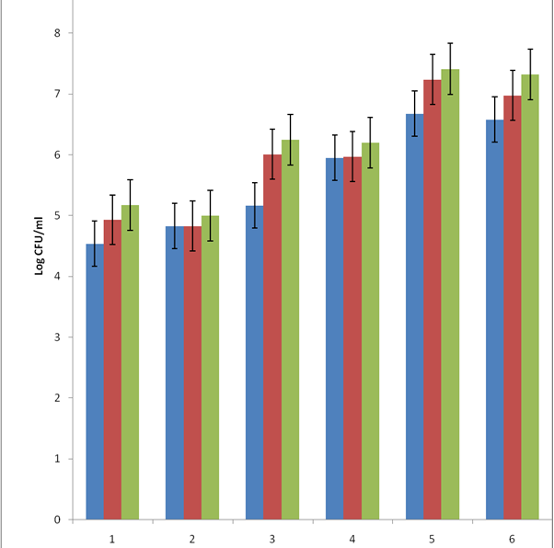
Figure 1. Standard plate counts after 12 hours
Key: 1. Maize ogi, 2 Maize soy ogi, 3 Sorghum ogi, 4 Sorghum soy ogi, 5 Millet ogi, 6 Millet soy ogi
.coliforms on MacConkey .lactic acid bacteria on MRS Total bacteria on Nutrient Agar
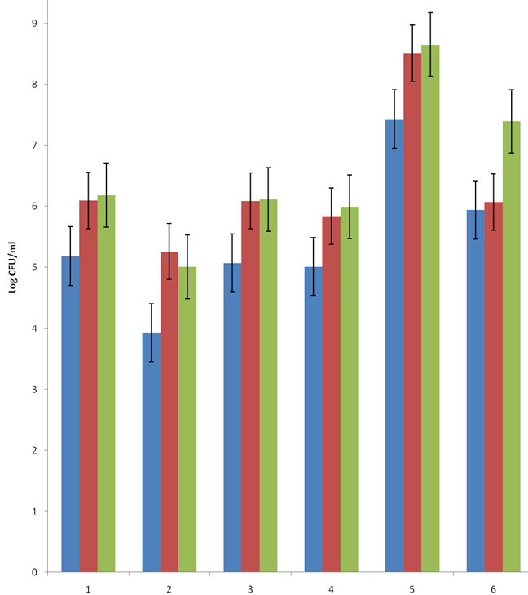
Figure 2. Standard plate counts after 24 hours
Key: 1. Maize ogi, 2 Maize soy ogi, 3 Sorghum ogi, 4 Sorghum soy ogi, 5 Millet ogi, 6 Millet soy ogi
.coliforms on MacConkey .lactic acid bacteria on MRS Total bacteria on Nutrient Agar
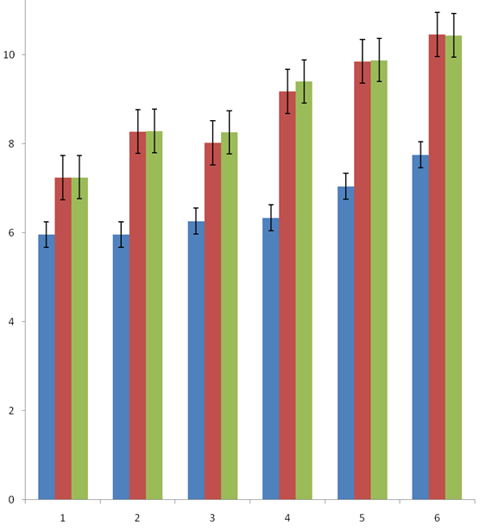
Figure 3. Standard plate counts after 48 hours
Key: 1. Maize ogi, 2 Maize soy ogi, 3 Sorghum ogi, 4 Sorghum soy ogi, 5 Millet ogi, 6 Millet soy ogi
.coliforms on MacConkey .lactic acid bacteria on MRS Total bacteria on Nutrient Agar

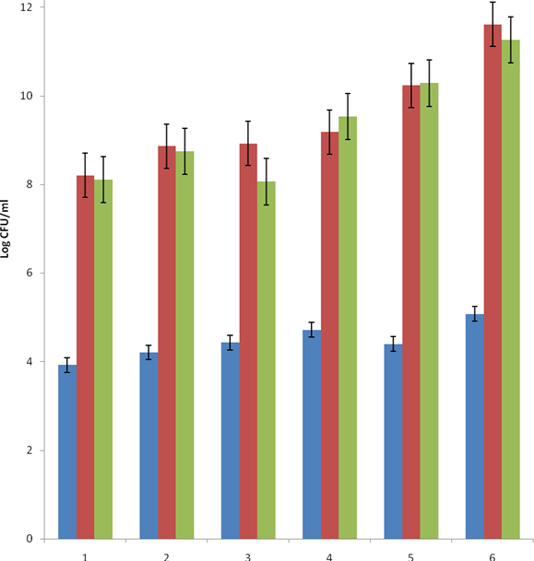
Figure 4. Standard plate counts after 72 hours
Key: 1. Maize ogi, 2 Maize soy ogi, 3 Sorghum ogi, 4 Sorghum soy ogi, 5 Millet ogi, 6 Millet soy ogi
.coliforms on MacConkey .lactic acid bacteria on MRS Total bacteria on Nutrient Agar
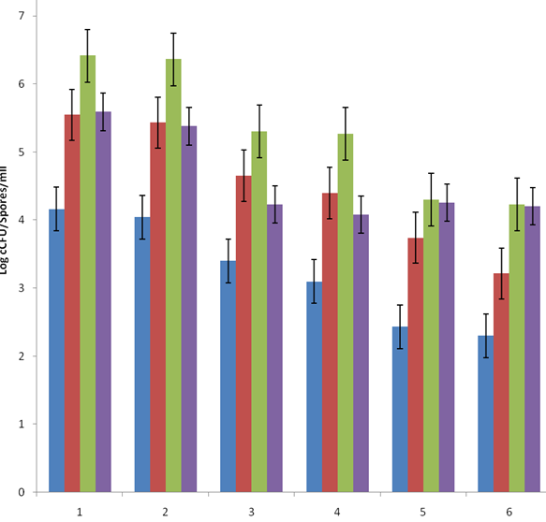
Figure 5. Yeasts counts after 72 hours
Key: 1. Maize ogi, 2 Maize soy ogi, 3 Sorghum ogi, 4 Sorghum soy ogi, 5 Millet ogi, 6 Millet soy ogi
.12 hours 24 hours 48 hours 72 hours

Fermented soybean millet mixture had the highest total bacteria viable count of 10.46 log cfu/ml at 48 hours of fermentation, followed by fermented millet, sorghum soybeans, sorghum, maize soybeans and maize respectively in MRS agar (Figure 3) and the pattern is similar in nutrient agar and in all cases significant differences were noted between grain types as well as soybean supplementation at 95% probability.
The trend was also noted in total coliform counts but the differences were not significant between maize ogi and maize soybean ogi as well as sorghum and sorghum soybean ogi (P>0.05). Significant differences were however noted between grain types (P<0.05). At 72 hour higher numbers of lactic acid bacteria were obtained and a lower proportion of non faecal coliforms numbers were also recorded. Generally, higher counts of bacteria were obtained in co fermented mixtures compared to non supplemented cereals and these differences were significant (p<0.05.). Co fermented millet soybeans mixture had the overall highest count while unmixed maize ogi had the lowest counts (Figure 4).
For the yeasts, our results show that the growth was similar in cereals and co fermented cereal soybeans mixture (p>0.05). Significant differences were noted between the different types of cereals and significant (p<0.05). The only exception noted was in the growth pattern in maize (p<0.05). Yeasts counts generally increased with time of fermentation with the peak at 48 hours and then declined at 72 hours (Figure 5).
DISCUSSION

Our study shows the effects of addition of soybeans to cereals in the production of ogi. Increases in microbial population, protein content and lactic acid were significant. The differences observed can be attributed to several factors such as physicochemical properties of the grains, soybean supplementation, microbial interactions, and pH. Increase in growth rate can be attributable to nutrient availability to the microorganisms from soybeans. Soybean is a rich medium containing proteins, vitamins and importantly fermentable sugars such as sucrose and the, oligosaccharides raffinose and stachytose. The ability of to utilize these sugars by Lactobacillus plantarum and Enterobacter cloacae is an important feature that should feature in the development of starter culture because utilization of such sugars eliminates flatulence- a major draw back in legume based foods. It is also important to understand the factor(s) that cause the initial slower growth rate observed in soybeans cereal mixtures since faster production of a product is vital in the development and refinement of traditional fermentations. Soybeans addition undoubtedly increases protein content. However, the higher microbial load observed in fermented soybeans cereal mixtures could also be contributory. The higher lactic acid yield is not surprising due to higher microbial load observed in fermented soybeans cereal mixtures. The amount of lactic acid produced by L. plantarum is related to the type(s) of sugar present in a medium, the type of protein and quantity (Adesokan et al., 2009). The protein content of fermented soybeans millet mixture was the highest followed by fermented sorghum soybeans mixture and the difference was significant (P< 0.05). Maize ogi had the highest carbohydrate content. There are few documented comparative studies of ogi made from different cereals. The use of plant protein and other strategies to increase protein content of ogi is well documented.
Incorporation of soybeans in cereals did not result in any differences in microbial types. The bacteria Lactobacillus plantarum, Enterobacter cloacae and Corynebacterium spp and yeast Saccharomyces. Cerevisae and C. tropicalis, were the the predominant organisms isolated from all samples which is in agreement with earlier reports on ogi fermentation (Odunfa, 1985; Ohenhen, 2002; Ijabadeniyi, 2004; Omemu et al. 2007). However Lei and Jakobsen (2004) found Weisella confusa and Lactobacillus fermentum, followed by Lactococcus salivarius and Pediococcus spp as the dominating micro-organisms in koko in northern Ghana were millet is used and this has not been reported by other workers. This probably reflects the use of different kinds of spices used in fermentation which could have altered the microbiota and make it similar to kunu fermentation which has similar but not identical method of preparation. Mineral content showed increases with soybean addition both as ash content and in magnesium content in elemental determination with use of atomic absorption spectrophotometer. These results suggests the use of legumes can increase mineral contents as documented by Oyarekua et al. (2008) using starter cultures of Lactobacillus plantarum, Lactobacillus fermentum and natural inoculum on cofermented maize-cowpea. They found significant increase in mineral contents in cofermented maize-cowpea with starter cultures compared with the use of natural inoculum. Mbata et al. (2009) also found significant increase in mineral content of maize flour blended with bambara groundnut (Vigna subterranean L).
Soybean (Glycine max (L) Merril) seeds are known to contain different proteins displaying antinutritional and/or toxic effects, such as soybean agglutinin (an N-acetylgalactosamine-specific lectin), proteinase inhibitors (Kunitz- and Bowman-Birk-type trypsin and chymotrypsin inhibitors) and urease (seed and tissue isoforms) and two other toxic proteins soyatoxin (21 kDa) and soybean toxin (18.4 kDa). Raw soybeans or unheated soybean meal will impair growth when fed to young rats or chicks and this effect is completely eliminated when the soybean component is properly heated or fermented. Chicks fed diets from the fermented mixtures showed better weight gain and food efficiency than those fed on fermented cereals without soybeans. These results indicate that traditional fermentation inactivates protein inhibitors present in soybeans since unprocessed soybeans will impair chick growth. This is agreement with other workers that have investigated the effects of fermented soybean products in animals ( Mathivanan et. al., 2006; Feng, et al., 2007).
The low water activity as a result of drying is expected reduced microbial load and lengthened shelf life by at least 6 months in contrast to the spoilage of fresh samples in which off odour was observed as early as two days of storage. No differences were noted however in between the different types of Ogi from different grains or between soy ogi from the different cereals soybeans mixture during the period of six months. There were however significant differences between the pH of fresh ogi slurries and dried samples. These differences probably reflect the loss of volatile acids such as acetic acids from ogi as well as loss of some lactic acid during drying. The present study shows good keeping quality of all dry samples stored in tin containers at room temperature for a period of 6 months where as fresh fermented samples showed spoilage signs within a few days.
This study shows that the same kinds of microorganisms are responsible for fermentation in all types of cereals and cereals soybean mixtures tested. Isolates from these are probably the best candidates as starters because they are well adapted to the environment and should therefore be more competitive than isolates from other sources. The differences in growth rates reflect the difference in nutrient concentration, type and availability. These have significance on the fermentation rate as well as lactic acid yield. From these results soybean mixtures can easily be seen as the most desirable. However other factors need to be considered among which are taste and acceptability. This is somewhat complex because as earlier on stated; the choice of cereals is dependent on social and cultural preferences. Any test on acceptability will have to include geographical and ethnic backgrounds. A logical conclusion will be to suggest that depending on the social and cultural preferences, the grain of choice should be blended with soybeans probably with the addition of spices as is practiced in some areas.
The animal feeding experiment using broiler chickens to test bioavailability of protein has shown that the observed increases by chemical analysis of cereals soybean mixture is correlated to the bioavailabity of protein. One can say with some confidence that ogi prepared from cereals soybeans blend is highly nutritious and suitable for human use since the downside of unprocessed soybeans is the presence of anti nutritional factors such as trypsin inhibitors. Furthermore documented studies positive effects of fermented soybean products in Asia where they are common. These effects include anticancer and anti hypertension as well as the nutritional value highlighted. These foods are mainly based on mold fermentation and fermentations by bacteria in the genera Bacillus. The current research indicates that indeed traditional ogi fermentation involving yeasts and bacteria in the genera Lactobacillus , Corynebacterium and Enterobacter are effective. However, which of these organisms and to what extent they do so remain unanswered.
Corresponding Author:
Bolaji Oluwatosin Akanbi
Department of Biological Sciences
PMB 117 University of Abuja, Abuja. Nigeria.
E-mail: tosinakanbi2@yahoo.co.uk

References
- Achi, OK. The potential of upgrading traditional fermented foods through biotechnology. African Journal of Biotechnology 2005: 4 (5):375-380

- Inyang CU, Idoko CA. Assessment of the quality of ogi made from malted millet. African Journal of Biotechnology 2006: 5(22):2334-2337
- Odunfa SA. African fermented foods. In: Wood, BJ (ed) Microbiology of fermented foods, Vol. 2. Elsevier applied science publishers. London, New York. 1985
- Ohenhen RE. Enrichment of ogi, A corn meal fermented product. PhD thesis. University of Benin, Benin city, Nigeria 2002.
- Ijabadeniyi AO. Effect of methods of processing on the microbiological and proximate composition of ‘ogi’ produced from three varieties of maize (M.Tech. Thesis) Federal University of Technology Akure, Nigeria. 2004.
- Omemu AM, Oyewole OB, Bankole MO. Significance of Yeasts in the fermentation of maize for ogi production. Food Microbiology 2007: 24(16):571-576
7. Ohenhen, RE., Ikenebomeh, MJ Shelf Stability and Enzyme Activity Studies of Ogi: A Corn Meal
Fermented Product The Journal of American Science: 2007;3(1):38-42
8. Olasupo NA, Olukoya DK, Odunfa SA. Assessment of a bacteriocin – producing Lactobacillus strain in the control of spoilage of a cereal-based African fermented food 1997: Folia Microbiologica 42: (1): 31-34.
9. Odunfa SA, Adeleye SJ, Microbiological changes during the traditional fermentation of ogi-baba a traditional West African fermented gruel. Journal of Cereal Science 1985: 3 (2):173-180

10. Holt, JG. ed Bergeys manual of systematic bacteriology Volume 1 and 2 Wiliams & Wilkins, Baltimore, USA 1986
11. Barnett, JA, Payne, RW, Yarrow, D. Yeasts: characteristics and identification. 3rd edition. Cambridge University press 2000.
12. Association of Official Analytical Chemists . Official methods of analysis. Association of official analytic chemists, Washinton DC, 1995 63,4125-142

13. Kingamkono R, Sjoegren E, Svanberg U, Kaijser B. pH and acidity in lactic-fermenting cereal gruels: effects on viability of enteropathogenic microorganisms. World Journal of Microbiology and Biotechnology. 1994 10: (6):664-669.

14. Adesokan IA, Odetoyinbo BB, Okanlawon BM. Optimization of lactic acid production by lactic acid bacteria isolated from some traditional fermented food in Nigeria. Pakistan Journal of Nutrition 2009: 8 (5): 611-615
15. Lei V, Jakobsen M. Microbiological characterization and probiotic potential of koko and koko sour water, African spontaneously fermented millet porridge and drink. Journal of Applied Microbiology 2004 96: 384–397
16. Oyarekua MA, Akinyele IO, Treche S, Eleyinmi AF. 2008. Amylolytic lactic acid bacteria fermentation of maize-cowpea ogi. Journal of food processing and preservation: 32(2): 286-305
17. Mbata TI, Ikenebomeh MJ, Ezeibe S. Evaluation of mineral content and functional properties of fermented maize flour blended with bambara groundnut (Vigna subterranean L) African Journal of Food Science. 2009: 3 (4):107-112
18. Mathivanan R, Selvaraj P, Nanjappan K. Feeding of Fermented Soybean Meal on Broiler Performance, International Journal of Poultry Science 2006: 5 (9): 868-872
19. Feng J, Liu X, Xu ZR, Lu YP, Liu YY. The effect of Aspergillus oryzae fermented soybean meal on growth performance, digestibility of dietary components and activities of intestinal enzymes in weaned piglets, Animal feed science and technology 2007: 134(3): 295-303

7/12/2010

