Contribution of mesophilic starter and adjunct lactobacilli to proteolysis and sensory properties of semi hard cheese

El-Sayed El-Tanboly, Mahmoud El-Hofi , N. S. Abd-Rabou and Wahed El-Desoki¹
Dairy Science Department, National Research Center, Dokki, Cairo, Egypt.
¹Dairy Science Department, Al-Azhar univ., Agriculture Faculty, Assuet Branch
tanboly1951@yahoo.com

Abstract: Cheese products enriched with probiotic bacteria are one of optimized functional foods. The objective of the present study was to influence of modified mesophilic starter and probiotic Lactobacillus, as adjunct culture, on product quality, in particular the proteolytic pattern of the cheeses. The composition and the pH value were almost identical between cheese. The rate of proteolysis of cheese with probiotic bacteria was slightly higher than that in control cheese, probably as a consequence of their different proteolytic activity. Levels of water soluble nitrogen (WSN/TN), non protein nitrogen (NPN/TN) and levels of phosphotungstic acid soluble nitrogen (PTA/TN) increased significantly with ripening period. Organoleptic evaluation showed that probiotic cheese had higher sensory evaluation than control cheese, without probiotic strain. The population of Lactobacillus survived to numbers > 10⁷ cfu/g, which is necessary for positive effects on health. These results showed that the contribution of mesophilic starter and probiotic strain as adjunct culture can be successfully used in production of semi hard cheese. [New York Science Journal 2010;3(10):67-73]. (ISSN: 1554-0200).

Keywords: Physically heat shock mesophilic starter ; probiotic bacteria; semi hard cheese;cheese proteolysis.

1. Introduction
Cheese consumption and production continue to increase over the past decades. Cheese contains a high concentration of essential nutrients, in particular high quality protein and calcium, as well as other nutrients such as phosphorus, zinc, vitamin A, riboflavin, and vitamin B12. In addition to its nutritional contribution to the diet, consumption of cheese has been demonstrated to reduce the risk of dental caries through various mechanisms .
The dairy products with probiotic bacteria recognition as functional foods that provide health benefits beyond basic nutrition and the emerging clinical evidence to their potential in preventing some diseases have notably enlarged their consumption and stimulated innovation and new product development (Boylston et al., 2004; Ong et al., 2007). Although yogurt and fermented milks have received the most attention as carriers of probiotic bacteria, some cheese varieties such as Gouda, white and Cheddar cheeses (Gomes et al., 1995; Kasmoglu et al., 2004; Ong et al., 2007).
Cheeses have a number of advantages over fermented milks as a delivery system for viable probiotic microorganisms, because they generally have higher pH and buffering capacity, more solid consistency, and relatively higher fat content (Ong et al., 2007; Joutsjoki, 2009). These features give protection to probiotic bacteria during storage and passage through the gastrointestinal tract. To exert positive health effects, the microorganisms need to be viable, active, and sufficiently abundant, in concentrations of at least 10⁶ cfu/g throughout the shelf life (Vinderola et al., 2000; Narvhus, 2009). Most publications concerning incorporation of probiotic bacteria into cheeses have focused on their survival during manufacture and storage, but few studies have considered also the effect of this incorporation on cheese organoleptic properties (Buriti et al., 2005). Moreover, most research has been centered on probiotic strains of bifidobacteria (alone or mixed with lactobacilli strains) in cheeses manufactured with mesophilic starters (Ross et al., 2002).
Cheese is a suitable matrix for ingesting Lactobacillus rhamnosus GG (LGG). LGG survived until the end of 120 days’ storage at the level of 107 cfu/g. It's well the cheesemaking process and shelf life, does not change the cheese sensory properties and survives well in GI tract also (Jatila et al., 2009).
Proteolysis is one of the most complex biochemical events which occur during cheese ripening. Proteolysis in probiotic cheeses is catalysed by proteinases and peptidases from several sources including indigenous enzyme from the milk, coagulant, starter lactic acid bacteria (SLAB), non-starter lactic acid bacteria (NSLAB) and probiotic adjuncts. The activities of these enzymes hydrolyze caseins (α_{s1}-, α_{s2}-, β- and κ-casein) to smaller peptides and amino acids, which contribute to flavour and texture of the cheeses (Sousa and McSweeney 2001). In addition to the role of these enzymes to overall proteolysis during cheese ripening, they may also contribute to a release of biologically-active peptides.
The aims of this study was to influence of physically modified mesophilic lactic starter bacteria by heat–shocked and probiotic strain of Lactobacillus, as adjunct on product quality, in particular the proteolytic pattern of the cheeses.

2. Materials and Methods
2.1 Mesophilic lactic starter bacteria and adjunct lactobacilli conditions
The mixed strains of mesophilic lactic starter bacteria 022 and adjunct lactobacilli used for experiments were obtained from the Production Laboratory of Dairy Biopreparation in Olsztyn, Poland. Bacteria were inoculated at 2% (v/v) into sterile 10%(w/v) reconstituted non–fat milk (RNFM). It was sub-cultured at least twice for 18 hrs at 23ºC before treatment. Overnight adjunct lactobacilli (37°C for 16 h) were obtained from (MRS) broth. Cells were harvested by centrifugation at 8,000 x g for 20 min at 4°C. The resultant pellet was washed twice with saline solution (0.9% NaCl in distilled water) and resuspended in 10% sterile skim.

2.2 Mesophilic lactic starter bacteria modification
Biomass cells were physically modified by heat–shocked by adding 1.5 liters of mixed mesophilic lactic starter bacteria 022 to about 15 kg whole milk at 60 or 70ºC. After 15 sec. (holding time), 105 kg of milk at 9ºC was added which rapidly cooled cheese milk to about 32ºC.

2.3 Semi hard cheese manufacturing
Cheeses were manufactured according to the standard procedure Walstra et al., (1999) from three trials, Tc (control) of milk with modified mesophilic lactic starter bacteria, Ta and Tb made using modified mesophilic lactic starter bacteria and probiotic Lactobacillus, as adjunct culture. Main features on semi hard cheese making technique is given in Table 1.

2.4 Microbiological analysis

Samples cheeses were tested for counts of mesophilic lactic starter bacteria, L. acidophilus and coliform bacteria using standard methods (Vanderzant & Splittoesser, 1992). Plate count agar was used for enumeration of mesophilic lactic starter bacteria. Plates were incubated aerobically at 30°C for 48 h. L. acidophilus was counted on acidified (pH 5.4) MRS agar and incubated anaerobically at 37°C for 3 days. For the count of coliform bacteria, violet red bile agar was used and incubated aerobically at 37°C for 48.

2.5 Chemical analysis of Semi hard cheese
pH was measured by pH-meter 646 with glass electrodes, Ingold, Knick, Germany. Titratable acidity (°SH) was done with Soxhlet Hankel method as described by (IDF,1993). Moisture content and cheese fat content was determined according to (IDF, 1986). Secondary proteolysis was measured by nitrogen fraction in cheese. Total nitrogen content was determined according to method of Kjeidahl, Water soluble nitrogen at pH 4.6 and Non protein nitrogen was estimated according to as described by (IDF,1999)

2.6 Organoleptic assessment of Semi hard cheese

The cheese were evaluated organoleptically by a team of experienced cheese graders. The cheese samples were characterized by appearance of body, texture and flavour during ripening period. Cheese samples were analyzed chemically, when fresh and after 3 and 6 weeks.

3. Results and Discussion
3.1 Gross chemical composition of Semi hard cheese
The composition of Semi hard cheese was almost identical for control and experimental vats within modified mesophilic lactic starter bacteria and probiotic Lactobacillus, as adjunct culture. The composition was similar between trials with a moisture content ranging 35-36 % , fat 30.0-31.5 %, salt in moisture 9.4-10.0 %, protein 24.8-26.09 % and PH 5.2-5.4 at 6 weeks of ripening. However, the production schedules were not altered because of the added modified mesophilic starter and probiotic Lactobacillus, as adjunct culture as illustrated in Table (2). Similar results were described by Degheidi et al., (2007).

3.2 Microbiological analysis
Initial numbers of L. acidophilus inoculated into the milk were 10⁵–10⁶ cfu ml ⁻¹, but they grew rapidly during the one week of ripening and reached to 10⁷–10⁸ cfu g⁻¹ in Ta and Tb cheeses, respectively. Rapid growth of L. acidophilus might be due to the fermentation of lactose by starter lactococci. It is well known that lactobacilli grow best under acidic conditions (Mäkeläinen , et al., 2009). The viable cell numbers of L. acidophilus began to decrease after two weeks of ripening, because of the decrease in moisture level, increase in salt content, and the low ripening temperature. Although L. acidophilus decreased until the end of the ripening period, it did not decrease below 10⁷ and 10⁶ cfu g⁻¹ in Ta and Tb cheeses, respectively. As indicated earlier, it is necessary to maintain the viability of L. acidophilus at 10⁷ cfu g⁻¹ of cheese, to call the cheese probiotic (Lane and Fox 1996). There were no differences between the Ta and Tb cheeses for he number of modified mesophilic starter bacteria count during the ripening period. Also, survival and growth of starter modified mesophilic starter bacteria was similar to that of the L. acidophilus at different stages of ripening for Ta, Tb and Tc cheeses. Modified mesophilic starter bacteria showed a decline after the one week of ripening. This reduction might be due to the low growth ability of modified mesophilic starter bacteria under acidic conditions (Mundt, 1986). Coliform bacteria were not detected in any of the samples in the present study.

3.3 Proteolysis of Semi hard cheese during ripening
3.3.1 primary proteolysis
Characterization of proteolysis of gel electrophoresis of cheese samples at various stages of ripening are shown in Figure 1. Polyacrymide gel electrophoresis (PAGE), as well as stacking gel electrophoresis (SGE), showed that considerably more proteolysis of αS-Casein had already occurred control sample of cheese containing regular of mixed mesophihic lactic starter bacteria compared to cheese treated with modified mesophilic starter and probiotic Lactobacillus, as adjunct culture.
After 3-weeks of ripening had undergone extensive proteolysis of α S1-Casein and α S1-1 peptide had also been degraded. Cheese containing regular of mixed mesophihic lactic starter bacteria (control) had large amount of intact α S1-casein and α S1-1 peptide. As light breakdown of α S1-1 peptide was evident in this cheese. Extent of breakdown of α S1-Casein to give α S1-1 peptide in trial 1 was smaller. This is shown by large amount of α S1-1 peptide present and large amount of intact α S1-Casein. ß-casein was only slightly degraded. The extent of degradation was obviously related to the amount of residual chymosin. This is evident by the intensity of the ß-1 band. At 6-weeks of ripening a small amount of α S1-1 peptide was present in all trials. Control cheese had a large amount α S1-1 peptide present. Intensity of γ 2- and γ 3-casein bands were high and there was concomitant decrease in ß-casein in all trials as shown in figure 1. Similar results were described by Jensen and Ardö (2009). However, the differences in proteolysis between cheese made with modified mesophilic

Table 1. Main features of the semi hard cheese making technique.

 | Trials* | Symbol | Ta |  | Tb | Tc
1 | Milk
 | Weight | kg | 40 |  | 40 | 40
 | Pasteurization | °C, sec | 72, 20 |  | 72, 20 | 72, 20
 | Acidity | pH | 6.28 |  | 6.40 | 6.31
 | Titratable acidity | °SH | 14.5 |  | 14.5 | 14.3
2 | Additives
 | C_{a}Cl₂ | % | 0.02 | 0.02 |  | 0.02
 | KNO₃ | % | 0.015 | 0.015 |  | 0.015
 | Modified starter | % | 2 | 2 |  | 2
 | Probiotic culture | % | 1 | 1 |  | 1
 | Rennet | g | 1.5 | 1.5 |  | 1.5
3 | Clotting
 | Temp. / Time | °C/min | 33 / 40 | 33/ 40 |  | 33 /40
4 | Scalding
 | Volume | I | 10 | 10 |  | 10
 | Temp. / Time | °C/min | 40 / 30 | 40 / 30 |  | 40 / 30
5 | Whey
 | Titratable acidity after cutting | °SH | 8.98 | 9.14 |  | 9.63
 | Titratable acidity after washing | °SH | 5.86 | 6.94 |  | 6.49
 | Acidity  after washing | pH | 5.54 | 5.34 |  | 5.27
6 | Bring salting
 | Concentration | % | 18 | 18 |  | 18
 | Temperature | °C | 12 | 12 |  | 12
 | Time | min | 48 | 48 |  | 48
7 | pH Cheese
 | After salting | pH | 5.14 | 5.14 |  | 5.35
 | After 3 weeks | pH | 5.34 | 5.25 |  | 5.35
 | After 6 weeks | pH | 5.57 | 5.20 |  | 5.44
*Trials Tc : control cheese, Ta :cheese made from addition of modified mesophilic lactic starter bacteria at 60°C/15 sec and probiotic culture , Tb :cheese made from addition of modified mesophilic lactic starter bacteria at 70°C/15 sec and probiotic culture.

Table (2) The changes in chemical composition during ripening of semi hard cheese made from modified mesophilic bacteria and probiotic culture during ripening

*Trials | Ripening period (weeks) | Composition (%) |  |  |  | **FDM (%) | ***S/M  (%)
*Trials | Ripening period (weeks) | fat | protein | Moisture | salt | **FDM (%) | ***S/M  (%)
TC | 0 | 27.5 | 22.83 | 42.70 | 2.10 | 47.99 | 4.92
TC | 3 | 27.5 | 24.09 | 39.04 | 2.39 | 45.11 | 6.12
TC | 6 | 31.5 | 25.56 | 37.36 | 3.79 | 50.29 | 10.14
Ta | 0 | 28.7 | 22.85 | 40.39 | 2.27 | 48.15 | 5.62
Ta | 3 | 31.0 | 25.56 | 39.08 | 2.33 | 50.89 | 5.96
Ta | 6 | 31.5 | 26.90 | 35.04 | 3.65 | 48.49 | 10.42
Tb | 0 | 27.8 | 24.35 | 39.60 | 1.89 | 46.03 | 4.77
Tb | 3 | 28.0 | 25.92 | 38.44 | 1.95 | 45.48 | 5.07
Tb | 6 | 30.0 | 26.80 | 36.06 | 3.42 | 46.92 | 9.43
*Trials Tc : control cheese, Ta :cheese made from addition of modified mesophilic lactic starter bacteria at 60°C/15 sec and probiotic culture , Tb :cheese made from addition of modified mesophilic lactic starter bacteria at 70°C/15 sec and probiotic culture, **FDM (%): Fat dry matter ***S/M (%): Salt in moisture

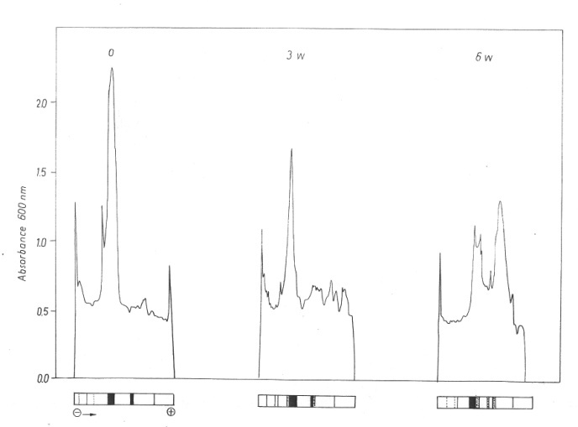

Tc
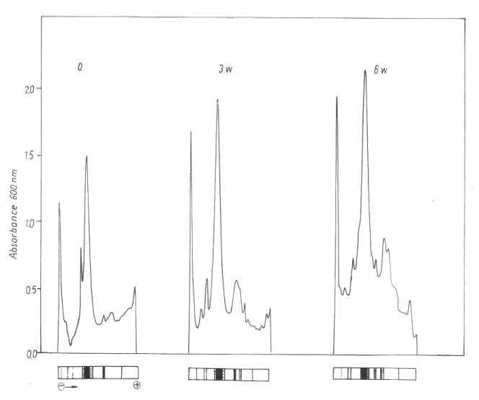
Ta
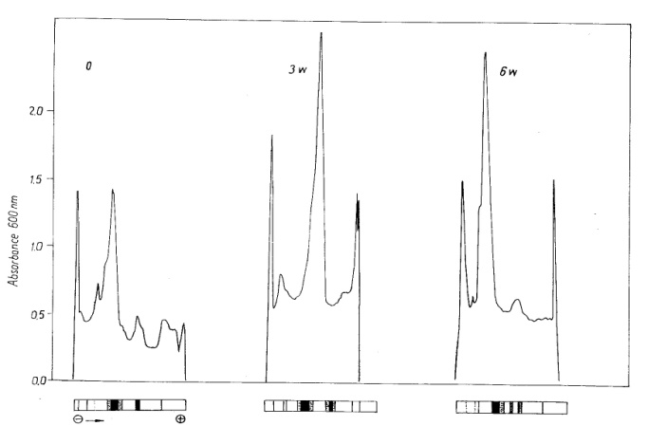
Tb

Figure 1. Densitometric scans of PAGE during semi hard cheese ripening made with modified mesophilic bacteria and probiotic culture (Tc, Ta and Tb).

starter and probiotic Lactobacillus, as adjunct culture and regular of mixed mesophilic lactic starter bacteria was probably due to increasing activities of proteinases and peptidases from residual coagulant and starter bacteria. The forgoing results of Polyacrymide gel electrophoresis (PAGE) of cheese samples treated with modified mesophilic bacteria and probiotic culture at different stages of ripening indicate that the proteolysis of both α S1-casein and ß-casein increased during ripening, ß-casein was more resistant to hydrolysis than α S1-casein which rapidly degraded during ripening, there are also increasing amount of some low-mobility peptides were detected in the γ -casein regions of all cheese samples.
3.3.2 Secondary proteolysis
Addition of modified mesophilic starter bacteria and probiotic Lactobacillus, as adjunct culture, increase soluble-N levels over those in the control in several trials (Table 3 ) In the period between after salting and 3- weeks of cheese age, about 7% of the total nitrogen content was transformed into the soluble phase in Ta while for Tb it was about 15% and between 3 and 6 weeks of cheese age was transformed into soluble-N were nearly 2% and 3% for the same trials. The data indicated that the Non protein-N values generally increased slightly for several trials through the ripening period. On the other hand the Non protein-N of the Total-N contents in Tb was greater than different trials at the end of ripening .
The accumulation of Peptide-N was more remarkable in modified mesophilic starter and probiotic Lactobacillus, as adjunct culture trials and to a lesser degree in control. In general, during the maturation process Amino Acids-N levels in modified mesophilic starter bacteria and probiotic Lactobacillus, containing cheeses were substantially greater than those of control cheese. At 6–weeks of age, Tb had the highest values than Ta and Tc. A comparison between the results and those by other investigators would reveal similar influences , Gagnaire et al., (2009) who reported that a heat treated culture of Lb. helveticus could be used to increase proteolysis and enhancement of cheese flavour without introducing bitter taste in Swedish hard cheese . This might be due to the results of cell lyses and release of intracellular proteinase of modified starter into surrounding cheese matrix, high level and specificities (Gagnaire et al., 2009).
In view of the foregoing available evidence, it could be concluded that a combination of rennet, regular and modified mesophilic starter bacteria and probiotic Lactobacillus was successful in accelerating maturation of semi hard cheese. They were mainly responsible for accelerating casein breakdown and contribute to hydrolysis of medium sized peptides to amino acids nitrogen . it is also clear that maturation time for semi hard cheese can be halved by using modified starter and can improve flavour intensity and reduce bitterness.
3.4 Organoleptic assessment of Semi hard cheese
Cheeses made with modified mesophilic starter bacteria and probiotic Lactobacillus, as adjunct culture were found to have delicate pure taste, clean typical aroma , larger number of eyes (Tb) and normal elastic consistency.
The increased eye formation was probably due to the higher number of citric acid fermenting bacteria (leuconostics or leuconostoc and Str. diacetylactis together also enclosed in the curd. Similar results have been reported (Møller et al., 2009). During the ripening of cheese, proteolysis is the most important pathway for flavour development. Short peptides and free amino acids are necessary for flavor development

Table (3) The changes in nitrogenous compounds during ripening of semi hard
cheese made from modified mesophilic bacteria and probiotic culture during
ripening

Nitrogen fraction as % of cheese |  |  |  |  | Ripening period week | *Trials
A.A.N | PEPT.N | N.P.N | S.N | T.N | Ripening period week | *Trials
0.042 | 0.078 | 0.231 | 0.238 | 3.579 | 0 | Tc
0.065 | 0.083 | 0.274 | 0.287 | 3.776 | 3
0.112 | 0.115 | 0.309 | 0.654 | 4.007 | 6
0.051 | 0.04 | 0.141 | 0.21 | 3.581 | 0 | Ta
0.075 | 0.095 | 0.236 | 0.514 | 4.006 | 3
0.149 | 0.132 | 0.316 | 0.607 | 4.217 | 6
0.055 | 0.049 | 0.095 | 0.187 | 3.818 | 0 | Tb
0.113 | 0.123 | 0.307 | 0.817 | 4.063 | 3
0.178 | 0.149 | 0.373 | 0.981 | 4.203 | 6

Nitrogen fraction as % of T.N |  |  |  | Ripening period week | *Trials
A.A.N | PEPT.N | N.P.N | S.N | Ripening period week | *Trials
1.173 | 2.179 | 6.454 | 6.649 | 0 | Tc
1.721 | 2.198 | 7.256 | 7.6 | 3
2.795 | 2.869 | 7.711 | 16.321 | 6
1.424 | 1.117 | 3.397 | 5.864 | 0 | Ta
1.871 | 2.371 | 5.891 | 12.83 | 3
3.533 | 3.13 | 7.493 | 14.394 | 6
1.44 | 1.283 | 2.488 | 4.899 | 0 | Tb
2.781 | 3.027 | 7.555 | 20.108 | 3
4.235 | 3.545 | 8.847 | 23.34 | 6

Nitrogen fraction as % of S.N |  |  | Ripening period week | *Trials
A.A.N | PEPT.N | N.P.N | Ripening period week | *Trials
17.647 | 32.773 | 97.058 | 0 | Tc
22.0648 | 28.919 | 95.47 | 3
17.125 | 17.584 | 47.247 | 6
24.285 | 19.042 | 67.142 | 0 | Ta
14.591 | 18.482 | 45.914 | 3
24.546 | 21.746 | 52.059 | 6
29.411 | 26.203 | 50.802 | 0 | Tb
13.831 | 15.055 | 37.576 | 3
18.144 | 15.188 | 38.022 | 6
* Trials Tc : control cheese, Ta :cheese made from addition of modified
mesophilic lactic starter bacteria at 60°C/15sec and probiotic culture,Tb:
cheese made from addition of modified mesophilic lactic starter bacteria
at 70°C/15sec and probiotic ; T.N: Total nitrogen, S.N: Soluble nitrogen,
N.P.N: Non protein nitrogen, Pept.N: peptide nitrogen, A.A.N: Amino acid
nitrogen.

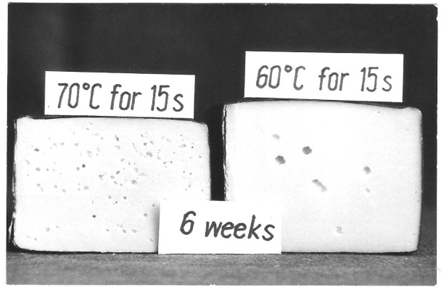
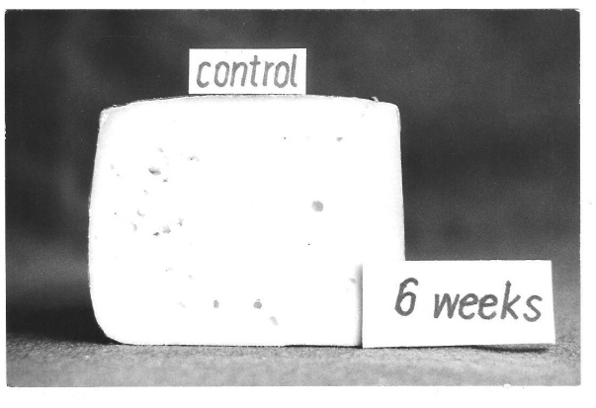
Figure 2. Texture of 6 weeks old semi hard cheese made with modified mesophilic bacteria and probiotic culture.

and are dependent on the extent of proteolysis. Gomes and Malcata (1998) reported that the high flavour scores of semi-hard goat cheese made with B. lactis and L. acidophilus strain Ki were associated with high levels of proteolysis. In addition, Flávia et al., (2005) they reported that L. paracasei had a positive effect on the sensory Minas fresh cheese and its a great potential as a functional food.

5. References
1. Boylston, T. D., C. G. Vinderola, C. G., Ghoddusi, H. B. and Reinheimer. J. A. Incorporation of Bifidobacterium into cheeses: Challenges and rewards. Int. Dairy J, 2004:14:375–387.
2. Buriti, F. C. A., da Rocha, J. S. and Saad, S. M. I. Incorporation of Lactobacillus acidophilus in Minas fresh cheese and its implications for textural and sensorial properties during storage. Int. Dairy J, 2005: 15:1279–1288.
3. Degheidi, M. A., Neimate, A., Hassin , Zedain, M. A and Malim,, M. A. Utilization of Probiotic bacteria on UF white soft cheese. Proc The International Agriculture Center , Cairo, 2007: 19-21.
4. Flávia, C. A., Buriti, Juliana S., da Rocha, Eliane, G. Assis and Susana, M. I. Saad Probiotic potential of Minas fresh cheese prepared with the addition of Lactobacillus paracasei. Lebensmittel-Wissenschaft und-Technologie, 2005: 38: 173-180.
5. Gagnaire, V., Piot, M., Mollé, D., Jardin, J., Pezennec, S., Ferré, A., Desmars, E., Duboz , G., Palme , R., Berthier F. and Buchin, S. Combinations of strains of Lactobacillus helveticus and Lactobacillus delbrueckii modify the antihypertensive activity in Swiss-type cheeses. Health aspects of cheese, Symposium in Dorback, Norway, 6-8 Octobaer, (2009).
6. Gomes, A. M. P. and Malcata, F. X. (Development of probiotic cheese manufactured from goat milk: Response surface analysis via technological manipulation. Journal of Dairy Science, 1998: 81: 1492–1507.
7. Gomes, A. M. P., Malcata, F. X., Klaver, F. A. M., and Grande, H. J. Incorporation and survival of Bifidobacterium sp. strain Bo and Lactobacillus acidophilus strain Ki in a cheese product. Neth. Milk Dairy J,1995:49:71–95.
8. International Dairy Federation (IDF). Milk. Determination of the nitrogen (Kjeldahl method) and calculation of the crude protein content. IDF Standard 20B. Brussels, Belgium, 1993.
9. International Dairy Federation (IDF). Cheese and processed cheese products. Determination of fat content. IDF Standard 5B. Int. Dairy Fed., Brussels, Belgium, 1996.
10. Jatila, H., Tanskanen, J., Hatakka, K., Salusjärvi, T. Probiotic cheese with Lactobacillus GG. Health aspects of cheese Symposium in Dorback, Norway, 6-8 October, 2009.
11. Jensen M. P., Ardö, Y. A. comparison of enzymatic activities of Lactobacillus helveticus and Lactobacillus casei strains with potential to improve ripening of low fat cheese. Health aspects of cheese, Symposium in Dorback, Norway, 6-8 Octobaer, 2009.
12. Joutsjoki, V.V. Probiotic Cheese. Health aspects of cheese, Symposium in Dorback, Norway, 6-8 October , 2009
13. Kasmoglu, A., Göncüolu, M. and Akgün, S. Probiotic white cheese with Lactobacillus acidophilus. Int. Dairy J, 2004: 14:1067–1073.
14. Mäkeläinen , H., Forssten, S., Olli, K., Granlund, L., Rautonen, N. and Ouwehand, A.C. Probiotic lactobacilli in a semi-soft cheese survive in the simulated human gastrointestinal tract . International Dairy Journal, 2009: 19: 675-683.
15. Møller K.K., Rattray, F.P., Høier, E. and Y. Ardö Use of Lactic Acid Bacteria and Enzymes to Improve Flavour and Texture of Low-Salt Cheese. Health aspects of cheese, Symposium in Dorback, Norway, 6-8 Octobaer, 2009.
16. Mundt, J. O. Streptococcus. Bergey’s manual of systematic bacteriology (pp. 1065–1066). Los Angeles: Williams & Wilkins, 1986.
17. Narvhus, J. Assessment of in vitro methods for the evaluation of probiotic potential. Health aspects of cheese Symposium in Dorback, Norway, 6-8 October, 2009.
18. Ong, L., Henriksson, A. and Shah, N. P. Chemical analysis and sensory evaluation of Cheddar cheese produced with Lactobacillus acidophilus, Lb. casei, Lb. paracasei or Bifidobacterium sp. Int. Dairy J, 2007: 17:937–945.
19. Ross, R. P., Fitzgerald, G., Collins, K. and Stanton, C. Cheese delivering biocultures-probiotic cheese. Aust. J. Dairy Technol., 2002: 57:71–78.
20. Sousa, M.J., Ardö, Y., McSweeney, P. L. H. Advances in the study of proteolysis during cheese ripening. Int. Dairy Journal, 2001: 11: 327-345.
21. Vanderzant, C., Splittoesser, D. F. Compendium of methods for the microbiological examination of foods. Washington, DC: American Public Health Association, 1992.
22. Vinderola, C. G., Prosello, W., Ghiberto, D. and Reinheimer, J. A. Viability of probiotic (Bifidobacterium, Lactobacillus acidophilus and Lactobacillus casei) and nonprobiotic microflora in Argentinean Fresco cheese. J. Dairy Sci, 2000: 83:1905–1911.
23. Walstra, P., Geurts, T. J., Omen, A., Jellema, D. and Van Boekel, M. Dairy Technology: Principles of milk properties and processes, Marcel Dekker, INC. New York, Basel, 1999.

7/19/2010

