Molecular Genetic Approach by using the RAPD-PCR Technique for Detection of Genetic Variability in Non- Human Isolates of Fasciola

Nashwa I. Ramadan¹, Lobna M. Saber², Maha M. Abd El Latif³, Nabila A. Abdalla⁴, and Halla M. Ragab⁴

¹Department of Parasitology, Faculty of Medicine, Ain Shams University, ²Department of Biochemistry, Faculty of Medicine for Girls, Al-Azhar University, ³Department of research and applications of supplementary medicine, ⁴Department of Biochemistry, Genetic Engineering and Biotechnology Division, National Research Centre, Cairo, Egypt
hmragab@yahoo.com

Abstract: Background: Understanding genetic structure and status of genetic variation of the Fasciola gigantica and F. hepatica isolates from different hosts, has important implications for epidemiology and effective control of fasciolosis. The aim of the present work was to study the molecular characterization of Fasciola gigantica and F. hepatica isolates collected from cows and sheep, using the random amplified polymorphic DNA fragments-polymerase chain reaction (RAPDs-PCR) technique. Methods: F. gigantica and F. hepatica of bovine and ovine origin were collected from the biliary tracts and gall bladders of condemned bovine and ovine livers from Cairo Governmental slaughter house.. By using (RAPDs-PCR) technique, optimal standardization of conditions of amplification and thermocyclation was made, using genetic markers. The methodology used compared the genetic pattern between the two species (inter-species) and inside each species (intra-species) between cow and sheep and the amplification fragments were between 135 and 741 base pairs of marker. Results: The results showed genetic variations (polymorphisms) of Fasciola gigantica and F. hepatica with amplification fragment based on a 500 – 400 base pair (bp). Inside each species, there were genetic variations in bovine and ovine strains and the amplification fragments were between 600 and 400 base pairs (bp). Conclusion: This assay is useful for both individual diagnosis and epidemiological surveys in endemic regions. [New York Science Journal 2010;3(10):88-96]. (ISSN: 1554-0200).

Keywords: Fasciola hepatica; Fasciola gigantica and (RAPDs-PCR) technique.

1. Introduction:
Fasciolosis, caused by the digenetic trematodes of the genus Fasciola, is one of the most important plantborne helminth infections of human and livestock in many parts of the world. Annual conomic loss caused by the disease is estimated to be US$2 billion mainly due to condemned livers, reduced milk yield, fertility disorders and reduced meat production. (Rokni et al., 2010, and Mas-Coma et al., 2005). Two species of F. hepatica and F. gigantica were recognized in humans and domestic farm animals.
Understanding genetic structure and status of genetic variation of the parasite populations has important implications for epidemiology and effective control of fasciolosis .(Ashrafi et al., 2006).
During the last 10 years, the diagnosis of agents of infectious disease has begun to include the use of nucleic acid-based technologies. Diagnosis of parasitic organisms is the last field of clinical microbiology to incorporate these techniques, due in part to the expense of new technology as well as a scarcity of these parasites in countries where this research is ongoing. Despite the slow start on developing these assays, the further progress and utilization of nucleic acid-based assays to detect parasitic pathogens can and will play a role in the epidemiology, prevention, and treatment of parasitic diseases (Weiss, 1995).
Currently, the detection and diagnosis of parasite infections rely on several methods in addition to clinical symptoms, clinical history, travel history, and geographic location of patient. Each diagnostic method has inherent advantages and disadvantages, irrespective of the type of parasite or clinical specimen being tested. The chief advantages of nucleic acid-based detection techniques are their sensitivity for detecting pathogens and the speed at which they can definitely identify an organism. If culture or animal inoculation is required for the identification of the parasite and the introduction of therapy, then probe detection or PCR offers an advantage.
When direct microscopy is sufficient for parasite detection and species identification by morphology, and the level of parasite is sufficiently high, then nucleic acid-based technology is not advantageous except for processing a large number of specimens with an automated assay. However, when the parasite load is low, then a sensitive diagnostic test involving nucleic acids is beneficial. Serologic detection of antibodies to parasites is useful as a screening device, but often there are cross-reactive antigens compromising specificity, and serology generally does not discriminate between current active infection and either prior or latent infection (Wolstenholme et al., 2004).
The results with nucleic acid-based assays are independent of immunocompetence or previous clinical history and can distinguish between organisms that are morphologically similar and/or share antigenic epitopes, and the organisms do not need to be viable or culturable. An inherent disadvantage of these assays is that isolates containing variant DNA sequences may be missed even though the sequence is not associated with virulence (Zhao et al., 1998).
Fascioliasis is a major zoonosis that causes a great deal of economic loss throughout the tropical region of the world (Gorokhov et al., 2008). And is an emerging public health problem in the Middle East including Egypt (Alcaino and Apt, 1989; Hussein et al., 2000). The advance of biogenetic technology has allowed advanced techniques to study and to characterize individuals from their basic molecular unit DNA (Wilson, 1993). Multiple applications of molecular biology have been developed (Gasser, 1999 and McGarry et al., 2007). Some investigations have focused to the identification and molecular typing of the etiological agents, which has allowed the establishment of characteristic genetic profiles to understand the relation between the definitive and the intermediate hosts (Leelayuwat et al., 2000 and Adisakwattana et al., 2007).
Genetic polymorphisms, establish the possible existence of genomic variants between individuals of the same species (Gomes et al., 2000). PCR (Polymerase Chain Reaction) and RFLP (Restriction Fragment Length Polymorphism) are molecular methods in the identification of polymorphic variants in DNA sequence of an organism. Both are highly sensitive, specific and reproducible. Nevertheless, they present the disadvantage of requiring previous information to this accomplishment, since it is necessary to know, at least, a part of the DNA sequence that is desired to amplify (Mullis et al., 1994). An alternative constitutes the application of a variant of the PCR; RAPDs (Random Amplified Polymorphic DNA), technique based on the arbitrary use of oligonucleotides sequence of primers synthesized, in vitro, which are nonspecific for the DNA tempering (William et al., 1990). This procedure displays the advantage of not requiring preliminary information on the DNA sequence to study. Nevertheless, it establishes possible genomic variants of organism in different host species (Espinosa and Borowsky, 1998).
This work aimed to study the genetic variability in non-human isolates of F.hepatica and F.gigantica collected from bovine and ovine definitive hosts, by the RAPDs-PCR technique.
2. Material and Method
F. gigantica and F. hepatica of bovine and ovine origin were collected from the biliary tracts and gall bladders of condemned bovine and ovine livers from Cairo Governmental slaughter house. DNA extraction involves three basic steps; a- cell lysis using a detergent (Triton 100X), b- removal of proteins & c- ethanol precipitation of nucleic acids at cold temperatures (at -70ºC) (McManus and Bowles, 1996), but with some modifications. The parasites were homogenized and suspended in lysis solution plug of 8% Triton 100X; 0.25M Sucrose; 50mM EDTA (pH 7.4). The extracts were centrifuged and the supernatant fraction was divided into two extractions. One was saturated with a volume of phenol in Tris (pH 8.0) and the second was saturated with chloroform. The DNA was then concentrated by ethanol precipitation. The sediment was re-suspended and hung in a solution of Tris-EDTA plug (T.E), quantified and stored at -20ºC until its use. RAPDs-PCR: 10 decamer oligoneocleotide primers were evaluated whose sequences were selected randomly, with the requirement that the percentage of guanine and cytosine (G&C) content fluctuated between 50 & 70% (Williams et al., 1993). The nucleotide sequences of these primers are shown (Tabel.1). Of the total primers, only four were selected: P2, P4, P6 and P7, their election was based on terms of greater polymorphism, resolution and reproducibility in distinguishing Fasciola isolates. The reaction mixture worked in a final volume of 50ml, using cushioning solution of amplification 10X reaction buffer formed of 200 mM Tris HCl, 500 mM KCl, (pH 8.4) (Advanced Biotechnologies Inc., UK), 20 mM MgCl₂, 0.4 mM dNTPs (Transgenic Inc., USA), 0.4 mm of each primer, 5 ng/ml of genomic DNA (template), 2 UI Taq DNA Polymerase (Advanced Biotechnologies Inc., UK).
Amplification PCR was made in a DNA thermal cycler (Perkin Elmer Cetus Thermal Cycler) which was programmed for 75 cycles of denaturation at 94ºC for 5 sec., annealing at 36ºC for 30 sec. and extension at 72ºC for 5 seconds. Resolution of amplified fragments: DNA was resolved by horizontal gel electrophoresis in 1% agarose gels to which ethidium bromide was added (0.005%) to an excess of solution plug of T.B.E. (0.09 M Tris-Borate and 0.002 M EDTA, 'pH 8'). The samples were diluted in solution of gel loading ficoll buffer. DNA molecular weight marker of 100 base pair (bp) (Roche Molecular Biochemicals) was loaded for accurate sizing of DNA fragments generated by PCR. The electrophoresis voltage was adjusted until obtaining a migration of 70% of the samples in the gel. The amplified fragments were examined and photographed on an ultraviolet light (UV) through a transilluminator using Polaroid camera and films (Polaroid Corporation, USA). The size of the RAPDs-PCR fragments was determined by the reciprocal graph of retardation factor (RF) versus the logarithm of the molecular weight of ladder.

Table (1): Oligonucleotide sequences of primers used
Primer code | Sequence
P1 | GGT CGG AGAA
P2 | TCG TCG CATT
P3 | AGC ACG GTGG
P4 | AGC AGC AGGC
P5 | GGA AGT CGCC
P6 | AGC CAG CGAA
P7 | GGG TAA CGCC
P8 | GTT GCG ATCC
P9 | AGT CGT CCCC
P10 | TCG GAC GTGA

3. Results
The genetic profiles of bovine F. gigantica and F. hepatica were compared. They displayed a polymorphic fragment of approximately 500 bp (Fig.1). The RAPDs-PCR analysis indicated a 100% polymorphism with an average marker value of 5.8 using the four primers. P6 yielded 8 fragments.
Genetic patrons of adult ovine F. gigantica and F. hepatica (Fig.2) displayed a polymorphic fragment of about 400 bp. Polymorphism reached 92%, with an average marker value of 1.8 using the four selected primers. P4) yielded 3 amplified fragments although with lower polymorphism (2), indicating unequal genetic patterns between the two ovine Fasciola species.
Comparison between bovine and ovine strains in each species of Fasciola, revealed genetic polymorphism of the animal (cow and sheep) in each Fasciola species with genetic variability observed in DNA amplification in some samples and absence of amplification in others. Genetic patrons of samples for bovine and ovine F. gigantica (Fig.3) displayed two amplified polymorphic fragments of about 375 and 500 bp. RAPDs-PCR analysis indicated 100% polymorphism with an average marker value of 10.75 by the four primers. P6 yielded 13 fragments.
Genetic patrons of samples for bovine and ovine F. hepatica (Fig. 4) displayed a polymorphic fragment of about 600 bp. RAPDs-PCR analysis indicated 100% polymorphism with an average marker value of 6.5 by the four primers. P2 yielded the ten amplified fragments.
Table (2): Genetic polymorphism between bovine Fasciola gigantica and Fasciola hepatica by RAPDs-PCR technique
Primer | RAPDs amplification | RAPDs polymorphism
P2 | 4 | 4 (100%)
P4 | 4 | 4 (100%)
P6 | 8 | 8 (100%)
P7 | 7 | 7 (100%)
Average value | 5.8 | 5.8 (100%)

Table (3): Genetic polymorphism between ovine Fasciola gigantica and Fasciola hepatica by RAPDs-PCR technique
Primer | RAPDs amplification | RAPDs polymorphism
P2 | 1 | 1 (100%)
P4 | 3 | 2 (67%)
P6 | 2 | 2 (100%)
P7 | 2 | 2 (100%)
Average value | 2 | 1.8 (92%)

Table (4): Genetic polymorphism between bovine and ovine Fasciola gigantica by RAPDs-PCR technique
Primer | RAPDs amplification | RAPDs polymorphism
P2 | 11 | 11 (100%)
P4 | 9 | 9 (100%)
P6 | 13 | 13 (100%)
P7 | 9 | 9 (100%)
Average value | 10.75 | 10.75 (100%)

Table (5): Genetic polymorphism between bovine and ovine Fasciola hepatica by RAPDs-PCR technique
Primer | RAPDs amplification | RAPDs polymorphism
P2 | 10 | 10 (100%)
P4 | 7 | 7 (100%)
P6 | 5 | 5 (100%)
P7 | 4 | 4 (100%)
Average value | 6.5 | 6.5 (100%)

4. Discussion
Studies on genetic variability within and between populations of Fasciola have important implications for epidemiology, control and diagnosis of fasciolosis. Different DNA-based molecular techniques have been applied to these flukes (Rokni et al., 2010, and Mas-Coma et al., 2005).There have been no data regarding genetic characterization of F. hepatica in Egypt using defined DNA sequences. This study was carried out to characterize F. hepatica and F. gigantica isolates collected from cows and sheep, using the random amplified polymorphic DNA fragments-polymerase chain reaction (RAPDs-PCR) technique.
Humans may become highly exposed to the risk of fascioliasis. There are many different tools that may help in early diagnosis. DNA based diagnostic methods using PCR and sequencing is fast, sensitive, specific, independent and doesn’t need any previous clinical history. The RAPD-PCR, which is also called Arbitrarily Primed-PCR (AP-PCR) is a DNA polymorphism assay based on the amplification of random genomic DNA segments using single primers of arbitrary sequence. It is a non-radioactive procedure that is simpler, faster and more sensitive than other DNA analysis methods for discrimination of intra-specific variants (Williams et al., 1990). It offers advantages over other methods. It is not only limited to a single locus but also detects polymorphisms across the whole genome (Nei,1987).
In this study, PCR; RAPDs assay have been used. Nucleic acid-based probe detection of parasitic agents consists of the use of a reporter DNA molecule to detect specific parasite DNA or RNA sequences. The parasite within the target specimen is lysed with a membrane perturbant such as alkali, detergent, heat, chaotropic agents (urea and guanidine hydrochloride), or sonic disruption, and the nucleic acid is liberated and then denatured. The target sequence is detected by the reporter molecule following successful hybridization. The reporter molecule can be composed of an oligonucleotide, a DNA fragment, single-stranded DNA, or plasmid DNA. A label consisting of a radionucleotide, enzyme, antigenic molecule, affinity label, or chemiluminescent substrate is attached to the reporter. A positive signal is generated directly or indirectly by the reporter molecules that hybridized to target sequences in solution or immobilized on solid supports, such as filter paper, nitrocellulose, and nylon membranes.

Fig. 1: DNA amplification fragments obtained by RAPDs-PCR of bovine F. gigantica and F. hepatica resolved by horizontal electrophoresis in 1% agarose stained with ethidium bromide and visualized on an ultraviolet transilluminator. Lane PM: protein molecular weight markers the arrow points to 500 bp. Lane C: negative control. Lanes 1, 2, 3, 4 = primers P2, P4, P6 and P7.
M C 1 2 3 4
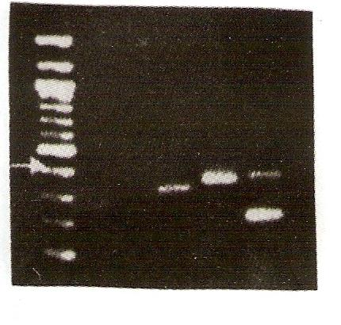
A) Bovine F. gigantica
M C 1 2 3 4
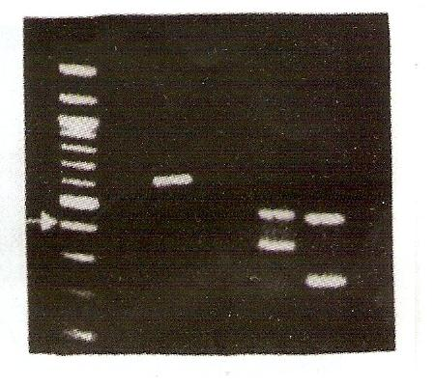
B) Bovine F. hepatica

Fig. 2: DNA amplification fragments obtained by RAPDs-PCR of ovine F. gigantica and F. hepatica resolved by horizontal electrophoresis in 1% agarose stained with ethidium bromide and visualized on an ultraviolet transilluminator. Lane PM: protein molecular weight markers, the arrow points to 400 bp. Lane C: negative control. Lanes 1, 2, 3, 4 = primers P2, P4, P6 and P7.
M C 1 2 3 4
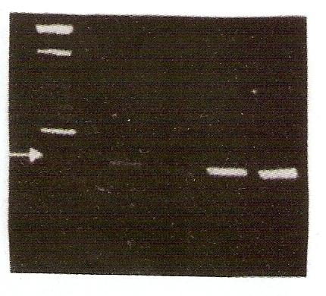
B) Ovine F. hepatica
M C 1 2 3 4
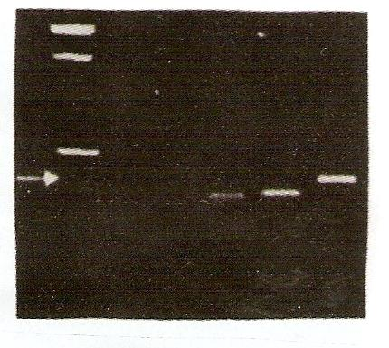
A) Ovine F. gigantica

Z

Fig. 3: DNA amplification fragments obtained by RAPDs-PCR of bovine and ovine F. gigantica resolved by horizontal electrophoresis in 1% agarose stained with ethidium bromide and visualized on an ultraviolet transilluminator. Lane PM: protein molecular weight markers the arrow points to 500 and 400 bp. Lane C: negative control. Lanes 1, 2, 3, 4 = primers P2, P4, P6 and P7.
M C 1 2 3 4
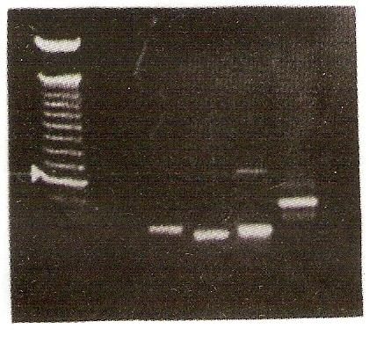

B) Ovine F. gigantica

M C 1 2 3 4
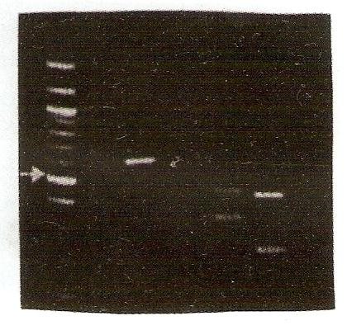
A) Bovine F. gigantica

A) Bovine F. gigantica

Fig. 4: DNA amplification fragments obtained by RAPDs-PCR of bovine and ovine F. hepatica resolved by horizontal electrophoresis in 1% agarose stained with ethidium bromide and visualized on an ultraviolet transilluminator. Lane PM: protein molecular weight markers the arrow points to 600 bp. Lane C: negative control. Lanes 1, 2, 3, 4 = primers P2, P4, P6 and P7.
M C 1 2 3 4
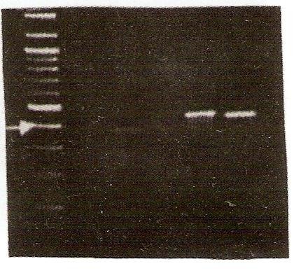
A) Bovine F. hepatica
M C 1 2 3 4
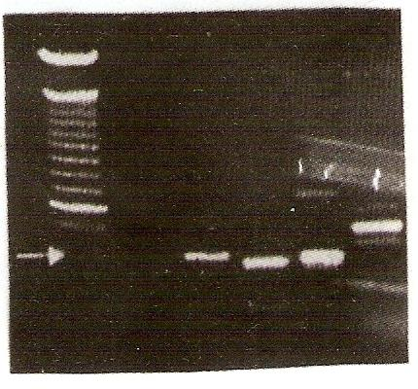
B) Ovine F. hepatica

In our study, DNA levels in F. gigantica and F. hepatica was satisfactory as concentration was measured by spectrophotometer and an average of 0.5 mg/ml was considered. The quality and purity of DNA were evaluated by spectrophotometer analysis 260/280 and the relation of the DNA and proteins was adapted to an average value of 2.1 (Mullis et al., 1994). The RAPD-PCR technique proved valuable using four primers of random sequences to verify the presence of polymorphism between F. gigantica and F. hepatica isolates from the same host (individual variation) and within isolates of the same Fasciola species from different hosts as cow and sheep (strain variation).

The present RAPDs-PCR primers recognized the size of polymorphic fragments fluctuating between 135 and 741 base pairs (bp). Primers P2 and P6 were very useful, where the greater number of RAPDs markers was obtained, allowing easy distinction between different Fasciola isolates. These two primer sequences may have annealed to variable sequences, which may be of great utility for differentiation of strain and individual variation. P4 and P7 showed lower polymorphism between the isolates used. This is in agreement with Kantanen et al. (1995) who found that some primers fail to amplify, while others produce too complex banding patterns. It also runs in common with Hadrys et al. (1992) and Bardakei and Skibinski (1994) who concluded that the choice of a primer is of major importance for the discriminating power of the technique. The RAPDs-PCR analysis of bovine F. gigantica and F. hepatica displayed a polymorphic fragment of about 500 bp, and indicated a 100% polymorphism with an average marker value of 5.8 by the used primers. P6 yielded 8 fragments. Analysis of ovine F. gigantica and F. hepatica displayed a polymorphic fragment of about 400 bp, and indicated a 92% polymorphism with an average marker value of 1.8 using the four primers. P4 yielded three fragments although with lower polymorphism (2), indicating unequal genetic patterns between the two ovine Fasciola sp. The detected differences between F. gigantica and F. hepatica isolates are in agreement with that of Mas-Coma et al. (1999). The RAPDs-PCR analysis of bovine and ovine F. gigantica displayed two amplified polymorphic fragments of approx. 375 and 500 bp giving 100% polymorphism with an average marker value of 10.75 by the four primers. P6 yielded 13 fragments. Analysis of bovine and ovine F.hepatica displayed a polymorphic fragment of approx. 600 bp and indicated 100% polymorphism with an average marker value of 6.5 by the four selected primers. P2 yielded 10 fragments. These results agree with Danilo et al. (2003) who demonstrated that the RAPD-PCR technique is capable of distinguishing ovine, bovine and equine strains of F. hepatica. But, Blair and McManus (1989) studied the DNA genetic mapping of F. hepatica, F. gigantica and Fascioloides magna, and found that each species had no more than two unique recognition sites, the remainder(s) being common to one or both of the other two species. No intra-specific variation in restriction sites was noted in F. hepatica from sheep, cattle and other laboratory animals from Australia, New Zealand, Mexico, U.K., Hungary and Spain, or in F. gigantica samples from Indonesia and Malaysia. Only one sample of F. magna was available. One specimen of Fasciola sp. from Japan yielded a restriction map identical to that of F. gigantica. Hashimoto et al. (1997) studied the whole mitochondrial DNA of F. hepatica from Australia, F. gigantica from Malaysia, and Fasciola sp. from Japan. The resulting patterns showed that there were some bands specific for each geographical isolate and that the Japanese Fasciola sp. shared more bands with F. gigantica than with F. hepatica. They concluded that the Japanese Fasciola sp. is not more than a strain of F. gigantica. It is concluded that polymorphic DNA sequences with inter-species and intra-species genetic distinction, can be used for phylogenetic analysis to identify the origin of Fasciola species. This data is a base for further investigations and new approaches concerning resistance, treatment and control of fascioliasis.

In conclusion, the results of this study suggest that polymorphic DNA sequences with inter-species and intra-species genetic distinction, can be used for phylogenetic analysis to identify the origin of Fasciola species which may have implications in the epidemiology and control programs of fasciolosis as a major helminth zoonosis of medical and veterinary importance.. This data is a base for further investigations and new approaches concerning resistance and treatment of fasciolosis.

Corresponding author:
Halla M. Ragab
Department of Biochemistry, Genetic Engineering and Biotechnology Division, National Research Centre, Dokki, Cairo, Egypt.
E mail: hmragab@yahoo.com

References:

1) Adisakwattana P. , Viyanant V. , et al. Comparative molecular analysis of two asparaginyl endopeptidases and encoding genes from Fasciola gigantica. Mol Biochem Parasitol.; 2007,156(2),102-106.

2) Alcaino, H. and Apt, W. Algunos Antecedentes sobre la Fascioliasis Animal y Humana. Monog. Med. Vet., 1989, 11, 14-29.
3) Ashrafi K., Valero M., Panova M., Periago M., Massoud J. and Mas-Coma S. Phenotypic analysis of adults of Fasciola hepatica, Fasciola gigantic and intermediate forms from the endemic region of Gilan, Iran. Parasitol Int; 2006,55,249-60.

4) Bardakei F. and Skibinski D. Application of RAPD technique in Tilapia fish: Species and subspecies identification. Heredity; 1994, 73, 117-123.

5) Blair, D. and Donald McManus, P.: Restriction enzyme mapping of ribosomal DNA can distinguish between fasciolid (liver fluke) species. Mol. Biochem. Parasit.; 1989, 36 (3), 201-208.

6) Danilo, V; Marsia. F. V. and Carmen, G. Approach to a molecular characterization of Fasciola hepatica by the RAPDs-PCR technique.Parasit.Latin.Am.; 2003,58:11-16.

7) Espinosa, L. and Borowsky, R. Evolutionary Divergence of AP-PCR (RAPD) Patterns. Mol. Biol. Evol.; 1998, 15: 408-414.

8) Gasser R. PCR- Based Technology in Veterinary Parasitology. Vet. Parasitol.; 1999, 84, 229-258.

9) Gomes, M., Melo M. and Macedo, A. RAPD in analysis of isolates of Entamoeba histolitica. Acta Trop.; 2000, 75, 71-77.

10) Gorokhov V., Sergiev V., et al. Incidence of human liver fluke infection Med Parazitol (Mosk); 2008,2, 57-59.

11) Hadrys H. Balick M. and Schierwater B. Application of randomly amplified polymorphic DNA (RAPD) in molecular ecology. Mol. Ecol; 1992, 1, 55-63.

12|) Hashimoto K.; Watanobe T.; et al. Mitochondrial DNA and nuclear DNA indicate that the Japanese Fasciola species is F.gigantica. Parasitology Research. ; 1997, 83, (3),220 – 225

13) Hussein, A..; El-Din, et al.,. Environmental survey and the occurrence of some helminthic parasites in Abis 7 and Abis 8 in Alexandria. Bull. High Inst. Pub. Hlth.; 2000, 30(1), 1-14.

14) Kantanen, J; Vilkki, J; et al. Randomly amplified polymorphic DNA (RAPD) in cattle and sheep: application for detecting genetic variation. Anim. Genet; 1995,26, 315-320.

15) Knapp, S. E; Dunkel, A. M; et al. Epizootology of fascioliasis in Montana. Vet. Parasitol.; 1992, 42, 241-246.

16) Leelayuwat, C; Romphruk, A et al. Genotype analysis of Burkholderia pseudomallei Using randomly amplified poly-morphic DNA (RAPD): Indicative of genetic differences amongst environmental and clinical isolates. Acta Trop; 2000, 77, 229-237.

17) Mas-Coma S. Esteban J. and Bargues M. "Epidemiology of human fascioliasis: a review and proposed new classification" Bull. WHO. ; 1999, pp. 340-346.
18) Mas-Coma S., Bargues M. and Valero M. Fasciolosis and other plantborne trematode zoonoses. Int J Parasitol; 2005,35,1255-78.

19) McManus D. and Bowles J. Molecular Genetic Approaches to Parasite Identification: Their value in Diagnostic Parasitology and Systematics. Int J Parasitol; 1996, 26,687-704.

20) McGarry J., Ortiz P., et al. PCR-based differentiation of Fasciola species (Trematoda: Fasciolidae), using primers based on RAPD-derived sequences. Ann Trop Med Parasitol. ; 2007, 101(5), 415-421.

21) Mullis K .Ferre F. and Gibbs R. The Polymerase Chain Reaction. Birkhäuser. Boston, 1994, 458 – 465.

22|) Nei M. Molecular evolutionary genetics. Columbia, University, Press, New York., 1987, 235- 265.
23) Rokni1 M., Mirhendi1 H., Behnia1 M., Fasihi M. and Jalalizand N. Molecular Characterization of Fasciola hepatica Isolates by RAPD-PCR and Ribosomal ITS1 Sequencing Iranian Red Crescent Medical Journal IRCMJ; 2010, 12(1),27-32.

24) Weiss B. DNA Probes And PCR For Diagnosis Of Parasitic Infections. Clinical Microbiology Reviews; 1995, 8 (1), 113–130

25) William J., Kubelik R. and Livak L. DNA polymorphisms amplified by arbitrary primers are useful as genetic markers. Nucleic Acids Res; 1990, 18, 6531-6535.

26) Williams J., HanafeyK; et al. Genetic analysis using random amplified polymorphic DNA markers. Methods Enzymol; 1993, 218, 704-740.

27) Wilson S. Application of Nucleic Acid-Based technologies to the diagnosis and detection of disease. Trans Royal Soc Trop Med Hyg; 1993, 87, 609-611.

28) Wolstenholme1 , Fairweather I. Prichar R. von Samson G and Nicholas C. Drug resistance in veterinary helminths. TRENDS in Parasitology; 2004, 20 (10) 469- 476.

29) Zhao S., G. Molnar J. Zhang L. Zheng L. Averboukh and A. Pardee. 39-end cDNA pool suitable for differential display from a small number of cells. BioTechniques ; 1998, 24842–850.

25 / 7 / 2010

