Assessment of Genetic Variations in Some Vigna Species by RAPD and ISSR Analysis

Elham A. A. Abd El-Hady^{*1}, Atef A. A. Haiba¹; Nagwa R. Abd El-Hamid¹; Abd El-Rahman M.F. Al-Ansary¹ and Ahmed Y. Mohamed².

¹Department of Genetics and Cytology, National Research Center, Dokki, Giza, Egypt
² Department of Botany, Al- Azhar University, Cairo, Egypt.
* elhamabdelhady@hotmail.com

Abstract: Genetic variations of seven Vigna species were evaluated using random amplified polymorphic DNA (RAPD) and inter-simple sequence repeats (ISSR) markers. Amplification of genomic DNA of the seven genotypes by RAPD analysis, five primers generated 64 fragments, of which 31 were polymorphic with an average of 12.8 bands/ primer. The amplified products varied in size from 2556 to 255 bp. Eleven selected ISSR primers produced 128 bands across seven genotypes of which 89 were polymorphic with an average of 11.64 / primer. The size of amplified bands ranged from 2838 to 264 bp. Similarity index values ranged from 0.913 to 0.120 (RAPD) 0.822 to 0.118 (ISSR) and 0.899 to 0.115 (RAPD and ISSR). The results indicated that both of the marker systems RAPD and ISSR, individually or combined can be effectively used in determination of genetic relationship among Vigna species. It could be concluded that, the information of genetic similarities and diversity among Vigna genotypes are necessary for breeding programs.
[Elham A. A. Abd El-Hady, Atef A. A. Haiba; Nagwa R. Abd El-Hamid; Abd El-Rahman M.F. Al-Ansary and Ahmed Y. Mohamed. Assessment of Genetic Variations in Some Vigna Species by RAPD and ISSR Analysis. New York Science Journal 2010; 3(11):120-128]. (ISSN: 1554-0200).

Keywords: Genetic Diversity, Vigna, RAPD, ISSR.

1. Introduction
The genus Vigna belonging to family Fabaceae and divided into seven subgenera, it includes over 150 species. Many Vigna species are cultivated for food. The morphological markers were not quite enough to expose the genetic diversity and do not reflect real genetic relationships. Therefore, molecular markers have several advantages over the traditional phenotypic markers. They are unaffected by environment and detectable in all stages of development. The molecular genetic techniques have been adopted for the management and manipulation of plant genomes. DNA markers are the most powerful and widely used because they can portray genome sequence composition (Karp et al., 1997).
Over the years, the methods for detecting and assessing genetic diversity have extended from analysis of discrete morphological traits to molecular traits. Several DNA marker systems are now common use in diversity studies of plants, the most commonly used marker systems are restriction fragment length polymorphism (RFLP) (Soller and Beckmann, 1983), random amplified polymorphic DNA (RAPD) (Williams et al., 1990), amplified fragment length polymorphism (AFLP) (Vos et al., 1995), inter-simple sequence repeats (ISSRs) (Zietkiewicz et al., 1994) and microsatellites or simple sequence repeats (SSRs) (Becker and Heun, 1994).
Among them to characterize DNA variation patterns within species and among closely related taxa in Vigna species have been RAPD (Dikshit et al., 2007), AFLP ( Yoon et al., 2007), RFLP (Kaga et al., 2000), ISSR (Ajibade et al., 2000) and SSRs ( Dikshit et al., 2007) .
The utility of PCR-based RAPD or ISSR variations as phylogenetic markers for investigating evolutionary relationships among plants has been clearly established (Maugham et al., 1996). Random amplified polymorphic DNA (RAPD) is a valuable tool for identifying genetic variation because it is inexpensive, quick, and simple (Williams et al., 1990).It permits the identification of DNA polymorphisms and can be used to amplify particular fragments of genomic DNA (Bielawski et al., 1996).Inter-simple sequence repeats (ISSRs) is a type of molecular marker, proposed by (Zeitkiewicz et al., 1994) for fingerprinting. ISSRs fingerprinting has been commonly used to study population genetics, taxonomy and phylogeny of many plant species (Wolf and Randle, 2001). ISSR primers can confirm specific amplified DNA polymorphic fragments within the variety (Leian et al., 2005).
Since knowledge of genetic diversity is essential for evolving systematic breeding and conservation strategies, the present molecular diversity analysis using RAPD and ISSR techniques were carried out on seven Vigna species.

2. Material and Methods
Seeds of seven Vigna species were used V. mango L., (Mang.), V. angularis L. (Angul.), V. umbellata (Thumb) (Umb), V. unguiculata L. (Ung-Ger.) and V. radiate L. (Radia.) were kindly obtained from the germplasm collection of the Institute for Plant Genetics and Crop Plant Research (IPK), Gatersleben, Germany. While another two species, V. sinesis (Endl.) (Sin-Egy) and Egyptian V. unguiculata L. (Ung-Egy.) from Horticulture Research Institute, Agricultural Research Center, Giza, Egypt.

DNA isolation
Total genomic DNA was extracted from the young leaves of the seven Vigna species by using Bio Basic Kits. Its integrity was checked on agarose gel electrophoresis according to Sambrook et al. (1989).

DNA amplification
RAPD fingerprinting:
RAPD amplification was carried out with five primers (Metabion International AG. ) in a 25μL volume, containing (5 µL of 5x buffer, 3.0 µL of dNTPs (2.5mM ) 3 µL of Mgcl₂ (25 mM), 3.0 µL primer (2.5 µ L ), 0.3 µ L of Taq polymerase ( 5U/ µL) and 2.0 µL of genomic DNA (50 ng/ µL) . Amplification was performed in PTC-100 PCR version 9.0 from M J Research-USA. programmed for an initial denaturation at 94ºC 5 min, 40 cycles of 1 min denaturation at 94ºC, 1 min annealing at 40ºC and 2 min extension at 72ºC followed by final extension for 5 min at 72ºC according to (Williams et al., 1990). Each PCR reaction was repeated twice in order to ensure that RAPD banding patterns were consistent and reproducible and only stable products were scored.

ISSR fingerprinting:
The isolated DNA was performed according to (Jonathan and Wendel, 1990) ISSR-PCR reaction for the seven genotypes of Vigna species was conducted using 12 primers. Amplification was carried out in 25 μl reaction mixture contained 2 μl of genomic DNA, 1 μl of the primer, 2.5 μl of 10X Taq DNA polymerase reaction buffer, 1.5 unit of Taq DNA polymerase and 200 mM of each dNTP. Amplifications were performed in DNA amplification Thermocycler (PTC-100 PCR version 9.0 from M J Research-USA). The apparatus is programmed to execute the following conditions, denaturation step of 5 min at 94°C, followed by 35 cycles composed of 30 s at 94°C, 90 s at the annealing temperature, and 90 s at 72°C. A final extension of 72°C for 5 min. Amplifications were performed at least twice and only reproducible products were taken into account for further data analysis.
Gel electrophoresis: Amplification products of RAPD and ISSR were separated on 1.5% agarose gels in 1X TAE buffer with DNA ladder (1Kb) and detected by staining with ethidium bromide according to Sambrook et al., (1989). Then, the PCR products were visualized by UV-transilluminator and photographed by gel documentation system, Biometra - Bio Doc. Analyze.
Data analysis
Pairwise comparison of genotypes based on the presence (1) or absence (0) of reproducible polymorphic DNA bands was used to generate the similarity coefficients by SPSS program version-10 (Norman et al., 1975). the similarity coefficients was used to construct a dendrogram by the unweighted pair group method with arithmetical average (UPGMA).

3. Results and Discussion
RAPD analysis:
The RAPD profiles of the amplification products of the five random primers are shown in Figure (1), the sequences of the primers and the number of bands generated by each primer is given in Table (1). Five primers were used to screen seven genotypes of Vigna species produce a total number of 64 amplified DNA products were generated across the studied genotypes with an average of 12.8 bands / primer. Out of the total bands, 31 were polymorphic and 23 were unique ones. The total number of the amplified RAPDs produced by each primer varied from a minimum number of 2 amplified products by primer OPX-17 to a maximum of 23 amplified products by primer OPA-03.
The size of amplified bands also varied with different primers. The largest 2556 bp band was amplified by primer OPD-13, while the smallest size was amplified by primer OPW-04 and detected about 264 bp.
The genetic similarity coefficients based on RAPD markers of the seven studied Vigna species Table (2) illustrated that the highest similarity value was 0.913 which recorded between V. unguiculata L. Ger. and V. unguiculata L. Egy while the lowest similarity value was 0.120 between V. sinesis Egy. and V. Radiata. Similarity coefficient matrices were used to generate a dendrogram of Vigna species based on UPGMA analysis Fig. (2), which grouped the seven genotypes into three main clusters. The first cluster included, V. unguiculata L. Ger. and V. unguiculata L. Egy. with highly related value (0.913) then come V. sinesis Egy. which is moderately related with V. unguiculata L. Ger. (0.556) and highly related (0.889) with V. unguiculata L. Egy., while the second cluster contained two genotypes, V. Radiata and V. umbellata with similarity index value of (0.785). Then, came the third cluster comprised V. angularis L. and V. mango L. which are moderately related to each other (0.756).
These results demonstrated that, RAPD analysis through UPGMA dendrogram revealed substantial polymorphism and gave precise phylogenetic relationship among investigated Vigna species. These results were in agreement with the results obtained by (Saini et al., 2010) they concluded that the information of genetic relationship among V. radiata L. genotypes by RAPD analysis may be useful for selecting the diverse parents and monitoring the genetic diversity in the breeder’s working collection of mung bean (V. radiate L.).
Several studies have reported using RAPD markers for the identification of the genetic relationships among cultivars of some Vigna species including, V. unguiculata (Ba et al., 2004), V. angularis (Yee et al., 1999) and V. radiata (Lakhanpaul et al., 2000 and Lavanya et al., 2008).

Table (1): Code and sequence of five DNA random primers used for identifying the Vigna species and the number of the amplified DNA bands.
Primer Code | Sequence  5'- 3' | polymorphic bands | total bands
OPA-03 | 5'-AGTCAGCCAC-3' | 12 | 23
OPC-19 | 5'-GTTGCCAGCC-3' | 3 | 9
OPD-13 | 5'-GGGGTGACGA-3' | 4 | 10
OPW-04 | 5'-CAGAAGCGGA-3' | 11 | 20
OPX-17 | 5'-GACACGGACC-3' | 1 | 2
Total | - | 31 | 64
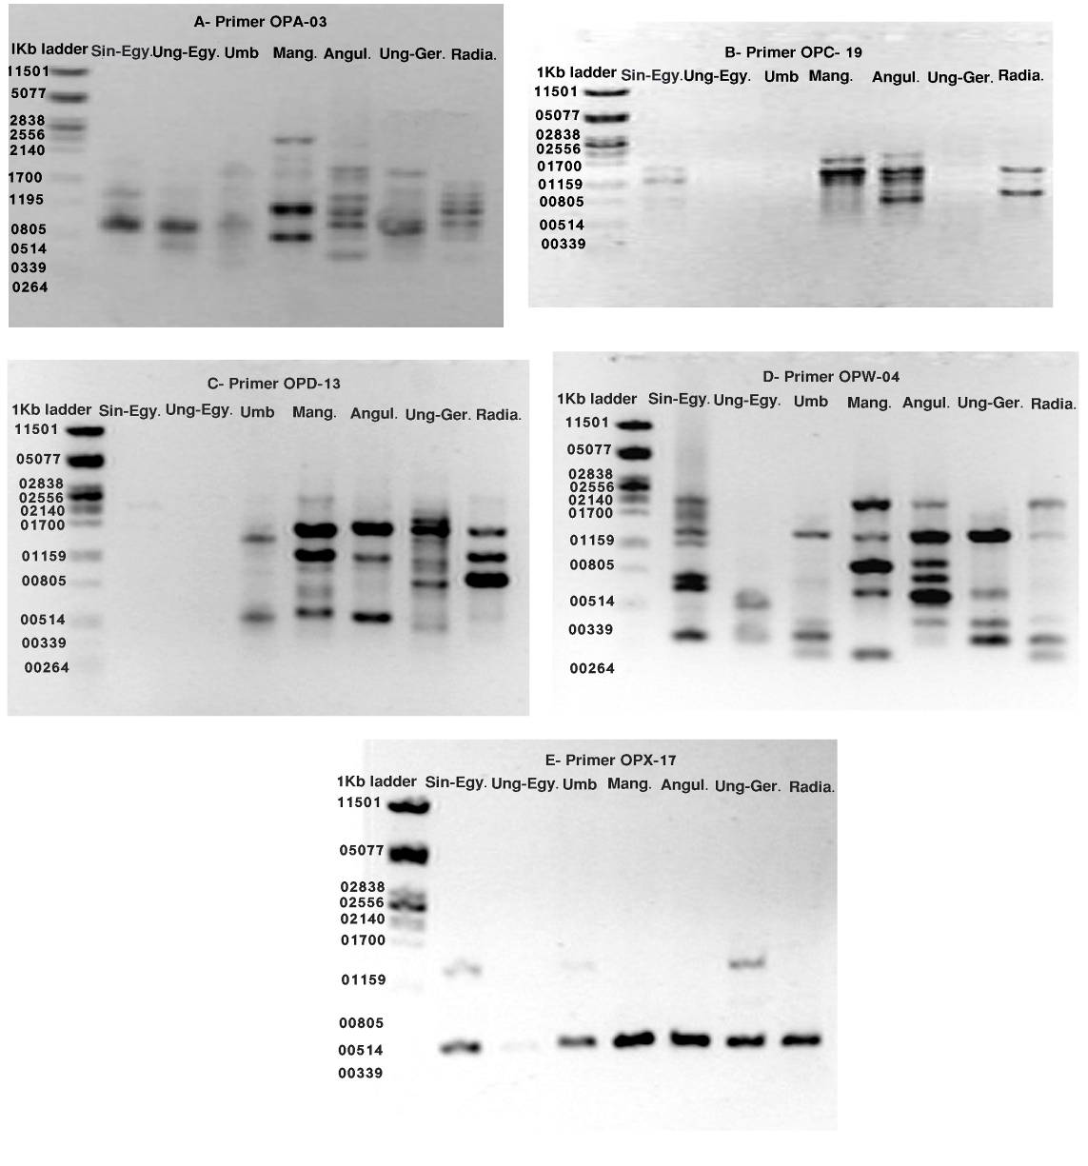
Fig. (1): RAPD fingerprints of the seven Vigna species generated by the seven primers: a) OPA-03
b) OPC-19 c) OPD-13 d) OPW-04 e) OPX-17.

Table (2): Similarity coefficients of the seven Vigna species based on RAPD markers.

Case | Matrix File Input
Sin-Egy. | 1.000
Ung- Egy. | 0.889 | 1.000
UMB | 0.296 | 0.593 | 1.000
Mang. | 0.185 | 0.556 | 0.519 | 1.000
Angul. | 0.174 | 0.370 | 0.311 | 0.756 | 1.000
Ung- Ger. | 0.556 | 0.913 | 0.333 | 0.259 | 0.593 | 1.000
Radia. | 0.120 | 0.370 | 0.785 | 0.685 | 0.444 | 0.467 | 1.000
 | Sin-Egy. | Ung- Egy | UMB | Mang. | Angul. | Ung- Ger. | Radia.

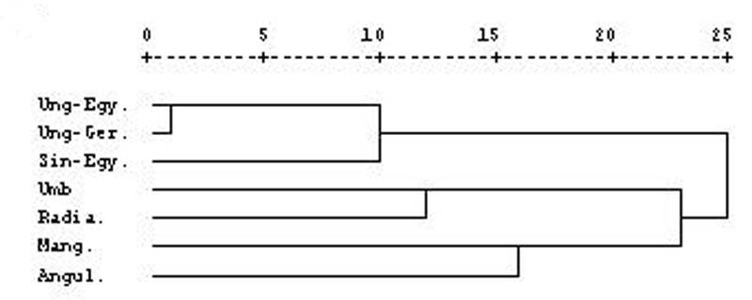

Fig (2): UPGMA dendrogram indicating the genetic relationships among Vigna species. based on RAPD markers.

ISSR Analysis:

Twelve selected ISSR primers were used and obtained from Pioneer (Lab. Technology Co.). Table (3). These primers were used to analyze the seven investigated Vigna genotypes. ISSR marker profiles produced by the eleven primers are shown in Fig. (3). Out of 12 primers, eleven gave rise to reproducible amplification products, while one primer (UBC 886-11) did not give any amplification. Eleven primers produced a total number of bands of 128 across seven genotypes with average of 11.64/ primer, of which 89 were polymorphic bands and 24 were unique. The total number of the amplified bands produced by each primer varied from a minimum number of 4 amplified products by primer UBC 829-11 to a maximum of 17 amplified products by primer UBC 834-11. The size of amplified bands also varied with different primers. The largest 2838 bp band was amplified by primer UBC 829-11, while the smallest size was amplified by primers UBC 807-11, UBC840-11 and UBC846-11 and detected about 255 bp.

Similarity coefficient values for the seven Vigna genotypes based on ISSR markers ranged from (0.822) between V. sinesis Egy. and V. unguiculata L. Egy. to (0.118) between V. angularis L. and V. unguiculata L. Ger. Table (4).

The ISSR data were used to generate UPGMA dendrogram (Fig.4) the obtained dendrogram showed that the seven vigna species are grouped into three groups. The first one includes V. sinesis. Egy., V. unguiculata L. Egy. and V. unguiculata L. Ger. Where, V. sinesis. Egy. was highly related with V. unguiculata L. Egy. (0.822) and closely related with V. unguiculata L. Ger. (0.745). The second group comprised V. umbellata and V. angularis L. they are moderately related to each other (0.673), then come V. radiate L. and V. mango L. represented the third group at a peripheral position and closer to V. radiate L. with similarity value of (0.615).

The results indicated that ISSR markers have been successfully utilized for assessing the genetic diversity and revealed a remarkable molecular discrimination between the seven Vigna species under study. Similar results were reported by (Ajibade et al., 2000) where they found that the ability of the ISSR technique to effectively distinguish species in the genus Vigna. Moreover, (Galvan et al., 2001) concluded that ISSR would be a better tool than RAPD for phylogenetic studies. Nagaoka and Ogihara (1977) have also reported that the ISSR primers produced several times more information than RAPD markers in wheat. The number of potential ISSR markers depends on the frequency of microsatellites, which changes with species (Depeiger et al., 1995), So that the Potential for integrating ISSR–PCR into plant improvement programme is enormous and their applications in different crop species are sufficiently reviewed ( Reddy et al. 2002).

Table (3): Code and sequence of the twelve ISSR primers used for identifying the Vigna species and numbers of the amplified DNA bands.
Primer  Code | Sequence | CG  % | No. of  Polymorphic  Bands | No. of  total bands
UBC 807-11 | AGAGAGAGAGAGAGAGT | 47.1 | 8 | 13
UBC 808-11 | AGAGAGAGAGAGAGAGC | 52.9 | 4 | 10
UBC 811-11 | GAGAGAGAGAGAGAGAC | 52.9 | 10 | 15
UBC 814-11 | CTCTCTCTCTCTCTCAT | 47.1 | 7 | 7
UBC 816-11 | CACACACACACACACAT | 47.1 | 5 | 8
UBC 826-11 | ACACACACACACACACC | 52.9 | 9 | 12
UBC 827-11 | ACACACACACACACACG | 52.9 | 10 | 13
UBC 829-11 | TGTGTGTGTGTGTGTGT | 52.9 | 4 | 4
UBC 834-11 | AGAGAGAGAGAGAGAGTT | 44.4 | 10 | 17
UBC 840-11 | GAGAGAGAGAGAGAGATT | 44.4 | 10 | 15
UBC 846-11 | CACACACACACACACAAT | 44.4 | 12 | 14
UBC 886-11 | AAACTCTCTCTCTCTCT | 41.2 | 0 | 0
total | - | - | 89 | 128

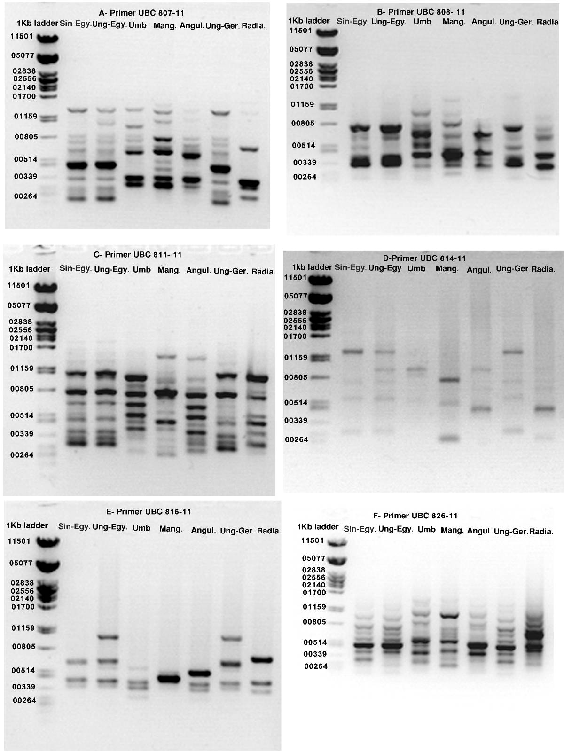

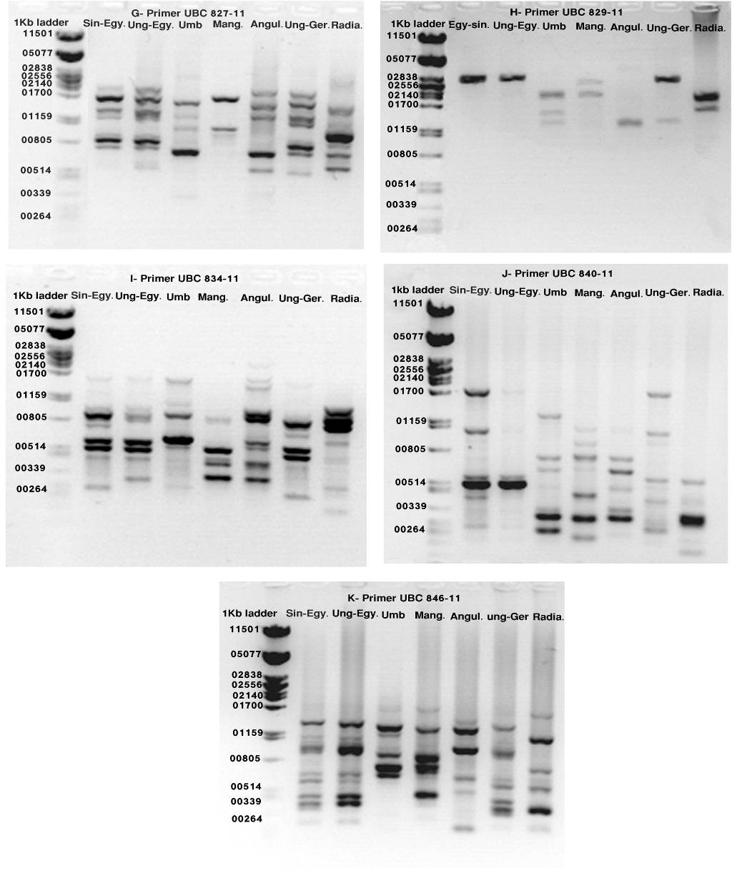

Fig. (3): ISSR fingerprints of the seven species of Vigna generated by the twelve primers:
a) UBC 807-11 b) UBC 808-11 c) UBC 8011-11 d) UBC 814-11 e) UBC 816-11 f) UBC 826-11 g) UBC827-11 h) UBC 829-11 i) UBC 834-11 j) UBC 840-11 k) UBC 846-11 l)UBC 886-11

Table (4): Similarity coefficients of the Vigna species based on ISSR markers.

Case | Matrix File Input
Sin-Egy. | 1.000
Ung- Egy. | 0.822 | 1.000
UMB | 0.137 | 0.457 | 1.000
Mang. | 0.059 | 0.339 | 0.275 | 1.000
Angul. | 0.314 | 0.490 | 0.673 | 0.337 | 1.000
Ung- Ger. | 0.745 | 0.810 | 0.437 | 0.120 | 0.118 | 1.000
Radia. | 0.294 | 0.235 | 0.396 | 0.615 | 0.455 | 0.237 | 1.000
 | Sin-Egy. | Ung-Egy | UMB | Mang. | Angul. | Ung- Ger. | Radia.

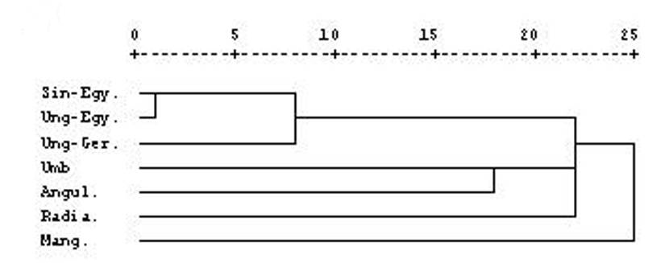
Fig (4): UPGMA dendrogram indicating the genetic relationships among Vigna species based on ISSR markers.

RAPD and ISSR analysis:
The similarity coefficients of the seven Vigna species based on RAPD and ISSR markers ranged from 0.899 to 0.115 among the seven genotypes. V. sinesis Egy. and V. unguiculata L. Egy. showed the highest similarity index (0.899), while the lowest value was (0.115) between V. sinesis Egy. and V. mango L. genotypes. Table (5) Cluster analysis performed from combining data of both markers generated a dendrogram separated the genotypes into three clusters. The first cluster included V. sinesis Egy., V. unguiculata L. Egy. and V. unguiculata L. Gre., where V. sinesis Egy. was highly related to V. unguiculata L. Egy. (0.899) and closely related to V. unguiculata L. Gre. (0.633). The second cluster comprised V. angularis L. and V. radiate L. (0.794), then come V. umbellata and V. mango L. (0.709) in the third cluster. Fig (5).
the present work used a combination of RAPD and ISSR markers to determine the further genetic affinities between Vigna species at the DNA level, the results indicated that, close correspondence between the similarity matrices of both RAPD and ISSR individually or combined, hence both the marker systems can be effectively used in determination of genetic relationship among Vigna species. Similar studies have been widely applied in a variety of plant genera, such as Cicer (Iruela et al. 2002), Vigna (Ajibade et al., 2000), and Vicia (Potokina et al., 1999).

Table (5): Similarity coefficients of the Vigna species based on RAPD and ISSR markers.

Case | Matrix File Input
Sin-Egy. | 1.000
Ung- Egy. | 0.899 | 1.000
UMB | 0.137 | 0.412 | 1.000
Mang. | 0.115 | 0.347 | 0.709 | 1.000
Angul. | 0.162 | 0.412 | 0.221 | 0.221 | 1.000
Ung- Ger. | 0.633 | 0.676 | 0.262 | 0.144 | 0.350 | 1.000
Radia. | 0.147 | 0.250 | 0.447 | 0.415 | 0.794 | 0.265 | 1.000
 | Sin-Egy. | Ung- Egy | UMB | Mang. | Angul. | Ung-Ger. | Radia.

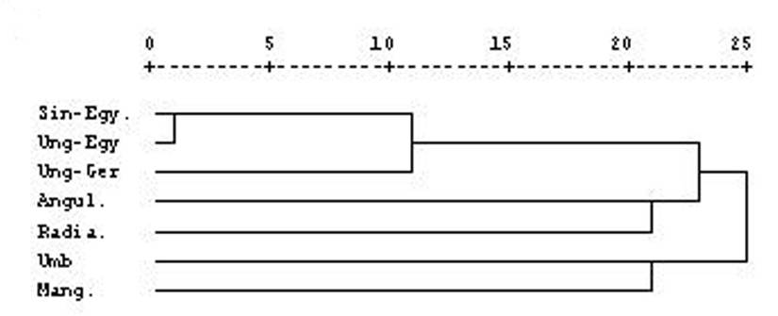

Fig (5): UPGMA dendrogram indicating the genetic relationships among Vigna sp. based on: Combination RAPD and ISSR.

The results indicated that RAPD, ISSR and combined RAPD and ISSR analysis provided the possibility of identifying the investigated Vigna genotypes. High degree of genetic similarity was observed among Egyptian species ( V. sinesis (Endl.) and V. unguiculata L.) .Also a close relationship was found between the two Egyptian Vigna genotype and one of the German genotype ( V. unguiculata L) as shown by high values of similarity index between them.
Another four German Vigna species, V. mango L., V. angularis L., V. umbellata (Thumb), and V. radiate L. recorded closely or moderately relationships between each other, on the other hand, they were less related with the two Egyptian species as recorded by low values of the genetic similarity index.
In addition, the three dendrograms showed minor differences in the cluster pattern of the different Vigna species as revealed by RAPD, ISSR and combined RAPD and ISSR, as expected, the two Egyptian genotypes tended to cluster together with high degree of genetic similarity regardless the type of molecular marker. Similarly, German genotypes tended to cluster together into two separated groups. A high degree of biodiversity between Egyptian and German species was recorded except German V. unguiculata L. genotype was clustered with the two Egyptian genotypes, Vigna sinesis (Endl) and Vigna unguiculata L. as mentioned above. This close relationship between species from different geographic region was supported by (Liavanya et al. 2008 and Pathak et al., 2010) they reported lack of correlation between geographic region and genetic diversity in other legumes or these genotypes may have been derived from the same pedigree and have common ancestor, at least for one of the parent (Saker et al., 2005 and Saraladevi et al., 2008). It could be concluded that, the information of genetic similarities and diversity among Vigna genotypes are necessary for breeding programs.

4. Conclusion:
The assessment of genetic diversity and identification of seven Vigna species were evaluated by RAPD and ISSR analysis. The obtained results indicated that both of the marker systems RAPD and ISSR, individually or combined can be effectively used in determination of genetic relationship among Vigna species. The two Egyptian genotypes Vigna sinesis (Endl) and Vigna unguiculata L. tended to cluster together with high degree of genetic similarity regardless the type of molecular marker. Similarly, German genotypes V. mango L., V. angularis L., V. umbellata (Thumb) and V. radiate L. tended to cluster together into two separated groups. A high degree of biodiversity between Egyptian and German species was recorded except German V. ungulate L. genotype was clustered with the two Egyptian genotypes. It could be concluded that The Vigna species have sufficient amount of genetic diversity and a wide range in genetic base of the studied genotypes which can be used for crop improvement.

Corresponding author
Elham A. A. Abd El-Hady
Genetics and Cytology, National Research Center, Dokki, Giza, Egypt
elhamabdelhady@hotmail.com

5. References
- Ajibade, S.R.; Weeden, N. F. and Chite, S.M. (2000). Inter-simple sequence repeats analysis of genetic relationships in the genus Vigna. J. Euphytica, 111 (1): 47-55.
- Ba, F.; Pasquet, R. S. and Gepts, P., (2004) Genetic diversity in cowpea [Vigna unguiculata (L.) Walp.] as revealed by RAPD markers. Genetic Resources and Crop Evolution, 51(5): 539-550.
- Becker, J. and Heun, M. (1994). Microsatellites: allele variation and mapping. Plant Molecular Biology, 27(4): 835-845.
- Bielawski J. P., Noack K, Pumo DE (1996). Reproducible Amplification of RAPD Markers from Vertebrate DNA. Biotechniques, 18: 856–60.
- Depeiger, A., Goubely, C., Lenoir, A., Cocherel, S., Picard, G., Rayanl, M., Greltel, F. and Delseny. (1995). Identification of the most represented repeat motif in Arabidopsis thaliana microsatellite loci. Theor. Appl. Genet., 91: 160-168
- Dikshit, H. K., Jhang, T., Singh, N. K., Koundal, K. R., Bansal, K.C., Chandra, N., Tickoo, J. L. and Sharma, T. R. (2007) Genetic differentiation of Vigna species by RAPD, URP and SSR markers. Biologia Plantarum, 51(3): 451-457.
- Galvan, M.Z.; Bornet, B.; Balatti, P.A. and Branchard, M. (2003). Inter simple sequence repeat (ISSR) marker as a tool for the assessment of both genetic diversity and gene pool origin in common bean (Phaseolus vulgaris L.). Euphytica, 132(3): 297-301.
- Iruela, M., Rubio, J., Cubero, J.I., Gil, J., Milla´n, T. (2002). Phylogenetic analysis in the genus Cicer and cultivated chickpea using RAPD and ISSR markers. Theor. Appl. Genet. 104:643–651
- Jonathan, F., W. and Wendel, N. F.,(1990). Visualization and interpretation of plant isozyme.in:Isozyme in plant Biology.D.E.Sdtis and P. S. Sottis (eds.) London Champan and Hall, 5-45.
- Kaga, A.; Yoon, M.S.; Tomooka, N. and Vaughan, D.A. (2000) Collection of Vigna spp. and other legumes from the islands of southern Okinawa prefecture, Japan. In: Report to IPGRI and East Asia Plant Genetic Resources Coordinators. National Institute of Agrobiological Resources, Japan, 2-25
- Karp, A., S. Kresovichi, K.V. Bhat, W.G. Ayad and T. Hodgkin (1997): Molecular tools in plant genetic resourcs conservation: a guid to the technologies: IPGR technical bull. No.2. International Genetic Resrouces Institute: Rome, Italy.
- Lakhanpaul, S., Chadha, S. and Bhat, K.V. (2000). Random amplified polymorphic DNA (RAPD) analysis in Indian mungbean (Vigna radiata (L) L. Wilczek) cultivars. Genetics, 109: 227-234.
- Lavanya G. R., Srivastava S. and Ranade S. A. (2008). Molecular assessment of genetic diversity in mung bean germplasm. J. Genet., 87: 65–74.
- Leian P., Bordallo P. and Colova V. (2005): Tracing the pedigree of Cynthiana grape by DNA microsatellite markers. Proc. Fla. State Hort. Soc. 118:200-204. 2005.
- Maugham PJ, Saghai Maroof MA, Buss GR and Huestis G. M., (1996). Amplified fragment length polymorphism (AFLP) in soybean: species diversity, inheritance, and near-isogenic line analysis. Theor. Appl. Genet., 93:392-401.
- Nagaoka, T. and Ogihara, Y. (1997). Applicability of inter simple sequence repeat polymorphisms in wheat for use as DNA markers in comparison to RFLP and RAPD markers. Theoretical and Applied Genetics, 94(5): 597-602.
- Norman H. Nie, C. Hadlia Hull, Jean G. Jenkins, Karin Steinbrenner and Dale H. Bent. (1975): SPSS, statistical package for the social sciences. 2nd ed. New York: McGraw-Hill.
- Pathak R., Singh S. K., Singh, M. and Henry, A. (2010). Molecular assessment of genetic diversity in cluster bean (Cyamopsis tetragonoloba.) genotypes, Journal of Genetics, 89(2): 243-246.
- Potokina E, Tomooka N, Vaughan D. A., and Alexandrova, T. (1999). Phylogeny of Vicia subgenus Vicia (Fabaceae) based on analysis of RAPDs and RFLP of PCR-amplified chloroplast genes. Genet Resour Crop Evol., 46:149–161
- Reddy, M.P., Sarla, N. and Siddiq, E.A. (2002). Inter simple sequence repeat (ISSR) polymorphism and its application in plant breeding Euphytica, 128: 9-17.
- Saini, M., Singh, S., Hussain, Z. and Yadav, A. (2010). RAPD analysis in mung bean (vigna radiata L. Wilezek)1-Assessment of genetic diversity. Indian, J. of Biotech., 9:137-146.
- Saker, M.;Nachtigall M. and Kuehne T. (2005):A comparative assessment of DNA fingerprinting by RAPD ,SSR and AFLP in genetic analysis of some Barley genotype.Egyptian J. of genetics and cytology, .34 (1): 81-97.
- Sambrook, J., Fritsch, K. F. and Maniatis, T.(1989). Molecular cloning, second edition (cold spring Harbor, New York).
- Saraladevi, M., Selvaraju, K. and Ponnusamy, S., (2008). Efficiency of RAPD and ISSR markers system in accessing genetic variation of rice bean (Vigna umbellata) landraces. Electronic Journal of Biotechnology, 11 (3):1-10.
- Soller, M. and Beckmann, J. S. (1983). Genetic polymorphism in varietal identification and genetic improvement. Theoretical and Applied Genetics, 67(1): 25-33.
- Vos, P. R., Hogers, R., Bleeker, M., Reijans, M., Lee, T. Van De, Hornes, M., Frijters, A., Pot, J., Peleman, J., Kuiper, M. and Zabeau, M. (1995). AFLP: a new technique for fingerprinting. Nucleic Acids Research, 23(21): 4407- 4414.
- Williams, J. G. K., Kubelik, A. R., Livak, K. J., Rafalski, A. J. A. and Tingey, S. V. (1990). DNA polymorphisms amplified by arbitrary primers are useful as genetic markers. Nucleic Acids Research, 18(22): 6531-6535.
- Wolf, A. D. and C. P. Randle. (2001). Relationships within and among species of the holoparasitic genus Hyobanche (Orobanchaceae) inferred from ISSR banding patterns and nucleotide sequences. Systematic Bot., 26:120-130.
- Yee, E., Kidwell K. K., Sills G. R. and Lumpkin T. A. (1999). Diversity among selected Vigna angularis (Azuki) accessions on the basis of RAPD and AFLP markers. Crop Sci., 39: 268–275.
- Yoon, M. S., Lee, J., Kim, C. Y. and Baek, H. J. (2007). Genetic relationships among cultivated and wild Vigna angularis (Willd.) Ohwi et Ohashi and relatives from Korea based on AFLP markers. Genetic Resources and Crop Evolution, 54 (4): 875-883.
- Zietkiewicz, E., A. Rafalshi & D. Labuda, (1994). Genome fingerprinting by simple sequence repeat (SSR)-anchored polymerase chain reaction amplification, J. Genomics, 20: 176-183.
9/10/2010

