Karyotype analysis for date palm (Phoenix dactylifera L) compared with tissue culture derived plants

Mohamed M. AbdAlla¹ and Aesha M. Abd El-Kawy²

¹Desert Research Center, Genetic Resources Department, Tissue Culture Lab.
²Botany Department. Faculty of Science, Al-Azhar University (for girls) Egypt.
Email: el_awadi@yahoo.com

Abstract: The cytological studies on the micropropagated date palm (phoenix dactylifera var. Karama) revealed that no morphological changes occurred during microproopagation and there were 36 chromosomes arranged in 18 bivalents of chromosomes in c-meta phase profile, seventeen bivalents are autosomal chromosomes and XY bivalent in male or XX in female. Chromosome No.2, 3, 4, 5 and 6 were meta centric, chromosomes No. 1,7,8,9 and 10 were submetacentric and chromosomes from No.11 to No17 were subtelocentric. While X chromosome was submetacentric and Y chromosome was subtelocentric. There were no significant differences in the chromosome length, area and centromer positions between the micropropagated plantlets and the mother plants.
[Mohamed M. AbdAlla¹ and Aesha M. Abd El-Kawy. Karyotype analysis for date palm (Phoenix dactylifera L) compared with tissue culture derived plants. New York Science Journal 2010;3(11):165-170]. (ISSN: 1554-0200).
. http://www.sciencepub.net

Keywords: date palm, cytology, karyotype, tissue culture

Introduction
Date palm (Phoenix dactylifera L.) is a tree crop of economic importance in Egypt. It is finding or represents an income to the oases inhabitants, protects the under-crops from the effects of the climate and reduces the speed and damage from sand storms and wind erosion. Date palm (Phoenix dactylifera var. Karama) grew in Siwa Oasis. Plantlets were produced through the micropropagation of this variety (Phoenix dactylifera var. Karama) in the Desert Research Centre, Genetic Resources Department, Tissue Culture Lab. It is a dioecious, perennial, monocotyledon, diploid (2n = 36) with long generation time, Almaarry (1995). Somaclonal variations can occur through utilization of tissue culture technique, one of these variations is chromosomal apparitions (duplication. deletion. translocation and ploidy). The progress in computer sciences enabled scientists to improve researches. Vra´na, et al (2000) develops an improved procedure for preparation of chromosome suspensions, and to evaluate the potential of flow cytometry for chromosome sorting in wheat. Torrell et al (2001) determinated the chromosome number in the metaphase stage of root tip meristems obtained from 12 Artemisia spp. from Armenia and Iran. Mártonfiová (2004), studied Karyology of Pulsatilla zimmermannii SOÓ, a pannonian endemic in details according to the position of centromere. Hussein (2005), mentioned that C-banding analysis of plant chromosomes has various applications including construction of karyotypes to identifylines with polymorphic banding patterns, to study structural apparitions and other cytogenetics studies. Madon et al (2005) studied the cytology of pollen mother cells of oil palm during meioses division. Fregonezi et al., (2006) studied the karyotypes of four Brazilian Cestrum species (C. amictum, C. intermedium, C. sendtnerianum and C. strigilatum) using conventional Feulgen staining, C-Giemsa and C-CMA₃/DAPI banding, induction of cold-sensitive regions (CSRs) and fluorescent in situ hybridization (FISH) with rDNA probes. Lanzone and De Souza (2006) used Orcein staining of spermatocytes to study the meiotic behavior of holocentric chromosomes in three member of the genus Antiteuchus (commonly known as stink bugs). They describe and illustrate the karyotype of some species. Chengqi (2008), determined somatic chromosome numbers individuals of Allium przewalskianum from the Qinghai-Tibet Plateau and five populations were selected for karyotype analysis based on the available chromosome data. Fernandes et al. (2009) studied the karyotypes of four South American species of Cestrum using conventional staining. Las Peñas et al (2009); performed karyotype analyses in members of the four Cactaceae subfamilies. Karyotypes can be used for many purposes; such as, to study chromosomal apparations, cellular function, taxonomic relationships, and to gather information about past evolutionary events.
This study aims to assess the chromosomal abberations (number. length. centromer position and size) and to make karyotype for Phoenix dactylifera var. Karama.
MATERIALS AND METHODS
Plant material
This study was carried out in Tissue Culture Laboratory, Genetic Resources Department, Desert Research Center, Cairo, Egypt; through the years 2006-2009. The micropropagated date palm plantlets (Phoenix dactylifera var. Karama) were produced through the micropropagation study for this variety (Phoenix dactylifera var. Karama). Some plantlets of this variety grew in Siwa Oasis and other are still in the micropropagation process. Root samples from the in vitro plantlets were collected to assess the cytological changes within the micropropagated plantlets through micropropagation process and the mother plants. Embryos of immature seeds from the mother plant were germinated in pettri dishes to get the root tips. Cytological studies are based on the morphological characteristics of chromosomes visualization (Fukui and Kakeda,1994). The excised root tips were chemically treated before microscope utilization as follow:
1- Germination of the immature date palm mother plant seeds in Petri dishes at 26-30° C.
2- Collection of lateral root tips from both (tissue culture rooted plantlets and mother plant germinated seeds) when they are (3-4 cm) long .
3- Pretreatment with colchicines (0.25%) for 2h at room temperature.
4- Root tips were fixed in fixation solution (Ethanol alcohol and Glacial acetic acid 3:1) at 4ْ C for 5 min. then were washed with distilled water.
5- The root tips (2-3mm) were then incubated in enzyme mixture of (4% cellulose and 1% pectenase, 75 mM KCl and 7.5 mM EDTA) on the glass slides at 37ºC for 40 min.
6- The root tips were washed with distilled water to remove enzymatic mixture and then root tips were squashed with a drop of aceto orcein stain after they were flamed.
7- The prepared samples were then examined on microscope using Image Processing Analysis System (Mac-Type).
The cytological profiles of the divided root tips cells of the tissue cultured plantlets and the mother plant samples were imaged by digital camera in the c-metaphase and analyzed using Image Processing analysis system (Video Test Karyotype). The chromosomal characteristics data for each chromosome of the three replicates (R1. R2 and R3) of Phoenix dactylifera var. Karama root samples were: (chromosomes number, chromosome lengths (µ), Chromosomes area (µ²), centromeric index percentage( length of short arm/ chromosome length) for each chromosome and chromosomes were arranged according their lengths in a karyotype.
Means were calculated using the obtained data from each of the three replicates of the tissue cultured plantlets and the mother plants. Mean values of the samples were evaluated by using L.S.D at 5% level as mentioned by Steel (1960).

RESULTS AND DISCUSSION
The cytological analysis data for both of the mother plants and the tissue culture derived plants in Table (1) showed the chromosome length of root samples of Phoenix dactylifera var. Karama at the c-metaphase profile. There are about 36 chromosomes arranged in 18 pairs of chromosomes according to their lengths for each of the tissue cultured plantlets and the mother plants. There were 17 bivalents of autosomal chromosomes and one bivalent (sex chromosome No. 18), it was XX in female and XY in male. The numerical changes in the c-metaphase did not observed in the cytological profile of any of the tissue cultured plantlets or the mother plants. This is in agreement with that of Almaarry (1995). The mean length of the micropropagated plantlets chromosomes in c-metaphase profile are high than those of the mother plants. The highest mean length was 9.93 µ for the chromosome No. 1 in tissue culture samples and 9.73 µ for the mother plants while lowest mean length was 3.37 µ in tissue culture samples and 3.73 µ in the mother plants for chromosome No. 17. The data in Table (1) revealed that there were no significant differences between the tissue cultured derived samples and the mother plants in chromosome lengths at c-metaphase profile, but small differences between the chromosomes lengths in c-metaphase profile were recorded from chromosomes No. 1- 14 . This difference may be due to the differences in cell size between the tissue culture samples and the mother plant whereas the tissue culture cells are larger than the mother plant cells. The tissue culture plantlets grew in highly moisture medium (95%water) that makes cells felled with water and large. The last chromosome was sex chromosome in which the mean length (6.17 µ and 6.61 µ) was non significance, and the mean length of Y chromosome (4.17µ) was lowest than X chromosome.

Table (1).The chromosome length of Phoenix dactylifera var. karama at c- metaphase profile.
Chromosome length (µ)
Ch. No | Mother plant |  |  |  | Tissue culture plants |  |  |  | LSD
Ch. No | R1 | R2 | R3 | M | R1 | R2 | R3 | M | LSD
1 | 9.9 | 9.4 | 9.9 | 9.73 | 10.0 | 9.8 | 10.0 | 9.93 | NS
2 | 8.1 | 7.9 | 8.0 | 8.0 | 8.2 | 8.0 | 8.2 | 8.13 | NS
3 | 7.9 | 7.7 | 7.5 | 7.7 | 7.9 | 7.8 | 7.7 | 7.8 | NS
4 | 7.6 | 7.6 | 7.4 | 7.53 | 7.7 | 7.7 | 7.4 | 7.6 | NS
5 | 7.1 | 7.0 | 7.1 | 7.07 | 7.2 | 7.1 | 7.1 | 7.13 | NS
6 | 6.9 | 6.8 | 6.5 | 6.73 | 7.0 | 6.8 | 6.6 | 6.8 | NS
7 | 6.7 | 6.5 | 6.2 | 6.47 | 6.8 | 6.6 | 6.4 | 6.6 | NS
8 | 6.2 | 6.1 | 6.0 | 6.1 | 6.3 | 6.1 | 6.1 | 6.16 | NS
9 | 6.1 | 6.0 | 6.0 | 6.03 | 6.1 | 6.1 | 6.1 | 6.1 | NS
10 | 5.9 | 5.9 | 5.9 | 5.90 | 5.9 | 6.0 | 6.0 | 5.96 | NS
11 | 5.6 | 5.6 | 5.5 | 5.57 | 5.6 | 5.7 | 5.6 | 5.63 | NS
12 | 5.6 | 5.4 | 5.2 | 5.44 | 5.6 | 5.4 | 5.6 | 5.50 | NS
13 | 5.4 | 5.1 | 5.0 | 5.17 | 5.5 | 5.2 | 5.2 | 5.3 | NS
14 | 5.1 | 4.9 | 4.9 | 4.97 | 5.2 | 5.2 | 5.1 | 5.13 | NS
15 | 4.9 | 4.8 | 4.8 | 4.83 | 5.4 | 4.5 | 4.7 | 4.87 | NS
16 | 4.1 | 4.0 | 4.0 | 4.03 | 4.4 | 4.0 | 4.1 | 4.17 | NS
17 | 3.9 | 3.8 | 3.5 | 3.73 | 3.7 | 3.4 | 3.0 | 3.38 | NS
X | 6.3 | 6.0 | 6.0 | 6.61 | 6.0 | 6.1 | 6.4 | 6.17 | NS
y | 4.0 | 4.5 | 4.0 | 4.17

The chromosomes as they were arranged in Table (2) according to the value of chromosome area. The chromosome area of the tissue culture plantlets is high than it in the mother plants. The high mean of area of chromosome No.1 for the tissue culture plantlets is 26.86 µ² and decreased to 8.33 µ² in chromosome No. 17, and in the same trend for the mother plant, the mean of chromosome area is 25.36 µ² and also decreased to 8.5 µ². As It is obvious from Table (2) there is a positive relation between chromosome length and chromosome area, it decreased with decreasing of chromosome length. Data in Table (2) revealed that no significant differences in area of the 18 bivalents of chromosomes in chromosome length, but clear differences in chromosome area were observed within tissue culture samples and mother plant, these differences were affected by the size of tissue culture cells

Table (2) Chromosomal sizes of Phoenix dactylifera var. karama at c- metaphase profile.
Ch. No | Chromosome area(µ²) |  |  |  |  |  |  |  | LSD
Ch. No | Mother plant |  |  |  | Tissue culture plants |  |  |  | LSD
Ch. No | R1 | R2 | R3 | Mean | R1 | R2 | R3 | Mean | LSD
1 | 26.3 | 24.5 | 25.0 | 25.36 | 26.80 | 26.9 | 26.88 | 26.86 | NS
2 | 23.8 | 21.7 | 21.5 | 22.33 | 22.50 | 23.50 | 23.06 | 23.02 | NS
3 | 20.9 | 20.6 | 20.0 | 20.50 | 21.10 | 21.20 | 21.12 | 21.14 | NS
4 | 20.3 | 19.5 | 19.0 | 19.60 | 20.07 | 20.2 | 20.24 | 20.17 | NS
5 | 19.4 | 19.3 | 19.5 | 19.40 | 19.92 | 20.12 | 19.90 | 19.98 | NS
6 | 19.3 | 18.8 | 19.0 | 19.03 | 19.30 | 19.40 | 19.80 | 19.50 | NS
7 | 18.7 | 17.3 | 17.2 | 17.73 | 18.10 | 18.30 | 18.26 | 18.22 | NS
8 | 17.0 | 16.4 | 16.3 | 16.56 | 16.90 | 16.98 | 16.88 | 16.92 | NS
9 | 16.2 | 15.6 | 15.0 | 15.60 | 16.10 | 16.10 | 16.13 | 16.33 | NS
10 | 15.3 | 15.1 | 15.0 | 15.13 | 15.00 | 15.60 | 15.42 | 15.34 | NS
11 | 14.3 | 13.9 | 13.2 | 13.80 | 14.57 | 14.60 | 14.90 | 14.69 | NS
12 | 13.6 | 13.6 | 13.0 | 13.40 | 13.70 | 13.98 | 14.02 | 13.90 | NS
13 | 13.4 | 13.1 | 13.0 | 13.16 | 14.00 | 14.05 | 14.04 | 14.09 | NS
14 | 13.0 | 12.3 | 13.1 | 12.80 | 13.25 | 13.50 | 13.45 | 13.40 | NS
15 | 12.2 | 11.6 | 12.0 | 11.93 | 12.00 | 12.20 | 12.10 | 12.10 | NS
16 | 9.70 | 8.90 | 8.20 | 8.93 | 9.10 | 9.30 | 9.20 | 9.20 | NS
17 | 9.40 | 8.10 | 8.00 | 8.50 | 8.40 | 7.90 | 7.80 | 8.33 | NS
X | 15.0 | 15.0 | 15.2 | 15.06 | 15.25 | 15.40 | 15.25 | 15.3 | NS
y | 11.0 | 10.6 | 11.3 | 11.3

Figure (1) shows that there are 36 chromosomes in the c-metaphase of date palm chromosome( Phoenix dactylifera var. Karama), the tissue culture sample (left) and the mother plant (right).The chromosomes are arranged in 17 bivalents and sex chromosome bivalent (XX) appeared at the left corner down of the tissue culture profile, while in the mother plant profile the sex chromosomes are at the right corner down the profile . There were 18 pairs of chromosomes appeared in the profile and no chromosomal apparitions were observed in the c-metaphase profile.

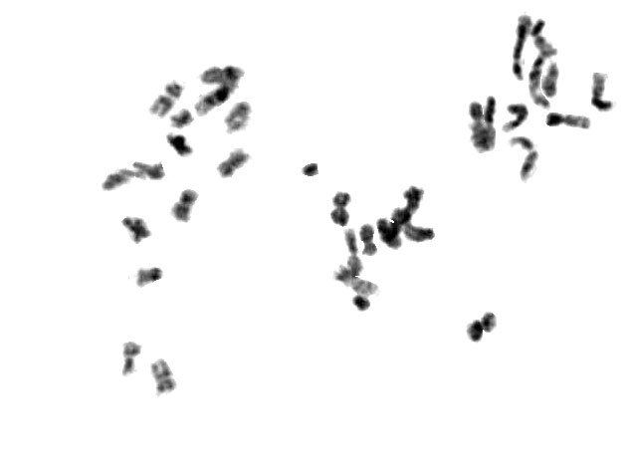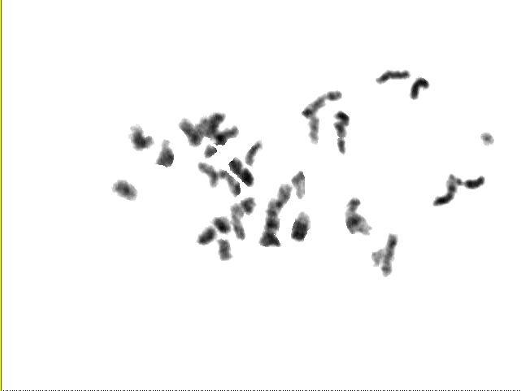
Figure (1) C- metaphase profile date palm Phoenix dactylifera var. karama for tissue culture derived plantlets (left) and mother plant (right).

The data in Table (3) illustrated the differences in the centromer positions in c-metaphase of the 18 bivalents of chromosomes. The centromer position was calculated by dividing the length of the short arm / chromosome length. Therefore some chromosomes are metacentric in which the centromer is near the chromosome center. Regarding to the centromer positions of the tissue culture plantlets and the mother plant, chromosome No.2, 3, 4, 5 and 6 their centromer position values were ranging between 45.33 and 41.0 %, probably they are metacentric chromosomes as it obvious in Table (3) and Figure (2). The chromosomes No. 1, 7, 8, 9 and 10 their centromer position values were ranging from 38.33 to 21.67%, their centromer were submetacentric while chromosomes from No.11 to No17, their position values were ranging from 9.0% to 4.33% and subsequently their centromers were subtelocentric Table (3) and Figure (2).
The centromer position of Chromosome X is sub-metacentric, it was excised at 35%, while chromosome Y is subtelocentric, its centromer was excised at 6.0% of the chromosome Table (3) and Figure (2).The karyo type profile of date palm Phoenix dactylifera var. karama for tissue culture derived plantlets illustrated the chromosomes according their lengths.

Table (3). Centromeric positions of Phoenix dactylifera var. karama chromosomes at c-metaphase profile.
Ch. No | Centromer position (%) |  |  |  |  |  |  |  | LSD
Ch. No | Mother plant |  |  |  | Tissue culture plants |  |  |  | LSD
Ch. No | R1 | R2 | R3 | M | R1 | R2 | R3 | M | LSD
1 | 35.0 | 37.0 | 36.0 | 36.0 | 34.0 | 36.0 | 36.0 | 35.33 | N.S
2 | 40.0 | 42.0 | 42.0 | 41.33 | 42.0 | 43.0 | 42.0 | 42.33 | N.S
3 | 45.0 | 44.0 | 45.0 | 44.67 | 42.0 | 42.0 | 42.0 | 42.0 | 2.07
4 | 41.0 | 41.0 | 41.0 | 41.0 | 44.0 | 43.0 | 44.0 | 43.67 | 0.93
5 | 46.0 | 45.0 | 45.0 | 45.33 | 45.0 | 46.0 | 45.0 | 45.33 | N.S
6 | 45.0 | 44.0 | 43.0 | 44.0 | 42.0 | 43.0 | 43.0 | 42.67 | NS
7 | 39.0 | 38.0 | 38.0 | 38.33 | 35.0 | 33.0 | 34.0 | 34.0 | 1.85
8 | 30.0 | 33.0 | 32.0 | 31.67 | 22.0 | 24.0 | 22.0 | 22.67 | 3.07
9 | 29.0 | 25.0 | 28.0 | 27.33 | 23.0 | 22.0 | 20.0 | 21.67 | 4.14
10 | 30.0 | 30.0 | 30.0 | 30.0 | 25.0 | 23.0 | 22.0 | 23.33 | 2.45
11 | 10.0 | 8.0 | 9.0 | 9.00 | 9.0 | 8.0 | 8.0 | 8.33 | N.S
12 | 9.0 | 8.0 | 8.0 | 8.33 | 8.0 | 7.0 | 8.0 | 7.67 | N.S
13 | 4.50 | 4.70 | 4.7 | 4.63 | 5.0 | 5.0 | 4.0 | 4.67 | N.S
14 | 4.50 | 4.70 | 4.40 | 4.53 | 5.0 | 4.0 | 4.0 | 4.33 | N.S
15 | 5.0 | 4.0 | 4.0 | 4.33 | 5.0 | 7.0 | 7.0 | 6.33 | N.S
16 | 5.0 | 5.0 | 4.0 | 4.67 | 5.0 | 5.0 | 4.0 | 4.67 | N.S
17 | 7.0 | 6.0 | 6.0 | 6.33 | 7.0 | 6.0 | 6.0 | 6.33 | N.S
X | 35.0 | 36.0 | 33.0 | 34.65 | 37.0 | 35.0 | 35.0 | 35.67 | N.S
y | 6.0 | 5.0 | 6.0 | 5.67

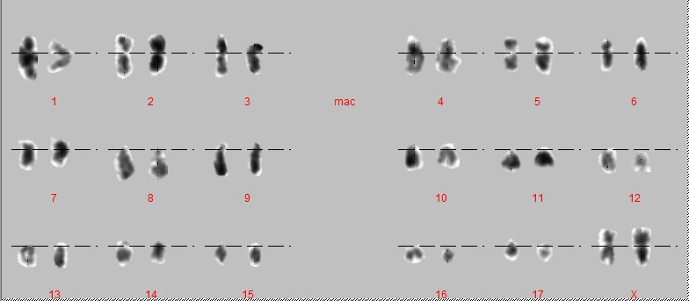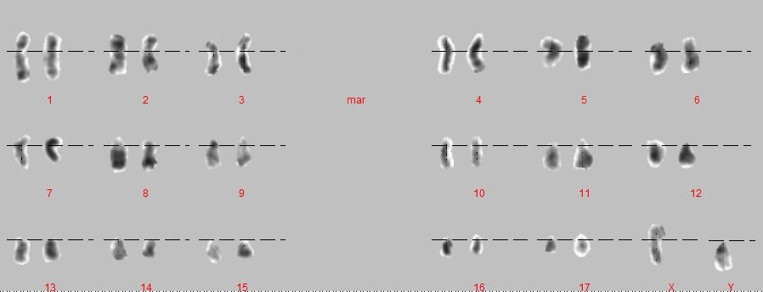

Figure (2) The karyo type profile of date palm Phoenix dactylifera var. karama for tissue culture derived plantlets ( left ) Mother plant (right).

Figure 4. Chormosome Length

References
Al-maarry K. (1995): Date palm propagation through tissue culture techniques. Eltanded eltaswere, (DBS) Damascus.
Chengqi, AO. (2008): Chromosome numbers and karyotypes of Allium Przewalskianum Populations. ACTA Biological Cracviensia Series Botanica 50 (1): 43-49.
Fernandes,T.; Do Nascimento L.; De Almeida A. R.; Mariana N.; Priscila Mary Y.; Vanzela, A. L. L. (2009). Karyotype differentiation of four Cestrum species (Solanaceae) revealed by fluorescent chromosome banding and FISH. Genetics and Molecular Biology.Genet. Mol. Biol. vol.32 no.2.
Fregonezi, J.N.; Fernandes, T.; Domingues, T.; Vieira, A. and Vanzela, A.L. (2006): Karyotype differentiation of four Cestrum species (Solanaceae) based on the physical mapping of repetitive DNA. Genetics and Molecular Biology, 29 (1): 97-104.
Fukui, K. and Kakeda, K. (1994): Dynamic changes in the morphology of barley chromosomes during the mitotic metaphase stage. The Japanese J. of Genetics, 69 (5): 545-554.
Hussein, S.(2005): C-banding analysis of chromosome translocations in doubled haploid wheats. Frican J. of Biotechnology,4 (6): 541-547.
Lanzone,C.;De Souza Maria J. (2006):Chromosome complement and meiosis in three species of the Neotropical bug genus Antiteuchus (Heteroptera, Pentatomidae, Discocephalinae). Genet. Mol. Biol. vol.29 no.1 São Paulo.
Las Peñas, M.L.; Urdampilleta, J.D.; Bernardello, G.; Forni-Martins E.R.(2009): Karyotypes, heterochromatin, and physical mapping of 18S-26S rDNA in Cactaceae. Cytogenetic and Genomic Research.Vol. 124, No.1.
Madon,M; Heslop-Harrison, J S; Schwarzacher, T; Mohd Rafdi, M. H. and Clyde, M. M.(2005) Cytological analysis of oil palm pollen mother cells (PMCs).Journal of Oil Palm Research Vol. 17, p. 176-180.
Martonfiova, L. (2004): Karyotype studies in Pulsatilla zimmermannii. Biologia, Bratislava, 59 (1): 61-64.
Steel, G.D.R. (1960). Principles and procedures of statistics. New York McGraw-Hill Book Co., pp. 481.
Vra`na, J.; Kubala, M.; Svimkova, H.; Jarmila, K.; Martin A.and Dolezvel, J. (2000). Flow Sorting of Mitotic Chromosomes in Common Wheat (Triticum aestivum L.). The Genetics Society of American Genetics, 156: 2033–2041.
Torrell, M.; Valles, J.; Garcia, J.N.; Mozaffarian, V. and Gabrielian, E. (2001): New or rare chromosome counts in the genus Artemisia (Asteraceae, Anthemideae) from Armenia and Iran. Botanical J. of the linnean socity, 135: 510-600.

9/6/2010

