Saccharomyces cereviciae ameliorates oxidative stress, genotoxicity and spermatotoxic effects induced by Ochratoxin A in male Albino Mice

Abdel-Aziz, K.B.ª; Farag, I.M.ª; Tawfek, N.S.^{b}; Nada, S.A.^{c}; Amra, H.A.^{d} and Darwish, H.R.ª

ª Cell Biology Dept., National Research Centre, , Cairo Egypt.;
^{b} Zoology Dept., Faculty of Science, Al-Mania Uni., Egypt.;
^{c} Pharmacology Dept.; National Research Centre
^{d} Food Toxicology and Contaminants Dept., National Research Centre

Abstract: The present study was undertaken to assess the possible protective effect of Saccharomyces cereviciae (Sc) against Ochratoxin-induced toxicity in mice. Four groups of 30 mice each were used: control group, Sc-treated mice (4 × 10⁸ CFU) group, OTA-treated mice (1.8 mg/kg b.w.) group and a group of mice given Sc two hours before OTA gavage. After 24 hr. of last gavage, the percentage of weight changes were measured; the levels of malondialdehyde (MDA), glutathione (GSH) and superoxide dismutase (SOD) activity were measured, as markers of oxidative status, in homogenates of liver and kidney. Cytogenetic analysis of bone marrow cells evaluating micronucleated polychromatic erythrocytes (MNPCEs) rate and chromosomal aberrations in metaphase I and II (MI & MII) in spermatocytes, besides mitotic and meiotic activities were recorded. Also, sperm parameters (count, motility and morphology) were evaluated. Results showed that ochratoxin A significantly decreased the body weight. The levels of MDA and non-enzymatic antioxidant (GSH) as well as enzymatic antioxidant, (SOD) were significantly decreased in both liver and kidney of OTA-treated mice in comparison with control. OTA increased the frequencies of MNPCEs in bone marrow and structural and numerical chromosome aberrations in spermatocytes. Also, OTA caused a significant reduction in cauda epididymal sperm count and sperm motility, and increased sperm abnormalities, as compared to control. In mice received Sc before OTA gavage, a significant amelioration in lipid peroxidation (LPO) in liver and kidney along with increasing in GSH contents and activities of SOD were recorded, compared to OTA group, consequently enhancing growth performance. Cytogenetic analyses revealed that Sc administration reduced genotoxicity and cytotoxicity induced by OTA. Sc plus OTA treatment caused a significant recovery in sperm parameters and improved morphologic features of sperm. In conclusion, Saccharomyces cereviciae was found to be safe and successful agent in counteracting the oxidative stress and protecting against genotoxicity and cytotoxicity, as well as ameliorates spermatotoxic effects induced by OTA in male Albino Mice.
[Abdel-Aziz, K.B.; Farag, I.M.; Tawfek, N.S.; Nada, S.A.; Amra, H.A. and Darwish, H.R. Saccharomyces cereviciae ameliorates oxidative stress, genotoxicity and spermatotoxic effects induced by Ochratoxin A in male Albino Mice. New York Science Journal 2010;3(11):177-190]. (ISSN: 1554-0200). (http://www.sciencepub.net).

Keywords: ochratoxin A, Saccharomyces, oxidative stress, micronucleus, spermatocytes, sperm

1. Introduction
Ochratoxin A (OTA ) has been found in barley, oats, rye, wheat, coffee beans, and other plant products, (Bennet and Klich, 2003) and in dry foods such soybeans, garbanzo beans, nuts and dried fruit, also in grapes and grape products, coffee, and pork (Sage et al. 2004). OTA causes a wide array of toxicological effects in animal models, including genotoxicity, nephrotoxicity, nephrocarcinogenicity, teratogenicity, neurotoxicity and immunotoxicity (Mally et al., 2005; EFSA, 2006; Clark and Snedeker, 2006; Fink-Gremmels, 2005; Alvarez et al., 2004). OTA has been classified as a class 2B carcinogen (possibly carcinogenic to humans) by the International Agency for Research on Cancer (IARC, 1993). OTA is one of the most potent renal carcinogens studied to date (Adler et al., 2009). OTA toxicity has been associated with inhibition of protein synthesis, DNA and RNA synthesis, mitochondrial dysfunction, formation of DNA adducts, disruption of calcium homeostasis, and the generation of reactive oxygen species (Ringot et al., 2006; Marin-Kuan et al., 2006; Rached et al., 2007). OTA induced lipid peroxidation (LPO), formation of reactive oxygen species (ROS) and consequent oxidative DNA damage; Meki and Hussein (2001) found that LPO levels were significantly increased in serum and in liver and kidney tissues of OTA-treated rat, besides the levels of GSH and antioxidant enzymes activities of superoxide dismutase (SOD) and glutathione peroxidase (GPX) were significantly decreased. Schaaf et al. (2002) found an increase of ROS levels, depletion of GSH levels and an increase in oxidative DNA damage in rat proximal tubular cells and in LLC-PK1 cells treated by OTA. Recent gene expression data, in F344 rat kidney, showed that OTA alters a battery of genes that are involved in antioxidant defense and detoxification (Marin-Kuan et al., 2006). Genotoxic effects of OTA have been demonstrated in different in vitro and in vivo studies; chromosomal aberrations have been induced in vivo in mice (Bose and Sinha, 1994) and in human lymphocytes (Dönmez-Altuntas et al., 2003). OTA was shown to induce DNA strand-breaks as assessed by comet assay in liver, kidney and spleen of F344 rats given 0, 0.25, 0.50, 1.0 and 2.0 mg/kg bw/day by gavage for 2 weeks (Mally et al., 2005). OTA also, induced micronuclei in human hepatic (HepG2) cells (Ehrlich et al., 2002), in V79 Chinese hamster fibroblast cells and in primary cultures of porcine urothelial bladder epithelial cells in a dose-dependent manner (Föllmann, et al., 2007). At cytotoxic concentrations, OTA caused DNA-oxidative damage in HK-2 cells (Arbillaga et al., 2007). It induced DNA-ploidy in kidney after chronic exposure (Brown, et al., 2007), and caused increase in endoreduplicated cells (Mosesso, et al., 2008). OTA induced cytotoxic effects in vivo in mouse liver (Atroshi et al., 2000) and in cultured monkey kidney Vero cells (El Golli-Bennour et al., 2010). OTA is a reproductive toxicant and prolong exposure to it caused a significant decrease in sperm count and increased abnormalities in sperm morphology (Bose and Sinha, 1994; Biró et al., 2003). In a more recent study, alterations in various reproductive parameters (sperm count, sperm motility, sperm viability and fertility rate) were observed in male albino mice treated orally with OTA (50 and 100 μg/day) for 45 days, in a dose-dependent way (Chakraborty and Verma, 2009). So, strategies for minimizing the possible deleterious effects resulting from human exposure to mycotoxins in our environment are of utmost need. Nowadays, there is considerable interest in the potential antioxidant, antigenotoxic and anticarcinogenic effects associated with probiotics (). Saccharomyces cerevisiae (Sc), in particular, has proven to benefit health in several ways including stimulation of the growth of intestinal microflora in mammals, pH modulation in ruminants, as well as reduction in the number of pathogenic microorganisms in monogastric animals (Dawson, 1993; Wallace, 1994, 1998). Moreover, yeasts have been reported to have high adsorption ability against mycotoxins in aqueous solution; Also, Bejaouii et al. (2004) suggested that oenological strains of Saccharomyces yeasts can be used for the decontamination of OTA in synthetic and natural grape juice. Biernasiak et al., (2006) indicated that S. cerevisiae LOCK 0142 had a stable feature of detoxication of OTA during fermentation. Recently, Var et al. (2009) studied 21 yeast strains isolates to bind OTA; among them, Candida famata D7 was found to be the most efficient binder to OTA both in spiked white wine and PBS. Similarly, Meca et al. (2010) studied 16 yeast strains of S. cerevisiae during alcoholic fermentation of the Italian wine Moscato, all yeasts analyzed showed a significant reduction in OTA content during the fermentation process.
With respect to genotoxic inhibition, Vlčková et al. (2004) demonstrated the antigenotoxic effect of polysaccharide glucomannan isolated from Candida utilis yeast against 9-aminoacridine and sodium azide using some Salmonella typhimurium strains. Also, Madrigal-Santillán et al. (2007) indicated an antigenotoxic effects of α-mannan (yeast cell wall component) against DNA damage induced by AFB₁ in mice using micronucleus and SCE assays; and in mouse hepatocytes using comet assay (Madrigal-Santillán et al., 2009). Recently, Tovar-Ramírez et al. (2010) determined the effect of dietary live marine yeast Debaryomyces hansenii on the enzymatic antioxidative status of sea bass Dicentrarchus labrax larvae; they indicated that D. hansenii CBS 8339 positively enhanced growth performance and antioxidant status of sea bass larvae by means of preventing oxidative stress, and by maintaining a stable activity and gene expression of superoxide dismutase (SOD) and glutathione peroxidase (GPX). Furthermore, Dönmez and Keskin (2008) found that the glucomannan supplement modulated oxidative status caused by AFB₁in rabbits.
The present work was undertaken for evaluating the in vivo potential protective properties of live Sc (antioxidant, antigenotoxic and antispermatotoxic effects) against OTA in male albino mice.

2. Material and Methods
2.1.Materials:
2.1.1.Chemicals, reagents, and reagent kits
Were purchased from Riedel-de Haën, Germany and Biodiagnostic, Cairo, Egypt. Ochratoxin A was provided by Food Toxicology and Contaminants Dept., National Research Center, Egypt, as a crude mycotoxin.

2.1.2.Yeast strain and culture preparation:
Yeast (Saccharomyces cerevisiae) was purchased from market, as lyophilized powder (PAK GIDA, Turkey) and stored at 4C°; SC was dosed at (4 x 10⁸ CFU) in 0.4 mL dist water and given once-a-day daily treatment.

2.1.3 Experimental animals:
Male Swiss Albino mice (Mus musculus) three months old weighing 25–30 grams were obtained from the animal house at the National Research Center, Giza, Egypt. The animals were maintained on standard casein diet and water ad libitum at the Animal House Laboratory, National Research Center, Giza, Egypt and housed in a temperature-controlled and artificially illuminated room free from any source of chemical contamination.

2.2.Methods:
2.2.1. Experimental design
Mice were randomly divided into four groups each consisting of 30 mice, each group was subdivided into three subgroups (10 mice for each). Animals were treated orally for successive 7 days as follows: (1) untreated control given 0.4ml NaHCO₃ daily, (2) treated with OTA (1.8 mg/kg b.w.) in 0.4ml NaHCO₃, , (3) treated with Sc (4 × 10⁸) in H₂O and (4) treated with the Sc (4 × 10⁸) 2 hours before OTA gavage (1.8 mg/kg b.w.). On the 8th day of the study, the 1st subgroup was killed and femoral bones were removed, stripped and cleaned from extraneous tissues. Also, liver and kidney samples were dissected out and washed immediately with ice-cold saline and stored immediately at -80º C until analysis. On the 15th day of the study, the 2nd subgroup was killed and both testes removed and washed in warm citrate saline for spermatocytes chromosomal analyses. At the end of the experiment (35th day), cauda epididymis, of the 3rd subgroup, were quickly isolated, blotted free of blood and utilized for the analysis of various reproductive parameters.

2.2.2. Body weight
Mice were weighed at the beginning of the study, at the 8th day, 15th day and the 35th day from the beginning of the study. The percentage of weight gain or loss is then calculated.

2.2.3. Biochemical analyses
2.2.3.1. Measurement of lipid peroxidation:
Liver and kidney tissues were homogenized individually in 20 mm Tris–HCl (pH 7.4). Homogenates were centrifuged at 6000 g for 30 min. MDA levels in the supernatants were determined using a spectrophotometric assay kit according to the manufacturer’s instructions. Briefly, thiobarbituric acid (TBA) reacts with malondialdehyde (MDA) in acidic medium at temperature of 95°C for 30 min to form thiobarbituric acid reactive product the absorbance of the resultant pink product can be measured at 534 nm (Ohkawa et al., 1979). The lipid peroxidation values are expressed as nm MDA/mg tissue.

2.2.3.2. Reduced Glutathione (GSH) content
GSH levels were measured using a spectrophotometric assay kit according to the manufacturer’s instructions. 5,5` dithiobis-2-nitrobenzoic acid ( DTNB ) is reduced by glutathione (GSH) to produce a yellow compound .The reduced chromogen directly proportional to GSH concentration and its absorbance can be measured at 405 nm (Beutler et al., 1963). GSH values are expressed as mmol/g tissue.

2.2.3.3. Superoxide dismutase (SOD) activity
Liver and kidney homogenates were prepared in cold Tris–HCl (5 mmol/L, containing 2 mmol/L EDTA, pH 7.4) using a homogenizer. The unbroken cells and cell debris were removed by centrifugation at 10,000g for 10 min at 4º C. The supernatant was used immediately for the assays for SOD. 100µl of supernatants were added to 2.8 ml tris HCL buffer containing 25µl pyrogallol and 20µl catalase (Marklund and Marklund, 1974). The activities of all of these enzymes were determined. The SOD activities were expressed as units per mg of tissue.

2.2.4. Micronucleus test
Bone marrow slides were prepared according to the method described by Krishna and Hayashi (2000). The bone marrow was washed with 1 ml of fetal calf serum and then smeared on clean slides. The slides were left to air dry and then fixed in methanol for 5 min, followed by staining in May-Grünwald-Giemsa for 5 minutes then washed in distilled water and mounted.
For each animal, 2000 polychromatic erythrocytes (PCEs) were examined for the presence of micronuclei. In order to evaluate bone marrow mitotic activity, 1000 erythrocytes per animal were scored and the rate of polychromatic erythrocytes (PCEs) relative to the number of normochromatic erythrocytes was calculated.

2.2.5.. Chromosomal aberrations examination
Metaphases for analysis of chromosome aberrations in spermatocytes were prepared according to the method of Evans et al. (1964) and recommendations by Russo (2000) were considered. Structural aberrations analysis was studied in metaphase I (MI): MI with only 20 bivalents was scored; the presence of univalents, chromosome breaks, fragments and chain or ring multivalents, which are classified as reciprocal translocations were considered. For aneuploidy assay, metaphase II (MII) was studied: MII with 18<n>22 chromosomes were recorded and polyploidy was considered as 2n, 3n or 4n. Fifty metaphase spreads were analyzed per animal. For Meiotic activity of cells, meiotic index was calculated as the frequency of MII/MI, normal ratio should be equal 2.

2.2.6. Sperm parameters:
Sperm parameters were prepared and analyzed according to the protocols of Wyrobek and Bruce (1975).

2.2.6.1. Collection of Epididymal sperm:
Epididymal sperm were collected by cutting the cauda epididymis and perfusing the cauda with normal saline (0.9%) at 37◦ C. An aliquot of sperm suspension was used for the sperm examination.

2.2.6.2. Epididymal sperm counts and sperm motility:
Epididymal sperm counts and evaluation of the motility were performed visually using counting chamber. The epididymal perfusate was centrifuged at 225×g for 10 min. The pellet was re-suspended in 1.0 ml of normal saline. The count was repeated three times for each sample to minimize error, and calculated as 10⁶ per sperm dilution. Sperm motility was determined by counting both motile and non-motile sperms in at least 16 separate and randomly selected fields. These results were expressed as percent motility.

2.2.6.3. Epididymal sperm morphology
A drop of sperm suspension was smeared onto a slide, left to dry; then stained with Giemsa-Eosin A, the slides were washed in water and air dried again. The smears were microscopically analyzed at a magnification of ×1000 for observation of abnormalities.

2.2.7. Statistical analysis
Statistical analyses were performed by one-way ANOVA followed by Tuckey’s test or by Two-way ANOVA followed by Bonferroni’s test comparing all groups. Analysis was conducted with GraphPad Prism software V.5.0.3 (Inc., San Diego, CA; USA).

3. Results
3.1. Change in body weight:
The current results indicated that no mortalities were recorded among any treated groups; no specific symptoms occurred within all groups. At the 8th day of the study, OTA-treated mice showed a significant reduction in body weight gain in comparison with the control group at p<0.01 (Fig. 1). Furthermore, at the 15th day, OTA-treated mice showed significant weight loss which was significant (5.98 % at p< 0.001), this weight loss reached 9.62 % at the 35th day and it was highly significant compared to all other groups at p < 0.001.
Figure 1: Effects of Sc on ochratoxin-induced mice body weight change.
On the other hand, mice treated with Sc before OTA showed an insignificant decrease in body weight gain compared with the control at the 8th day or 15th day; whereas at the 35th day, body weight gain exhibited a significant decrease when compared with control at (p<0.05). This group showed a very significant weight recovery when compared with OTA group at p< 0.001 for all time points. Mice given Sc alone showed an insignificant increase in body weight gain compared with control at p>0.05.
3.2. Biochemical study
3.2.1. Effect on MDA levels
In OTA-treated mice, the levels of MDA in liver and kidney were highly significant increased compared to levels in control and Sc groups (table 1). While, the administration of Sc before OTA-intoxication showed very significant reduction in MDA levels in liver and kidney tissues compared with OTA-treated group. In this group, the levels of MDA in liver tissue was not significantly changed in comparison with control groups, whereas it still significant high in kidney tissue when compared with control group at p<0.01. In mice receiving Sc alone, no significant differences were found in the levels of MDA compared with control.

3.2.2. Effect on the reduced Glutathione (GSH level)
Reduced glutathione contents in both liver and kidney decreased significantly in OTA-treated group as compared to the control and Sc groups at p<0.01. Mice received Sc before OTA gavage showed a significant increase in GSH level when compared with the OTA-treated group. This enhancement was significantly below the GSH level of control and Sc groups at p<0.01. Mice given Sc alone exhibited an insignificant increase in GSH content, compared to control group at p < 0.01.

3.2.3. Effect on Superoxide dismutase (SOD) activity
In both liver and kidney homogenates, superoxide dismutase activity was significantly decreased in OTA administered groups, as compared to all groups. However, the activity of SOD in groups received Sc before treatment with OTA, was significantly increased as compared to the OTA treated group (Table 1). The recovery of SOD activity in both tissues reached the basal activity of controls. This recovery was still significantly below that of Sc group in case of kidney tissue. Mice received Sc alone showed an enhancement in SOD activity which was insignificant in liver tissue and significantly higher in kidney compared to control at p<0.01.

Table 1: Effects of Sc on MDA, GSH levels and SOD activity in liver and kidney of mice treated with OTA
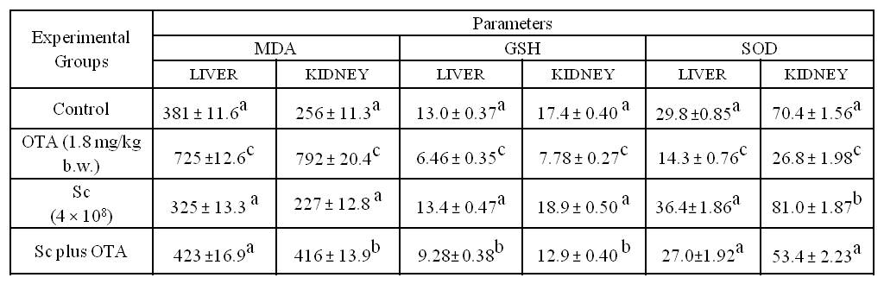
Means with different superscript letters (a, b, c) are
-- significantly different (P ≤ 0.05).
-All data are expressed as means ± SEM.

3.3. Cytogenetic studies:
3.3.1. Effects of Sc on OTA-induced genotoxicity in bone marrow cells
Results for the MNPCE rate are indicated in Table 2, where mice treated with OTA showed a high significant increase in MNPCEs (with mean value of 38.6 at P< 0.01) when compared with other groups. On the other hand, mice received Sc before OTA gavage revealed a significant reduction in MN value (mean 11.0) with respect to the OTA-treated group, but this reduction is not enough to lower the MN to the basal level of control group, where it remains significant high at P< 0.01. Insignificant differences had shown in the control and the Sc given mice (a mean of 3.0 and of 2.8 per 2000 MNPCEs at P< 0.01, respectively). The mitotic index values (table 2) exhibited the same pattern along with MN values.
Table 2: The effect of different treatments (OTA, Sc and Sc plus OTA) on the frequency of Micronucleated polychromatic erythrocytes (MNPCEs) in bone marrow cells of mice.
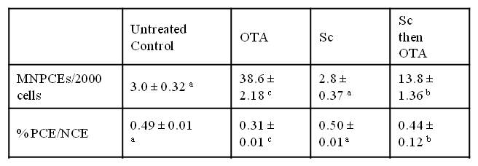
- Means with different superscript letters (a, b, c) are
---significantly different (P <0.01).
- All data are expressed as means ± SEM.

3.3.2. Effects of Sc on OTA-induced genotoxicity in spermatocytes
The results of our study revealed that oral treatment with OTA induced structural and numerical chromosomal aberrations in germ cells of male mice (Table 3). X-Y univalents, autosomal univalents and the total structure aberrations increased significantly (P < 0.01) in OTA-treated mice compared to other groups. In mice given Sc before OTA, structural aberrations were decreased significantly compared to the OTA-treated animals at p < 0.01; no significant differences were found between this group and the control group except for the total structural aberrations at p<0.05. The Sc only treated group showed no significant differences in structure aberrations in respect to the control. OTA increased periploidy, polyploidy and the total numerical aberrations which were significant (p ≤ 0.01) compared to all other groups. Meanwhile, the Sc plus OTA group showed a significant reduction in numerical aberrations compared to the OTA-treated group (p<0.01) and no significant differences when compared to the control or Sc groups, except for the total numerical aberrations when compared with the control group at p<0.05. Sc only treated group showed no significant differences in numerical aberrations in respect to the control. The meiotic index (Tab. 3) revealed a significant meiotic delay in mice treated with OTA with respect to all other groups (p < 0.01). In the Sc and Sc plus OTA groups, there were no significant differences observed compared with them or the control group at p <0.05.

Table 3: Mean values of different types of chromosomal aberrations in spermatocyte cells of male mice treated with OTA, Sc and Sc plus OTA
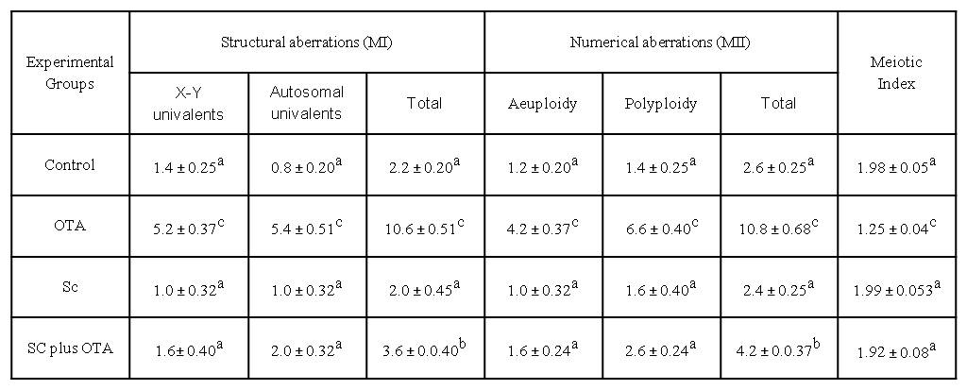
- Means with different superscript letters (a, b, c) are
-significantly different.
- All data are expressed as means ± SEM

3.4. Spermatological parameters:

3.4.1. Sperm count and motility
Data on sperm concentration and motility are presented in Table 4. There was a highly significant change in the sperm concentration in mice treated with OTA, showing drastic reduction in sperm concentration at p<0.01, whereas in those treated with SC before OTA there was a significant increase in sperm count respect to the OTA-treated group (p<0.01). This increase was significantly below that of control and Sc groups at p < 0.01. In mice given SC alone, an insignificant increase in sperm count was observed compared to the control at p>0.05.
The motility of the sperm was affected dramatically in OTA-treated mice which was 6.8 × 10⁶, this reduction was statistically highly significant at p <0.01. In Sc then OTA group, there was a significant enhancement in sperm motility when compared to the OTA-treated group at p<0.01. Again, this increase is still below the basal count of the control, which was significant with respect to control at p<0.01. Sc group showed no significant increase in sperm count in respect to that of the control at p>0.05.

3.4.2. Sperm Morphology
The percentage of sperm displaying abnormalities increased on OTA treatment (Table 4). OTA induced a high significant increase in sperm abnormalities compared to control at p<0.001. Head abnormalities consisted of head without the hook, big head, unusual head shapes (23.6%). The mid-piece abnormalities consisted of folded, disrupted neck and hairpin (20.8%). The tail abnormalities essentially consisted of bi-tail, angular and coiled tail (11.4%). In OTA-treated mice, 12.2 % of sperm head was detached from the flagellum, which was statistically significant when compared with control at p<0.001. In addition, a highly significant percentage of sperm (15.0 %) had sticky flagellum; remained fused over short to long distances (Plate 1I). The quantitative assessment of retention of CD by the cauda epididymal sperm was 9.4% in control mice whereas it was 46.6 % in the OTA-treated mice; this difference was statistically highly significant (p<0.001). In Sc plus OTA group, different sperm abnormalities decreased significantly in comparing with OTA-treated group at p<0.001. Though, this enhancement was significantly below that of control; except for the tail abnormalities and decapitation which showed insignificant differences with control at p>0.05. Meanwhile, Sc only mice showed a non-significant reduction in sperm abnormalities when compared with the control group at p>0.05.

Table 4: Effect of SC on ochratoxin-induced changes of sperm parameters in mice
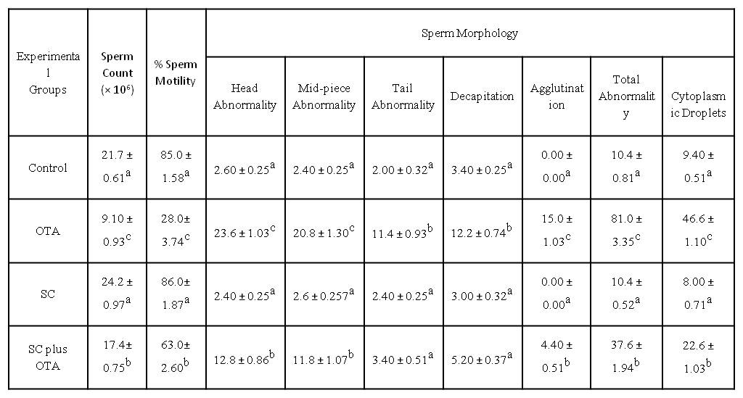
- Means with different superscript letters (a, b, c) are =significantly different.
- All data are expressed as means ± SEM.
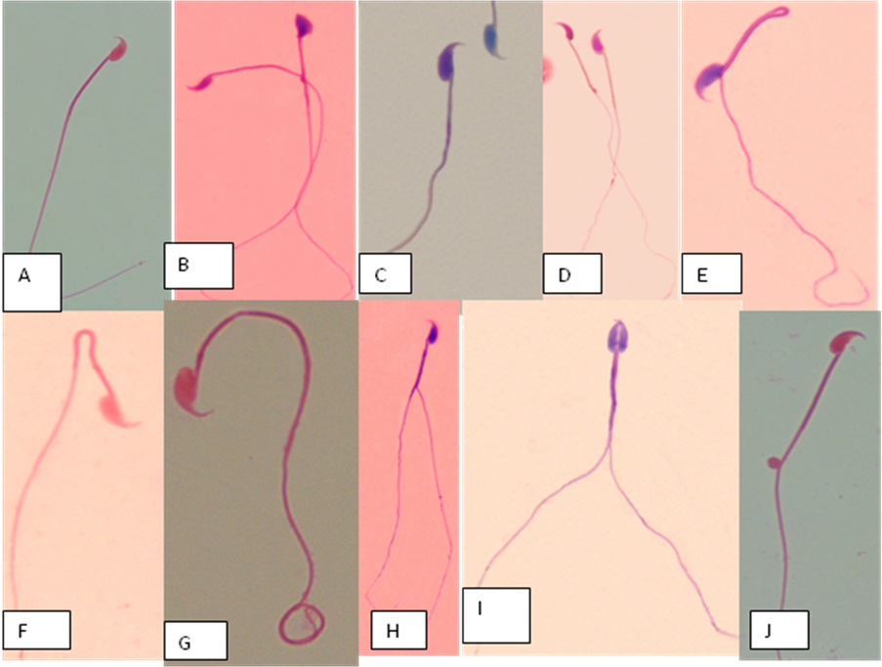
Plate 1: Eosin-stained sperm of mouse. (A) Control mouse. The various abnormalities of the sperm of OTA-treated mice (B–D) abnormal head shape; e.g, amorphous head, big head, banana-like; (E), hair-pin; (F-J) tail angulation bi- and coiled tails; (G), sperm agglutination ; (K), sperm retained CD

4. Discussion
In the current study, the role of Sc on the OTA-induced toxicities was investigated in male albino mice. The selective doses of OTA and Sc were literature-based (Mally et al., 2005; Abdel-Wahhab et al., 2005; Madrigal-Santillán et al., 2006) and the oral dosage of crude toxin was chosen to mimic the natural occurrence and represents the typical route for human expoxure. The present results indicate that OTA treatment resulted in a significant reduction in body weight gain, which was attributed to OTA and not to reduced food intake (Abdel-Wahhab et al., 2005). This reduction in body weight may explained by the ability of OTA to generate free radicals (Pfohl-Leszkowicz et al., 1993), which may lead to DNA breakage, inhibition of protein biosynthesis and gluconeogenesis, lipid peroxidation, disruption of oxidative phosphorylation in mitochondria, inhibition of blood clotting and apoptosis (Hohler, 1998; Petzinger and Ziegler, 2000). On the other hand, administration of Sc alone to mice showed insignificant enhancement on growth performance. Improvement in growth performance had been previously observed in adult and juvenile fish and sea bass larvae fed live yeast (Noh et al., 1994; Lara-Flores et al., 2003; Tovar-Ramírez et al., 2010). Yeast viability seems critical for such growth-promoting effect, since it was not observed when inactive yeast was incorporated into the feed (Métailler and Huelvan, 1993; Oliva-Teles and Gonçalves, 2001). Moreover, digestion of yeast cells releases active compounds like polyamines, proteases and phosphatases, which could be beneficial for the digestive process (Zanello et al., 2009). The current results showed that giving mice Sc before OTA intoxication enhanced growth performance and resulted in a significant recovery in body weight, compared to OTA treated group.
The results of this study confirm and extend previous data which have demonstrated that OTA induces a significant increase in LPO in liver and kidneys of OTA-treated mice as increasing in malondialdehyde (MDA) production. MDA is an end product of lipid peroxidation, and it is considered a late biomarker of oxidative stress and cellular damage (Carampin et al., 2003). The increase in malondialdehyde (MDA) production had been reported under in vitro and in vivo conditions (Verma and Chakraborty, 2008; Malekinejad et al., 2010). Our results showed that OTA caused significant decrease in the levels of non-enzymatic antioxidants GSH in comparison to the vehicle control. Intracellular GSH status appears to be a sensitive indicator of cell’s overall health and its ability to toxic challenges (Verma and Chakraborty, 2008). This finding of decrease in the GSH content corroborates with that of previous studies (Atroshi et al., 2000; Kamp et al., 2005; Abdel-Wahhab et al., 2008). It is possible that this depletion might be a consequence of OTA²⁻ conjugation with GSH or/and increased LPO which known to generate reactive intermediates (such as α, β-unsaturated aldehydes) that covalently bind to GSH (Glaab et al., 2001). To assess the balance of reactive oxygen species (ROS) production in liver and kidney, the superoxide dismutase (SOD) activity was measured. SOD activity in OTA-treated mice decreased in both liver and kidney; this decrease indicated the cell damage of liver and kidney tissues (Doorten et al., 2004). The decrease in SOD activity and GSH content increase the level of superoxide radicals, leading to an increase in oxidative stress enhancing early cell death, probably by apoptotic mechanisms (Soyöz et al., 2004). Our finding of decrease in the activities of SOD corroborates with that of previous studies (Schaaf et al., 2002; Ozcelik et al., 2004; Kamp et al., 2005; Abdel-Wahhab et al., 2008). Oral administration of Sc cultures before OTA gavage caused a decrease in LPO; which might due to the ability of Sc to bind OTA in gastrointestinal tract and consequently decreasing its bioavailability (Celyk et al., 2003; Santin et al., 2003). Recent studies showed that dietary Debaryomyces hansenii stimulates both immune and antioxidant responses in juveniles of gilthead sea bream and in leopard grouper Mycteroperca rosacea after exposure to pathogens (Reyes-Becerril et al., 2008). In addition, feeding rabbits with glucomannan caused an increase in SOD activity and GSH contents (Dönmez and Keskin, 2008). More recently, Tovar-Ramírez et al. (2010) reported that live marine yeast D. hansenii CBS 8339 positively enhanced growth performance and antioxidant status of sea bass larvae by means of preventing oxidative stress, and by maintaining a stable activity and gene expression of SOD and GPX.
Regarding the genotoxicity, we have investigated the OTA genotoxicity by induction of micronuclei (MN) in somatic cells (bone marrow), as an endpoint suitable to detect both aneugenic and clastogenic effects and chromosomal aberrations in germ cells (spermatocytes). In the present study, OTA induced a very high significant increase in MN in bone marrow cells and both structural and numerical aberrations in spermatocytes. Also, mitotic and meiotic activities had declined in a significant way. These finding is in agreement with the previous studies; OTA induced micronuclei in ovine seminal vesicle cells (Degen, 1997), in Syrian hamster fibroblasts (Dopp et al., 1999) and in human hepatic (HepG2) cells (Ehrlich et al., 2002). Significant dose-dependent increases in the frequency of micronucleated cells were also obtained in primary kidney cells from both male rats and humans of both genders with OTA (Robbiano et al., 2004). A statistical increase of structural chromosomal aberrations and sister chromatid exchanges associated with a decrease of the mitotic index was observed in bovine lymphocytes (Lioi et al., 2004). In vivo, oxidative damage to DNA was detected in target (kidney) and non-target (liver) tissues in male F344 rats (Kamp et al., 2005; Mally et al., 2005). Also, OTA induced structural and numerical chromosomal aberrations in bone marrow and germ cells of male mice (Ezz El-Arab et al., 2006). The mitotic and meiotic delay observed in the present study was in agreement with previous studies where OTA found to inhibit the catalytic activity of topoisomerase II and might interfere with chromosome distribution during cell division (Cosimi, et al., 2009) and also, found to modulate key regulators of chromosome segregation and progression through mitosis (Adler et al., 2009). Besides, OTA was shown to inhibit cell cycle progression by arresting cells at G2/M phase (Palma, et al., 2007). Pfohl-Leszkowicz and Manderville (2007) proposed that OTA genotoxicity may be caused by direct (covalent DNA adduction) and indirect (oxidative DNA damage) mechanisms of action. Administration of Sc alone to mice showed no change in MN frequency in bone marrow cells or in chromosomal aberrations in spermatocytes. The obtained results showed that the pretreatment with SC reduced significantly the genotoxicity of OTA in both cell types, somatic and germ cells by around three folds and restored the mitotic and meiotic activities. These data are consistent with other experimental studies have evidenced the ability of Sc to reduce oxidative damage to DNA as a consequence of scavenging of both *OH radicals and singlet oxygen induced by H₂O₂ and visible light-excited Methylene Blue in V79 hamster lung cells (Slamenŏvá et al., 2003), reducing MNNE produced by AFB₁ in mice (Madrigal-Santillán et al., 2006) as well as the capacity of yeast α-Mannan to protect against the DNA damage induced by AFB₁ in mouse hepatocytes (Madrigal-Santillán et al., 2009).
Concerning reproductive toxicity; the present study showed that oral administration of OTA caused adverse effects on male reproductive parameters in mice. In OTA-treated mice, cauda epididymal sperm count was reduced significantly (9.1%), along with a decrease in motility (28%) and a dramatically increase in sperm abnormalities (81%). These findings clearly indicate to severe impact of OTA on spermatogenesis and/ or spermiogenesis; and it is a clear reflection of a direct or indirect toxic manifestation of OTA treatment in the spermatogenic compartment. Various authors have reported similar kind of observations in different animals emphasizing OTA as a reproductive toxicant (Kumari and Sinha, 1994); it induced a decrease in spermatogenic numbers in mice (Bose and Sinha, 1994), decreased motility and longevity of breeding boar semen (Solti et al., 1999). The toxin was found to impair spermatogenesis and cause accumulation of premeiotic germinal cells (Fenske and Fink-Gremmels, 1990). OTA was also found to inhibit testosterone secretion in isolated testicular interstitial cells of gerbils under in vitro conditions (Gharbi et al., 1993). The decline in sperm motility might be due to mitochondrial disruption and/or oxidative stress, where a fairly percent of mid-piece disruption was found (20.8%), in addition to the deformation of the flagellum (22.4%).These findings conform the previous data correlating the decrease in human sperm motility to mitochondrial disruption and/ or an increase in lipid peroxidation (Lodish et al., 2003). Furthermore, OTA treatment disrupted the cytoskeletal proteins of the flagellum causing sticky flagella, where two or more spermatozoa remaining fused (30.6 %). ROS peroxidized fatty acids producing metabolites that could damage phosphatides of cell membrane; consequently, damage the sperm function and morphology (Alvarez et al., 1987). Similarly, elevated seminal ROS production has been associated with decreased sperm motility, defective acrosome reaction, and loss of fertility (Griveau and Le Lannou 1997). Moreover, our data indicated clearly that OTA treatment rendered a significantly higher percentage of the cauda epididymal sperm to retain the CD (44.6 %). These spermatozoa carrying cytoplasmic droplets are thought to be immature and functionally defective (Huszar et al., 1997). Akbarsha et al. (2000) had claimed that cytotoxic and xenobiotic insults cause the sperm to fail to shed the CD, whereas in normal cases most of sperms shed the CD during transit from the corpus to the cauda.
By contrast, the results indicated that, Sc gavage to mice showed slight insignificant enhancement in reproductive parameters; and the pretreatment with Sc to intoxicated animals improved the sperm motility and raised the sperm number; along with reducing sperm abnormalities. The overall data indicate that Sc exerted miscellaneous protective activities in vivo including antioxidative, antigenotoxic and anti-spermatotoxic effects. This might be, in part, due to the adsorption of OTA by Sc; where several studies clearly reported the adsorption mechanisms for OTA de-contamination in vitro. Bejaoui et al. (2004) demonstrated the adsorption of OTA by oenological Saccharomyces strains, since they verified that heat and acid treated cells could bind significantly more OTA than viable ones. Viable yeast bound up to 35% and 45% of the OTA, depending on the medium and strain. Additionally, yeast was reported to reduce OTA in alcoholic fermentation processes such as brewing or vinification. During wort fermentation, yeasts adsorbed a maximum of 21.40% in white wine, of the added OTA (Var et al., 2009). Also, almost 30% of the added OTA was removed after extended contact with yeast biomass (Bizaj et al., 2009). Several reports explained this phenomena by relating it to yeast β-D-glucans (Yiannikouris et al., 2006), glucomannans (Raju and Devegowda, 2002) and mannanoligo-saccharide (Oguz and Parlat, 2004). But, the binding phenomena alone does not explain the protection found in this study; where all the previous studies were carried out in vitro, besides the dose used in the current study was too high (1.8 mg/kg bw/day). Another explanation might be the ability of yeast to degrade OTA, where, S. cerevisiae was claimed to biodegrade 41% of 0.3 mg OTA/L after 24 h at 30 °C (Piotrowska and Zakowska, 2000). Similarly, Böhm et al. (2000) claimed that some strains degraded up to 38% of 0.05 mg OTA/L. Trichosporon, Rhodotorula and Cryptococcus had been demonstrated for their ability to biodegrade OTA through the cleavage of the amide bond and releasing OTα; the most effective strain degraded up to 100% of 0.2 mg OTA/L after five hours of incubation at 35 °C (Schatzmayr et al., 2003). Also, Phaffia rhodozyma strain was also able to degrade 90% of 7.5 mg OTA/L after 15 days at 20 °C; the authors were able to verify the conversion of OTA into OTα and the adsorption of OTA into viable and heat-treated cells (Peteri et al., 2007). More recently, Aureobasidium pullulans was reported to degrade OTA through the hydrolysis of the amide bond since OTα was detected (de Felice et al., 2008), although it has been found to exhibit genotoxic effects (Föllmann et al., 1995).
In conclusion, the present study indicates that oral administration of live yeast S. cerevisiae to mice positively enhances growth performance and significantly mitigates ochratoxin-induced toxicity by means of preventing oxidative stress, and by maintaining glutathione content, as well as a stable activity of SOD, and protected against OTA-induced genotoxicity and spermatotoxicity.

5. References
Abdel-Wahhab, M. A., Abdel-Azim, S. H. and El-Nekeety, A. A. (2008): Inula crithmoides extract protects against ochratoxin A-induced oxidative stress, clastogenic and mutagenic alterations in male rats. Toxicon, 52: 566–573.

Abdel-Wahhab, M.A., Abdel-Galil, M.M. and Ellithey, M.M. (2005): Melatonin counteracts oxidative stress in rats fed ochratoxin A-contaminated diet. J. Pineal Res., 38: 130–135.

Adler, M., Müller, K., Rached, E., Dekant, W. and Mally, A. (2009): Modulation of key regulators of mitosis linked to chromosomal instability is an early event in ochratoxin A carcinogenicity. Carcinogenesis, 30 (4): 711–719.

Alvarez, J.G., Touchstone, J.C., Blascol, J.C. and Storey B.T. (1987): Spontanous lipid peroxidation and hydrogen peroxide and superoxide in human spermatozoa: superoxide dismutase as major enzyme protectant against oxygen toxicity. J. Androl., 18: 338- 348.

Alvarez, L., Gil, A.G., Ezpeleta, O., Garcia-Jalon, J.A. and Lopez de Cerain, A., (2004): Immunotoxic effects of Ochratoxin A in Wistar rats after oral administration. Food Chem.Toxicol., 42: 825-834.

Arbillaga, L., Azqueta, A., Ezpeleta, O. and de Cerain, A.D. (2007): Oxidative DNA damage induced by ochratoxin A in the HK-2 human kidney cell line: evidence of the relationship with cytotoxicity. Mutagenesis, 22: 35–42.

Akbarsha M.A.,Latha P.N.,and Murugaian P.(2000):Retention of cytoplasmic droplet by rat cauda epididymal spermatozoa after treatment with cytotoxic agents.Journal of Reproduction and fertility,120:385-390

Atroshi, F., Rizzo, A., Sankari, S., Biese, I.,Westermarck, T. and Veijalainen, P. (2000):. Liver and enzyme activities of rats exposed to ochratoxin A and T-2 toxin with antioxidants. Bull. Environ. Contam. Toxicol., 64:586.

Bejaoui, H., Mathieu, F., Taillandier, F. and Lebrihi, A. (2004): Ochratoxin A removal in synthetic and natural grape juices by selected oenological Saccharomyces strains. J. Appl. Microbiol., 97: 1038-1044.

Bennet, J.W. and Klich, M. (2003): Mycotoxins. Clinical Microbiolgy Reviews, 16:497-498.

Beutler, E., Dubon O.B. and Kelly, M. (1963): Improved method for the determination of blood glutathione. J. Lab. Clin. Med., 61:882–888.

Biernasiak, J. Piotrowska, M. and Libudzisz, Z. (2006): Detoxification of mycotoxins by probiotic preparation for broiler chickens. Mycotoxin Res., 22: 230–235.

Biro, K., Barna-Vetro, I., Pecsi, T., Szabo, E., Winkler, G., Fink-Gremmels, J. and Solti, L. (2003): Evaluation of spermatological parameters in ochratoxin A-challenged boars. Theriogenology, 60: 199-207.

Bizaj, E., Mavri, J., Cus, F. and Raspor, A. (2009): Removal of ochratoxin A in Saccharomyces cerevisiae liquid cultures. S. Afr. J. Enol. Vitic., 30: 151–155.

Böhm, J., Grajewski, J., Asperger, H., Rabus, B. and Razzazi, E. (2000): Study on biodegradation of some trichothecenes (NIV, DON, DAS, T-2) and ochratoxin A by use of probiotic microorganisms. Mycot. Res., 16: 70–74.

Brown, A.L., Odell, E.W. and Mantle, P.G. (2007): DNA ploidy distribution in renal tumours induced in male rats by dietary ochratoxin A. Exp. Toxicol. Pathol., 59: 85–95.

Bose, S. and Sinha, S.P. (1994): Modulation of ochratoxin-produced genotoxicity in mice by vitamin C. Food Chem. Toxicol., 32: 533–537.

Carampin, P., Rosan, S. and Dalzoppo D., Zagotto, G. and Zatta, P. (2003): Some biochemical properties of melatonin and the characterization of a relevant metabolite arising from its interaction with H2O2. J Pineal Res. 34:134–142.

Celyk, K., Denly, M., and Savas, T. (2003): Reduction of toxic effects of aflatoxin by using baker yeast (Saccharomyces cerevisiae): in growing broiler chicken diets. Revista Brasileira de Zootecnia, 32: 615–619.

Chakraborty, D. and Verma, R. (2009): Spermatotoxic effect of ochratoxin and its amelioration by emblica officinalis aqueous extract Acta Poloniae Pharmaceutica. Drug Research, 66 (6): 689-695.

Clark, H.A.and Snedeker, S.M. (2006): Ochratoxin A: its cancer risk and potential for exposure. J. Toxicol. Environ. Health B Crit. Rev. 9: 265–296.

Cosimi, S., Orta, L. Mateos, S. and Felipe Cortes, F. (2009): The mycotoxin ochratoxin A inhibits DNA topoisomerase II and induces polyploidy in cultured CHO cells Toxicology in Vitro 23: 1110–1115.

Dawson, K.A. (1993): Yeast culture as feed supplements for ruminants: Mode of action and future applications. J. Anim. Sci., 71: 280–284.

de Felice, D.V., Solfrizzo, M., De Curtis, F., Lima, G., Visconti, A. and Castoria, R. (2008): Strains of Aureobasidium pullulans can lower ochratoxin A contamination in wine grapes. Phytopathology, 98, 1261–1270.

Degen, G.H. (1997): Induction of micronuclei with ochratoxin A in ovine seminal vesicle cell cultures. Archives in Toxicology, 71:365-371.

Dönmez, N. and Keskin, E. (2008): The effects of aflatoxin and glucomannan on some antioxidants and biochemical parameters in rabbits Acta Veterinaria (Beograd), 58 (4): 307-313.

Dönmez-Altuntas, H., Hamurcu, Z., Imamoglu, N., and Liman, B.C. (2003): Effects of ochratoxin A on micronucleus frequency in human lymphocytes. Nahrung, 47(1)::33.

Doorten, S.Y., Bull, S., Van Der Doelen, M.A. and Fink-Gremmels, J., (2004): Metabolism-mediated cytotoxicity of ochratoxin A. Toxicol. In Vitro, 18 (3): 271–277.

Dopp, E., Muller, J., Hahnel, C., and Schiffmann, D. (1999):. Induction of genotoxic effects and modulation of the intracellular calcium level in Syrian hamster embryo (SHE) fibroblasts caused by ochratoxin A. Food and Chemical Toxicology, 37(7):713-721.

EFSA (2006): Opinion of the CONTAM Panel related to ochratoxin A in food. EFSA EFSA-Q-2005-154.

El Golli-Bennour, E., Kouidhi, B., Bouslimi, A., Abid-Essefi, S. Hassen, W. and Bacha, H. (2010): Cytotoxicity and Genotoxicity Induced by Aflatoxin B1, Ochratoxin A, and Their Combination in Cultured Vero Cells. J Biochem Molecular Toxicology, 24: 1, 42-50.

Evans, E.P. Breckon, G. and Ford, C.E. (1964): An air-drying method for meiotic preparations for mammalian testes. Cytogenetics, 3: 289–294.

Ezz El-Arab, A., Girgis, S. Hegazy, E. and Abd El-Khalek, A. (2006): Effect of dietary honey on intestinal microflora and toxicity of mycotoxins in mice. BMC Complementary and Alternative Medicine, 6:6.

Ehrlich, V., Darroudi, F., Uhl, M., Steinkellner, H., Gann, M., Majer, B.J., Eisenbauer, M., and Knasmüller, S. (2002): Genotoxic effects of ochratoxin A in human-derived hepatoma (HepG2) cells. Food and Chemical Toxicology, 40:1085.

Fenske, M. and Fink-Gremmels, J. (1990): Effects of fungal metabolites on testosterone secretion in vitro. Arch Toxicol., 64: 72–75.

Fink-Gremmels, J. (2005): Conclusions from the workshops on ochratoxin A in food: Recent developments and significance, organized by ILSI Europe in Baden (Austria):, 29 June–1 July. Food Addit. Contam.

Föllmann, W., Behm, C. and Degen, G.H. (2007): Induction of micronuclei by ochratoxin A is a sensitive parameter of its genotoxicity in cultured cells. Mycotoxin Research, 23 (2): 101-109.

Föllmann, W., Hillebrand, I.E., Creppy, E.E. and Bolt, H.M. (1995): Sister chromatid exchange frequency in cultured isolated porcine urinary bladder epithelial cells (PUBEC) treated with ochratoxin A and alpha. Arch. Toxicol., 69: 280–286.

Gharbi, A., Trillon, O., Betbeder, A.M., Counord, J., Gauret, M.F., Pfohl-Leszkowicz, A., Dirheimer, G. and Creppy, E.E. (1993): Some effects of ochratoxin A, a mycotoxin contaminating feeds and food, on rat testis. Toxicology 83: 9–18.

Glaab, V., Collins, A.R., Eisenbrand, G. and Janzowski, C. (2001): DNA damaging potential and glutathione depletion of 2-cyclohexene-1-one in mammalian cells, compared to food relevant 2-alkenals. Mut. Res., 497: 185–197.

Griveau J.F. and Le Lannou D. (1997): Reactive oxygen species and human spermatozoa: physiology and pathology. Int J Androl., 20: 61-69.

Hohler, D. (1998): Ochratoxin A in food and feed: occurrence, legislation and mode of action. Z. Ernahrungswiss, 37: 2–12.

Huszar, G., Sbracia, M., Vigue, L., Miller, D.J. and Shur, B.D. (1997): Sperm plasma membrane remodeling during spermiogenetic maturation in men: relationship among plasma membrane beta 1,4-galactosyltransferase, cytoplasmic creatine phosphokinase, and creatine phosphor-kinase isoform ratios. Biol Reprod, 56: 1020-1024.

IARC (1993): Ochratoxin A In: IARC Monographs on the Evaluation of Carcinogenic Risks to Humans, Some Naturally Occurring Substances: Food Items and Constituents, Hetrocyclic Aromatic Amines and Mycotoxins. Vol. 56, Lyon: IARC, 489-521.

Kamp, H.G., Eisenbrand, G., Janzowski, C., Kiossev, J., Latendresse, J.R., Schlatter, J. and Turesky, R.J., (2005): Ochratoxin A induces oxidative DNA damage in liver and kidney after oral dosing to rats. Mol. Nutr. Food Res., 49: 1160–1167.

Krishna, G. and Hayashi, M. (2000): In vivo rodent micronucleus assay: protocol, conduct and data interpretation. Mutation Res., 455: 155–166.

Kumari, D. and Sinha, S.P. (1994): Effect of retinol on ochratoxin produced genotoxicity in mice. Food Chem. Toxicol., 32:471–475.
Lara-Flores, M., Olvera-Novoa, M.A., Guzmán-Méndez, B.E. and López-Madrid, W. (2003): Use of the bacteria Streptococcus faecium and Lactobacillus acidophilus, and the yeast Saccharomyces cerevisiae as growth promoters in Nile tilapia (Oreochromis niloticus). Aquaculture 216: 193–201.

Lioi, M.B., Santoro, A., Barbieri, R., Salzano, S. and Ursini, M.V. (2004): Ochratoxin A and zearalenone: a comparative study on genotoxic effects and cell death induced in bovine lymphocytes. Mutation Res., 557:19–27.

Lodish, H., Berk A., Kaiser, C.A., Kreiger M., Scott, M.P., Zipursky, S.L. and Derreli J.( 2003): Molecular Cell Biology. Scientific American Books, Freeman and Company, New York 5.

Madrigal-Santillán, E., Álvarez-González, I., Máquez-Márquez, R., Velázquez-Guadarrama, N., Madrigal-Bujaidar, E. (2007): Inhibitory Effect of Mannan on the Toxicity Produced in Mice Fed Aflatoxin B1 Contaminated Corn. Arch. Environ. Contam. Toxicol., 53: 466–472.

Madrigal-Santillán, E., Madrigal-Bujaidar, E., Márquez-Márquez, R., and Reyes, A. (2006): Antigenotoxic effect of Saccharomyces cerevisiae on the damage produced in mice fed with aflatoxin B1 contaminated corn. Food and Chemical Toxicology, 44: 2058–2063.

Madrigal-Santillán, E., Morales-González, J., Sánchez-Gutiérrez, M., Reyes-Arellano, A. and E Madrigal-Bujaidar (2009): Investigation on the Protective Effect of α-Mannan against the DNA Damage Induced by Aflatoxin B₁ in Mouse Hepatocytes. Int. J. Mol. Sci., 10: 395-406

Malekinejad H., Farshid A. and Mirzakhani N. (2010): Liquorice plant extract reduces ochratoxin A-induced nephrotoxicity in rats. Experimental and Toxicologic Pathology (in press).

Mally, A., Pepe, G., Ravoori, S., Fiore, M., Gupta, R., Dekant, W. and Mosesso, P. (2005): Ochratoxin A causes DNA damage and cytogenetic effects but no DNA adducts in rats. Chem. Res. Toxicol., 18: 1253–1261.

Marin-Kuan, M., Nestler, S., Verguet, C., Bezencon, C., Piguet, D., Mansourian, R., Holzwarth, J., Grigorov, M., Delatour, T., Mantle, P., Cavin, C. and Schilter, B. (2006): A toxicogenomics approach to identify new plausible epigenetic mechanisms of ochratoxin A carcinogenicity in rat. Toxicol. Sci., 89 (1): 120–134.

Marklund, S., and Marklund, G., (1974): Involvement of the superoxide anion radical in the autoxidation of pyrogallol and a convenient assay for superoxide dismutase. Eur. J. Biochem., 47: 469–474.

Meca, G., Blaiotta, G., and Ritieni, A. (2010): Reduction of ochratoxin A during the fermentation of Italian red wine Moscato. Food Control, 21: 579-583.

Meki, A. and Hussein, A. (2001):. Melatonin reduces oxidative stress induced by ochratoxin A in rat liver and kidney. Comparative Biochemistry and Physiology Part C, 130: 305.

Métailler, R. and Huelvan, C., (1993): Uitilisation des levures dans l'alimentation du juvénile de bar (Dicentrarchus labrax). In: Kaushik, S.J., Luquet, P. (Eds.):, Fish Nutrition in Practice Les Colloques, vol. 61. Institut National de la Recherche Agronomique, Paris, 945–948.

Mosesso, P., Cinelli, S., Pinero, J., Belacima, R., Pepe, G. (2008): In vitro cytogenetic results supporting a DNA nonreactive mechanism for ochratoxin A, potentially relevant for its carcinogenicity. Chem. Res. Toxicol., 21: 1235–1243.

Noh, S.H., Han, K., Won, T.H. and Choi, Y.J., (1994): Effect of antibiotics, enzyme, yeast culture and probiotics on the growth performance of Israeli carp. Korean J. Anim. Sci., 36: 480–486.

Ohkawa, H., Ohishi, N. and Yagi, K., (1979): Assay for lipid peroxides in animal tissues by thiobarbituric acid reaction. Analytical Biochemistry, 95: 351–358.

Oguz, H. and Parlat, S.S. (2004): Effects of dietary mannanoligosaccharide on performance of Japanese quail affected by aflatoxicosis. S. Afr. J. Anim. Sci., 34: 144–148.

Oliva-Teles, A. and Gonçalves, P. (2001): Partial replacement of fishmeal by brewer’s yeast (Saccharomyces cerevisiae): in diets for sea bass (Dicentrarchus labrax): juveniles. Aquaculture, 202: 269–278.

Ozcelik, N., Soyoz, M. and Kilink, I. (2004): Effects of ochratoxin A on oxidative damage in rat kidney: protective role of melatonin. J. Appl. Toxicol., 24: 211–215.

Palma, N., Cinelli, S., Sapora, O.,Wilson, S. H. and Dogliotti, E. (2007): Ochratoxin A-induced mutagenesis in mammalian cells is consistent with the production of oxidative stress. Chem. Res. Toxicol., 20: 1031 –1037.

Peteri, Z., Teren, J., Vagvolgyi, C. and Varga, J. (2007): Ochratoxin degradation and adsorption caused by astaxanthin-producing yeasts. Food Microbiol., 24: 205–210.

Petzinger E. and Ziegler, K. (2000): Ochratoxin A from a toxicological perspective. J. Vet. Pharmacol. Therap., 23: 91.98.

Pfohl-Leszkowicz, A., Grosse, Y., Kane, A., Gharbi, A., Baudrimont, I., Obrecht, S., Creppy, E.E. and Dirheimer, G. (1993): Is the oxidative pathway implicated in the genotoxicity of ochratoxin A? In: Creppy, E.E., Castegnaro, M., Dirheimer, G. (Eds.):, Human Ochratoxicosis and its Pathologies, vol. 231 Colloque INSERM/John Libbey Eurotext Ltd., 177–187.

Pfohl-Leszkowicz, A. and Manderville, R.A. (2007): Ochratoxin A: an overview on toxicity and carcinogenicity in animals and humans. Mol Nutr Food Res., 51:61–99.

Piotrowska, M. and Zakowska, Z. (2000): The biodegradation of ochratoxin A in food products by lactic acid bacteria and baker's yeast. In Progress in Biotechnology (Food Biotechnology): Bielecki, S., Tramper, J., Polak, J., Eds; Elsevier: Amsterdam, The Netherlands Volume 17, 307–310.

Rached, E., Hard, G.C., Blumbach, K., Weber, K., Draheim, R., Lutz, W.K., Ozden, S., Steger, U., Dekant, W. and Mally, A. (2007): Ochratoxin A: 13-week oral toxicity and cell proliferation in male F344/n rats. Toxicol. Sci., 97; 288–298.

Raju, M.. and Devegowda, G. (2002): Esterified-glucomannan in broiler chicken diets-contaminated with aflatoxin, ochratoxin and T-2 toxin: Evaluation of its binding ability (in vitro): and efficacy as immunomodulator. Asian Australas. J. Anim. Sci., 15: 1051–1056.

Reyes-Becerril, M., Tovar-Ramírez, D., Ascencio-Valle, F., Civera-Cerecedo, R., Gracia-López, V. and Barbosa-Solomieu, V. (2008): Effects of dietary live yeast Debaryomyces hansenii on the immune and antioxidant system in juvenile leopard grouper Mycteroperca rosacea exposed to stress. Aquaculture, 280: 39–44.

Ringot, D., Lerzy, B., Bonhoure, J.P., Auclair, E., Oriol, E.and Larondelle, Y. (2005): Effect of temperature on in vitro ochratoxin A biosorption onto yeast cell wall derivatives. Process Biochem., 40: 3008–3016.

Robbiano L., Baroni, D., Carrozzino, R., Mereto, E. and Brambilla, G. (2004): DNA damage and micronuclei induced in rat and human kidney cells by six chemicals carcinogenic to the rat kidney. Toxicology, 204: 187 –195.

Russo, A. (2000): In vivo cytogenetics: Mammalian germ cells. Mutation Res., 455: 167–189.
Sage, L., Garon, D. and Seigle-Murandi, F. (2004): Fungal microflora and ochratoxin risk in French vineyards. J. Agric Food Chem., 52: 5764–5768.

Santin, E., Paulilo, A. C., Maiorka, A., Nakaghi, L. S. O., Macan, M., de Silva, A. V. F. and Alessi, C.A. (2003):. Evaluation of the efficiency of Saccharomyces cerevisiae cell wall to ameliorate the toxic effects of aflatoxin in broilers. International Journal of Poultry Science, 2: 241–344.

Schaaf, G.J., Nijmeijer, S.M., Maas, R.F., Roestenberg, P., de Groene, E.M. and Fink-Gremmels, J. (2002): The role of oxidative stress in the ochratoxin A-mediated toxicity in proximal tubular cells. Biochim. Biophys. Acta, 1588 (2): 149–158.

Schatzmayr, G., Heidler, D., Fuchs, E., Mohnl, M., Täubel, M., Loibner, A.P., Braun, R. and Binder, E.M. (2003): Investigation of different yeast strains for the detoxification of ochratoxin A. Mycot. Res., 19; 124–128.

Slamenová, D., Lábaj, J., Krizková, L., Kogan, G., Sandula, J., Bresgen, N. and Eckl, P. (2003): Protective effects of fungal β-D-glucan derivatives against oxidative DNA lesions in V79 hamster lung cells. Cancer Lett., 198: 153–160.

Solti, L., Pecs, T., Betro-Barna, I., Szasz, F., Biro, K. and Azabo, E. (1999): Analysis of serum and seminal plasma after feeding ochratxoin A with breeding boars. Anim Reprod Sci., 28: 123–132.

Soyöz, M., Ozcelik, N., Kilinc, I. and Altantas I. (2004): The effects of ochratoxin A on lipid peroxidation and antioxidant enzymes: a protective role of melatonin. Cell Biol Toxico., 20:213–219.

Tovar-Ramírez, D., Mazurais, D., Gatesoupe, J.F.,Quazuguel, P., Cahu, C.L., Zambonino-Infante, J.L. (2010): Dietary probiotic live yeast modulates antioxidant enzyme activities and gene expression of sea bass (Dicentrarchus labrax) larvae. Aquaculture (in press).

Var, I. Erginkaya, Z. and Kabak, B. (2009): Reduction of Ochratoxin A Levels in White Wine by Yeast Treatments J. Inst. Brew., 115(1): 30–34.

Verma, R. and Chakraborty, D. (2008): Emblica officinalis aqueous extract ameliorates ochratoxin-induced lipid peroxidation in the testis of mice. Acta Pol. Pharm., 65; 187–194.

Vlckova V., Duhova V., Svidova S., Farkassova A., Kamasova S., Vlcek D., Kogan G., Rauko P., and Miadokova E. (2004): Antigenotoxic potential of glucomannan on four model test systems. Cell Biol. Toxicol., 20:325–332.

Wallace, R.J. (1994): Ruminal microbiology, biotechnology and ruminant nutrition: Progress and problems. J. Anim. Sci., 72: 2992–3003.

Wallace, R.J., (1998): Yeast benefits examined. Feed Mix., 6: 27–29.

Wyrobek, A. J. and Bruce, W. R. (1975): Chemical induction of sperm abnormalities in mice Proc. Nat. Acad. Sci. USA, 72 (11): 4425-4429.

Yiannikouris, A., Andre, G., Poughon, L., Francois, J., Dussap, C.G., Jeminet, G., Bertin, G. and Jouany, J.P. (2006): Chemical and conformational study of the interactions involved in mycotoxin complexation with -D-glucans. Biomacromolecules, 7: 1147–1155.

Zanello, G., Meurens, F., Berri, M. and Salmon, H., (2009): Saccharomyces boulardii effects on gastrointestinal diseases. Curr. Issues Mol. Biol., 11: 47–58.

10/5/2010

