Genetic stability on Phoenix dactylifera var. Karama produced in vitro

Mohamed Mohamed Abd-Alla
Desert Research Center, Genetic Resourced Department, Cairo, Egypt.

Abstract: ISSR-PCR technique was utilized to assess the genetic stability of the micropropagated date palm plantlets Phoenix dactylifera var. Karama. The detected 49 amplicons from the five ISSR anchored primers showed that there were a high similarity within the micropropagated date palm plantlets Phoenix dactylifera var. Karama and the mother plant and some dissimilarity was detected among some samples which is due to the somaclonal variations that may occurred during micropropagation process. A UPGMA dendrograme was constructed to illustrates the genetic similarity among the 10 plants (9 micropropagated plants and donor mother plant). In the present study, molecular profils by using ISSR markers proved to be a reliable method for assessing genetic stability of micropropagated plants.
[Mohamed Mohamed Abd-Alla. Genetic stability on Phoenix dactylifera var. Karama produced in vitro. New York Science Journal 2010;3(12):70-75]. (ISSN: 1554-0200).

Keywords: ISSR-PCR, date palm, genetic stability, somaclonal variation.

1. Introduction
Date palm (Phoenix dactylifera L.) is a tree crop of economic importance in Egypt. It is considered as a source of income to inhabitants in Oases, provides protection to people and plants from the climate effects and reduces the damage from sand storms and wind speed. Every thing in the Date palm tree is available for use (food, fuel, and environmental industries). It is a dioecious, monocotyledon, diploid (2n = 36) with long generation time, Almaarry (1995) and Ebtisam et al (2004). Date palm (Phoenix dactylifera var. Karama) grew in Siwa Oasis suffering from the shortage in its offshoots and the grown plants are adults. Plantlets were produced through the micropropagation of this variety (Phoenix dactylifera var. Karama) in the Desert Research Centre, Genetic Resources Department, Tissue Culture Lab. Somaclonal variations can occur through utilization of tissue culture technique.
The ISSR technique is a powerful, rapid, simple, reproducible and inexpensive way to assess genetic diversity or to identify closely related cultivars in many species, including fruit trees (González et al., 2002). ISSR technique permits the detection of polymorphisms without previous knowledge of the DNA sequence (Hamama, et al., 2003,). Gupta (2010) used ISSR and RAPD to assess the variations in three varieties of Finger millet (Eleusine coracana L). The sequences of repeats and anchored nucleotides are randomly selected (Fang et al., 1997). ISSRs have been also successfully employed to identify date palm cultivars (Adawy et al., 2002 and 2004; Ben Saleh and El-Helaly, 2003). Zehdi et al (2004) used genetic markers generated from selected ISSR primers to assess genetic diversity among a set of Tunisian date palm varieties. The micropropagated plantlets of a cultivar of dessert banana, namely, Nanjanagudu rasabale (NR), classified under group “silk” (of genotype AAB),were analyzed for their genetic stability using randomly amplified polymorphic DNA (RAPD) and inter simple sequence repeats (ISSR) markers. Band intensity histogram of each gel confirmed their monomorphic nature with no genetic variation among the plantlets analyzed Venkatachalam, et al( 2007). Inter simple sequence repeat (ISSR) markers were employed to determine the genetic stability of plantlets multiplied in vitro by using stem segments Chandrika and Rai (2009). Johnson et al (2009) used ISSR to assess the off-type of the micropropagated plants and the genomic regions that vary in somaclonal “off-types” are a possible source of such labile regions of the genome. The clones derived from capitulum and shoot tip explants did not show any genetic variation, whereas, one of the leaf-derived clones exhibited some degree of variation. Bhatia et al. (2009) and Piña-Escutia et al (2010) used inter simple sequence repeat analysis was carried out to check for possible genetic alterations in plants obtained after successive subcultures. Their results revealed that the recovered plants did not exhibit any type of polymorphism.
The main objective of the present investigation is to assess the genetic stability among the micropropagated date palm (Phoenix dactylifera var. Karama) plantlets and the mother plant using ISSR technique. ISSR markers proved to be a reliable method for assessing genetic stability of micropropagated plants.
2. Material and Methods
1-Plant Material
This study was carried out in Tissue Culture Laboratory, Genetic Resources Department, Desert Research Center, Cairo, Egypt through out the years from 2002to 2006. to propagate date palm (Phoenix dactyliferaL. var. Karama) and produce plantlets through somatic embryos. tissue culture derived plantlets were taken to determine their genetic stability using ISSR technique compared with mother plant samples which were collected from the young leaves surrounding the date palm meristem from plant.

2- Methods
a- Extraction and Purification of Genomic DNA
A modified CTAB (hexadecyl trimethyl ammonium bromide) procedure based on the protocol of Porebski et al. (1997) was adopted for obtaining a good quality of total DNA. After estimating the concentration of the individual DNA samples, aliquots of the same concentration of the DNA individual samples were performed. The DNA samples in this study were nine samples representing eight samples of the date palm tissue culture derived plantlets and one of mother plant.

b- ISSR analysis
ISSR-PCR reaction was performed in a 25 μl reaction volume containing 1X PCR buffer,a 3.0 μl of MgCl2, a 2.05 μl of each dNTPs, a 2.0 μl of oligonucleotide primer, a 2.0 μl of genomic DNA , a 0.3 μl of Taq DNA polymerase and up to 25 μl with ddH2O. Amplification was carried out in Stratgene Robocycler Gradient 96 which was programmed for 45 cycles as follows: Denaturation (one cycle) at 94 Cº for 2 minutes, followed by 30 cycles: as follows: at 94 Cº for 30 sec., at 44 Cº for 45 sec., at 72 Cº for 1 minute and finally one extension cycle at 72 Cº for 20 minutes, and 4 Cº (infinitive).The PCR products were performed on a 2% of agarose gel in 1X TBE buffer containing Ethidium bromide. Bands were detected on UV- transilluminator and photographed by Gel documentation system Biometra Bio Doc Analyze 2000.
ISSR – PCR reactions were conducted using eight specific primers, as presented in table (1).
c. Gel electrophoresis:
A 15 μl of PCR- products were resolved in a 2 % of Nusieve GTG agarose gel with 1x TAE running buffer. The run was performed at 80 V for 180 min and the gel was stained with Ethidium bromide. A 1μg /μl marker of 1 Kb plus DNA Ladder (In vitro gen) that contains a total of twenty bands ranging from 10000 to 300 bp was used.

d-Data analysis
The banding patterns generated by ISSR markers were used to determine the genetic similarity of the eight date palm tissue culture samples and one mother plant. Clear and distinct amplification products were scored as ‘1’ for presence and ‘0’ for absence of bands. The genetic similarity coefficient (GS) between each two samples was estimated according to Dice coefficient. The software used through this study were SPSS 10.0, POPGEN 3.2, XLSTAT-Pro 7.1, and Microsoft EXCEL

Table (1): ISSR 3′ anchored primers and their sequences:-
Primer name | Sequence | Primer name | Sequence
ISSR4 | (CA)6 AC | ISSR6 | (CA)6 AG
ISSR7 | (CA)6 GT | ISSR1 | (CA)6 GG
ISSR 10 | (GA)6 CC | HB15 | (GTG)3 GC
ISSR 11 | (GT)6 CC | UBC-811 | (GA)6C

3. Results and Discussion
In the present study the ISSR analysis was performed on ten DNA samples represented nine tissue culture derived plantlets and the mother plant sample of Phoenix dactylifera var. karama using 8 inter simple sequence repeat (ISSR) primers. Only five primers out of the eight used ISSR primers produced good reproducible and scorable patterns. The amplification profiles were screened for the presence of polymorphisms among the nine date palm samples (Fig. 1) as shown in Table (2). The survey of all obtained amplified fragments which produced by five of the eight used primers are listed in table (2). The eight micropropagated date palm plantlets (Phoenix dactylifera var. karama) varied in a total fragments numbers than their mother plant. The eight plantlets had new fragments which ranged from one to nine, while they showed a disappearance of some fragments which ranged from one to six. All plantlets had more fragments than their mother plants which ranged from two to seven, except the first one which had a less of one fragment and considered as the most similar one to its mother plant. However, the occurrence of new or absent fragments in the plantlets with respect to their mother plant. These results are in agreement with those of Ben Saleh and El-Helaly (2003), they used ISSR on date palm to detect the polymorphism between date palm cultivars, Adawy et al. (2002 and 2004) stimated the genetic relationship within date palm varieties, and Vankatachlam et al(2007) found that there were no genetic variations among tissue culture derived plants by utilization of ISSR technique. Chandrika and Rai (2009), Johnson et al (2009) and used ISSR to assess the off-type of the micropropagated plants and the genomic regions that vary in somaclonal “off-types” are a possible source of such labile regions of the genome. Bhatia et al. (2009) and Piña-Escutia et al (2010) used inter simple sequence repeat analysis to check for possible genetic alterations in plants obtained after successive subcultures. Their results revealed that the recovered plants did not exhibit any type of polymorphism.
The similarity matrix among the eight plantlets and their mother plant based on ISSR analysis in Table (3). High similarity values were detected between all plantlets and their mother plant which ranged from 00.996 with the sample No. one to 0.82 with last one with an average of 0.875. On the other hand, high similarity values were detected among the eight plantlets which ranged from 0.97 between the fourth and the fifth sample to 0.80 between the sample one and sample nine, with an average of 0.892. However, the average of similarity matrix among the eight plantlets and their mother plant was 0.884 which indicated an narrow genetic differences among them. The dendrogram tree (Fig 2) showed the genetic relationships among the eight date palm tissue culture derived samples and the mother plant based on ISSR analysis. The dendrogram classified the eight plantlets and their mother plant into two main groups. The first group was classified into two sub-group, where the first one included five samples from sample No. 2 to sample No. 6 ( 2,3,4,5 and 6), while the second sub-group comprised only the mother plant and first sample (No.1). Finally the second group included only the last two samples (No.7 and No.8) which considered as the most distance ones from the other plantlets and their mother plant. However, the dendrogram reflected the genetic relationships among these propagated plantlets and considered as a good tool to select the closet plantlets with respect to their mother plant.
Therefore, these results revealed that ISSR represent an efficient tool for estimating the genetic stability and the genetic relationships among the tissue culture derived plantlets to stop multiplication when the similarity is decreased.

Table (2) The ISSR amplification fragments obtained from the DNA of tissue culture derived plantlets and mother plant of date palm ( phoenix dactylifera var. karama) represents 0/1 bands using 5 ISSR primers.
m. size | samples
ISSR7 | Moth | 2 | 3 | 4 | 5 | 6 | 7 | 8 | 9
1479 | 1 | 1 | 1 | 1 | 1 | 1 | 1 | 1 | 1
1215 | 1 | 1 | 1 | 1 | 1 | 1 | 1 | 1 | 1
1017 | 1 | 1 | 1 | 1 | 1 | 1 | 1 | 1 | 0
927 | 1 | 1 | 1 | 1 | 1 | 1 | 1 | 1 | 1
877 | 1 | 1 | 1 | 1 | 1 | 1 | 1 | 1 | 1
639 | 1 | 1 | 1 | 1 | 1 | 1 | 1 | 1 | 1
547 | 0 | 0 | 1 | 1 | 1 | 1 | 0 | 1 | 1
459 | 1 | 1 | 1 | 1 | 1 | 1 | 1 | 1 | 1
394 | 1 | 1 | 1 | 1 | 1 | 1 | 1 | 1 | 0
262 | 1 | 1 | 1 | 1 | 1 | 1 | 1 | 1 | 1
10bands | 9 | 9 | 10 | 10 | 10 | 10 | 9 | 10 | 8
ISSR4
1159 | 1 | 1 | 1 | 1 | 1 | 1 | 1 | 1 | 1
996 | 1 | 1 | 1 | 1 | 1 | 1 | 1 | 1 | 1
665 | 1 | 1 | 1 | 1 | 1 | 1 | 1 | 1 | 1
593 | 1 | 1 | 1 | 1 | 1 | 1 | 1 | 1 | 1
500 | 1 | 1 | 1 | 1 | 1 | 1 | 1 | 1 | 1
417 | 0 | 0 | 1 | 1 | 1 | 1 | 1 | 1 | 1
283 | 1 | 1 | 1 | 1 | 1 | 1 | 1 | 1 | 1
7bands | 6 | 6 | 7 | 7 | 7 | 7 | 7 | 7 | 7
ISSR6
1230 | 0 | 0 | 1 | 1 | 1 | 1 | 0 | 1 | 1
1085 | 1 | 1 | 1 | 1 | 1 | 1 | 1 | 1 | 1
959 | 1 | 1 | 1 | 1 | 1 | 1 | 1 | 0 | 0
879 | 1 | 0 | 0 | 0 | 0 | 0 | 1 | 1 | 1
700 | 1 | 1 | 1 | 1 | 1 | 1 | 1 | 1 | 0
682 | 0 | 0 | 0 | 1 | 1 | 1 |  | 1 | 1
505 | 0 | 0 | 0 | 0 | 0 | 0 | 1 | 1 | 1
470 | 1 | 1 | 1 | 1 | 1 | 1 | 1 | 1 | 1
394 | 1 | 1 |  | 1 | 1 | 1 | 1 | 1 | 1
244 | 1 | 1 | 1 | 1 | 1 | 1 | 1 | 1 | 1
10 band | 7 | 6 | 6 | 8 | 8 | 8 | 8 | 9 | 8
ISSR1
1534 | 0 | 1 | 1 | 1 | 1 | 1 | 1 | 1 | 1
1305 | 1 | 1 | 1 | 1 | 1 | 1 | 1 | 1 | 1
1213 | 0 | 0 | 0 | 1 | 1 | 1 | 0 | 0 | 0
1010 | 1 | 1 | 0 | 1 | 0 | 1 | 1 | 1 | 1
839 | 0 | 0 | 1 | 1 | 1 | 1 | 1 | 1 | 1
739 | 1 | 1 | 1 | 1 | 1 | 1 | 1 | 1 | 1
635 | 1 | 1 | 1 | 1 | 1 | 1 | 1 | 1 | 1
525 | 1 | 1 | 1 | 1 | 1 | 1 | 1 | 1 | 1
476 | 1 | 1 | 1 | 1 | 1 | 1 | 1 | 1 | 1
390 | 1 | 1 | 1 | 1 | 1 | 1 | 1 | 1 | 1
360 | 0 | 0 | 0 | 0 | 1 | 1 | 1 | 0 | 0
300 | 1 | 1 | 1 | 1 | 1 | 1 | 1 | 1 | 1
12bands | 8 | 9 | 9 | 11 | 11 | 12 | 11 | 10 | 10
HB15
911 | 0 | 0 | 0 | 1 | 1 | 1 | 1 | 1 | 1
811 | 1 | 1 | 1 | 0 | 1 | 0 | 0 | 1 | 1
691 | 1 | 1 | 1 | 1 | 1 | 1 | 1 | 0 | 0
607 | 1 | 0 | 1 | 0 | 1 | 1 | 1 | 1 | 1
584 | 1 | 1 | 1 | 1 | 1 | 1 | 1 | 0 | 0
485 | 1 | 1 | 1 | 1 | 1 | 1 | 1 | 1 | 1
395 | 1 | 1 | 1 | 1 | 1 | 1 | 1 | 1 | 1
328 | 1 | 1 | 1 | 1 | 1 | 1 | 1 | 1 | 1
284 | 0 | 0 | 0 | 1 | 0 | 0 | 1 | 0 | 0
214 | 1 | 1 | 1 | 1 | 1 | 1 | 1 | 1 | 1
10bads | 8 | 7 | 8 | 8 | 9 | 8 | 9 | 7 | 7
Total band | 38 | 37 | 40 | 44 | 45 | 45 | 44 | 43 | 40
New band |  | +1 | 5 | 9 | 9 | 9 | 7 | 8 | 8
Absence |  | -2 | 3 | 3 | 2 | 2 | 1 | 3 | 6
Difference from  mother plant |  | -1 | +2 | +6 | +7 | +7 | +6 | +5 | +2

Table (3) The similarity matrix among the tissue culture derived samples and the mother plant of Phoenix dactylifera var. karama based on ISSR analysis.
Case | Samples
Case | Mother | 1 | 2 | 3 | 4 | 5 | 6 | 7 | 8
Mother
1 | .96
2 | .89 | .90
3 | .85 | .88 | .90
4 | .86 | .87 | .94 | .94
5 | .86 | .87 | .91 | .96 | .97
6 | .90 | .88 | .88 | .90 | .89 | .92
7 | .86 | .85 | .89 | .89 | .90 | .90 | .89
8 | .82 | .80 | .85 | .85 | .87 | .87 | .85 | .96

C A S E 0 5 10 15
Label Num +---------+---------+---------+

VAR000015 5 ─┬─┐
VAR000016 6 ─┘ ├───┐
VAR000014 4 ───┘ ├───┐
VAR000013 3 ───────┘ ├─┐
VAR000017 7 ───────────┘ ├─┐
VAR000011 m ───┬─────────┘ ├
VAR000012 2 ───┘ │
VAR000018 8 ─┬─────────────┘
VAR000019 9 ─┘

Figure (2) the similarity matrix among the tissue culture derived plants and the mother plant of Phoenixx dactylifera var. karama based on ISSR analysis.

M 1 2 3 4 5 6 7 8 9 M 1 2 3 4 5 6 7 8 9
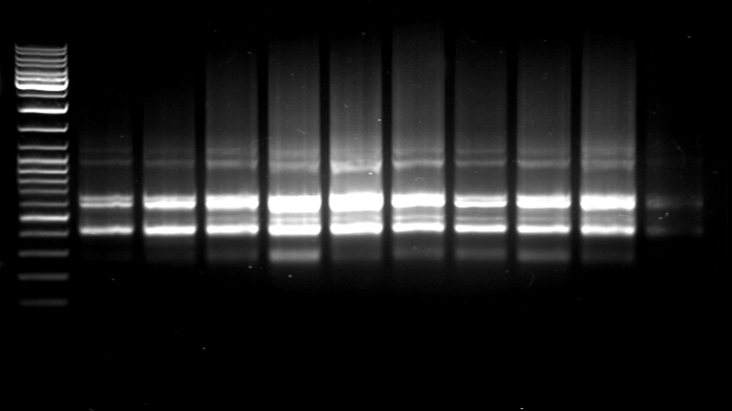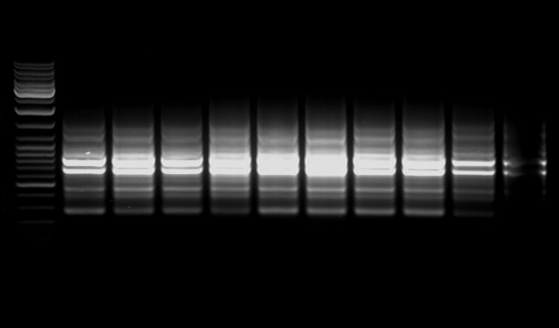
1159
996
665
53
500
417
283

1479
1215
1017
927
877
639
547
459
394
262
ISSR4 ISSR7
M 1 2 3 4 5 6 7 8 9 M 1 2 3 4 5 6 7 8 9
1230
1085
959
875
700
682
505
470
394
244
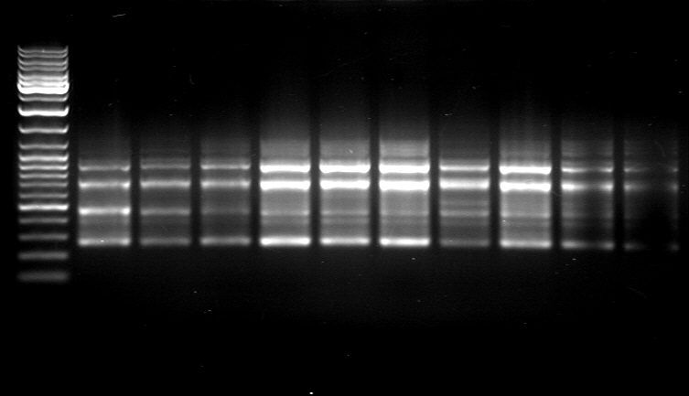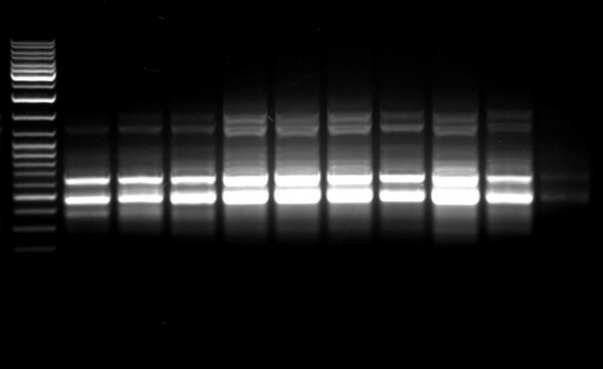
1534
1305
1212
1010
839
739
635
525
476
390
360
300bp

ISSR6 ISSR1

M 1 2 3 4 5 6 7 8 9 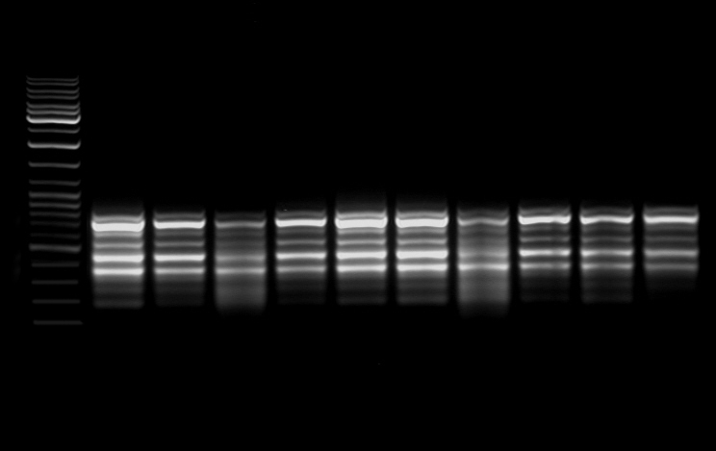
911
811
691
607
584
485
395
328
284
214bp
HB 15(11-20)

Fig.(1) ISSR-PCR of DNAs of Phoenix dactylifera var. karama using 5 primers.

References
- Adawy, S.S., Hussein, Ebtissam H.A., El-Khishin, Dina, Moharam, H. and El-Itriby, Hanayia A. (2002). Genetic variability studies and molecular fingerprinting of some Egyptian date palm (Phoenix dactylifera L.) cultivars: II. RAPD and ISSR profiling. Arab J. Biotech., 5(2): 225-236.
- Adawy, S.S., Hussein, Ebtissam H.A., Saker, M.M. and El-Itriby, Hanaiya A. (2004). Intra- and Inter-varietal variation of Upper Egypt date palm cultivars (Phoenixdactylifera L.): I. As revealed by RAPD and ISSR markers. Proceed. Int. Conf. Genet.Eng. & Appl., Sharm El-Sheikh, South Sinai, Egypt (April, 8-11, 2004): 165-179.
- Ben Saleh, M. and El-Helaly, R. (2003). Using ISSR to investigate the similarities and dissimilarities between some Tunisian date palm (Phoenix dactylifera L.) cultivars. (in Arabic and abstract in English). International Conference on Date Palm, Kingdom of Saudia Arabia, Ministry of Higher Education, King Saud University, Qaseem branch, College of Agriculture and Veterinary Medicine (16-19September 2003).
- Bhatia R.; Singh, K.P; Jhang, T. and Sharma T.R.( 2009) Assessment of clonal fidelity of micropropagated gerbera plants by ISSR markers. Scientia Horticulturae Volume 119 , Issue 2, , Pages 208-211
- Chandrika, M. and Ravishankar Rai, V.(2009) Genetic fidelity in micropropagated plantlets of Ochreinauclea missionis an endemic, threatened and medicinal tree using ISSR markers African Journal of Biotechnology Vol. 8 (13), pp. 2933-2938, 6 July, 2009
- Fang, D.Q. and Roose, M.L. (1997).Identification of closely related citrus cultivars with inter-simple sequence repeat markers. Theor. Appl. Genet., 95: 408-417.
- Gupta, R., Verma2,K. Joshi,D.C., Yadav, D., Singh, M. (2010):Assessment of Genetic Relatedness among Three Varieties of Finger Millet with Variable Seed Coat Color Using RAPD and ISSR Markers Genetic Engineering and Biotechnology Journal, Volume: GEBJ-2.
- González, A., Coulson, M. and Brettell, R.(2002). Development of DNA markers (ISSRs) in Mango. Acta Hort. (ISHS), 575:139-143.
- Hamama, L., Cornee, N., Leclerc, V., Marionnet, F., Javouhey, M. and Letouze, R. (2003) Date palm (Phoenix dactylifera) offshoot identification by PCR-ISSR markers, Acta. Hort., 616 : 453 - 457.
- Jonson, C., Cullis, T. A., Cullis, M. A. and Cullis,C. A. (2009):DNA markers for variety identification in date palm (Phoenix dactylifera L.) Journal of Horticultural Science & Biotechnology 84 (6) 591–594
- Piña-Escutia J. L.; Vázquez-García, L.M. and Arzate-Fernández A. M. (2010)In vitro regeneration and genetic fidelity of Tigridia pavonia (L.f.) DC. Electronic Journal of Biotechnology ,Vol. 13 No. 1.
- Venkatachalam, L.; Sreedhar, R. V. ; Bhagyalakshmi, N.(2007):Genetic analyses of micropropagated and regenerated plantlets of banana as assessed by RAPD and ISSR markers.In Vitro Cellular and Developmental Biology - Plant 43(3):267-274.
- Zehdi S. Sakka H., Rhouma A, Ould Mohamed Salem A. Marrakchi M and Trifi M.(2004): Analysis of Tunisian date palm germplasm using simple sequence repeat primers. African Journal of Biotechnology Vol. 3 (4), pp. 215-219

9/9/2020

