Genetic Assessment of Salinity Tolerance in Red Tilapia

Mariam G. Eshak¹, Naglaa M Ebeed², Hoda F. Booles¹ and Kh. Fahmy²*

¹Department of Cell Biology, National Research Center, Dokki, Cairo, Egypt.
²Department of Genetics, Faculty of Agric., Ain Shams University, Cairo, Egypt.
*khalid.fahmy@med.lu.se

Abstract: Red tilapia stock was introduced to Lake Maryut fishery to increase its fish production due to its high tolerance to salinity and its rapid growth rate under high salinity conditions. The main strategy of red tilapia production is to generate the hybrid between Oreochromis mossambicus male and Oreochromis. niloticus females in order to improve its growth rate and its tolerance to high salinity. In this study, the selective effect of high salinity conditions on the genetic stability and/or segregation of hybrid traits were assessed using biochemical and DNA molecular marker approaches. Samples obtained represented three generations of red tilapia from Lake Maryut during the 2008/2009 season. The obtained samples revealed strong reduction in growth rate descending from the first to the third generation with high variability in skin colors that varied between black and red. Protein electrophoresis profile as well isozyme polymorphism assays showed high similarity of protein and isozyme banding pattern either between individuals or between generations on different test organs. On the molecular level, Inter Simple Sequence Repeats (ISSR) assays represented slight difference between the three generations which reflected strong selection effect of salinity condition on segregated traits. The observed high similarity was due to the narrow genetic variation in the original parental stock. Obtained results indicated that selection pressure increased genetic homogeneity and kept only the high salt tolerant individuals of segregated red tilapia progenies.
[Mariam G. Eshak, Naglaa M Ebeed, Hoda F. Booles and Kh. Fahmy. Genetic Assessment of Salinity Tolerance in Red Tilapia New York Science Journal 2010;3(12):132-141]. (ISSN: 1554-0200). http://www.sciencepub.net/newyork.

Keywords: Red tilapia, hybrid, salinity, polymorphism, isozyme, electrophoresis, ISSR.

1. Introduction
Fish farming has developed due to the fact that the supply of traditional fish is declining because of over fishing and pollution. Furthermore, the demand for high-quality seafood is increasing due to population growth and health-related considerations. Tilapias are among the world’s most important aquacultural finfishes (Naylor et al., 2001). A multitude of studies have addressed means to grow bigger tilapia faster, experimenting with water temperature, salinity, hybridization, and administration of growth-promoting hormones.
Notably, tilapine species differ in salt tolerance and growth response in different salinities (Suresh and Lin, 1992). Moreover, there are species and strain-specific variations with respect to the possible effect of salinity on growth performance (Suresh and Lin 1992; Garcia-Ulloa et al., 2001). In addition, the growing popularity of tilapia among consumers and the ever increasing need to improve food production, impose the need to seek production alternatives to cultured tilapia. Such as the use of saline environments and even marine waters.
Tilapia popularity is due to its market acceptability and for its relatively tolerance to a wide range of water temperatures, dissolved oxygen (DO), salinity, pH, light intensity and photoperiods. Tilapia hybrids that have descended from an O. mossambicus parent are believed to be highly tolerant to saline waters (Romana-Eguia and Eguia, 1999). Therefore, red tilapia stock was introduced to Lake Maryut fishery to increase its fish production due to its high tolerance to salinity and rapid growth rate under high salinity conditions. The main strategy of red tilapia production is to generate a hybrid between Oreochromis mossambicus male and Oreochromis niloticus females in order to improve its growth rate and its low temperature resistance as well as high salinity tolerance. In interspecific tilapia hybrids, the genes of the two species are associated and combined as they would in ordinary pure species offspring's. Also, unlike most animals, interspecific tilapia hybrids are fertile. These features allow selection from a hybrid population, to produce synthetic strains with association of characters one would not find in pure species. Salinity tolerance seems to be inherited from O. mossambicus (Rosario et al., 2004).
Red color of red tilapia is one of the most favorite trait in addition to its tolerance to salinity many studies were interested to invistigate the genetic system of body color inheretance in red tilapia, where it was reported to be single in complete dominance inheretance (Huang et al., 1988 and Hulata et al., 1995). However, in a review by Tave (1987) he stated that there are three different genetic mechanisms responsible for the body coloration system in tilapia. A single gene with incomplete dominance for pink, red and black colors, two genes with epistatic interaction and two independent genes, one for producing melanin and the other for producing red pigmentation. No studies were done on the population genetics of body color in wild populations of tilapias, many of which exhibit wide ranges of melanism and also have color variants. However, tilapia culturist in Taiwan had reduced the incidence of melanistic patches in red tilapia by selective breeding, which suggests that these patches were controlled by a modifier gene (s).
Studies of genetic stability, variation and equilibrium in cultivated living stocks under stress or variable environmental conditions are very important for improving animal production. Biochemical as well as molecular genetic markers has been employed to monitor genetic relationships and genetic diversity especially when the phenotypic variation is restricted (Guimarães et al., 2007).
Protein electrophoresis was used to evaluate polymorphism among some tilapia species and their hybrids (Galman et al., 1983) as well as in catfish to determine locality variations (Rashed et al., 2000). Electrophoresis of tissue-specific enzymes can be used to determine the purity of fish genomes and to compare between different populations of tilapia species. McAndrew and Majumdar (1983) reported that the variations among 27 isozyme loci were sufficient to differentiate the species but not all of the surveyed populations. However, Brummett et al. (1988) used biochemical markers especially isozymes to establish a key for identification of American populations of tilapia and their hybrids. Three regions of muscle esterase were detected in O. niloticus, O. aureus and different phenotypes of red tilapia. The similarities between O. aureus and the different phenotypes of red tilapia was less than that between O. nilotica and different phenotypes of red tilapia (EL-Deep and Essa 1991). However, Rashed et al., (1998) used isozyme organs distribution and RAPD-PCR DNA markers for detecting Oreochromis niloticus lines in Egypt. They concluded that the used systems for characterization of these lines were effective.
Zietkiewicz et al (1994) and Kantley et al (1995) described a marker system referred to as Inter Simple Sequence Repeats (ISSR) which makes use of anchored primers to amplify simple sequence repeats without the requirement for prior sequence information. This method uses single primers of 15–20 nucleotides with a 3′ or 5′ anchor sequence. The technique is more reliable than the RAPD technique and generates larger numbers of polymorphism per primer (Qian et al. 2001). Each band corresponds to a DNA sequence delimited by two inverted microsatellites. Like RAPDs, ISSRs markers are quick and easy to handle, but they seem to have the reproducibility of SSR markers because of the longer length of their primers (Bornet and Branchard 2001).
Inter Simple Sequence Repeats has been widely employed to detect intraspecific polymorphisms in plants such as in citrus (Poncirus trifoliata (L.), Fang et al. 1997) and peanut (Arachis hypogaea L., Raina et al. 2001). This technique has also been applied to study interspecific polymorphisms such as in rice (genus Oryza, Joshi et al. 2000), tomato (genus Lycopersicon, Kochieva et al. 2002), chickpea (genus Cicer, Iruela et al. 2002) and Grevillea (Proteaceae, Pharmawati et al. 2004).
This study aimed to investigate and to assess the selective effect of salinity condition on the genetic stability and/or segregation of red tilapia hybrid traits using biochemical and DNA molecular marker approaches.

2. Material and Methods
1. Fish samples
Red tilapia, (Oreochromis mossambicus X Oreochromis niloticus) brood stock that was used in this study descended from Lake Maryut fishery, Alexandria, Egypt during the season of 2008/2009.

2. Biochemical genetic techniques
2.1. SDS-PAGE electrophoresis:
Sodium Dodycyl Sulphate Polyacrylamide Gel Electrophoresis (SDS-PAGE) was performed on skeletal muscles according to the method of Laemmli (1970) which was modified by Studier (1973).

2.2. Allozyme analysis:
Muscles samples (approximately 100 mg) were homogenized in 250 mg ml−1 extraction buffer (0.17 M Sucrose, 0.2 M EDTA, 0.2 M Tris–HCl, pH 7.0). Homogenized samples were centrifuged for an hour at 10,000 rpm at 4 °C and the supernatant was recentrifuged for 20 min. Allelic variation was investigated using 10% polyacrylamide gel electrophoresis. Electrophoresis was carried out at constant voltage 150 V at 4 °C. A total of five enzyme systems were examined. Chemical staining procedure, described by Whitmore (1990) was, used to visualize different alleles. Loci were designated following the nomenclature system of Shaklee et al. (1990). Esterase (Est; EC 3.1.1.1), alcohol dehydrogenase (ADH; EC .1.1.1), malate dehydrogenase (MDH; EC 1.1.1.37), superoxide dismutase (SOD; EC 1.15.1.1) and 6-phosphogluconate dehydrogenase (6PGDH; EC 1.1.1.44), isozymes were analyzed in white skeletal muscle of H-H1, L-H1, and 1st and 2nd segregated generation of red tilapia
2.3. Molecular genetic studies:
2.3.1. DNA extraction (Isolation of genomic DNA):
Total genomic DNA was isolated from fish muscle tissues samples (ca. 100 mg) by sheared first into very fine pieces and digested at 37 °C overnight in TNES-Urea solution (10 mM Tris–HCl, 125 mM NaCl, 10 mM EDTA 2Na, 1% SDS and 8 M Urea) with 10 mg/ml proteinase K as described by Asahida et al. (1996). DNA was extracted from each sample following the standard SDS-phenol chloroform procedure, after which DNA was precipitated in cold ethanol, resuspended in TE buffer, and stored at 4°C until PCR amplification. The concentration of genomic DNA samples was determined by UV spectrometer and necessary dilutions were done, followed by verification with 0.8% agarose gel electrophoresis.

2.3.2. ISSR-PCR and electrophoresis:
Inter Simple Sequence Repeat (ISSR) analysis was performed using six different primers listed in Table (1). The primers contained different di- and tri-nucleotide repeat motifs in order to achieve genome coverage as wide as possible. For each primer, the annealing temperature was chosen after different trials with different temperatures (tested range from 48 °C to 52 °C), in order to maximize the information obtained from the patterns, i.e. maximum amplification, minimum smear on gels (from non-specific amplification), and well-resolved bands.
The PCR solution (25 μl total volumes) contained 0.5 units of Taq DNA Polymerase (Pharmacia®), 1× reaction buffer, 2.5 mM MgCl2, 0.2 μM primer, 200 μM of each dNTP, and up to 30 ng of genomic DNA. PCR amplifications were performed with the following conditions: 94ºC for 2 minutes; 35 cycles of: 94ºC for 30 secs, 44ºC for 45 secs, 72ºC for 1 min 30 secs; 72ºC for 20 min; and 4ºC soak forever. In order to exclude PCR artifacts and verify repeatability of results, negative controls and replicates were included in each PCR amplification. For ISSR marker profiling, PCR products were subjected to electrophoresis on 1.5% agarose gels, followed by staining with ethidium bromide. The electrophoretic patterns of the PCR products were recorded digitally using a Gel-Doc 2000 image analysis system (Bio-Rad) according to the instruction of manufactory.

3. Statistics and data analysis
Data of polymorphic and monomorphic bands for all analysis (Protein, Isozymes and ISSR) on the basis of the band mobility, clear bands were scored using Gel-Doc (Bio-Rad) Gel analysis program as (1) for presence and (0) for absence in a binary data form, the unclear unidentified bands were excluded. Amplicon sizes were estimated using 1kb DNA ladder standard (Fermentas, Germany).
RAPDistance (Armstrong et al., 1995) software was used for calculating the Neighbor joining based phylogenetic trees which was used to evaluate the genetic similarity/distance between tested generations.

3. Results and Discussion
1. Evaluation of genetic variation in red tilapia generations at Lake Maryut
a - Morphological variations:
Fish samples were collected from Lake Maryut during the season of 2008/2009. Four different samples represented the red tilapia hybrid generations. Parental high weight (H-H1) hybrid, which has pinky skin color with a range of weight 150 -200 gm/fish. Parental low weight (L-H1) hybrid, which has pinky skin color, its weight ranged from 60 to 100 gm/fish. First segregated generation which has strong variable skin color varied from pinky skin with small black patches to complete black skin, while weight range was from 25 – 150 gm/fish. Second segregated generation with large patches of black color and light silver pinky spots, the range of fish weight was 20 – 50 gm/fish. All fish samples were sexually mature. However, many individuals carried bronze-color patches in both segregated generations as shown in Figure (1).
The high variability of skin color and weight of the segregated generations of the hybrid red tilapia stock which was cultivated in Lake Maryut indicated that it is not a selected line with stable genetic background. Many commercial red tilapia lines were selected to be homogeneous and stable to regenerate in aquaculture farms with high salinity condition (Watanabe et al., 1989 and Armas-Rosales, 2006). The appearance of black and bronze colors, with wide range of variability, in the segregated generations indicated that body color of red tilapia, in Maryote Lake, is controlled at least by two epistatic interaction genes in addition to the presence of modifier genes where the segregation of this trait, under selection pressure, showed wide ranges of body colors. Anyhow, body coloration in red tilapia needs more investigations to determine its genetic mechanism. The decrease in body weight in the segregated generations, could be due to the loss of genetic composition of the original red tilapia hybrid which is responsible for salinity tolerance and fast growth rate. Also this could be due to the rapid increase of population number, in lake Maryut, which affect their sexual maturity. This is known to be an effective factor to decrease body weight of tilapia in high density populations (Suresh and Lin, 1992 and Hulata et al., 1995).

b-Protein analysis:
The electrophoretic protein pattern of the (H-H1), (L-H1), first segregated generation and second segregated generation of red tilapia hybrid are shown in Figure (2). According to the relative front (mobility) of bands, a total of 29 bands were detected. The molecular weights and its band frequencies are also presented in Table (3). The mean band frequency was 0.48. The banding patterns of the total protein fractions revealed wide variation of different bands (10 monomorphic and 19 polymorphic bands, Tables 2 and 4). The protein system results accounted for 65.5% of polymorphism. The obtained polymorphism from protein electrophoretic pattern was not enough alone, to give a good characterization for the genetic variability among the four tested generations of red tilapia in Maryote Lake. This result is in agreement with the results of Galman et al. (1983) on red tilapia and Rashed et al. (1998) on Oreochromis niloticus. They concluded that protein electrophoresis was not enough alone, to give complete characterization for the tested fish.

c. Isozyme analysis:
The patterns of differential expressions of the six studied isozymes, i.e., α-esterase, β-esterase, alcohol dehydrogenase, malate dehydrogenase, superoxide dismutase and 6phosphogluconate Dehydrogenase, exhibited wide variations of different bands (11 monomorphic and 14 polymorphic bands) as presented in Fig. (3) and Tables (2 and 4). The mean band frequencies ranged from 0.42 to 0.85. Electrophoretic analyses revealed 4, 6, 3 and 1 polymorphic loci for Est, Adh, Pgd and SOD isozymes respectively as shown in Table (4). From the results of esterase isozyme patterns, under salinity, two distinct zones were observed in red tilapia sample. Zone A had three bands with high polymorphism in all samples, while zone B had two distinct common monomorphic bands. From the results of Mdh and Sod isozymes the most striking observation were that there is very limited variation due to salinity. phosphogluconate dehydrogenase gave the highest percentage of polymorphism (75% polymorphism), while malate dehydrogenase gave the least polymorphism among the used systems. The combination of isozyme systems recorded 50 % polymorphism, which was not enough to differentiate among the 4 studied populations. This result is in agreement with the results of McAndrew and Majumdar (1983) and Brummett et al. (1988).

d. ISSR analysis:
Six anchor primers (814, HB8, HB9, HB10, HB11 and HB15) were used in the present study to analyze the genetic variation among the tested populations
(Fig.4). One monomorphic and eighty two polymorphic distinct fragments (98.8% polymorphism) were detected (Table 3 and 4). The results of ISSR analysis showed that all primers produced 100% polymorphic bands, except primer HB15, which showed the only monomorphic band (93.3% polymorphism). The obtained result of ISSR gave remarkable distinct characterization for each tested generation and also was able to reveal the genetic variation within each generation’s individuals. The high sensitivity of ISSR assay and its efficiency to illustrate the genetic variation between and within species, varieties and individuals was reported for many plant crops (Fang et al., 1997; Joshi et al., 2000; Raina et al. 2001; Qian et al., 2001; Kochieva et al., 2002; Iruela et al., 2002; Pharmawati et al., 2004).

2. Genetic similarity analysis
Pooling the whole data of protein, isozymes and ISSR assays revealed the distinct variation between the four tested generations. Where, the present or absence of bands in banding pattern of each assay for each sample were recorded for analyzing the genetic distance between the tested generations of red tilapia using a RAPdistance program. The obtained phylogeny tree grouped the 4 generations (populations) into two main groups (Fig. 5). The first group contained the parental high and low red tilapia hybrids and the other group contained the two segregated generations. The highest dissimilarity was observed for H-H1 while the highest similarity was found for the 1st segregated generation. The genetic distance within each group was varied from .004 to 0.129 (Fig. 5). It is evident that proteins, isozymes and ISSR analysis, which revealed high degree of polymorphism, are good tools in determining genetic diversity among segregated generations under study. They are generally much simpler to apply and more sensitive than traditional morphological and biochemical analysis because they are more polymorphic (Williams et al., 1990).

Table (1): ISSR primer codes and sequences used for ISSR-PCR and their annealing temperature
Primer set | Primer code | Primer sequence  (5 3) | Annealing T °C
1 | 814 | 5'(CT)8 TG 3' | 44
2 | HB8 | 5' (GA) 6 GG 3' | 48
3 | HB9 | 5' (GT) 6 GG 3' | 48
4 | HB10 | 5' (GA) 6 CC 3' | 48
5 | HB11 | 5' (GT) 6 CC 3' | 48
6 | HB15 | 5' (GTG)3GC 3' | 52

Table (2): Number of obtained bands using biochemical marker analysis i.e., protein, isozymes in the four tested population of red tilapia, H-H1, L-H1, 1st and 2nd segregated generation.

Marker type | Analysis type | Marker name | Total band number | Mobility Range |  | Number of bands
 |  |  |  |  |  | H-H1 |  |  |  | L-H1 |  |  |  | 1st segregated generation |  |  |  | 2nd segregated generation
 |  |  |  |  |  | 1 | 2 | 3 | 4 | 5 | 6 | 7 | 8 | 9 | 10 | 11 | 12 | 13 | 14 | 15 | 16
1 | Protein | Total  protein | 29 | MW | 144 .- 6 | 18 | 18 | 19 | 17 | 17 | 18 | 15 | 13 | 16 | 17 | 16 | 15 | 15 | 14 | 14 | 18
2 | isozymes | α- Est | 6 | RF | 0.88 - 0.43 | 5 | 5 | 5 | 5 | 4 | 5 | 5 | 6 | 5 | 4 | 6 | 5 | 6 | 6 | 5 | 5
3 | isozymes | β- Est | 5 | RF | 0.98-0.32 | 4 | 5 | 5 | 3 | 3 | 5 | 5 | 5 | 5 | 5 | 5 | 5 | 4 | 5 | 3 | 5
4 | isozymes | Adh | 3 | RF | 0.89 - 0.33 | 4 | 4 | 4 | 3 | 3 | 3 | 3 | 3 | 6 | 3 | 3 | 3 | 3 | 3 | 3 | 3
5 | isozymes | Gpd | 4 | RF | 0.89 - 0.29 | 2 | 2 | 2 | 4 | 4 | 4 | 4 | 4 | 3 | 3 | 3 | 3 | 3 | 3 | 3 | 3
6 | isozymes | Mdh | 5 | RF | 0.89 - 0.33 | 4 | 4 | 4 | 4 | 4 | 4 | 4 | 4 | 4 | 4 | 4 | 4 | 4 | 4 | 3 | 4
7 | isozymes | SOD | 2 | RF | 0.91- .0.51 | 2 | 2 | 2 | 3 | 2 | 2 | 2 | 2 | 2 | 2 | 2 | 2 | 2 | 2 | 2 | 2
MW= Molecular Weight RF = Relative Fronts

Table (3): Number of obtained bands using ISSR analysis in the four tested populations of red tilapia, H-H1, L-H1, 1st and 2nd segregated generations.

Marker type | Analysis type | Marker name | Total band number | Mobility Range bp | Number of bands
 |  |  |  |  | H-H1 |  |  | L-H1 |  |  | 1st segregated generation |  |  | 2nd segregated generation
 |  |  |  |  | 1 | 2 | 3 | 4 | 5 | 6 | 7 | 8 | 9 | 10 | 11 | 12
1 | ISSR | HB 814 | 16 | 1.060 - 245 | 3 | 3 | 3 | 2 | 2 | 2 | 10 | 10 | 10 | 3 | 3 | 9
2 | ISSR | HB 8 | 12 | 670 - 284 | 3 | 3 | 4 | 4 | 7 | 6 | 5 | 5 | 8 | 6 | 6 | 6
3 | ISSR | HB 9 | 10 | 551- 185 | 3 | 3 | 4 | 3 | 3 | 2 | 2 | 2 | 4 | 4 | 2 | 6
4 | ISSR | HB 10 | 23 | 902 - 729 | 9 | 8 | 6 | 12 | 5 | 4 | 5 | 8 | 3 | 8 | 11 | 8
5 | ISSR | HB 11 | 6 | 1.036 - 467 | 3 | 3 | 3 | 4 | 4 | 4 | 3 | 3 | 3 | 3 | 3 | 3
6 | ISSR | HB 15 | 15 | 712 - 209 | 8 | 8 | 8 | 4 | 6 | 2 | 4 | 5 | 3 | 4 | 4 | 3
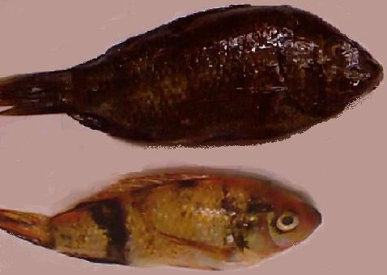
Fig. 1. a. skin color Fig. 1. b. growth rate

Fig. 1. Morphological variations in red tilapia hybrid

H-H1

L-H1

1st seg. generation

2nd seg.
generation

M

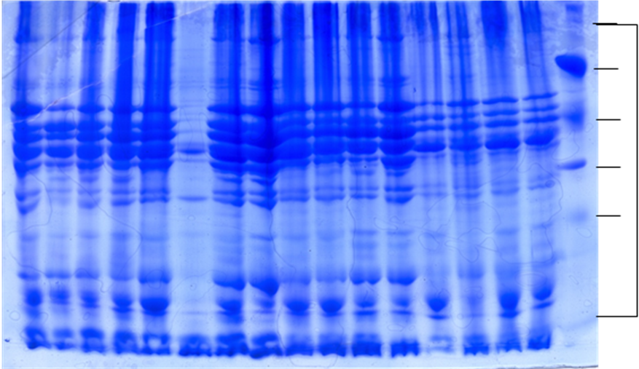

Fig. 2. SDS-PAGE profile of soluble muscle proteins for -H1, L-H1, 1st and 2nd segregated generations of red tilapia from lake Maryout

205

97

66

29

18

H-H1

L-H1

1st seg. generation

2nd seg.
generation

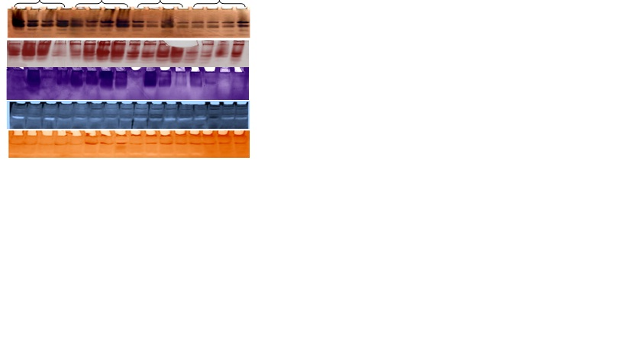 Fig. 3: Zymogram of five enzymes , α-EST activity (A), β-EST (B) , Adh activity (C), Mdh, SOD activity (D) and 6PGD activity (E) for H-H1, L-H1, and 1st , 2nd segregated generations of red tilapia
(A)

(B)

(C)

(D)

(E)

(E)

M

H-H1

L-H1

1st seg. generation

2nd seg.
generation

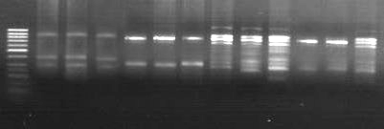
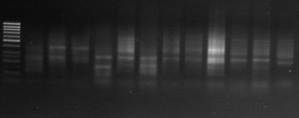
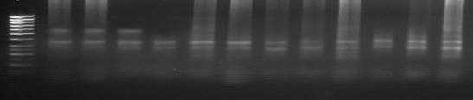
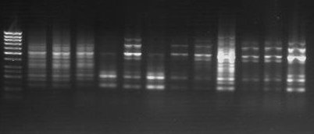
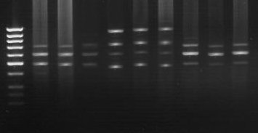
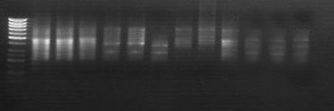

Fig. 4: ISSR –PCR fragments of six primers for 814 (A), HB8 (B) , HB9 (C), HB10 (D), HB 11 (E) and HB 15 (F) for H-H1, L-H1, and 1st, 2nd segregated generations of red tilapia.

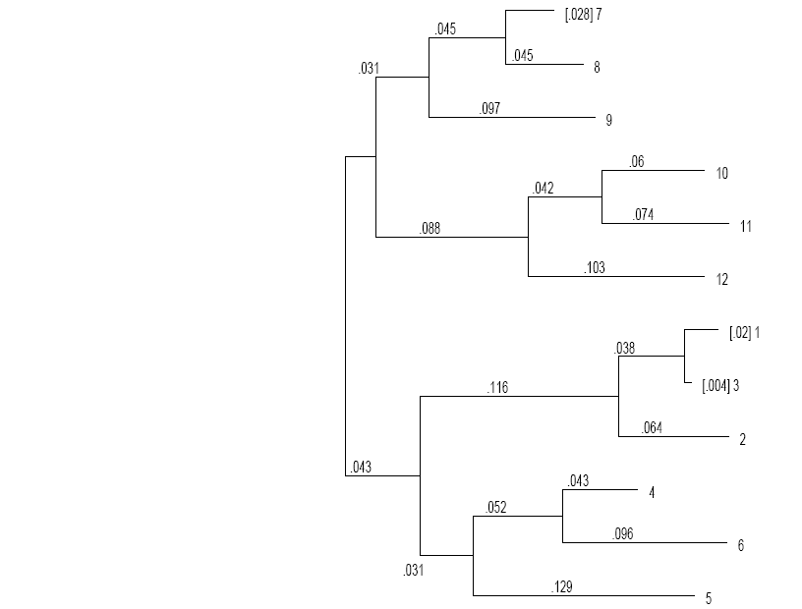

Fig. 5: Diagram represents the relative genetic distance between and within the four tested generations of red tilapia based on RAPDistance software analysis.

Table (4): Detected polymorphism for each used marker system, protein, isozymes and ISSR in the four tested populations of red tilapia, H-H1, L-H1, 1st and 2nd segregated generations.
Marker Number | Marker system |  | Polymorphism detected at each marker system
Marker Number | System | Marker | Monomorphic | unique | Polymorphic | Total |  | % polymorphism | Mean of band frequency
1 | Protein | Total protein | 10 | 0 | 19 | 29 |  | 65. 6 | 0.48
2 | Isozymes | α- esterase | 2 | 0 | 4 | 6 |  | 67 | 0.85
3 | Isozymes | Adh | 2 | 0 | 6 | 8 |  | 75 | 0.42
4 | Isozymes | Pgd | 1 | 0 | 3 | 4 |  | 75 | 0.78
5 | Isozymes | Mdh | 4 | 1 | 0 | 5 |  | 0 | 0.80
6 | Isozymes | Superoxide dismutase | 2 | 0 | 1 | 3 |  | 33 | 0.69
 | Isozymes | Total | 11 | 1 | 14 | 26 |  | 45 | 0.71
7 | ISSR | 814 | 0 | 0 | 16 | 16 |  | 100 | 0.33
8 | ISSR | HB 8 | 0 | 1 | 11 | 12 |  | 92 | 0.43
9 | ISSR | HB 9 | 0 | 5 | 5 | 10 |  | 50 | 0.24
10 | ISSR | HB 10 | 0 | 2 | 21 | 23 |  | 91 | 0.31
11 | ISSR | HB 11 | 0 | 1 | 5 | 6 |  | 83 | 0.58
12 | ISSR | HB 15 | 1 | 1 | 13 | 15 |  | 87 | 0.31
 | ISSR | Total | 1 | 10 | 71 | 82 |  | 83 | 0.37
Total bands numbers detected for all markers |  |  | 22 | 10 | 104 |  | 137 | 64.5 | 0.52

4. Conclusion:
Phenotypic variations between the three generations were noticeable for skin color. While genetic variations on the biochemical i.e. protein and isozymes and molecular levels were (65.6%, 57.7% and 98.8%, respectively) with an average polymorphism of 83.9% as shown in Table (4). The similarity index tends to be very high within and generations while the four populations showed remarkable dissimilarity. These results could be interpreted on two bases, (1) selection effect of salinity which eliminates all salinity sensitive genotypes, and (2) low recombination between O. mossambicus and O. niloticus or high linkage on the chromosome level.
- Salinity conditions exerted effective selection pressure on studied traits.
- Remarkable elimination of growth hormone gene(s) of O. niloticus from the segregating progeny, along with high inbreeding level and a very low recombination rate between chromosomes.
- Selection pressure increased genetic homogeneity and kept only the high salt tolerant individuals of segregating red tilapia progenies.
- It is recommended that the red tilapia hybrid has to be used only for production, and not for breeding.

Corresponding author
Kh. Fahmy
Department of Genetics, Faculty of Agric., Ain Shams University, Cairo, Egypt.
khalid.fahmy@med.lu.se

5. References
- Armas-Rosales, A. M. (2006). Genetic effects influencing salinity and cold tolerance in tilapia. M. Sc. Thesis, Agricultural and Mechanical College, Louisiana State University, USA, pp. 130.
- Armstrong, J.; Gibbs, A.; Peakall, R. and Weiller, G. (1995): The RAPDistance package: http//www.life.anu.edu.au/molecular/software//rapd.html.
- Asahida, T.; Kobayashi, T.; Saitoh, K. and Nakayama, I. (1996) Tissue preservation and total DNA extraction from fish stored at ambient temperature using buffers containing high concentration of urea. Fish. Sci., 62: 727–730.
- Bornet, B. and Branchard, M. (2001). Nonanchored Inter Simple Sequence Repeat (ISSR) Markers: Reproducible and Specific Tools for Genome Fingerprinting, Plant Molecular Biology Reporter 19: 209–215.
- Brummett, R.; Halstrom, M; Dunham, L. and Smitherman, R. (1988). Development of biochemical dichotomous keys for identification of american population of O.aureus, O.mossambicus, O.niloticus, O.urolopis hornorum and red tilapia. In Pullin, R.; Bhukaswan,T.; Tonguthai,K. and Maclean,J. (Editors). The second International symposium on Tilapia in Aquaculture. ICLARM conferece proceedings 15. Dep. of Fisheries. Bangkok. Thayland and ICLARM Maila. Philippines,pp:135-141.
- EL-Deep, I. and Essa, M. (1991). Genetic approach of Red tilapia. Egypt.J.Genet. Cytol., (20):75-80.
- Fang, D. Q.; Roose M. L.; Krueger R.R. and Federici C.T. (1997) Fingerprinting trifoliate orange germ plasm accessions with isozymes, RFLPs, and inter-simple sequences repeat markers. Theoretical and Applied Genetics, 95: 211–219.
- Galman, O.; Moreus, J. and Avtalion, R. (1983). Appriliminary investigation of the characteristics of red Tilapias from the philippines and Taiwan. In Proc. Int. Symp. On Tilapia in aquaculture, Fishelson, L. and Yaron, Z.(Comilers), pp: 291-301.
- Garcia-Ulloa, M.; Villa, R. and Martinez, T. (2001). “Growth and feed utilization of the tilapia hybrid Oreochromis mossambicus x Oreochromis niloticus cultured at different salinities under controlled laboratory conditions”. Journal of the World Aquaculture Society, 32: 117-121.
- Guimarães, P.; Ruane, J.; Scherf, B.; Sonnino, A. and Dargie, J. (2007) Marker-assisted selection:Current status and future perspectives in crops, livestock, forestry and fish, Food And Agriculture Organization Of The United Nations, Rome,pp: 123-168.
- Huang, C. M., Chang, S. L., Cheng, H. J. and Liao, I. C. (1988) Single gene inheritance of red body coloration in Taiwanese red tilapia, Aquaculture, 74 (3-4): 227-232.
- Hulata, G.; Karplus, I. and Harpaz, S. (1995) Evaluation of some red tilapia strains for aquaculture: growth and color segregation in hybrid progeny, Aquaculture Research, 26 (10): 765–771.
- Iruela, M.; Rubio, J.; Cubero, J.; Gil, J. and Millan, T. (2002) Phylogenetic analysis in the genus Cicer and cultivated chickpea using RAPD and ISSR markers. Theoretical and Applied Genetics, 104: 643–651.
- Joshi, S. P.; Gupta, V. S.; Aggarwal, R. K.; Ranjekar, P.K. and Brar, D. S. (2000) Genetic diversity and phylogenetic relationships as revealed by inter simple sequence repeat (ISSR) polymorphism in the genus Oryza. Theoretical and Applied Gen etics,100: 1311–1320.
- Kantley, R.V.; Zeng, X.; Bennetzen, J. L. and Zehr, B. E. (1995). Assessment of genetic diversity in dent and popcorn (Zea mays) inbred lines using inter-simple sequence repeat (ISSR) amplification. Molecular Breeding, 1: 365-373.
- Kochieva, E. Z.; Ryzhova, N.N.; Khrapalova, I. A, and Pukhalskyi, V. A. (2002) Genetic diversity and phylogenetic relationships in the genus Lycopersicon (Tourn.) Mill. As revealed by inter-simple sequence repeat (ISSR) analysis. Russian Journal of Genetics, 38: 958–966.
- Laemmli, U. K. (1970). Cleavage of structural proteins during the assembly of the head of bacteriophage T4. Nature, (227): 680-685.
- McAndrew, B. J. and Majumdar, K. C. (1983). Tilapia stock identification using electrophoretic markers. Aquaculture, (218): 249-261.
- Naylor, R. L.; Goldburg, R. J.; Primavera, J. H.; Kautsky, N.; Beveridge, M. C.\; Clay, J.; Folke, C.; Lubchenco, J.; Mooney, H. and Troell, M. (2001) Effects of aquaculture on world fish supplies. Nature, 405: 1017–1024.
- Pharmawati, M.; Yan, G. and. McFarlane, I. (2004) Application of RAPD and SSR markers to analyse molecular relationships in Grevillea (Proteaceae). Australian Systematic Botany, 17: 49–61.
- Qian, W. S. and Hong, D. Y. (2001). Genetic variation within and among populations of a wild rice Oryza granulata from China detected by RAPD and ISSR markers. Theoretical and Applied Genetics, 102: 440-449.
- Raina, S. N.; Rani, V.; Kojima, T.; Ogihara, Y.; Singh, K. P. and Devarumath, R. M. (2001) RAPD and ISSR fingerprints as useful genetic markers for analysis of genetic diversity, varietal identification, and phylogenetic relationships in peanut (Arachis hypogaea) cultivars and wild species. Genome, 44: 763–772.
- Rashed, M. A.; EL-Gamal, A. A.; Tantawi, T. M. and Saad, Y. M. (1998). Detection of Oreochromis niloticus lines by isozyme organs distribution and RAPD-PCR DNA markers. 3rd Arab conference Modern Biotech. And Area of Application in the Arab World, 14-17 Dec., Cairo, Egypt, pp: 127-146.
- Rashed, M. A.; Tantawi, T. M.; Atta, A. H.; Salah, S. H. and El-Gamal, A. A. (2000). Plasma and muscle protein electrophoretic locality variations in catfish of different locations (Calarias gariepinus L.). Egyptian Journal of Genetics and Cytology, (29): 127-141.
- Romana-Eguia, M. R. and Eguia, R. V. (1999). Growth of five Asian red tilapia strains in saline environments. Aquaculture, 173: 161-170.
- Rosario, W.; Georget, C.; Chevassus-Au-Louis, B.; Morissens, P.; Muyalde, N. ; Dela Cruz, A.; De Vera, E. and Poivey, J. (2004). Selection from an interspecific hybrid population of two strains of fast growing and salinity tolerant Tilapia, Proc. 6th International Symposium on Tilapia in Aquaculture Philippine International Convention Center Roxas Boulevard, Manila, Philippines September 12-16, p. 73.
- Shaklee, J. B.; Allendorf, F. W.; Morizon, D. C. and Whitt, G. S. (1990). Gene nomenclature for protein -coding loci in fish. Trans. Am. Fish. Soc., 119: 2–15.
- Studier, F.W. (1973). Analysis of bacteriophage T1 ealry RNAs and proteins of slab gels. J. Mol. Biol., 79:237-248.
- Suresh, A. V. and Lin, C. K. (1992) Tilapia culture in saline waters: a review. Prog Fish Cult 448: 161–167.
- Tave, D. (1987). Genetics and breeding of tilapia: A review, Proc. of The Second International Symposium on Tilapia in Aquaculture, Bangkok, Thailand, pp: 285 – 294.
- Watanabe, W. O.; Ernst, D. H.; Olla, B. L. and Wicklund, R. I. (1989) Aquaculture of red Tilapia (Oreochromis sp.) in marine environments state of the art. Advances In Tropical Aquaculture. Tahiti, Feb. 20 - March 4. AQUACOP IFREMER Actes de Colloque 9, pp: 487-498.
- Whitmore, D.H. (1990). Electrophoretic and Isoelectric Focusing Techniques in Fisheries Management. CRC Press, Inc., Florida, pp: 23–80.
- Williams, J. G.; Kubelik, A. R.; Livak, K. J.; Rafalski, J. A. and Tingey, S. V. (1990). DNA polymorphisms amplified by arbitrary primers are useful as genetic markers. Nucl. Acid Res., 18: 6531-6535.
- Zietkiewicz, E.; Rafalski, A. and Labuda, D. (1994). Genome fingerprinting by simple sequence repeat (SSR)-anchored polymerase chain reaction amplification. Genome, 20: 176-183.

11/1/2010

