Characterisation and Identification of Feather - Degrading Streptomyces sp From Chick Feather Wastes

T. Jayalakshmi 1, P. Krishnamoorthy 1, G. Ramesh kumar 2, P. Sivamani 3

1 Dept of Bioinformatics, Bharath University, Chennai, Tamilnadu - 600073, India.
2 Dept of Bioinformatics, MIT Campus, Anna University, Chennai, Tamilnadu-600044, India.
3 Microlabs, Vellore, Tamilnadu-632521, India.
jayamaniraaja07@gmail.com

Abstract: Keratinases are exciting proteolytic enzymes that display the capability to degrade the insoluble protein keratin. Keratinases display a great diversity in their biochemical and biophysical properties. Members of the genus Streptomyces are Gram positive and form extensive, branched, stable substrate and aerial hypae bearing long chains of conidia. The cell wall is a peptidoglycan that contains L-DAP (diaminopimelic acid) but no characteristic sugar. From 1940 through 1957, over 1000 Streptomyces spp. was described. Identification to the species level was based on a limited number of subjectively chosen features, with a significant emphasis on morphology and pigmentation. To characterize a species of a member of the genus Streptomyces, growth of the organism is mainly based on a variety of different media, including complex plant and animal products such as potato, milk, and gelatin, and artificial media comprising both organic and inorganic or synthetic media. Keratinolytic actinomycetes can be degraded without any chemical or physical treatment. Optimum temperature at 60◦C and pH above 10 completely degrade the feathers. A feather degrading actinomycete Streptomyces spp. was identified by microscopic wet mount method and their characteristics were analysed.
[T. Jayalakshmi, P. Krishnamoorthy, G. Ramesh kumar, P. Sivamani. Characterisation and Identification of Feather - Degrading Streptomyces sp From Chick Feather Wastes. New York Science Journal 2011;4(1):34-37]. (ISSN: 1554-0200). http://www.sciencepub.net/newyork.

Keywords: Keratinase, Streptomyces, degradation, peptidoglycan

- Introduction:
To characterize a species of an actinomycetes, especially a member of the genus Streptomyces, certain morphological and cultural properties should be considered. These are based upon the growth of the organism on a variety of different media, including complex plant and animal products such as potato, milk and gelatin and artificial media comprising both organic and inorganic or synthetic media (Waksman, 1919). Burkholder et al., in 1954 illustrated the morphology of several species of Streptomyces and kuster, 1955 classified the conidia of Streptomyces into smooth surface and rough surface where krassilnikov, 1941 attached great importance of morphology of Streptomyces as a diagnostic feature. In 1986, Goodfellow et al., studied 475 strains, which included 394 Streptomyces type cultures by using 139 unit characters. Keratin by virtue of its insolubility and resistance to proteolytic enzymes is not attacked by most living organisms. Nevertheless, keratin does not accumulate in nature and therefore biological agencies may be presumed to accompalish its removal. Several insects, including clothes.
Moth larvae, carpet beetles and chewing lice are known to digest keratin (Waterhouse, 1957). In
addition, the literature contains numerous reports that the ability to decompose keratin is possessed by various other microorganisms, members of the genus Streptomyces albus (Hirschman et al., 1944) and an oral bacterium (Schatz et al., 1955)

2. Materials and Methods:
2.1 Study of Morphology
2.1.1 Observation of isolation plates
Observing the soil isolation plate under a high power magnifying lens, the colony morphology was noted with respect to color, aerial mycelium, size and nature of colony, reverse side color and feeling the consistency with a sterile loop. Baldacci and Grien (1955) examined 50 strains of actinomycetes by the electron microscope.

2.1.2 Microscopic observation wet mount.
On clean grease free glass slide, actinomycete colony was suspended in 1-2 drops of water and coverslip was placed then it was Observed under microscope. It is used to study the shape, size spores, motility etc.

2.1.3 Staining
The Actinomycetes was preliminarily stained by Gram staining procedure described by Cappuccino and Sherman (1966) and the acid fast staining procedure by Ziehl-Neelsen method was done and the slide was viewed under the microscope.

2.1.4 Diffusible pigments test
Cultures were inoculated in the glycerol/asparagines agar medium and incubated at 28⁰C for 14 days. Different color series of Actinomycetes were recorded in soil (Ndonde and Semu, 2000) such as yellow- brown, blue, green, red, orange, gray or violet .

2.1.5 Melanin pigment production
Melanin production was considered to cause browning of organic media containing tyrosine and was carried out with tyrosine agar medium. The agar medium was transferred into test tubes, sterilized and slanted. The slants were inoculated with active cultures and incubated at 27º C. The readings were taken on second and fourth day for the production of soluble pigments and color of vegetative and aerial mycelium.

2.1.6 Degradation activity of Actinomycetes
Biodegradation by microorganisms possessing keratinolytic activity represents an alternative attractive method for improving the nutritional value of keratin wastes , as it offers cheap and mild reaction conditions for the production of valuable products (kim et al., 2001). A number of keratinolytic microorganisms have been reported, including some species of Bacillus (Suh and Lee, 2001); Joo et al., 2002; Amare et al., 2003) actinomycetes (Bressollier et al., 1999) and fungi (El-Naghy et al., 1998; Gradisar et al., 2000).

2.1.6.1 Starch hydrolysis
Nutrient starch agar plates were prepared and sterilized. Then the medium was poured in to plates. After solidification of medium the culture was streaked on a single line and incubated. A positive test was indicated by the clearance of the medium around the Colonies, which was further visualized by addition of Lugol’s iodine?

2.1.6.2 Casein hydrolysis
Skim milk agar plates were prepared and sterilized. The plates were inoculated with the Actinomycetes isolate in a single line and incubated at 30º C for 72 hours. The zone of clearance around the colonies indicated a positive result.

2.1.6.3 Gelatin test
Nutrient gelatin agar plates were prepared and sterilized. Then the medium was poured into plates. After solidifying, the actinomycete isolate was streaked as single line on the agar and incubated. A positive test was indicated by the clearance of the medium around the colonies. This was further visualized by flooding cultures with acidified HgCl_{2.}

2.1.6.4 Lipid hydrolysis
Spirit blue agar was prepared and tributyrin was added as the substrate for lipase activity. The substrate mixture as homogenized in the magnetic thermal stirrer and sterilized. The medium was then inoculated with the Actinomycetes isolate in a zigzag manner and incubated. A positive lipase activity was determined by the reaction of dye round the colonies and on further incubation a zone of clearance around the colonies with dye concentrated around the colonies.

2.1.6.5 Pectinase Assay
400 ml of dissolved agar powder was taken and sterilized. Pectin and yeast extract in another 100ml of distilled water was prepared. 500ml of mineral salt solution was dissolved After sterilization the organisms were inoculated and the plates are incubated at room temperature for 5 days. After incubation, the plates were flooded with 1% aqueous solution of hexadecyltrimethyl ammonium bromide.

3. RESULTS:

Table: 3.2 Color of soluble pigments produced by the Actinomycetes isolates and their frequency of occurrence.

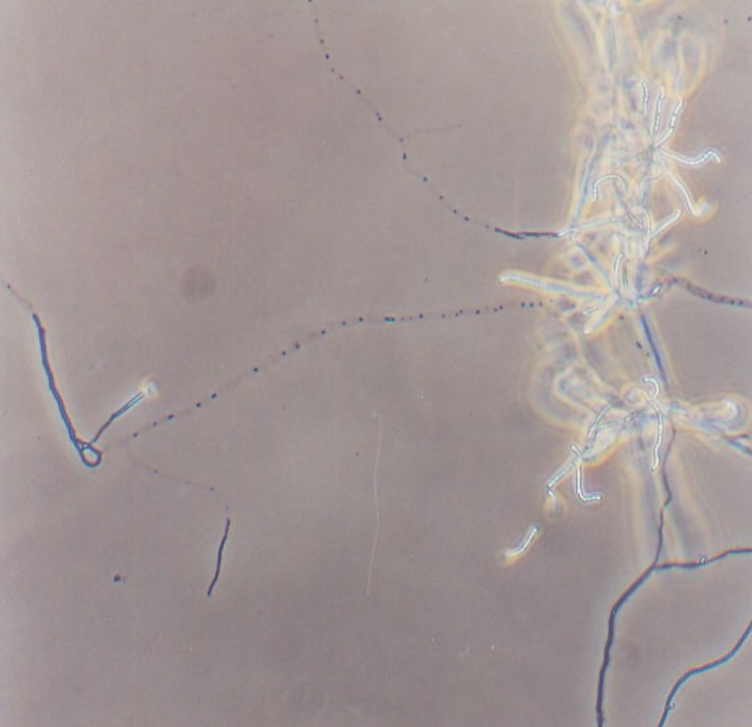
S.  NO | COLOR OF SOLUBLE PIGMENTS | NUMBER OF ISOLATES | PERCENTAGE OF ALL ISOLATES (%)
1  2  3  4 | Brown  Yellow  Pink  Not clear | 2  1  1  1 | 40  20  20  20
TOTAL 5
Figure 1. Plate shows the Microscopic view of
Streptomyces spp

4. Discussion:
By the wet mount technique morphology of actinomycetes was observed. The cells were producing sporophore, which were spirals and rectus flexibilis, spores were in long chains and single spores formed.
In the present study three strains of actinomycetes were chosen from soil habitats. It was possible to classify actinomycetes colonies to the genus level while they are still in the primary culture after sub culturing to obtain pure isolates, the bulk of the isolates were classified in groups having the following characters.

a) Formation of aerial mycelium, long chains spores no sporangia (Lechevalier et al., 1976)
b) Formation of aerial mycelium, hyphae having single spores, no sporangia,
c) Formation of substrate and aerial hyphae forming spore chains, no sporangia.

All the isolates of actinomycetes are gram positive, branched filamentous in nature producing spores in chains. All the isolates of actinomycetes are non acid fast bacteria. The cells will be blue color.
Diffusible pigment of Actinomycetes isolates produce brown, yellow, pink coloured pigments which determines the presence of Streptomyces spp.
The degradation activity of actinomycetes shows that the majority of the isolates were Glyomyces, Saccharomonospora and Streptomyces sp respectively.

5. Summary and Concluding remarks:
The present study mainly involved in the isolation of Streptomyces based on the morphology and identification such as wet mount and staining techniques. The Streptomyces species isolation was also mainly based on the physiological characters and its potentiality were identified. Further work is focused on the processing and isolation of bacterial species which is based on a limited number of subjectively chosen features, with a significant emphasis on morphology and pigmentation (Williams et al., 1983).

Acknowledgements:
The authors are grateful to thank Bharath University, Chennai, Tamilnadu for their support to carry out this work.

Corresponding Author:
T.Jayalakshmi
Dept of Bioinformatics, Bharath University,
Chennai, Tamilnadu – 600073, India.
E-mail: jayamaniraaja07@gmail.com

REFERENCES:
- Amare, G., Rajni, H.k., Berhanu, A. Gashe, B.M., 2003. Novel alkaline proteases from alkaliphilic bacteria grown on chicken feather. Enzyme Microb. Technol. 32, 519-524.

- Baldacci, E., Spalla, C., and Grein, A. 1955. The classification of the Actinomyces species. Arch. Mikrobiol., 20, 347-357, 1954, Giorn. Microbiol, 1, 28-34.

- Bressollier. P., Letourneau. F., Urdaci. M., Verneuil. B., 1999. Purification and characterization of a keratinolytic serine proteinase from Streptomyces albidoflavus. Appl. Environ Microbiol. 65 (6), 2570-2576.

- Burkholder, P.R., SUN, S.H., Ehrlich, J., AND Anderson, J.L. 1954 Criteria of speciation in the genus Streptomyces . Ann. N. Y. Acad. Sci., 60, 102-103.

- Cappuccino JG, Sherman N (2004). Microbiology, a laboratory manual. Pearson Education, Inc., New Delhi pp. 282-283.

- El- Naghy, M.A, El-Ktatny, M.S, Fadl-Allah, E.M., Nazeer,W.W., 1998.Degradation of chicken feathers by Chrysosporium georgiae, Mycopathology 143, 77-84.

- Goodfellow, M.S.T. Williams, and Anderson, 1986. Transfer of kitasatoa purpurea Matsumae and Hata to the genus Streptomyces as Streptomyces purpureus Comb nov. Syst. Appl. Microbiol.8:65-66.

- Gradisar, H., Kern, S., Friedrich, J., 2000. Keratinase of Doratomyces microspores. Appl. Microbiol. Biotechnol. 53,196-200.

- Hirschman, D.J., Zametkin, J.M., and Rogers, R.E. 1944. The utilization of wool by four saphrophytic microorganisms in the presence of added nutrients. Am. Dyestuff Reptr., 33, 353-359.

- Joo, H.S., Kumar, C.G., Park, G.C., Kim, K.T., Paik, S.R, Chang ,C.S., 2002.Optimisation of the production of an extracellular alkaline protease from Bacillus hirikoshii Process biochem, 38,155-159.

11/05/2010

- Kim, J.M., Lim, W.J., Suh, H.J., 2001. Feather-degrading Bacillus species from poultry waste. Process Biochem . 37, 287-291.

- Krassilnikov, N.A. 1941 The guide to the ray fungi, Actinomycetales. Acad. Nauk. USSR, Moskau (Translated title).

- Kuster, E. 1953, 1955 Beitrag sur Geneseund Morphologie der Streptomyceten-Sporon. Atti del congress Intern. Microbiol. Roma, 1,114-116, Zentr. Bacteriol. Parasitenk. II Abt., 108,376-382.

- Lechevalier, M.P. 1976. The taxonomy of the genus Nocardia; The biology of the Nocardiae. Academic press, Inc., New York.

- Ndonde MJM, Semu E (2000). Preliminary characterization of Strepto- myces species from Tanzanian soils and their antimicrobial potential against selected plant and animal pathogenic bacteria. World J. Microbiol. Biotech. 7: 595-599.

- Schatz, A., Karlson, K.E., and Martin, J.J. 1955 Destruction of tooth organic matter by oral keratinophilic microorganisms. N.Y.State Dental J., 21, 438-446.

- Suh, H.J., Lee, H.K. 2001. Characterisation of a keratinolytic serine protease from Bacillus subtilis K.S.I. J. Protein Chem. 20,165-169.

- Waksman, S. A. 1919 Cultural studies of species of Actinomyces. Soil Sci., 8, 71-215.

- Waterhouse, D.F. 1957 Digestion in insects. Ann .Rev .Entomol, 2, 1-18.

- Williams, S.T.M. Goodfellow, G.Alderson, E.M.H. Wellington, P.H.A.Sneath, and M.J.Sachin. 1983. Numerical classification of Streptomyces and related genera.J.Gen.Microbiol.129:1743-1813.

11/5/2010

