Protection by Selenium Against Adriamycin-induced Genotoxic and Biochemical Changes in Mice

A. Ezz El-Din, S. M. Girgis*, S. M. Kassem And T. M. T. Shoman
Department of Cell Biology, National Research Centre, Egypt
*Corresponding author: Dr. S. M. Girgis, , E-mail: shenoudagirgis10@yahoo.com
Absrtact: The present study was carried out to evaluate the protective effect of selenium (Se) against genotoxic and biochemical alterations induced by the anticancer drug, adriamycin (ADR) in mice. Adult Swiss albino male mice were divided into 8 groups, the first group served as control, the 2nd treated intraperitoneally (i.p) with ADR (3 mg/kg bw) once a week. The 3rd, 4th and 5th group treated orally with Se (0.25, 0.5 and 1 mg/kg bw, respectively) once a day. The other 3 groups (combination groups, 6, 7 and 8, respectively) treated with the same concentrations of Se plus i.p dose of ADR once a week. The results of the present study revealed that animals treated with Se plus ADR (groups 6, 7 and 8) presented a statistically significant reduction in all types of chromosomal aberrations compared to ADR only treated group. As well a reduction in enzyme (AST, ALT, ACP, ALP and LDH) activities and total protein and uric acid levels as indicators of hepatic and kidney functions was obtained. This study concludes that Se has protective effects against ADR- induced chromosome damage and biochemical alterations due to its ability to scavenge free radicals and antioxidant properties. That antioxidant supplementation could be used in combination with ADR to protect against oxidative stress without attenuating the clinical efficacy of ADR, avoiding the need to take other medications, and improving the patients quality of life.
[A. Ezz El-Din, S. M. Girgis, S. M. Kassem And T. M. T. Shoman. Protection by Selenium Against Adriamycin-induced Genotoxic and Biochemical Changes in Mice. . New York Science Journal 2011;4(1):104-111]. (ISSN: 1554-0200). http://www.sciencepub.net/newyork.
Keywords: Adriamycin, genotoxic, biochemical, changes, selenium, protection, mice.

1. Introduction
Adriamycin (ADR and also named doxorubicin, DXR) is an anthracycline antibiotic that has been used for the treatment of a wide variety of cancers. It can be obtained from Streptomyces peucetius or totally chemical synthesis is also possible. It is cytotoxic and mutagenic in both bacterial and mammalian systems. One type of interaction with the DNA is associated with the production of reactive free radicals Akman et al.,(1992),but its cytotoxic activity has been related to its interaction with nuclear topoisomerase II, Wassermann (1996). Adriamycin is known to be a cell cycle- epecific for the S phase of cell division. It was shown to produce an increase in DNA strand breakage and in the percentage of abnormal frequencies of chromosomal damage in the FISH and conventional chromosomal aberration assays Anderson et al.,(1996).
The ability of ADR to inhibit DNA synthesis has been assumed to be a mechanism of action of ADR. This mechanism may be related to DNA intercalation or inhibition of DNA polymerase activity. It is possible that this effect is due to growth arrest signaling events and p53 function. Another mode of action of ADR through alterations in DNA is induction of enzymatically or chemically activated DNA adducts and DNA cross-linking. Interference with DNA strand separation and helicase activity has also been postulated as mechanisms of action for ADR, Quiles et al.,(2002).A large number of dietary components, such as vitamin C and E and selenium are known for their antioxidant properties. Selenium (Se) an essential trace element of fundamental importance for animals and humans as a cancer chemo-preventive agent is obtained from dietary sources including cereals, grain products, vegetables, seafood, meat and nuts Tapiero et al.,(2003).. It has been suggested that Se is a potent antioxidant involved in cellular defence against free radicals, Antunes et al.,(2002) .
The most promising results come from the combination of the drug delivery together with an antioxidant in order to reduce oxidative stress. Many antioxidants have been assayed with very different results. Among these molecules, metal ions chelators and low -molecular- mass agents that scavenge reactive oxygen species and that are synthesized in vivo have been widely studied Quiles et al.,(2002). However, the present study will be exclusively focused on the antioxidants that are derived from the diet, in particular the role of Se as an antioxidant.
Santos et al.,(2007), examined the ability of 2 selenium compounds- sodium selenite (SS) and selenomethionine (SM)- to protect DNA against the damage induced by ADR in Wistar rats and concluded that Se-supplementation was effective in protecting DNA against ADR-induced DNA damage in rats, confirming the antioxidant properties of Se compounds.
The study of Fischer et al,(2007), seeked to define the genetic basis for the observed selectivity of Se in combination chemotherapeutics, suggested that: (a) the tumor suppressor p53 gene may be an important genetic determinant that distinguishes normal cells from cancer cells, and (b) combinatorial (with Se) chemotherapeutics that act by p53- dependent mechanisms may enhance chemotherapeutic efficacy by increasing the chemotherapeutic window distinguishing cancer cells from normal cells. Mechanisms for Se-anticancer action are not fully understood, however, several have been proposed: antioxidant protection, enhanced carcinogen detoxification, enhanced immune surveillance, modulation of cell proliferation (cell cycle and apoptosis), inhibition of tumor cell invasion and inhibition of angiogenesis, Zeng and Combs(2008).
A direct relationship between Se intake and cancer risk in humans has been reported, indicating that Se-deficiency enhances the probability of developing cancer Li, et al.,(2004). There is a moderate to high health risk of too much Se. High blood levels of Se can result in a condition called selenosis. Symptoms include gastrointestinal upsets, hair loss, white blotchy nails, and mild nerve damage are similar in animals and man, Koller and Exon(1986).It is beneficial properties occur in a limited range of daily intake below which it cannot perform its essential functions, and above which it is toxic Aleajos et al., (2000). It participates in processes of detoxification because it forms a part of glutathione peroxidase, a cellular enzyme that maintains appropriately low levels of hydrogen peroxides within a cellular environment Tapiero et al.,(2003). Therefore, the present study was undertaken to investigate the possible protective effect of Se- against genetic and biochemical alterations induced by ADR in mice using cytogenetic and biochemical analysis.

2. Materials and Methods:
2.1.Materials:
2.1.1.Chemicals:
Adriamycin (ADR), CAS no.25316-40-9 and selenium as sodium selenite were purchased from Sigma Chemicals Co. (St. Louis, Mo, USA). Random primer kits for determination of enzymatic activities and organic components (total protein and uric acid) were purchased from Operon Technologies, USA. All reagent and chemicals were of the highest purity. Substances were prepared fresh on the day they were applied into mice. ADR was dissolved in distilled water.

2.1.2.Animals:
Eighty adult Swiss albino male mice weighing 20-25g were obtained from the Animal House Colony, National Research Centre, Giza, Egypt, maintained on standard laboratory diet (protein, 16.04%; fat, 3.63%; fibre, 4.1%; and metabolic energy, 0.012 MJ) and water ad libitum. After an acclimation period of 1 week, animals were divided into eight groups (10 mice/ group) and housed individually in filter-top polycarbonate cages housed in a temperature- controlled (23 ± 1°C) and artificially illuminated (12 h dark/ light cycle) room free from any source of chemical contamination. All animals received human care in compliance with the guidelines of the Animal Care and Ethics Committee of the National Research Centre, Cairo, Egypt.

2.2.Methods:
2.2.1.Experimental Design:
Animals within different treatment group were treated (daily at a 24-h interval) for 30 days as follows: group 1, untreated control: group 2, treated I.p with ADR (3mg/kg bw) once a week, group 3 treated by gavage with 0.25 mg/kg bw of selenium (Se_{0.25}), group 4, treated with 0.5 mg/kg bw of selenium (Se_{0.50}), group 5, treated with 1mg/kg bw of selenium (Se_{1.00}) Hill et al.,(2003). Groups 6, 7 and 8 treated with selenium similar to groups 3, 4 and 5, respectively, plus i.p dose of ADR (3 mg/kg bw) once a week throughout the selenium treatment, Kratz et al.,(2007). At the end of the experimental period, all animals were sacrificed and dissected on day 31. Bone marrow cells and blood samples were collected from all animals for cytogenetic and biochemical analysis.

2.2.2.Cytogenetic Analysis:
Animals were injected with colchicine (6 mg/kg bw) 2 hours before sacrifice by cervical dislocation. Femurs were removed and the bone marrow cells were aspirated using saline solution. Metephase spreads were prepared using the method of Preston et al.,(1987). Fifty metaphase spreads per animal were analyzed for scoring the different types of chromosomal aberrations.

2.2.3.Biochemical Analysis:
Blood serum was used for analysis of enzymatic activity and total protein and uric acid. The activities of both aspartate aminotransferase (AST) and alanine aminotransferase (ALT) were estimated, Bergemeyer et al.,(1978).The level of alkaline phosphatase (ALP) was measured, Belfield and Goldberg (1971), while the level of acid phosphatase (ACP) was determined by the colorimetric method, Kind and King(1954). The assay of lactate dehydrogenase (LDH) was determined, Buhl and Jackson(1978).For estimation of the level of total protein, colorimetric method was used, Gomal et al.,(1949), as well the level of uric acid was measured, Barham and Trinder (1972).

2.2.4.Statistical Analysis:
Results were statistically analyzed by one way analysis of variance (ANOVA) using SAS program SAS,SAS/Stat (2001). Student t-test at 0.05 (p<0.05) significant level was used to test the differences between means of treatment.

3. Results
3.1. Structural and numerical chromosomal aberration
Table 1, showed the frequency of structural and numerical chromosomal aberrations in mice bone marrow cells of control and ADR and /or Se treated groups. The ADR treated group showed a high frequency of both structural chromosomal aberrations (i.e, gaps, deletions and centromeric attenuations) and numerical aberrations hypoploidy and hyperploidy, 2n±1) when compared with the control group, the Se groups and the ADR + Se groups (combination groups) (p <0.05). The ADR treated group also showed a high frequency of both total structural and numerical aberrations when compared with the control, the Se and the ADR + Se treated groups (except for the Se_{1.00} group for the hypoploidy), (p<0.05). When the Se treated groups (Se_{0.25}, Se_{0.50} and Se_{1.00}) were compared with the control group in all types of structural and numerical and/ or total aberrations, the Se_{0.25} group displayed no significant differences (p<0.05), whereas, in the Se_{1.00} group, the same types of aberrations were significantly higher (p<0.05). The high concentration of Se was found to be clastogenic (p<0.05). Meanwhile, the Se_{0.50} group displayed a higher frequency of only structural aberrations (deletions and centromeric attenuations as well the total structural aberrations (p<0.05).
In the combination groups (Se_{0.25} + ADR, Se_{0.50} + ADR and Se_{1.00} + ADR) there was no difference (P<0.05) in the numerical aberrations and their total compared to the control group. However, all types of structural chromosomal aberration and their total showed a significant difference (p<0.05) compared to the control group (except for ADR+Se_{1.00} treated group in term of gap aberration).
A comparison of the combined groups (Se_{0.25} + ADR, Se_{0.50} + ADR and Se_{1.00} +ADR) with the ADR group revealed that there was a significant difference between the combined groups and ADR group in terms of all types of structural and numerical aberrations as well their total. Medium and high doses of Se (0.5 and 1 mg/ kg bw) displayed more efficacy than the low dose (0.25 mg/kg bw) concerning the protection from ADR toxicity on cells (Table 1). In the combination groups none of the Se concentrations restored the structural aberration (except gaps) induced by ADR to the level of the control, whereas all Se doses in the combination groups restored the numerical aberrations and their total near the level of the control group.

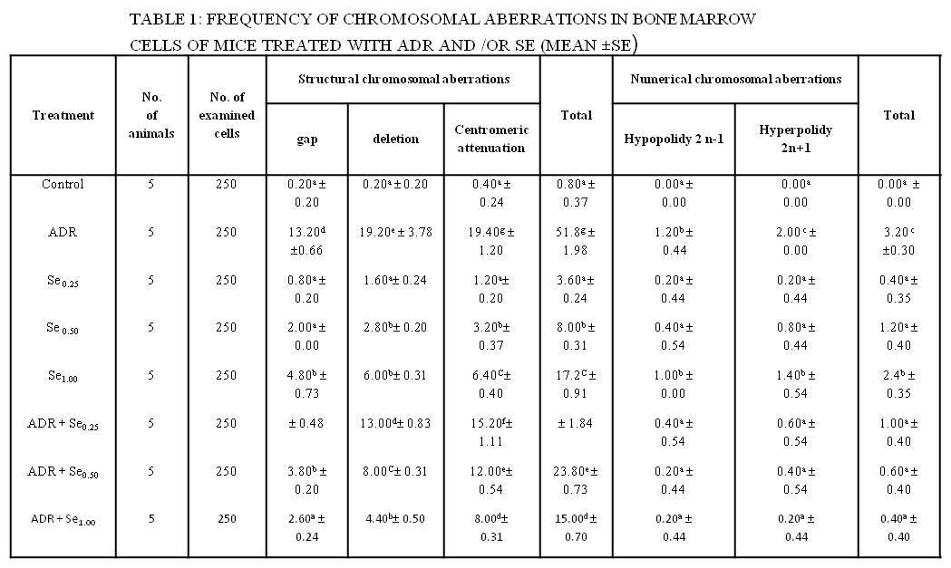

3.2.Biochemical Analysis:
3.2.1. Enzyme activities in the liver :
Table 2, represents the enzyme activities in liver mice treated with ADR and/ or Se. Values for AST enzyme activity increased in ADR, Se₁ and the combined groups compared with control group. ALT, ACP and LDH enzyme activities increased in ADR and the combined groups compared with control group. Whereas, ALP increased significantly in ADR, Se_{0.5}, Se₁ and the combined groups compared with control. Se alone administration did not cause a significant increase in the biochemical parameters tested except for GOT (AST) in Se_{1.00} treated and ALP in Se_{0.50} and Se_{1.00} treated groups. Thus, Se at doses up to 1mg/ kg almost did not cause liver damage or increase the biochemical parameters under study. So, the combination of Se with ADR decreased the incidence of biochemical parameters compared to ADR treated group, but not restored to the control level.

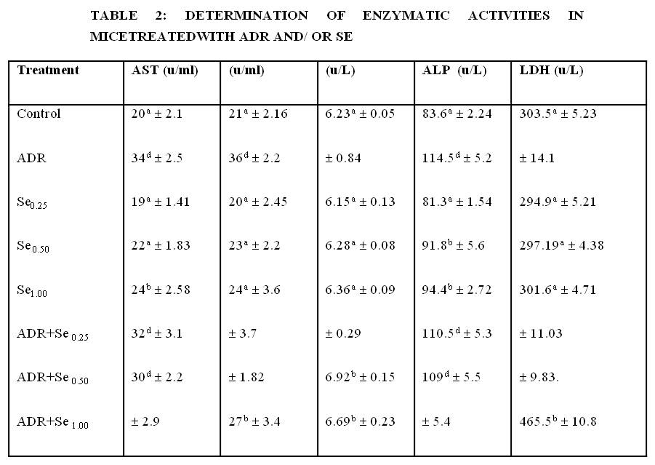
- Values are expressed as mean ± S.E.
3.2.2.Total protein and uric acid level:
Total protein and uric acid level were presented in Table (3). Total protein values of ADR and ADR + Se_{0.25} were decreased significantly compared with control group. While, the combination groups with medium and high concentration of Se (ADR + Se_{0.50} and ADR + Se_{1.00}) restored the total protein to the level of control. Values of uric acid of ADR and the combined groups were significantly increased compared with control and Se treated groups. However, Se supplementation in the combined groups (groups, 6, 7 and 8) reduced the uric acid values up to 20% according to Se concentration but not restored to the control level.

Table 3: Effect of ADR and/or Se treatment on serum total protein and uric acid levels
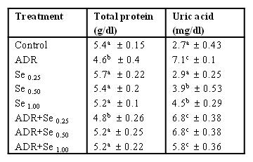
- Values are expressed as mean ± S.E.
4.Discussion
Adriamycin is one of the most anticancer drugs because it is effective against a broad spectrum of human neoplasms, Au and Hsu(1980) . Like most anticancer drug, ADR produces undesirable complications in chemotherapy. The main genotoxic effect of ADR and related compounds is binding to DNA and cause DNA- topoisomerase II poisoning which generates reactive oxygen species (ROS). As well it is known that ADR and other anthracyclines induce biochemical change in various tissues. ADR toxicity may be mediated by free radicals derived from this drug, Quiles et al.,(2002).
In order to reduce ADR-induced these toxicities, antioxidant substances that are derived from the diet such as vitamins E, C and A, senzyme Q, flavonoides, Se, and antioxidant components of virgin olive oil have been investigated, Chattopadhyay and Bandyopadhyay (2006).
The present study evaluated the protective effects of Se supplementation in the form of sodium selenite against the damage induced by the chemotherapeutic agent ADR in mice. Genotoxic and biochemical changes were investigated by cytogenetic and biochemical analysis.
The most important finding in this work is the ability of Se to protect ADR- induced genetic damage by its antioxidant properties. This protective effect of Se is dose – dependent ( up to certain limit) and coincide with the findings of Tapiero et al.,(2003),which suggest that there is a threshold effect for Se where no further protective effect is evident.
In contrast, the study of Santos and Takahashi^{[25]}, revealed that the protective effects of Se did not occur in a dose-dependent manner and the ability of Se to reduce the ADR-induced damage equally in the lowest and in the highest concentrations tested, and that may due to its antioxidant properties.
It was observed the Se treatment alone did not reduce chromosomal aberrations specially with the higher concentration (1mg/kg) treatment. However, the lower concentration of Se (0.25 mg/kg) did not show a genotoxic effect and had no difference in the frequency of chromosomal aberration compared to the control, Santos and Takahashi (2008). The other tested concentrations of Se alone exhibited some genetoxic effects however, also reduced the chromosomal aberrations induced by ADR as well in ADR + Se combination groups. The literature underlines the observation that Se, in low concentrations, may have antigenotoxic effects whereas in high concentrations, it can be genotoxic and carcinogenic, Bronzetti et al.,(2001). Thus it is of fundamental importance to determine the optimal concentration of Se that provides protection against genetic damage with the least toxicity.
The results have shown that ADR produces both aneugenic (2n±1) and genetoxic effects. That in agreement with Aly et al.,(1999); Dhawan et al.,(2003), where an increase in the trisomy of chromosomes 7 and 17 was found in lymophocytes from healthy individuals and cancer patients treated in vitro by ADR. Similar findings were reported, Giavini et al.,(1990); Antunes andTakahashi(1998); Venkatesh et al.,(2007) where, ADR- induced genotoxic effects (micronuclei formation) in rat embryos and in rat and mice bone marrow. However, the treatment with vitamin C and/or vitamin E and Aegle marmelos (as an antioxidants) significantly reduced these toxicities. They attributed that protective effect to inhibition of free radicals and increased antioxidant status.
Se was able to suppress in 75% of single- strand break formation, Roussyn et al.,(1996). In accordance, our results confirmed that Se had the ability to reduce the frequencies of chromosomal aberrations and aberrant metaphases. This can be explained by a cell cycle perturbation by selective cell killing, reducing the frequency of mitosis available for the chromosomal aberration record. Although Se treatment increased the number of apoptotic cells, it was not sufficient to reduce the number of viable cells and the mitotic index was not reduced. Furthermore, when combined with ADR treatment, Se prevented cell death induced by this chemotherapeutic agent and increased the mitotic index, thereby reducing the genotoxicity of ADR.
In the present study, data from the chromosomal aberration assay also showed the ability of Se (specially the high concentration) to reduce chromosome gaps induced by ADR. This effect was also found in all types of numerical aberrations but with all concentrations of Se in combination with ADR treatment. Sodium selenite was found to prevent the clastogenic effects of ADR, reducing the frequencies of micronuclei and DNA damage in Wistar rats. The action of a protective agent by a single mechanism may be the exception rather than the rule, and therefore Se may have a protective effect based on different mechanisms, Kunitomo et al.,(1985),however, as motioned in the literature, Se act in the antioxidant defense and modulate the response of DNA repair factors and p53 expression, Antunes et al.,(2000); Santos et al.,(2007) ;Fischer et al.,(2007).
A study performed on mice and Waster rats indicated an increase in ALT value in ADR treated group compared to the control, Kunitomo et al.,(1985);Saad et al.,(2001) in accordance with our study.
The ADR-treated mice showed significant increase in AST, ALT and LDH levels when compared with the untreated control group. These results are in accordance with those reported, Al-Nasser (1998); Chen et al., (1998); Venkatesan (1998); Saad et al., (2001); Oz and Ilhan (2006). However the increase in AST, ALT and ALP activities compared to the control in the present study which was different from that of Cosanet al.,(2008).
Compared to ADR treated group, administration of Se in the combined groups revealed that mice responded with a decreasing in all biochemical variables (AST, ALT, ACP, ALP, ALP and LDH levels) in a dose dependent manner specially with the high concentration of Se. The results of the present study clearly indicate that Se treatment offered some protection against ADR-induced biochemical toxicity in mice. This could be attributed to the antioxidant properties of Se, Antunes et al.,(2000); Santos et al.,(2007); Zeng and Combs (2008). Previous studies have shown that ADR inhibits the overall synthesis of DNA and protein compared to the control, Yin et al.,(1998); Oz and Ilhan (2006). It was presumed that the depressed antioxidant activity resulted from the inhibited gene expression and leading to the inhibition of protein synthesis. Which was in accordance with our findings.
ADR causes tissues injury in the kidney and this damage was demonstrated by the biochemical analysis performed in the present study. ADR toxicity is attributed to its pro-oxidant action (generation of reactive oxygen species, ROS), which attack proteins and genetic materials, Injac et al.,(2008) .The data support the hypothesis that ROS are involved in ADR-induced renal toxicity. ADR induced a severe nephrotic syndrome with hypoproteinemia. These changes were associated with a marked decrease in the antioxidant defense of the kidney. The changes reflect many functional alteration such as a drop in glomerular filtration rate, glomerular capillary damage and tubulotoxicity, or may be the consequence of oxidative stress.
These characteristic features of ADR-induced renal toxicity are similar to those reported ,Venkatesan et al.,(1997); Badary et al.,(2000). In our study, the total protein level was restored to the normal control in the combination groups as a result of Se supplementation. That due to its ability to scavenge free radicals and antioxidant properties Zeng and Combs (2008). Adriemycin treatment alone induced a significant increase in serum uric acid level that exceeded the control values by approximately 3- fold. It could be attributed that, uric acid is the final product of purine (one of the two main components of protein) metabolism. The final two reactions of its protection catalyzing the conversion of hypoxanthine to xanthine and the latter to uric acid are catalyzed by the enzyme xanthine oxidoreductase, which may attain two inter- convertible forms, namely xanthine dehydrogenase or xanthine oxidase (XO).
The latter uses molecular oxygen as electron acceptor and generates superoxide anion and other reactive oxygen products (ROS) associated with oxidative stress of ADR, Ghiggeri et al.,(1990); Kishore et al.,(2009).
In the combination groups in which Se was given, uric acid level was reduced compared to the ADR-treated group (Table 3). These results are similar to Saad et al.,(2001); Oz and Ilhan(2006). So, once again the reduction of uric acid level due to Se supplementation support its antioxidant properties.
In conclusion, the present work describes the protection afforded by Se against genotoxicity induced by ADR on the basis of its antioxidant properties, and was confirmed by biochemical examination. The results demonstrate that i.p injection of ADR at a dosage of 3 mg/kg to Swiss albino male mice caused genotoxic and biochemical alterations. Se (as an antioxidant) administration, may prevent ADR-induced genetic and biochemical toxicities by its antioxidant action. Therefore, the study recommend that Se supplementation, at safe dose level, is able to limit adriamycin toxicities. That antioxidant supplementation could be used in combination with ADR to protect against oxidative stress without attenuating the clinical efficacy of ADR, avoiding the need to take other medications, and improving the patients quality of life.

5. References

Al-Nasser I A. In vivo prevention of adriamycin cardiotoxicity by cyclosporin A or FK 506. Toxicol 1998;131: 175-81.

Akman S A, Doroshow J H, Burke T G, Dizdaroglu M.
DNA base modification induced in isolated human chromatin byNADH dehydrogenase-catalysed reduction of doxorubicin. Biochemistry 1992; 31: 3500-3506.

Aleajos M S, Romero F J D, Romero, C. D. Selenium and cancer: some nutritional aspects. Nutrition 2000;16: 376-383.

Antunes L M G, Francescato H D C, Darin J D C, Bianchi M L P. Effect of selenium pretreatment on cisplatin-induced chromosome aberrations in Wistar rats. Teratog. Carcinog. Mutagen 2000; 20: 341-8.

Anderson D, Yu T W, Browne M A. The use of the same image analysis system to detect genetic damage in human lymphocytes treated with doxorubicin in the comet and fluorescent in situ hybridization (FISH) assays. Mutat. Res 1997; 390: 69-77.

Antunes L M G, Takahashi C S. Effects of high doses of vitamins C and E against doxorubicin-induced chromosomal damage in Wistar rat bone marrow cells. Mutat. Res1998; 419 (1-3): 137-143.

Aly M S, Othman O E, El-Nahas S M. Specific numerical chromosomal aberrations induced by adriamycin. Environ. Mol. Mutagen 1999;33: 161-166.

Badary O A, Adel-Naim A B, Abdel-Wahab M H, Hamada F M A. The influence of thymoquinone on doxorubicin- induced hyperlipidemic nephropathy in rats. Toxicol 2000;143: 219-226.

Barham D, Trinder P. An improved color reagent for the determination of blood glucose and uric acid by the oxidase system. Analyst 1972; 97: 142-145.

Bergemeyer H U, Scheibe P, Wahlefeld A W. Optimization of methods for aspartate aminotransferase and alanine aminotransferase. Clin. Chem. 1978;24: 58-73.

Belfield A, Goldberg D M. Colorimetric determination of alkaline phosphatase activity. Enzyme 1971; 12: 561-568.

Bronzetti G, Cini M, Andreoli E, Caltavuturo L, Panuzio M Croce, C D. Protective effects of vitamins and selenium compounds in yeast. Mutat. Res 2001; 496: 105-115.

Buhl S N, Jackson K Y. Optimal conditions and comparison of lactate dehydrogenase catalysis of the lactate-to- pyruvate and pyruvate- to –lactate reactions in human serum at 25, 30 and 37°C. Clin. Chem 1978; 24: 828-831.

Chattopadhyay A, Bandyopadhyay D. Vitamin E in the prevention of ischemic heart disease. Pharmacol Rep 2006; 58: 179-187.

Chen A, Sheu L F, Ho Y S, Lin Y F, Chou Y W, Chou T C, Lee W H. Experimental focal segmental glomerulosclerosis in mice. Nephron 1998;78: 440-52.

Cosan D, Basaran A, Gunes H V, Degirmenci I, Aral E. The effect of doxorubicin on rats that received toxic and carcinogenic benzo (a) pyrene. Folia Histochem Cytobiol 2008; 46 (3): 367-372.

Dhawan A, Kayani M A, Parry J M, Parry E, Anderson D. Aneugenic and clastogenic effects of doxorubicin in human lymphocytes. Mutagenesis 2003;18 (6): 487-490.

Fischer J L, Michelc E M, Pollok K E, Smith M L. Chemotherapeutic selectivity conferred by selenium: a role for p53- dependent DNA repair. Mol. Cancer Ther 2007; 6 (1): 355-61.

Gebhart E. Anticlastogenicity in cultured mammalian cells. Mutat. Res1992;267: 211-220.

Ghiggeri G M, Ginevri F, Cercignani G, Oleggini R, Garberi, A, Candiano G, Altieri P, Gusmano R. Effect of dietary protein restriction on renal purines and purine-metabolizing enzymes in adriamycin nephrosis in rats: a mechanism for protection against acute proteinuria involving xanthine oxidase inhibition. Clinical Science 1990;79: 647-656.

Giavini E, Lemonica I P, Lou Y, Broccia M L, Prati M. Induction of micronuclei and toxic effect in embryos of pregnant rats treated before implantation with anticancer drugs: cyclophosphamide, Cis- platinum, adriamycin. Teratogen. Carcinogen. Mutagen 1990; 10 (5): 417-426.

Gomal A C, Bardawill G J, David M M. A colorimetric method for determination of protein. J. Biol. Chem 1949; 177: 751-756.

Hill K E, Zhous J, McMahan W J, Motley A K, Atkins J F, Gesteland R F, Burk R F. Deletion of selenoprotein P alters distribution of selenium in the mouse. J. Biol. Chem 2003; 278 (16): 13640-13646.

Injac R, Boskovic M, Perse M, Kaprivec- Furlan E, Cerar A, Djordjevic A, Struckelj B. Acute doxorubicin mephrotoxicity in rats with malignant neoplasm can be successfully treated with fullerenol C₆₀ (OH)₂₄ via suppression of oxidative stress. Pharmacol. Reports 2008;60: 742-749.

Kind P R, King E J. Estimation of plasma alkaline phosphatase by determination of hydrolysed phenol with amino-antirpyrine. J. Clin. Pathol 1954; 7: 322-326.

Koller L D, Exon J H. The two faces of selenium-deficiency and toxicity-are similar in animals and man. Can. J. Vet. Res 1986; 50: 297-306.

Kratz F, Ehling G, Kauffmann H M, Unger C. Acute and repeat-dose toxicity studies of the (6-maleimidocaproyl) hydrazone derivative of doxorubicin (DOXO-EMCH), and albumin-
binding prodrug of the anticancer agent doxorubicin. Hum. Exp. Toxicol. 2007;26 (1): 19-35.

Krishna Kishore R, Sudhakar D, Parthasarathy P R. Embryo protective effect of pomegranate (Punica granatum L.) fruit extract in adriamycin- induced oxidative stress. Indian J. Biochem. Biophys 2009;46: 106-111.

Kunitomo M, Yamaguchi Y, Matsushima K, Futagawa Y, Bando Y. Hyperlipidemic effects of adriamycin in rats. Jpn. J. Pharmacol 1985;39: 323-329.

Li,H, Stampfer M J, Giovannucci E L, Morris J S, Willett W C. Gaziano J M, Ma J. A prospective study of plasma selenium levels and prostate cancer risk. J. Natl. Cancer Inst 2004; 96: 696-703.

Oz E, Ilhan M N. Effects of melatonin in reducing the toxic effects of doxorubicin . Mol. Cell. Biochem 2006; 286: 11-15.

Preston R J, Dean B D, Galloway S, Holden H, McFee A F, Shelby M. Mammalian in vivo cytogenetic assays: analysis of chromosome aberrations in bone marrow cells. Mutat. Res 1987; 189: 157-165.

Quiles J L, Huertas J R, Battino M, Mataix J, Ramirez-Tortosa M C. Antioxidant mutrients and adriamycin toxicity. Toxicol 2002; 180 (1): 79-95.

Roussyn I, Karlis B, Masumoto H, Sies H. Selenium-containing compounds protect DNA from single- strand breaks by peroxinit rite. Arch. Biochem. Biophys 1996; 330: 216-218.

Saad S Y, Najjar T A, Al-Rikabi A C. The preventive role of deferoxamine against acute doxorubicin- induced cardiac, renal and hepatic toxicity in rats. Pharmacol. Res 2001; 43 (3): 211-218.

SAS. SAS/Stat. User's Guide Statistics, Ver. 8.2. SAS Institute Inc. Cary, NC, USA, 2001.
Au W W, Hsu, T C. The genotoxic effects of adriamycin in somatic and geminal cells of the mouse. Mutat. Res 1980; 79: 351-361.

Santos R, Takahashi C. Anticlastogenic and antigenotoxic effects of selenomethionine on doxorubicin – induced damage in vitro in human lymphocytes. Food Chem. Toxicol 2008; 46: 671-677.

Santos R, Jordao A Jr, Vannucchi H, Tokahashi C. Protection of doxorubicin-induced DNA damage by sodium selenite and selenomethionine in Wistar rats. Nutr. Res 2007; 27 (6): 343-348.

Tapiero H, Townsend D M, Tew K D. The antioxidant role of selenium and seleno –compounds. Biomed Pharmacother 2003; 57: 134-44.

Venkatesan N. Curcumin attenuation of acute adriamycin myocardial toxicity in rats. Br. J. Pharmacol 1998; 124: 425-7.

Venkatesan N, Venkatesan P, Karthikeyan J, Arumugam V. Protection by taurine against adriamycin-induced proteinuria and hyperlipidemia in rats. Proc. Soc. Exp. Boil. Med 1997; 215: 158- 164.

Venkatesh P, Shantala B, Jagetia G C, Rao, K K. Modulation of doxorubicin-induced genotoxicity by Aegle marmelos in mouse bone marrow: a micronucleus study. Integr. Cancer. Ther 2007; 6 (1): 42-53.

Wassermann K. Intragenomic heterogeneity of DNA damage formation and repair: a review of cellular responses to covalent drug DNA formation. Crit. Rev. Toxicol 1996; 24: 281-322.

Yin X, Wu H, Chen Y, Kang Y J. Induction of antioxidants by adriamycin in mouse heart. Biochem. Pharmacol 1998; 56 (1): 87-93.

Zeng H, Combs G F, Jr. Selenium as an anticancer nutrient: roles in cell proliferation and tumor cell invasion. J. Nutr. Biochem 2008; 19 (1): 1-7.

11/28/2010

