Improvement of Galvanized Steel -Stainless Steel Spot welded joint Using Inserted Pin Technique

M.A. Morsy*, A.A Sadek and Essam R. I. Mahmoud

CMRDI, Cairo, Egypt
morsy_abokhala@yahoo.com*

Abstract: Resistance spot welding of galvanized steel to stainless steel was conducted using inserted pin technique. In this technique, the galvanized steel sheet was drilled and a stainless steel pin of 2 or 4 mm diameter was pushed into the drilled hole. The resistance spot welding was conducted between the galvanized steel inserted-pin sheet and the stainless steel sheet. The performance of the joint welded using inserted pin technique was evaluated and compared with that of the normal resistance welding technique at different levels of welding time, welding current and welding pressure. The joints welded using 2mm inserted pin technique show higher fracture load than that welded by normal one. On the other hand, joints welded using 4 mm inserted pin show lower fracture load compared with normal technique. This may be attributed to the decrease in the circumferential fused area around the pin between the stainless steel and the galvanized steel. Hardness of weld metal is very close to that of stainless steel HAZ. However, the hardness of the galvanized steel HAZ is much higher than that of the base metal. The results was discussed on the basis of microstructure, heat generated and fracture load of welded joint.
[M. A. Morsy, A.A Sadek and E. Rabea. Improvement of Galvanized Steel -Stainless Steel Spot welded joint Using Inserted Pin Technique. New York Science Journal 2011;4(2):27-34]. (ISSN: 1554-0200). http://www.sciencepub.net/newyork.
Keywords: Galvanized Steel; Stainless Steel; Spot welding; Inserted pin technique; Welding variables; Fracture load; Microstructure

1. Introduction
In the previous papers ^{1, 2} the effect of welding parameters, on the microstructure and quality of galvanized steel joint and stainless steel-galvanized steel joint was studied. Zinc extrusion mechanism outside the weld nugget was confirmed by zinc distribution along the faying surface². Cracking was observed in weld metal of galvanized steel joint and in both weld metal and base metal of stainless steel- galvanized steel joints².
The increase in welding pressure affect on the disappearance of LME cracking through pushing of zinc vapor outside the weld nugget. Nevertheless, increase in welding pressure resulted in a significant decrease in the fracture load of the joint due to the decrease in heat generated at the interface as a result of the decrease in the interfacial resistance ².
Resistance spot welding of dissimilar metals was proposed by inserting a pin in the hole of either or both sheets³. This process was applied for joining of steel to aluminum alloy and different combination of metal sheets^{3, 4}.
The aim of the present work is to study the effect of using inserted pin technique on the improvement of the quality of stainless steel-galvanized steel joint. The results is discussed on the basis of microstructure, heat generated and fracture load of the welded joint.

2. Material and Methods
2.1 Material
Hot dip zinc coated steel sheets of 1&1.5 mm thickness and coating thickness of 15-20 µm, as will as stainless steel sheets grade 304, of 1 mm thickness were used. The sheets were cut into strips of 40 mm wide and 100 mm length. In all experiments lap joint design was used as shown in Fig. 1. 316L Stainless steel bars of 2 & 4mm diameter were used as a pin to weld galvanized steel to stainless steel.
The chemical composition and tensile properties of metals used are shown in Tables 1 and 2 respectively.
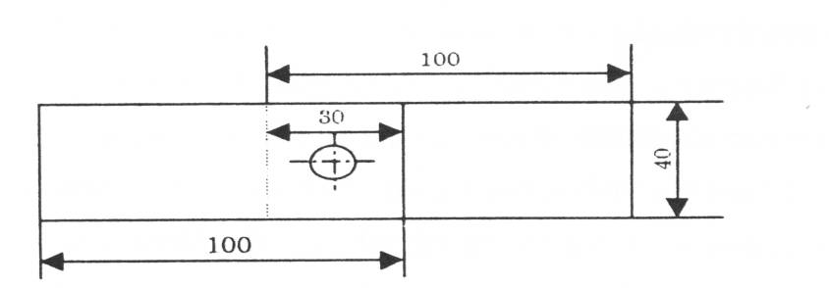
Fig. 1 Welding specimen (dimension in mm)

Table 1 Chemical composition of the base metals, mass %
Steel type | Chemical Composition (%)
Steel type | C | Si | Mn | S | P | Cr | Ni | Mo | Fe
Galvanized steel | 0.08 | 0.05 | 0.46 | 0.02 | 0.03 | 0.01 | 0.05 | 0.00 | Bal.
Stainless steel 304 | 0.05 | 0.51 | 1.38 | 0.01 | 0.05 | 17.9 | 8.10 | 0.35 | Bal.
Stainless steel 316L | 0.03 | 0.75 | 2.00 | 0.03 | 0.04 | 17.5 | 10.12 | 2.30 | Bal.
Table 2. Tensile properties of the base metals
Steel Type | Tensile properties
Steel Type | Yield Strength,  MPa | Tensile Strength,  MPa | Elongation  %
Galvanized steel | 325 | 387 | 26
Stainless steel 304 | 352 | 651 | 52
Stainless steel 316L | 283 | 515 | 40

2.2 Welding techniques
For all welding experiments a single phase alternating current (AC) pedestal resistance welding machine (18 kA, 50 Hz) was used. The electrode used is made of a class II copper alloy of a composition of 99.2% Cu and 0.8% Cr. The face of the electrode is flat (R= 40 mm). The constant parameters include a slop time of 61 cycles, squeeze time of 10 cycles and a cooling water flow rate of 3-4 1/min. The variable parameters include welding current of 7-10 kA, welding time of 10-15 cycles and welding pressure of 2-6 bars.
All specimens were cut into 40 mm width and 100 mm length. Welding was performed at 30 mm far from the edge in the middle of lap joint by direct single spot welding. In this study, two different types of weld joints were investigated namely, welding of 1mm galvanized steel to 1 mm 304 stainless steel by normal process and welding of 1mm galvanized steel to 1mm 304 stainless steel using inserted pin of 316L stainless steel with diameters of 2 &4 mm and 1 mm length. The galvanized steel strips were drilled by a drilling machine and the pins were pushed into the hole and directly spot welded as shown in Fig. 2.
The mechanical testing was carried out by shear tension test. In this test, the specimen is tested in a tensile testing machine and the maximum load (fracture load) of the weld is measured.

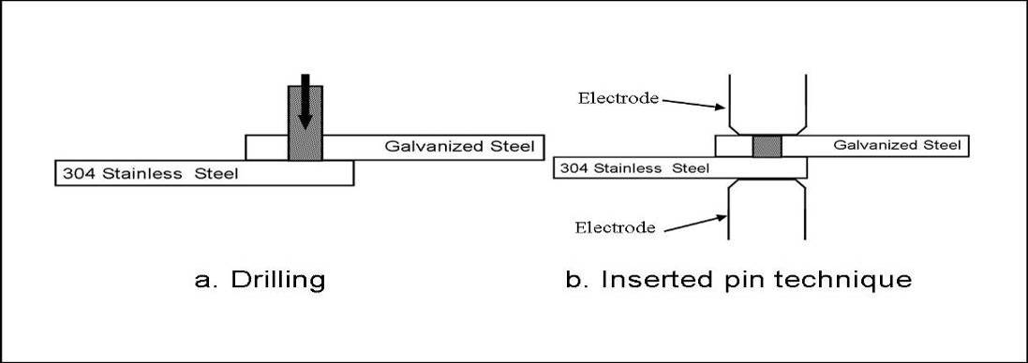
Fig.2 Schematic diagram of weld joint using inserted pin technique

2.3 Metallographic examination
Samples were cut out from weld centerline using a cooling microcutting disk machine and ground through grit silicon papers up to grade 1000. Final polishing was preformed using 0.5 µm alumina paste, then cleaned in an ultrasonic cleaner with acetone, and dried. Etching solution used for coated steel is Nital (3% HNO₃), and for stainless steel a solution of 10 ml HNO₃ ₊ 10 ml acetic acid + 15 ml HCl + 5 ml glycerine is used.
A microhardness tester was used to measure the hardness distribution across the weld nugget.

3. Results and Discussion
3.1 Fracture load of welded joints
Figure 3 shows the effect of applying inserted pin technique on the fracture load of welded joint using different welding current (as compared with normal welding technique). The joint made by 2mm inserted pin showed higher fracture load than that of the joint welded using normal technique. The fracture load increases with the increase in welding current. On the other hand, joint made by 4mm inserted pin technique showed lower fracture load than that of normal welding technique.
Using 2mm 316L stainless steel pin, the fracture occurred by shear in the stainless steel pin resulting in a higher value of fracture load compared with normal technique where the fracture occurred by tearing in the galvanized steel side. By increasing the diameter of inserted pin, the circumferential area around the pin becomes small and it is semi or infused. Thus the fracture occurred at a lower value.
Figure 4 shows the effect of welding time on the fracture load of welded joints using inserted pin technique compared with that obtained using normal technique.
At shorter welding time (10 and 15 cycles), normal welding technique showed higher fracture load values than that obtained using inserted 2mm pin technique. This indicates that the time is not sufficient to produce adequate nugget size between galvanized steel sheet, stainless steel, and inserted pin.
At longer welding times (20 and 25 cycles) the phenomenon was inversed, i.e., the joint welded using 2mm pin technique showed higher fracture load values than that obtained using normal welding technique.
Figure 5 shows the effect of welding pressure on the fracture load of welded joint at welding current of 7kA and time of 20 cycles using inserted pin technique.
Using inserted 2mm pin technique significantly improves the fracture load of welded joints with the increase in welding pressure as compared with normal technique. However, using 4mm inserted pin resulted in a slight decrease in the fracture load with the increase in welding pressure as compared with 2mm inserted pin as shown in Fig 5. These results can be explained by the change in the interfacial resistances and the corresponding heat generated at the joint interfaces as shown in Fig. 6. In case of using 2 mm inserted pin, there is a large circumferential area around the pin (Fig. 6 a) and the less deformable pin resist the decrease in the resistance (R2) at this large circumference area around the pin. This results in a generation of considerable amount of heat at this area². This besides the effect of pressure in pushing the zinc outside the nugget and as a result a sound weld was obtained with the increase fracture load (Fig. 5).
The increase of the diameter of the inserted pin to 4mm resulted in a significant decrease in the circumferential area around the pin as shown in Fig. 6b. Thus, the interfacial resistance between the pin and the stainless steel sheet (R1) is the predominant in heat generation^{2, 3}. The increase in pressure resulted in a decrease in the interfacial resistance (R₁) and a decrease in the heat generated and the weld nugget size with the decrease in the fracture load as shown in Fig. 5

3.2 Hardness of inserted pin technique
The hardness values of welded joints of 2 mm inserted pin at different welding parameters are shown in table 3.
Obviously, the hardness differences between the stainless steel base metal and HAZ are almost small. On the other hand, the hardness of galvanized steel HAZ is much higher than base metal. Also, the hardness of the weld metal is very close to the hardness of the stainless steel HAZ.

3.3 Weld nugget microstructure
Figures 7 and 8 show the microstructures of the spot weld nugget using welding current of 7kA and 9kA respectively at welding pressure of 2 bars and time of 20 Cycles for two sheet metal thickness of l mm using 2mm inserted stainless steel pin technique.
Figure 7 (a) shows a complete macrograph of stainless steel pin, galvanized steel and stainless steel weld. Generally, there are two main cavities, smaller one at the interface between the inserted pin and stainless steel and the second (which is bigger) at the interface between the galvanized steel and stainless steel (Fig. 7(a)). The difference in size between the two cavities can be related to the differences in thermal heat transfer coefficient and electrical resistivity of welded metals. Between the two cavities there is a scatter of zinc porosity as shown in Fig. 7 (b) and (c). This means that the heat generated from 7kA is not enough to get sound weld nugget. Also, Fig.7 (d) shows the presence of small branched LME crack started from the galvanized sheet and propagated intergranulary through the heat affected zone of the stainless steel just beside the weld nugget.
Figure 8 shows a typical example of an optical micro-graph of a cross section taken from welded joint at welding current of 9 kA. The nugget becomes larger due to the high heat generated by 9 kA. Figure 8 b shows some cracking and porosity in the weld metal started from the edge of the galvanized steel and the stainless steel pin of a total length of 0.628 mm. By the large heat input produced by high current (9 kA), large amount of zinc is vaporized and there is no way to escape which cause this LME cracking.
Fig.8 c shows LME cracking at stainless steel pin and propagated through the weld intergranulary. SEM observation (Fig. 8d) shows the presence of solidified zinc on the crack wall side (white color). This may be resulted from zinc contamination on the electrode from the previous weld.
Figures 9 and 10 show the microstructures of the spot weld nugget using welding time of 10 Cycles and 25 Cycles respectively at welding current of 7kA and pressure of 2 bars for two sheet metal thickness of l mm using 2mm inserted stainless steel technique. The joint welded for 10 Cycles shows a large cavity between the stainless steel pin and stainless steel sheet in the center (Fig. 9a).
Figure 9b shows other LME cracking appear in the stainless steel pin, started from the outside edge of the stainless steel pin and galvanized steel. This crack propagated intergranulary at the grain boundary as shown in SEM micrograph (Fig 9c).
Using 25 cycles, the weld shows homogeneous, sound, complete fusion, and there is almost no defects as shown in (Fig. 10).
Figure 11 shows the microstructures of the spot weld for welding pressure of 6 bars, welding current of 7 kA and time of 20 Cycles for two sheet metal thickness of l mm for inserted stainless steel 2 mm pin technique to show the effect of welding pressure on the microstructure. The weld nugget is elongated and narrow. It is clear that the weld shows homogeneous, sound, complete fusion, and there is almost no zinc held in the fusion zone, also, no evidence of LME cracking. This is due to the high pressure which pushes the zinc vapor outside the weld nugget. This also reflects the high fracture load obtained using inserted 2 mm pin technique as shown in Fig. 5.

Table 3.2 Hardness measurements of inserted pin technique
Welding parameters | Hardness values, Hv (average of 5 readings)
 | 304 Stainless steel, base | 304 Stainless steel, HAZ | Weld zone | 316 Stainless steel pin | Galvanized steel, base | Galvanized steel, HAZ
7 KA, 2bars, 20 Cycles | 182 | 205 | 209 | 183 | 151 | 304
9 KA, 2bars, 20 Cycles | 178 | 225 | 205 | 179 | 155 | 322
7 KA, 2bars, 10 Cycles | 198 | 207 | 195 | 172 | 148 | 325
7 KA, 2bars, 25 Cycles | 197 | 213 | 192 | 176 | 150 | 329
7 KA, 6bars, 20 Cycles | 175 | 210 | 199 | 230 | 142 | 312

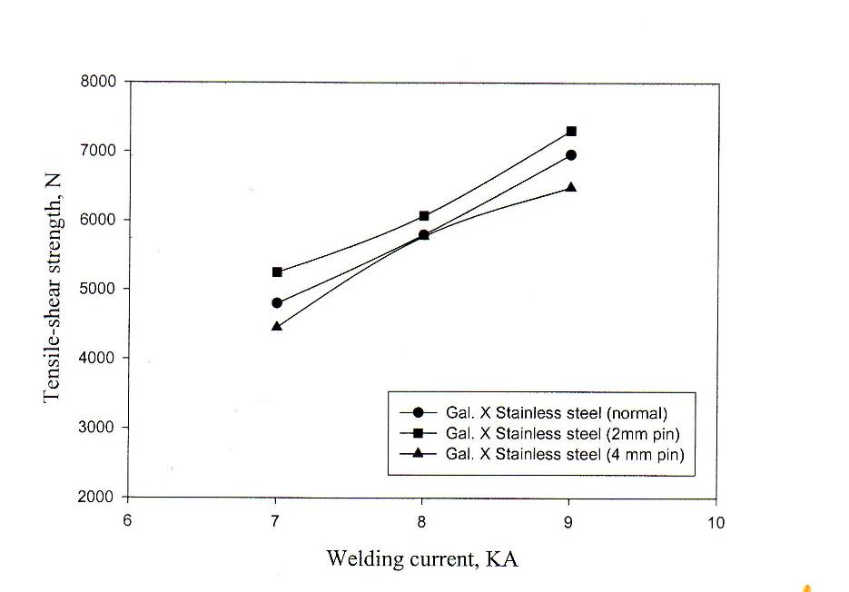
Fracture load, N

Fig. 3 Effect of welding current on fracture load

Fracture load, N N

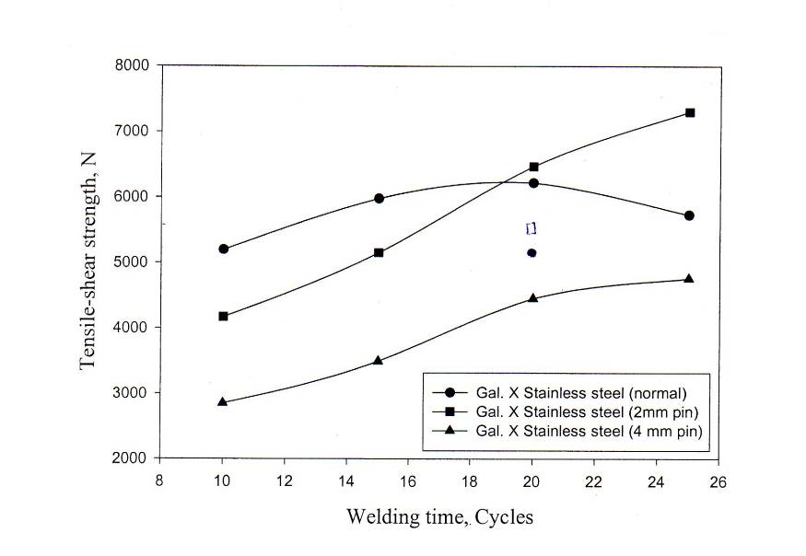

Fig. 4 Effect of welding time on fracture load

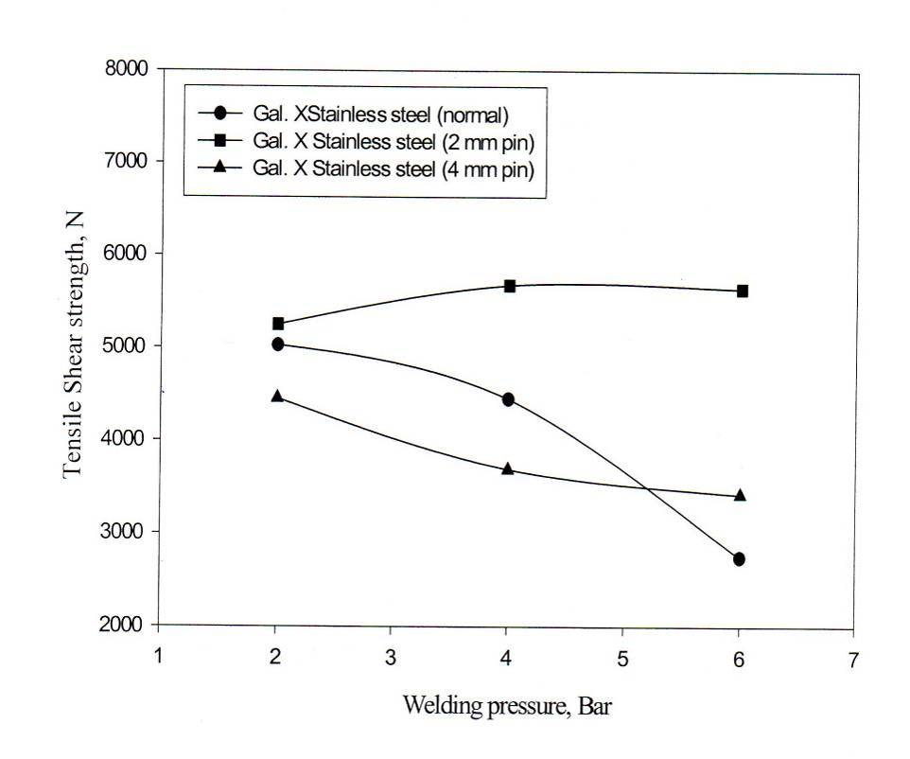

Fig. 5 Effect of welding pressure on fracture load
Fracture load, N

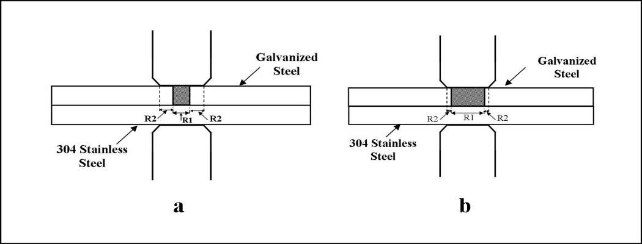

Fig. 6 Schematic diagram showing the interfacial resistance using 2 mm (a) and 4mm (b)

inserted pins

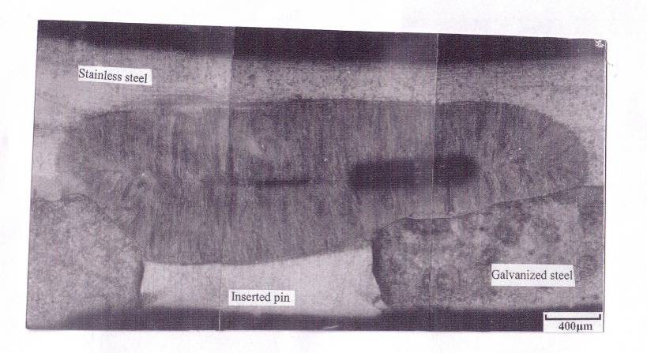  (a) | 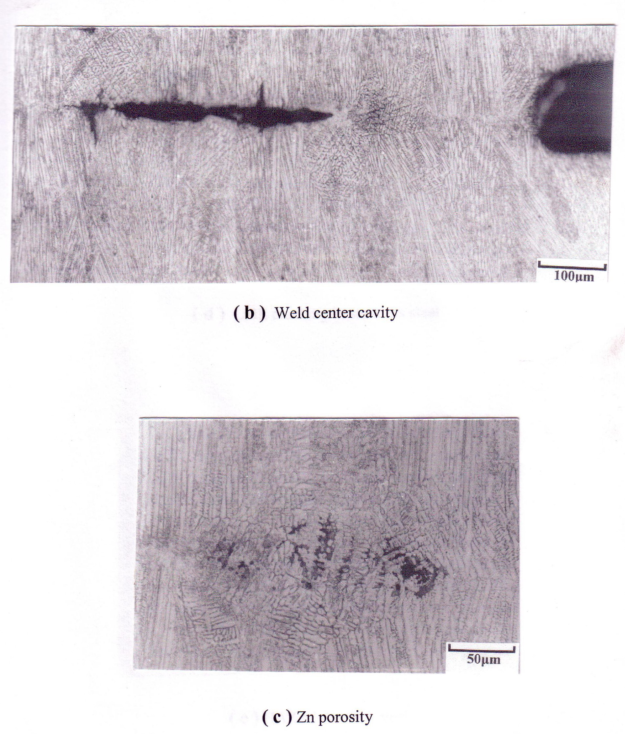  (b)
(c) | 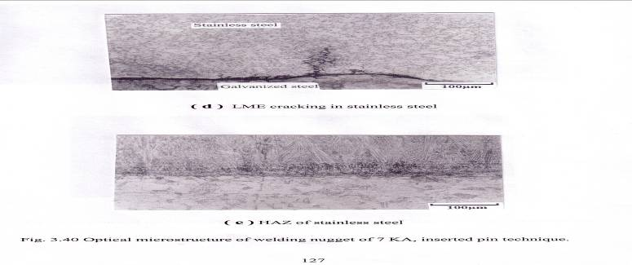  (d)
Fig. 7 Optical microstructure of welding nugget of 7 kA, inserted pin technique

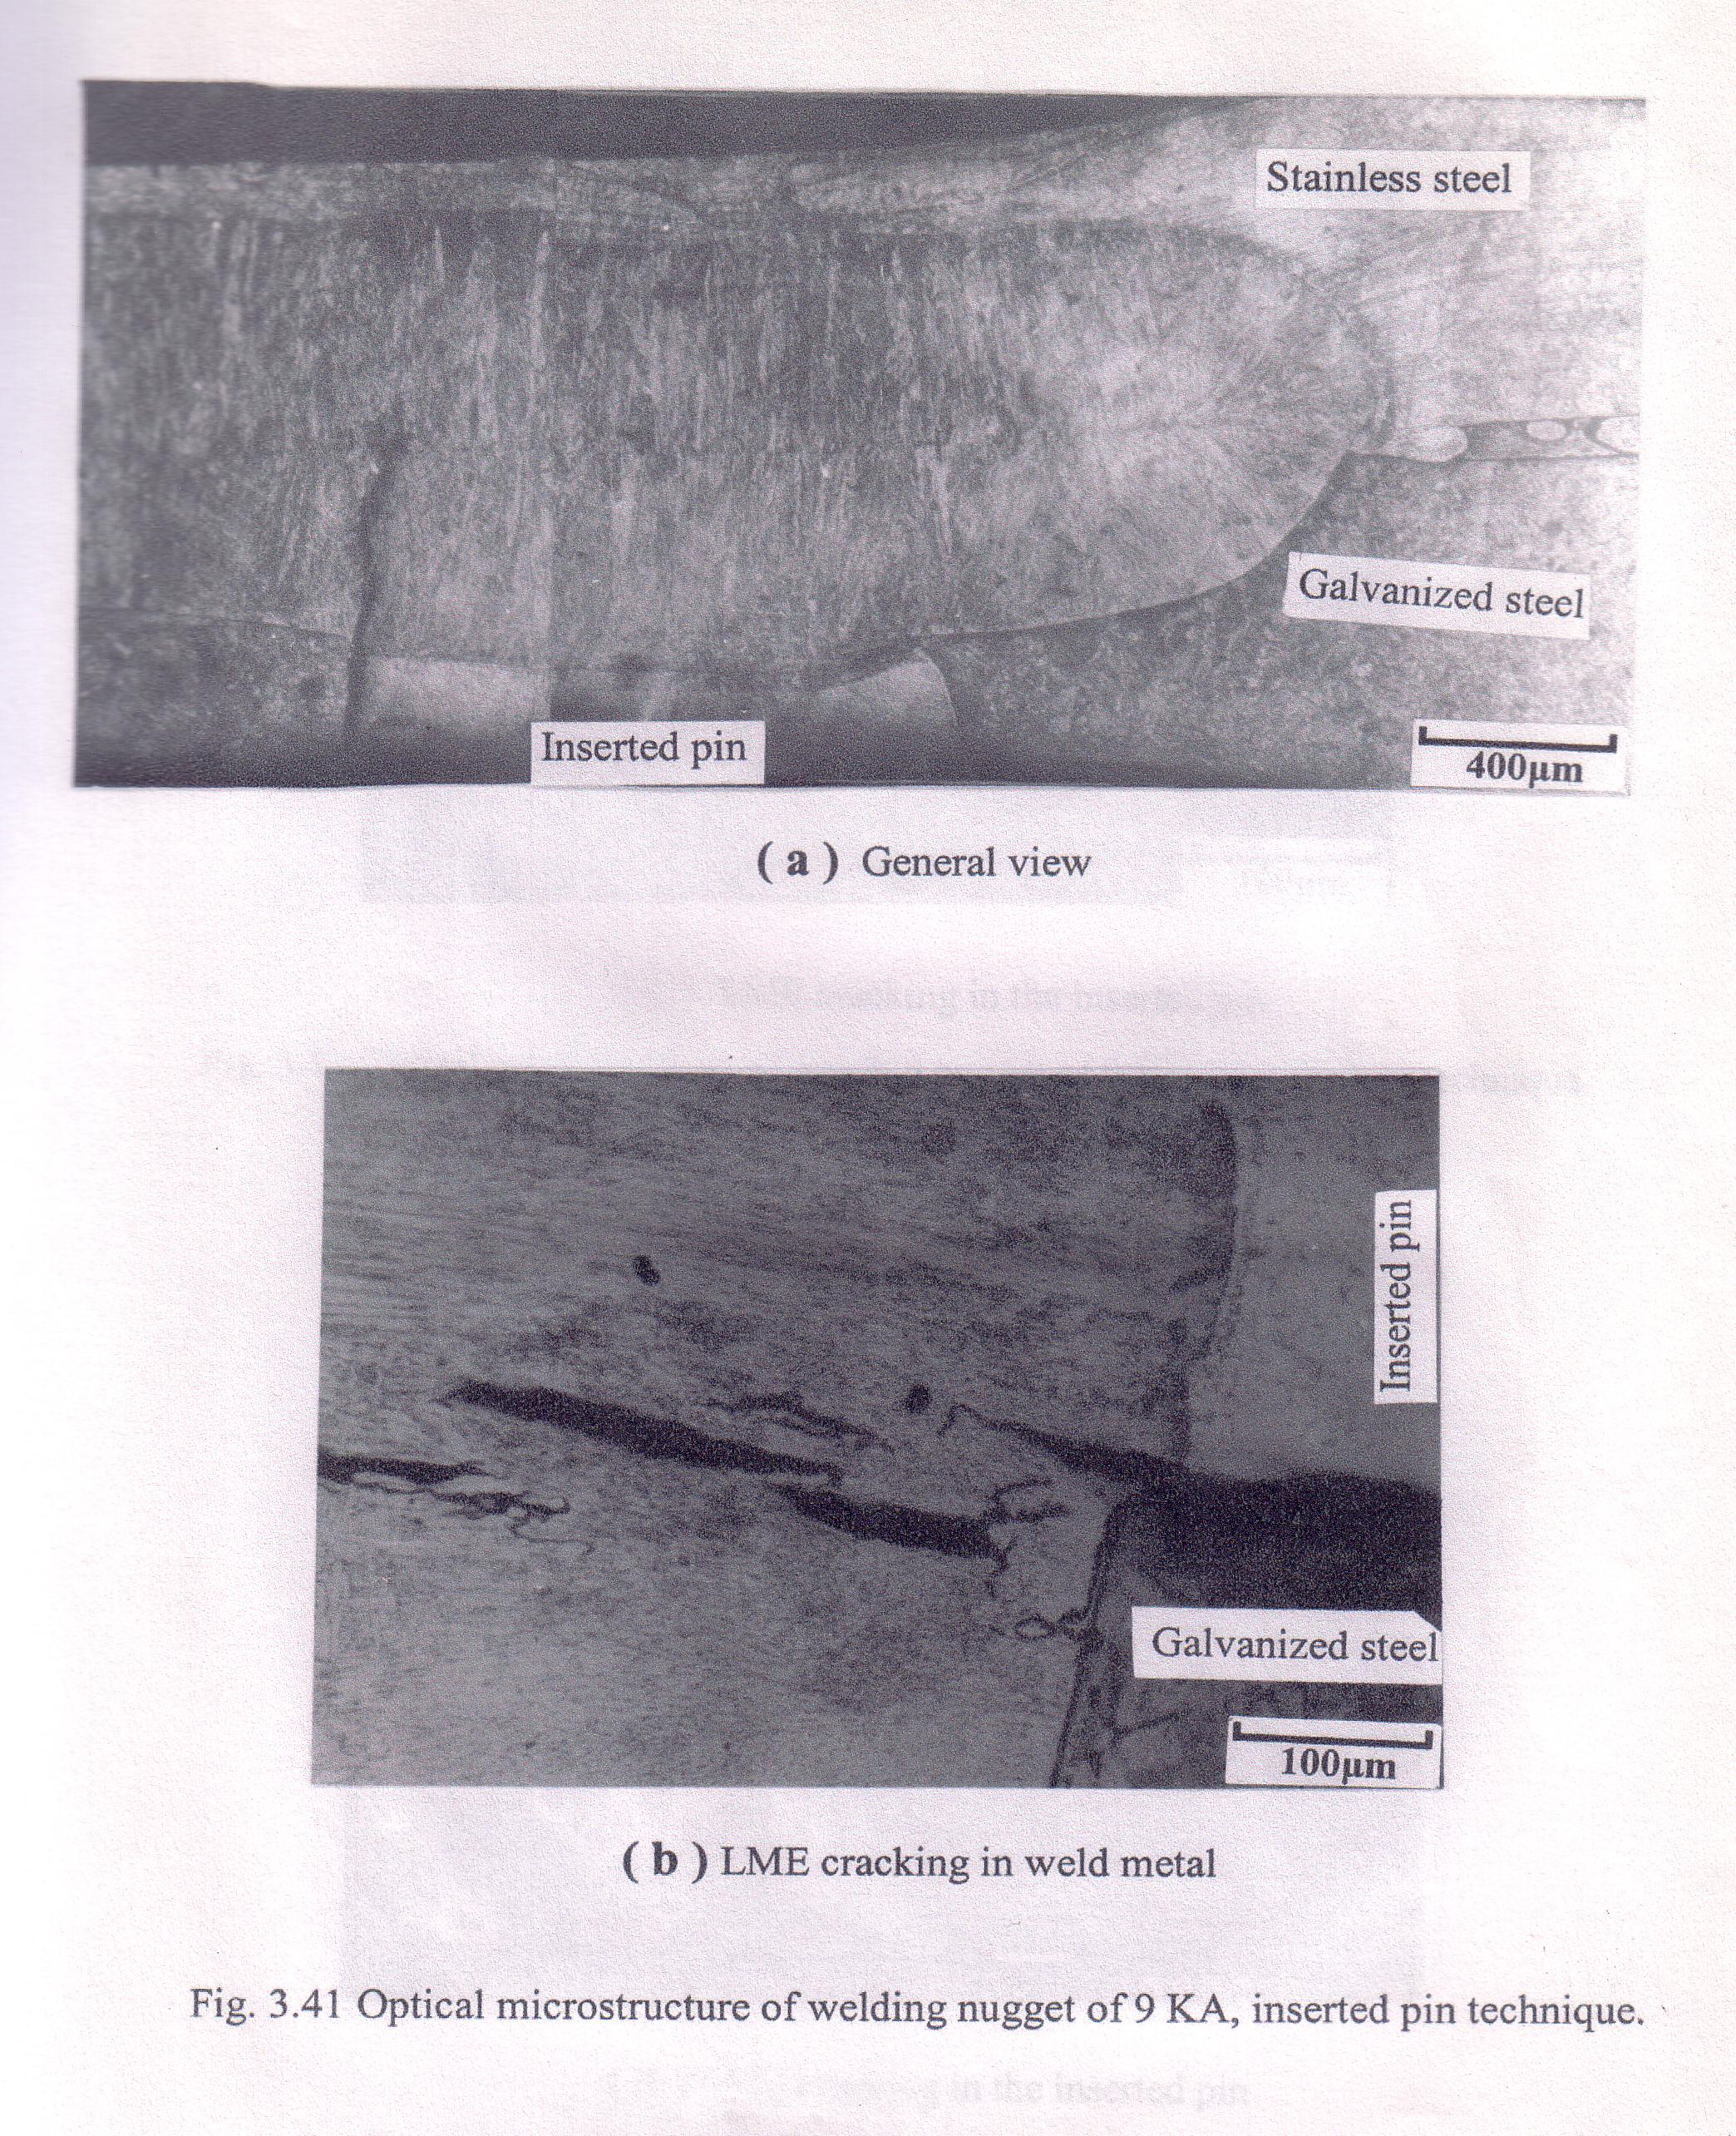  (a) | (b)
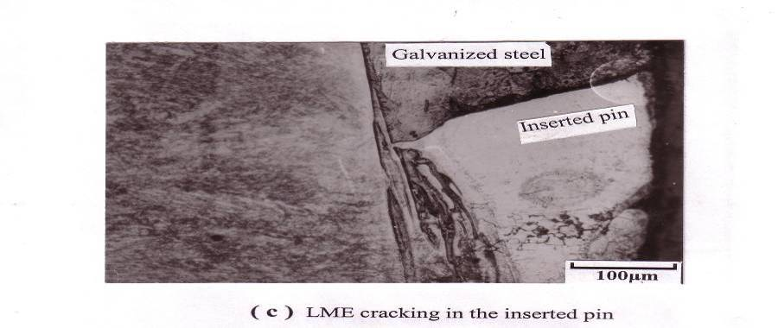  (c) | 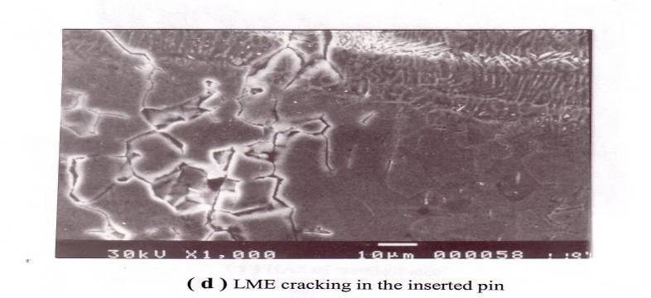  (d)
Fig. 8 Microstructure of welding nugget of 9 kA, inserted pin technique

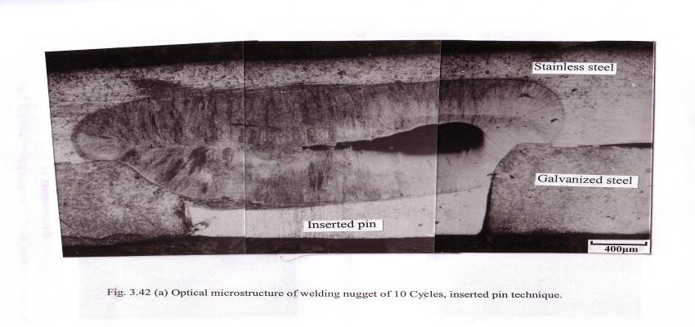  (a) | 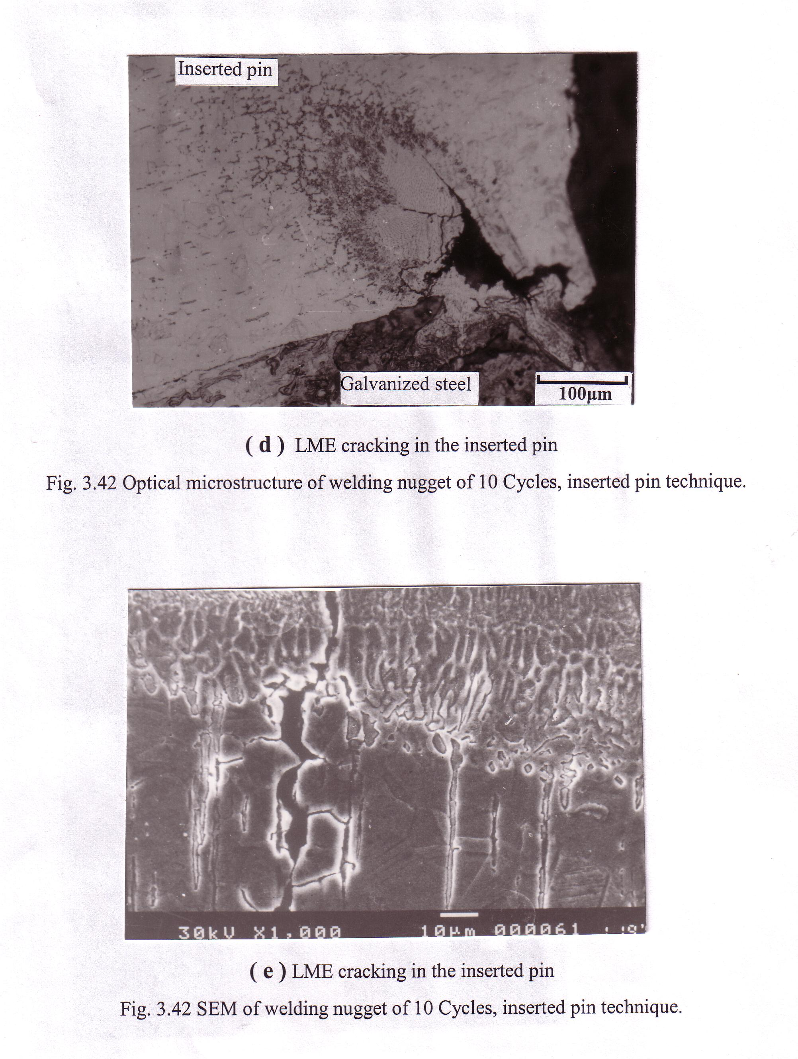  (b)

(C)
Fig. 9 Microstructure of welding nugget of 10 Cycles, inserted pin technique
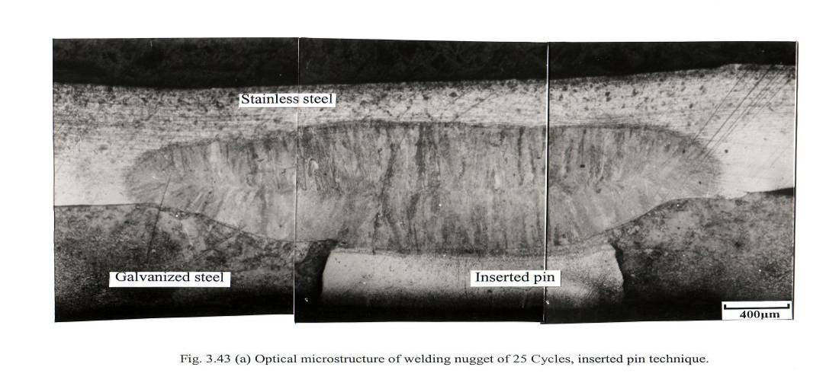
Fig. 10 Optical microstructure of welding nugget of 25 Cycles, inserted pin technique
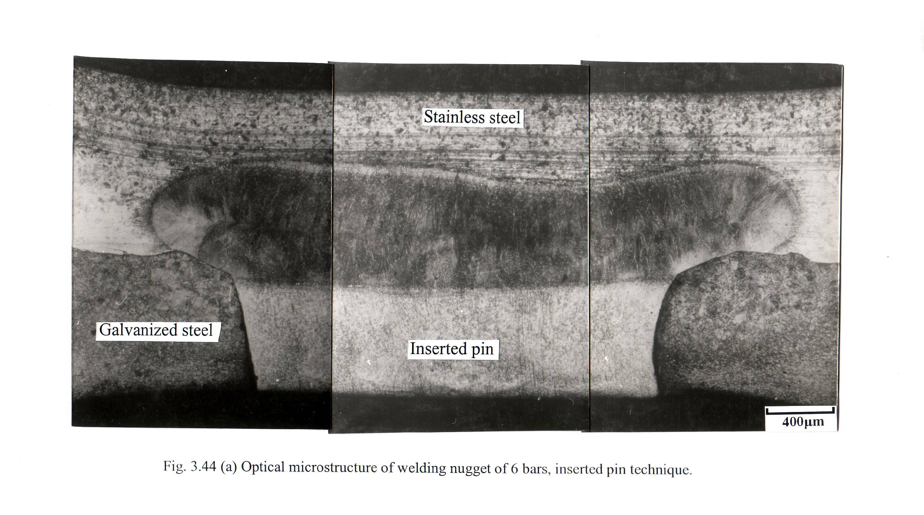

Fig. 11 Optical microstructure of welding nugget of 10 Cycles, inserted pin technique

4. Conclusion
Resistance spot welding of galvanized steel to stainless steel was conducted using inserted pin technique. The following results are obtained and compared with normal welding technique:
1. The joint made using 2mm inserted pin showed higher fracture load than that of normal technique. However, using 4 mm inserted pin resulted in a significant decrease in the fracture load as compared with the normal one. The fracture load increased with the increase of welding current.
2. At shorter welding time (10 and 15 cycles), normal welding technique showed higher fracture load than that obtained using inserted 2 mm pin technique.
3. At longer welding time (20 and 25 cycles), the joints showed higher fracture load using inserted 2mm pin technique than that obtained using normal technique.
4. Using inserted 2mm pin technique significantly improves the fracture load of welded joints with the increase in welding pressure as compared with normal technique. However, using 4mm inserted pin resulted in a slight decrease in the fracture load with the increase in welding pressure as compared with 2mm inserted pin.

Corresponding author
M.A. Morsy
CMRDI, Cairo, Egypt
morsy_abokhala@yahoo.com

4. References
- M. A. Morsy and M.B. Zaghloul, Effect of welding parameters on the quality and microstructure of the resistance spot welded joints, TESCE, Vol. 27, NO.2 October 2001, p319.
- M. A. Morsy, A.A Sadek and Essam R. I. Mahmoud, Weldment cracking in resistance spot welding of galvanized steel and stainless steel, to be published, TIMS Bulletin.
- S. Satonaka, K. Tsukamoto, H. Kiyoto and H. Shirskawa , Resistance spot welding for dissimilar sheet metals, IIW Doc. No. III-1180, 2001.
- H. Oikawa and T. Saitoh, Resistance spot welding of steel and aluminum sheets using inserted metal, Welding international, 13 (5), 1999.

