Utilization potentials of rubber seed oil for the production of Alkyd Resin Using Variable Base Oil Lengths.

M.C. Menkiti * and O.D. Onukwuli

Department of Chemical Engineering,
Nnamdi Azikiwe University Awka, Anambra State, Nigeria.
*Corresponding author : cmenkiti@yahoo.com

ABSTRACT: This work presents the potential utilization of Rubber Seed Oil (RSO) as a base oil for the production of alkyd resin using a nine sample oil lengths of 40,50 and 60%. The basic feed stocks for the production of the alkyd resin are RSO; Pthalic anhydride and Glycerol reacted at different stipulated ratios. The methodology employed is the experimental frame works and procedures developed by Rubber Research Institute of Nigeria (RRIN), Iyama, Benin City, Project Research and Development Institute (PRODA), Enugu and America Standard for testing of Materials (ASTM), USA. The parameters tested for both the RSO and produce alkyd resin include: Colour, specific gravity, viscosity, smoke point, flash point, saponification value, acid value and iodine value. Experimental results show that the acid value, iodine value and saponification value range from 8.08 to 10.60mgNaOH/g oil, 46.4 to 86.18 gI₂/100g oil; and 389.90 to 531.08mg NaOH/g fat, respectively. It can be concluded that the 60% of oil length is of the best drying qualities in terms of tack free conditions with respective to the oil investigated and at the conditions of the experiment.
New York Science Journal 2011;4(2):51-59]. (ISSN: 1554-0200). http://www.sciencepub.net/newyork.

Key words: Rubber seed oil, Alkyd Resin, Saponification, Pthalic anhydride, Base oil length, Glycerol.

INTRODUCTION
Natural rubber plant, otherwise known as Hevea brasilensis in botanical field is a high utility resource base. Currently, there are widespread abundance of rubber in Nigerian states of Edo, Oyo and Ondo that can source adequate amounts of latex, cake meal and RSO, which is a potential base oil for the manufacture of alkyd resins. These rubber derivatives find their uses in the manufacture of leather, putty, soaps/detergents, cosmetics, drugs and alkyd resins, which is the subject matter of this study.
The RSO is unique because of its relative abundance, level of unsaturation and possession of similar properties with linseed oil, which is traditionally employed in the manufacture of Alkyd Resins (Aigbodion ,1991). In addition, due to non use of RSO for edible purposes,it stands out as a veritable substitute for the linseed oil which is currently being imported into the country at a great cost.
However, doubts have been expressed about the sustained successful use of RSO for the large scale production of alkyd resin. Such doubts are attributed to fears that low percentage yield may result from the sourcing of oil from the rubber seed. Against this backdrop, many works had been conducted to verify the sustainability of RSO in the manufacture of alkyd resin. As a further step in this direction, this work attempts to contribute to the pool of scientific knowledge for the possible application of RSO in the production of alkyd Resin at industrial scale. The major aspects of the study were concentrated in the investigation of (a) the physiochemical characteristics of RSO and production RSO based alkyd resins (b) variation of Acid value (AV), Average Molecular weight (M_{AV}) and Degree of polymerization (DP) with reaction time (c) Effects of AV and DP on drying time of the RSO based Alkyd resin. Nine samples formulations (composed of RSO, Pthalic anhydride and Glycerol) of 40, 50 and 60% Oil lengths (OL) were considered using Lead Oxide (PbO), Lithium hydroxide (Li OH) and calcium carbonate (CaCO₃) as catalysts.
It is expected that the successful application of RSO as good substitute for linseed oil and other edible oils in the manufacture of alkyd resin will conserve the nations foreign exchange and lessen the pressure on the demand for edible oils. This will ultimately translate to low prices for the edible oils and other associated products derivable from them.

MATERIALS AND METHODS.
a. Extraction of oil from rubber seed.
The extraction of oil from rubber seed was performed based on solvent extraction using soxhlet extractor. The framework of the procedure is based on RRIN (2004) and ASTM (1973) manuals.

b. Characterization of refined rubber seed oil (RSO).
The characterization of RSO was performed based on RRIN (2004) and ASTM (1973) frame works and procedures. The characterization involved the determination of the following parameters: colour, specific gravity, viscosity, smoke point, flash point saponification value, acid value and iodine value.
c. Production of rubber seed oil (RSO) based medium alkyd resin.
The RSO based medium alkyd resin was produced based on frame work manuals and procedures developed by PRODA (2004), and RRIN (2004). The production was carried out for three different oil lengths of 40%; 50% and 60%.Each of the oil length alkyd resin were processed with three different catalyst namely lead (II) oxide, lithium hydroxide and calcium carbonate. The samples are arrayed below:

Samples | Catalyst oil length (OL) | Common catalyst
I | PbO-40% OL
II | PbO-50% OL | Lead Oxide , PbO
III | PbO-60% OL
IV | LiOH-40% OL
V | LiOH-50% OL | Lithium Hydroxide, LiOH
VI | LiOH-60% OL
VII | CaCO₃-40% OL
VIII | CaCO₃-50% OL | Calcium Carbonate, CaCO₃
IX | CaCO₃-60% OL

The following formulations were made for each sample:

Sample | Formulation | Amount (g)
Sample I,IV,VII 40%-Oil Length | Rubber Seed Oil (RSO)  Phthalic anhydride  Glycerol  Total | 120.00  120.63  59.37  300.00
Sample II,V,VIII 50%-Oil Length | Rubber Seed Oil (RSO)  Phthalic anhydride  Glycerol  Total | 150.00  102.96  47.04  300.00
Sample III,VI,IX 60%-Oil Length | Rubber Seed Oil (RSO)  Phthalic anhydride  Glycerol  Total | 180.00  89.92  30.18  300.00

d. Characterization of RSO Based medium Alkyd Resin.
The characterization was performed based on RRIN (2004) and ASTM (1973) frame works and procedures. The characterization involved the determination of the following parameters; acid value, saponifaction value, iodine value, colour, specific gravity and viscosity.

e. Determination of Degree of polymerization DP.
The degree of polymerization was determined according to the theory of end-group analysis (Aigbodion and Pillai; 2001). The mathematical expressions are outlined below:
DP=(1-Pav)⁻¹
Pav = (Co-C_{t})/Co
Where Pav is extent of esterification reaction
Co is the initial acid value
C_{t} is the acid value after time, t, of the reaction

RESULTS AND DISCUSSION
The results and discussions arising from the work are presented as shown below:
- Characterization results for the RSO and RSO Based Alkyd Resin
- Variation of acid value (AV) with time
- Variation of Degree of polymerization (DP) with time
- Variation of average molecular weight (Mav) with time
- Effect of AV on drying time of the resin
- Effect of DP on drying time of the resin

a. Characterization result for the RSO and RSO based alkyd resin
The characterization results are presented in tables 1 and 2.Table 1 presents the result for rubber seed Oil (RSO) while Table 2 presents the result for the produced RSO Based medium alkyd Resin. The two characterization results present both physical and chemical properties of the analysed samples. Observation of tables 1 and 2 shows that there are pronounced changes between the RSO and the alkyd resin in the following parameters: colour, acid value, saponification value and iodine value. The brown colour observed in the alkyd resin could be attributed to the oxidation reaction that is associated with the production process. Generally, there are increase in the values of acid value, saponification value and iodine value for the alkyd resin when compared to that of RSO.
From table 2, the alkyd samples were produced at acid value below 10mg NaOH/g. This is because a higher acid value translates to reduced drying rate, since acid group usually delay drying rate (Hymore and Audu,1991). In addition, industrial products (such as paints) formulated with alkyd resin of high acid value usually cause rusting or corrosion of substrate surfaces. Hence, such alkyds are associated with poor performance characteristics.The RSO alkyd resin samples produced had a higher saponification value when compared to that of the RSO. This can be attribute to the dominance of ester links in the alkyd resin (Aigbodion and Pillai , 2001).
The iodine value points at the level of unsaturation, thus it affects the drying qualities. For the alkyd samples, the iodine value increases as oil length increases. This stems from the fact that the level of double bonds of unsaturated fatty acid molecules increase with oil length. Consequently, the higher the iodine value, the higher the drying qualities of the alkyd resin (Gardner ,1948). The short oil length alkyd resin has the highest value of viscosity among the three lengths. This variation in viscosity is consistent with the degree of polymer formation during alkyd production.

(b)Variation of AV with time
Acid value expresses the mass (here mg) of (KOH/NaOH) needed to neutralize the free acid in a unit mass (gramme) of test sample. This parameter is used for monitoring and verification of the completion time for the reactions that produce RSO Based Medium Alkyd Resin. Figures 1 to 6 show that the AV decreases as the reaction time progresses. The curves show two distinct portions: the early and late stage. AV decreased faster at early stage of the reaction than late stage. Kienle (1949) reported a faster reaction during early stages of the reaction and attributed it to high rate of conversion of glycerol and phthalic anhydride. It can be observed that in between two stages, their seems to be an abrupt drop in the acid values of the samples. A similar variation in AV was reported by Aigbodion (1991) for the poly condensation of glycerol and phthalic anhydride.
The observed pattern of AV with time may be explained in terms of reactivity of the primary (α) and secondary (β) hydroxyl groups of glycerol with carboxyl group of pthalic anhydride (Aigbodion and Okeimen 2002;Aigbodion and Pillai 2001).It was reported that α-OH group of glycerol react much faster than β –OH groups. This accounts for the initial rapid decrease in acid value which corresponds to the time when α- OH groups reacted with phalitic anhydride. However, the gradual decrease of the AV on the second stages corresponds to time when β-OH group was reacting (Aigbodion and Pillai 2001).
Bobalek and Chiang (1964) and Yahaya et al (2001) argued that the region of sharp decrease in AV indicated the beginning of gelation (i.e formation of three dimensional networks) that results in the retardation of esterification reaction due to the physical limitation in molecular interaction.In another account, Aigbodion and Pillai (2001) and Aigbodion and Okieimen (2002) proposed that the abrupt decrease in AV is due to the phase heterogeneity arising from the formation of large molecules.Figure 1 shows that the 40% oil length resin processed faster than the 50% oil length. 60% oil length processed with least speed. One possible explanation is that the concentration of pthalic anhydride in the reaction mixture is greater for the 40% oil length alkyd formulation. This results to the crowding of reacting particles and high collision frequency that produces increased rate of conversion of pthalic anhydride. The easy monitoring of the conversion of pthalic anhydride explains why it is employed as a measure of reaction rate.
Figure 4 shows that the PbO, LiOH and CaCO₃ catalysts have fastest, faster and fast processing speed respectively, for the alkyd. The processing efficiency of PdO is attributed to high rate of adsorption of reactants on the catalyst sites where surface reaction occurs. This catalyst action reduces the activation energy required in the esterification thereby allowing more molecular collision to speed up the reaction. LiOH has higher affinity to adsorb reacting particle more than CaCO₃, and this explains why LiOH processed the alkyd at a greater rate. Similar trends of behaviors are observed in figures 5 and 6.

(c) Variation of DP with reaction time
The graphical variation of DP with time is presented in figures 7 to 9. It is expected that the graphs should be linear throughout the reaction. However, figures 7 to 9 show that the DP increase linearly at the early stage of the reaction up to the gel point (i.e. the point at which network formation commenced), where deviation from linearity occurs. The initial linear portion corresponds to a period where the primary hydroxyl (α-OH) group of glycerol reacted rapidly with carboxyl group of pthalic anhydride to form linear molecules ( Aigbodion and Okieimen , 2002). This point of commencement of deviation from linearity indicates the portion at which the secondary hydroxyl (β-OH) group (which is less reactive than α-OH) reacts with the pthalic acid to form three dimensional molecules (Yahaya et al , 2001).
The region of deviation from linearity has been termed nucleation phase (i.e the beginning of microgel formation) (Yahaya et al, 2001). This region is considered to mark changes in physical characteristics (such as viscosity ) of the reaction.Figures 7 to 9 show that 40% OL attains the highest degree of polymerization at the shortest possible time. This is followed by 50% and 60% OL. This can be accounted for by reaction stoichiometric ratio for the formation of the samples. By implication, OL with the highest proportion of pthalic anhydride in the ratio has the highest degree of polymerization within the shortest reaction time. Therefore, 40% OL with highest proportion of anhydride (1.5:1 for monoglycerid:anhydride) has the highest Dp, followed by 50% OL and 60% OL. The highest DP attained by 40% OL translate to corresponding highest degree of gelation and viscosity of 40% OL among the three oil lengths.

(d) Variation of Average Molecular Weight With Reaction Time.
The graphical variation of Mav with reaction time is very similar to that of figures 7 to 9. In effect, if Mav is plotted in place of DP it produces curves similar to figures 7 to 9.The low molecular weight associated with early period of these reactions is due to low degree of Polyesterification. As the polyesterfication reaction proceeds, the average molecular weight of the reaction samples increase until it gets to nucleation phase of gelation that marks the commencement of structural changes in the polymer size of the molecule in the solution (Yahaya et al, 2001).

(e) Effects of Acid value and Carboxyl Functionality (F-COO) on Drying time of the Resin
Alkyds processed to a low acid value dries faster as presented in figure 10. This is expected because the F-COOH of the pthalic anhydride known to delay drying would have been consumed. The decrease in acid implies a higher conversion of acid groups that were initially present in the alkyd mixture. It follows that as the the percentage conversion of the acid group increases, the reaction goes toward completion and the finished alkyd attains a low acid value. Consequently, the alkyd resin dries faster as the extent of conversion of the acid group in the alkyd mixture increases.

(f) Effect of degree of polymerization on the drying time of resin film (set to touch)
The effect of DP on the drying time of the alkyd resin is presented in figure 11. The plot shows that as DP increases, the drying time decreases. As the DP increases, a critical stage is reached when nucleation process commences. This stage of nucleation is generally believed to correspond to microgel formation. It has pronounced effects on drying time such that further increase in nucleation site do not have proportional effect when compared to the effect at early stage (Hymore and Audu ,1991). The microgel particles facilitate oxygen uptake and consequently speeden up drying.

Table 1: Characterization Result of Refined Rubber Seed Oil (RSO) Stock.
Parameters | Result value
Colour | Golden yellow
Specific Gravity (25⁰C) | 0.9201
Viscidity (cs) | 30.21
Smoke point (⁰C) | 250.00
Flash point (⁰C) | 300.00
Saponification Value (Mg NaOH/g fat) | 192.05
Acid Value (Mg NaOH/g Oil) | 2.22
Iodine Value (gI₂/100g oil) | 135.00

Table 2: Characterization Result for the Produced Nine Alkyd Resin Samples
Parameters | Sample I | Sample II | Sample III | Sample IV | Sample V | Sample VI | Sample VII | Sample VIII | Sample IX
Acid Value  (Mg NaOH/g oil) | 9.19 | 9.39 | 8.48 | 8.20 | 8.08 | 10.60 | 8.18 | 10.20 | 10.12
Saponification Value (MgNaH/g fat) | 38.99 | 427 | 521.0 | 391.39 | 430.47 | 524.16 | 392.33 | 429.20 | 531.08
Iodine Value  (gI/100g oil) | 45.22 | 59.08 | 83.70 | 46.4 | 61.14 | 86.18 | 47.7 | 60.5 | 85.65
Colour | Dark brown | Dark brown | Dark brown | Dark brown | Dark brown | Dark brown | Dark brown | Dark brown | Dark brown
Specific gravity | 0.960 | 0.956 | 0.944 | 0.971 | 0.967 | 0.951 | 0.968 | 0.952 | 0.931
Viscosity (cs) | 40 | 28 | 20 | 47 | 34 | 25 | 42 | 31 | 22

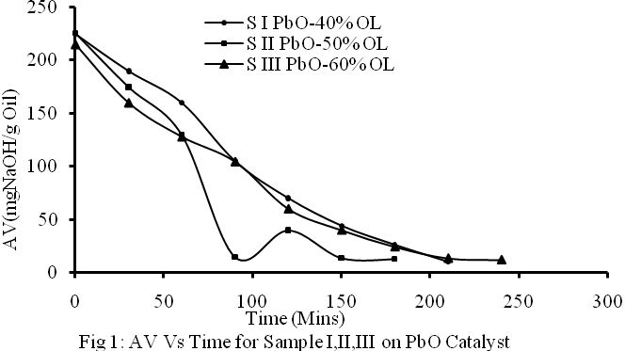

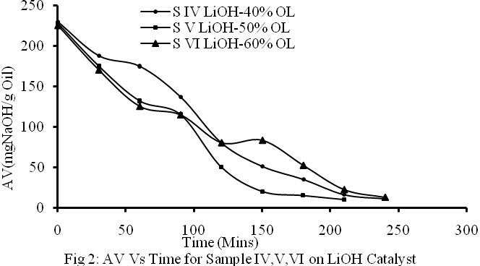

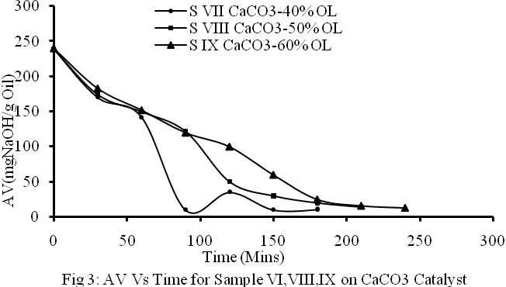

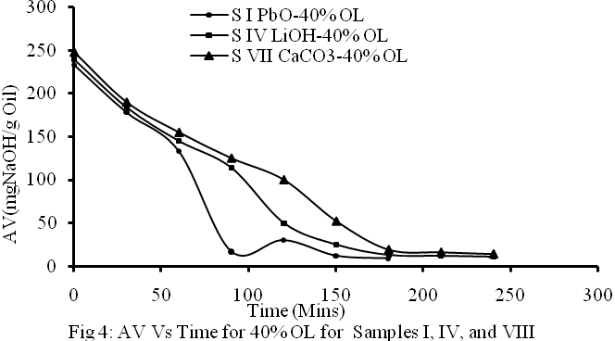

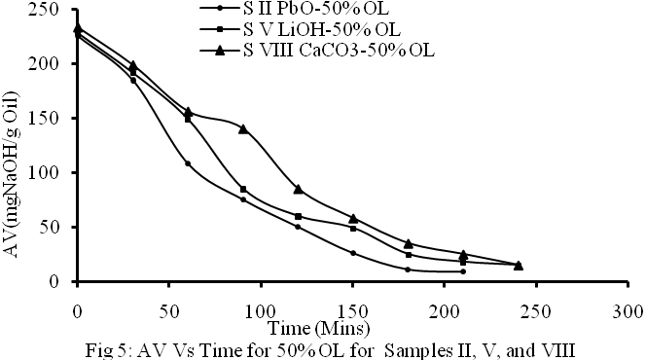

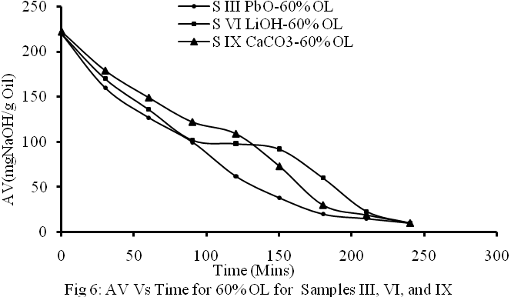

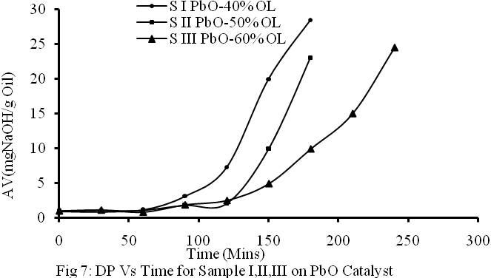

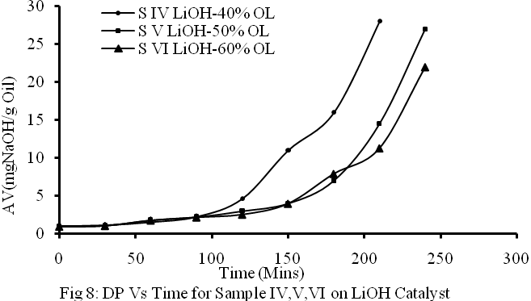

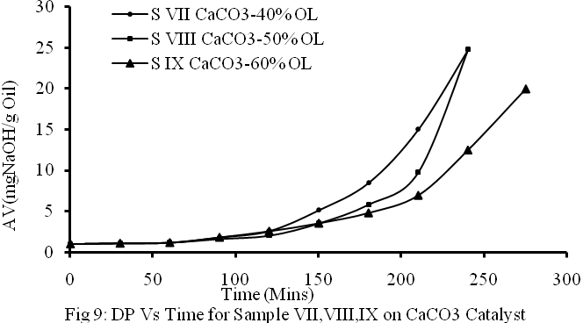

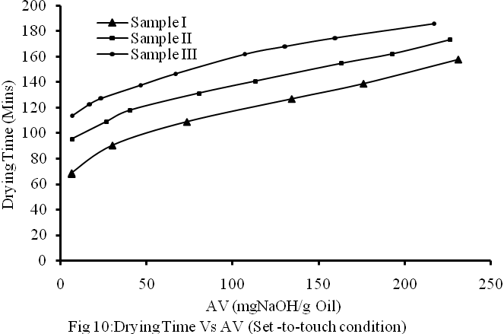

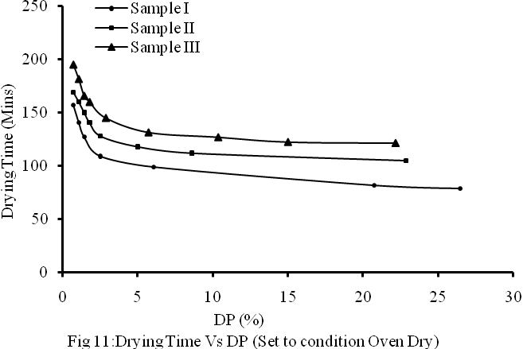

CONCLUSION
The 60% oil alkyd formation has shortest drying time at tack free condition. This is followed by 50% and 40% of alkyd resin formulations. 60% OL formulation has least cost of production since it has least quantities of material for its formulation.Processing of the alkyd resin to a low acid value of 10% gives a finished alkyd resin of excellent air drying time. Also., LiOH catalyst has the most desired drying and performance effect on the produced alkyd resin sample.Characterization result of RSO indicates that it has a high potential in the manufacture of alkyd resin. Hence, it can serve as a substitute for the edible oils.

REFFERNCES
Aigbodion, A.I (1991): Prelimanary Studies on the preparation of rubber seed oil, Indian journal of Natural Rubber Resaerch, 4(2): 114-117.
RRIN (2004); Extraction Methods;Rubber Research Institute of Nigeria, Benin City, Nigeria.
ASTM (1973); Characterization Producers for Drying Oils ; part 20:1-18: USA.
Eze, U.H (2004): Synthesis and Properties of Rubber Seed Oil Based Medium Alkyd Resin, B. Eng thesis; ESUT, Enugu, Nigeria.
PRODA (2004); Alkyd Resin production procedures; project development and Research Institute, Enugu.
Aigbodion, A.I and Pillai, C.K.S (2001); Synthesis and molecular weight characterization of Rubber Seed Oil- modified Alkyd Resin; Journal of Applied Polymer Science. Vol. 32, No9, pp 1105-1108.
Hymore, F.K and Audu, T.O.K (1991); Studies on the drying of a rubber Seed Oil Based Medium Alkyd Resin: In Eze U.H (2004) B. Eng. Thesis, ESUT, Enugu.
Gardner, H.A (1948); Driers for drying oil; Journal of the American Oil Chemist’ society; Vol 36; pp 570-571.
Kienle R.H (1949); The polyhydric Alcohol-Polybasic Acid Reaction; Ind. Eng. Chem. No 41,pp726-731.
Aigbodion A.I & Okieimen, F.E (2002); Kinetics of the Preparation of Rubber seed Oil Alkyd ; European Polymer Journal, Vol. 32 No 9; Pp 1105-1108
Bobalek, E.C & Chang M.T (1964); Synthesis and Properties of some Alkyds of more Complex Carboxylic Functionality, J. Appl. Polymer Sc. No 18, Pp 1147-1168.
Yahaya L.E., Aigbodion, A.T and Bakare J.O (2001); Investigation of Network Formation in Rubber Seed Oil Alkyd System by Dilute Solution Viscometry. Nigerian Journal of science, Vol. 35, No 2, Pp 117-122.

31/12/2010

