Perception of Ghanaian mango farmers on the pest status and current management practices for the control of the African invader fly Bactrocera invadens (Diptera: Tephritidae)

Abdullahi G¹., Obeng-ofori, D²., Afre-Nuamah, K³., and Billah M. K⁴.

1 Department of Crop Science, Adamawa State University, P.M.B. 25, Mubi, Nigeria. E-mail-
2 Crop Science Department, University of Ghana, Legon. 3 Agricultural Research Centre, Kade, Institute of agricultural Research, University of Ghana: 4 Zoology Department, university of Ghana Legon.
gatsaranyi@yahoo.com

Abstract: The African invader fly Bactrocera invadens Drew, Tsuruta and White, generally considered as the most devastating pest of mango was detected in Africa (in Kenya, East Africa) in 2003. It was first detected in Ghana, West Africa in 2005. The perception of mango farmers from Dangbe West and Yilo Krobo districts in Ghana on the pest status and the current management options adopted for the control of this pest was sought by use of a Questionnaire. The survey results indicated that Ghanaian farmers rank B. invadens among the major pests of mango in Ghana. Farmers generally, believed that it is more damaging than other arthropod pest of mango. Possible losses such as loss of market value, rejection of produce at the international markets and quarantine restriction due to the presence of the pest were also reported by the farmers Several strategies are being adopted by farmers for the control of fruit flies (including B.invadens) in Ghana. These strategies include the use of insecticides, cultural control measures, and use of trappings to manage fruit flies. Some of the respondents use a combination of insecticides and cultural practices to reduce the menace of fruit flies. It was evident that farmers adopt multiple strategies to minimize the loses due to fruit flies in an IPM fashion.
[Abdullahi G, Obeng-ofori, D, Afre-Nuamah, K, and Billah M. K. Perception of Ghanaian mango farmers on the pest status and current management practices for the control of the African invader fly Bactrocera invadens (Diptera: Tephritidae). New York Science Journal 2011;4(2):74-80]. (ISSN: 1554-0200). http://www.sciencepub.net/newyork.
Keywords: Bacrocera invadens, quarantine restriction, Dangbe west, Yilo krobo, survey.

Introduction
Fruit and vegetable production is one of the fastest growing agricultural sectors providing both income and employment to growers and exporters (Lux et al., 2003a; Ekesi and Billah, 2006). The sustainability of this lucrative business is threatened by the infestation of fruit flies. Tephritid fruit flies are considered of greatest economic importance in fruit production because they are key pest of most of the fruit crops (Silva, 2008); causing millions of dollars worth of damage every year (CRC, 2009). Economically important tephritid fruit flies worldwide can be found in five genera: Anestrepha, Bactrocera, Ceratiris, Rhagoletis, and Dacus (White and Elson-Harris, 1992). The fruit fly Ceratitis cosyra has been long recognized as the most damaging tephritid fruit fly pest of mango (Mangifera indica) in Africa, including Ghana (Lux et al., 2003a). However in 2003, a new species Bactrocera invadens Drew et al invaded Africa from the Indian subcontinent (Mwatawala, et al., 2004, Drew et al., 2005). Within a span of few years, the species rapidly spread across Africa and was detected in Ghana in 2005 (Billah et al., 2006). Mango is considered the primary host of B. invadens (Ekesi and Billah 2003, Mwatawala 2009). Yield loss of 15-50% in mango was reported from some African countries especially in West Africa (Vayssierres et al., 2006).
Mango (Mangifera indica L.) is the most widely cultivated fruit tree in the Sahel and one of the most important tree crops in the tropics (Deng and Janssen, 2004). It is a highly prized exotic fruit on the European market and one of the important fruit crops grown in tropical and sub-tropical regions (Nakasone and Paull, 1998; Nofal and Haggag, 2006). World production of mango in 2005 was estimated at 28.51 million tonnes (Mt) (Evans, 2008). Of this Africa produced only 2.5 million tonnes, accounting for about 10 per cent of fresh fruits and 11 per cent of processed mango. Ghana's current production is said to have increased from about 1,200 tonnes in 2007 to about 2,000 tonnes in 2008 (Qaurtey, 2008). In Ghana, it is targeted as the next non-traditional export crop that is expected to fetch the highest foreign exchange for the country and replacing cocoa (Qaurtey, 2008). Export of 857.57 tonnes in 2008 was valued at US $521,820 (ISSER, 2009).
The presence of B. invadens in Ghana has already brought some setback in the mango trade between Ghana and South Africa. For example, mango consignment from Ghana was rejected at the port in South Africa and there was subsequent ban on import from Ghana) (Wilson, 2006).
The perception of Ghanaian mango farmers on the pest status and current management options for the control of this pest was studied in two districts in the Greater Accra and Eastern Regions of Ghana. The Objectives of this study was to assess the general perception of mango farmers on the pest status of B. invadens and to study the management practices adopted by the farmers for the containment of same.
Materials and Methods
Field surveys
A field survey was conducted between October, 2008 and January, 2009 to establish the perception of mango farmers on the pest status and current management options for the control of B. invadens in Ghana. Semi-structured questionnaires were administered to farmers selected at random with majority being members of the Papaya and Mango Producers and Exporters Association of Ghana (PAMPEAG). The study was conducted in two regions of Ghana namely, the Greater Accra and the Eastern, where B. invadens was previously reported as being prevalent (Fig. 1). In each region, a district was selected; Dangbe West and Yilo Krobo in the Greater Accra and Eastern regions, respectively.
Fifty-two (52) farmers were selected for the study, with each selected farmer having a farm size of at least, 2 ha. Stratified random sampling procedure was adopted for the study so that, each mango producing village in the selected district represented a stratum (sampling unit). Farmers were selected at random from each of the sampling units. Criteria for selection included, the farmer being in production for at least four seasons. Where applicable, farmer registration or affiliation to PAMPAEG was sought to confirm their status. This is because the level of awareness of members of the group is high due to their export disposition, which ensures adoption of reasonably fair technologies that will guarantee the production of high quality fruits. PAMPEAG officials, therefore, assisted in the selection of most of the sampling units.
Questions in the questionnaire were premised on finding information on pest problems commonly encountered by farmers in mango fruit production as well as finding the major and minor pests. Questions were also asked relating to the awareness on fruit flies, their species composition and the nature of the damage caused by fruit flies.
Farmers were also asked to rate the effect of B. invadens on fruit production relative to other arthropod pests commonly encountered in the mango agro-ecosystem. Question relating to knowledge of the economic significance of the species with regards to it being a quarantine pest and the losses it could cause in the mango industry were asked in the questionnaires. They were requested to indicate whether B. invadens was an exotic, endemic and/ or occasional pest. The concluding aspect of the questionnaire dealt with matters relating to management options adopted by farmers.

Data analysis
All data generated from the field survey (questionnaire) were analyzed using descriptive statistics (percentages).

RESULTS
Perception of mango farmers on the pest status of B. invadens.
Results from the survey questionnaire indicated that, all the respondents (100%) have encountered some sort of pest problem at a point in their career as mango producers. Several arthropod species were listed by the respondents as being pests in mango agro-ecosystems in Ghana. The arthropod pests mentioned by the farmers fell under two categories namely; major and minor pests (Table 1).
Farmers categorized pests as being major mostly on the basis of the length of time they spend dealing with them on their farms over the production period and the extent of intervention required in terms of monetary values. Few 4 (7.7%) of the farmers were of the opinion that scale insects and thrips were of major concern in the mango agro ecosystem. Majority of the respondents 40 (77.0%) indicated that mealy bugs were of major economic importance causing damage that can lead to the production of unmarketable fruits. The second in order of significance as a major pest to 39 respondents (75.0%) were the fruit flies. This proportion of farmers believed that, fruit flies caused a lot of problems leading to yield reduction in the mango enterprise. They were fully aware of fruit flies being pest of economic significance. However, some farmers simply dismissed fruit flies as houseflies that are just opportunistic and taking advantage of the abundant food (rottening) found at the peak period of harvest. To this group, no harm was done to the fruit as the result of their presence. Similarly, 38 of the respondents (73.0%) also the indicated mango stone weevils as being major pests that caused significant reduction in fruit quality especially, in those that are meant for export.

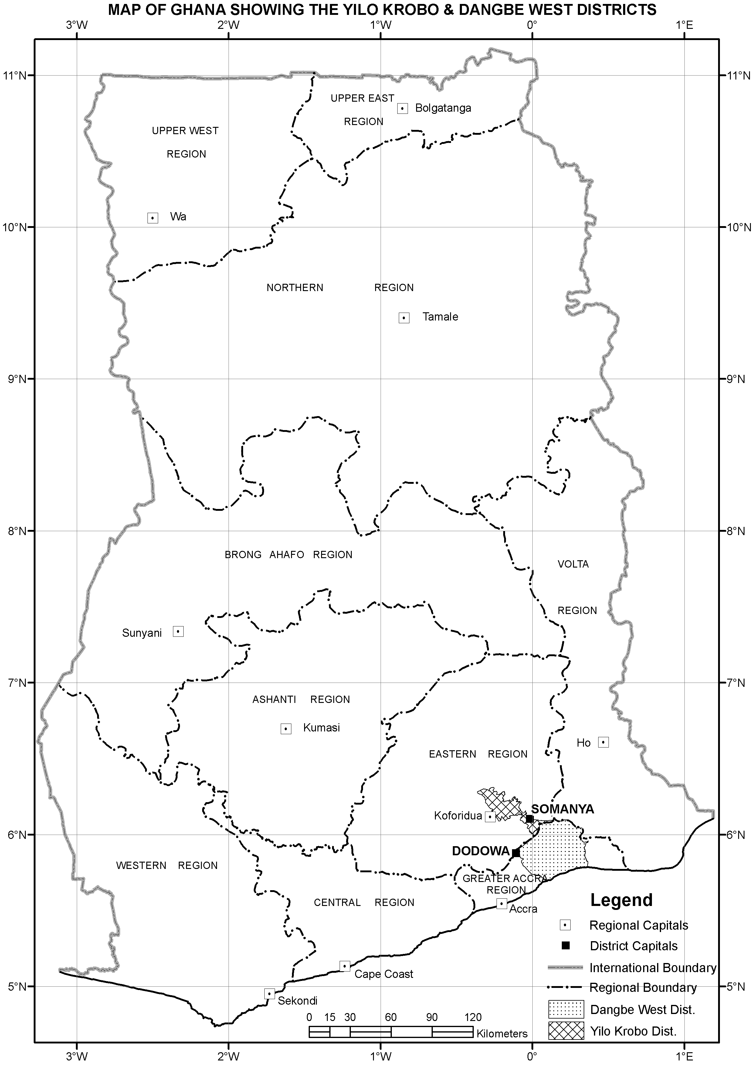

Fig. 1 Map of Ghana showing the study area (Yilo Kobo and Dangbe West districts)

Few farmers cited termites (1.9%) and ants (21.2%) as pests of major economic importance that required some attention during and even after the production cycle. Arthropod pests indicated as minor pests by the respondents during the survey included fruit flies (1.9%), grasshoppers (5.8%), mites (7.7%) and ants (32.8%).

Fruit fly species known to the farmers
Two fruit flies species were known to the farmers in the study area (Fig. 2). These species were C. cosyra and B. invadens. Forty-eight per cent (48.1%) of the farmers indicated that they knew some species of fruit flies, of these, 19.2 % attested to knowing C. cosyra and 28.8% to B. invadens. This is an indication that a reasonable number of the farmers are already aware of the presence of the African invader fly relative to other species in spite of its recent introduction and establishment in Ghana.

Table 1: Arthropod pests enccountred by farmers on mango farms
Name of Insect |  | Percentage (%) (n = 52)
(a) Major
Scale insects |  | 7.7
Thrips |  | 7.7
Mealy bugs |  | 77.0
Mango stone Weevil |  | 73.0
Fruit flies |  | 75.0
Termites |  | 1.9
Ants |  | 21.2
(b) Minor
Fruit flies |  | 1.9
Grasshoppers |  | 5.8
Mites |  | 7.7
Ants |  | 32.8

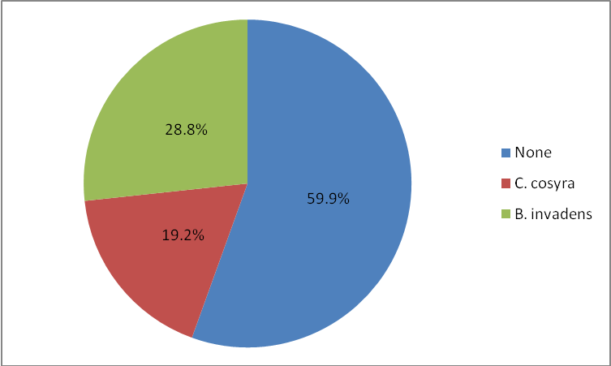Fig. 2 Percntage of respondents in relation to their knowledge of fruit fly species (n=52).
Nature of damage caused by fruit flies
The perceptions of farmers on the nature of damage caused by fruit flies also vary greatly (Fig. 3). About 25.0% of them cited fruit destruction as one of the damage caused by the invader fly. Some 15.4% of the farmers believed that, the fruit flies only pierced the skin of the fruit and sucked little quantity of the sweet juice and the fruit could easily heal the wound with no loss of market value. Others (21.2%), indicated that the species caused fruit rottening, while 7.7% of the farmers indicated that a change in colour resulted from the attack by the fruit fly, and this led to premature ripening of the fruit. Total loss in yield is the direct effect of the presence of mango fruit fly in the mango agro-ecosystem to some respondents (1.9 %), because the flies caused total destruction of the fruit leading to complete loss of yield in the absence of some intervention measures to control them.

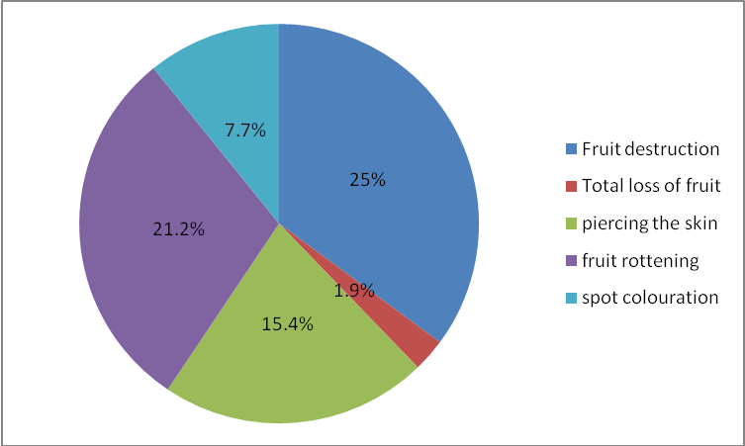
Fig 3: Perception of farmer on nature of damage caused by B. invadens in the study area (n=52).

Effects of B. invadens on fruit production
Generally, majority of the farmers (55.8%) are of the opinion that, the African invader fly caused very severe damage to the mango industry. This implies that mango producers in Ghana are aware that, the African invader fly can cause serious damage to their crops with detrimental consequences to their earnings. On the rating of the mango fruit fly relative to other pests in the mango agro-ecosystem, 50.0 % of the respondents indicated that the fly was more damaging to their fruit. Thus, mango farmers are aware of the threat posed by the invader fly to the mango industry.

Losses caused by the B. invadens
A greater number of the respondents (71.4%) admitted that, the presence of the African invader fly in Ghana causes some huge losses to farmers. These losses (fig. 4) ranged from loss of market value (51.9%), loss in quality of the fruits (51.9%), rejection of fruits at international markets (48.1%), and increase in cost of production (15.4%).

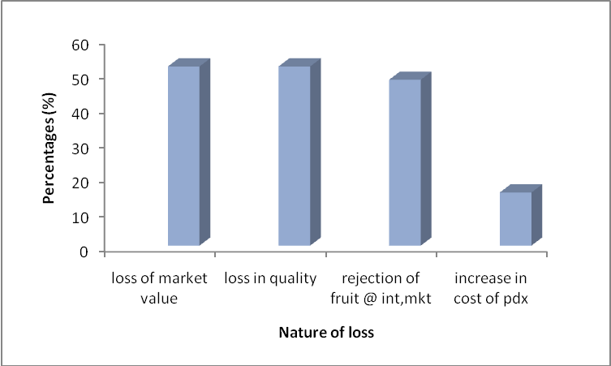
Fig. 4 Response on nature of losses incurred by mango farmers (n=52)

Pest status of B. invadens
Responding to the question on the pest status of the African invader fly, 7.7% of the respondents believed that the pest was an endemic one i.e. it has been in the system since they started the business of mango fruit production. On the other hand 38.5% of the farmers said, it was an exotic pest that found itself unto the country’s landscape some four years ago. Similarly, some 34.6% of the respondents firmly believed that it was an occasional pest occurring only when there were excess fruit in the system. About 56.9% of the farmers indicated that, the pest was of quarantine significance. Their damage could result in the loss of lucrative market opportunities from many importing countries.

Some management strategies adopted by Ghanaian farmers to control B. invadens
All the respondents (100%) have used one control measure or the other to reduce the effects of fruit flies in their bid to produce fruit that will meet the needs of their customers. Two control strategies namely chemical and cultural were dominant among all the respondents (fig. 5). Some 61.5% of the farmers apply chemicals as either a single control strategy or alongside one or more other control measure(s). Similarly, (76.9%) of the farmers adopted cultural control measures e. g. fruit destruction and farm sanitation to control the fly.
All the respondents were ignorant of any deliberate use of resistant varieties for the management of the African invader fly in Ghana. They generally believed that no variety of mango was in any way resistant to the attack of the pest and hence the use of host-plant resistance as means of controlling would be ineffective for all practical commercial purposes. Some 38.5% of the farmers attested to the use of trapping for the reduction of the male fruit flies numbers. Significant number (76.9%) used insecticides and traps in combination on their farms to combat the menace of fruit flies. Similarly, 45 respondents (86.5%) used insecticides alongside cultural practices like collection and burial of fallen fruits to maintain better sanitary conditions on their farms. This in essence, has the advantage of reducing the source of infestation. Some 38 farmers (76.1%) used a combination of insecticides, traps and cultural methods for the control of fruit flies including B. invadens (fig. 5)
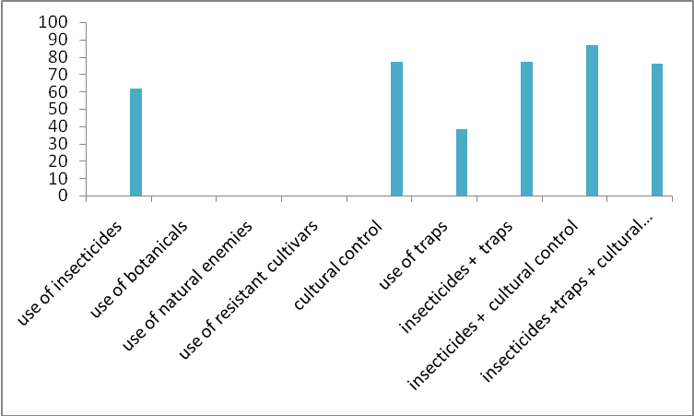
Fig. 5: Percentage adoption of different management strategies by farmers to control B. invadens in the study area (n=52).

Discussion
Farmer Perceptions of pest status and Management option for B. invadens control
The results of the survey indicated that mango farmers rank fruit flies (including B. invadens) among the major pests of mango in Ghana (Table 1). This is an indication that Ghanaian mango farmers are already aware of the potential damage of the mango-infesting fruit flies. This confirms Vayssieres et al., (2005) observation that losses caused by fruit flies range from 12- 50% for mangos in Benin, depending on the season and management practices adopted. Thus, fruit flies inflict heavy losses on fruits and vegetable crops because of their phytophagous habits (Norrbom et al., 1999). Activities by different fruit fly species lead to these loses and vary between fruit fly species, fruit host involved and between communities. Thus, they are accorded different economic status in different farming systems in the world (Mwatawala et al., 2009).
About 48.1% of the respondents were familiar with some species of the flies, B. invadens being the most commonly cited (28.9% of the respondents). This knowledge could have been gained as a result of curiosity on the part of the farmers trying to know the identity of flies they see most often or through contact with extension workers. In essence, this is a clear indication that some farmers are already aware of this species in Ghana in spite of its recent introduction. The B. invadens was first reported from Eastern Africa in 2003 (Lux et al., 2003; Mwatawala et al., 2004). It was later reported from various parts of the continent (Drew et al., 2005), including Ghana in 2005 (Drew et al., 2005; Billah et al., 2006). The knowledge of the presence of B. invadens in mango farms in Ghana has the implication of aiding in developing solutions to minimize the menace of the pest and/or farmers accepting new innovations in tackling this pest. It also has the advantage of prompting farmers to collaborate with researchers in developing on-farm environmentally friendly strategies to reduce the losses caused by the pest.
On the effect of B. invadens on fruit production, 26 (50%) of respondents were of the opinion that fruit flies (including B. invadens) were more damaging than other arthropod pests associated with mango in Ghana. This also implies that mango farmers in Ghana are aware that tephritid fruit flies (including B. invadens) cause serious damage to their crop with detrimental consequence on their earnings. The effect of B. invadens has been earlier reported to be of a severe impact on the local economy. Local farmers elsewhere have indicated that there is a huge impact that this fly has made on their current fruit production (Yaya Toure, 2007, cited in Mwatawala et al., 2009). Some local studies have shown the predominant presence of this pest in a wide variety of hosts (Ekesi et al., 2006; Mwatawala et al., 2006, 2009; Rwomushana et al., 2008) and its high infestation rate in commercial fruits like mango (Vayssieres et al., 2005). Bactrocera invadens is currently considered as one of the major pests in Africa (Mwatawala et al., 2009). Its polyphagous nature, predominance in certain hosts and rapid spread throughout Africa (Drew et al., 2005) makes it a devastating pest (Mwatawala et al., 2009). These characteristics make it easy for recognition among farmers who are pest conscious due to inherent fear of yield loss.
On the issue of pest status of B. invadens, 38.5% of the respondents indicated that it is an exotic pest. This confirms the fact that, B. invadens is an alien species introduced to the African continent from Sri Lanka (Lux et al., 2003; Billah et al., 2006). It rapidly spread throughout Africa due to increased travel and international trade in fruit and vegetables (Ekesi and Billah, 2006), and must have therefore been introduced into Ghana inadvertently through un identified route (Billah et al., 2006).
Several strategies are being adopted by farmers for the control of fruit flies (including B.invadens) in Ghana. These strategies include the use of insecticides (61.5%), cultural control measures (75.9%), and use of trappings (35.5%) as strategies to manage fruit flies. While 86.5% of the respondents use a combination of insecticides and cultural practices to reduce the menace of fruit flies. It was evident that farmers adopt multiple strategies to minimize the loses due to fruit flies in an IPM fashion outlined by Ekesi and Billah (2006) and Obeng-Ofori (2007). There is the need therefore, to carefully study how these practices are carried out by farmers and improvement made upon them where necessary to enhance their effectiveness in fruit fly suppression.
Mango is one of the most important tropical fruit crops grown worldwide. Its demand and cultivation is also on the increase worldwide. It is targeted as the next major export crop in Ghana that has the potential of boosting the foreign exchange earnings of the country in addition to providing employment opportunities to large number of the population. Mango production is also aimed at increasing the food security of the nation by providing suitable fruit that is rich in many of the nutrients required for the proper nourishment of the body. One of the major constraints to the production of this important crop is the attack by arthropod pests, among which the African invader fly, B. invadens is most destructive. It is generally believed to cause yield losses of up to 50% in West Africa, and also ranks high among the quarantine pest of fruit and vegetable crops worldwide.
The perception of Ghanaian farmers of the pest status and current management options for the control of this pest was studied in two districts in the Greater Accra and Eastern Regions of Ghana. It was found that B. invadens is a major pest infesting mango in Ghana. The study also showed that farmers are already aware of the tremendous yield and other losses that can be incurred due to the activities of the pest. Its quarantine status was found to be clearly understood by some farmers. Management strategies such as use of insecticides, cultural control (e.g. destruction of fallen fruits), trapping alone or in various combinations in an IPM approach, have been found to be practiced against the pest by farmers in the study area.
3 Recommendations
From this study, the following recommendations could be made:
- Aggressive public advocacy campaigns should be organized by Agricultural Extension agents to increase farmer’s awareness of B. invadens and its effects on mango production.
- There is the need to study the rate of infestation of B. invadens in farmers’ field, to confirm whether there is a displacement of the indigenous species of fruit flies in the mango agro-ecosystem. This will curtail the development of new pest spectrum in other fruit and vegetable crops that may arise from host switching by those displaced species. This will also have implications on control strategies aimed at fruit fly management.
Acknowledgement
We gratefully acknowledge the German Academic Exchange Service (DAAD) for funding this research
Corresponding Author:
Abdullahi Gambo
Department of Crop Science,
Adamawa State University, P.M.B. 25, Mubi
Adamawa State-Nigeria.
E-mail: gatsaranyi@yahoo.com

REFERENCES
1 Billah, M. K., Wilson, D. D., Cobblah, M. A., Lux, S. A. and Tumfo, J. A.. Detection and preliminary survey of the new invasive Fruit fly species Bactrocera invadens (Diptere: Tephritidae) in Ghana. Journal of the Ghana Science Association 2006; 8 (2): 139-149.
2 Deng, X. and Janssen, M. Shaping the future through pruning the mango tree- A case study in Upper-Oueme, North Benin. Introduction for the IMPETUS International Conference on integrated water resource management of tropical river basins. 2004; 4th to 6th October 2004, Cotonou, Benin. http://www.tropen.uni-bonn.de/new_website /englische. accessed on 12/01/2008.
3 Drew, R. A. I., Tsuruta, K. and White, I. M. A new species of pest fruit fly (Diptera: Tephritidae: Dacinae) from Sri Lanka and Africa. 2005; 13: 149-154.
4 Ekesi S. and Billah, M. K. A Field Guide to the management of economically important Tephritid fruit flies in Africa. ICIPE Science Press Nairobi, Kenya. 2006; 206 pp.
5. Ekesi, S., Nderitu, P. W. and Rwomushana, I. Field infestation and demographic parameters of the fruit fly Bactrocera invadens (Diptera: Tephritidae) in Africa. Bulletin of Entomological Research. 2006; 96: 379- 386.
6. Evans, E. A. Recent Trends in World and U.S. Mango Production, Trade and Consumption. Electronic Data Information Source UF/IFAS Extension Publication # FE718. 2008. http://www.edis.ifas.ufl.edu/fe718. Accessed 4/20/2009.
7. ISSER. The state of the Ghanaian economy in 2008. Institute of Statistics, Social and Economic Research (ISSER), University of Ghana, Legon, Ghana. , 2009; 225 pp.
8. Lux, S. A., Ekesi, S., Dimbi, S., Mohamed, S., and Billah, M. K. Mango-infesting fruit flies in Africa: perspectives and limitations of biological approaches to their management. 2003a; pp. 277–294. In: Neuenschwander, P., Borgemeister, C., and Langewald, J. (eds.), Biological control in IPM systems in Africa. CABI Publishing, Wallingford, United Kingdom.
9. Lux, S. A., Copeland, R. S., White, I. M., Manrakhan, A. and Billah, M. K. A new invasive fruit fly species from the Bactrocera dorsalis (Hendel) group detected in East Africa. Insect Science Application. 2003b; 23: 355-361.
10. Mwatawala, M.W., White, I.M., Maerere, A.P., Senkondo, F.J. and de Meyer, M. A new invasive Bactrocera species (Diptera: Tephritidae) in Tanzania. African Entomology. 2004; 12:154-156.
11. Mwatawala, M. W., De Meyer, M., Makundi, R. H., and Maerere, A. P. Host range and distribution of fruit-infesting pestiferous fruit flies (Diptera, Tephritidae) in selected areas of Central Tanzania. Bulletin of Entomological Research. 2009; 10: 1-13.
12. Nakasone, H. Y. and Paull, R. E. Tropical Fruits. CAB International, Wallingford, London. 1998; 233 pp.
13. Nofal, M. A. and Haggag, W. M. Integrated Management of Powdery Mildew of Mango in Egypt. Crop Protection. 2006; 5: 480-486.
14. Norrbom, A. L., Carroll, L. E., Thompson, F. C., White, I. M. and Freidberg, A. Systematic Database of Names. In: Thompson, F.C. (Ed.), Fruit fly expert identification system and systematic information Database. Myia 9. 1999; pp. 65–251.
15. Obeng-Ofori, D. Arthropod Pests of mango- Mangifera indica Anacardiaceae, In: Obeng-Ofori, D. (ed.). Major Pests of food and selected fruits and industrial crops in West Africa, Ghana, City Printers Ltd. 2007; pp. 113 – 118.
16. Qaurtey, L. Mango, Ghana's untapped "Gold Mine". Ghana news agency, Ministry of Information and National Orientation. 2008. http://www.ghanaweb.com/GhanaHomepage/NewsAchive /artikel.php . Accessed on 6/7/2009.
17. Rwomushana, I., Ekesi, S., Gordon, I. and Ogal, C. K. P. Host plants and host plant preference studies for Bactrocera invadens (Diptera: Tephritidae) in Kenya, a new invasive fruit fly species in Africa. Annals of the Entomological Society of America. 2008; 101(2): 331-340.
19. Vayssieres, J. F., Goergen, G., Lokossou, O., Dossa, P. and Akponon, C. A new Bactrocera species in Benin among mango fruit fly (Diptera: Tephritidae) species. Fruits. 2005; 60: 371-377.
20. Wilson, D. D. Management of mango fruit flies. Paper presented at a workshop on the management of fruit flies for PPRSD, MOFA staff, Department of Zoology, University of Ghana, Legon. 10-13 April, 2006.
21. Yaya Toure, M. Te´moignage. La lutte re´gionale contre les mouches des fruits et le´gumes en Afrique de l’Ouest. Lettre d’Information. 2007; 4, 3.
30/12/2010

