Studies on dye removal from aqueous media using activated coal and clay: an adsorption approach

M.C.Menkiti* and O.D. Onukwuli

*Corresponding author : cmenkiti@yahoo.com
Department of Chemical Engineering
Nnamdi Azikiwe University Awaka, Anambra State, Nigeria.

ABSTRACT: The use of activated clay and coal as adsorbents in the removal of three different colors of dyes (acidic orange dye, D1, basic yellow dye, D2 dispersed blue dye D3) from aqueous media is studied. The study involved the continuous fixed bed and batch adsorption process employed for the determination of breakthrough times and adsorption constants (Freundlich and Langmuir) respectively. For the activated coal in fixed bed the breakthrough time were 20 mins and 25 mins for D1, D2 and D3, respectively. For activated clay, the break through time were 20 mins and 25 mins for D1,D2 and D3 respectively. The experimental equilibrium data obtained for coal and clay fit better in the Freundlich and Langmuir adsorption isotherms, respectively at the conditions of the experiment. It can be concluded that if will processed, clay and coal are potential sources of adsorbing materials.
[M.C.Menkiti and O.D. Onukwuli. Studies on dye removal from aqueous media using activated coal and clay: an adsorption approach. New York Science Journal 2011;4(2):91-95]. (ISSN: 1554-0200). http://www.sciencepub.net/newyork.

Key words: Dye, Adsorption, Isotherm, coal, clay

INTRODUCTION
Adsorption is a major industrial separation technique for the purification of effluent media. It is a mass transfer operation by which a solid material can selectively remove dissolved components from an aqueous solution by attracting the dissolved solute to it’s surface. Therefore, it involves the interphone accumulation of concentration of substance at a surface or at the inter phase (Tien,1994). This separation technique finds wide application in removal of dye from aqueous media. Specially, it finds application in textile industries where water recovery is very essential. In order to achieve and sustain this efficient recovery of desired water quality, a careful selection of adsorbent is very paramount (Keller et al, 1987, Albarins and Hela,1993),
However, the array of adsorbents available in our local markets are imported from other countries; inspite of abundance of raw materials in Nigeria for the production of the required quantity of adsorbents for our local industries. This situation calls for inward looking that adds impetus to the need to produce adsorbents sourced from our local raw materials such as plantain peels, animal hairs, corn cobs, coal, and animal bones etc. (Swaraj et al, 2001,) .
Several studies on the adsorption of a single component from an aqueous solution onto activated carbon and similar materials have been performed experimentally with different system. (Olafadehan and Aribikel, 2001). In one of such studies, activated carbon was used to was used to remove highly odorous p-cresol from waste water (Baker et al,1973).Adsorption tests also showed that granular activated carbon removed colour and phenol completely from industrial effluent (Gould and Taylor, 1969).
As a contribution towards sourcing of local adsorbents, the study investigates the adsorption of acidic orange dye, basic yellow dye and dispersed blue dye using activated coal and kaolin obtained from Enugu and Anambra states, respectively. The investigation also incorporates the study of the of the Freundlich and Langmuir isotherms. Armed with the data from this study, a valuable assessment on the efficiency and design of adsorption units can be made.

EXPERIMENTAL SET UP
A schematic diagram of the experimental set up for the fixed bed adsorption of three different samples of dyes (acidic orange dye, basic yellow dye, dispersed blue dye) using activated carbon and activated clay as adsorbents is shown in fig 1.
The adsorption materials: activated coal (sample A) and activated clay (sample B) were respectively sourced from coal corporation Enugu and Ukpo, in Anambra State.The internal diameter of the experimental glass column was 0.356m. Fibre glass wool was used at the end of the column to support the adsorbent contained in the column.
The adsorbates: acid orange dye, basic yellow dye and dispersed blue dye were sourced from commercially available stocks and labeled D1, D2 and D3, respectively.
Each run is preceded by wetting process which involves passing distilled water through the column to improve the wetting properties of the adsorbents. This ensures the provision of high interfacial area within the column. The distilled water allowed to drain and the adsorbates solution (days) was allowed to flow through the bed from reservoir by gravity for 70 min.
Batch adsorption equilibrium studies were also carried out using the locally sourced adsorbents and adsorbates. The adsorbates were prepared into 100mg/1, 200mg/1, 300mg/1, 400mg/1, 500mg/1 and 600mg/1 concentration. 50ml of each of the concentration was collected and allowed to percolate through 2.0g of adsorbents placed in 100ml bottles until equilibrium was achieved. These bottles with properly fitted top lids were shaken for 1.5 hours at 129rev/min on an orbit platform shaker. After settling occurred, the solution was filtered through 0.45mm membrane filters followed by further analysis using model 969 atomic absorption spectrophotometer.
The specification of the fixed bed adsorption column used in this study are given in table 1.

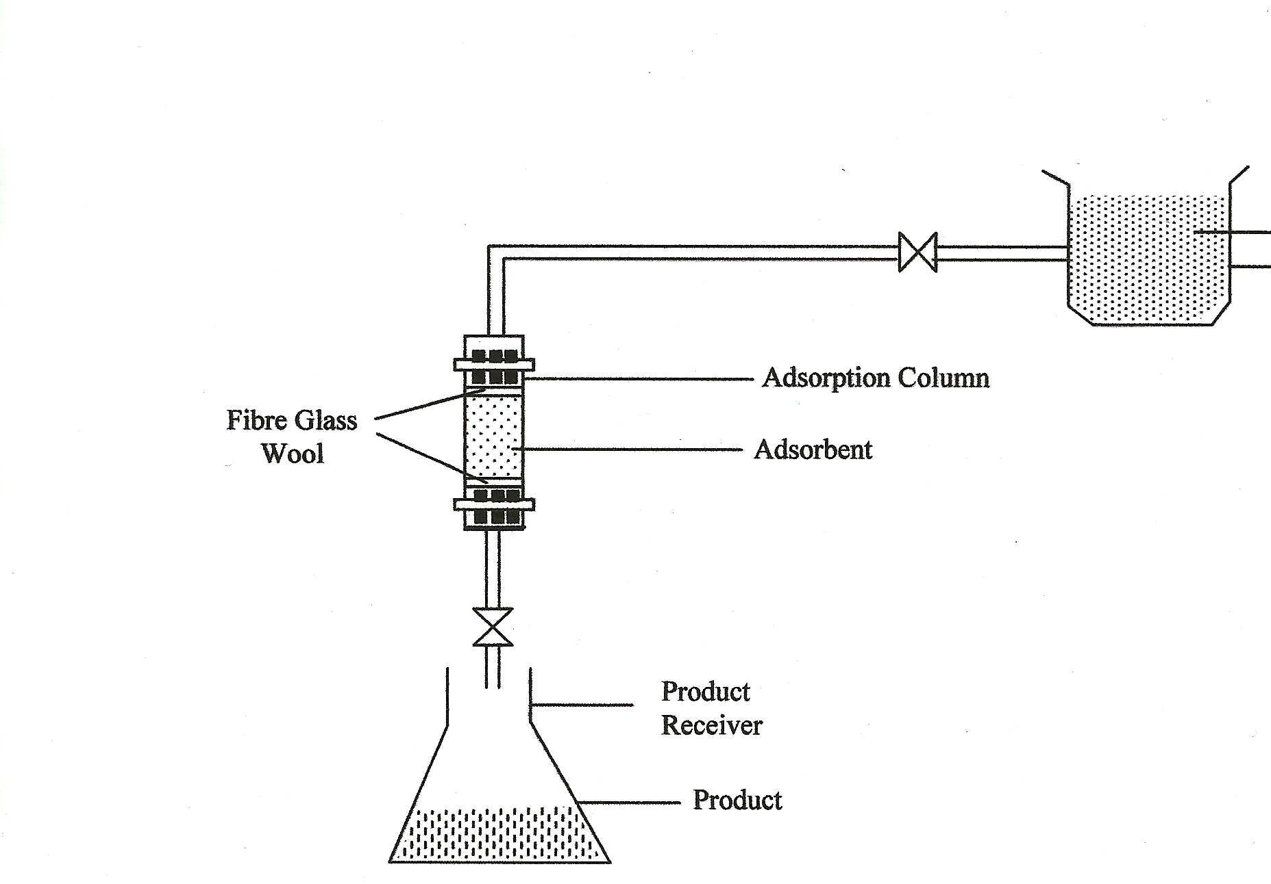

Dye solution
Reservoir

Figure 1: Schematic Diagram of experimental Set up.

Table 1: Specification of the fixed bed adsorption column
Parameter | Value
Column length (m) | 0.38
Bed height (m) | 0.95
Internal diameter (m) | 0.0356
External diameter (m) | 0.0406
Average particle diameter (m) | 0.0036
Volume of dye solution (m³) | 0.5
Mass of adsorbent (kg) | 0.02

RESULTS AND DISCUSSION
The results of the batch adsorption experiment are presented in tables 2 and 3. The results established the nature of equilibrium that existed in the dye solution-adsorbent system. The results indicated that for sample A, the amount of adsorbate removed by 1g of the adsorbent increases as the concentration of the feed stock increases. Similar result is obtained for sample B on the three dyes D1, D2 and D3
The batch adsorption data were confronted with the Freundlich and Langmuir isotherms to determine the constants of the model. Recall that the Freundlich and Langmuir adsorption isotherms are given by equations 1 and 2 respectively (Olafadehan, 2000; Fogler , 1999, Susu,1997)
$Q_{\text{as}}^{e}=a_{f}{\left(C_{\text{lp}}^{e}\right)}^{1/n}$ …1
$Q_{\text{as}}^{e}=\frac{a_{L}\left(C_{\text{lp}}^{e}\right)}{1+b_{L}C_{\text{lp}}^{e}}$ …2
In linear form, these isotherms are expressed as
$\text{log}Q_{\text{as}}^{e}=\text{log}a_{f}+\frac{1}{n}\text{log}C_{\text{lp}}^{e}$ …3
$\frac{1}{Q_{\text{as}}^{e}}=\frac{1}{a_{L}}\text{.}\frac{1}{C_{\text{lp}}^{e}}+\frac{b_{L}}{a_{L}}$ …4

The constants in Freundich and langmur isotherms were determined by fitting the experimental equilibrium data to equations 3 and 4 ( Bischof and Levinspel, 1963; Levinspel, 2004). The generated constants and models for both the Freundlich and Langmuir isotherms are shown in tables 2,3and 4.
The estimates of the standard deviation, S, of the lines of best fit to the experimental data are given as follows in table 5 (Spiegel and Stephens, 1999). It can be inferred that for all cases of sample B, that the experimental data fit better in Langmuir isotherm. For sample A, with the exception of D2, the experimental data fit better in Freundlich isotherm.
To confirm the favorability of the adsorption system, the dimensionless Hall separation factor, R_{L} was calculated by the following expression (Ruthsen, 1984):
$R_{L}={\left(1+b_{L}C_{0}\right)}^{−1}$ …5
R_{L} indicates the shape of the isotherm. This adsorption is (i) unfavorable when R_{L}>1, (ii) linear when R_{L}=1 (iii) Favorable when 0 < R_{L} <1, and (iv) irreversible when R_{L} = 0.The calculated R_{L} values for the two adsorbents , shown in table 2 were all in the range of 0-1, which confirms that adsorption process is favorable within the studied experimental conditions.
In respect of Frendlich isotherm, favorability of the process is achieved if n lies in range of 1-10. Based on the values of Frendlich constant (n) displayed in table 3, the present adsorption system could be considered favorable since n values lie between 1and 10 for all cases studied.
Breakthrough curve
The experimental breakthrough data obtained for the continuous adsorption system using different adsorbents (sample A and B) and adsorbates (D1, D2 and D3) are presented in figures 2 and 3. These figures show the plots of dimensionless total concentration of dye against time. These plots are some what smooth and gave the characteristic sigmoid shape peculiar to breakthrough curves for the different dyes distributed between sample A and B.
For sample A, the dye concentrations were reduced from initial value of 100mg/dm³ to 53, 46 and 49 mg/dm³ for D1, D2 and D3 respectively. While for sample B, the dye concentrations were reduced from the initial value of 100mg/dm³ to 66, 63 and 62 for D1, D2 and D3 respectively. For the activated coal in fixed bed the breakthrough time were 20 mins and 25 mins for D1, D2 and D3, respectively. For activated clay, the break through time were 20 mins and 25 mins for D1,D2 and D3 respectively. These reductions were not higher than these recorded values because D1, D2 and D3 are considered to be of low strength effluent. Also, porosity and particle size of the adsorbents can contribute to these levels of removal rates. (McCabe et al, 1985, Kirk and Othmanl, 1979, Trebal, 1980).Consequently, the system requires longer run time to achieve higher dye removal. Therefore, the effective application of sample A and B in the removal of dye particle has been ascertained and established.

CONCLUSION
This study has shown that coal and clay material can serve as adsorbing substances for dyes if well activated and treated to enhance their efficiency. Sample A and B are found to correlate better to Freundlich and Langmur isotherm, respectively. The breakthrough times for the study varies between 5 and 10 minutes to 45 and 65 minutes for the specified particle size, dye sample and operating conditions of the experiments.

NOTATION
STD DEV: Standard deviation
D1.D2, D3: Sample of orange dye, yellow dye and blue dye respectively
Sample A: Activated Coal
Sample B: Activated Clay.
C₀: initial inlet concentration of the adsorbate.
C_{t}: The exit concentration of the adsorbate in effluent at time t.
C_{t} / C₀: Dimensionless Total Concentration of Dyes.
$Q_{\text{as}}^{e}:$Adsorption capacity at equilibrium.
b_{L :} Langmuir isotherm constant
n: Freundlich exponent related adsorption interval (dimensionless)
a_{f} : Freundlich isotherm constant

Table 2: Adsorption Constants for Langmuir Isotherms
Adsorbates | Sample A |  |  |  | Sample B
 | a_{L} | b_{L} | R_{L} |  | a_{L} | b_{L} | R_{L}
D1 | 0.1998 | 0.0027 | 0.7874 |  | 0.3092 | 0.0115 | 0.465
D2 | 0.3013 | 0.011 | 0.909 |  | 0.2403 | 0.0089 | 0.528
D3 | 0.2216 | 0.0031 | 0.764 |  | 0.2515 | 0.0097 | 0.5067

Table 3: Adsorption Constants for Freundlich Isotherms
Adsorbates | Sample A |  |  | Sample B
 | 1/n | a_{f} |  | 1/n | a_{f}
D1 | 0.4773 | 2.1667 |  | 0.4252 | 1.831
D2 | 0.4296 | 1.8067 |  | 0.4486 | 1.5149
D3 | 0.6012 | 1.0715 |  | 0.4627 | 1.5883

Table 4: Models of Langmuir and Freundlich Isotherms
 | Langmuir |  |  | Freundlich
Dye colour | Sample A |  | Sample B | Sample A | Sample B
D1 | $$Q_{\text{as}}^{e}=\frac{0\text{.}\text{1997}C_{\text{lp}}^{e}}{1+0\text{.}\text{0027}C_{\text{lp}}^{e}}$$ |  | $$Q_{\text{as}}^{e}=\frac{0\text{.}\text{3092}C_{\text{lp}}^{e}}{1+0\text{.}\text{011502}C_{\text{lp}}^{e}}$$ | $$Q_{\text{as}}^{e}=\text{217}{\left[C_{\text{lp}}^{e}\right]}^{0\text{.}\text{477}}$$ | $$Q_{\text{as}}^{e}=1\text{.}\text{83}{\left[C_{\text{lp}}^{e}\right]}^{0\text{.}\text{425}}$$
D2 | $$Q_{\text{as}}^{e}=\frac{0\text{.}\text{3013}C_{\text{lp}}^{e}}{1+0\text{.}\text{01099}C_{\text{lp}}^{e}}$$ |  | $$Q_{\text{as}}^{e}=\frac{0\text{.}\text{2403}C_{\text{lp}}^{e}}{1+0\text{.}\text{00893}C_{\text{lp}}^{e}}$$ | $$Q_{\text{as}}^{e}=1\text{.}\text{81}{\left[C_{\text{lp}}^{e}\right]}^{0\text{.}\text{430}}$$ | $$Q_{\text{as}}^{e}=1\text{.}\text{51}{\left[C_{\text{lp}}^{e}\right]}^{0\text{.}\text{449}}$$
D3 | $$Q_{\text{as}}^{e}=\frac{0\text{.}\text{2216}C_{\text{lp}}^{e}}{1+0\text{.}\text{00308}C_{\text{lp}}^{e}}$$ |  | $$Q_{\text{as}}^{e}=\frac{0\text{.}\text{2515}C_{\text{lp}}^{e}}{1+0\text{.}\text{00973}C_{\text{lp}}^{e}}$$ | $$Q_{\text{as}}^{e}=1\text{.}\text{07}{\left[C_{\text{lp}}^{e}\right]}^{0\text{.}\text{601}}$$ | $$Q_{\text{as}}^{e}=1\text{.}\text{59}{\left[C_{\text{lp}}^{e}\right]}^{0\text{.}\text{463}}$$
Table 5: Estimates of The Standard Deviation (STD DEV)
 | STD DEV Sample A |  |  | STD DEV Sample B
Dye Clour |  | Langmuir | Freunldich | Langmuir | Freundlich
D1 |  | 11.59 | 9.807` | 3.77 | 5.55
D2 |  | 3.9 | 5.65 | 4.05 | 5.52
D3 |  | 11.50 | 2.08 | 3.81 | 6.47

References
Albarins, T.A and Hela, T.M (1993); Removal of dyes from aqueous solutions by adsorption on mixture of fly ash soil in batch and column techniques, Department of Chemistry, University of loannins, loanina, Greece.
Baker, C.D, Clark E.W, Jeserning W.V, and Huether C.H, (1973) Chem. Eng. Progress, 6(69), 77-80.
Bischoff, K.B, and Levinspel, O; (1963) ,Advances in chemical Engineering, Academic press, vol. 4, U.S.A.
Fogler, H.S (1999); Elements of Chemical Engineering, Prentic-Hall, India
Gould, M and Taylor, J (1969), AIChE- Symposium Series, 65(97), 196-199
Keller; Anderson, and You (1987); Handbook of Separation Process Technology, Wiley
Kirk, R.E and Othman D.F (1979); Encyclopedia of Chemical Technology, 3rd Ed. Wiley and sons, New York.
Levinspel, O (2004); Chemical Reaction Engineering, 3rd Ed. Wiley Publishers, India.
McCabe, W.L ,Smith, J.C and Harriot P. (1985); Unit operations of Chemical Engineering ,4th Ed. McGraw Hill.
Olafadehan, O.A and Aribike D.S (2000); Treatment of industrial Waste Water Effluent: Adsorption of Organic Compounds on Granular Activated Carbon; JNSChE, vol 19, No 182.
Ruthsen, DM. 1984. Principles of adsorption and adsorption processes, Wiley New York.
Spiegel, M and Stephens L.J (1999); Statistics;Schuams Outline Series, McGraw Hill Publishers.
Susu, A,A (1997); Chemical Kinetics and Heterogeneous catalysis, CJC Press LTD, Lagos.
Swaraj, R., Nama, S and Velu, K (2001); Orange Peel as an adsorbent in the Removal of Acid violet from Aqueous Solution. www. Esleveirnl. Locate/wasman
Tien, C. (1994); Adsorption, Calculations and modeling, Butterworths-Heinemarn, U.S.A
Trebal, R.E (1980); Mass Transfer Operations, 3rd Ed McGraw-Hill, New York.

4/1/2010

