Some Physical Properties of Doum Palm Fruit (Hyphaene thebaica Mart.)

A.K., Aremu^{1*} and O.K., Fadele²

¹Department of Agricultural and Environmental Engineering, University of Ibadan, Ibadan, Nigeria
²Department of Agricultural Engineering, Federal College of Forestry Mechanization Kaduna Forestry Research Institute of Nigeria.
*Corresponding author’s email and phone no: ademolaomooroye@gmail.com, + 234 8023843272

Abstract: The physical properties of doum palm fruit were determined as a function of moisture content. The average dimension of doum palm fruit in the three principal axes (viz., length, width, and thickness) and its equivalent diameter, projected area, sphericity, porosity, bulk and true densities were determined for moisture contents ranging from 24.05 to 67.59% d.b and were found to be 60.65, 48.78, 47.09 and 51.61 mm, 19.94 cm² and 0.85 respectively while the true and bulk densities increased from 711.05 to 958.53 kg/m³ and 370.51 to 483.77 kg/m³ respectively with moisture content but the porosity increased from 46.45 to 51.66% and later decreased to 49.53%. The dimension of doum palm fruit with its equivalent diameter, projected area and sphericity were found to be constant with moisture content variation. It was found that the relationships between true and bulk densities and moisture content of doum palm fruit followed a linear pattern while that of porosity exhibited a non-linear relationship with the moisture content at 0.05 significant level.
[Aremu, A.K. and Fadele,O.K Some Physical Properties of Doum Palm Fruit (Hyphaene thebaica). New York Science Journal 2011;4(3):63-69]. (ISSN: 1554-0200). http://www.sciencepub.net/newyork.

Keywords: Doum palm, bulk density, true density, moisture content and projected area.

1.0 Introduction

Doum palm fruit (Hyphaene thebaia) is a desert palm tree with edible oval fruit, originally native to the Nile valley. It also grows very well in the northern part of Nigeria. It is a member of the palm family, Arecaceae. The trunk of this small palm commonly branches into two like Y and often each branch divides again in a Y form, giving the tree a very distinctive appearance; it is dichotomous and arborescent in nature. It is listed as one of the useful plants of the world (Fletcher, 1997). It is represented by the genus Hyphaene, the fruit of interest in the current study. Its fibre and leaflets are used by people along the Nile to weave baskets. Doum palm fruit is also a source of potent antioxidants (Hsu et. al., 2006). The fruit has a brown outer fibrous flesh which is normally chewed and spewed out. Doum palm kernel is edible when it is unripe but hard when it is ripe.

Moreover, doum palm is also used for local craft, for construction and the root is also medicinal. The foliage is used to make mats, ropes, baskets, and hats while the stem with the leaves are used for construction purpose (Moussa et. al., 1998). Roots of doum palm are used for treatment of bilharzias while the fruit is often chewed to control hypertension (Orwa et al., 2009). The hard seed inside the fruit, known as ‘vegetable ivory’, is used to treat sore eyes in livestock using charcoal from the seed kernel as well as making buttons and small carvings, and artificial pearls (Orwa et al.,2009). It has similar morphology with coconut except for the fact that it is not as big as coconut. However, the husk of this fruit is mostly eaten while the fleshy part of coconut is the only part that is edible. So also, the husk of doum palm is not as hard as that of coconut. Moreover, Hyphaene thebaica is a variety was carried out to determine some physical properties that are useful in doum palm processing.

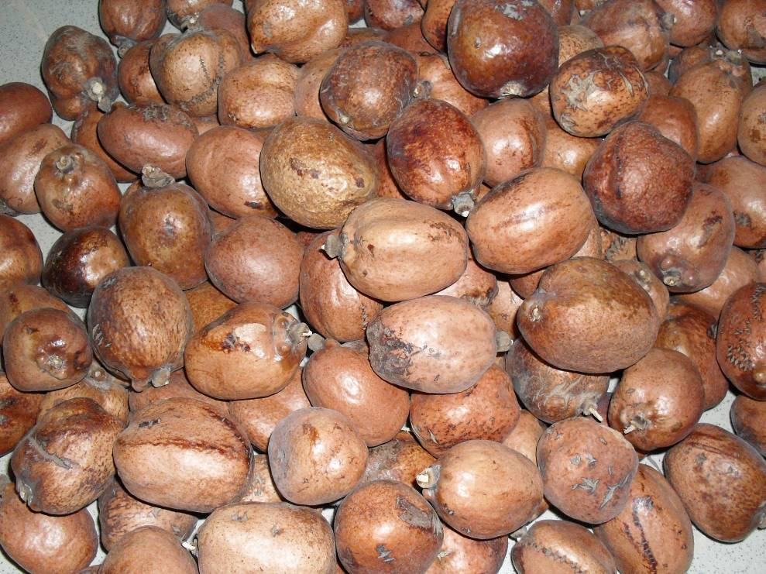

Figure 1: doum Palm Fruit

Notation
a length of doum palm fruit (mm)
a initial moisture content (%)
A initial mass of doum palm fruit (g)
b width of doum palm fruit (mm)
b desired moisture content (%)
c thickness of doum palm fruit (mm)
D_{b} bulk density of doum palm fruit (kg/m³)
D_{e} geometric mean diameter (mm)
D_{t} true density of doum palm fruit (kg/m³)
M_{b} bulk mass of doum palm fruit (kg)
MC Moisture content (%)
M_{t} true mass of doum palm fruit (kg)
Q quantity of water added to the fruit (g)
V_{b} bulk volume of doum palm fruit (m³)
V_{t} true volume of doum palm fruit (m³)
S equivalent surface area (cm²)
S_{p} Sphericity
R_{a} Aspect ratio

ε porosity of doum palm fruit (%)

D_{e} = (abc)^{1/3} D_{e} = (abc)^{1/3} D_{e} = (abc)^{1/3}

R_{a} R_{a} R_{a} R_{a}

of doum palm which is dark to light brown in colour. The nut of this fruit with the kernel is very hard, closely similar to palm kernel nut.
Despite an extensive search, no published literature was available on the detailed physical properties of doum palm and their dependency on
operation parameters that would be useful for design of processing machines. Therefore, an investigation

2.0 Materials and Methods
Some quantities of doum palm fruits were purchased from Mando Market Kaduna, Nigeria and stored in a cool place before carrying out the experiment. Ripe fruits of doum palm were used for the purpose of this experiment as shown in Figure 1. All the experiments were conducted at an average room temperature of 28.47ºC±1.22. All the engineering properties considered were determined using 18 to 50 doum palm fruits for each test. The following methods were used in the determination of some physical properties of doum palm fruit (H. thebaica).

2.1 Moisture Content Adjustment
Some moisture levels (ranging from 24.05 to 67.59%) were obtained by moisture adjustment as reported by Olaniyan and Oje, (2002). A method for adjusting the fruit’s moisture content without damaging its morphology was developed to prepare samples for subsequent tests. This involved oven-drying some of the fruit in order to obtain its initial moisture content. The fruit was oven-dried at 110ºC for 16 hours until there was no change in its mass. In this method, the initial moisture content (19.39% w.b.) was used with the value for quantity of water absorbed by the fruit using mass balance equation in equation 1, to get the following moisture contents: 29.85%, 38.50%, 50.07% and 67.59% (db) after it was soaked in water for 3, 7, 16 and 36 hours, respectively. After conditioning the fruits to the moisture levels, the adjusted samples were stored in the cellophane bags and stored in the fridge at about 15ºC before the experiment.

Q = A(b - a)/(100 - b) (1)

2.2 Determination of Physical Properties of Doum Palm Fruit
Some of the physical properties that were determined include moisture content, true density, bulk density, porosity, shape and size of the biomaterial.

2.2.1 Determination of Moisture Content
The moisture content of the fruits was determined by oven-drying method (Razavi and Taghizadeh, 2007). The moisture content was obtained from fifty samples of oven-dried fruits which were weighed before and after oven-drying. The fruits were oven dried at 110ºC using a drying oven (yamato dx 41), for 16 hours until the mass of the fruit remained constant. The difference between the masses gives the quantity of water evaporated during drying. The moisture content was calculated on dry basis.

2.2.2 Determination of True Density
The true density of the fruit was determined by weighing the mass of the fruit using a digital weigh balance (AND Ek-6100i) reading to 0.1g, while its volume was determined by water displac-ement method. The water displacement method was used having ascertained that it takes longer period of time for water to penetrate through the fruit. The true density was evaluated by finding the ratio of the true mass to that of the volume. This is given in equation 2.

D_{t} = M_{t} / V_{t} (2)

2.2.3 Determination of Bulk Density
The bulk density was determined using a regular container having a specific volume. The container was filled with some fruits to the brim. The mass of the fruit inside the container was found together with the volume of the container. This is referred to as bulk mass and bulk volume respectively. The ratio of the bulk mass to the bulk volume was evaluated to give the bulk density as;

D_{b} = M_{b} / V_{b} (3)

2.2.4 Determination of Porosity
The porosity of the doum palm fruit was estimated from its bulk and true densities using the relationship given by Mohsenin, (1980) as;

ε = (1 – D_{b}/D_{t}) x 100 (4)

2.2.5 Determination of Size and Shape
The linear dimensions of the doum palm fruits was determined using a digital vernier caliper (Carrera Precision Instrument, reading to 0.01mm) to measure the length, thickness and width of the fruit denoted as a, b and c respectively. In this experiment 50 samples were selected at random and measured when the fruit was at state of rest and it was gently raised up to measure its thickness. This was determined at a single moisture level having ascertained that increasing the moisture content of the fruit does not have any significant effect on its linear dimensions. The size was also expressed in geometric mean diameter and equivalent surface area. These were determined from the values obtained from linear dimensions as reported by Balasubramanian, (2001) and Baryeh, (2001). The geometric mean diameter was calculated as;

D_{e} = (abc)^{1/3} (5)

The equivalent surface area of the fruit was evaluated using equation 5 as reported by Baryeh, 2001; calculated as.

S = π (D_{e})² (6)

The shape of the doum palm fruits was determined from the values obtained for length, width and thickness. The shape of the fruit was described and evaluated in terms of its sphericity ratio index and aspect ratio. The sphericity of the fruits was determined from the longitudinal, transverse and minor axes of the fruits. The linear
dimensions obtained were used to evaluate the sphericity of the doum palm fruit using equation 7.

S_{p} = (abc)^{1/3} (7)
a

The aspect ratio was also computed from the values obtained above for length and width. It is given as;

R_{a} = b/a x 100 (8)

However, the projected area of the fruit was determined using a digital planimeter equipped with a magnifying glass (Tamaya Planix 7, reading to 0.1cm²). A digital camera (Samsung ES10) was adjusted to capture the image of the fruit at a scale of 1:1 while lying at natural state of rest both longitudinally and transversely. The planimeter was carefully used to trace the edges of the captured image to obtain the projected area. The ratio of the projected area to the circumscribed area gives the roundness of the fruit.

Roundness (R_{o}) = A_{p}/A_{c} (9)

3.0 Results and Discussion
3.1 Moisture Content of Doum Palm Fruits
The moisture content of the doum palm fruit was found to be 24.05%(db) while the adjusted moisture content values of the fruit were 29.85%, 38.50%, 50.07% and 67.59% all in dry basis, when it was soaked in water. It was observed that the period of detention of the fruit in water was a function of the adjusted moisture content. The surface of the fruits was dry while the mesocarp was wet due to the water absorbed. The husk that covers the fruit is porous in nature, thus making the fruit to absorb moisture without swelling and allowing water to be retained in the fruit. No swelling was observed during soaking because of the pores within the fruits; therefore there was no significant increase in size of the fruit. The behaviour of the fruit indicated that when the fruit attained equilibrium with the atmosphere, the rate of moisture loss was minimal or even not significant as result of glossy outer cover of the fruit which restrict moisture from leaving the surface of the fruit.

3.2 Size and Shape of Doum Palm Fruit
The size and shape of doum palm fruit were found at the initial moisture content, having ascertained that the shape and size remain constant with increase in moisture content. The result of some of the physical properties of doum palm fruit determined is shown in Table 1. The doum palm fruit mean length, width and thickness were found to be 60.65mm, 48.78 mm, and 47.09 mm respectively. The mean values obtained for length, width and thickness of doum palm fruit was lower than what Kheiralipour et al., (2008) got for Redspar and Delbarstival apples; thus indicating that doum palm fruit is not as big as Redspar and Delbarstival apples. The results showed that the length, width and thickness for the fruit ranged between 52.44 - 71.16, 39.59 – 61.77 and 38.92 – 56.18 mm respectively, while the geometric mean diameter and equivalent surface area ranged between 43.30 – 62.48 mm and 58.90 – 122.65 cm² respectively. The flesh thickness was found to have a mean value of 5.43 mm with a range between 3.19 - 7.57 mm. The values obtained for the dimension of doum palm fruit is useful in separation of the fruit from foreign materials. These values may be used to determine the size of aperture that can retain the fruit in the chamber when it is being husked as well as the size of the machine components. The following expression in equation 10 was derived from length, width and thickness of doum palm fruit and it can be used to describe the relationships between the dimensions of doum palm fruit:

a = 1.25b =1.29c (10)

Table1: Some Characteristics of Doum Palm Fruit at 24.05% Moisture Content (db)

Property Number Values
of
Observations Minimum Maximum Mean S.D

Volume (cm³) 50 30.27 54.68 38.83 4.80
Length, a (mm) 50 52.44 71.16 60.65 4.22
Width, b (mm) 50 39.59 61.77 48.78 3.76
Thickness, c (mm) 50 38.92 56.18 47.09 3.12
GM Diameter, D (mm) 50 43.30 62.48 51.61 3.22
Surface Area, (cm²) 50 58.90 122.65 84.00 10.49
Sphericity 50 77.00 91.00 85.19 3.27
Aspect Ratio 50 67.00 90.00 80.56 5.29
Flesh Thickness (mm) 20 3.19 7.57 5.43 1.15
Roundness (longitudinal axis) 18 0.73 0.92 0.83 0.05
Roundness (transverse axis) 18 0.71 0.94 0.87 0.06
A_{p} (longitudinal axis) 18 18.60 26.10 21.14 2.12
A_{p} (transverse axis) 18 16.30 22.30 18.73 1.49
A_{c} (longitudinal axis) 18 20.43 32.17 25.66 3.16
A_{c} (transverse axis) 18 18.86 25.52 21.69 1.95

SD, standard deviation; GM, geometric mean; A_{p}, projected area; A_{c}, circumscribed area

The mean values of the sphericity index and aspect ratio were 0.85 and 0.81 with ranges between 0.77 – 0.91 and 0.67 – 0.90 respectively. The sphericity index and aspect ratio values for doum palm fruit were found to be within the range of 0.32 – 1.00 reported by Mohsenin, (1980) for most agricultural materials. Table 1 shows the values obtained for sphericity index and aspect ratio. The high sphericity of the doum palm fruit indicates nearness of its shape to a sphere. The aspect ratio relates fruit width to length; with a mean value of 0.81 there is high tendency for the fruit to roll when tilted along the axial axis. However, the fact that the aspect ratio value is close to the sphericity values may also mean that the doum palm fruit will undergo a combination of rolling and sliding action on their flat surfaces (Owolarafe et al., 2007).
Moreover the roundness and projected area with circumscribed areas along the longitudinal axis were found to have mean values of 0.83, 21.14cm²
25.66cm² and ranges from 0.73 to 0.92, 18.60 to 26.10cm², 20.43 to 32.17cm² respectively. The roundness and projected area with circumscribed areas along the transverse axis were also found to have mean values of 0.87, 18.73cm², 21.69cm² and ranges from 0.71 to 0.94, 16.30 to 22.30cm², 18.86 to 25.52cm² respectively.

3.3 Effect of Moisture Content on 100 Fruit Mass
The mass of 100 doum palm fruits varied from 3.88kg to 5.24kg when the moisture content increased from 24.05 to 67.59% (db) as shown in Figure 2. The variation of mass of 100 doum palm fruits with moisture content was significant (P<0.05). The 100 fruit mass of doum palm fruit increased linearly with increase in moisture content as shown in Figure 2; this may be due to availability of pore spaces within the fruit; thus allowing for water to be retained within it. A similar increasing trend in mass has been observed by Baryeh, (2001) for bambara groundnut seed, Balasubramanian, (2001) for raw cashew nut, Ahmadi et al., (2009) for fennel seed and Kiani Deh Kiani et al., (2008) for red bean.

4.1.4 Effect of Moisture Content on True Density
The true density of doum palm fruit varied from 711.10 to 959.00 kg/m³ when the moisture content was increased from 24.05 to 67.59% (db) as shown in Figure 3. The variation of the true density with moisture content was significant at P < 0.05. The true density values increased linearly with increase in moisture content. This can be attributed to a higher weight increase of the fruit in comparison with its volume expansion on moisture gain. However there was no significant increase in the volume of the fruit with moisture content. A similar increasing trend in true density of some agricultural materials has also been observed by Aydin, (2007) for peanut and its kernel, Balasubramanian, (2001) for raw cashew nut, Singh et al., (2010) for barnyard millet grain and kernel, Kiani Deh Kiani et al., (2008) for red bean and Fathollahzadeh, et al. (2008) for apricot kernel.

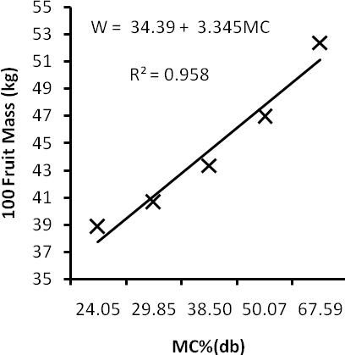
Figure 2: Variation of 100 fruit mass with moisture content

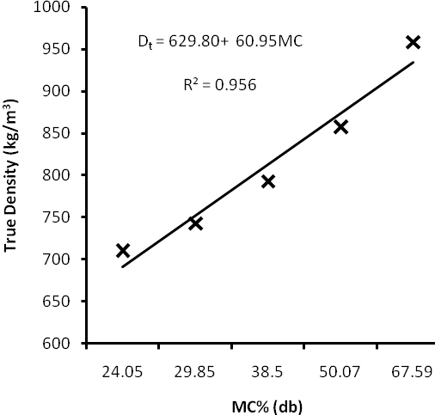

Figure 3: Variation of true density of doum palm fruit with moisture content

Moreover, the values obtained for the true density indicated that doum palm fruit will not sink in water between a moisture content of 24.05 and 67.59% db. This could be exploited in separating sinkable foreign materials from the fruit. Advantage could also be taken of this property in handling of the fruit during washing. The relationship between true density and moisture content of the doum palm fruit is shown in Figure 3.

4.1.5 Effect of Moisture Content on Bulk Density
The bulk density of doum palm fruit varied from 370.51 to 483.77 kg/m³ with the increase of moisture content from 24.05 to 67.59% db. The bulk density of the fruit increased in a linear fashion with the moisture content. This ensued from the tendency of the doum palm fruit to absorb water without swelling up. This is as result of pore spaces within the husk of the fruit. This indicated that there was increase in mass with negligible effect on volume as the fruit gained moisture. Kibar and Ozuturk, (2009) observed the same trend for hazel nut. However, other researchers showed negative linear relationship between bulk density and moisture content (Singh et al., 2010, Ahmadi et al., 2009, Balasubramanian, 2001, Aydin, 2007, and Dursun et al., 2007). The values obtained for the bulk density could be useful in handling of the fruit. This property of doum palm also showed its behaviour when subjected to pretreatment such as soaking. The variation of bulk density of doum palm fruit with moisture content is depicted in Figure 4.
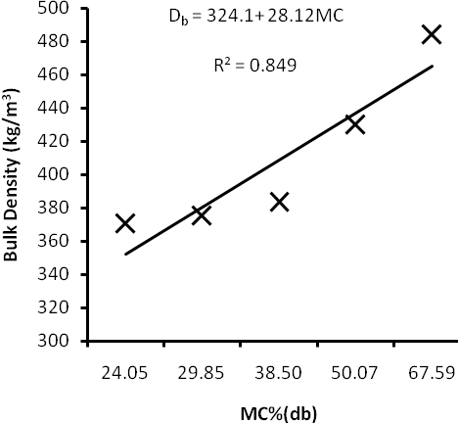
Figure 4: Variation of bulk density of doum palm fruit with moisture content

4.1.6 Effect of Moisture Content on Porosity
The porosity of doum palm fruit has a range of 46.45 – 51.66 % with the increase of moisture content from 24.05 to 67.59% db. The relationship between the porosity of doum palm fruit was found be non-linear as shown in Figure 5. This curve indicated that porosity increased with moisture content until it got to a point when it started to drop. The porosity increased from 46.45% to 51.66% with the increase of the moisture content from 24.05 % to 38.50%; however it declined to 49.53% as the moisture content increased to 67.59%. Bup et al., (2008) and Baryeh, (2001) observed a similar trend for shea nut kernel and bambara groundnut respectively.

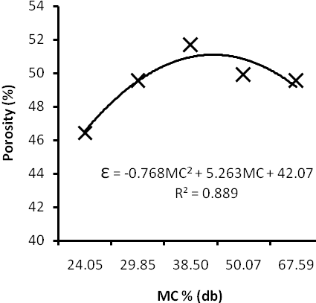 Figure 5: Variation of porosity with moisture content

Conclusions
The investigations on some physical properties of doum palm fruit revealed that the results of the test is in good agreement with some of the general trend and ranges obtained for other similar fruits. The dimensions of the fruits are relatively uniform hence will improve the process optimization in design and development of husking or cracking machine for the fruit as well as in separation and cleaning. The fruit being glossy and fibrous indicates that it has high tendency to absorb water and retain it when exposed to it for a long period of time. Finally, the data obtained will be useful in design of handling equipment for doum palm fruit(Hyphane thebaica).

References
Ahmadi, H., Mollazade, K., Khorshidi, J., Mohtasebi, S.S. and Rajabipour, A. (2009). Some Physical and Mechanical Properties of Fennel Seed (Foeniculum vulgare). Journal of Agricultural Science. CCSE. Vol.1: 66 – 75.
Aydin, C. (2007). Some Engineering Properties of Peanut and Kernel. Journal of Food Engineering. Elsevier Science Direct. Vol. 79: 810 – 816.
Balasubramanian, D. (2001). Physical Properties of Raw Cashew Nut. Journal of Agricultural Engineering Research. Vol. 78(3): 29 –297.
Baryeh, E.A. (2001). Physical Properties of Babara Groundnut. Journal of Food Engineering. E- lsevier Science Direct. Vol.47: 321 – 326.
Bup, D.N., Kapseu, C., Tenin, D., Kuitche, A., Abi, C.F. and Tchiegang, C. (2008). Variation of the Physical Properties of Sheanut (Vitellaria Paradoxa Gaertn.) Kernels during Convective Drying. International Journal of Food Engineering. The Berkeley Electronic Press. Vol. 4: 11 – 12.
Dursun, I., |Tugrul, K.M. and Dursun, E. (2007). Some Physical Properties of Sugar Beet Seed. Stored Products Research. Elsevier Science Direct. Vol. 43: 149 – 155.
Fathollahzadeh, H., Mobli, H., Beheshti, B., Jafari, A. and Borghei, A.M. (2008). Effect of Moisture Content on Some Physical Properties of Apricot Kernel (C.V. Sonnati Salmas). Agricultural Engineering Internati- onal: the CIGR Ejournal. Manuscript FP 08 008. Vol. X.
Fletcher, R. (1997). Listing of useful plants of the world. Australian New Crops http://www.ne wcrops.uq.edu.au/listing/hyphaenethebaica.
Hsu, B., Coupar, I.M. and Ng, K. (2006). Antioxidant activity of hot water extract from the fruit of the Doum palm, Hyphaene thebaica. Food Chemistry. Elsevier Science Direct. Vol.98:317 – 328.
Kheiralipour, K., Tabatabaeefar, A., Mobli, H., Rafiee, S., Sharifi, M., Jafari, A. and Rajabipour, A. (2008). Some physical and hydrodynamic properties of two varieties of apple(Malus domestica Borkh L.). International Agrophysics.Vol.22:225– 229.
Kiani Deh Kiani, M., Minaei, S., Maghsoudi, H. and Varnamkhasti, M.G. (2008). Moisture Dependent Physical Properties of Red Bean (Phaseolus vulgaris L.) Grains. International Agrophysics.Vol:22,231-237.
Kibar, H. and Ozturk, T. (2009). The Effect of Moisture Content on the PhysicoMechanical Properties of Some Hazelnut Varieties. Jou- rnal of Stored Product Research. Elsevier Science Direct. Vol.45: 14 - 18.
Mohsenin, N.N. (1980a). Physical properties of plant and animal materials. Vol. 1. Physical characteristics and mechanical properties. New York: Gordon and Breach.
Moussa, H.; Hank A. Margolis, H.A.; Dube´, P. and Odongo, J. (1998). Factors Affecting the Germination of Doum Palm (Hyphaene thebaica Mart.) Seeds from the Semi-Arid Zone of Niger, West Africa. Forest Ecology and Management. Elsevier Science Direct. Vol.104: 27 – 41.
Olaniyan, A.M. and Oje, K. (2002). Some Aspects of the Mechanical Properties of Shea Nut. Biosystem Engineering. Vol. 81(4): 413 – 420.
Orwa, C.; Mutua, A.; Kindt, R.; Jamnadass, R. and Anthony, S. (2009). Agro-Forest Tree Data Base: A Tree Reference and Selection versio n 4.0 (http://www.worldagroforestry.org/site s/treedbs/treedatabases.asp)
Owolarafe, O.K., Olabige, M.T. and Faborode M.O. (2007). Physical and Mechanical Properties of Two Varieties of Fresh Oil Palm Fruit. Journal of Food Engineering. Elsevier Science Direct. Vol. 78: 1228 – 1232.
Razavi, S.M.A. and Taghizadeh, M. (2005). The Specific Heat of Pistachio Nuts as affected by Moisture Content, Temperature and Var- iety. Journal of Food Engineering. Elsevier Science Direct. Vol.79:158–167.
Singh, K.P., Mishra, H.N. and Saha, S. (2010). Moisture-Dependent Properties of Barnyard Millet Grain and Kernel. Journal of Food Engineering. Elsevier Science Direct. Vol.96: 598 – 606.

1/31/2011

