Welding of Austempered Ductile Cast Iron

E. El-Kashif ¹ and M. A. Morsy^{2*}

¹Department of Mining, Petroleum and Metallurgical Engineering Cairo University, Egypt
²Central Metallurgical R & D Institute El-Tebein, Egypt
morsy_abokhala@yahoo.com*

Abstract: Austempered ductile iron (ADI) with an austenitic bainitic matrix is a new type of engineering materials and has gained increasing interests in academic research and industrial application due to its exceptional combination of tensile strength and ductility. However, welding of ADI parts remains as a great problem during manufacturing.
In this investigation, Shielded Metal Arc Welding (SMAW) was attempted to weld ADI with AWS E11018-G, ENiFeCI and ENiCI electrodes. The results obtained from SMAW were compared with that produced from Gas Tungsten Arc Welding (GTAW) using filler metal as stripes machined from base metal material. It was found that welding with GTAW process using filler with the same material followed by austempering heat treatment has superior properties (mechanical and metallurgical)free from any discontinuities compared with SMAW using different electrodes for cast iron welding.
[E. El-Kashif and M. A. Morsy. Welding of Austempered Ductile Cast Iron. New York Science Journal 2011;4(4):21-27]. (ISSN: 1554-0200). http://www.sciencepub.net/newyork.

Keywords: Austempered Ductile Iron, Welding, Austempering, SMAW, GTAW, Microstructure

1. Introduction
The combination of high strength, toughness, excellent machinability and wear resistance is the primary appeal of austempered ductile iron (ADI). Designers have exploited these properties to produce many engineering parts such as gears, automobile crankshaft and axle box. Furthermore, Austempered ductile iron has replaced forged steel in many of its applications. ADI provides the designer with a family of materials with attractive properties usually at lower cost and weight than the competing materials. Therefore, the material has been recommended for high duty applications. ADI with an austenitic- bainitic matrix is a new type of engineering material and has gained increasing interest in research and industrial applications due to its exceptional combination of tensile strength (850-1400) and ductility (4-10%) as reported by Darwish and Elliot1, ^{1, 2)}; Kobayashi and Yamamato ³⁾; Bayati and Elliot ⁴⁾; Rao and Putatunda ⁵⁾; Bayati and Elliot ⁶⁾ and Ahmadabadi et al ⁷⁾.
One of the most problems encountered by designers is the welding of ADI parts during manufacturing and the need for developing new welding consumables. There are two problems during welding of ADI; first the formation of massive cementite in the as-welded ductile iron because of fast cooling rate; second the properties of ADI weld should match those of ADI as reported by Hayrynen et al ⁸⁾.; Zhang et al. ⁹⁾; Wu et al ¹⁰⁾ and Gong et al ¹¹⁾.
The present work investigates the welding of Austempered Ductile cast iron using SMAW with different electrodes and the Gas Tungsten Arc Welding process using similar base metal material followed by austempering of the specimens to gain the microstructure of the austempered ductile iron base matel.

2. Experimental Work
The austempered ductile cast iron was produced from ductile cast iron (DIN 1693 – GGG 40) with chemical composition (3.86% C, 2.1% Si, 0.4% Mn, 0.042% Mg, 0.059% S and 0.07% P). Austempering for all samples was conducted by Austentizing at 900ºC for 60 minutes, and then Austempering by rapidly transferring specimens to a salt bath (100% Na₂NO₃) at 380 ºC for 2 hours followed by quenching the specimen in water to room temperature. The heat treatment cycle is shown schematically in Fig.1
The dimensions of the test specimens were 100x200x10 mm with a 90º groove angle for all conditions as shown in Fig. 2. Preheat was conducted at 400 ºC for 20 min. After welding, the specimens were immediately transferred to an electric furnace, kept there at 300 ºC for 2 hours and then furnace cooled to room temperature. Each weldment was examined visually and using Dye penetrant test prior to sectioning for metallographic examination and mechanical property evaluation.

Fig. 1 Schematic representation of the heat treatment cycle
60 min.
900 ºC
120 min.
380 ºC
Water Quenching
Time.
Temperature

Two welding processes were applied, SMAW and GTAW. In the first process two filler metals were applied as shielded metal arc welding electrodes, namely AWS-ENiFeCI and AWS-E11018-G. The first electrode is directly applied to the ADI base metal, the groove angle was 90º and the dimensions of the test specimen as shown in Fig. 2. In the application of AWS- E11018-G electrode, an AWS- ENiCI electrode was used for buttering of the groove face, then welding with E11018-G electrode. The welding conditions for the first process are given in Table 1. The chemical compositions of the weld metal produced from their filler metals are shown in Table 2.
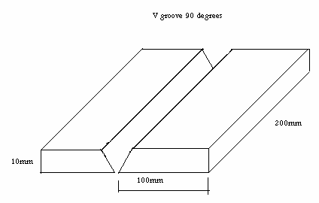
Fig. 2 Dimensions of the test specimens

In the second GTAW process with DC positive polarity of 100 A, slides of GGG-40 cast iron were cut to 1 mm thickness and used as a filler metal. Then the welded specimens were austempered using the same austempering heat treatment conducted before welding.

Table 1 Welding conditions using SMAW process
Current / Polarity | 100A/ DC positive polarity for 3.2 diameter Electrode  60A/ DC positive polarity for buttering using 2.5 mm electrode
Travel speed | 100 mm/min
Preheat | 25 ºC and 400 ºC

Table 2 Chemical composition of weld metal, mass%
- Electrode | - C | - Si | - Mn | - Cr | - Ni | - Mo | - Fe
- E11018-G AWS- | - 0.06 | - 0.5 | - 1.8 | - 0.35 | - 2.2 | - 0.4 | - Bal
- ENiFeCI AWS- | - 0.5 | - - | - - | - - | - 53 | - - | - Bal
- ENiCI AWS- | - 0.5 | - - | - - | - - | - 97.5 | - - | - 2

Transverse tensile test specimens were prepared from all welded specimens. A 20 kN universal testing machine was used for tensile test with cross head speed of 10 mm/min. Two specimens were tested for each weldment and for ductile and austempered base metals.
Microscopic examination was conducted at the cross section specimens. The specimens were cutout using fine cutter. The cross section was then ground through grit Silicon papers (180 to 1000). Final polishing was performed using 0.5 μm alumina past, then cleaned and dried. The polished specimens were etched by 2% Nital solution. Microstructure of base metal and welded specimens were observed using optical microscope. Hardness test was conducted using micro hardness tester with 200 gm load.

3. RESULTS AND DISCUSSION
3.1. Preparation of ADI used
Microstructure of as-received GGG-40 is shown in Fig. 3. The microstructure consists of graphite nodules embedded in a ferritic matrix. The application of the austempering heat treatment cycle to the Ductile Cast Iron resulted in the production of ADI. The microstructure of the produced ADI is shown in Fig. 4. The ferritic matrix has been transformed to a bainitic one and some retained austenite is usually formed during austempering. The tensile, yield and elongation are 970 MPa, 601 MPa and 8.8 % respectively after austempering. The microhardness was measured and found to be 370 HV.
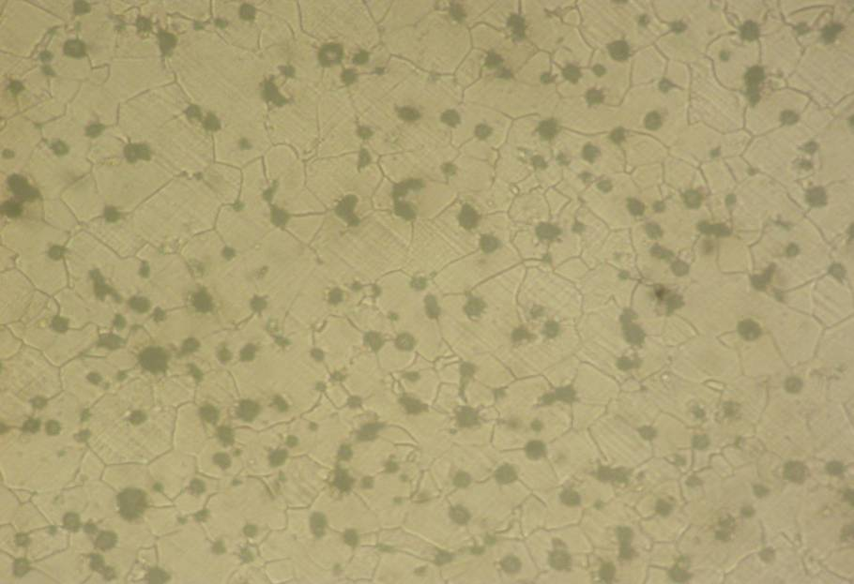

50 µ m

Fig. 3 Microstructure of as-received ferritic ductile cast iron

50 µ m

Fig. 4 Microstructure of ADI after austempering

3.2. Welding of ADI using SMAW electrodes
3.2.1 Tensile test results
The tensile test results (Ultimate Tensile Strength(UTS) and Yield Strength (YS)) of the joints welded using AWS-ENiFeCI and buttering by AWS-ENiCI followed by welding using AWS-E11018-G electrodes in Table 3.

Table 3 Tensile test results using different SMAW electrodes
Electrode type | UTS, MPa | YS, MPa
AWS-ENiFeCI | 450 | 300
Buttering with AWS-ENiCI followed by welding using AWS- E11018-G | 500 | 300

The tensile test results are very low compared with that of ADI base metal. Thus these procedures can be applied in repair welding for restoration or for gaining the original dimension. However another procedure is required if matching the tensile strength of ADI is the most important factor.
3.2.2 Microstructure
Figure 5 shows the microstructure of fusion zone and HAZ of the joint welded at room temperature (without preheat) using AWS-ENiFeCI electrode. HAZ has a martensitic structure and the fusion zone has a carbide structure.
Increasing the preheating temperature to 400ºC resulted in a formation of bainitic structure at the HAZ instead of the martensitic one because preheating decreases the rate of cooling after welding. However, the amount of carbides has been increased in the fusion zone and become coarser as shown in Fig. 6. The same results were obtained with El- Banna et al ¹²⁾ in welding of ductile case iron.
Microstructure at the weld metal of the specimen welded using AWS-E11018-G electrode without preheating shows the existence of some cracks as shown in Fig. 7. This could be attributed to the increase in hardenability of the weld metal resulted from the deposition of AWS-E11018-G electrode. Preheating to 400ºC resulted in the disappearance of such cracks as shown in Fig. 8. The use of AWS-E11018-G electrode shows higher UTS of the joint than AWS-ENiFeCI electrode which may be attributed to the higher the strength of the former as listed in Table 3.

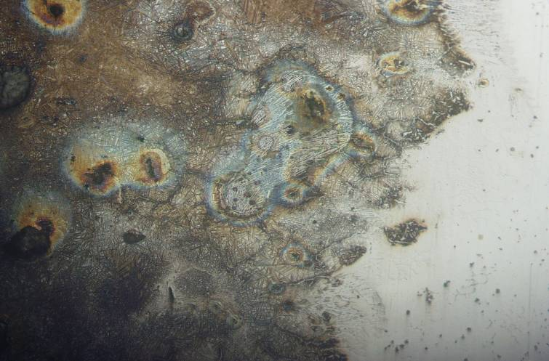
400X

50 µ m

Fig. 5 Microstructure of fusion zone and HAZ without preheat

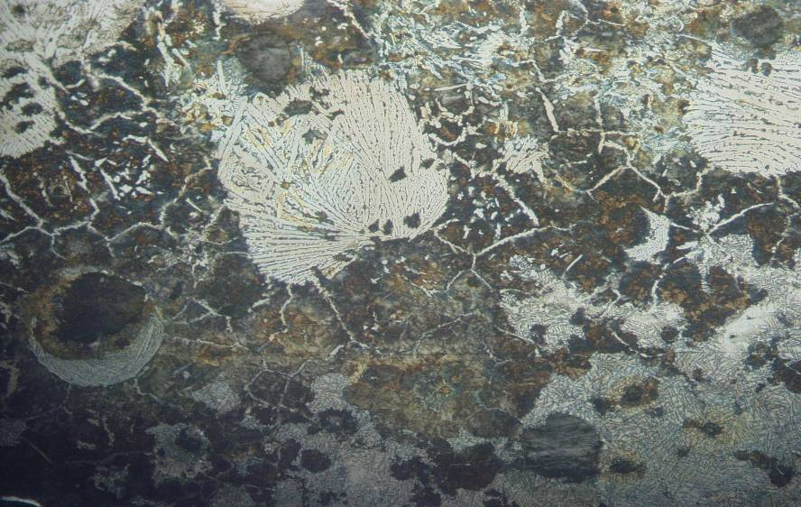
400X

50 µ m

Fig. 6 Microstructure of fusion zone and HAZ with preheating at 400ºC
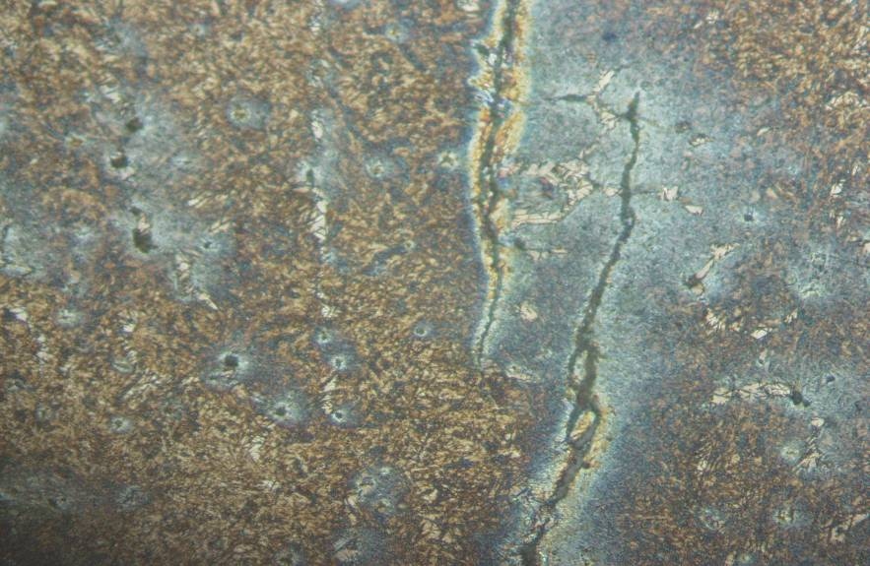
200X

50 µ m

Fig. 7 Microstructure of weld metal using E11018-G electrode without preheating

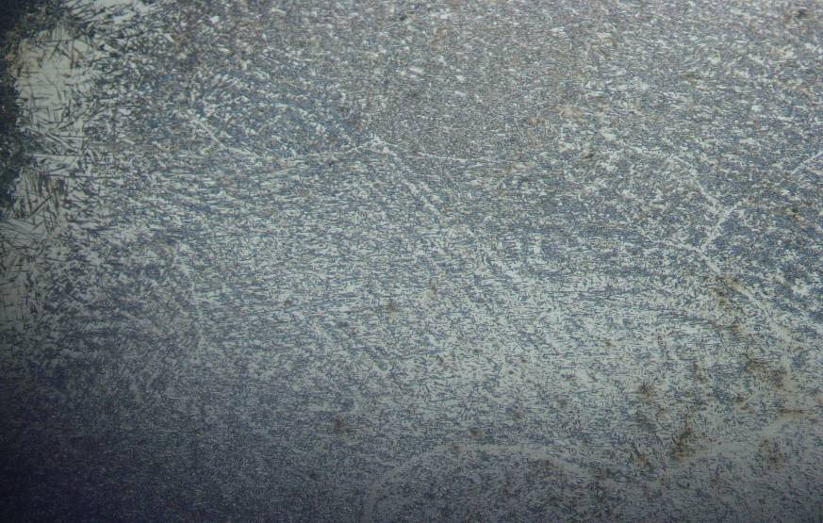
200X

50 µ m

Fig. 8 Microstructure of weld metal using E11018-G electrode with preheating at 400ºC

3.3 Welding of ADI using GTAW process and slides of GGG40 ductile cast iron
Welding of ADI was performed using ductile cast iron as a filler wire and applying GTAW process. A preheating temperature of 400ºC was also applied. After completion of welding, the joint was immediately kept at 400ºC for 2 hours and then gradually cooled in the furnace to room temperature. The joint was visually and dye-penetrant tested to check the existence of cracks or defects. The joint was found to be free from any defects, then it was austempered using the same heat treatment cycle applied in production of ADI.

3.3.1 Tensile test results
The results of tensile test specimen after welding and austempering are shown in Fig. 9. The tensile strength is comparable to that of the ADI base metal. This confirms the success of this procedure in welding of ADI.
YS
UTS

Fig. 9 Tensile test results of ADI base metal and welded

3.3.2 Microstructure
Microstructure at weld metal after austempering process is shown in Fig. 10 the microstructure is a bainitic structure which is comparable to that of base metal. Micro-hardness values are also comparable to that of ADI base metal (359HV). Therefore, welding of ADI using GTAW process using filler metal from the same material followed by austempering after welding; resulted in better weld joint properties from both micro-structural and mechanical point of view.
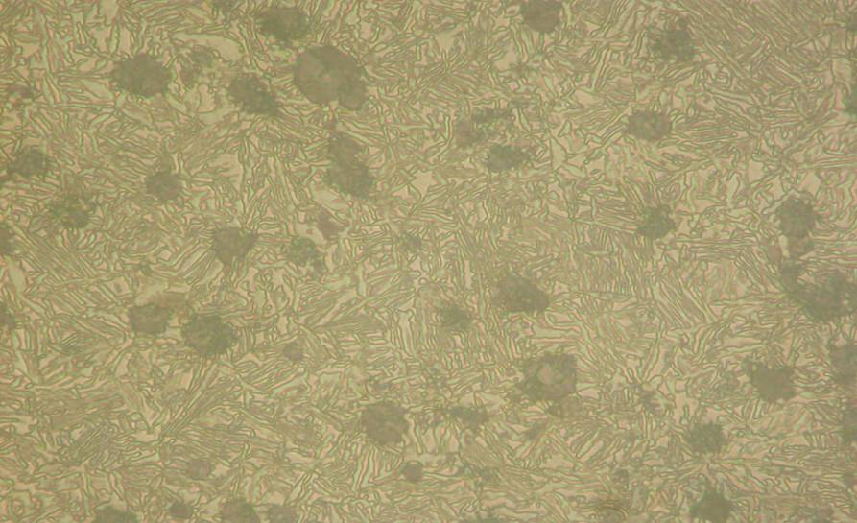
400X

50 µ m

Fig. 10 Microstructure of weld metal after austempering.4. Conclusions

Investigating welding of ADI was conducted using SMAW with AWS-ENiFeCI electrode and buttering with AWS-ENiCI, then welding with E11018-G. Also, GTAW process was applied using slides of GGG-40 ductile iron as a filler metal followed by austempering heat treatment. The following conclusions were obtained:
The tensile test properties of the joints are lower than that of ADI using AWS-ENiFeCI electrode; preheating temperature of 400ºC resulted in the disappearance of martensite in HAZ and the coarsening of carbides.
Cracks were observed using buttering technique at weld metal using E11018-G electrode. These cracks could be eliminated by applying a preheating temperature of 400ºC. However, the tensile test result is still lower than that of ADI base metal.
GTAW of ADI using slides of GGG-40 ductile iron as a filler metal followed by austempering heat treatment leads to a weld metal microstructure, which is comparable to that of the ADI and the tensile properties of the welded specimens are comparable to that of ADI base metal as well.

Corresponding author
M. A. Morsy
Central Metallurgical R & D Institute El-Tebein, Egypt
morsy_abokhala@yahoo.com*

5. References
- N. Darwish and R. Elliot: Materials Science and Technology, 9(1993), 882.
- N. Darwish and R. Elliot: Materials Science and Technology, 9(1993), 572.
- T. Kobayashi and H. Yamamato: AFS Transactions, 19A(1988), 314.
- Bayati and R. Elliot: Materials Science and Technology, 13(1997), 319.
- P. Rao and S. Putatunda: Materials Science and Technology, 14(1998), 1258.
- Bayati and R. Elliot: Materials Science and Technology, 13(1997), 118.
- M. Nili Ahmadabadi, B. Abassi khazai and M. Bahmani, AFS Transactions 105 (1997) 501.
- K. Hayrynen, K. Brandenberg and J. Keough, AFS Transactions 110 (2002) 929.
- Z. Zhang, K. Li and J. Wu, Foundary 2 (2004) 87.
- J. Xi and Z. Wu, Heat Treat. Met. 1 (2004) 70.
- W. Gong, J. Yu and G. Xiang, Foundary 6 (2004) 447.
- E. El-Banna, M. Nageda, and M. Abo El-Saadat, "Study of Restoration by Welding of pearlitic ductile cast irons", Materials letters, Vol. 42, (2000) 311–320.

2/2/2011

