Performance Evaluation for QoS Guarantee in ATM Networks with OPNET

Elsayed Abdelhameed Sallam¹, Ahmed Aisa Hussein² and Yahia Ahmed Zakaria³

1- Computers and Automatic Control Department, Faculty of engineering, Tanta University, Tanta, Egypt
2- Chemical engineering and pilot plant Department, Engineering Division, National Research Centre, Cairo, Egypt
3- Systems and Information Department, Engineering Division, National Research Centre, Cairo, Egypt
sallam@f-eng.tanta.edu.eg,; a.eissa@alraed.com.eg and Yahia_z@hotmail.com

Abstract: Voice over Asynchronous Transfer Mode Network (VoATM) Network is currently a popular research topic as a real time voice packet transmission method. The percentage of real time traffic (voice and video) over Internet is rapidly increasing due to growing trend of using real-time traffic oriented applications. People want to talk, watch TV, do video conferencing etc over Internet. This kind of real time traffic requires extra care because of more delay sensitivity, minimum QoS requirements and limited bandwidth. Simulation is the best way to study performance evaluation for the Quality of Service (QoS). The goal of this paper is to analyze the performance of QoS Guarantee and presents the discrete-event simulation which provides detailed and accurate network simulation results. Due to the increased number of networks in existence and their greater complexity, designing new systems and improving the performance of existing ones has become more difficult and time consuming. It is therefore more practical to use modeling and simulation tools such as OPNET to deal with this complexity. It provides an opportunity to examine the higher level and more complex behavior of ATM networks. The software simulation package, OPNET has many attractive features and can simulate large communication networks with detailed protocol modeling and performance analysis.
[Elsayed Abdelhameed Sallam, Ahmed Aisa Hussein and Yahia Ahmed Zakaria. Performance Evaluation for QoS Guarantee in ATM Networks with OPNET. New York Science Journal 2011;4(4):40-44]. (ISSN: 1554-0200). http://www.sciencepub.net/newyork.

Keywords: ATM network; QoS; OPNET simulation; TDM; CBR; VBR; CLR; CTD; PCR; SCR.

Introduction
Asynchronous Transfer Mode ( ATM ) well suited for multimedia applications due to its intrinsic characteristics of supporting multiple streamlines with varying data rates and Quality of Service (QoS ) features that can be adjusted to user's needs. While network designers are familiar with quality of service (QoS) requirements for specialized data network. All services (voice, video, data) can be transported via ATM, including connectionless services. To accommodate various services an adaptation function is provided to fit information of all services into ATM cells and to provide service applications like online transaction processing, packet voice often has more stringent QoS requirements. If the network is not properly conditioned to meet these requirements, the quality of the speech may be impacted. This is particularly true if voice is carried on public data networks like the Internet, where voice users have few options for securing end-to-end quality of service (Bo Li, 2000 and Jonadan, 2000)
ATM is considered as a specific packet oriented transfer mode based on fixed length cells. Each cell consists of a 48bytes of information field and a 5 bytes of header, which is mainly used to determine the virtual channel and to perform the appropriate routing. Cell sequence integrity is preserved per virtual channel. ATM is connection-oriented. The header values are assigned to each section of a connection for the complete duration of the connection. Signaling and user information are carried on separate virtual channels. The information field of ATM cells is carried transparently through the network. No processing like error control is performed on it inside the specific functions.
The ATM (Asynchronous Transfer Mode) Technology is the merged result of Packet Switching (Packet switching is a store vand forward data transmission technique in which a message is broken up into small parts each called packet.) and TDM (Time Division Multiplexing is a method of putting multiple data streams in a single signal by separating the signal into many segments, e.g. having a very short duration) These technique are clearly describe by Prycker et al ., 1993. The first 5 bytes contain cell-header information and the remaining 48 bytes contain the payload (Prycker, 1993).
ATM Network is designed to carry different type of traffic at the same type. Traffic could be voice, video or IP traffic. Internally all different traffic is carried as 53 byte cells.
However, handling of traffic depends on the characteristics and requirement of the traffic. There are four categories of Service; the QoS Parameters for those categories are [3] as follows:
Constant Bit Rate (CBR)
Variable BIT Rate (VBR)
- Real Time VBR and Non Real Time VBR.
- Real Time Variable Bit Rate(Rt-VBR)
- Non Real time Variable Bit Rate(Nrt-VBR)
- Available Bit Rate(ABR)
- Unspecified Bit Rate(UBR)

- Quality of Service (QoS) Parameters in ATM Networks
Primary objectives of ATM are to provide QoS Guarantees, while transferring cells across the network. There are mainly three QoS parameters specified for ATM and they are indicators of the performance of the network.

  - Cell loss Ratio (CLR)
The percentage of cells lost in the network due to error or congestion that is not received by the destination. CLR value is negotiated between user and network during call set up process and is usually in the range of 10 -1to 10 -15.

  - Cell Transfer Delay (CTD)
The Delay experienced by a cell between the first bits of the cell is transmitted by the source and the last bit of the cell is received by the destination. This includes propagation delay, processing delay and queuing delay at switches. Maximum cell transfer delay (Max CTD) and Mean cell Transfer Delay (Mean CTD) are used.

- Traffic Management
A key advantage of ATM is that it can carry traffic of different type like voice, video, data etc. different type of traffic necessitates a mechanism that can fairly mange the traffic coming on different virtual connection of different type. Traffic management in ATM does this by appropriately providing QoS for different type of traffic. By doing so traffic management has following Components.

Negotiations of a Contract Between end System and the Network
To make the QoS job easier for the Network, ATM forum define 5 different QoS classes.
Five different classes are Class 0, Class 1, Class 2, Class 3, Class 4.which corresponds to best effort applications, CBR circuit emulation applications, VBR video and audio applications, connection-oriented data, and connectionless data respectively. For each Specified QoS class, the network specifies an objective value for each QoS parameters.

2.1 Connection Admission Control
ATM network uses Connection admission control to reserve the bandwidth for each virtual connection on atm network. Every time a new connection is made, the network checks to see if it can fulfill the QoS requirements and the traffic characteristics of the incoming connection.

* Peak Cell Rate (PCR)
Define an upper bound on the traffic that can be submitted by the source into the ATM network. PCR is defined in terms of T, where T is the minimum inters cell spacing in seconds. This is needed for CBR traffic.

* Sustainable Cell rate (SCR)
It is the upper bound on the average rate that could be sent over a period on an ATM connection. SCR is basically measure of bursty traffic. SCR is needed for VBR services as it enables the network to allocated resources efficiently.

2.2 Traffic Policing
The Incoming traffic on a virtual connection is measured by traffic policing component and it discards the traffic that exceeds the negotiated parameters specified in the contract. Traffic policing employs Generic cell rate Algorithm (GCRA), which is also commonly known as leaky bucket algorithm. Leaky bucket algorithm checks the rate at which traffic arrives on a virtual connection. And if the arrival doesn't conform to the contract then it either marks them as potential candidates for discard during congestion or if arrival rate too high, it immediately drops them. Cells could be marked as potential candidate for discard my setting the CLP bit in the cell. CLP=1 makes them likely candidates to be dropped in case of congestion. Policing is usually used for VBR traffic where source is allowed to send burst of traffic over a period of time.

2.3 Traffic Shaping
Traffic shaping shapes the traffic coming on ATM interface that doesn't conform to the traffic contract and then it ensures by adjusting the incoming rate that traffic reaches the destination without getting discarded. Traffic shaping does this by buffering the traffic and sending it into the network at some later time.

- Performance Parameter
The performance of ATM systems can be characterized by the following parameters:

  - Jitter on the Delay
This is also called Cell delay variation (CDV) and this is denoted as the probability that the delay of the switch will exceed a certain value. This is called a quantile and for example, a jitter of 100 µsecs at a 10exp-9 quantile means the probability that the delay in the switch is larger than 100 Microsecs is smaller than 10exp-9.

  - Cell Loss Probability
In ATM switches when more cells than a queue in the switch can handle will compete for this queue, cell will be lost. This cell loss probability has to be kept within limits to ensure high reliability of the switch. In Internally Non-Blocking switches, cell can only be lost at their inlets/outlets. There is also possibility that ATM cell may be internally misrouted and they reach erroneously on another logical channel. This is called Insertion Probability.

  - Throughput
This can be defined as the rate at which the cells depart the switch measured in the number of cell departures per unit time. It mainly depends on the technology and dimensioning of the ATM switch. By choosing a proper topology of the switch, the throughput can be increased. Since ATM is connection oriented, there will be a logical connection between the logical inlet and outlet during the connection set up phase. Now the connection blocking probability is defined as the probability that there are not enough resource between inlet and outlet of the switch to assure the quality of all existing as well as new connection.

4. Simulation Configuration
Optimized Network engineering Tools (OPNET) is a powerful comprehensive engineering system that can be used to model communication systems and predict network performance. It is capable of simulating large communications networks with detailed protocol modeling and performance analysis.
OPNET provides four tools called editors to develop a representation of a system being modeled. These editors, the Network, Node, Process and Parameter Editors, are organized in a hierarchical fashion, which supports the concept of model level reuse. Models developed at one layer can be used by another model at a higher layer.

4.1 ATM Model Features
Signaling Support: Signaling is provided for point-to-point, full-duplex, Switched Virtual Circuit (SVC), Soft-Permanent Virtual Circuit (SPVC) and Soft-Permanent Virtual Path (SPVP). Traffic Control: Traffic control includes Call Admission Control (CAC) and Usage Parameter Control (UPC). Traffic Control is based on specific service category, traffic parameters (PCR, SCR, MCR,MBS) and QoS parameters (ppCDV, maxCTD,CLR).
Buffering: Buffers can be configured at each switch for various QoS levels. A QoS level is made up of the QoS category (CBR, rt-VBR, nrt-VBR, ABR, UBR), the QoS parameters, (ppCDV, max CTD, CLR) and the traffic parameters.

4.2 ATM Model attributes
The intermediate and advanced ATM nodes have several attributes that can be used to specify ATM con. guration details. Some of the important ATM model attributes we concern in our simulation are:

4.2.1 Traffic Contract
This attribute specifies the traffic contract used by the application layer when it sends traffic over an ATM stack. Although the application layer includes data traffic, signaling traffic and IP/ATM routing traffic, only data traffic has a configurable traffic contract. The Traffic Contract attribute has 3 parts: the Category, the Requested Traffic Contract, and the Requested QoS.
• Requested QoS: This attribute specifies the application's requested Quality of Service, which includes the peak-to-peak cell delay variation (ppCDV), the maximum cell transfer delay (maxCTD), and the cell loss ratio (CLR). During call admission control, these requested values will be compared to the supported parameters on all intermediate nodes.
• Category: This attribute specifies the service category used by the application. OPNET supports all five categories specified by the ATM Forum Traffic Management Specification 4.0: CBR, rt-VBR, nrt-VBR, ABR, and UBR. For a call to be admitted by call admission control, there should be at least one path to the destination where all nodes support the requested service category.
• Requested Traffic Contract: This attribute specifies the traffic parameter settings for the connection. The Requested Traffic Contract allows you to specify the peak cell rate (PCR), minimum cell rate (MCR), sustainable cell rate (SCR), and mean burst duration (MBS) in the incoming and outgoing directions. During call admission control, these requested values are compared to the supported parameters on all intermediate nodes. Table 1 shows the typical values and parameters of our traffic model. Note that the given data rates are just a typical value for one run which are varied to observe the performance metrics.

Table 1. typical values and parameters of traffic model
Link Speed | 155Mbps
FTP data rate | 100kbps
Video frame rate | 10fps
Video frame size | 128*144 pixels
Video data rate | 56kbps
Voice data rate | 8kbps
Voice codec | G.729
Video codec | H.263

4.3 Codecs
Voice codecs supported by OPNET simulator are G.711, G.729, G.723.1 and GSM. In current Internet environment with the large delay and high loss probability, G.723.1 and G.729, which has a small packet size and bandwidth, are more appropriate than G.711.

4.3.1 G.729
G.729 was created primarily for wireless applications. The bit rate was fixed at 8kbps from the outset and it was agreed that this would not include channel coding. One of the critical trade-offs was between delay and complexity. The frame size is 10ms. The look ahead delay is 5ms. Assuming 10ms for computation processing, the total one-way codec delay is 25ms. The complexity of some of the initial implementations of G.729 used about 20 MIPS and 3000 words of RAM.

4.3.2 G.723.1
The entire process for G.723.1 was carried out in a more urgent mode than G.729. Comparing the overall performance of G.723.1 at 6.3kbps and G.729, there is not a great deal of difference; nor is there much difference in complexity. The real differences are in bit rate and delay. G.723.1, with its 30ms frame size and 7.5ms look ahead, has a one-way delay of 67.5ms compared with 25ms for G.729. If an additional frame is added for transmission delay, this becomes 97.5ms versus 35ms. Table 2 lists the characteristics of the codecs.

Table 2. haracteristics of the codecs
Codecs | Bit rate (bps) | Frame size/Look ahead (ms) | Frame Length(byte)
G.723.1 | 5.3/6.3 | 30/7.5 | 20/24
G.729 | 8 | 10/5 | 10

5. Simulatiom Results and Analysis
We constructed the ATM network using OPNET as shown in figure1. The ATM network which we are simulating consists of several ATM switches, server and clients. We notice that we use OC3 link to connect the network for supporting maximum 155Mbps traffic.
We adjust the traffic load by changing the Traffic Scaling Factor in Configure Simulation menu before we run the simulation every time as shown in figure 2. The three traffic components: video, voice and data are generated; we use rt_VBR for video, CBR for the voice, and ABR for data traffic. However, the ratio of the three kinds of traffic is difficult to set to exactly 30%, 40% and 30%. Fig2 is the comparison of the traffic generated by video, voice and data.
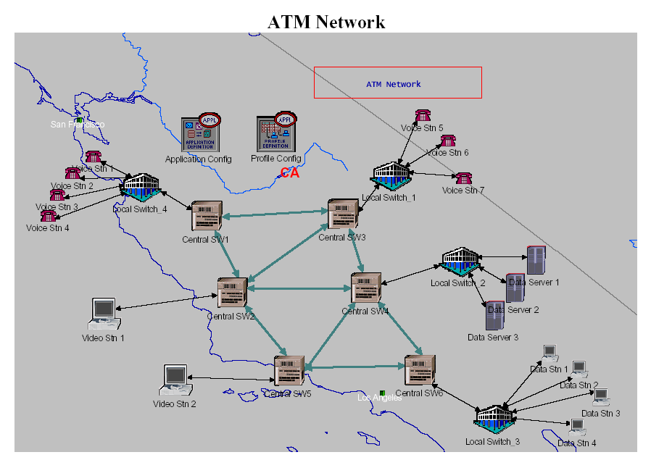
Figure 1. ATM network structure

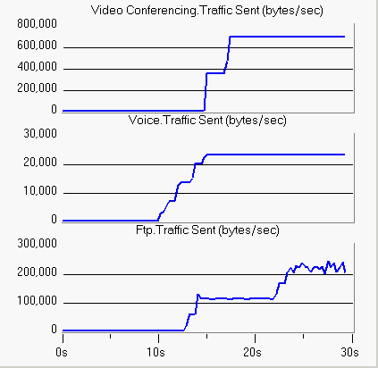
Fig2. Traffic load comparison

Now we can show the results of data, voice and video services as shown in the following tables 3 and 4.

Table 3. Results of data, voice and video services (1)
Minimum | Maximum | Average | Statistic
0 | 39 | 19.4 | Video Conferencing  Traffic Sent  (packets/sec)
0.0705 | 0.0706 | 0.0705 | Video Conferencing  Packet End-to-End Delay (sec)
0 | 691.200 | 315.320 | Video Conferencing  Traffic Sent (bytes/sec)
0 | 691.201 | 314.038 | Video Conferencing  Traffic Received  (bytes/sec)

Table 4. Results of data, voice and video services (2)
Maximum | Maximum | Average | Statistic
0.058 | 0.109 | 0.072 | Ftp Upload  Response Time (sec)
0 | 286.440 | 85.309 | Ftp Traffic  Received  (bytes/sec)
0 | 94.1 | 31.9 | Ftp Traffic Sent (packets/sec)
0.058 | 0.110 | 0.074 | Ftp Download  Response Time (sec)
0 | 96.8 | 31.7 | Ftp Traffic  Received  (packets/sec)
0 | 242.267 | 85.815 | Ftp Traffic Sent (bytes/sec)

Conclusion
Not long ago, one might have chosen Asynchronous Transfer Mode (ATM) Network, because it was faster, more scalable and offered a higher quality of service (QoS).
ATM is supposed to be fit for real time traffic due to its prior path establishment feature. Furthermore, the quality of the real time traffic, especially for voice data, is deteriorated on such a high value of the delay.
In our study, we notice that when the load increase the traffic increases also, this mean that ATM Network accepts high traffic in the network.
In conclusion we have found that, as priority of client increase its corresponding traffic increase.
OPNET provides an opportunity for developers and researchers of communication networks to develop a feel for what is happening in complex network environments by changing parameters and seeing the corresponding impact through performance statistics and animations.
Simultaneously, discrete-event simulation provides detailed, accurate network simulation results and can observe a wide variety of network statistics.

References
- Bo Li; Hamdi M.; Dongyi Iang; Xi-Ren Cao and Hou, Y.T. "QoS enabled voice support in the next generation Internet: issues, existing approaches and challenges". IEEE Communications Magazine 2000; 38 (4): 54 -61.
- Jonadan Davidson and James Peters, "Voice over IP Fundamentals", Cisco press, 2000.
- Prycker, M.de; Peschi, R. and Landegem, T.Van, "B-ISDN and the OSI Protocol reference Model". IEEE Network Magazine 1993; 7(2):10-18.
- Prycker, M. de. ''Asynchronous Transfer Mode solution for Broadband ISDN'',IInd Edition.Chichester England:Ellis Horwood, 1993: 112, 118,157,159-168, 289, 323.
- Network simulation with OPNET: http://www.informs-cs.org/wsc99papers/043.PDF
- http://www.microsoft.com/windows2000/en/server/help/default.asp?url=/windows2000/en/server/help/ATM_und_atmqos.htm

3/6/3011

