Biosurfactant Production by Pseudomonas Sp from Soil Using Whey as Carbon Source
¹Praveesh B. V., ² Soniyamby A.R., ³ Mariappan C., ⁴ Kavithakumari P., ² Palaniswamy M and ² Lalitha S.
1- Karpagam Arts & Science College, Coimbatore, Tamil Nadu, India
2-Karpagam University, Coimbatore, Tamil Nadu, India
3-Sivanthi Aditanar College, Nagercoil, Tamil Nadu, India
4- Cashew Export Promotion council Laboratory & Technical division, Kollam, Kerala, India
praveesh_bv@yahoo.co.in

Abstract: Biosurfactants are surface active compounds released by microorganisms. They are biodegradable non-toxic and ecofreindly materials. Nowadays, the use of biosurfactant has been limited due to the high production cost. Nevertheless, biosurfactants can be produced with high yield by some microorganisms, especially Pseudomonas sp. These microorganisms can use the various renewal resources, especially agro industrial wastes, as the potential carbon sources. The production of biosurfactant by Pseudomonas sp using the following Carbon (whey, used frying oil and rice water) and Nitrogen source (ammonium sulfate, sodium nitrate urea, and potassium nitrate) sources were examined in this work. Whey as carbon and sodium nitrate as nitrogen source were found to give the optimal yield of biosurfactant production (9.2g/L).
[Praveesh B. V., Soniyamby A.R., Mariappan C., Kavithakumari P., Palaniswamy M and Lalitha S. Biosurfactant Production by Pseudomonas Sp from Soil Using Whey as Carbon Source. New York Science Journal 2011;4(4):99-103]. (ISSN: 1554-0200). http://www.sciencepub.net/newyork.

Keywords: Biosurfactant, Pseudomonas sp, whey, sodium nitrate

Introduction
Microbial surfactants are surface-active metabolites produced by microorganisms when grown on water miscible or oily substrates: they either remain adherent to microbial cell surfaces or are secreted in the culture broth. They possess the characteristic property of reducing the surface and interfacial tensions using the same mechanisms as chemical surfactants. Research in the area of biosurfactant has expanded quite in recent years due to its potential use in different areas such as the food industry, agriculture, pharmaceutics, the oil industry, petrochemistry and the paper and pulp industry amongst others (Abouseoud et al.2007).
Biosurfactants have advantages over their chemicals counterparts because they are biodegradable (Zajic et al., 1977), have low toxicity (Poremba et al., 1991), are effective at extreme temperatures or pH values and show better environmental compatibility (Georgiou et al., 1990). Nevertheless, from an economic standpoint, biosurfactants are not yet competitive with the synthetics. Biosurfactants can only replace synthetic surfactants if the cost of the raw material and the process is minimal. So far, several renewable substrates from various sources, especially from industrial wastes have been intensively studied for microorganism cultivation and surfactant production at an experimental scale (Maneerat, 2005).
Rhamnolipid has been known as biosurfactant which is produced by Pseudomonas aeruginosa in fermentation process. Several carbon sources such as ethanol, glucose, vegetable oil and hydrocarbon have been used to produce rhamnolipid. The genus Pseudomonas is capable of using different substrates such as glycerol, mannitol, fructose, glucose, n-paraffins and vegetable oils to produce rhamnolipid type biosurfactants (Cooper et al., 1981).
Industrial effluents have recently shown good promise as potential substrates for biosurfactant production. The purpose of this work was to study biosurfactant production from whey covering different aspects of process parameters of biosurfactant production by the isolated Pseudomonas sp.

Materials and Methods

Isolation of biosurfactant-producing Pseudomonas sp
Soil samples collected from oil-contaminated soil from near a petrol pump (Marthandam, Tamilnadu). The method of serial dilutions of the sample and plate count in selective medium Cetrimide agar was used for isolation purposes. The plates were incubated at 30 ºC for 48 hours.

Screening for an isolate for biosurfactant production
Biosurfactant activity of isolated five different Pseudomonas sp was detected by using oil-displacement method [Youssef et al., 2004]. Forty milliliters of distilled water was added to a petri dish followed by the addition of 10 µl of crude oil to the surface of the water, 10 µl of sample was added onto the centre of the oil film. The diameters of the clear zone on the surface were measured and compared with control using uninoculated medium and efficient biosurfactant producing bacterial isolate was then identified as per IS 13428:1998 Annex D.

Biosurfactant production from different substrates
Different substrates such as whey, rice water and used frying oil were screened as carbon source for biosurfactant production. Production of the biosurfactant was carried out in 250 ml Erlenmeyer flasks containing 50 ml of the medium composed of (g/l): KH₂PO₄: 0.5, K₂HPO₄: 1, KCl: 0.1, MgSO₄.H₂O: 0.5, FeSO₄.7H₂O: 0.008, CaCl₂: 0.05, Urea: 6 and 0.05 ml of trace elements solution (Br: 0.026, Cu: 0.05, Mn: 0.05 and Zn: 0.07) carbon source was added at 2% (wt or vol/vol), pH was adjusted to 7.0. The medium was inoculated with 5% of the 18 hours bacterial culture grown on nutrient broth. Incubation was carried out at 37 ºC in an incubator shaker at 150 rpm for 48 hours (Sifour et al., 2005)

Quantification of rhamnose
The quantification of rhamnolipids expressed in rhamnose (g/l) was measured in the cell-free culture medium, using the phenol sulfuric acid method (Kappeli and Finnerty 1980).

Determination of the emulsifying activity
To estimate the emulsifying activity, two equal volumes of supernatant and kerosene (2ml each) were added in a test tube and mixed at high speed for 2 minute.The emulsion stability was determined after 24 h. The emulsification index, E24 (%) was the ratio of the height of the emulsion layer by the total height of the mixture (Iqbal et al., 1995).

Optimization of cultural conditions
Various physical and chemical parameters such as concentration of carbon source (1, 2, 3, 4 and 5%), incubation period (24, 48, 72, 120, and 144 hour), temperature (20, 30, 35, 40 and 45 ºC), pH (6, 7, 8, 9 and 10) and effect of nitrogen source (ammonium sulfate, sodium nitrate, urea, potassium nitrate 0.5%) were studied.

Result and Discussion

Isolation and screening of biosurfactant producing microorganisms
For screening of biosurfactant-producing microorganisms, the oil displacement method was selected. Among the five isolates one isolate which showed very strong positive reaction was selected and identified as Pseudomonas sp (Table 1) on IS 13428:1998 Annex D.

Table 1: Table showing Characteristics of Pseudomonas sp

Test Performed | Results
Gram staining | Gram Positive
Morphology | Rod
Skim milk agar | Greenish yellow colony with clearing of medium
Oxidase test | Positive
Catalase test | Positive
Hugh-Liefson test | Non fermentative
Gelatin Liquefaction | Positive
Asparagine proline broth | Turbidity, Fluorescence under UV

Selection of carbon source
Among 3 substrates screened (Figure 1), whey gave highest biosurfactant production (3.8g/L) which is almost two times higher than that produced by other substrates. Used frying oil (2.1 g/L) and rice water (1.3g/L) also yielded significant biosurfactant yields. Sweet whey, a potent pollutant, is produced in large quantities by cheese industries and in most cases is discharged without any treatment to rivers or streams (Ben-Hassan and Ghaly, 1994; Ghaly and Singh 1989). In Brazil, production of whey is estimated to be around 3 million tons per year. The pollution caused by whey is due essentially to the lactose content of the product (Juengst, 1979). Fermentation of whey by microorganisms is one possible way of reducing the pollutant effect. The higher value of E₂₄ (75%) was recorded during Pseudomonas sp growth on whey based medium.

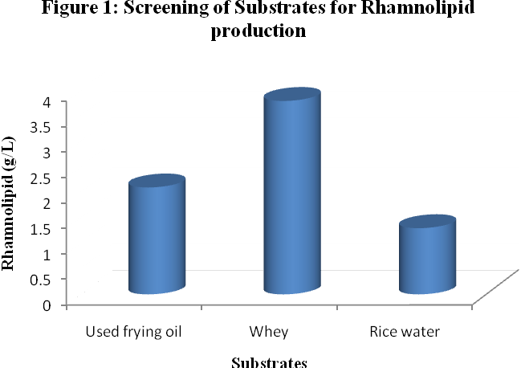

Effect of concentration of Carbon source on rhamnolipid production
The experiments were conducted in fermentation medium containing 1 to 5% whey as carbon source. The maximum amount of rhamnolipid concentration (4.92 g/L) was observed at 3% whey in the medium. There was not any difference in the production of rhamnolipid biosurfactant over 5% whey concentrations (Figure 2).
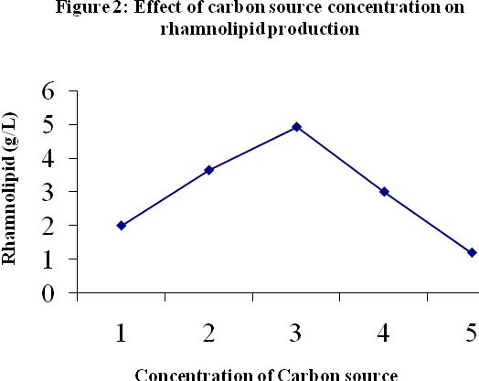
Effect of the Nitrogen Source
Figure 3 show that sodium nitrate (6.4g/L) is more effective than ammonium sulphate, potassium nitrate and urea. Our results are in agreement with those obtained by Rhashedi et al. (2006), who worked with the strain Pseudomonas aeruginosa which produced rhamnolipids when sodium nitrate was used as nitrogen source.
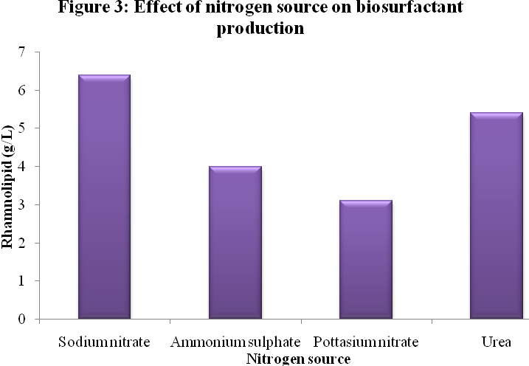
Effect of incubation period for biosurfactant production
Figure 4 showed the effect of different incubation period on biosurfactant productivity by Pseudomonas sp. From the recorded results, it was found that biosurfactant revealed its best production after 72 h of incubation period. Maximum rhamnolipid production was 8 g/L.

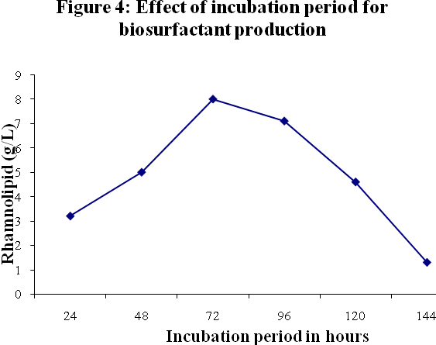

Effect of pH for biosurfactant production
In our study the biosurfactant production by Pseudomonas sp, was found maximum at pH 7 (8.6 g/L) (Figure 5). Further increase in the pH resulted decrease in the production of rhamnolipid. When the pH is altered below or above the optimum, the production is decreased. Different organisms have different pH optima and decrease or increase in pH on either side of the optimum value results in poor microbial growth.
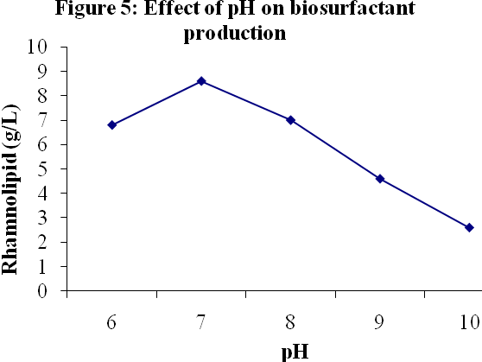

Effect of Temperature for biosurfactant production
Results from Figure 6 shows the effect of different incubation temperature on the production of biosurfactant by Pseudomonas sp., the maximum production of rhamnolipid (9.2 g/L) was obtained at 35 ºC. Increase in incubation temperature, decreased the production of biosurfactant. The production of the enzyme was greatly inhibited at 45 ºC. It might be due to that at high temperature, the growth of the bacteria was greatly inhibited and hence, biosurfactant production was also prohibited.
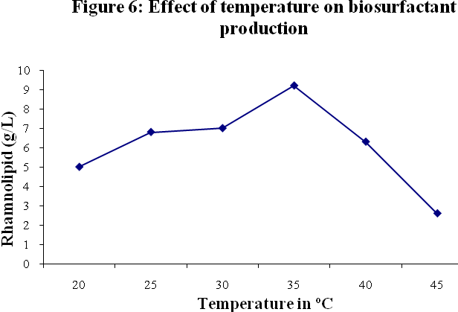

Conclusion
In conclusion, the Pseudomonas sp isolated from soil sample has a higher capacity to produce biosurfactant with whey as the substrate at neutral pH with maximum production of 9.2g/L. The main factor limiting commercialization of biosurfactants is associated with non-economical large-scale production. To overcome the obstacle and to compete with synthetic surfactants, inexpensive substrate and effective microorganism has to be intensively developed for biosurfactant production. Agro-industrial wastes are considered as the promising substrate for biosurfactant production and can alleviate many processing industrial waste management problems.

Corresponding Author:
Praveesh B.V.
Department of Microbiology
Karpagam Arts & Science College
Eachanari-641021
Coimbatore
Tamil Nadu
India.
Email id: praveesh_bv@yahoo.co.in
Mobile: +91 9600637071

References

- Abouseoud , M., R. Maachi, R., Amrane, A. 2007. Biosurfactant Production from olive oil by Pseudomonas fluorescens Communicating Current Research and Educational Topics and Trends in Applied Microbiology A. Méndez-Vilas (Ed.)340 :340-347.
- Ben-Hassan, R. M., Ghaly, A.E. 1994. Continuous Propagation of Kluyveromyces fragilis Cheese Whey for Pollution Potential Reduction. Appl. Biochem. Biotechn. 47: 89-105.
- Cooper, D. G., MacDonald, C. R., Duff, S. J. B., Kosaric, N. 1981. Enhanced production of surfactin from Bacillus slubtilis by continuous product removal and metal cation additions. Appl. Environ. Microbiol.42 : 408.
- Georgiou, G., Lin, S.C., Sharma, M.M. 1990. Surface active compounds from microorganisms. Biotechnology. 10: 60-65.
- Ghaly, A.E., Singh, R.K. 1989. Pollution potential reduction of cheese whey through yeast fermentation. Appl. Biochem. Biotechnol, 22 :181-203.
- Iqbal,S., Khalid, Z.M., Malik K.A. 1995. Enhanced biodegradation and emulsification of crude oil and hyperproduction of biosurfactants by a gamma ray-induced mutant of Pseudomonas aeroginosa. Lett. Appl. Microbiol. 21: 176.
- Juengst, F. W. J. 1979. Use of total whey constituents – Animal feed. J. Dairy Sci, 106-111.
- Kappeli,O., Finnerty, W. R. 1980. Characteristics of hexadecane partition by the growth medium of Acinetobacter sp. Biotechnol. Bioeng, 22 : 495-503.
- Maneerat, S.2005. Production of biosurfactants using substrates from renewable-resources, Songklanakarin J. Sci. Technol. 27.
- Poremba, K., Gunkel, W., Lang, S., Wagner, F. 1991. Marine biosurfactants, III. Toxicity testing with marine microorganisms and comparison with synthetic surfactants. Z. Naturforsch, 46: 210- 216.
- Rashedi, H., Mahnaz, M. A., Esmaeil, J., Babak, B. 2006. Optimization of the Production of Biosurfactant by Pseudomnas aeruginosa HR Isolated from an Iranian Southern Oil Well. Iran. J. Chem. Chem. Eng, 25: 25-30.
- Sifour, M., Haddar, H.O., Aziz, G.M. 2005. Production of Biosurfactants from two Bacillus species Egyptian, Journal Of Aquatic Research1687-4285, 31: 142-148.
- Youssef, N.H., Duncan, K.E., Nagle, D.D., Savage, K.H., Knapp, R.M., Mclnerney. 2004. Comparison of methods to detect biosurfactant production by diverse microorganisms. J. Microbiol. Methods, 56 :339-347.
- Zajic, J.E., Gignard, H., Gerson, D.F. 1977. Properties and biodegradation of a bioemulsifier from Corynebacterium hydrocarboclastus. Biotechnol. Bioeng, 19: 1303-1320.

3/26/2011

