Molecular Characterization of Intraspecific Protoplast Fusion in Trichoderma Harzianum

Hassan*^{1,} M. M., Ragaa A. Eissa¹, and H. A. Hamza²

¹Department of Genetics, Faculty of Agriculture, Minufiya University, Egypt
²Department of Microbial Biotechnology, Genetic Engineering and Biotechnology researches Institute (GEBRI), Sadat City, Minufiya University, Egypt
khyate_99@yahoo.com

Abstract: Protoplast was isolated from two fungicide tolerant mutants PTz-C and PTz-F of T. harzianum, obtained from 18 h old mycelium digested by Novozyme 234 and fused by polyethylene glycol (PEG). The frequency of fusion resulting in double fungicide tolerant isolates was about 0.32 % and seven fusants were selected for further studies. Fusion between the two fungicide tolerant mutants of T. harzianum developed some superior strains. The present study shows that it’s possible to obtain temporary nuclear fusion in which recombination events can occur. The confirmation of occurrence of Intraspecific protoplast fusion using inter simple sequence repeat (ISSR) technique was carried out using two primers. ISSR banding pattern indicated that protoplast fusion was done at molecular level and it was consistent with data obtained from the protoplast fusion identification as nuclear and cytoplasmic fusion. Results of the present study demonstrated the scope and significance of the protoplast fusion technique, which can be used to develop superior hybrid strains of filamentous fungi that lack inherent sexual reproduction.
[Hassan, M. M., Ragaa A. Eissa, and H. A. Hamza. Molecular Characterization of Intraspecific Protoplast Fusion in Trichoderma Harzianum. New York Science Journal 2011;4(5):48-53]. (ISSN: 1554-0200). http://www.sciencepub.net/newyork.

Key words: Protoplast fusion, PCR-ISSR technique, Trichoderma.

1. Introduction:
Fungal protoplasts fusion is an important tool in physiological and genetic research (Hanson and Charles 2002) and genetic manipulation can successfully be achieved through fusion of protoplasts in filamentous fungi that lack the capacity for sexual reproduction (Savitha, et al., 2010). Hence, protoplast fusion is one of the important approaches in strain improvement programmes (Balasubramanian, and Lalithakumari, 2008). Isolation, fusion and regeneration of protoplasts have been achieved in the genus Trichoderma mainly to enhance its bicontrol potential (Furlaneto, and Pizzirani (1992), and Prabavathy et al., 2006). This approach, has been successfully used by Ogawa et al., 1987 who suggested that protoplast fusion appears to be a useful tool for combining desirable traits, suggesting the existence of a parasexual cycle and presented the possibility that diploidization occurred in T. reesei (Stasz, et al., 1988 and Watanapokasin, et al., 2007) using T. harzianum, and Gunashree and Venkateswaran 2010 using Aspergillus spp. Suggested that protoplast fusion appears to be a useful tool for combining desirable traits. Several attempts have been made to obtain satisfactory differentiation by using molecular fingerprinting. Moreover, modern techniques offer a valuable means for more direct approaches to improving existing superior strains and enhance its antagonistic activity (Salama and Tolba, 2003). Assessment of genetic diversity and phylogenetic relationships in Trichoderma species are fundamental to their improvement and to enhance the role of these techniques (Hermosa, et al., 2001). The present work aims to 1- prepare and fuse protoplast of fungicide tolerant mutants of T. harzianum, in an attempt to obtain nuclear products. 2- Occurrence of intraspecific protoplast fusion using PCR-ISSR technique.

2. Materials and Methods
Strains:
T. harzianum PTz-C and PTz-F mutants were used as parental strains in fusion experiments obtained by EMS/UV treated according to Papavizase, et al., (1990). PTz-C mutant tolerated Carboxin (5,6-dihydro-2-methyl-1,4-oxathiin-3-carboxamide) up to 15 µg/ml (wild type mycelium growth was completely prevented at 5 µg/ml Carboxin). PTz-F mutant tolerated Fungo (thiophanate-methyl) up to 15 µg/ml (mycelium growth of the wild type was completely prevented at 2.5 µg/ml Fungo).

Media:
Potato dextrose agar medium (PDA, Defico) was used as growth medium for fungal cultures. The basal medium (BM) described by Toyama et al., (1984) containing 100 μg ampiciline / ml was used as growth medium for protoplast isolation. Selective basal medium contained the same component of BM supplemented with Fungicide, Carboxin and/or Fungo. Protoplast regeneration minimal medium (PRMM): was used as described by Stasz et al., (1988) for protoplast regeneration.

Protoplast preparation:
Protoplasts preparation was carried out using fungicide tolerant isolates of Trichoderma harzianum according to Stasz et al., (1988).

Protoplast regeneration:
Viable numbers of protoplasts, which were able to give rise to colonies on PRMM, were determined by preparing appropriate dilutions in STC buffer. Aliquots of 100 ml overlay PRMM + 2 % top agar was poured over a lager of PRMM or PRMM supplemented with one of the fungicides. Plates were incubated for 5-7 days at 25°C. Developing colonies were counted.

Protoplast fusion:
Protoplasts were fused using a procedure similar to that described by Pe′er and Chet (1990).
Fusant colony characterization: The double fungicide tolerant colonies which developed on PRMM + Carboxin + Fungo were consequences of either cytoplasmic fusion (heterokaryosis) of parental fused cells or their karyogamy (nuclear fusion), as described by Picataggio, et al. (1983).

DNA extraction:
DNA was extracted from Trichoderma parents and fusants according to Al-Samarrai and Schmid (2000).

PCR-ISSR technique:
PCR reaction and amplification conditions were done as demonstrated by Salama et. al. (2000). Using two ISSR primers YES-1 and YES-2.

3. Result and Discussion:
Protoplast isolation and regeneration:
The efficient production of protoplasts from 18 h old mycelium of T. harzianum wild type, PTz-C and PTz-F strains were released at rate ranged from 7.8 x 10⁵ to 1.2 x 10⁶ protoplasts/100 mg wet weight of mycelia using Novozyme 234. Regeneration frequencies were determined as viable number of protoplasts that were able to give rise to colonies on PRMM. On fungicide free PRMM 1.9 x 10⁴, 2.3 x 10⁴ (2.3%) and 1.6 x 10⁴ (1.6%) colonies arose per 10⁶ protoplasts from both wild type and mutants (PTz-C and PTz-F), respectively. (Table 1). Regeneration of isolated protoplasts using PRMM containing only one fungicide gave different responses with wild type and mutant isolates. While it was slightly decreased for mutant isolates, 0.4 x 10⁴ and 1.0 x 10⁴ colonies per 10⁶ protoplasts with Carboxin and Fungo, respectively, it was completely inhibited for wild type. These results are longer thanthat obtained by Salama (1997) who showed regeneration frequencies of 1.9 % using T. lignorum, 1.7 % (Salama et al. 2000) using T. harzianum and more than 5 % by Savitha, et al., (2010), these different frequencies may be caused by laboratory conditions and/or strains used.

Table (1): Number of regenerated colonies per 10⁶ protoplasts derived from T. harzianum, fungicide tolerante mutants and their wild type.
Strains-derived protoplast | No. of regenerated colonies on PRMM supplemented with
Strains-derived protoplast | None | Carboxin | Fungo
Wild type | 109 x 10⁴ | 0.00 | 0.00
PTz-C | 2.3 x 10⁴ | 0.4 x 10⁴ | 0.00
PTz-F | 1.6 x 10⁴ | 0.00 | 1.0 x 10⁴
Whereas, PTz-C = T. harzianum, Carboxin tolerant: PTz-F = T. harzianum, Fungo tolerant mutant.

Protoplast fusion:
Data in Table (2) and Fig. (3)., showed that fused protoplasts of the two fungicide tolerant mutants, PTz-C and PTz-F plated into PRMM fusion frequencies for both fungicide tolerant mutants was about 0.32 %. Consequently, colonies appearing in presence of both fungicides are probably due to protoplast fusion and complementation between the fused parents. The complementation may be owing to either heterokaryosis or karyogamy (Pe'er and Chet, 1990). The protoplast fusion frequency was found to be 1.92 % for interspecific fusion (Balasubramanian and Lalithakumari, 2008) To distinguish between the two events, about 50 single conidium colonies produced from each of ten fusant colonies that appearing in presence of both fungicides were analyzed for tolerance to fungicides. Results in Fig. (1), showed that all of fusants are able to grow in the presence either Carboxin or Fungo as well as, in the presence of both fungicides, indicating that these colonies are a result of a karyogamy (nuclear fusion). The similar results are obtained by Amer and Salama, (2000), Watanapokasin, et al. (2007) who reported that the heterokaryotic colonies appearing into non-fusant types, in approximately equal numbers.

Fusants stability:
Genetic stability of the double fungicide tolerant (nuclear fusion) isolates was represented by their ability to maintain tolerance to both fungicide after three subculturing in the absence of fungicides. Data in Fig. (2), showed that five fusants Fu 3, 4, 5, 6 and 7, retained the double fungicide tolerance, whereas, both Fu 1 and Fu 2 lost their double fungicide tolerance after the third subculture. These results suggest that Fu 1 and Fu 2 probably are the result of temporary cytoplasmic fusion formation that was unstable and may be lost through successive cycles of mitotic division during mycelial growth. However, combination events might have taken place during the short period of transient nuclear fusion. Subsequently, recombinant isolates could be obtained from segregant phenotype colonies produced from nuclear fusion isolates. Similar finding were observed by Stasz et al. (1988); Salama (1997) and Gunashree, and Venkateswaran (2010), who suggested that protoplast fusion appears to be a useful tool for combining desirable traits in T. harzianum. The possibility of genetic recombination that happens through a parasexual cycle and the occurrence of a highly unstable diploid phase has been discussed by Watanapokasin et al. (2007) in T. viride, Savitha, et al., (2010) in T. harzianum,

Table (2): The frequency of fusion following the fusion of protoplasts from fungicide tolerant mutants.
Mutant-derived protoplast | No. of colonies appearing on PRMM supplemented with
Mutant-derived protoplast | None | Carboxin | Fungo | Car.+Fun. | Fus. %
PTz-C x PTz-F | 8.62 x 10³ | 2.04 x 10³ | 1.04 x 10³ | 0.1 x 10² | 0.32
Whereas, PTz-C = T. harzianum, Carboxin tolerant: PTz-F = T. harzianum, Fungo tolerant mutant, Fus = Fusants.

Colonies growth percent
Fig. (1): Analysis of single conidium colonies derived from T. harzianum, fusant isolates to distinguish between cytoplasmic fusion (heterokaryosis) and nuclear fusion (karyogamy).

Conidial germination
Fig. (2): Behavior of Carboxin and Fungo tolerant markers in T. harzianum, nuclear fusants after third subculturing

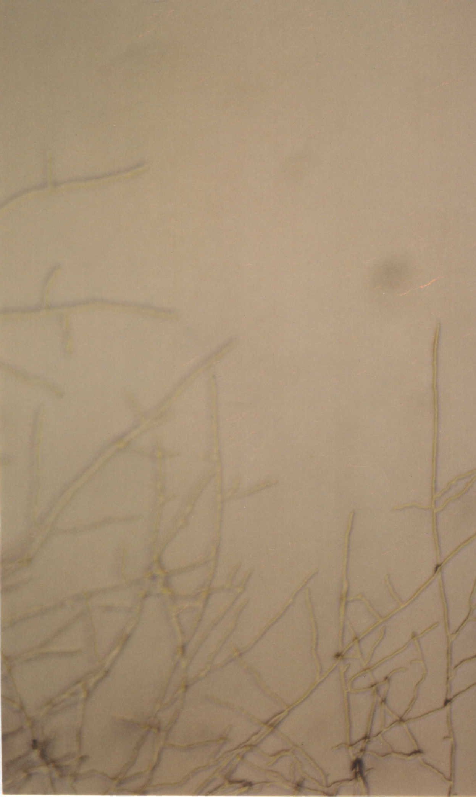 | 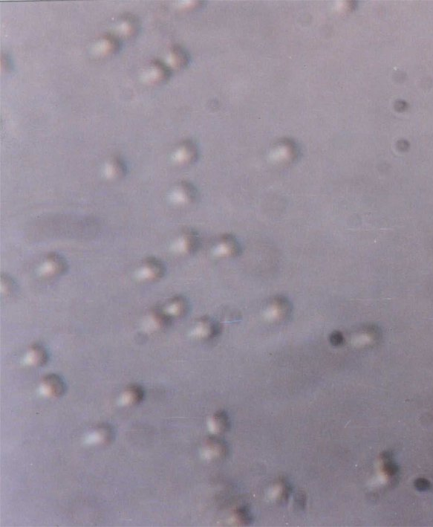 | 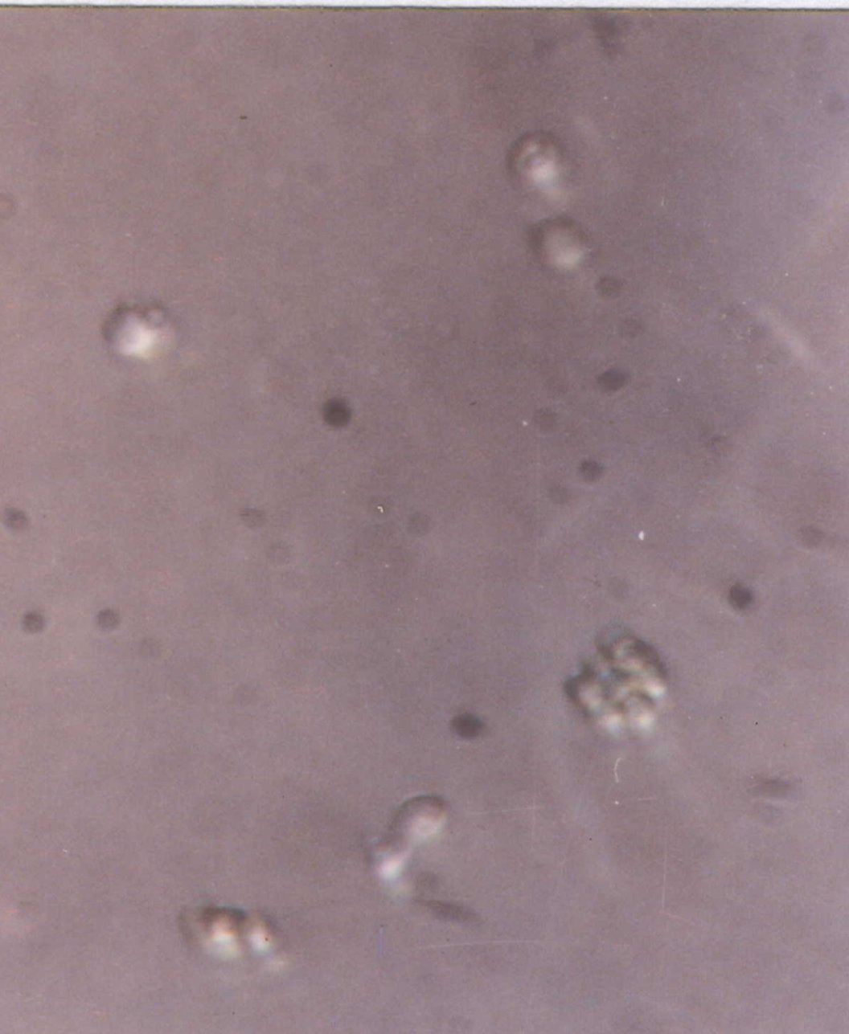
a. Mycelium | b. Protoplast isolated | c. Protoplast throw and after fusion
Fig. (3): Show mycelium and protoplast before and after fusion

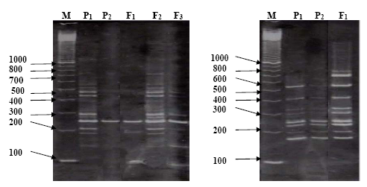
Fig. (4): Inter simple sequence repeats (ISSR) patterns obtained with two primers yes-1 and yes-2. of parental and some fusants, M, 100 bp DNA ladder.

Molecular occurance of protoplast fusion
In the present study two DNA primers were used to detect the occurrence of fusion using inter-simple sequence repeat (ISSR) technique. The first primer showed 17 polymorphic bands in the two parental strains tested and their corresponding fusants. The molecular weight of bands ranged from 95 bp to 647 bp. The second primer showed 18 polymorphic bands for the same parents and fusants, with molecular weight ranging from 112 bp to 695 bp. Comparison of the patterns of DNA bands of P₁, P₂ and their fusant indicated that, the fusant has the same pattern as the P₂ except the band with molecular weight 238 bp which present in P₁ and absent in P₂. It also indicated that the bands with molecular weight 647, 326, 226 and 209 bp present in the fusant strain that missed in both parents, these bands could be produced from recombination between parents. The use of the second primer with the same tested strains indicated the presence of three extra DNA bands in F₁ compared to P₁ and P₂.
In general the obtained new combination of DNA fragment patterns (F₁ with primer one) and the presence of new DNA fragment (recombinants) or the absence of existing parental DNA fragments (recombinants) in the fusant strains compared to their respective parents could be considered as indicator of nuclear fusion of the two parental nuclei in the fused protoplasts. Therefore, there was unique proof that F₁ was a real nuclear fusant since it contained both bands (loci). Since the parents were tolerant to only one fungicide fusant was tolerant to both. Therefore, these two loci might be locating near by the loci for resistance. Further studies for these two loci are needed to analyze their genetic map. These results agreed with Savithaand Venkateswaran (2010), who found that fusant formation was confirmed by genetical markers like, mycelial protein pattern, restriction digestion pattern and random amplified polymorphic DNA (RAPD) analysis.
The present results reflect the good occurance of nuclear fusion accompanying protoplast fusion between Trichoderma strains and species leading to the production of recombinants. Therefore, we could savely recommend protoplast fusion between different and within species to obtain recombinant strains. This fact could overcome the absence of sexual reproduction to introduce desired characters in Trichoderma species.

Corresponding author
Hassan, M. M.
Department of Genetics, Faculty of Agriculture, Minufiya University, Sheben El-Kom, Egypt.
khyate_99@yahoo.com

References
- Al-Samarrai, T.H. and J. Schmid (2000). A simple method for extraction of fungal genomic DNA. Lett. Appl. Microbiol. 30: 53 - 56.
- Amer, G.A. and S.A. Salama (2000). Enhancement the efficiency of Trichoderma hamatum for the biologecal control using intraspecific protoplast fusion. Minufiya J. Agric. Res. 25 : 907 - 920.
- Balasubramanian, N. and D. Lalithakumari. (2008). Characteristics of protoplast inter, intra-fusant and regeneration of antagonistic fungi Trichoderma harzianum and Trichoderma viride. Afric. J. Biotechnol. 7: 3235-3243.
- Furlaneto, M.C. and A.A. Pizzirani-Kleriner (1992). Intraspecific hybridization of Trichoderma pseudokonigii by anastomosis and protoplast fusion. FEMS Microbiology Letters., 90: 191 - 196.
- Gunashree, B. S. and G. Venkateswaran. (2010). Enhanced phytase production through interspecific protoplast fusion of Aspergillus niger CFR 335 and Aspergillus ficuum SGA 01 auxotrophic mutants. Enz. Microbiol. Technol. 46: 562-567.
- Hanson E. L. and C. R. Howell. (2002). Biocontrol efficacy and other characteristics of protoplast fusants between Trichoderma koningii and T. virens. Mycol. Res. 106:321-328.
- Hermosa, M.R.; I. Grondona; E.A. Iturriaga; J.M. Diaz Minguez; C. Castro; E. Monte and I. G. Acha (2001). Molecular characterization and identification of biocontrol isolates of Trichoderma spp. Appl. Environ. Microbiol., 66: 1890 - 1898.
- Ogawa, K.; J.A. Brown and M. Wood (1987). Intraspecific hybridization of Trichoderma reesei QM 9414 by protoplast fusion using colour mutants. Enzyme. Microb. Technol., 9: 229 - 232.
- Papavizase, G. C.; D. P. Roberts and K. K. Kim (1990). Development of mutants of Gliocladium virens tolerant to benomyl. Can. J. Microbiol. 36: 484 - 489.
- Peberdy, J. F. (1980). Fungal protoplasts: isolation, reversion, and fusion. Ann. Rev. Microbiol. 33: 21 - 39.
- Pe'er, S. and I. Chet (1990). Trichoderma protoplast fusion: a tool for improving biocontrol agents. Can. J. Microbiol., 36: 6 - 9.
- Picataggio, S.K.; D.H.J. Schemata ; B.S. Montenecourt and D.E. Eveleigh (1983). Sphaeroplast formation and regeneration in Trichoderma reesei., Eur. J. Appl. Microbiol. Biotechnol. 17: 121 - 125.
- Prabavathy, V. R.; N. Mathivanan and E. Sagadevan. (2006). Self-fusion of protoplasts enhances chitinase production and biocontrol activity in Trichoderma harzianum. Biores. Technol. 97: 2330-2334.
- Salama S. A. (1997). Improving antagonistic activity of Trichoderma lignorum using intraspecific protoplast fusion. Egypt. J. Genet. Cytol., 26: 23-32.
- Salama S. A. and A. F. Tolba (2003). Identification of Trichoderma reesei using specific molecular marker and their ability as biocontrol agent. Egypt. J. Genet. Cytol. 32: 137-151.
- Salama, S.A., G.A. Amer and SH. M. El-Desouky (2000). Phylogenetic relationships among Trichoderma species using molecular markers to assess their efficiency as biocontrol agents. Egypt. J. Genet. Cytol. 31: 253 – 266.
- Savitha, S. : S. Sadhasivam and K. Swaminathan. (2010). Regeneration and molecular characterization of an intergeneric hybrid between Graphium putredinis and Trichoderma harzianum by protoplasmic fusion. Biotechnol. Adv. 28: 285-292.
- Stasz, T.E.; G.E. Harman and N.F. Weeden (1988). Protoplast preparation and fusion in two biocontrol of Trichoderma harzianum. Mycol., 80 : 141 - 150.
- Toyama, H.; T. Yokoyama ; A. shinmyo and H.J. Okada (1984). Protoplast fusion in Trichoderma reesei using immature conidia. Appl. Environ. Microbiol., 47: 363 - 368.
- Watanapokasin, R. ; N. Sawasjirakij ; S. Usami and K. Kirimura (2007). Polyploid formation between Aspergillus niger and Trichoderma viride for enhanced citric acid production from cellulose. Appl. Biochem. Biotechnol. 143: 176-186.

4/20/2011

