Design and development of Pedal operated flour mill.

Prasad A.Hatwalne¹*, Sushil T.Ambadkar², R.V.Paropate³,Vivek R.Gandhewar⁴, A.M.Wankhade⁵

1,2,3,Department of Mechanical Engineering,Yashavantrao collage of Engineering,Nagpur-440001,India
4,5Department of Mechanical Engineering,JDIET,Yavatmal-445001,India
hatwalneprasad1@gmail.com.

Abstract: The socio-economic conditions of peoples living in villages of developing countries including India, human muscle power can be good alternative to fulfill the energy requirements for performing many activities like flour milling. Pedaling is the most efficient way of utilizing power from human muscles. Keeping these things in mind a pedal operated flour mill is developed. The machine consists of a chain drive and belt drive that turns rotates conventional stone wheels ,where the poured wheat gets crushed to produce flour. The machine is economically viable, can be used by common people, save time otherwise spent in traditional hand cranking of stone wheels and can be adopted for human-powered process units which could have intermittent operation without affecting the end-product.
[Prasad A. Hatwalne, Sushil T. Ambadkar, R.V. Paropate, Vivek R. Gandhewar, A.M. Wankhade. Design and development of Pedal operated flour mill. New York Science Journal 2011;4(5):74-77]. (ISSN: 1554-0200). http://www.sciencepub.net/newyork.

Keywords: flour mill, chain drive, belt drive, stone wheels.

1. Introduction:
Wheat is most widely produced cereal in the world, most of which is destined for human consumption thus its contribution to energy intake is significant. The processing of wheat to wheat flour is generally carried out in flour mills which is then used to make bread, biscuits ,pasta etc. In India Chapatti and other variants of wheat forms the staple food of majority of population of India & subcontinent. The majority of portion of wheat produced in these countries is utilized for this purpose after processing in chakki (flour mill) which are generally operated electrically. As far as manual process is concerned flour is produced by hand cranking the heavy stone wheels which physically demanding through its energy and postural requirements. It may also lead to clinical and anatomical disorders which may affect the operators health.

2. Need for pedal operated flour mill:
The main objective is to design & develop a machine which uses human power as source of energy to drive the machine. It basically consists of a simple bicycle mechanism.
In many developing countries like India, the gap between the ever increasing demand of power and its generation has prepared a daily busy schedule of load shedding (power cuts). There are millions of people in remote villages in India who lives day to day without reliable power supply. And thus to fulfill there demand of flour there are conventional hand cranked grain mill without an easy way to power it. This process of hand cranking of stone wheels is characterized by slow operation, fatigue and low production rate.
Pedal power is the transfer of energy from a human source through the use of a foot pedal and crank system (Kajogbola R,2010) Since the thigh or quadriceps is largest and most powerful muscles in the human body it make sense to utilize it for generating as much as energy from human body. With the body in seat, the legs can provide a pedal work (Wikipedia 2008).
The person can generate four times more power (1/4 horsepower (hp)) by pedaling than by hand cranking. At the rate of 1/4 hp, continuous pedaling can be done for only short time ,about 10 minutes . However pedaling at half of this power (1/8 hp)can be sustained for around 60 minutes Maximum power produced with legs is generally limited by adaptions within the oxygen transportation system. On the other hand the capacity for arm exercise is dependent upon the amounts of muscle mass engaged and that is why a person can generate more power by pedaling than hand cranking (Tiwari P.S.,2011). Pedal power enables a person to drive device at same rate as achieved by hand cranking but with less efforts and fatigue.
There are millions of people who live day to day without reliable power to complete daily work. Often these people are living in situations where manual labour allows them to sustain themselves, but mechanical devices can offer one way to ease the work load .The international labor organization (ILO) has reported that “The processed grain is one of the most important elements in the diet of low income groups in developing countries” The ILO found that appropriate technologies for grain milling keep the employment and local earnings. Further According to United states department of Agriculture, fresh grains as part of diet reduce the risk of several chronic diseases, including heart diseases and provide many vital nutrients. Thus it was felt to have some machine which can be operated by common people without any electric power supply and the result is pedal operated flour mill.

3. Concept development:
The power levels that can be produced by an average healthy athlete is 75 W maximum(Modak, 1998). A person can generate more or same amount of power for longer time if they pedal at certain rate. A simple rule is that most people engaged in delivering power continuously for an hour or will be more efficient when pedaling rate is in the range of 50-70 rpm.(Wilson D.G. VITA volunteer)
Keeping these limitations of human capabilities in mind the proposed machine consists of three sub systems: (1) The energy unit, (2) Transmission mechanism (3) The process unit. The energy unit basically consists of conventional bicycle mechanism; the transmission mechanism consists of chain drive running over a pair of sprockets and belt drive running over pulley and stone wheels. The process unit is a pair of stone wheels mounted over one another where the wheat gets crushed into powered form to produce wheat flour. All these units are assembled on bicycle like structure(seat, saddle, handle etc).

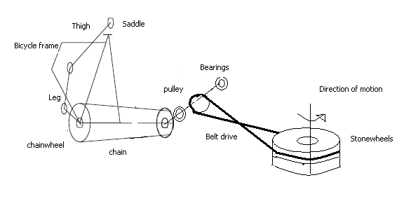Figure1.Energy unit, Transmission unit, Process unit

4. Constructional details
4.1 Drive unit:
The transmission of power from human to processing unit is carried out in two stages namely chain drive and belt drive. The operators uses his feet & legs to rotate pedal around the crank axel. The pedals, in turn, are fixed to a chain ring (sprocket) with teeth that engages the bicycle’s continuous chain. The chain then transmits the pedaling action to a cog on the hub of the front wheel causing the front sprocket to rotate and then drive the shaft on which pulley is mounted. (Kajogbola R,2010)This is first stage of transmission. In second stage this power is transmitted to stone wheels from pulley with the help of cross belt drive.

3.2 Processing Unit
Process unit is the one where actual crushing of wheat kernels take place. This process unit basically consists of stone wheel, hopper &the hemispherical collector.
Stone wheels are the two rigid chiseled emery stones placed one above the other. The bottom wheel is fixed one &the upper one can rotate about vertical axis. The selection of stone wheels are made in such a way that it should not be too heavy to cause early fatigue to operator but it should be capable of delivering the required finess of flour at optimum production rate. The provision is also made to enter the wheat kernels inside through the hole at center of upper stone.
Hopper is mounted exactly above the stone wheels, in which the wheat to be crushed is collected. Since the intermittent flow is required from hopper to stone wheels the provision is also made to control the flow of wheat kernels.
The hemispherical collector is fixed below the stone wheels where the flour is collected.

4. Working principle:

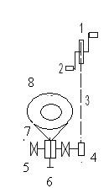
Figure2.Schematic diagram of pedal operated flour mill
1-Front Chain Sprocket 2-Pedal 3-Chain 4-Rear chain sprocket 5-Bearings for belt drive shaft 7-Cross V Belt, 8-Stonewheels
The basic principle of operation of “Pedal Operated Flour Mill” is that when a sufficient amount of power is applied by means of cycling through chain as well as cross belt drive to the conventional stone wheel mechanism, then the upper wheel revolves in a particular direction say clockwise or anticlockwise direction. The frictional force between two wheels is responsible for the grinding.
In conventional stone wheel mechanism the intermittent flow is required to get fine output. The same type of arrangements of flow is made in Pedal operated flour mill. It consists of Hopper mechanism in which the grains are stored. It is having a flow control unit, which is connected by means of mechanical spring to the left hand brakes. By breaking, the flow may control. The output of the stone wheel mechanism is collected between a hemispherical collector which is located below the stone wheel mechanism.
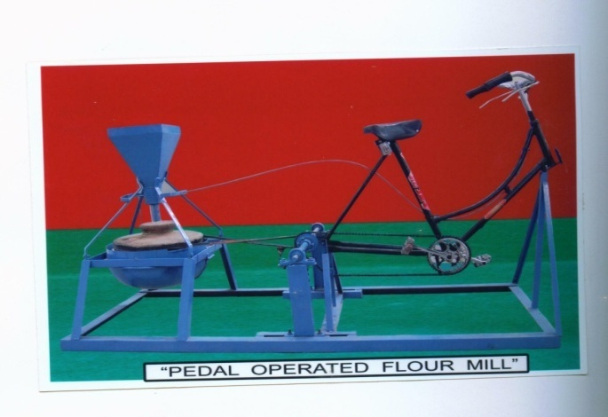

Figure3.pedal operated flour mill

5. Result And discussion:
A simple, easy to maintain and pedal operated flour mill was developed, constructed and tested as shown in figure3.
For conducting trials 8 personals from age group 20-35 were selected. The mean (± SD) of age, weight, height were 26.5± 3.5.years ,68.62±21 Kg ,176.8±3 cm respectively. All the trials started at 10 A.M.in the morning in the laboratory where the room temperature varied from 25-28˚C and relative humidity was 50-60% during experiment.
In order to find out most efficient, productive way operating the system, the input pedaling rate is set in three stages viz 30-50-rpm,50-70 rpm,70-90 rpm.
For 30-50 rpm, production rate observed was slow but the texture of flour was fine enough. The production rate found to be 25 mins per Kg& average time that subject can maintain the pedaling is 15 mins.
For 70-80 rpm the production rate of flour was observed to be maximum but the flour obtained was some what coarser and requires regrinding. Further it was finding difficult to maintain this pedaling rate more than 5 mins.
When input pedaling rate is set to 50-70 rpm 1 Kg of wheat requires 15 mins. To get required fineness double crushing was required but not to extent as that requiring at higher pedaling rate.So overall for 1Kg requires 20 mins and this pedaling rate found more comfortable than other two.

6. Conclusion:

The main objective behind development of pedal operated flour mill was on producing cheap, easy to operate system which can be easily fabricated by readily available material and thus we proposed a simplistic design that can deliver efficient, productive and reliable flour mill which can be used in rural as well as urban areas. this equipment can be easily operated by semi rather lowskilled operator. Further this equipment can easily find its place where there is no or limited power supply.

Corresponding Author:
Prasad Aravind Hatwalne
Department of Mechanical Engineering
Yashvantrao Chavan Collage Of Engineering
Nagpur,440001,India
Telephone:+91-07232-23799
Cellular Phone:91-09096273285
Email: hatwalneprasad1@gmail.com

References:
1. Modak J, Bapat A. Design of experimentation for establishing generalized experimental model for a manually driven flywheel motor.Proc. International Conference on Modeling and Simulation. New Delhi, India. 1987 8(2): 127-140
2.P.S.Tiwari,L.P.Gite,M.M.Pandey,A.K.Shrivastava.Pedal power for occupational activities :Effect of power output & Pedalling rate on physiological responses.Internationl journal of Industrial Ergonomics 41 (2011);pp261-267.
3. Modak J, Bapat A. Formulation of Generalised Experimental Model for a Manually Driven Flywheel Motor and its Optimization. Applied Ergonomics. 1994 25 (2):119-122.
4. Modak J, Moghe S. Comparison of some bicycle drive mechanisms designed in the light of transmission angle optimization and J. Papadopoulos Hypothesis, Part II. International Symposium on Machines and Mechanisms (ISMM '97), September 2-5, 1997.
5.Zakiuddin sayed kazi and J P Modak. Design and Development of human energized chaff cutter.New York science journal 2010.
6. Kajogbola R. Ajao, Kadiri Mustapha, Modupe R. Mahamood and Muritala O. Iyanda.Design & development of pedal powered soap mixer.New York science journal.2010;3(1)
7.David Gordon Wilson VITA volunteer.Undestanding the pedal power. ISBN: 0-86619-268-9
8.CCAT pedal power grain mill, from Wikipedia, encyclopedia.“http://www.appropedia.org/CCAT_pedal_powered_grain_mill”category:engr305 Appropriate Techonology.
9.Pichan prabhakaran and Punaroor Haridas rao.Effect of different milling methods on chemical composition of wheat flour.Eur food Res Technol (2001)213;pp465-469.

Date of submission:03/05/2011

