The Influence of Pulsation on Heat Transfer in a Heat Exchanger for Parallel and Counter Water Flows

A.E. Zohir

Mechanical Eng. Dept., Tabbin Institute for Metallurgical Studies, Cairo, Egypt
alaa_sadegh@yahoo.com

Abstract: In this study, in order to increase the heat transfer rate in concentric double-pipe heat exchangers by an active method, a rotating ball valve was mounted downstream of the outer pipe end and used as a pulse generator. In the experimental set-up, hot water (40-70 °C) was passed through the inner pipe with fixed mass flow rate (Reynolds number ≈ 10,200) while cold water was passed through the annulus with Reynolds number ranging from 2,000 to 10,200 and exposed to pulsation. The investigation is performed for pulsation frequency ranged from zero to 40 Hz while the amplitude was kept constant by fixing the ball valve at heat exchanger outlet. The influences of pulsation frequency, Reynolds number, and inlet hot water temperature on heat transfer enhancement were reported for both parallel and counter flows. The experimental results indicate that the tube with the ball valve inserting downstream provides considerable improvement of the heat transfer rate. The maximum enhancement in Nusselt number for the parallel flow was about 20% while it was about 90% for counter one. Correlations for relative average Nusselt number, for different pulsation frequencies and Reynolds numbers are provided with maximum standard error of 12%.
[A.E. Zohir. The Influence of Pulsation on Heat Transfer in a Heat Exchanger for Parallel and Counter Water Flows. New York Science Journal 2011;4(6):61-71]. (ISSN: 1554-0200). http://www.sciencepub.net/newyork.

Keywords: pulsated flow; turbulent pipe flow; heat exchanger

1. Introduction
Several techniques for heat transfer enhancement have been introduced to improve the overall thermal performance of heat exchangers resulting in the reduction of the heat exchanger size and the cost of operation. In general, the heat transfer enhancement techniques can be classified into two methods including active method (requires external power source) and passive method (not requires external power source). The mechanism for improvement of heat transfer performance in the passive method is promoting the turbulence near the tube wall surface to reduce the thermal boundary layer thickness. This turbulence introduces a chaotic fluid mixing which acted by several enhancing modified tubes such as a finned tube, tube with rib, tube with spirally roughened wall, corrugated tube, fluted tube, helical tube, elliptical axis tube and micro-fin tube, etc. Active techniques, which require an extra external power source, include mechanical aids, surface vibration, fluid vibration, fluid pulsation, electrostatic fields, injection or suction of fluid and jet impingement. Recently, there has been growing interest in the effects of pulsating flow on convective heat transfer [1-6].
The effect of pulsating flows, in a heat exchanger, has been studied previously by many investigators [7-24], with conflicting conclusions. Baird et al. [7] used steam-water heat exchanger to test the heat transfer performance of a pulsating water flow for Reynolds number ranged from 4300 to 16,200. The cold water was passed upward through a steam jacketed copper tube. Sinusoidal pulsation was produced by an air pulsar, located upstream of the test section. Frequency of pulsation ranged from 0.8 to 1.7 Hz while pulsation amplitude varied from 0.0274 to 0.335 m. The results showed a maximum enhancement of about 41 % based on the overall heat transfer coefficient for Reynolds number of 8000. It was concluded also that pulsations would improve heat transfer, particularly if the flow could be made to reverse in direction. Karamercan and Gainer [8] studied experimentally the effect of pulsation on heat transfer for water stream in a double-pipe heat exchanger, with steam on the shell side. Two heat exchangers, differed in length, were used. Pulsation frequencies ranged up to 5 Hz. Five different displacement amplitudes were used at each flow rate investigated. Reynolds number varied from 1000 to 50000. The pulsator (a reciprocating pump) was located upstream of the heat exchanger and then located downstream. The heat transfer coefficient was found to increase with pulsation, with the highest enhancement observed in the transition flow regime. Lemlich [9] investigated the effect of pulsation on heat transfer coefficient of water in a double pipe, steam-water heat exchanger. An electrical-hydraulic pulsator consisting of a solenoid valve triggered by an adjustable pressure switch was employed. The valve was installed at a short distance upstream the water line. Frequency of 1.5 Hz was attained and Reynolds number varied from 500 to 5000. The pulsation increased the overall heat transfer coefficient by 80%, depending on the upstream location of the solenoid valve, at Reynolds number equal to 2000. The closer the valve to the test section inlet, the better improvement in the overall heat transfer coefficient was achieved. Lemlich and Hwu [10] studied the effect of acoustic vibration on forced convective heat transfer of air following in the core of a horizontal, double pipe stream-air heat exchanger. Frequencies of 198, 256, and 322 Hz were imposed on air flowing at Reynolds number of 560 to 5900. The sound vibration frequency was introduced by an electromagnetic driver, actuated through audio amplifier by variable sinusoidal audio signal generator, located upstream of the test section. The results showed an increase of about 51 % in Nusselt number in the nominally laminar regime and up to 27 % in the nominally turbulent regime. The improvement is peaked with both amplitude and frequency. Shuai et al. [11] studied experimentally the effect of pulsed perturbation on convective heat transfer for laminar flow in a co-axial cylindrical tube heat exchanger for a viscous fluid. Reynolds number ranged from 150 to 1000 and frequency ranged from about 0 to 2 Hz. The amplitude of pulsation varied from 155-mm to 400-mm. The flow pulsation was introduced by a reciprocating pump, located upstream of the heat exchanger. The pulses significantly increased the heat transfer coefficient by more than 300 %, obtained with strong-pulsed perturbations. West and Taylor [12] studied experimentally the effect of the pulsation on heat transfer coefficient of water in a long horizontal tube of a steam-water heat exchanger. The pulsating stream of water was pulsated by a reciprocating pump, located upstream, with a variable air chamber, through a 50-mm inner diameter and 6130-mm length galvanized iron pipe of the test section. Reynolds number was varied from 30,000 to 85,000 and pulsation frequency was fixed at 1.6 Hz. The amplitude ratio varied from 1 to 1.56. They recorded an increase between 60 to 70 % in the heat transfer coefficient at amplitude ratio of 1.42. Darling [13] reported an increase of 90% in the heat transfer coefficient, at a Reynolds number of 6000 and a pulsation rate of 160 cycles/mm, when pulses were introduced upstream of the heaters. No improvement in the heat transfer coefficient was observed with the interrupter value downstream of the heater. Havemann and Narayan Rao [14], using pulsations at 5-33 cycles/s, obtained an increase of 42% in the heat flux over the steady flow value under turbulent flow conditions. Keil and Baird [15] observed as much as a 100% increase in the overall heat transfer coefficient using pulsating frequencies of 24:66 cycle/min in a commercial shell and-tube heat exchanger with steam in the shell. Ludlow [16], using a double pipe heat exchanger with hot water in the annulus, obtained a 500% increase in the tube-side heat transfer coefficient in the transition flow regime. His pulsation frequencies were between 10 and 170 cycles/min.
Studies of Mueller [17] showed that, for pulsating flows which encompassed a frequency range of 2.3 to 14.9 cycles/mm and a Reynolds number range of 53000 to 76000 the average Nusselt number was found to be less than the corresponding steady flow Nusselt number. McMichael and Hellums [18] have presented a theoretical development, which concludes that for laminar flow, pulsations cause a decrease in the rate of heat transfer at flow amplitudes which do not allow flow reversal to take place. Martinelli et al. [19], using semi-sinusoidal velocity disturbances on the tube side fluid in a concentric tube heat exchanger, conducted experimental studies under laminar flow conditions. They found that overall heat transfer coefficient was increased over the steady flow coefficient by 10% at the most. Experiments performed by Lemlich and Armour [20] on a double-pipe, steam-to- water heat exchanger showed increases up to 80% in the overall heat transfer coefficient when the pulsator was installed upstream. However, when installed downstream, a decrease in the overall heat transfer coefficient was observed. The Reynolds numbers investigated were between 500 and 5000 and the pulsation frequencies ranged from 30:200 cycle/min.
From the previous work, it can be observed that, due to variety of heat transfer control parameters, previous work showed conflicting results for effect of pulsation on heat transfer. Some investigators reported increases in heat transfer due to pulsated flow [7-16]. While others reported little increase, no increase, and even decrease in heat transfer [17-24]. The purpose of this study is determining the effect of pulsation on the heat transfer in a concentric double pipe heat exchanger equipped with a ball valve mounted at outlet of the outer pipe as a pulse generator.

2. Test rig and instrumentation
An experimental facility was designed and constructed to investigate the heat transfer characteristics of the turbulent pulsating water flow through the concentric tube heat exchanger. The test rig, as shown in figure 1, consists mainly of a pulsator mechanism, temperatures measuring devices and a horizontal water-to-water concentric tubes heat exchanger with parallel or counter flows. To minimize the heat losses in the system, the hot water is fed through the inner pipe, with cooling water in the outer annulus. The heat losses to the atmosphere from the outer tube are minimized by insulating the heat exchanger. The heat exchanger of 1500 mm in length, 20.2 mm inner diameter of outer tube with 0.9 mm wall thickness and 15 mm outer diameter of inner tube with 0.7 mm wall thickness, (0.07 m² heat transfer area), was used in the experiments. The outer tube of heat exchanger were made of stainless steel (k = 13.4 W/mK) while the inner tube was made of copper (k = 398 W/mK). Six type-K thermocouples are installed in both the inside and outside tubes, to measure the fluid temperatures accurately at the middle and end caps of the heat exchanger. Heat transfer coefficient (h_{i}) is determined from the overall heat transfer coefficient and then Nusselt number can be calculated, Pethkool et al. [2] and Meter [30]. The cold water entering the system, through outer annulus, was driven by a 3/4 hp pump from cold water supply tank, and passed to the drain out at downstream where the rotating ball valve was installed. The pulsator device (ball valve) was located downstream the cold water annulus flow. Control valves are incorporated in each of the two hot and cold streams to regulate the flow. The flow rates are measured using independent Rota-meters that installed in each line and calibrated manually by standard beaker and stopwatch. The hot water system is completely self-contained. A hot storage tank (50 liter) is equipped with an immersion type heater and adjustable temperature controller, which can maintain a temperature to within ± 1.0 °C. Circulation of the hot water to the heat exchanger is provided by a pump, and water returns to the storage tank via a baffle arrangement to ensure adequate mixing. The temperature of the hot water varied from 40 to 80 °C. The pulsator mechanism was constructed of three main parts: an electric motor (220 volt and 1hp), a variable speed transmission (AC inverter, 4 KW and 0-60 Hz), and a rotating ball valve of 1 inch (f = 0-40Hz). The output of the inverter was used as the input to an AC motor of 1 hp. The output of the motor could be adjusted to any value within the range of 0-1550 rpm. The pulsation was imposed to the cold water by the ball valve. The heat losses are the losses of heat through the insulation to the atmosphere and the axial conduction losses due to tube thickness. The major heat losses are assumed to be through insulation only with neglecting other losses as concluded by Baughn et al. [25] and Incropera and Dewitt [26].

Nomenclature:
A  C  D  F  f  h  k  m  Nu  Pr | heat transfer area (m²)  specific heat capacity (kJ/kg K)  diameter (m)  friction factor  pulsation frequency (Hz)  convective heat transfer (W/m² K)  thermal conductivity (W/m K)  mass flow rate (kg/s)  Nusselt number  Prandtl number (µCp/k) | Q  Re  T  U  ΔT_{m}  V  Greek Symbols  µ  ν  ε |  | heat transfer rate (W)  Reynolds number  temperature (°C)  overall heat transfer coefficient (W/m²K) logarithmic mean temperature difference (K) average axial velocity (m/s)  dynamic viscosity (N s/m²)  kinematic viscosity (m²/s)  heat exchanger effectiveness
Subscripts
C  H  h  i | cold fluid  hydraulic  hot fluid  inlet/inner | o  p  s  t | outlet/outer/un-pulsated  pulsated  steady  total

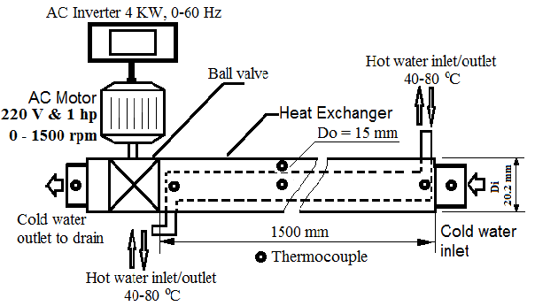
Figure 1, Simplified schematic diagram of the apparatus

3. Experimental Procedure
An experimental program was designed to study the effect of pulsation on the heat transfer through a concentric tube heat exchanger for the turbulent water flow. The studied values of Reynolds numbers of cold water are 2035, 4070, 6100, 8135, and 10170. These correspond to mass flow rates of 0.008318, 0.016637, 0.024955, 0.033273 and 0.041592 kg/s, where the mass flow rate of the hot water was kept at 0.042 kg/s. The inlet hot water temperature was varied from 40 to 70 °C (40, 50, 60, and 70 °C). The outer surface of the test section was insulated to minimize convective heat losses, and necessary precautions were taken to prevent leakages in the system. The frequency of the pulsations could be varied up to 1500 rpm (f up to 50.0 Hz) where the amplitude was kept constant by fixing the ball valve at heat exchanger end. Reynolds number is defined as (4m_{c}/πD_{H}.μ_{ci}) based on inlet cold water flow conditions. Measurements were carried out with the pulsator located downstream of the outer annulus of concentric heat exchanger. The value of the overall heat transfer coefficient of pulsated flow was normalized with the corresponding un-pulsated one. Since the temperatures of the hot and cold water vary over the length of the tubes, the temperature difference, ∆T = T_{h} - T_{c}, is not constant over the length. To account the temperatures variations, a log mean temperature difference (∆T_{m}) is used.

3.1 Theoretical analysis
The heat given by the hot fluid (i.e. water) at any Reynolds number is:
Q = m_{h}C_{ph}(T_{hi} – T_{ho}) = U_{i}A_{i}∆T_{mi} (1)
While the heat transferred to the cold fluid, (i.e. water) is:
Q = m_{c}C_{pc}(T_{ci} – T_{co}) = U_{o}A_{o}∆T_{mo} (2)
As usual, this heat may be expressed in terms of a heat transfer coefficient and tube logarithmic mean temperature difference ∆T_{m}:
Q_{t} = UA∆T_{m} (3)
In the experiments, the tube-wall temperature was not measured, with negligible losses to surrounding air from the cold water, by equalizing the energy loss of hot fluid and the energy received by the cold fluid, convective and overall heat transfer coefficients were deduced and Nusselt numbers were acquired as follows, [25-28, 30&31]:
(4)
where, h_{i} and h_{o} are the tube-side and the air-side heat transfer coefficients, A_{i} and A_{o} are the inner and the outer surface areas of each tube, D_{i} and D_{o} are the inner and the outer tube diameters, U is the overall heat transfer coefficient, k is the thermal conductivity of the tube material and L is the total tube length. For fully developed, turbulent flow in tubes where the Reynolds number is between 2300 and 5x10⁶ and the Prandtl number is between 0.5 and 2000, an empirical correlation to determine h_{i} proposed by Gnielinski, V. [31], is widely used and hence you can get h_{o} & Nu_{Do}.

 (5)
The tube-side heat transfer coefficient could be evaluated from Gnielinski correlation,
 (6)
Where, for smooth tubes, the friction factor is given by:
(7)
For the hot and cold fluids, the Reynolds numbers are:
Re_{D} = VD_{H}/ν (8)
Heat exchanger effectiveness, ε, is defined as,
ε = m_{h}C_{h}(T_{hi} - T_{ho})/mC_{min}(T_{hi} – T_{ci}) = m_{c}C_{c}(T_{co} – T_{ci})/(mC_{min})(T_{hi} – T_{ci}) (9)
Where (mC)_{min} = minimum of either m_{h}C_{h} or m_{c}C_{c}.
The enhancement in heat transfer was then calculated as the ratio of the heat transfer coefficient obtained in pulsed flow, h_{p} to that obtained in unpulsated steady flow, h_{o}. Where the subscripts s and p refer to values calculated from unpulsated steady flow and pulsated flow temperature readings, respectively. All fluid properties were determined at the overall bulk mean temperature. A more precise method of estimating uncertainty in experimental results has been presented by Kline and McClintock, which is described in Holman [29]. The method is based on careful specification of the uncertainties in the various primary experimental measurements, suppose that the result dependant variable (R) is a given function of the independent variables x₁, x₂, x₃, ……………, x_{n}. Thus: R = R (x₁, x₂, x₃, ……………, x_{n}). Let u_{R} is the uncertainty in the result and u₁, u₂, u₃, …….., u_{n} are the uncertainties in the independent variables. The uncertainty in the result is given as:
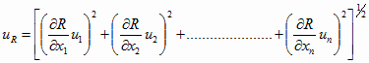
The following table (3.1) summarizes the calculated values of the uncertainty of the measured quantities.

Table 3.1, values of the uncertainty of the measured quantities
Parameter | Absolute Uncertainty | Relative Uncertainty
Mass flow rate |  | ± 1.1 %
Reynolds number |  | ± 1.1 %
Bulk mean temperature | ± 0.11 to ± 1.1 ºC
Surface temperature | ± 1.0 ºC
Heat transfer coefficient or Nu |  | ± 4.4 %

4. Results and Discussions
The most important aspects of this work were the extent of augmentation of heat transfer associated with the introduction of pulsation into the water flow. With the values obtained from the experimental data of both parallel and counter flows in the outer pipe, the changes in Nusselt numbers with Reynolds numbers were drawn for six different pulsation frequencies, as shown in Figures (2-11). The experiments were performed for both parallel and counter flows. The main target of the present work is to investigate the influence of pulsation frequency, Reynolds number and inlet hot water temperature, in a water-to-water concentric heat exchanger with both parallel and counter flows, on heat transfer.
Figures (2-5) show the variation of average Nusselt number versus Reynolds number at different pulsation frequencies and different inlet hot water temperatures for both parallel and counter flows. All curves of the average Nusselt number variation against Reynolds number have approximately same behavior. In the case of the parallel flow for the pulsating flow, Nusselt number decreases or increases according the value of pulsation frequency and Reynolds number. It is seen from the figures that the Nusselt number increases as the pulsation frequency created by the pulse generator (ball valve) increases especially at high Reynolds number. In the parallel flow (Figs. 2&3), for the highest pulsation frequency (30 & 40 Hz), the increase in heat transfer rate was about 14% to 20% according to Reynolds number and inlet hot water temperature. The heat transfer rate was strongly affected with both Reynolds number and pulsation frequency at low inlet hot water temperature (40 °C) while it was slightly affected with pulsation frequency at hot water temperature (70 °C). In the counter flow (Figs. 4&5), for the moderate pulsation frequency (10 & 20 Hz), the increase in heat transfer rate was about 45% to 90% according to Reynolds number and inlet hot water temperature.
Figures (6-9) show the variation of average relative Nusselt number (Nu_{mp}/Nu_{mo}) versus Reynolds number and different pulsation frequency for different inlet hot water temperatures 40 & 70 °C for both parallel and counter flows. The results of heat transfer show that, more enhancements in relative Nusselt number are obtained for the counter flow than that obtained for the parallel flow. Although similar increases in heat transfer rates are found for counter flow of the water as shown in Figs. 7 & 9, this improvement is about 70% higher than that for the parallel flow Figs. 6 & 8. The maximum enhancement in Nu_{mp}/Nu_{mo} for the parallel flow was 20% at 30 Hz and 70 °C. While the maximum enhancement in Nu_{mp}/Nu_{mo} for the counter flow was 90% at 10 Hz and 70 °C.
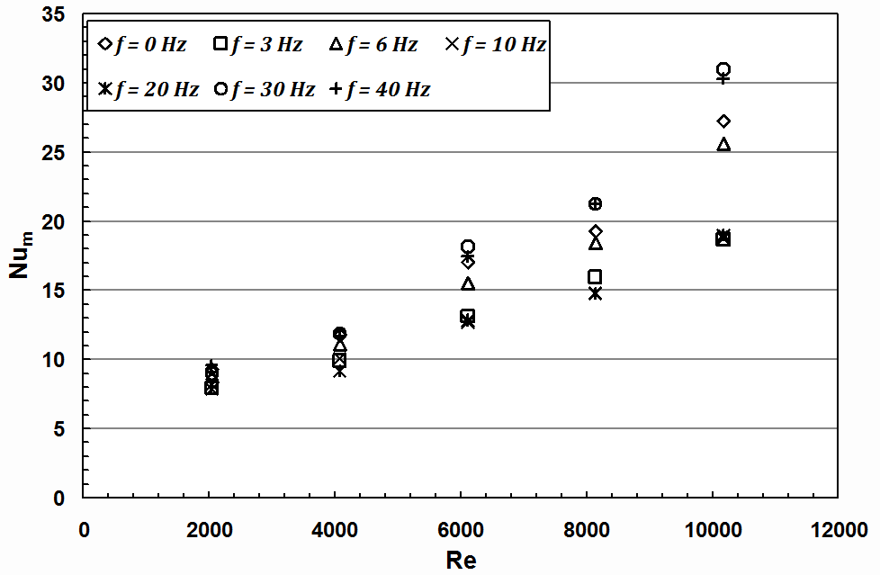 | 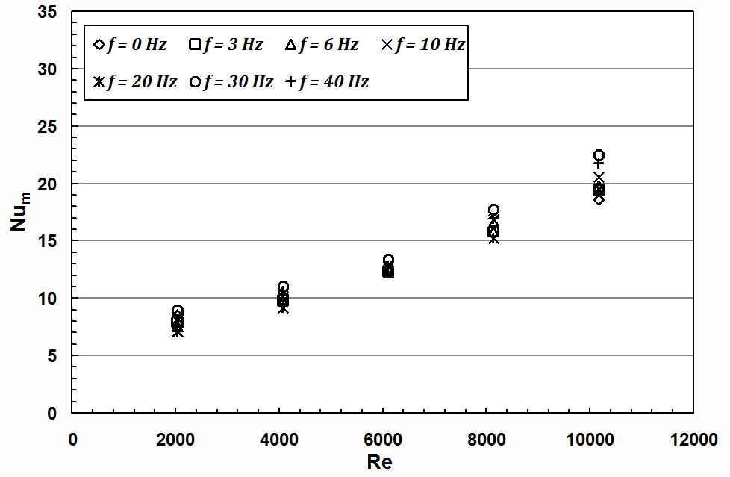
Fig. 2. Nusselt number in the parallel flow as a function of Reynolds number for different pulsation frequencies (Th_{i} = 40 °C) | Fig. 3. Nusselt number in the parallel flow as a function of Reynolds number for different pulsation frequencies (Th_{i} = 70 °C)
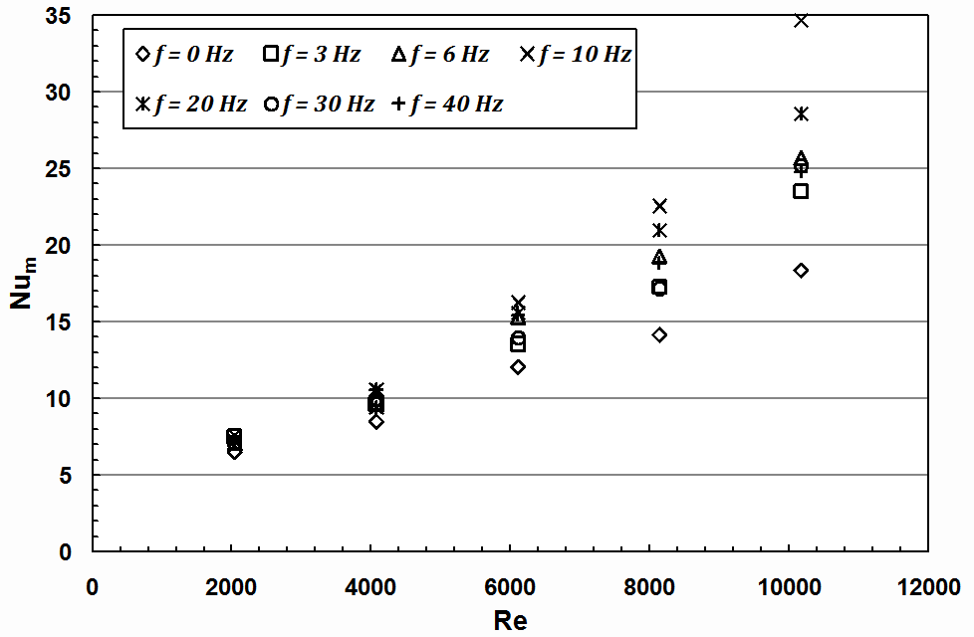 | 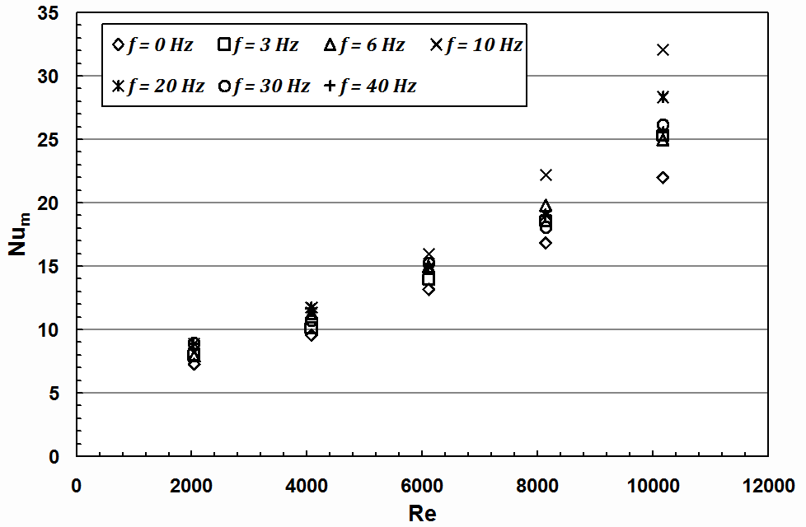
Fig. 4. Nusselt number in the counter flow as a function of Reynolds number for different pulsation frequencies (Th_{i} = 40 °C) | Fig. 5. Nusselt number in the counter flow as a function of Reynolds number for different pulsation frequencies (Th_{i} = 70 °C)
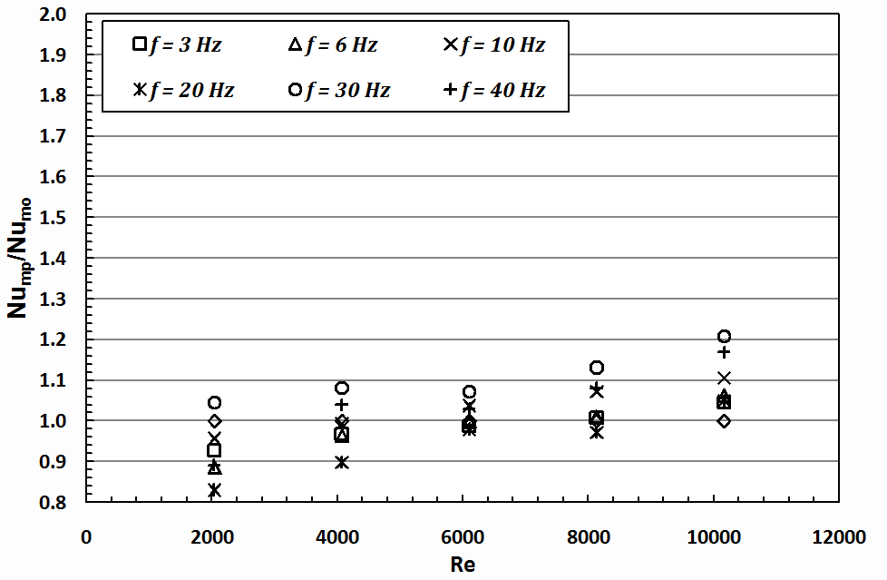 | 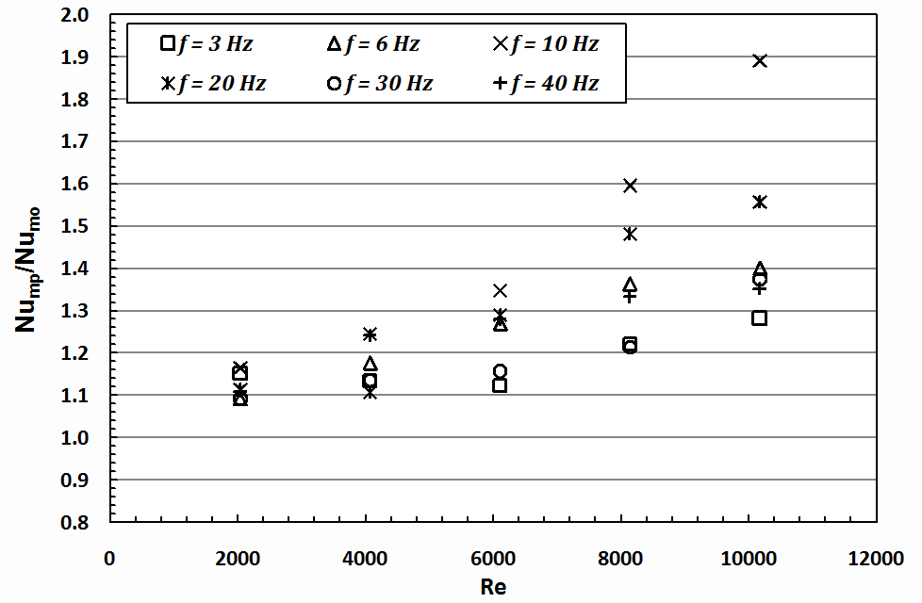
Fig. 6. Average Nusselt number ratio in the parallel flow as a function of Reynolds number for different pulsation frequencies (Th_{i} = 70 °C) | Fig. 7. Average Nusselt number ratio in the counter flow as a function of Reynolds number for different pulsation frequencies (Th_{i} = 40 °C)
The increases in heat transfer with pulsation are due to the higher pulse intensity imparted to the flow through the whole external pipe. The pulsation motion of the fluid results in a pressure gradient being created in the radial direction, thus affecting the boundary layer development. The increased rate of heat transfer in such flows is a consequence of the renewing and reducing the boundary layer thickness and increased resultant velocity. From the figures (6-9), it is also seen that the effect of pulsation flow on the heat transfer is less for low Reynolds numbers. Thus, the relative increase in Nusselt number was low at smaller Reynolds numbers, while it became greater at high Reynolds numbers. This effect is related to the high turbulence that comes from the interacting between pulsation frequency and the bursting frequency of high turbulent of water flow which results from the breakdown of the boundary layer in a shorter time [12-18]. In the counter flow, the heat transfer rates are somewhat greater than that in the parallel flow [28]. Because the temperature effectiveness of parallel flow is limited with respect to counter-flow, the thermal capacity of the counter heat exchanger can be higher than that of the parallel flow heat exchanger. In addition, the difference between parallel and counter heat transfer results is due probably to later development of a thermal boundary layer.
As concluded by many investigators [8-12], a great increase in pressure losses occurs when pulsated or swirl flow generators is mounted at inlet or at outlet of the pipe, in comparison with inner pipe entrance without pulsation or swirling. This results mainly from the dissipation of the dynamical pressure of the fluid (i.e. water) due to very high viscous losses near the pipe wall, and to the extra forces exerted by rotation. Pressure losses will be minimized with low Reynolds number and well designed pulsator generation. Moreover, the pressure drop increase is probably due to the secondary flows occurring because of the interaction of pressure forces with inertial forces in the boundary layer. At relatively low Reynolds numbers (2,000-10,000), as in the present study, and high pulsation frequencies, namely there is an improvement in heat transfer in mentioned range of Reynolds numbers and pulsation frequency. It would also be possible that, using different types of pulsator generator with more proper constructions, to reduce the pressure drop and increase the net heat gain.
Figures 10 and 11 show a variation of relative effectiveness of the heat exchanger versus Reynolds number at different pulsation frequencies, for both parallel and counter flows respectively. Similar trends were obtained as the relative mean Nusselt number. The figures show that more enhancement (about 35%) in the effectiveness was obtained for the counter flow at Thi = 40.
Figures 12 and 13 show a comparison of the present results, of maximum enhancement values of heat transfer rates, with that obtained by Karamercan and Gainer [8]. With comparing the results of the counter flow using downstream pulsation, the maximum enhancement in h_{p}/h_{o} given by [8] ranged between 20% to 150% (Re = 2000 – 10,000). While for the present results, the maximum enhancement in h_{p}/h_{o} ranged between 20% to 90% at the range of Reynolds number (Re = 2000 – 10,000). In addition, the experimental results of Karamercan and Gainer [8] showed that the highest enhancements in the heat transfer coefficient obtained within a Reynolds number range of 7500 to 9500. These enhancements in heat transfer are related to the increased level of turbulence, to the introduction of forced convection in the boundary layer [4-10]. Pulsations of sufficient frequency and amplitude can improve heat transfer in such a way as to increase the longitudinal flow for part of the cycle which, in turn, decreases the film thickness in the tube. Hence, pulsated flow is associated with a periodic pressure gradient reversal which causes an increase in radial and longitudinal mixing.
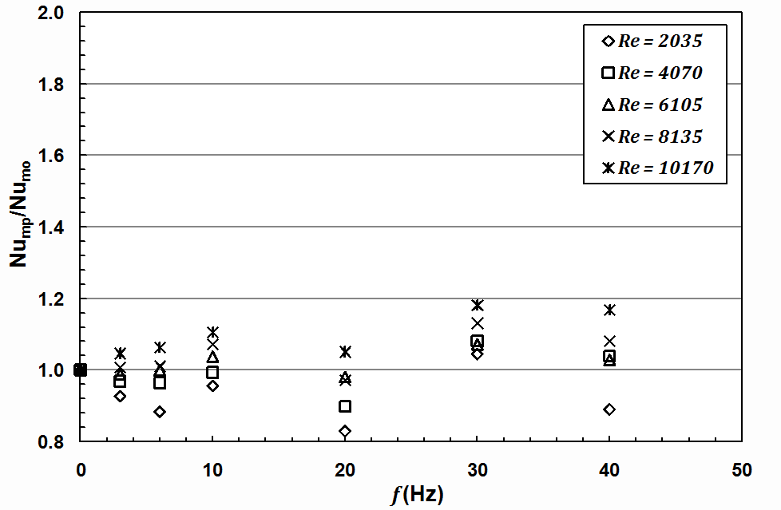 | 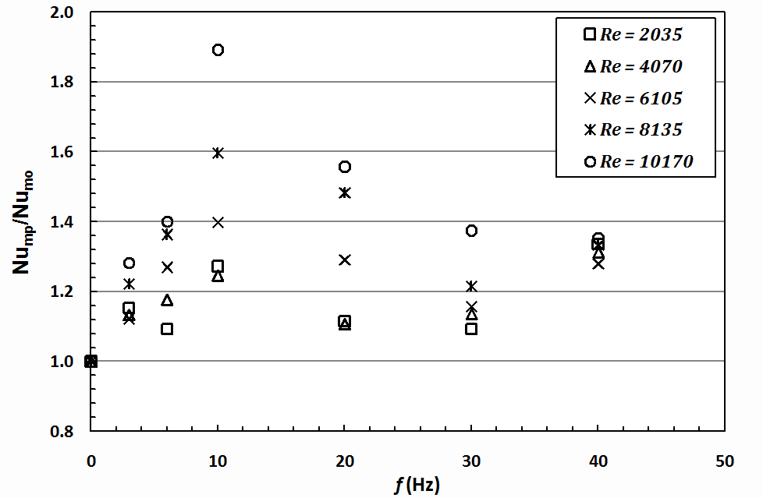
Fig. 8. Average Nusselt number ratio in the parallel flow as a function of pulsation frequency for different Reynolds numbers (Th_{i} = 70 °C) | Fig. 9. Average Nusselt number ratio in the counter flow as a function of pulsation frequency for different Reynolds numbers (Th_{i} = 40 °C)
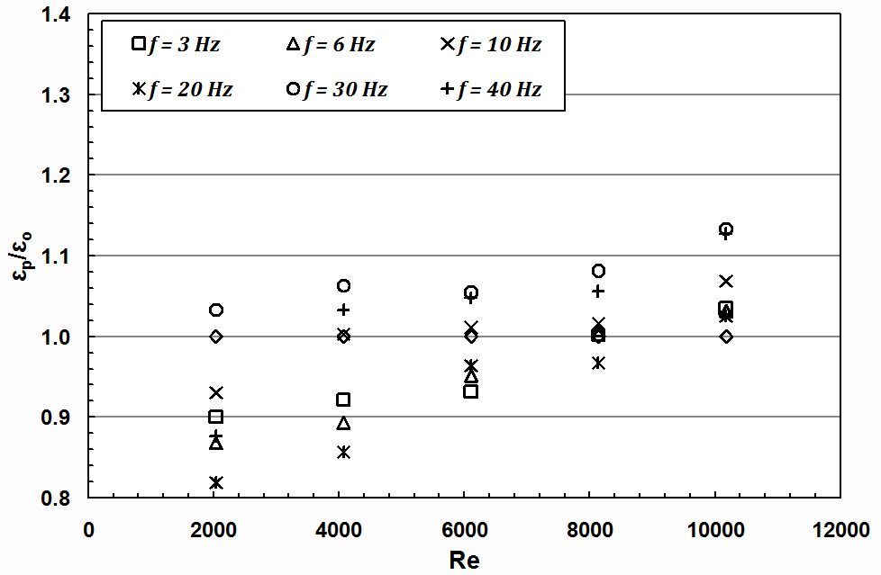 | 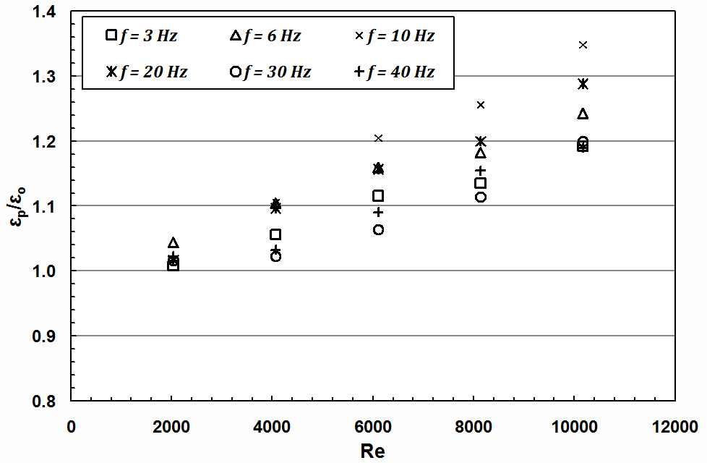
Fig. 10. Effectiveness ratio in the parallel flow as a function of Reynolds number for different pulsation frequencies (Th_{i} = 70 °C) | Fig. 11. Effectiveness ratio in the counter flow as a function of Reynolds number for different pulsation frequencies (Th_{i} = 40 °C)
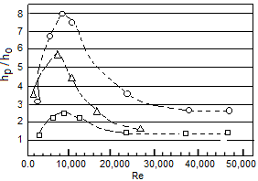 | 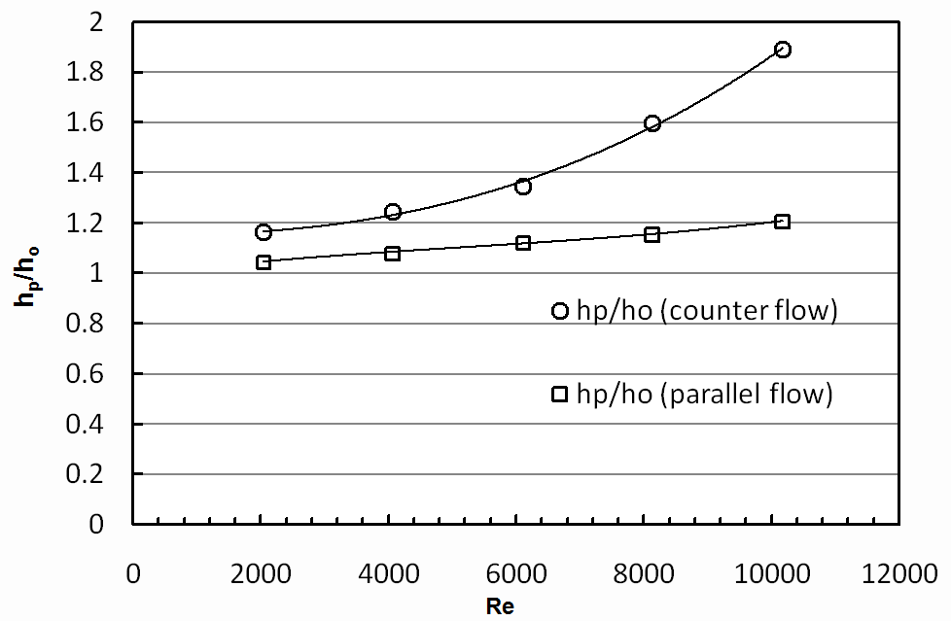
Fig. 12: Maximum enhancement values for upstream pulsation (Ο, 180 cm long & Δ, 90 cm long) and downstream pulsation (□, 180 cm long). Counter flow using reciprocating pump, [8]. | Fig. 13: Maximum enhancement values: downstream pulsation using ball valve;
4.1 Numerical Correlations for the Results
Correlations for the pulsating flow (Re=2000–10,000) with different downstream pulsation frequencies, for predicting the relative Nusselt number and relative effectiveness, were derived and shown in tables 4.1 and 4.2.
Table 4.1, equations of counter flow heat exchanger (Nu_{r} = Nu_{mp}/Nu_{mo} &)
Th_{i} = 40°c |  | Standard error = 12%
Th_{i} = 70°c |  | Standard error = 8 %
Th_{i} = 40°c |  | Standard error = 5%
Th_{i} = 70°c |  | Standard error = 5%
Table 4.2, equations of counter flow heat exchanger (Nu_{r} = Nu_{mp}/Nu_{mo} &)
Th_{i} = 40°c |  | Standard error = 11%
Th_{i} = 70°c |  | Standard error = 5%
Th_{i} = 40°c |  | Standard error = 6%
Th_{i} = 70°c |  | Standard error = 5%

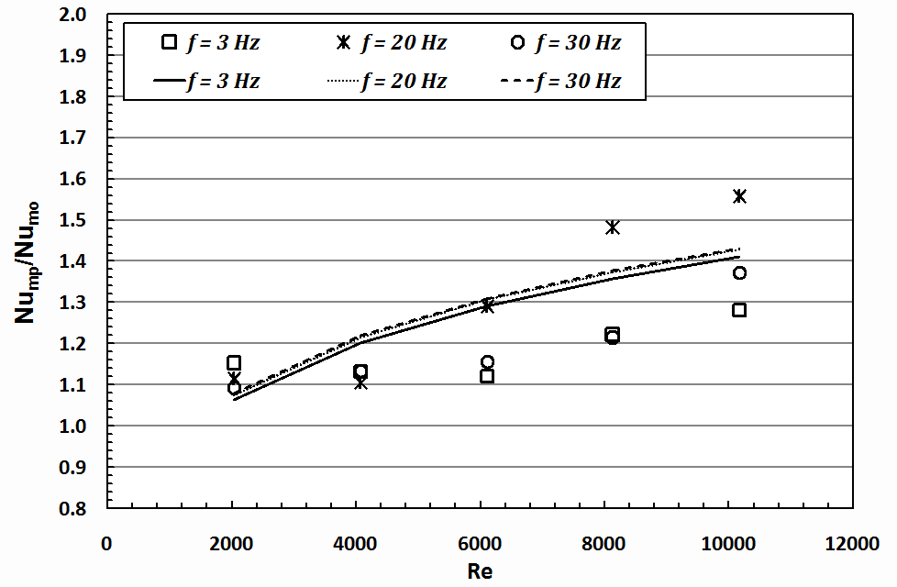 | 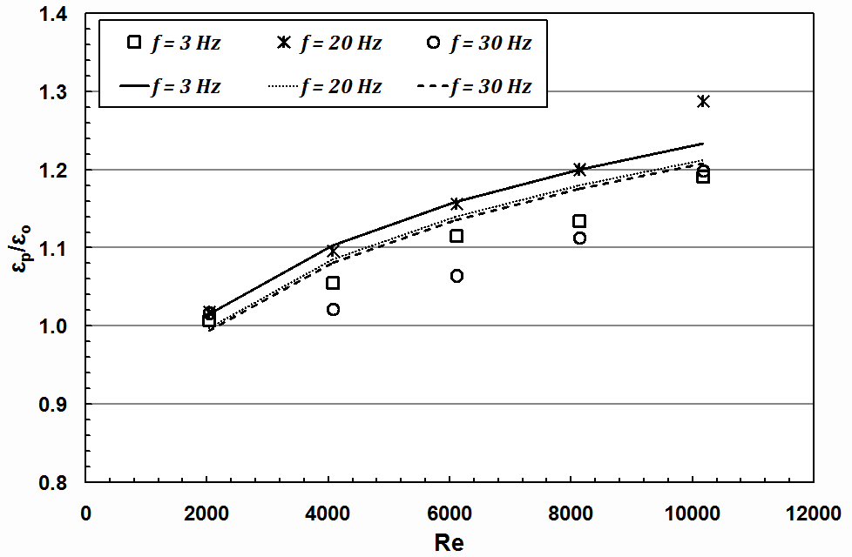
Fig. (14) Correlation of results of Nu_{mp}/Nu_{mo} for  Counter flow (T_{hi} = 40 °C) | Fig. (15) Correlation of results of for  Counter flow (T_{hi} = 40 °C)

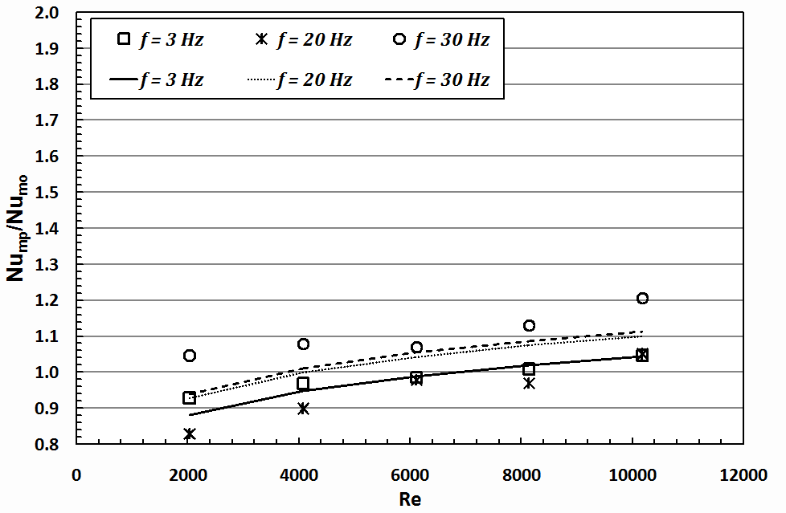 | 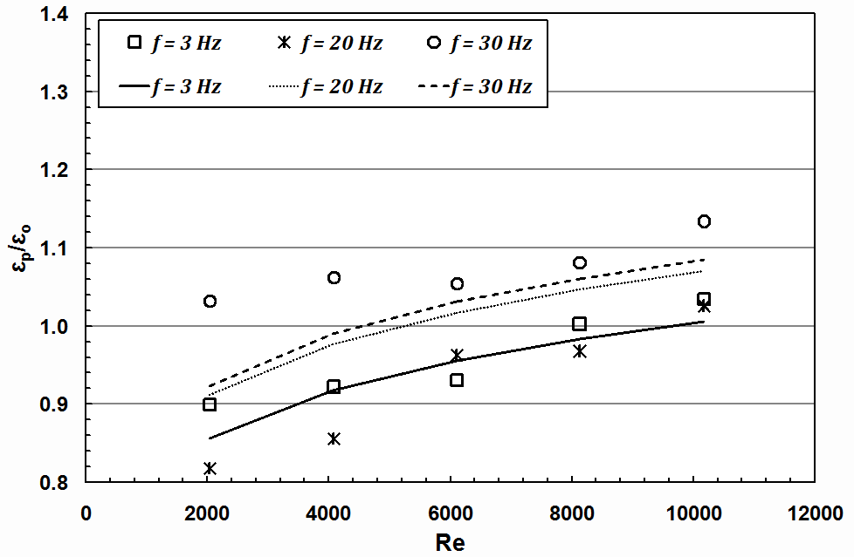
Fig. (16) Correlation of results of Nu_{mp}/Nu_{mo} for  parallel flow (T_{hi} = 70 °C) | Fig. (17) Correlation of results of for  parallel flow (T_{hi} = 70 °C)

The correlations are valid with a certain error for f = 0 – 40 Hz and Re = 2,000 to 10,000. The maximum standard error of Nu_{mr}, for both counter and parallel pulsating flows, is about 12% and 11%, respectively. The maximum standard error for of both counter and parallel pulsating flows is about 5% and 6% respectively. Figures 14–17 show comparison between the experimental results and the correlations, and a reasonable agreement was found as shown in these figures.
Conclusions
Pulsation generators can be used to augment heat transfer rates, because the pulsated flow enhances the heat transfer mainly due to increasing of turbulence levels in the boundary layer. From the results of this work, the following conclusions can be extracted:
(1) The Nusselt numbers in the concentric double-pipe heat exchanger may be increased from 20% to 90% for pulsated flow by giving pulsation to the water with the help of the ball valve used as a pulse flow generator in the parallel and counter flows. For parallel flow of these improvements are about 70% lower than that for the counter-flow. Further improvements may be achieved with increasing pulsation frequencies and Reynolds numbers due to increasing of the momentum transfer that causes the heat transfer rates to increase. As a result, the heat transfer coefficients of pulsated flow are larger than those encountered in smooth pipes.
(2) Evaluating the effectiveness of the pulse generator for enhancing heat transfer, it was found that there is an important improvement in performance provided that high frequencies and relatively low Reynolds numbers are used. The effectiveness in the concentric double-pipe heat exchanger may be increased from 15% to 35% for pulsated flow. Consequently, the method of improving heat transfer by a ball valve placed at outlet of the outer pipe of the concentric double-pipe heat exchanger can be suggested as an effective method, as an alternative to other passive improvement methods given in the literature.

Corresponding author
A.E. Zohir
Mechanical Eng. Dept., Tabbin Institute for Metallurgical Studies, Cairo, Egypt
alaa_sadegh@yahoo.com

References
- Bergles, A.E., Jensen, M.K., and Shome, B. (1996) ''The literature on enhancement of convective heat and mass transfer''. Jornal Enhanc. Heat Transfer, 4: 1-6.
- Pethkool,S., Eiamsa-ard, S., Kwankaomeng, S. and Promvonge, P. (2011) ''Turbulent heat transfer enhancement in a heat exchanger using helically corrugated tube''. International Communications in Heat and Mass Transfer, 38: 340–347.
- Cheng, L., Luan, T., Du, W., and Xu, M. (2009) ''Heat transfer enhancement by flow-induced vibration in heat exchangers''. International Journal of Heat and Mass Transfer, 52: 1053–1057.
- Zamankhan, P. (2010) ''Heat transfer in counterflow heat exchangers with helical turbulators''. Commun Nonlinear Sci Numer Simulat, 15: 2894–2907.
- Zheng, J., Zeng, D., Wang, P. and Gao, H. (2004) ''An experimental study of heat transfer enhancement with a pulsating flow''. Heat transfer – Asian Research, 33 (5): 279-286.
- Hatami, R. (1980) ''Pulsating flow in a heat exchanger''. Journal of Warme and Stoffubertragung, 14: 109-118.
- Baird, M. H. I, Duncan, G. J., Smith, J. I. and Taylor, J. (1966) "Heat transfer in pulsed turbulent flow". Chemical Engineering Science, 21: 197 -199.
- Karamercan, O. E. and Gainer J. L. (1979) "The effect of pulsation on heat transfer". Ind. Eng. Chem. Fundam., 18, (1): 11-15.
- Lemlich, R. (1961) "Vibration and pulsation boost heat transfer". Chemical Engineering, May: 171-176.
- Lemlich, R. and Hwu, C. (1961) "The effect of acoustic vibration on forced convective heat transfer". AIChE Jornal, 21: 197-199.
- Shuai, X., Cheng, S. and Antonini, G. (1994) "Pulsation effects on convective heat transfer in the laminar flow of a viscous fluid". The Canadian Journal of Chemical Engineering, 72: 468 - 475.
- West, F. B. and Taylor, A. T. (1952) "The effect of pulsation on heat transfer in turbulent flow of water inside tubes". Chemical Engineering Progress, 48, (1): 39-43.
- Darling, G. B. (1959) "Heat Transfer to Liquid in Intermitted Flow Petroleum". London 22: 177.
- Havemann, H. A., Marayan R. N. N. (1954) "Heat transfer in pulsating flow". Nature, London, 174: 41.
- Keil, A. H. Baird, M. H. I. (1971) "Enhancement of heat transfer by flow pulsations". Ind., Eng. Chem. Process Des. Dev., 10: 473.
- Ludlow, J. C. (1975). MS. Thesis, University of Virginia, Charlottesville, Va.
- Muller, W. K. (1957) ''Proceedings fifth Midwestern conference of fluid mechanics''. p 146, Ann Arbor, Mich.
- McMichael, W. J., Hellums, J. G. (1975) "The Effect of Pulsations on Heat Transfer for Laminar Flow". AIChE Jornal, 21: 743.
- Martinelli, R. C., Boelter, L. M. K., Weinberg, E. B. and Yakal, S. (1943) "Heat transfer to a fluid flowing periodically at low frequencies in a vertical tube". Transaction of ASME, Oct., 789-798.
- Lemlich, A., Armour, J. C. (1965) "Enhancement of Heat Transfer by Flow Pulsations". Chern. Eng. Prop. Symp. Ser., 61: 83.
- West, A. B., Taylor, A. T. (1952) "The effect of pulsation on heat transfer in turbulent flow of water inside tubes". Chem. Eng. Prog., 48: 39.
- Krishnan, K. N. and Sastri, V. M. K. (1982) "Pulsating flows in heat exchangers - an experimental Study". Warme - und Sroffubertragung, 16: 169 - 173.
- Robert C. Herndon, Preston E. Hubble, and John L. G. (1980) "Two Pulsatlors for Increasing Heat Transfer". Ind. Eng. Chem. Process Des. Dev., 79: 405- 410.
- Marchant, J. H. (1943) "The Effect of Pulsations on Heat Transfer". Trans. ASME, 65: 786.
- Baughn, J. W., Hoffman, M. A., Launder, B. E., and Takahashi, R. (1984) "Turbulent Heat Transport in Circular Ducts with Circumferentially-Varying Heat Flux". ASME Journal of heat Transfer, 106: 64-70.
- Kays, W.M., and Crawford, M.E. (1993) "Convective Heat and Mass Transfer". Third ed., McGraw-Hill, Singapore.
- Incropera, F., and Dewitt, P.D. (1996) "Introduction to Heat Transfer". Third edition, John Wiley & Sons Inc.
- Durmus, A., Durmus, A., and Esen, M. (2002) "Investigation of heat transfer and pressure drop in a concentric heat exchanger with snail entrance". Applied Thermal Engineering, 22: 321–332.
- Holman, J. P. (1984) "Experimental Methods for Engineers". 4Th Editions, McGraw- Hill Book Company, New York.
- Meter, J. V. (2008) "Experimental investigation of a printed circuit heat exchanger using super critical carbon dioxide and water as heat transfer media". MS. Thesis, Kansas, University, Manhattan, Kansas.
- Gnielinski, V. (1976) "New Equation for Heat and Mass Transfer in Turbulent Pipe and Channel Flow". International Chemical Engineering 16: 359-368.

5/1/2011

