Incidence And Intensity Of Powdery Mildew Fungi On The Plants Of Papilionaceae

Riyaz Ahmad Mir, Abdul Hamid Wani, Mohd. Yaqub Bhat, Taskeen-Un- Nisa and Shauket Ahmad Pala

Section of Plant Pathology and Mycology, Department of Botany, University of Kashmir, Srinagar , India 190006. Email: myaqub35@gmail.com

Abstract: Powdery mildew fungi have been known to cause heavy loss to various crops every year through out India and across the world. Keeping this in view, a thorough survey was carried out in four districts of Kashmir valley, viz. Kupwara, Baramulla, Srinagar and Anantnag in order to assess the incidence and severity of the disease on some plants of family Papilionaceae. It was revealed from the study that the plants such as Phaseolus aconitifolis, Phaseolus aureus, Phaseolus vulgaris, Pisum sativum and Robina pseudoaccacia showed moderate to mild infection in different localities of Kupwara and Baramulla whereas P. aconitifolis, P. aurens, P. vulgaris and P. sativum showed mild infection in different localities of district Kupwara, Baramulla, Srinagar and Anantnag during the study. However, no infection was observed in some areas of the valley on plants of Papilionaceae surveyed during the study. The overall study reveals the need for the management strategies at the early stage before the disease can spread widely.
[Riyaz Ahmad Mir, Abdul Hamid Wani, Mohd. Yaqub Bhat, Taskeen-Un- Nisa and Shauket Ahmad Pala. Incidence And Intensity Of Powdery Mildew Fungi On The Plants Of Papilionaceae. New York Science Journal 2011;4(7):14-20]. (ISSN: 1554-0200). http://www.sciencepub.net/newyork.

Key words: Powdery mildew; severity; incidence; Papilionaceae; Kashmir valley.

1. Introduction
Powdery mildew is a disease causing significant damage on a variety of cultivated and wild plants across the world as well as in India. They are also known to cause damage on various economically important plants in Kashmir valley as well. Three powdery mildew species, Erysiphe cichoracearum D.C., Sphaerotheca fuliginia (Schleht.) Poll. and Leveilluca taurica (Lev.) Arn. infect various cultivated and wild crops in India and the world wide “(Kennet and Palti, 1984; Amano, 1986; Khan et al., 1970, 1974; Bains et al., 1996; Hussain and Akram, 1997; Pervez and Akram, 2001; Garibaldi et al., 2002)”. The powdery mildew fungi are also known to cause a heavy damage to different plants of the family Papilionaceae throughout India “(Shastree et al., 1990; Plenk et. al., 1991; Sing et al., 2000)”. Some work has been done on the powdery mildew of the family Asteraceae “(Wani, et al., 2003; Mir, et al., 2008)” whereas a little attention has been given to the other families. Therefore, present study entitled, “Incidence and intensity of powdery mildew fungi on the plants of Papilionaceae in some districts of Kashmir valley” was carried out in some d Severity (intensity) of the disease on different hosts were assessed as per the following scale (0-5 scale), given by ( Khan, 1972) as: (-) = No infection i.e., plants without powdery mildew infection; (+) = mild infection (25% infection); (++) = moderate infection, (25-60% infection) and (+++) = heavy infection, (60-100% infection).

3. Results and Discussion
A survey was carried out in different localities of district Kupwara, Baramulla, Srinagar and istricts of Kashmir valley.

2. Materials and Methods
To evaluate the incidence and severity of powdery mildew fungi on the plants of Papilionaceae a survey was carried out in different localities of four districts of Kashmir valley, viz. Kupwara, Baramulla, Srinagar and Anantnag. The samples of plants such as Phaseolus aconitifolis, Phaseolus aureus, Phaseolus vulgaris,Pisum sativum and Robina pseudoaccacia were collected from different localities of these districts and were brought to the laboratory for further studies. The identification of the causal pathogen was made on the basis of anamorph and teleomorph characteristics. The incidence of disease in each locality on each host was calculated as per the formula given by Johnson and Booth (1983) as:

No of infected plant units
Incidence = ___________________ ×100

Total no of (infected and healthy)plant units Severity (intensity) of the disease on different hosts were assessed as per the following scale (0-5 scale), given by ( Khan, 1972) as: (-) = No infection i.e., plants without powdery mildew infection; (+) = mild infection (25% infection); (++) = moderate infection, (25-60% infection) and (+++) = heavy infection, (60-100% infection).

3. Results and Discussion
A survey was carried out in different localities of district Kupwara, Baramulla, Srinagar and Anantnag of the Kashmir valley inorder to assess the incidence and severity of the disease powdery mildew fungi on some members of the family papilionaceae. The plants which were evaluated for incidence and severity of powdery mildew fungi were as: Phaseolus aconitifols, Phassolus aureua, Phaseolus vulgaris, Pisum sativum and Robina pseudoaccacia. During the survey moderate to mild infection of the powdery mildew disease was found on the plants of family papilianaceae collected from various localities,hoever some plants showed high resistance against the fungus in some localities (Table 1,2).

Table 1: Incidence of powdery mildew on Papilionaceae in some localities of district Kupwara and Baramulla of Kashmir valley
Localities | Phaseolus aconitifolis | Phaseolus aureus | Phaseolus vulgaris | Pisum sativum | Robinia pseudoaccacia
KupwaraKupwaraHandwaraLangat  KralgundQalamabadMawer  Baramulla  Baramulla  Sopore  Baba-Reshi  Tangmarg  Gulmarg | 30.50  10.80  0  11.0  0  0  08.50  10.00  12.50  11.0  0 | 08.75  12.00  09.00  0  0  0  0  0  0  07.50  06. 80 | 10.50  11.00  15.50  0  0  16.80  0  0  0  9.50  7.50 | 0  08.50  09.00  12.00  15.50  0  09.50  10.50  11.00  10.50  0 | 45.50  40.00  20.00  18.50  0  0  15.50  16.00  12.00  09.50  07.50
Data shows Percent incidence(%)
0 = no infection

Table 2: Incidence of powdery mildew on Papilionaceae in some localities* of district Srinagar and Anantnag of Kashmir valley
Localities | Phaseolusaconitifolis | Phaseolus aureus | Phaseolus vulgaris | Pisum sativum | Robinia pseudoaccacia
Srinagar  Hazratbal  Nigeen  Nishat  Shalimar  Harvan  Chesmishahi  Anantnag  Anantnag  Phalgam  Achabal  Verinag | 08.00  0  09.50  0  0  0  0  10.50  10.00  0 | 0  0  0  0  0  0  0  0  09.00  08.50 | 0  06.50  0  10.50  09.50  0  08.50  0  0  07.50 | 06.50  08.00  08.00  0  0  0  07.50  10.50  10.0  0 | 12.50  0  0  0  10.00  08.50  0  0  10.50

*Data shows Percent incidence(%)
0 = no infection

In district Kupwara, Robina pseudoaccacia showed moderate to mild disease severity and intensity in localities of Kupwara (45.50%),Handwara (40%), Langate (20%) and Kralgund (18.50%) whereas the other plants of the family papillionaceae showed mild disease severity and intensity or were found free from the infection of the powdery mildew (Table 1,3).

Table 3: Severity of powdery mildew on various members of the family Papilionaceae in some localities of district Kupwara and Baramulla of Kashmir valley
Localities | Phaseolusaconitifolis | Phaseolus aureus | Phaseolus vulgaris | Pisum sativum | Robinia pseudoaccacia
Kupwara  Kupwara  Handwara  Langat  Kralgund  Qalamabad  Mawer  Baramulla  Baramulla  Sopore  Baba-Reshi  Tangmarg  Gulmarg | ++  +  -  +  _  -  +  +  +  +  - | +  +  +  -  _  -  -  -  -  +  + | +  +  +  -  _  +  -  -  -  +  + | -  +  +  +  +  -  +  +  +  +  - | ++  ++  +  +  -  -  +  +  +  +  +
+++ = Heavy Infection; ++ = Moderate infection; + = Mild infection; - = No infection;t
In the district Srinagar and Anantnag, the surveyed plants of family Papilionaceae were generally found free from the disease infection(Table-2,4).

Table 4: Severity of powdery mildew on various members of the family Papilionaceae in some localities of district Srinagar andAnantnag of Kashmir Valley
Localities | Phaseolusaconitifolis | Phaseolus aureus | Phaseolus vulgaris | Pisum sativum | Robinia pseudoaccacia
Srinagar  Hazratbal  Nigeen  Nishat  Shalimar  Harvan  Chesmishahi  Anantnag  Anantnag  Phalgam  Achabal  Verinag | +  -  +  -  -  -  -  +  +  - | -  -  -  -  -  -  -  -  +  + | -  +  -  +  +  -  +  -  -  + | +  +  +  -  -  -  +  +  +  + | +  -  -  +  -  +  +  -  -  +
+++ = Heavy Infection; ++ = Moderate infection; + = Mild infection; - = No infection;t
In the district Srinagar and Anantnag, the surveyed plants of family Papilionaceae were generally found free from the disease infection(Table-2,4).

Table 4: Severity of powdery mildew on various members of the family Papilionaceae in some localities of district Srinagar andAnantnag of Kashmir Valley
Localities | Phaseolus aconitifolis | Phaseolus aureus | Phaseolus vulgaris | Pisum sativum | Robinia pseudoaccacia
Srinagar  Hazratbal  Nigeen  Nishat  Shalimar  Harvan  Chesmishahi  Anantnag  Anantnag  Phalgam  Achabal  Verinag | +  -  +  -  -  -  -  +  +  - | -  -  -  -  -  -  -  -  +  + | -  +  -  +  +  -  +  -  -  + | +  +  +  -  -  -  +  +  +  + | +  -  -  +  -  +  +  -  -  +
+++ = Heavy Infection; ++ = Moderate Infection; + = Mild Infection; - = No infection;

Table 5: Characteristics of powdery mildew fungi causing disease on some members of family Papilionaceae in different localities* of Kashmir valley
Name of the Host | Characteristics of Pathogen | Conclusion
Phaseolus aconitifolis  Phseolus aureus  Phaseolus vulgaria  Pisum sativum  Robina pseudoaccacia | Leaves were found infected, conidia varied in size and shape i.e., barrel to spherical, Fibrosin bodies absent, germ tube simple, appressoria well developed.  Leaves shows mild infection, conidia barrel in shape, fibrosin bodies absent, germ tube simple with well developed ,appressoria.  Leaves showed mild infection, conidia barrel to spherical in shape, fibrosin bodies absent, germ tube simple with well developed, appressoria.  Leaves showed mild infection, conidia barrel to spherical in shape, fibrosin bodies absent, germ tube simple with well developed, appressoria.  Leaves showed mild infection, conidia barrel to spherical in shape, fibrosin bodies absent, germ tube simple with well developed, appressoria. | The characteristics of pathogen shows presence of Erysiphe cichoracearum.  The characteristics of pathogen shows presence of Erysiphe cichoracearum.  The characteristics of pathogen showed presence of Erysiphe cichoracearum.  The characteristics of pathogen showed presence of Erysiphe cichoracearum.  The characteristics of pathogen showed presence of Erysiphe cichoracearum.
* Kupwara, Handwara, Langate, Kralgund, Qalambad, Baramulla, Sopore, Baba-Reshi, Tangmarg, Gulmarg, Hazratbal, Nigeen, Nishat, Shalimar, Harvan, Chesmashahi, Anantnag, Pahalgam, Achabal, Verinag

The microscopic study reveals that the conidia were generally barrel to spherical in shape, fibrosin bodies were absent in conidia assessed from all plants, germ tube were simple with well developed appressoria (Fig.1).
Figure1 : Erysiphe cichoracearum
- Mycellium with appressorium
- Conidiophores
- Conidia
- Germinating conidia

In district Srinagar,Robina pseudoaccacia showed mild disease disease severity in locality Hazratbal(12.50%) and Chesmashahi (10.00%),Phaseolus vulgaris in Shalimar (10.50%) Harvan (09.50%) and Nigeen (06.50%) ,P.satvium in Nigeen and Nishat (08.00%), and Hazratbal (16.50%), Phaseolus.aconitifolis in the locality of Nishat(9.50%) and Hazratbal (8.00%), whereas Phaseolus aureus was found highly resistant to the disease to the disease powdery mildew.In district Anantnag Pisum sativum showed mild disease severity and intensity in the all localities surveyed during the study, Pahalgam (10.50%), Achabal (10.00%), Verinag (10.00%) and Anantnag (07.50%) where as the other plants were found generally resistant to the disease.These observations are in accordance with that of “( Saluja and Bhide,1962., Eshad, 1975., El-Kazzaz et.al., 1990., Wani, et.al., 2003)”. In order to establish the identity of species, conidial characteristics (anamorph) were considered instead of cleistotheicial (teleomorph) characteristics because the cleistothecia were not found in surveyed plants. The conidial characteristics which were taken in to account for identification of powdery mildew fungi were conidial shape and size, presence or absence of fibrosin bodies, shape of the germ tube and the presence or absence of appressoria (Table 5).

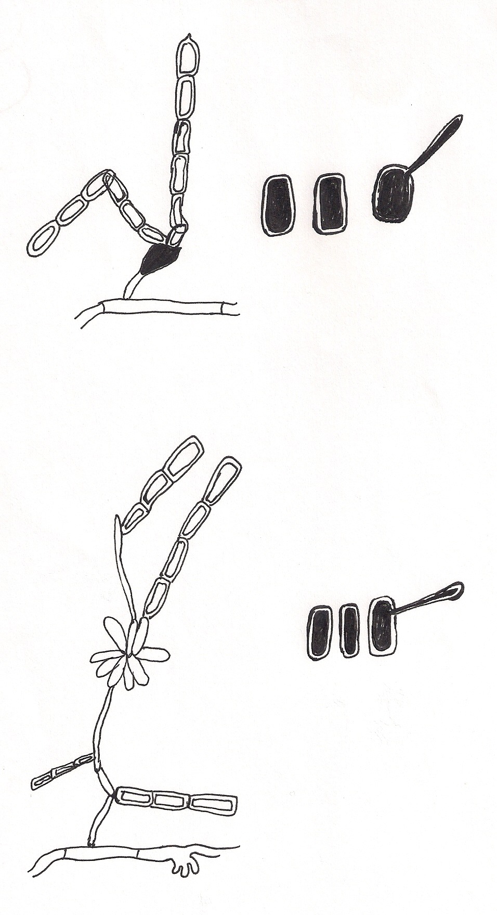
- Mycellium with appressorium

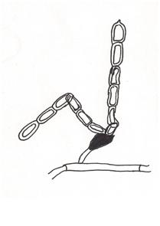
- Conidiophores

C) Conidia

D) Germinating conidia

Thus, these characteristics indicate that Erysiphe cichoracearum is the common pathogen causing powdery mildew disease in plants of family papilionaceae in the Kashmir valley.

Acknowledgement.
The authors are thankful to Head, Department of Botany, University of Kashmir, Srinigar, Jammu and Kashmir. India for providing necessary facilities for completion of this work.

Corrosponding Author:
Mohd. Yaqub Bhat
Section of Plant Pathology and Mycology, Department of Botany,
University of Kashmir, Srinagar, India 190006. Email: myaqub35@gmail.com

References.
1. Amano, K. 1986. Host range and geographical distribution of powdery mildews. Japan scientific Press Tokyo 741 pp.
2. Bains , S. S., Hardip , S., Karanpal S., Dhima J. S. H., and Singh, K .1996. Powdery mildew of sunflower in Punjab. Ind. J. of Mycology and Plant Pathology 26(1): 90-92.
3. El-Kazzaz ,M. K., Fadel , F. M., El-Kewey, S.A., and Ghoneium , K.E., 1990. Survey and taxonomy of Erysiphaceae in Egypt on the basis of conidial state. Egyptian J. Phytopath.21:1-12.
4. Eshed , N. ,1975. New host records of powdery mildews in Israel. Phytoparasitica 3:139-140.
5. Garibaldi, A., Minuto, A., Berterri. ,D, andGullino , M. L. ,2002. First report of powdery mildew on Euryops pectinatus in Italy. Plant Disease 86(8): 920.
6. Hussain, S.I, and Akram, M. , 1997. Distribution pattern and identity of powdery
mildew of composities in the districts
of Agra division. Ind. Phytopath 52(2):
250-255.
7. Johnson , A., and Booth C., 1983. In P
lant pathologist’s pocket book Oxford
and IBH Pub. Co. Calcutta :136 pp.
8. Kenneth, R. G. and Palti , J. , 1984. The distribution of downy and powdery mildews of rusts over tribes of Composites (Asteraceae). Mycologia 76: 705-718. 9. Khan , M.W., Khan, A., and Akram M., 1974. Studies on Cucurbit powdery mildew-III. Intensity and identity of cucurbit powdery mildew in Kashmir. Ind. Phytopath 27(1): 93-96.
10. Khan, A. M. 1972. Studies on Plant resistance in Cucurbit. Final Technical Report. PL-480 Research Project :100pp.
11. Mir, R.A., Wani A.H., Akram M., and Hamza, R. 2008. Identity and incidence of powdery mildew fungi in Kupwara and Baramulla districts of Kashmir Valley . Science for Better Tomorrow : 65-68.
12 Saluja, V.K., and Bhide V.P.,1962. Powdery mildew of safflower (Carthmus tinctorius L.) caused by Erysiphe cichoracearum in Maharashtra. Indian Phytopathology 15: 291.
13 Pervez, M.S., and Akram , M., 2001. Teleomorph of Sphaerotheca fuliginea (Schlecht.) Poll. on Chrysanthemum coronarium. A new report. Jr. Ind. Bot. Soc. 80: 123-125.
14 Plenk A., Holzey V., andBedlan, G ,1991. Powdery mildew fungi in the domestic garden .Pflanzenschutz (Wien) 4: 6-9.
15 Shastree, N.K., Pandey, M.K., Pathak ,S. , and Islam, M.S. ,1990. Studies on the expression of disease incidence and severity of powdery mildew infected peas. Adv. Plant Science 3(1): 66-72.
16. Sing ,V.P., Prithiviraj , Sharma, B. K. 2000. Development of Erysiphe pisi (Pm) on normal and albino mutants of Pea (Pisum sativum).Journal of Phytopathology 14 (11-12): 591-95.
17 Wani, A.H. and Ashraf, M. (2003). Incidence and severity of powdery mildews of some plants of Asteraceae in some famous gardens of Kashmir Valley. Bioved 41(1, 2): 15-19.

11/17/2010

