Inhibitory effect of essential oils on the growth of Colletotrichum gloeosporioides (Penz.) Penz. & Sacc. the causal organism of leaf spot disease of Murraya koenigii L

MIDHILA PADMAN and JANARDHANA G R*

Mycology and Phytopathology Laboratory, Department of Studies in Botany, University of Mysore
Manasagangotri, Mysore-570 006, Karanataka-India
Tel. Phone : +91-821-2419763; Fax: + 91-821-2419759
*Corresponding Address: E mail: grjbelur@gmail.com

Abstract: Six essential oils viz., clove, cedarwood, lemongrass, peppermint, eucalyptus, citronella and neem oils were tested for their inhibitory effect on spore germination, growth of germ tube and mycelial growth of Colletotrichum gloeosporioides isolated from Murraya koenigii. All essential oils inhibited the germination and growth of germ tube at different concentrations. However, significant reduction in colony growth was observed with Citrus, Lemongrass and Peppermint oils at 1000, 1500 and 2000 ppm concentrations respectively. Citrus oil at 1360ppm inhibited the maximum growth of the test fungus followed by Lemongrass oil at 1720ppm and peppermint at 2260ppm respectively. The effect of essential oils on mycelial dry weight showed that there is significant effect on growth of the fungi. The study revealed the possibility of some of these essential oils for the management of leaf spot disease of Murraya koenigii.
[MIDHILA PADMAN and JANARDHANA G R. nhibitory effect of essential oils on the growth of Colletotrichum gloeosporioides (Penz.) Penz. & Sacc. the causal organism of leaf spot disease of Murraya koenigii. New York Science Journal 2011;4(7):80-84]. (ISSN: 1554-0200). http://www.sciencepub.net/newyork.

Key words: Murraya koenigii; leaf spot disease; essential oils, inhibitory effect; Colletotrichum gloeosporioides.

Introduction
Murraya koenigii L. (Rutaceae) commonly known as curry vegetable is also a medicinal plant grown throughout greater part of India and South East Asia, and is used as an antibacterial, anti-inflammatory and anti feedant agent in ayurvedic medicinal preparations (Kirthikar and Basu, 1935). The leaf spot disease of Murraya koenigii caused by Colletotrichum gloeosporioides (Penz.) Penz.& Sacc. In Penz. (teleomorph Glomerella cingulata (Stoneman) Spauld.& H. Schrenk) reduces its use in food industry (Smith and Black, 1990). Chemical management of the disease is not suitable as this method leaves behind the chemical residues (Daferera et al., 2003). Numerous studies have documented the antifungal properties of plant essential oils (Bouchra et al., 2003, Sokmen et al., 2004). They are complex volatile compounds produced in different plant parts, which are known to have various function in plants including conferring pest and disease resistance (Goubran and Homes, 1993). The natural plant products are not only readily available to the farmers, but have biodegradable, non phytotoxic, environmentally friendly and promising. Hence, in the present investigation, essential oils were evaluated against causal organism to find some essential oils substitutes for fungicides for the management of leaf spot disease in Murraya.

Methods

Sources of essential oils
Essential oils such as clove, cedar wood, lemon grass, peppermint, eucalyptus, citronella and neem oils were obtained from Karnataka Aromas, Essential Oil Distillery, Bangalore, Karnataka. Eucalyptus oil was purchased from Venus Eucalyptus Oil Distillery, Nilgiris, Tamilnadu, India.

Fungal isolates
The isolates of Colletotrichum gloeosporioides were isolated from leaf spot diseased leaves of Murraya koenigii collected from different regions of Mysore District (Karnataka State). The isolates were maintained on potato dextrose agar (PDA) medium for further use.

Effect of essential oils on conidial germination, germ tube growth and colony diameter of Colletotrichum gloeosporioides
The conidial suspension of Colletotrichum gloeosporioides was prepared in 0.1% yeast extract, 0.1% sucrose with phosphate buffer and the suspension was adjusted to 1x10⁶ conidia/ml by using Haemocytometer. Five different concentrations of all the six essential oils at 500ppm, 1000ppm, 1500ppm, 2000ppm and 2500ppm were evaluated for their effect on conidial germination and the length of germ tube by incubation at 25ºC for 72 h. After incubation percent conidial germination and germ tube growth was measured using micrometry. The conidia were considered to have germinated when the germ tubes were equal in length or more than the conidia.
The inhibitory effects of essential oils were tested on Colletotrichum gloeosporioides by agar dilution method (Fraternale et al., 2003). Potato dextrose agar medium (20 ml) was mixed with requisite amount of each oil separately to prepare 500, 1000, 1500, 2000 and 2500 ppm concentrations. 0.005% (v/v) Tween 80 was used as an emulsifying agent. Tween 80 (0.005% v/v) without essential oil was used as control. A 5mm diameter agar disk was taken from five day old culture of Colletotrichum gloeosporioides placed on the centre of each agar plate and incubated at 25+2ºC for 16 days. Three replicates were maintained for each treatment. The inhibitory effect was evaluated by measuring fungal colony diameter by using a centimeter scale. The minimum inhibitory concentration (MIC) and minimal fungicidal concentration (MFC) were determined and compared with the control.

Effect of essential oils on mycelial wet and dry weights
Effect of essential oils on mycelial wet and dry weights was determined by liquid culture method (Mukhopadhyay and Nandi, 1997). Potato dextrose broth was used as basal medium for growth of Colletotrichum gloeosporioides. Briefly, 100ml of potato dextrose broth in 250 ml Erlenmeyer flasks, containing different concentrations 0, 500, 1000, 1500, 2000, 2500 ppm concentrations of essential oils were inoculated with 5mm mycelial discs of Colletotrichum gloeosporioides and incubated at 25 +2ºC for 16days. The mycelial mats filtered through dried pre-weighed Whatman 45 filter disc, and wet weight was noted. The mycelial mats were then dried at 110º C in a hot air oven for 16h and dry weight was determined.

Statistical analysis
Conventional statistical methods were applied to calculate means and standard deviations for all the data. Statistical analysis ANOVA was used to know the effect of essential oils on mycelial growth, conidial germination, growth of germ tube, wet and dry weights respectively.

Results and Discussion
Effect of essential oils on conidial germination and germ tube growth
The effect of essential oils on the conidial germination and growth of germ tube is presented in Table 1 and 2. The conidial germination was significantly inhibited by all essential oils with increasing concentrations of oils tested when compared to control after 24 hours of incubation. However, among six essential oils tested, citrus, lemongrass and peppermint oils significantly inhibited the conidial germination and conidial growth with increasing concentrations of essential oils.

Effect of essential oils on fungal colony diameter Colletotrichum gloeosporioides
Inhibitory effect of essential oils on the fungal colony diameter is presented in Table 3. All essential oils showed inhibitory effect on the growth of Colletotrichum gloeosporioides with increasing concentrations as measured in terms of colony diameter. Among the six essential oils tested, lemongrass, peppermint, and citrus oils showed strong inhibitory effect than eucalyptus, cedar wood and neem oils. At 2500 ppm of concentrations of lemongrass, peppermint and citrus oils, there was no growth of Colletotrichum gloeosporioides. The minimum inhibitory concentration (MIC) of citrus, lemongrass and peppermint oil was found to be 1000, 1500 and 2000ppm respectively while the minimum fungicidal concentrations (MFC) was found to be 1360, 1720 and 2260ppm respectively.
Significant decrease was observed in wet and dry weight of the test fungus with increased in the concentrations of essential oils tested (Figure1).
In this study the ability of six essential oils to inhibit the fungal pathogen of leaf spot disease of Murraya koenigi, was evaluated. The data revealed that, all the tested essential oils exhibited, in vitro, broad spectrum of antifungal activity against Colletotrichum gloeosporioides. Further, citrus, lemongrass and peppermint oils were very effective in inhibiting the conidial germination, growth of germ tube and wet and dry weight of Colletotrichum gloeosporioides. The conidial germination and germ tube formation are prerequisite for successful infection (Nielson et al. 2000). The inhibition of germ tube formation by essential oils and the effectiveness of these essential oils in reducing the germination and germ tube length appear to be important in controlling the disease. The present study support the application of certain essential oils to control Colletotrichum gloeosporioides isolated from Murraya koenigii. Hence, these essential oils could be safely used as protectants against leaf spot disease of Murraya koenigii in-vivo after further studies.

Table 1: Effect of essential oils on spore germination of Colletotrichum gloeosporioides at 25+2^{O} C.

Concentration  (ppm) | Essential Oils
Concentration  (ppm) | Control |  | Peppermint | Cedar  wood | Lemon  Grass | Citrus | Eucalyptus | Neem | F-value | Sig.
Concentration  (ppm) | Per cent conidial germination (%)
500 | 176.33 | 90.00 |  | 111.33 | 26.00 | 28.33 | 94.00 | 76.67 | 90.26 | 0.00
1000 | 188.67 | 68.67 |  | 69.00 | 12.33 | 18.33 | 73.33 | 67.33 | 289.35 | 0.00
1500 | 189.67 | 41.67 |  | 54.33 | 10.00 | 00.00 | 59.33 | 61.67 | 537.30 | 0.00
2000 | 195.33 | 0.00 |  | 33.00 | 2.670 | 00.00 | 32.33 | 45.33 | 1089.46 | 0.00
2500 | 176.33 | 0.00 |  | 13.67 | 0.00 | 00.00 | 27.67 | 22.33 | 176.81 | 0.00

Table 2: Effect of different concentrations of essential oils on the growth of germ tube after 24 hours of incubation at 25+2^{O} C .

Concentration  ( ppm) | Essential Oils
Concentration  ( ppm) | Lemon grass |  | Ceddar  wood | Neem | Citrus | Pepper  mint | Eucalyptus | F-value | Sig.
Concentration  ( ppm) | * Growth of conidial germ tube in range ( µm)
Control | 115 -180 | 115-180 |  | 115-180 | 115-180 | 115-180 | 115-180 | 90.26 | 0.00
500 | 28-30 | 105-135 |  | 128-180 | 57-84 | 115-152 | 105-135 | 90.26 | 0.00
1000 | 21-30 | 93-102 |  | 80-116 | 33-36 | 90-105 | 84-118 | 289.35 | 0.00
1500 | 17-25 | 44-50 |  | 53-68 | 00-00 | 86-93 | 40-58 | 537.30 | 0.00
2000 | 00-00 | 29-37 |  | 38-56 | 00-00 | 53-68 | 35-52 | 1089.46 | 0.00
2500 | 00-00 | 23-31 |  | 00-00 | 00-00 | 00-00 | 18-19 | 176.81 | 0.00

Values given are mean of ten readings.

Table 3: Effect of essential oils on mycelial growth of Colletotrichum gloeosporioides

Sl. No. | Concentrations  (ppm) | Essential Oils
Sl. No. | Concentrations  (ppm) | Control | Peppermint | Cedar  wood | Lemon  Grass | Citrus | Eucalyptus | Neem | F-value | Sig.
Sl. No. | Concentrations  (ppm) | Fungal colony diameter (cm)
1 | 500 | 9.00 | 7.60 | 9.00 | 7.66 | 7.00 | 7.00 | 8.00 | 31.683 | 0.00
2 | 1000 | 9.00 | 4.33 | 8.00 | 5.00 | 6.33 | 7.00 | 7.5 | 34.283 | 0.00
3 | 1500 | 9.00 | 2.00 | 7.16 | 1.66 | 0.00 | 7.00 | 6.00 | 173.275 | 0.00
4 | 2000 | 9.00 | 1.66 | 6.00 | 0.00 | 0.00 | 5.00 | 5.00 | 2864.00 | 0.00
5 | 2500 | 9.00 | 0.00 | 6.00 | 0.00 | 0.00 | 4.00 | 5.00 | 0000.00 | 0.00

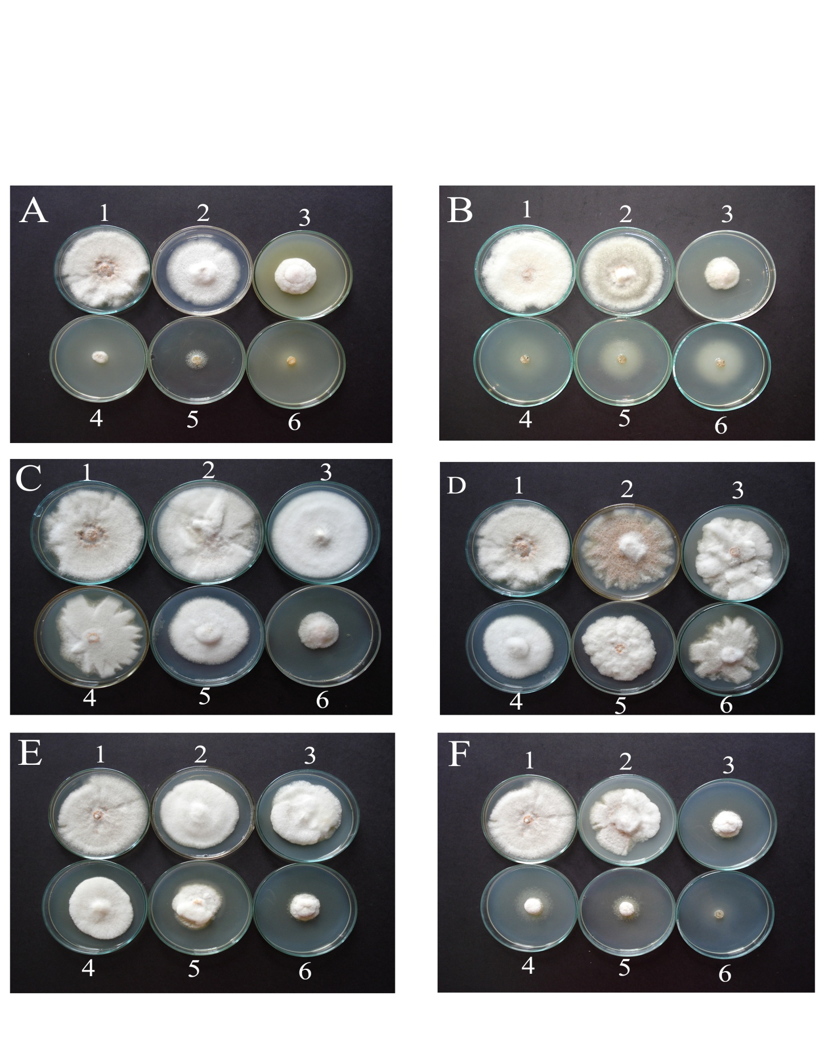
Figure 1: Effect of different concentrations of essential oils on the dry and wet weight of Colletotrichum gloeosporioides.

Figure 2: Effect of different concentrations of essential oils 0- ppm (1), 500-ppm (2), 1000-ppm (3), 1500 - ppm (4), 2000- ppm (5), 2500-ppm (6) on the colony diameter of Colletotrichum gloeosporioides (A-Lemongrass oil ; B- Citrus oil ;C-Cedarwood oil ;D- Neem oil; E-Eucalyptus oil ;F-Peppermint oil.

References
- Burt, S. 2004. Essential oils: their antibacterial properties and potential applications in foods – a review. Int J Food Microbiol. 94: 223-53.
- Daferera, D.J., Ziogas, B.N., Polissiou, M.G. 2003. The effectiveness of plant essential oils on the growth of Botrytis cinerea, Fusarium sp. and Clavibacter michiganensis subsp. Michiganensis. Crop Protection. 22: 39-44.
- Fraternale, D., Giamperi L., and Ricci, D. 2003. Chemical composition and antifungal activity of essential oils obtained from in-vitro plants of Thymus mastichina L. J. Essent. Oil Res. 15: 278-281.
- Kirthikar, K.R., and Basu, B.D. 1935. Indian Medicinal Plants. 2nd ed. Dehra Dun. Bishen Singh Mahendra Pal Singh. p 474-475
- Nielsen, K.A, Nicholson, R.L., Carver ,T.L.W., Kunoh, H., and Oliver, R.P. 2000. Physiol. Mol. Plant Pathol. 56: 63-70.

- Mukhopadhyay, S., and Nandi, B. 1997. Cellulase production by stains of Trichoderma on water Hyacinth biomass. J. Mycopathol. Res. 35: 21-28.
- Smith, B.J., and Black, L.L. 1990. Morphological, cultural and pathogenic variations among Colletotrichum species isolated from Strawberry. Plant Disease. 74: 69-76.
- Bouchra, C., Achouri, M., Hassani, I.L.M. and Hmamouchi, M. 2003. Chemical composition and antifungal activity of essential oils of seven Moroccan labiates against Botrytis cinerea Pers: Fr. J. Ethnopharmocol. 89: 165-169.
- Sokmen, A., Gulluce, M., Akpulat, H.A., Daferera, D., Tepe, B., Polissiou, M., Sokmen, M. and Sahin, F. 2004. The in vitro antimicrobial and antioxidant activities of the essential oils and methanol extracts of endemic Thymus spathulifolius. Food Control.
- Goubran, F.H. and Holmes, R.J. 1993. The development of alternative fungicides from essential oils Victoria, Australia: Institute for Horticultural Development, Knoxfield, Department of Agriculture.

6/25/2011

