Alkyl Mercury chloride compounds-induced genotoxicity in human blood cultures and corrective role of Ascorbic acid (Vitamin C)

Rania, M. A. Abdel Kader ¹ , Elkholy, Y.M. ³ , Helmy, N.A.¹, Eltoukhy, S.E. ², Kayed, H.F. ¹

1 Human Cytogenetics Department, Human Genetics and Genome Research Division, National Research Centre, Dokki, Giza, Egypt
2 Medical Biochemistry Department, Medical Researches Division National Research Centre, Dokki, Giza, Egypt
3 Organic Chemistry Department, Faculty of Science, Helwan University, Helwan, Egypt
Roony82008@hotmail.com

Abstract:Methyl mercury chloride is a xenobiotic metal that is a highly deleterious environmental pollutant. The biotransformation of mercuric chloride (HgCl₂) into methyl mercury chloride (CH₃HgCl) in aquatic environments is well-known and humans are exposed by consumption of contaminated fish, shellfish and algae. The genotoxicity induced by mercury compounds remains controversial. Therefore we have investigated the genotoxic effect of methyl mercury chloride (MMC; CH₃HgCl) at two concentrations (100, and 1000 μg/L) and the role of ascorbic acid (Vitamin C) at a single concentration of (9.734 mm) on MMC-treated short-term human lymphocyte cultures. We assessed the chromosomal aberrations (CAS), sister chromatid exchange (SCE) and COMET assay in control and MMC-treated lymphocyte cultures with and without Vitamin C supplementation. The results showed that MMC has increased the frequency of CAS and SCE/cell in a dose-dependent manner than control values. CH₃HgCl also, induced DNA damage in determined by COMET assay. These effects were prevented by the addition of Vitamin C to MMC-treated lymphocyte cultures. Data revealed that, mutagenic activity of MMC and the protective role of Vitamin C on mercury compounds-induced genotoxicity in human lymphocyte cultures is probably due to its strong antioxidant and nucleophilic nature.
[Rania, M. A. Abdel Kader, Elkholy, Y.M., Helmy, N.A., Eltoukhy, S.E., Kayed, H.F. Alkyl Mercury chloride compounds-induced genotoxicity in human blood cultures and corrective role of Ascorbic acid (Vitamin C).
New York Science Journal 2011;4(7):92-104]. (ISSN: 1554-0200). http://www.sciencepub.net/newyork.

Key words: Alkyl mercury chloride compounds, Mutagenic activity, Geneotoxcity, Carcinogenic effect, COMET assay, Ascorbic acid, Anticlastogenic effect.

Introduction
Mercury, one of the most widely diffused and hazardous organ-specific environmental contaminants, exists in a wide variety of physical and chemical forms, each of which with unique characteristics of target organ specificity (Aleo et al., 2002). Different forms of mercury found naturally; include the metallic form, inorganic compounds as well as alkyl, alkoxy and aryl mercury compounds. Once introduced into the environment, mercury compounds can undergo a wide variety of transformations. In sediments, inorganic mercury (HgCl₂) may be converted into methyl (CH₃HgCl) and dimethyl (CH₃CH₂HgCl) forms by methanogenic bacteria. This biotransformation constitutes a serious environmental risk, given that CH₃HgCl is the most toxic of the mercury compounds that accumulates in the aquatic food chain, eventually reaching human diets (Tchounwou et al., 2003).
Efforts were made to find therapeutic agents capable of minimizing genotoxicity of various natural and man-made compounds. The genotoxicity induced by mercury compounds remains controversial (Rao, 1997).The three modern “faces” of mercury are our perceptions of risk from the exposure of billions of people to CH₃HgCl in fish, mercury vapor from amalgam tooth fillings and CH₃CH₂HgCl in the form of thimerosal added as an antiseptic to widely used vaccines (Clarkson, 2002).
Mercury genotoxicity has been usually attributed to its ability to react with the sulfhydryl groups of tubulin, impairing spindle function and leading to chromosomal aberrations and polyploidy (De Flora et al., 1994). Another important mechanism of mercury genotoxicity is its ability to produce free radicals that can cause DNA damage (Schurz et al., 2000; Ehrenstein et al., 2002).
In vivo studies have demonstrated a clastogenic effect of mercury on people exposed to this element in their work environment, through the consumption of contaminated food, or accidentally, Increased numbers of chromosome alterations and micronuclei have been reported in people who consume contaminated fish (Franchi et al., 1994; Amorim et al., 2000) and in miners and workers of explosive factories (Anwar et al., 1991; Al-Sabti et al., 1992). Negative results were also obtained in some cases (Mabille et al., 1984; Hansteen et al., 1993), demonstrating that cytogenetic monitoring of peripheral blood lymphocytes in individuals exposed to mercury from different sources may not be completely specific (Schurz et al., 2000).

Most of in vitro studies with lymphocytes also used high doses (250 to 6250 μg/L) of mercury compounds in order to evaluate its clastogenic effects (Betti et al., 1993; Ogura et al., 1996)
Ascorbic acid (AA) is well known antioxidant. The antioxidant property can be helpful in reducing clastogenic, mutagenic and carcinogenic properties of certain chemical agents (Siddique et al., 2007).

Ascorbic acid (AA) is involved in various biological activities, including free radical scavenging, and it has been demonstrated that treatment with AA significantly reduced the genotoxicity of well-known mutagens (Odin, 1997; Cabrera, 2000; Kaya et al., 2002; Siddique et al., 2005).
In this context, an anticlastogenic activity of ascorbic will be studied against the genotoxic damage induced in human lymphocyte cultures in vitro by an organic mercury compound; Methyl mercury chloride (CH₃HgCl). Low doses were used in order to assess genotoxic and cytotoxic effects of these compounds at concentrations normally found in nature (40 to 500 μg/L in the earth’ crust environment). Also, low doses of ascorbic acid will be used because AA has both antioxidant and pro-oxidant activities (Bijur et al., 1997).
In DNA, there are four different nucleobases, the pyrimidines Thy and Cty, and the purines Gua and Ade. In their free-radical chemistry, these nucleobases have many properties in common There are, however, also considerable differences which strongly affect the various reaction pathways. In nucleoside and nucleotides, free-radical attack mainly occurs at the base moiety. These reactions largely involve addition reaction. Only the sugar moiety and the methyl group in Thy can act as H-donors. (Mathews and Holde, 1996)
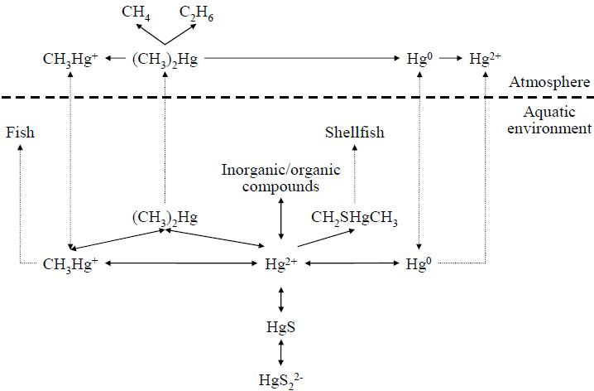
There is good evidence that H₂O₂ and O₂ radicals do not react directly with DNA. The main species responsible for oxidative DNA damage in cells appear to be hydroxyl radicals that are generated by a Fenton reaction involving the reduction of H₂O₂ by transition state metal ions e.g. Fe⁺² or Hg⁺² (Henle and Linn,1997). Hydroxyl radical-induced oxidation of DNA is complex, leading to a multitude of modifications at the level of DNA bases (thymine, cytosine, adenine, guanine, and 5-methylcytosine) (Breen and Morphy , 1995; Cadet et al., 1997) .Such reactions can be generalized as follows:
DNA [Hg²⁺] + H₂O₂  DNA [Hg²⁺] + •OH + OH¯

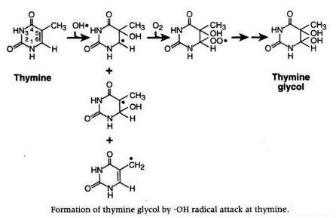
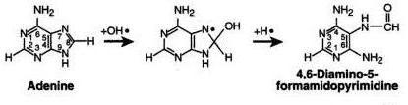
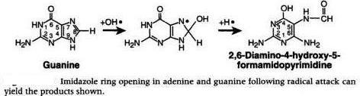
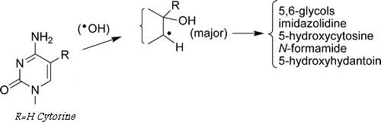

The COMET assay is a method used to measure DNA damage in individual cells was done for the first time by Singh and his colleagues in 1988. The idea was to combine DNA gel electrophoresis with fluorescence microscopy to visualize migration of DNA strands from individual agarose-embedded cells. If the negatively charged DNA contained breaks, DNA supercoils were relaxed and broken ends were able to migrate towards the anode during a brief electrophoresis. If the DNA was undamaged, the lack of free ends and large size of the fragments prevented migration. Determination of the relative amount of DNA that migrated provided a simple way to measure the number of DNA breaks in an individual cell (Olive and Banáth, 2006).
Much of the interest in this method comes from its potential applications in human biomonitoring and in ecological assessment of sentinel organisms exposed to environmental contaminants (Speit and Hartmann, 2005; Azqueta et al., 2009).

Material and Methods
1- Subjects
The present study was carried out In Human Cytogenetics Department, National Research Centre, Cairo, Egypt. Blood samples were obtained from 20 healthy nonsmokers, among cytogenetic staff, 10 females and 10 males, aged 25-50 years, with no recent history of exposure to mutagens. The donors had given an informed written consent to participate in the study.

2- Methods
Chemical reagents
a) CH3HgCl
Two concentrations of CH₃HgCl were used in the cytogenetic tests (D1=1000 μg/L and D2=100 μg/L) corresponded to levels observed normally in nature (low doses). These CH₃HgCl concentrations and durations of exposure were evaluated from various earlier studies (Verschaeve et al., 1984; Tchounwou et al., 2003). Cells treated only with distilled water were used as controls.

b) Ascorbic acid (Vitamin C)
Ascorbic acid (Vitamin C) was used at a single concentration of 8.6 μg /5 ml culture medium (9.734 mm).

In vitro test with peripheral blood lymphocytes:
Peripheral blood lymphocyte micro-cultures were performed according to standard methods (Moorehead et al., 1960; Hungerford, 1978). For differential staining of sister chromatids, 0.26 mm bromodeoxyuridine (BrdU; Sigma) was added to the cultures, mixed gently and cultures were incubated at 37 °C for 72 h in complete darkness.
After 24 h, the treatment of CH₃HgCl (100 and 1000 μg/L) was given separately and along with a single concentration of 8.6 μg /5 ml culture medium of ascorbic acid. Cells were cultured for another 48 h at 37°C in an incubator.

- For chromosomal aberrations and SCE (sister chromatid exchange):
Cells were collected by centrifugation, then exposed to hypotonic solution (0.075 m KCl) for 45 min and fixed three times in acetomethanol (1:3). A few drops of this concentrated cell suspension were placed on clean and chilled slides and allowed to air dry.
- Slides were stained with solid Giemsa stain, GTG banding, SCE.

Scoring of slides
For chromosomal aberrations, Giemsa-stained and GTG- banded slides were used and a total of 50 metaphase plates were counted from each culture of an individual following the standard classification (Lisa et al., 2009).
A minimum of 25 well-spread metaphases from each culture of an individual were scanned to calculate SCE/cell and SCE/chromosome at the magnification of 100X.

- For COMET assay:
- Cultured lymphocytes were isolated according to the procedures of Sierens et al., (2001) with some modiﬁcations using Ficol-Hypague (separating medium). Samples were then centrifuged at 1400 ×g at 25°C for 15 min.
- Lymphocytes were apparent as a layer directly above the Ficoll-Hypague in the tube, and was carefully aspirated.
- Lymphocytes were then washed 3 times with PBS (50 mM, pH 7.4), and then centrifuged for 5 min at 180 × g. Cell pellets were resuspended in 50 mM PBS solution.
- After centrifugation, tubes were decanted and the alkaline COMET assay procedure on isolated lymphocytes was performed according to (Singh et al., 1988; Woznika and Blasiak 2003).
- 110 µl of 0.5% agarose solution was added to a fully frosted microscope slide, immediately covered with a No. 1 coverslip and allowed to solidify. Next, lymphocytes were mixed with 75 µl of 0.5% LMPA (kept at 37°C), the coverslip was removed carefully and the cell mixture added.
- The coverslip was replaced and the slide placed on a tray kept on ice packs to solidify the LMPA. Next, the coverslip was removed and a top layer of 75 µl 0.5% LMPA was added. The coverslip was replaced and the slide returned onto the cold tray. After the top agarose layer had solidified, the coverslip was removed and the slide immersed in a jar containing cold lysing solution (2.5 M NaC1, 100 mM EDTA, 1% SLS and 10 mM Tris, pH 10.0, to which 1% Triton X-100 and 10% DMSO were added fresh). The slides were left at 4°C for at least 1 h.

- Electrophoresis and staining:
Slides were removed from the lysing solution and placed on a horizontal electrophoresis box. The unit was filled with an alkaline buffer (300 mM NaOH and 1 mM EDTA, pH 13.0) to a level ~ 0.25 cm above slides. Cells were exposed to alkali for 20, 40 or 60 minutes to allow for DNA unwinding and expression of alkali-labile damage. To electrophorese the DNA, an electric current of 25 V and 300 mA was applied for either 20 or 40 minutes using a compact power supply.
- All of these steps were conducted under yellow light to prevent the occurrence of additional DNA damage. After electrophoresis, the slides were placed horizontally and Tris buffer (0.4 M Tris, pH 7.5) was added gently to neutralize the excess alkali. Slides were allowed to sit for 5 minutes and this was repeated 3 times. Finally, 50 µl EtBr (2 µg/ml) was added to each slide and covered with a coverslip. After 2-5 minutes, coverslips were removed and the slides rinsed in distilled water to remove excess EtBr. Slides were covered again with coverslips, placed in a humidified air-tight container to prevent drying of the gel, and analyzed within 24 h.

Statistical analysis:
Results of chromosomal aberrations, and SCE, were compared with controls by Student’s t-test. Probability values of 0.05 or less were considered significant. For COMET assay multiple comparisons between groups were done by means of multifactor ANOVA.

Results:
- Chromosomal aberrations:
Cytogenetic analysis of all subjects using GTG banding revealed that all karyotypes of all subjects under investigation were as shown in Table (1).
Methyl mercury chloride at both concentrations was able to induce structural aberrations at the chromosome level. Table (2) summarizes the results of analysis of chromosomal aberrations in human peripheral lymphocytes in culture following treatment with two different concentrations of CH₃HgCl and their negative controls (Photo: 1). Data obtained from 500 metaphases analyzed per treatment (50 metaphases / individual) showed a significant increase in the frequency of chromosomal gaps and chromosomal breaks for Dose1 (D1) of CH₃HgCl concentration alone compared with D1 and Vit.C. Meanwhile a significant increase in the frequency of chromosomal breaks was occurred when comparing Dose2 (D2) of CH₃HgCl concentration alone and with D2 and Vit.C. and the comparison between D1 and D2 alone revealed significant increase in chromosomal gaps only (Table 3). No significant variation was noted with respect to numerical aberrations throughout this study.

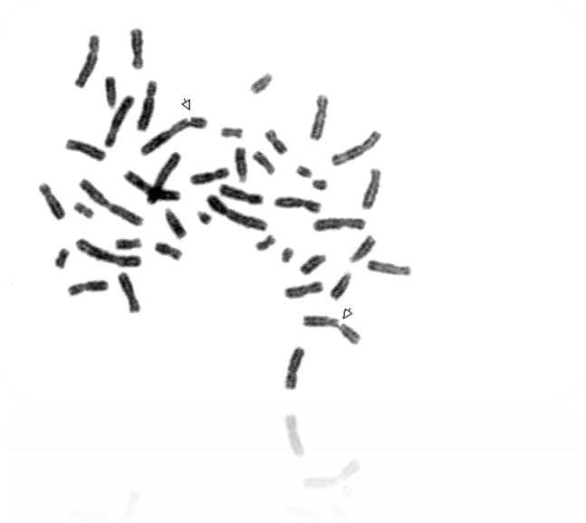

Photo 1: Metaphase spread stained with solid Giemsa stain showing chromosome and chromatid breaks.

Table (1): Age, sex, and karyotype results of subjects
Karyotype | Gender | Age | Subject no.
46,XX N | female | 28 | 1
46,XY N | male | 30 | 2
46,XY N | male | 43 | 3
46,XX N | female | 31 | 4
46,XX N | female | 39 | 5
46,XX N | female | 30 | 6
46,XX N | female | 31 | 7
46,XX N | female | 32 | 8
46,XY N | male | 40 | 9
46,XX N | female | 51 | 10
46,XX N | female | 28 | 11
46,XX N | female | 50 | 12
46,XY N | male | 32 | 13
46,XY N | male | 28 | 14
46,XY N | male | 29 | 15
46,XX N | female | 22 | 16
46,XY N | male | 30 | 17
46,XY N | male | 32 | 18
46,XY N | male | 35 | 19
46,XY N | male | ِ27 | 20

Table (2): Frequency of cells with gaps, and breaks after exposure to two different doses of Methyl Mercury chloride alone and with Vit.C.
S | D1ª |  | D1+ Vit. C |  | D2^{b} |  | D2+ Vit. C^{c}
S | Break | Gab | Break | Gab | Break | Gab | Break | Gab
1 | 10 | 2 | 8 | 0 | 4 | 0 | 1 | 0
2 | 9 | 0 | - | 0 | 2 | 0 | 2 | 0
3 | 8 | 0 | 7 | 0 | 0 | 0 | 1 | 0
4 | 14 | 6 | 6 | 0 | 3 | 0 | 1 | 0
5 | 9 | 5 | 9 | 0 | 0 | 0 | 0 | 0
6 | 8 | 0 | 7 | 0 | 5 | 2 | 3 | 1
7 | 12 | 2 | 8 | 0 | 4 | 0 | 4 | 0
8 | 9 | 0 | 7 | 0 | 7 | 0 | 5 | 0
9 | 5 | 3 | 3 | 0 | 4 | 0 | 0 | 0
10 | 8 | 0 | 2 | 0 | 1 | 1 | 2 | 0
11 | 7 | 0 | - | 0 | 1 | 0 | 3 | 0
12 | 13 | 1 | 8 | 0 | 5 | 0 | 0 | 0
13 | 8 | 0 | 6 | 0 | 4 | 2 | 2 | 3
14 | 10 | 5 | 8 | 0 | 5 | 0 | 3 | 1
15 | 9 | 0 | 7 | 1 | 6 | 0 | 4 | 3
16 | 13 | 6 | 11 | 1 | 9 | 4 | 5 | 6
17 | 9 | 0 | 7 | 3 | 6 | 1 | 0 | 0
18 | 11 | 3 | 5 | 0 | 0 | 0 | 0 | 0
19 | 7 | 0 | 4 | 0 | 0 | 0 | 0 | 0
N | 19 | 19 | 17 | 19 | 19 | 19 | 19 | 19
Mean ± SD | 9.42±2.32 | 1.74±2.26 | 6.65±2.21 | 0.26±0.73 | 3.47±2.65 | 0.53±1.07 | 1.89±1.76 | 0.74±1.59
- MMC (D1) = methyl mercury chloride treated culture with higher dose.
- MMC (D2) =methyl mercury chloride treated culture with lower dose.
- Vit.C = Vitamin C (Ascorbic acid).

Table (3): Comparison of the 2 doses alone and with Vit. C
Culture types | Break | Gap
D1 Vs D1+ Vit. C | 0.0008** | 0.0167*
D1 Vs D2 | 4.7680 | 0.0373*
D2 Vs D2+ Vit. C | 0.0053** | 0.3597
*P < 0.05 Significant, **P ≤ 0.005 Highly significant.

- SCE values:
There was a significantly (P<0.05; P<0.005) higher number of SCE in CH₃HgCl treated cultures at lower and higher concentrations than in either the control or ascorbic acid alone added cultures except in control Vs D2+ Vit. C it was non significant "P >0.05" (Photo: 2, Tables: 4 and 5).
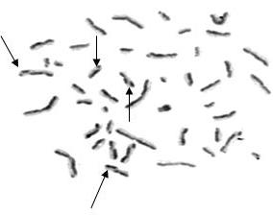
Photo 2: Metaphase spread showing increased Sister Chromatid Exchange (SCE).

Table (4): Values of Sister Chromatid Exchanges (SCEs) in human blood cultures

S | Control | D1 | D1+Vit. C | Control | D2 | D2+Vit. C
1 | 2.6 | 8.2 | 3.2 | 2.6 | 3.5 | 4.8
2 | 2.5 | 2.3 | 1.9 | 2.5 | 3.4 | 3.2
3 | 4.8 | 2.4 | 5.2 | 4.8 | 6.2 | 4.5
4 | 5.5 | 8.6 | 3.2 | 5.5 | 4.3 | 5.4
5 | 4.2 | 7.9 | 6.2 | 4.2 | 6.3 | 5.6
6 | 3.2 | 8.2 | 6.2 | 3.2 | 2.5 | 5.6
7 | 5.4 | 2.8 | 4.8 | 5.4 | 3.6 | 1.9
8 | 2.3 | 7.4 | 3.7 | 2.3 | 4.8 | 2.7
9 | 5.6 | 8.5 | 5.8 | 5.6 | 6.2 | 5.6
10 | 5.2 | 8.7 | 6.2 | 5.2 | 6.1 | 5.6
11 | 2.5 | 2.3 | 3.2 | 2.5 | 3.4 | 1.2
12 | 4.8 | 3.2 | 2.1 | 4.8 | 2.5 | 1.2
13 | 3.2 | 6.2 | 4.3 | 3.2 | 5 | 2.1
14 | 4.8 | 7.4 | 5.3 | 4.8 | 6.2 | 4.4
15 | 4.2 | 8 | 5.8 | 4.2 | 6.1 | 3.5
16 | 5.7 | 8.3 | 6.1 | 5.7 | 6.4 | 5.2
17 | 4 | 7.8 | 5.3 | 4 | 5.9 | 4.2
18 | 3.8 | 6.2 | 5.8 | 3.8 | 4.5 | 5.5
19 | 2.5 | 7.4 | 5.3 | 2.5 | 5.1 | 5.6
20 | 5.2 | 6.8 | 5.7 | 5.2 | 4.9 | 3.2
N | 20 | 20 | 20 | 20 | 20 | 20
Mean ±SD | 4.10±1.198 | 6.40±2.38 | 4.80±1.40 | 4.10±1.198 | 4.80±1.32 | 4.00±1.56

Table (5): Comparison of results of SCEs of 2 doses alone and with Vit. C versus control.

Control Vs D1 | 0.0005**
Control Vs D1+ Vit. C | 0.0529*
Control Vs D2 | 0.0254*
Control Vs D2+ Vit. C | 0.9003
D1 Vs D1+ Vit. C | 0.0112*
D1 Vs D2 | 0.0142*
D2 Vs D2 + Vit. C | 0.0316*
*P < 0.05 Significant, **P ≤ 0.005 Highly significant.

COMET assay:
A significant DNA damage was observed for the applied two concentrations of CH₃HgCl alone when compared with the control and no significant damage when comparing the two concentrations of CH₃HgCl and the added vitamin C (Photo: 3, Tables 6 and 7).

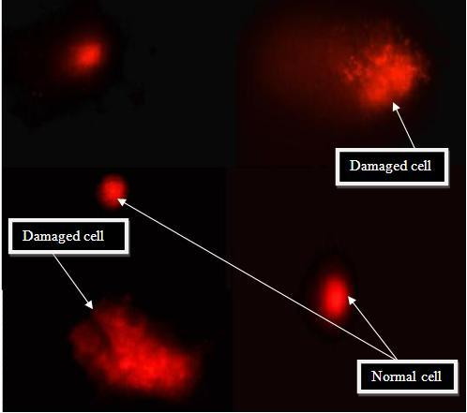

Photo 3: Typical COMETs from lymphocytes treated with CH₃HgCl to induce breaks. Damage categories were indicated.

Table (6): Percentage of DNA damage estimated by COMET assay

S | Control (%) | D1 (%) | D1+Vit. C (%) | D2 (%) | D2+Vit. C (%)
1 | 7.00 | 90.00 | 12.00 | 25.00 | 8.00
2 | 4.00 | 45.00 | 15.00 | 30.00 | 18.00
3 | 5.00 | 45.00 | 5.00 | 13.00 | 3.00
4 | 3.00 | 79.00 | 42.00 | 30.00 | 7.00
5 | 4.00 | 30.00 | 10.00 | 17.00 | 5.00
6 | 5.00 | 65.00 | 28.00 | 24.00 | 17.00
7 | 4.00 | 78.00 | 40.00 | 55.00 | 32.00
8 | 6.00 | 58.00 | 28.00 | 22.00 | 19.00
9 | 3.00 | 88.00 | 52.00 | 60.00 | 30.00
10 | 4.00 | 62.00 | 32.00 | 28.00 | 8.00
11 | 4.00 | 26.00 | 8.00 | 19.00 | 6.00
12 | 3.00 | 48.00 | 15.00 | 25.00 | 8.00
13 | 5.00 | 62.00 | 28.00 | 40.00 | 10.00
14 | 3.00 | 58.00 | 30.00 | 25.00 | 8.00
15 | 6.00 | 75.00 | 38.00 | 30.00 | 12.00
16 | 3.00 | 62.00 | 28.00 | 18.00 | 8.00
17 | 4.00 | 65.00 | 34.00 | 25.00 | 12.00
18 | 3.00 | 74.00 | 51.00 | 30.00 | 12.00
19 | 5.00 | 85.00 | 42.00 | 26.00 | 15.00
20 | 4.00 | 74.00 | 51.00 | 30.00 | 12.00
N | 20 | 20 | 20 | 20 | 20
Mean ±SD | 4.25±1.16 | 63.45±0.18 | 29.45±0.15 | 28.60±0.12 | 12.50±0.08

Table (7): Percentage of DNA damage estimated by COMET assay
DNA damage (%) | Control | D1 | D1 + Vit. C | D2 | D2 + Vit. C
DNA damage (%) | 4.20±1.060 | 63.50± 17.90 ^{a,b} | 29.50±14.70 | 28.60±11.50 ^{c,d} | 12.50±7.70
a,b= statistical significant difference between control and D1 alone or with Vitamin C. c,d= statistical significant difference between control and D2 alone or with Vitamin C

Discussion
Most of or almost all carcinogenic and mutagenic agents take the DNA molecule as a target site. So, many of these agents are cytotoxic to cell because they damage this DNA molecule. Mercury has been found to be a causative agent of various disorders including neurological, nephrological, immunological, cardiovascular, musculoskeletal, reproductive and even genetic. Organic mercury is considered to be more toxic as it can pass via blood brain barrier (Zahir et al., 2005; Zahir et al., 2006).
Our investigated agent Methyl Mercury Chloride (MMC; CH₃HgCl) is an interesting example to study the cytogenetic effect of one of mercury compounds. The present study also, showed a protective role of vitamin C on mercury-induced genotoxicity in vitro.
Mercury compounds induce a general collapse of antioxidant mechanisms in the cell by binding to the sulfhydryl groups of glutathione, a radical scavenger. Such a collapse results in cell degeneration, loss of membrane integrity and finally cell necrosis (Schurz et al., 2000). Necrosis can be indicated by a decrease in mitotic index, as shown by the present results. A decrease in mitotic index followed by an increase in the generation of reactive oxygen species was detected in human blood lymphocytes exposed to CH₃HgCl (Ogura et al., 1996). Another mechanism that may contribute to cell death induced by mercury compounds is apoptosis. Shenker et al., (2000) reported that, CH₃HgCl caused a significant increase in cytochrome c in the cytosol of T cells. This effect may justify the higher cytotoxic action of CH₃HgCl, as observed in the present study. Previous obtained results support the higher cytotoxic effect of CH₃HgCl (Ogura et al., 1996; Bahia et al., 1999).
A number of in vitro studies on genotoxic effects of mercury and its compounds based on cytogenetic tests have been published. Their results suggest that ,organic compounds are generally more active, in terms of genotoxicity, than inorganic compounds (Gebhart and Rossman 1991; De Flora et al., 1994; Ogura et al., 1996; Bahia et al., 2000). The binding of this metal to sulfhydryl groups of glutathione blocks its function as a free radical scavenger (Schurz et al., 2000). Thus, free radicals become available to cause DNA damage (Ogura et al., 1996). These mechanisms can lead to “double-strand breaks” that can be visualized as the chromatid gaps observed in the present study (Harvey et al., 1997) and/or give rise to more evident chromosome alterations such as breaks, rearrangements, and so on (Morgan et al., 1998).
In the present study, a significant dose related increase in the number of cells showing chromosome aberrations was observed after treatment with CH₃HgCl (Table1 and 2). However, such increase was not linearly related to dose. This effect can be explained by the fact that CH₃HgCl acts similarly to X-rays (Betti et al., 1993), increasing DNA damage in a dose-dependent manner until a plateau is reached, with a decrease in damage being observed eventhough the doses continue to increase.
There was a significantly (P<0.05 ; P<0.005) higher number of SCE in CH₃HgCl -treated cultures at lower and higher concentrations than in either the control or ascorbic acid added cultures except in control Vs D2+ Vit.C it was non significant (P >0.05).
Sister chromatid exchange (SCE) frequency is a commonly used index of chromosomal stability in response to environmental or genetic mutagens. Induction of the frequency of SCE/cell was significantly higher and found to be dose related in our study, indicating the genotoxic nature of CH₃HgCl in human blood cultures. Other inorganic and organic mercury compounds are also known to increase induction of SCE/cell in human (Betti et al., 1993) this supports our data.
This effect reflects two different phenomena: a dose-dependent increase in the proportion of normal cells whose DNA is damaged and a dose-dependent decrease of the probability that such cells can survive higher exposures (Hall, 2000). Our results showed that, exposure of peripheral blood lymphocytes to low doses of CH₃HgCl is sufficient for the expression of evident genotoxic and cytotoxic effects.
The mechanism of genotoxicity induced by mercury compounds is quite complex. Heavy metals meet directly with DNA as metals are positively charged ions or electrophiles and easily form complexes with DNA by binding with negatively charged centres or nucleophilic sites to cause mutagenesis (Gebhart and Rossman, 1991). Further, metals including mercury can react with sulfhydryl (SH) groups of proteins (Burton et al., 1995) associated with DNA replication and alter genetic information and replication fidelity. Another mechanism by which mercury damages DNA molecule is via its probable involvement of reactive oxygen species (ROS) or oxygen free radicals (OFRs) and induces DNA strand breaks (Cantoni et al., 1984; Aust et al., 1985). Further, OFRs are known to reduce glutathione (GSH) levels (Shenker et al., 1993) or inhibit GSH synthesis (Chang et al., 1999), leading to a decline in intracellular thiol levels. Moreover, mercury alters DNA base pairs by binding with DNA and also forms cross-links between DNA strands, causing mutations (Guille et al., 1981).
Previous results suggested that, the COMET test was highly effective in revealing DNA-damaging caused by environmental mutagens such as MMC (Olive and Durand, 2005).
In the present work it was confirmed that, COMET assay is more sensitive than chromosomal aberrations and SCE in revealing the damaging effect of MMC.
Ascorbic acid is known to provide antimutagenic and anticlastogenic properties against a number of chemicals in a variety of systems including man. In the present study also, addition of ascorbic acid to CH₃HgCl -treated blood cultures prevented such genotoxic and mitotis disturbing effects induced by mercury, revealing the protective nature of vitamin C. Vitamin C is a strong antioxidant having nucleophilic properties and binds to mercury ions (Hg²⁺) to reduce mercury- induced DNA damage (Sato et al., 1997; Rao, 1997; Alpsoy et al., 2009). It further manifests its detoxification effect by removing or minimizing free radicals produced by mercury (Herbaczynska et al., 1995). Ascorbic acid also protects DNA from oxidative damage (Antunes and Takahashi, 1999), reduces DNA damage exerted by irradiation (Green et al., 1994) and also reduces micronucleus (MN) frequencies in polychromatic erythrocytes of bone marrow in rodents exposed to heavy metals and irradiation (Konopacka et al., 1998), in support of our data.
Ascorbic acid was extremely unstable in vitro. It reduces other radicals including the hydroxyl radical, organic alkoxyl and peroxyl radicals, urate radical, tocopherol radical, and the ferric and cupric ions. It readily oxidizes to dehydro-ascorbate in a two step reaction. When the ascorbate anion loses one electron, it becomes an ascorbate radical, A• .This ascorbate radical has several possible fates in vitro. It can loose another electron and become dehydro-ascorbate, gain an electron and proton to regenerate the ascorbate anion and react with another radical and form a stable compound, or two ascorbate radicals can dismutate to form one ascorbate anion and one dehydro-ascorbate molecule. (Noctor and Foyer, 1998; Deutsch, 2000; Smirnoff, 2005)
Ascorbic acid, or ascorbate, is an antioxidant because of the high reducing potential of its carbon-carbon double bond (Buettner, 1993) .Each step of ascorbate oxidation is reversible, and this permits recycling back to ascorbate. (Mehlhorn et al., 1991; Coassin et al., 1991; Buettner et al., 1993). Loss of the second electron results in dehydroascorbic acid, which is not an acid. This contrasts with ascorbate, which carries a negative charge at physiologic pH (the pK_{a} of the carbon-3 hydroxyl is 4.2). DHA is quite unstable at physiologic pH and temperature, with a half-life of about 6 minutes (Drake et al., 1942; Winkler, 1987). With hydrolysis of the lactone ring, DHA is converted to 2,3-diketo-1-gulonic acid (Chatterjee,1970 ; Bode et al., 1990). This last step is probably irreversible in cells, although it can be reversed by mercaptoethanol in vitro (Deutsch et al., 1996). Loss of ascorbate through decomposition of DHA is obviously wasteful, and cells such as the erythrocyte have redundant mechanisms to recycle DHA back to ascorbate.
Vitamin C (ascorbate, AscH–), for example, can donate a hydrogen atom to a free radical molecule (R•) thereby neutralizing the free radical while becoming an ascorbate radical itself (•Asc–, or Asc•–, in different notation). But the •Asc– free radical is very stable because of its resonance structure (shown by the dashed lines in the illustration). Moreover, AscH– is readily regenerated from •Asc– with NADH or NADPH-dependent reductases (Hossain, 1985; Menon et al., 2008).

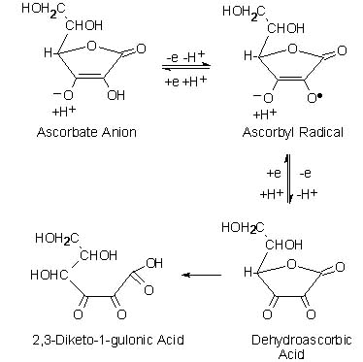

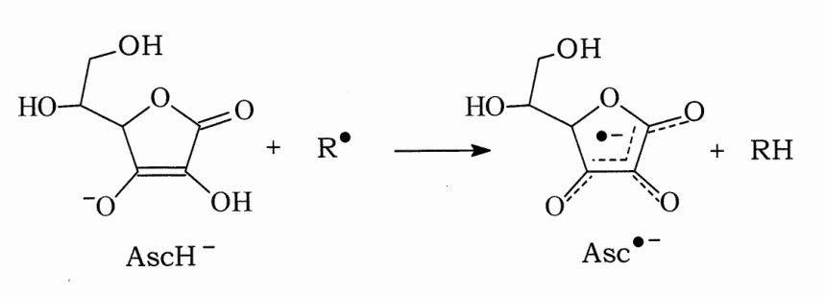

Thus it is evident from our study that ascorbic acid prevents mercury compounds induced-genotoxicity in blood cultures due to its probable nucleophilic and detoxifying nature. Hence, supplementation of vitamin C through the diet might be useful to the population occupationally exposed to heavy metal poisoning.

References:
- Aleo MF., Morandini F., Benttoni F. In vitro study of the nephrotoxic mechanism of mercuric chloride. Medicina del Lavoro 2002 ; 93: 267-278.
- Alpsoy L., Agar G. and Ikbal, M. Protective role of vitamins A, C, and E against the genotoxic damage induced by aflatoxin B1 in cultured human lymphocytes. Toxicology and Industrial Health 2009; 25: 183–188.
- Al-Sabti K., Lloyd DC., Edwards AA. and Stenar P.. Survey of lymphocyte chromosomal damage in Slovenian workers exposed to occupational clastogens. Mutation Research 1992; 280: 215-223.
- Amorim MIM., Mergler D., Bahia MO., Dubeau H., Miranda D., Lebel J., Burbano RR. and Lucotte M.. Cytogenetic damage related to low levels of methyl mercury contamination in the Brazilian Amazon. Anais da Acadêmia Brasileira de Ciências 2000; 72: 497-507.
- Antunes LM. , Takahashi CS. , Protection and induction of chromosomal damage by vitamin C in human lymphocyte cultures. Teratogenesis, Carcinogenesis and Mutagenesis 1999; 19: 53–59.
- Anwar WA. and Gabal MS. Cytogenetic study in workers occupationally exposed to mercury fulminate. Mutagenesis 1991; 6: 189-192.
- Aust SD. , Morehouse LA. and Thomas CE.. Role of metals in oxygen radical reactions. Journal of Free Radicals in Biology and Medicine 1985; 1: 3–25.
- Azqueta A., Shaposhnikov S., Collins AR.. DNA oxidation: Investigating its key role in environmental mutagenesis with the comet assay. Mutation Research 2009; 674:101–108.
- Bahia MO., Amorim MIM., Burbano RR., Vincent S. and Dubeau H. Genotoxic effects of mercury on in vitro cultures of human cells. Anais da Academia Brasileira de Ciências 1999; 71: 437-443.
- Betti C. , Davini T. , He J. and Barale R. Liquid holding effects on methylmercury genotoxicity in human lymphocytes. Mutation Research 1993; 301: 267-273.
- Bijur GN. , Ariza ME. , Hitchcock CL. and Williams MV. Antimutagenic and promutagenic activity of ascorbic acid during oxidative stress. Environ Mol Mutagen 1997; 30:339-345.
- Bode A. M., Cunningham L. and Rose R. C. . Spontaneous decay of oxidized ascorbic acid (dehydro-Lascorbic acid) evaluated by high-pressure liquid chromatography. Clin Chem 1990 ;36, 1807-9.
- Breen A. P. and Murphy J. A. Free Radical Biol. Med 1995: 18 ;1033-1077.
- Buettner G. R. and Jurkiewicz B. A.. Ascorbate free radical as a marker of oxidative stress: an EPR study. Free Radic Biol Med 1993: 14; 49-55.
- Buettner G. R. The pecking order of free radicals and antioxidants: lipid peroxidation, alpha-tocopherol, and ascorbate. Arch Biochem Biophys 1993: 300; 535-43 .
- Burton CA., Hatlelid K., Divine K., Carter DE. , Fernando Q., Brendel K. and Gandolfi AJ.. Glutathione effects on toxicity and uptake of mercuric chloride and sodium arsenite in rabbit renal cortical slices. Environmental Health Perspectives 1995; 103: 81–84.
- Cabrera G. Effect of five dietary antimutagens on the genotoxicity of six mutagens in the microscreen prophageinduction assay. Environ Mol Mutagen 2000; 36;206-220.
- Cadet J. , Berger M. , Douki T. and Ravanat J. L. Rev. .Physiol. Biochem. Pharmacol. 1997: 131 ; 1–87
- Cantoni O., Christie NT., Swann A., Drath DB. and Costa M. Mechanism of mercury (II) chloride cytotoxicity in cultured mammalian cells. Molecular Pharmacology 1984: 26; 360–368.
- Chang WK., Yang KD. and Shaio MF. Lymphocyte proliferation modulated by glutamine: involved in the endogenous redox reaction. Clinical and Experimental Immunology 1999; 117: 482–488.
- Chatterjee I. B. Biosynthesis of L-ascorbate in animals. Methods Enzymol 1970: 18;28-34.
- Clarkson RW. The three modern faces of mercury. Environmental Health Perspectives 2002: 110; 11-23.
- Coassin M., Tomasi A., Vannini V. and Ursini F. Enzymatic recycling of oxidized ascorbate in pig heart: oneelectron vs two-electron pathway. Arch Biochem Biophys 1991: 290 ; 58-62
- De Flora S., Benniceli C.and Bagnasco M. . Genotoxicity of mercury compounds, A review. Mutation Research 1994: 317; 57-79.
- Deutsch J. C. and R. Santhosh-Kumar: Dehydroascorbic acid undergoes hydrolysis on solubilization which can be reversed with mercaptoethanol. J Chromatogr 1996: 724; 271-8.
- Deutsch JC. Dehydroascorbic acid. Journal of Chromatography 2000):881; 299–307.
- Drake B. B., Smythe C.V.and King C. G. Complexes of dehydroascorbic acid with three sulfhydryl compounds. J Biol Chem 1942: 143 ; 90-98.
- Ehrenstein C., Shu P., Wickenheiser EB., Hirner AV., Dolfen M., Emons H. and Obe G. Methyl mercury uptake and associations with the induction of chromosomal aberrations in Chinese hamster (CHO) cells. Chemico-Biological Interactions 2002: 141; 259-274.
- Franchi E., Loprieno G., Ballardin M., Petrozzi L. and Migliore L. Cytogenetic monitoring of fishermen with environmental mercury exposure. Mutation Research 1994: 320; 23-29.
- Gebhart E. and Rossman TG.. Mutagenicity, carcinogenicity and teratogenicity. In: Merian E (Editor), Metals and Their Compounds in the Environment. VCH, New York, 1994; 617-640.
- Green M., Lowe JE., Waugh AP., Aldridge KE. , Cole J. and Arlett CF. Effects of diet and Vitamin C on DNA strand breakage in freshly isolated human white blood cells. Mutation Research 1994: 316; 91–102.
- Guille E., Grisvard J. and Sissoeff I.. Structure and function of metallo-DNA in the living cells. In: Williams, D.F. (Ed.). Systemic Aspects of Biocompatibility, Volume I. CRC Press, FL, 1981; 39–85.
- Hall EJ. Radiobiology for the Radiologist. 5th edn. Lippincott Williams & Wilkins, Philadelphia, PA, USA. 2000.
- Hansteen H. , Ellingsen DG. , Clausen KO. And Kjuus H.. Chromosome aberrations in chloralkali workers previously exposed to mercury vapour. Scandinavian. Journal of Work, Environment and Health 1993: 19; 375-381.
- Harvey AN., Costa ND., Savage JR. and Thacker J. Chromosomal aberrations induced by defined DNA double-strand breaks: the origin of achromatic lesions. Somatic Cell and Molecular Genetics 1997: 23; 211-219.
- Henle E. S., and Linn S. J. Biol. Chem. 1997: 272 ; 19095–19098
- Herbaczynska CK , Ktosiewicz WB., Cedro K , Wasek W., Panczenko KB and Wartanowicz M.. Supplementation with vitamins C and E suppresses leukocyte oxygen free radical production in patients with myocardial infarction, European Heart Journal 16:1044–1049,induction of single and double DNA strand breaks and DNAprotein cross-links. Mutat. Res. 1995: 535; 127–139.
- Hossain MA. the journal of biological chemistry 1985: 260(24);12920-12926
- Hungerford DA. Chromosome structure and function in man. VI, Pachytene chromosome maps of 16.17,18 and Pachytene as a reference standard for metaphase bandings. Cytogen Cell Genet 1978: 21; 212 – 230.
- Kaya B., Creus A., Velázquez A., Yanikoglu A. and Marcos R. Genotoxicity is modulated by ascorbic acid: Studies using the wing spot test in Drosophila. Mutat Res 2002: 520; 93-101.
- Konopacka M., Widel M. and Rzeszowska WJ. Modifying effect of vitamins C, E and beta-carotene against gamma-ray-induced DNA damage in mouse cells. Mutation Research 1998; 417; 85–94.
- Lisa G. Shaffer, Marilyn L. Slovak, Lynda J. Campbell .Karger AG. And Basel,. ISCN (An International System for Human Cytogenetic Nomenclature). 2009, Swisserland
- Mabille V., Roels H., Jacquet P., Léonard A. & Lauweris R. Cytogenetic examination of leucocytes of workers exposed to mercury vapor. International Archives of Occupational and Environmental Health 1984: 53; 257-260.
- Mathews C. K., Holde K. E., Biochemistry, 2nd Ed., Benjamin-Cummings Publishing 1996.
- Mehlhorn R. J. Ascorbate- and dehydroascorbic acidmediated reduction of free radicals in the human erythrocyte. J Biol Chem 1991: 27; 24-31.
- Moorhead PS, Novell PC, Mellman WJ, Battips DM and Hungerford DA. Chromosome preparation of leucocyte culture from peripheral blood. Exp. Cell Res 1960: 20; 613-615.
- Morgan WF., Corcoran J., Hartmann A., Kaplan MI., Limoli CL. And Ponnaiya B. DNA double-strand breaks, chromosomal rearrangements, and genomic instability. Mutation Research 1998: 404;125-128.
- Noctor G., Foyer CH. Ascorbate and glutathione, keeping active oxygen under control. Annual Review of Plant Physiology and Plant Molecular Biology 1998: 49; 249–279.
- Odin AP. Vitamins as antimutagens: Advantages and some possible mechanisms of antimutagenic action. Mutat Res 1997; 386; 39-67.
- Ogura H., Takeuchi T. and Morimoto K. A comparison of the 8- hydroxydeoxyguanosine, chromosome aberrations and micronucleus techniques for the assessment of the genotoxicity of mercury compounds in human blood lymphocytes. Mutation Research 1996: 340; 175-182.
- Olive PL. and Banáth JP. The COMET assay: a method to measure DNA damage in individual cells, Nature protocols 2006: 1; 23-39.
- Olive P.L. and Durand R.E. Heterogeneity in DNA damage using the comet assay, Cytometry 2005: 66; 1−8.
- Rao M.V.. Mercury and its effects on mammalian systems—a critical review, Indian Journal of Environment and Toxicology 1997:7; 3–11.
- Sato K., Kusaka Y., Zhang Q., Deguchi Y., Li B., Okada K., Nakakuki K. and Muraoka R. Direct effect of inorganic mercury on citrate uptake by isolated rat renal brush border membrane vesicles. Industrial Health 1997: 35; 456–460.
- Schurz F., Sabater-Vilar M. and Fink-Gremmels J.. Mutagenicity of mercury chloride and mechanisms of cellular defence: the role of metal-binding proteins. Mutagenesis 2000: 15; 525-530.
- Shenker BJ., Mayro JS., Rooney C., Vitale L. and Shapiro IM. Immunotoxic effects of mercuric compounds on human lymphocytes and monocytes IV, Alterations in cellular glutathione content. Immunopharmacology and Immunotoxicology 1993: 15; 273–290.
- Shenker BJ., Guo TL. and Shapiro IM. Mercury-induced apoptosis in human lymphoid cells: evidence that the apoptotic pathway is mercurial species dependent. Environmental Research. 2000: 84; 89-99.
- Siddique Y H., Beg T. and Afzal M. Anticlastogenic Effects of Ascorbic Acid Against the Genotoxic Damage Induced by Norethynodrel. Advances in Environmental Biology 2007: 1(1) ; 27-32.
- Siddique YH, Beg T and Afzal M. Antigenotoxic effects of ascorbic acid against megestrol acetate-induced genotoxicity in mice. Hum Exp Toxicol 2005: 24; 121.
- Sierens J., Hartley J.A., Campbell M.J., Leathem A.J.C. and Woodside J.V. Effect of phytoestrogen and antioxidant supplementation on oxidative DNA damage assessed using the comet assay. Mutat. Res. (2001); 485, 169–176.
- Singh NP., McCoy MT., Tice R.R. and Schneider EL. A simple technique for quantitation of low levels of DNA damage in individual cells, Exp. Cell Res. 1988: 175; 184−191.
- Smirnoff N. Ascorbate, tocopherol and carotenoids: metabolism, pathway engineering and functions. In: Smirnoff N, ed. Antioxidants and reactive oxygen species in plants, Oxford: Blackwell Publishing 2005; 53–86.
- Speit G. and Hartmann A. The COMET assay: a sensitive genotoxicity test for the detection of DNA damage, Methods Mol. Biol. 2005 : 291; 85−95.
- Tchounwou PB., Ayensu WK., Ninashvili N. and Sutton D. Environmental exposure to mercury and its toxicopathologic implications for public health. Environmental Toxicology 2003: 18; 149-175.
- Verschaeve L., Kirsch-Volders M. and Susanne C. Mercury induced segregational errors of chromosomes in human lymphocytes and in Indian muntjac cells. Toxicology Letters 1984: 21; 247–253.
- Winkler B. S. In vitro oxidation of ascorbic acid and its prevention by GSH. Biochim Biophys Acta 1987: 925; 258-64
- Woznika K. and Blasiak, J. In vitro genotoxicity of lead acetate: ´induction of single and double DNA strand breaks and DNA protein cross-links. Mutat. Res 2003: 535; 127–139.
- Zahir F., Rizvi SJ. , Khan RH. and Haq SK. Low dose mercury toxicity and human health, Environmental toxicology and Pharmacology (2005) ; 20: 351-360.
- Zahir F.., Rizvi SJ. , Haq SK. and Khan RH. Effect of methyl mercury induced free radical stress on nucleic acids and protein: implications on cognitive and motor functions. Indian Journal of Clinical Biochemistry 2006: 21 (2); 149-152.

6/25/2011

