Effects of Casein Hydrolysates and Glutamine on Callus and Somatic Embryogenesis of Date Palm (Phoenix dactylifera L.).

Sara Ageel and Khaled Elmeer

Biotechnology Centre, Ministry of Environment Doha Qatar. elmeer@gmail.com.

Abstract: This study was conducted to examine the effect of glutamine and casein concentrations on callus growth and somatic embryogenesis of date palm (Phoenix dactylifera L.). Explant derived from offshoot tip was cultured on MS medium containing four different macro nutrients and different concentrations of casein and glutamine. The type and concentration of amino acid significantly affected the size and differentiation of date palm explant. As concentration increases the size and differentiation decreases up to 40% especially with casein, while 3gl⁻¹ casein increase the callus weight up to 80g comparing with control which gave 20g. The best result of somatic embryos per treatment achieved with half macro nutrient medium supplemented with 3gl⁻¹ casein This study provides an insight into the importance of optimizing various culture medium and amino acid components to overcome in vitro recalcitrance of date palm.
[Sara Ageel and Khaled Elmeer. Effects of Casein Hydrolysates and Glutamine on Callus and Somatic Embryogenesis of Date Palm (Phoenix dactylifera L.). New York Science Journal 2011;4(7):121-125]. (ISSN: 1554-0200). http://www.sciencepub.net/newyork.

Key words: Callus; somatic embryogenesis; tissue culture; glutamine and casein.

- Introduction
Growth of date palm callus tissue was significantly stimulated by the addition of amino acids specifically glutamine This stimulation suggested that organic nitrogen was a growth-limiting factor in date palm cultures The inclusion of glutamine decreased the culture lag phase, which indicated that glutamine was much more readily assailable than inorganic nitrogen. Glutamine plays an important role in nitrogen assimilation as it is an intermediate in the transfer of ammonia into amino acids. Supplementing date palm culture media with organic nitrogen, especially glutamine in high concentrations improved callus induction and rate of growth and many stimulate embryogenesis in such a manner similar to other plants (Abo El-Nil, 1989).
Glutamine supports the growth of cells that have high energy demands and synthesize large amounts of proteins and nucleic acids. It is an alternative energy source for rapidly dividing cells and cells that use glucose inefficiently. Cells require nitrogen atoms to build molecules such as nucleotides, amino acids, amino-sugars and vitamins.
When glucose levels are low and energy demands are high, cells can metabolize amino acids for energy. Glutamine is one of the most readily available amino acids for use as an energy source and it is a major source of energy for many rapidly dividing cell types in vitro.
Casein hydrolysates can be a source of calcium, phosphate, several microelements, vitamins and most importantly, a mixture of up to 18 amino acids. Several casein hydrolysates are available commercially but their value for plant tissue culture can vary considerably. Acid hydrolysis can denature some amino acids and so products prepared by enzymatic hydrolysis are to be preferred. The best can be excellent sources of reduced nitrogen, as they can contain a relatively large amount of glutamine. Casein hydrolysate overcomes the shortage of glutamine when there is insufficient phosphorus for adequate biosynthesis however several investigators have concluded that casein hydrolysate itself is more effective for plant culture than the addition of the major amino acids. This has led to speculation that casein hydrolysates might contain some unknown growth promoting factor (George et al 2008).
L-glutamine can serve as the sole source of nitrogen which can be taken more rapidly than inorganic nitrogen (Thorn et aI., 1980). The effect of casein hydrolysate (amino acids mixture) as a sole nitrogen sources on callus growth was reported by Heimer and Filner (1970) on tobacco callus. Zenk et aI., (1975) found that, when cultured medium was supplemented with casein hydrolysate at level greater that 4 gl⁻¹, callus growth was stimulated in Morinda citrifolia. Casein hydrolysate was used as a sole nitrogen source for beans (Crocomo et aI., 1976), carrot (Wetherell and Dougall, 1976) and fenugreek (Singh et aI., 1981). Cardi and Monti (1993) found that, the addition of casein hydrolysate at 2gl⁻¹ is important for callus production from pea. Also, in a study on kidney bean and pea callus
The present study was conducted to define the optimum requirements of glutamine and casein hydrolysate in an effort to enhance growth of callus and somatic embryos of date palm

- Materials and Methods
Date palm (Phoenix dactylifera L.) Cv. Khalas offshoots, a well-known cultivar throughout Qatar and gulf region collected from healthy, disease-free mother palms, 2-3 years old, weighed approximately 7-10kg was cleaned and the outer large leaves and fibers were carefully and gradually removed by a sharp knife until the appearance of the shoot tip zone. Special care was taken not to injure the meristematic region. Shoot tips were then vigilantly delimited to approximately 5-7cm in length and 3-5cm in width and then the excised shoot tips were placed in a chilled antioxidant solution consisting of 150 mg ascorbic acid and l20mg citric acid to minimize production of phenols (cause the browning), and to protect them from desiccation. Shoot tip tissue, about 6cm long, was surface disinfected in 70% ethanol for 1min, followed by 15min in 1.6% (w/v) sodium hypochlorite (30% v/v Clorox, commercial bleach) containing a few drops of Tween20.The explants were then rinsed three times with autoclaved distilled water, each for 5min in aseptic conditions under laminar airflow hood, and cut into several (20- 25) pieces longitudinally. The explants were cultured on MS medium (Murashige and Skoog, 1962) containing four different macro nutrients medium:

Macro nutrient components | (M1) Medium concentration mgl⁻¹ | (M2) Medium concentration mgl⁻¹ | (M3) Medium concentration mgl⁻¹ | (M4) Medium concentration mgl⁻¹
CaCl2 | 332.02 | 166 | 249.02 | 332.02
KH2PO4 | 170 | 85 | 127 | 170
KNO3 | 1900 | 950 | 1425 | 1900
MgSO4 | 180.54 | 87.54 | 136.54 | 180.54
NH4NO3 | 1652 | 825 | 1237 | Non

The mediums contains four different concentrations of casein and glutamine (0, 1, 2 and 3gl⁻¹), with six replicate for each treatment. The medium was supplemented with 2,4-D 100mgl⁻¹ + 2ip 3mgl⁻¹, solidified with 0.7% agar, pH was adjusted to 5.8 then autoclaved at 121°C and 1.2 Kg/cm² for 20 min. The prepared media were poured into heat sterilized 100ml glass containers. Each contained about 25 ml then incubated at 27°C under a photoperiod of 16 hr light (2000 Lux) and 8 hour dark, subculturing was carried out after 6 weeks. The experiment consisted of factorial arrangements of treatment (medium at four levels and amino acids at two levels with four concentrations) in a completely random design. Six replicates (culture tube) were assigned per treatment. Data were analyzed using the statistical analysis system, general linear model (GLM procedure, SAS Institute Inc., 2004) and means evaluated by LSD.

- Results and discussions
Casein hydrolysate and glutamine have been the principal sources of nitrogen utilized in tissue culture and the growth of date palm callus tissue was significantly stimulated by the addition of amino acids specifically glutamine and casein This stimulation suggested that organic nitrogen was a growth-limiting factor in date palm cultures The inclusion of glutamine decreased the culture lag phase, which indicated that glutamine was much more readily assailable than inorganic nitrogen. Glutamine plays an important role in nitrogen assimilation as it is an intermediate in the transfer of ammonia into amino acid (Abo El-Nil, 1989).
The type and concentration of amino acid significantly affected the size and differentiation of date palm explants, as concentration increases the size and differentiation decreases up to 40% especially with casein (Fig. 1, 2 and 5).
Abdel-Rahim, et al., (1998) found that the fresh weight and growth rate of callus tissues were decreased as affected by amino acids supplemented to culture medium compared with control. Filner (1966) reported that the growth of tobacco callus in culture was inhibited by a wide variety of amino acids added singly to the nitrate medium on which the cells were grown, and that the inhibition could be attributed to repression of the nitrate reductase activity in the cells. Also, Fukunaga and King (1982) reported that, some single amino compounds inhibited the growth of datura cells at points in metabolism other than nitrate assimilation and that in no case could growth and nitrate reductase activity inhibition is causally unequivocally.
The color of explant become brighter with rising of amino acid concentration reaching up to 80% at 3gl⁻¹ casein while glutamine gave dark and brown explant comparing with casein in the tested concentrations (Fig. 3 and 6).

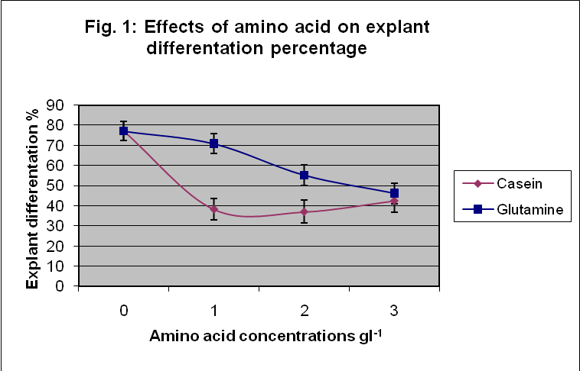

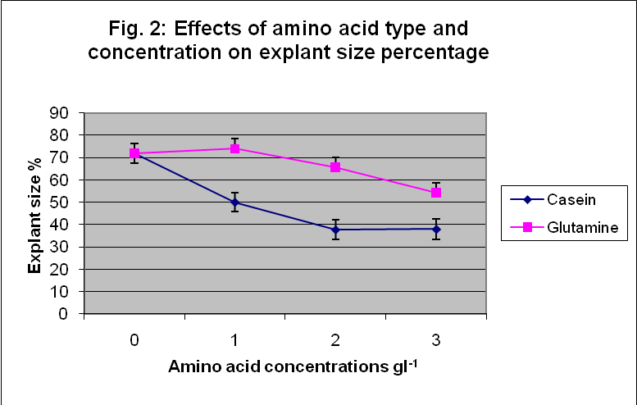

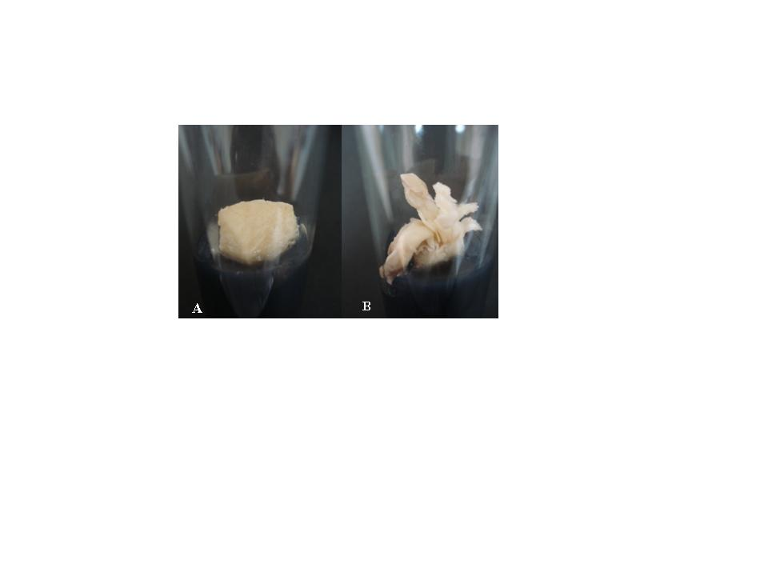
Fig. 5: A. No differentiation and B. well differentiation

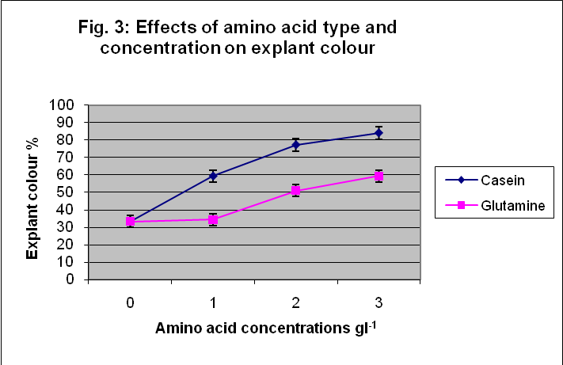

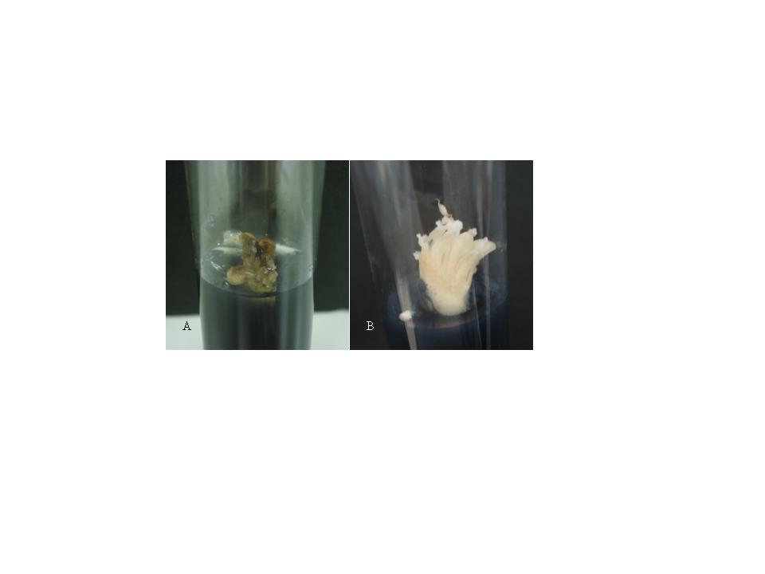
Fig. 6: A. Dark color and B. Bright color

AboEl-Nil, (1989) find that callus grew at high-glutamine concentrations showed highly dense white clusters that formed roots when transferred out onto the same medium and incubated for another eight weeks. Some of these nodules turned green when transferred into a similar medium with a lower NAA concentration of 0.5 µM and devoid of charcoal. Regeneration medium with casein hydrolysate was found to be best medium composition for regeneration protocol developed from suitable explant for callus induction of sorghum (Indra and Krishnaveni 2009). Data also shows increasing in callus weight due to increase in casein concentration which was getting to 80g callus weight at concentration of 3gl⁻¹ (Fig. 7) comparing with control which gave only 20g.The effects of different supplementations of casein hydrolysate on the growth of date palm callus was determined by (Abdel-Rahim, et al.,1998) which was noted that the fresh weight and growth rate of calli gave increasing values during cultivation period.
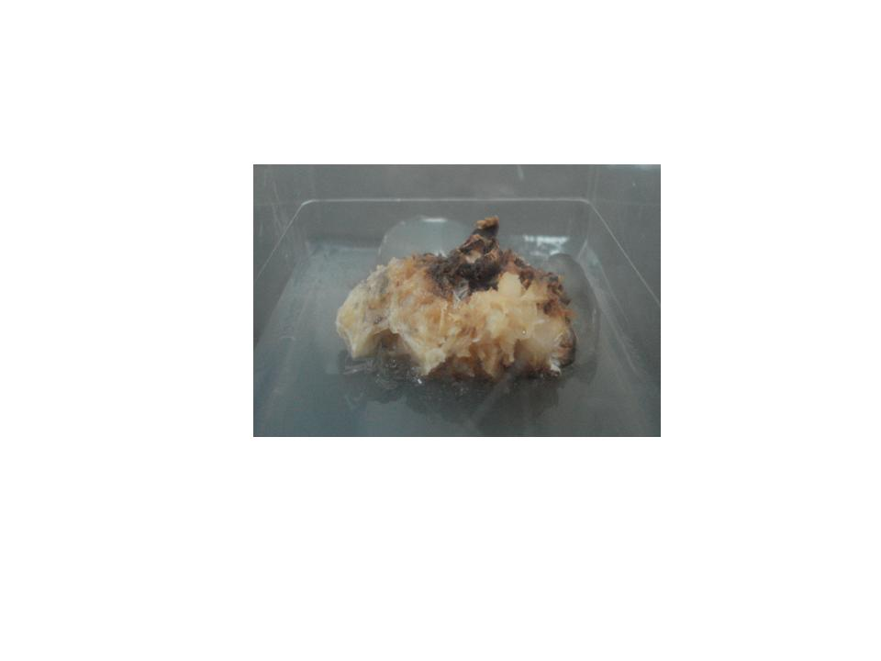
Fig. 7: High callus weight.

It is found that, when casein hydrolysate concentration increased in the medium, the growth of the tissue as fresh weight and growth rate were increased. Similar results for the positive effects of casein hydrolysate on callus growth were reported by Crocomo et aI., (1976), and Mok and Mok (1985) on kidney bean, Murashige and Skoog (1962) on tobacco .
The type and concentration of amino acid tested have an impact on the percentage of embryogenesis callus formation, 3gl⁻¹ casein produced more embryogenic callus than 1gl⁻¹ glutamine which produced only 4% embryogenic callus as shown in (Fig. 4 and 8). The data presented by Abdel-Rahim et al., (1998) indicated that, all concentrations of casein treatment steadily increase both fresh weight and growth rate of calli compared with control. Two gl⁻¹ casein hydrolysate treatments gave the highest value of both fresh weight and growth rate.

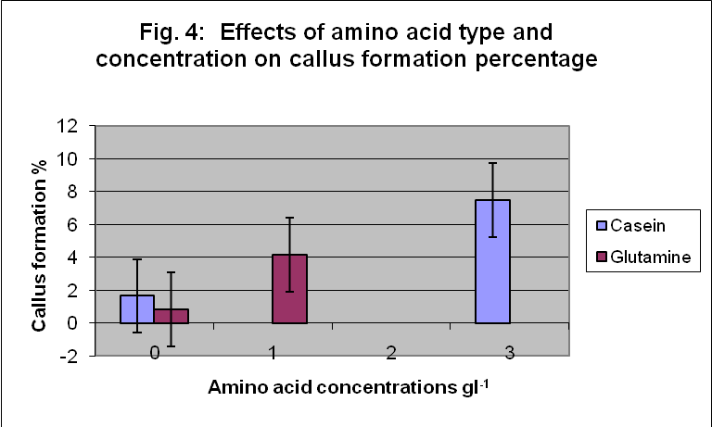

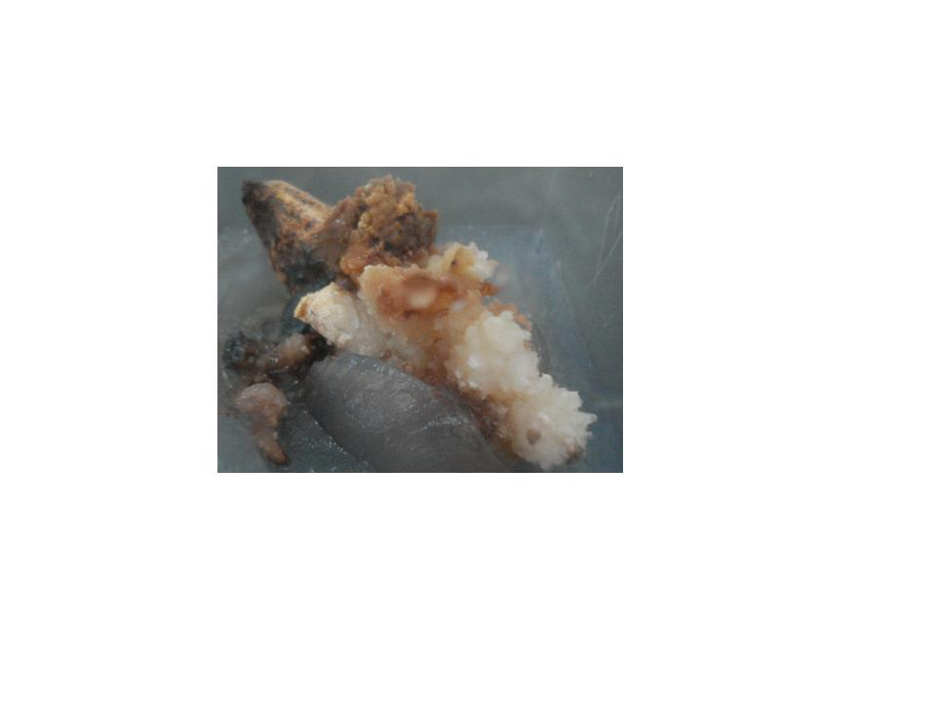
Fig. 8: Embryogenic callus

On the other hand, Matsumoto et aI., (1976) showed that, the requirement of amino acids for plant tissue culture could be estimated by adding different amounts of protein hydrolysate. The enhancement of growth or morphogenesis could be explored further by using a mixture of amino acids. They provide plant cells with an immediately available source of nitrogen which generally can be taken up by the cells more rapidly than inorganic nitrogen (Thorn et aI., 1980).
Finally the best result of somatic embryos per treatment achieved with 3gl⁻¹ casein combined with macro nutrient medium (M2) containing 166mgl⁻¹ CaCl2, 85mgl⁻¹ KH2PO4, 950mgl⁻¹ KNO3, 87.54mgl⁻¹ MgSO4 and 825mgl⁻¹ NH4NO3, which transferred after 8 months to hormone free MS medium without charcoal for two months and then relocated on free MS medium with charcoal for 8 months allowing somatic embryogenesis callus to produced more than five thousand embryos and two thousand date palm plantlet (Fig. 9and 10).
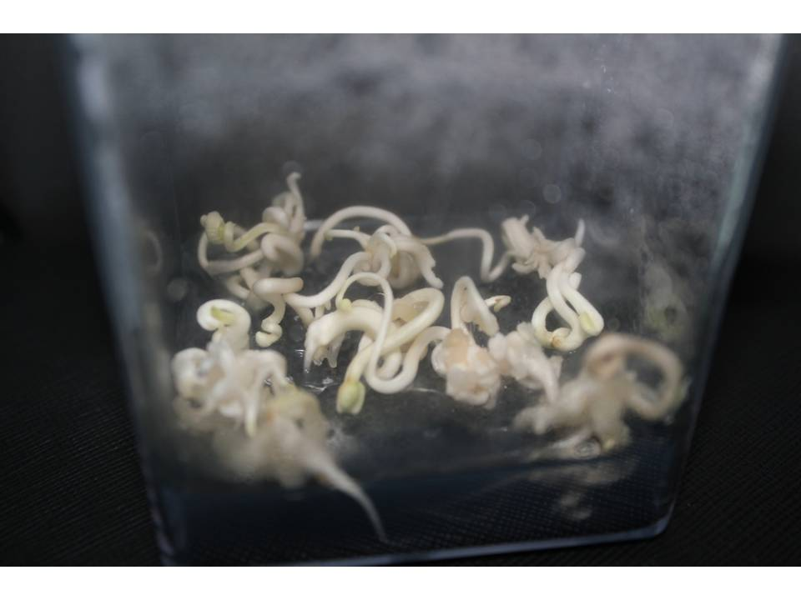
Fig. 9: Somatic embryos

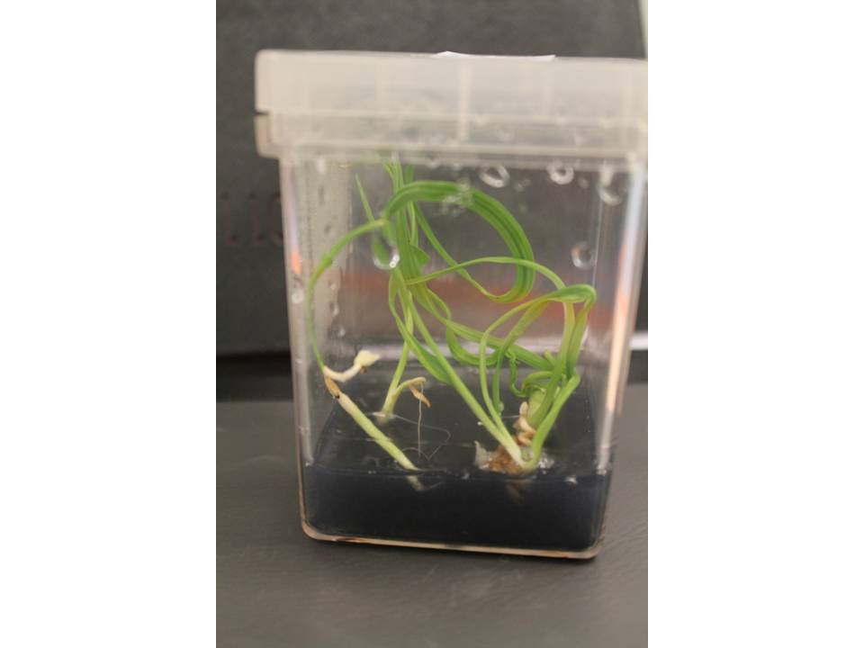
Fig. 10: plantlet derived from somatic embryos

It was concluded, from this investigation, that supplementing date palm culture media with organic nitrogen, specially casein in high concentrations in addition to half macro Ms medium with NH4NO3 improved callus induction and rate of growth and many stimulate embryogenesis in such a manner similar to other plants.

References
- Abdel-Rahim, E.A.; Abdel-Fatah, O.M.; EI-Shemy, H.A.I and Abd EISamei, M.B. Growth of date palm callus as affected by amino acids as organic nitrogen source. First International Conference on Date Palms Al-Ain, UAE, March 1998: 8-10, 19980.
- Abo El-Nil M. The effects of amino acid nitrogen on growth of date palm callus. Second Symposium on date palm, K.F.U., AI-Hassa, Saudi Arabia. 1989: 59-65.
- Cardi J. and Monti M. Optimization of callus culture in pea (Pisum sativum). Annali Della Facolta di Scienze 1993: 24: 11.
- Crocomo O.J., Sharp W.R. and Peter J.C. Platelets morphogenesis and control of callus growth and root induction of Phaseolus vulgaris with the addition of bean seed extract. Pflanzen PhysioI. 1976: 78; 456.
- Filner P. Regulation of nitrate reductase in cultured tobacco cells. Biochem. Biophys. Acta. 1966: 118-299.
- Fukunaga Y. and King J. The effect ofL-Amino acid on the growth and nitrate reductase activity in cultured cells of Datura innoxia. Plant. Sci. Lett. 1982; 24-45.
- George, Edwin F., Michael A. Hall, and Geert-Jan De Klerk. Plant Propagation by Tissue Culture: Volume 1. The Background 2008; PP:81 Originally published by Exegetics, Basingstoke, UK 3rd ed
- Heimer Y.M. and Filner P. Regulation of the nitrate assimilation pathway of cultured tobacco cells. H. Properties of a variant line. Biochem. Biophys. Acta. 1970: 215- 152.
- Indra Arulselvi P, and Krishnaveni S. Effect of hormones, explants and genotypes in in vitro culturing of sorghum. J Biochem Tech 2009: 1(4);96-103.
- Matsumoto T., Okunishi K. and Noguchi M. Defined medium for crown gall cells of tobacco in suspension culture. Agric. BioI. Chem. 1976: 40; 1335.
- Mok M.C. and Mok W.S. Genotype responses to auxins in tissue culture of Phaseolus vulgaris. Physiol. Plant. 1985: 40-261.
- Murashige T. and Skoog F. A revised medium for rapid growth and bioassays with tobacco tissue culture. PhysioI. Plant. 1962:15-473.
- Singh N.N., Kokate C.K. and Tipnis H:P. A note on development of callus cultures of Trigonellsfoenum-graecum for diosgenin biproduction. Indian Drugs, 1981: 19;(1).
- Thorn M., Maretzki A., Jomer E. and Soaki W.S; Nutrient uptake and accumulation by sugar cane cell culture in relation to growth cycle. Plant Cell and Organ Culture. 1980: 1-3.
- Wetherell D.F. and Dougall D.K. Sources of nitrogen supporting growth and embryogensis in cultured wild carrot tissue. Physiol. Plant. 1976: 37-97.
- Zenk M.H., EI-Shagi Hand Schulte U. Anthraquinone production by' cell suspension cultures of Marinda citrifolia. Planta Med. 1975: 34-79.

7/17/2011

