Climatic drought forecasting using artificial neural network in Hamedan region

Ahnadi mahmoud

School member of agricultural and natural resources center of Hamedan province
Ahmadi.m.412@gmail.com

Abstract: Drought is one of the most important climatic phenomena which occur in all climates at all part of the earth. Drought forecasting, therefore, plays an important role in design and management of natural resources and water resources systems, assessing plant water requirement and etc. In recent decades, Artificial Neural Networks (ANNs) have shown great ability in modeling and forecasting nonlinear and non-stationary time series. In this study, multilayer perpesteron artificial neural network was employed for drought forecasting. The rainfall data of 34 years at 14 meteorological stations in Hamedan were used and drought conditions were calculated using SPI. After batret test limited data reconstruction in MS-Excel software, moisture condition was calculated by the mean of Standardized Precipitation Index (SPI). In order to calculate SPI, MS-VB was used and among the calculated data, 20 percent were selected randomly for training and the remaining data were employed for trial. In the next step, the data were transferred to the Matlab, and Neural Network Toolbox of this software was used to find the best algorithm and network arrangement with the least error in estimating the SPI in each station and among the 14 stations, Varayeneh was selected; Furthermore 10-4-1 was determined as the best arrangement and Levenberg-Marquart and Sigmoid function as the best algorithm in Hamedan to forecast drought. In addition, the data of rain fed wheat in the station over the years was compared to the drought and same results were found. Finally 1371-1372 to 1373-1374 cropping season were the wettest years and 1367-1368 to 1370-1371 and 1376-1377 to 1379-1380 were the driest years and the wheat results indicate this master.
[Ahnadi mahmoud. Climatic drought forecasting using artificial neural network in Hamedan region. New York Science Journal 2011;4(8):15-19]. (ISSN: 1554-0200). http://www.sciencepub.net/newyork.

Keywords: Artificial Neural Networks, Drought, Prediction, SPI

1. Introduction
Drought phenomenon potentially is possible under every rain and temperature regime. However features of that are perfectly different from one region to another. This phenomenon gradually or sometimes quickly reveals its effects on natural disasters and it is a normal and independent condition of climate that may cause vast damages on human life and ecosystems. Furthermore drought is a temporary problem and it is different from dry which is limited to some regions with low precipitation amounts and it is a permanent climate condition, on the other hand, lack of global acceptable and accurate definition drought makes it a complicated phenomenon. There are 3 kinds of drought: climatic drought, hydrologic drought and agricultural drought. Climatic drought is abnormal and long-term raining shortage. Hydrologic drought is related to decline of water level in lakes, rivers and etc... , and agricultural drought is a condition in which humidity in soil for plant production is inadequate. Precipitation is one of the most important parameters that applies in definition of drought and its lack or shortage is the threshold for drought occurrence. One of the most comprehensive definitions of drought is Palmer definition which says drought is continuous and abnormal reduction in humidity. For quantitative expression of this phenomenon and survey in different temporal and spatial scales drought indices are used based on climatic parameters. Akhtari and colleagues (2006) used Standard Precipitation Index (SPI) based on precipitation amount in their investigations. Since drought can be affected by other climate factors Artificial Neural Networks (ANNs) are used to increase accuracy and decrease modeling time. For decades, mathematical models and regression methods have been used for drought forecasting. In recent decades artificial neural networks have shown most ability in modeling and forecasting time series in hydrology and water sources management. (MISHRA , DISAY 2006).

2. Material and Methods
Hamedan province is located between 32⁰58′N to 35⁰48′N and 47⁰34′E to 39⁰36′E, at the west of Iran. With 19024.5 km² of area, this province has occupied 1.17% of total area of Iran. The climate of this area based on Domarten index is semi dry cold (Tafazoli et al (2007)). Alvand mountain with 3574m height and being located at 1800m altitude, has provided mountainous climate, cold winters and moderate summers for this region. This province has experienced low precipitation amounts, lower than long term mean precipitation amount, and severe drought in the recent years. This has been sensible even in water wealthy areas and has threatened agriculture and natural resources. In addition to precipitation low amount, improper distribution has intensified the harmful effects of droughts. Seasonal improper precipitation distribution is one of the parameters that endanger agriculture. Climate parameters are uncontrolled and auto-correlated variables that understanding them and their relation will greatly influence the agriculture planning. Temporal and spatial of precipitation behavior could be threshold of drought occurrence (Zare Abianeh et al 2001).
Location of study area is shown in figure 1
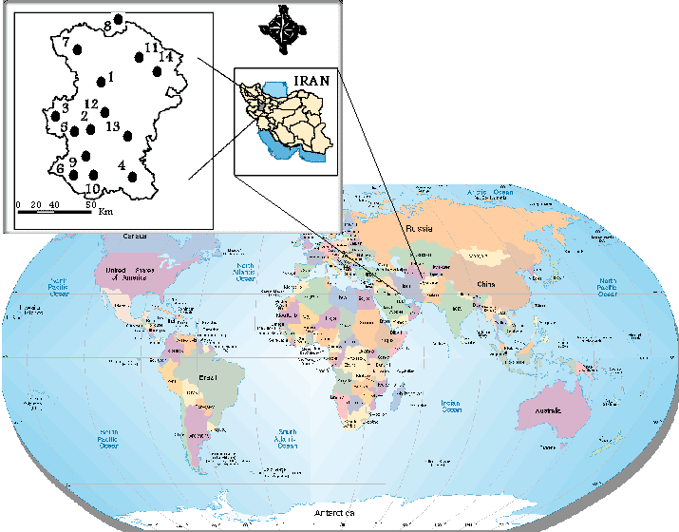
Figure 1. Location of Hamedan Province and meteorological stations

For studying drought in this region, monthly recorded parameters of 34 years have been extracted from all the meteorological stations shown in figure 1 (i.e. 14 stations). Geographical properties of stations are shown in table 1.

Table 1. Geographical properties of the stations
No. | Station | Coordinates |  | Altitude  (m) | Precipitation  (mm)
No. | Station | Longitude | Latitude | Altitude  (m) | Precipitation  (mm)
1 | Ghahavand | "8´0°48 | "37´51°34 | 1623 | 234.14
2 | Ekbatan | "61´36°48 | "35´45°34 | 1920 | 336.2
3 | Aghajan | "15´3°48 | "42´50°34 | 1780 | 303.47
4 | Malayer | "0´49°48 | "0´17°34 | 1925 | 311.43
5 | Khosro | "51´2°48 | "53´37°34 | 1504 | 325.18
6 | Kheir | "8´3°48 | "56´27°34 | 1740 | 354.16
7 | Khomeigan | "12´1°48 | "5´22°35 | 1840 | 283.66
8 | Kahriz | "0´25°48 | "0´45°35 | 1740 | 316.69
9 | Vasaj | "22´13°48 | "23´19°34 | 1545 | 362.73
10 | Varayaneh | "55´24°48 | "45´4°34 | 1760 | 546.15
11 | Amr Abad | "44´14°48 | "28´5°35 | 1590 | 275.67
12 | Hamedan | "12´32°48 | "16´51°34 | 1749 | 316.92
13 | Noujeh | "0´43°48 | "0´12°35 | 1679 | 326.87
14 | Dargazin | "4´0°48 | "35´21°35 | 1870 | 355.91

For evaluation of this study, data of the area under cultivation and performance of rain-fed wheat were collected. Agricultural data from 1984-1985 to 2006-2007 for 24 years overlap precipitation data. Wheat cultivation in the region begins from June to November and harvest would be in next July.

Drought indices:
To study drought several indices has been suggested like Percent Normal Precipitation Index (PNPI), Decades Precipitation Index (DPI), Rainfall Anomaly Index (RAI), Pulmer index, Z- score, Standard Precipitation Index (SPI). Zareh abianeh et al found that SPI has better performance in comparison to other indices.

Standard Precipitation Index
Calculating SPI involves fitting alpha density function on precipitation frequency for a specific station. Cumulative probability of gamma function, G(x), is calculated with equation 1.
$G(x)=\frac{1}{β{}^{α}Γ(α)}\int_{0}^{x}{x{}^{α−1}e{}^{{−x}/β}}\text{dx}$ (1)
In which $α$and $β$ are shape parameters, β is scale parameter, x is precipitation amount and is gamma function. Gamma function is not defined for x=0 so total cumulative probability that may have x=0 values would be determined with equation 2.
H(X)=q+pG(x) (2)
In which q is the probability of zero precipitation and p=1-q. if m is the number of zero precipitation in a n-numbered time series, then q will be calculated with equation 3.
$q=\frac{m}{n}$ (3)
After calculating the total cumulative probability H(x), standard normal random variable with probability equal to the aforementioned probability with average and standard deviation respectively equal to 0 and 1 will be calculated; this value is SPI. With H(x), SPI can be calculated using equations 4 and 5 (Zareh Abianeh et al. (2004)).

$Z=\text{SPI}=−\left[t−\frac{C{}_{0}+C{}_{1}t+C{}_{2}t^{2}}{1+d{}_{1}t+d{}_{2}t^{2}+d{}_{3}t^{3}}\right]$ $t=\sqrt{\text{Ln}\left[\frac{1}{(H(x))^{2}}\right]}$ (4)

$Z=\text{SPI}\text{=+}\left[t−\frac{C{}_{0}+C{}_{1}t+C{}_{2}t^{2}}{1+d{}_{1}t+d{}_{2}t^{2}+d{}_{3}t^{3}}\right]$ $t=\sqrt{\text{Ln}\left(\frac{1}{1−H(x)^{2}}\right)}$ (5)
In which we have
C₀=2.515517, C1=0.802853, C2=0.010328 (6)
d₁=1.432788, d2=0.189269, d3=0.001308 (7)

Table 2 shows SPI values and degree of drought or humidity.

Table 2. Drought intensity classification determined by SPI
SPI | Drought classes
2≤ | Highly wet
1.5-1.99 | Very wet
1-1.49 | Moderate wet
0-0.99 | Weak wet
(-0.99)-0 | Weak drought
(-1.49)-(-1.1) | Moderate drought
(-1.99)-(-1.5) | Severe drought
≤ -2 | Very severe drought

Positive SPI shows that precipitation amount is more than the average precipitation and vice versa. Intensity of a drought period is the sum of negative SPIs for all the months of that period (Mccee et al 1995).

Artificial Neural Networks
Regular structure of an artificial neural network is comprised of input layer, inner (hidden) layer(s) and output layer. Input layer is a transitive layer and a tool for data generation. The last layer or output layer involves the predicted values; therefore it represents the model output. Process takes place in Inner layer which are made of processing nods. Number of layers and nodes in each hidden layer is determined by trial and error procedure and nodes in adjacent layers are completely connected.
Neuron or nod which forms the procedure of neural networks is the smallest data processing unit with independent input and output. Each neuron with receives input data and processing them, produces an output signal.
Perceptron training procedure involves the following steps:
a) Model will be provided with input data.
b) Weight coefficients will be chosen randomly.
c) Output value will be calculated according to sum of weighted inputs and the threshold value.
d) For error reduction, weighted coefficients will be changed.
e) Going back to step b to reduce error to the negligible value.

This network is one the most favorable neural networks for nonlinear mapping in engineering. It's special features are:
1) It has strength to recognize the characteristics.
2) It can categorize data.
3) It is a powerful tool for generating nonlinear mapping between input and output spaces in large scales.
It is called world estimator because of its unique strength. In fact this network reveals the inherited and natural relations in data and saves them in the connector weights.

Model accuracy evaluation
Usually two parameters are used in order to evaluating performance of network and its strength in exact predication.

1) Root Mean Square Error (RMSE)
$\text{RMSC}=\sqrt{\text{Average}{\left(X_{a}−X_{c}\right)}^{2}}$ (8)
In which $X_{a}$ and $X_{c}$ are the observed and calculated values respectively. RMSE shows the difference between observed and calculated values. The less amount of RMSE shows better prediction.
2) Correlation coefficient (r), which shows the performance of network.

$r=\sqrt{1−\frac{\sum{{\left(y_{i}−y_{i}\right)}^{2}}}{\sum{y_{i}^{2}−\frac{\sum{y_{i}^{2}}}{n}}}}$ (9)
In which $y_{i}$ is the calculated value and $y_{i}$ is the average of calculated values.
The best prediction is when r and RMSE move to 1 and 0 respectively.

3. Results
To reach the optimum structure of ANN, networks with different layouts and different number of neurons in the hidden layer(s) were evaluated. Among the investigated layouts, 168 layouts (including 3 functions, 4 algorithms and 14 stations) had lower RMSE and greater r which among them the best layout for each station is shown in table 3 therefore the proposed structure will be as followed:

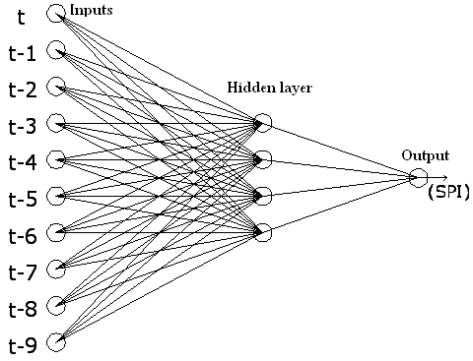
Figure 2. ANN Proposed structure

In this layout, input neurons are precipitation data and t-n is related to the precipitation of n month before the current month; also SPI is the output of the network. The table and graph of the result are provided in following.

Table 3. Results of the optimum structure of ANN for drought prediction in the investigated stations

St | f | T | str | Training step
 |  |  |  | RMSE | r
1 | sigmoid | LM | 10-4-1 | 0.0109 | 0.781
2 | sigmoid | LM | 10-8-1 | 0.0046 | 0.65
3 | Tangent | LM | 10-6-1 | 0.056 | 0.65
4 | Tangent | LM | 10-4-1 | 0.0411 | 0.787
5 | Tangent | LM | 10-9-1 | 0.0494 | 0.725
6 | Tangent | M | 10-4-1 | 0.034 | 0.822
7 | Tangent | M | 10-8-1 | 0.0366 | 0.808
8 | Tangent | LM | 10-7-1 | 0.0596 | 0.793
9 | sigmoid | LM | 10-8-1 | 0.0188 | 0.6
10 | Tangent | LM | 10-10-1 | 0.062 | 0.617
11 | Tangent | LM | 10-6-1 | 0.0393 | 0.784
12 | Tangent | LM | 10-9-1 | 0.0435 | 0.723
13 | sigmoid | LM | 10-4-1 | 0.0096 | 0.841
14 | sigmoid | LM | 10-8-1 | 0.0137 | 0.67

St | f | T | str | Testing step
 |  |  |  | RMSE | r
1 | sigmoid | LM | 10-4-1 | 0.007 | 0.848
2 | sigmoid | LM | 10-8-1 | 0.004 | 0.94
3 | Tangent | LM | 10-6-1 | 0.013 | 0.91
4 | Tangent | LM | 10-4-1 | 0.0328 | 0.847
5 | Tangent | LM | 10-9-1 | 0.007 | 0.95
6 | Tangent | M | 10-4-1 | 0.0177 | 0.893
7 | Tangent | M | 10-8-1 | 0.0328 | 0.863
8 | Tangent | LM | 10-7-1 | 0.0138 | 0.944
9 | sigmoid | LM | 10-8-1 | 0.002 | 0.946
10 | Tangent | LM | 10-10-1 | 0.0135 | 0.725
11 | Tangent | LM | 10-6-1 | 0.02 | 0.882
12 | Tangent | LM | 10-9-1 | 0.0095 | 0.93
13 | sigmoid | LM | 10-4-1 | 0.0043 | 0.905
14 | sigmoid | LM | 10-8-1 | 0.003 | 0.938
St=station, F= function, T=Training Rule, Str= structure, LM= Levenberg-markoat, M=Momentum

To evaluate the performance of the tested models and to determine the accuracy of the designed model, in addition to RMSE and r, scatter plot has been used for each station.
As it is clear from figure 3, there is a high correlation between observed and estimated SPI in training step, which the lowest R² value (0.7083) belongs to Nojeh station and the highest value (0.7668) belongs to Varayene station.

Figure 3. comparison of estimated and observed SPI
After selecting the optimum network layout in training step, this layout was investigated in trial step (figure 4).

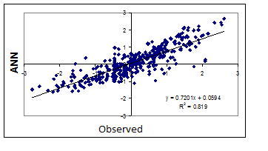
Figure 4. comparison of estimated and observed SPI in varayene station

High correlation (R²=0.819) between observed and estimated values is shown in figure 4. Furthermore the lowest RMSE value (RMSE=0.0043) for this station shows good condition of predicting drought in this station.
To evaluate the selected layout, performance of rain-fed wheat in Varayeneh was used (figure 5), so the estimated SPI in testing step and the performance of rain-fed wheat are is shown here.

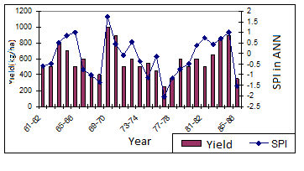
Figure 5- drought index and the performance of rain-fed wheat in varayeneh station

In figure 5 the relation between the estimated SPI and the performance of rain-fed wheat is clearly shown which proves the accuracy of this method.

4. Discussions
In this study, Artificial Neural Network (ANN) was designed and used for modeling dynamic non-linear systems in which their input and output data are in time series and the proposed method was used to predict drought.
Generally, in this issue like many other issues in climatology or hydrology, intelligent ANNs were more successful than other standard or empirical methods.
Using Varayeneh station data is more reliable because of better results among the investigated stations

Acknowledgements:
Authors are grateful to the agricultural and natural resources center of Hamedan province to carry out this work.

Corresponding Author:
Mahmoud Ahmadi
School member of agricultural and natural resources center of Hamedan province
Agricultural reaserch center, Hamedan, Iran
E-mail Ahmadi.m.412@gmail.com

References
1. Akhtari, R. Mahdian, H. Morid, S. (2006). Drought Indexes Local analysis in TEHRAN. Journal of Iran water resource research.No 3. 27-37.
2. Alizadeh, A. (1997). Soil, water, plant relationship. 2th edited. . Iran. Mashhad. P 253.
3. Alizadeh, A. (2004). Applied hydrologic principles. 17th edited. Iran. Mashhad. P 257.
4. Chmani, A. Makhdom, F. Jafari, M. Khorasani, M. CHERAGHI, n, m. (2005). Expansion effects evolution on economic environment in hamedan using destroy model. Ecologic journal. No 37. 35-44.
5. Ghafari, M. (2008). Modeling of evaporation from well tanks using artificial neural network. Zabol university. P 121.
6. Mackee, B., Nolan, T., Dooesken, J. And Kleist, J., (1995). Drought monitoring with multiple timescales. 9 .Conference on Applied Climatology. 15-20 January, Boston, Massachusetts:223-236.
7. Mishra, A.K. and Desai, V.R. (2006). Drought forecasting using feed-forward recursive neural network. ecological modelling 198: 127–138.
8. Tafazzoli, F. Sabzi parvar,A A. Zare abyaneh, H. (2007). Evaluation of Evapotranpiration current models semi arid climate in order to better use of radiation models. 9th congress irrigation and evaporation reduction. Iran. Kerman.
9. Vafakhah, M. Rajabi, M. (2005). Climatic drought indexes proficiency for droughts evolution in BAKHTEGAN, TASHK and MAHARLO basins. Journal of desert 10(2). 370-382.
10. Zaker , M, M. (2005). Usage Artificial neural network theory in water engineering. Water research institute. P 180.
11. Zare abyaneh, H. Mahbobi, A, A. Ehsani, M.(2000). Plant water requirement calculation and comparison with evaporation in hamedan region. First drought conference. Iran. Kerman.p 5.
12. Zare abyaneh, H. Mahbobi, A, A. Neishabori, M. (2005). Drought status assessment in hamedan region based on statistical Indexes. Journal of research and manufacture. No 64. 2-7.
13. Zare abyaneh, H. yazdani, V. khalili, A. (2009). Study and comparison of four climatic drought indexes based on rain red wheat yield in hamedan. Journal of natural geographic researches. No 64. 35-49.

7/7/2011

