Concomitant Production of Sporeless Fruiting Bodies and Laccase Release During Submerged Fermentation Practice of Pleurotus Fossulatus

Nirmalendu Das¹, Protik Chowdhury², Dipan Adhikari², Saikat Naskar¹
^{1.} PG Department of Botany, Barasat Government College, Barasat, North 24 Parganas, West Bengal 700124, India
Tel.: +919433451166. E-mail: nirmalendus@yahoo.co.uk
^{2.} Department of Botany, Acharya Brajendra Nath Seal College, Cooch Behar, West Bengal 736101, India

Abstract: Pleurotus fossulatus is a member of oyster mushroom though not so widely cultivated, proved itself to be an excellent storehouse of active biomolecules. The mushroom produces laccase in extracellular medium both in solid state and submerged fermentations. The laccase production was found to be optimum on the 26th day in potato-dextrose (PD) or potato-dextrose-yeast extract (PDY) medium. The number of laccase isozyme was found to be four in both PD/PDY media. The liquid media also facilitated the initiation and development of gill-less sporophore (fruiting body) in P.fossultatus in PD and PDY medium. This is the first report about the production of fruiting bodies in liquid submerged culture in relation to production of extracellular laccase in this very species.
[Nirmalendu Das, Protik Chowdhury, Dipan Adhikari, Saikat Naskar. Concomitant Production of Sporeless Fruiting Bodies and Laccase Release During Submerged Fermentation Practice of Pleurotus Fossulatus. New York Science Journal 2011;4(8):27-32]. (ISSN: 1554-0200). http://www.sciencepub.net/newyork.

Key words: Pleurotus fossulatus, laccase, submerged fermentation. fruiting body, sporeless

1. Introduction:
Mushroom production has been regarded as the second most commercially practicable microbial technology next to yeast (Pathak et al. 2009). Pleurotus spp.(oyster mushroom) are amongst the most widely exploited mushrooms positioned immediately after Agaricus (Sanchez, 2010). Pleurotus fossulatuus (Cooke) Sace., is a member of this group which appears in plenty between April and May on dead, decaying basal parts and roots of Ferula sp. This mushroom can be collected from Drass (Ladak), Zozila (Ladak) and Gurez(Kashmir) terrains of India and also some places of Pakistan and Afganistan (Kaul, 1999).
Owing to its high spore content it has become an allergen to the growers and in reality this particular mushroom has taken a backseat in terms of effective commercial production in comparison to other medicinal mushrooms (Olsen 1978; Das et al. 2010). Both the solid state fermentation (SSF) and submerged fermentation (SMF) have different opportunities in terms of a total turnover of biomolecules. The SSF not only provides nutritious fruiting body with pleasant flavour (Sanchez, 2010), but produces a large number of lignocelulosic enzymes which have immense roles to play in producer organisms and finds applications for different industrial and biotechnological purposes (Gomez et al. 2005; Couto and Herrerra, 2006; Mukherjee and Das, 2009). However, as fruiting body formation is a time consuming process, scientists are more interested in SMF which has been exploited for production of enzymes, exopolysaccharides and other bioactive molecules of innumerable nutraceutical, pharmaceutical and cosmeceutical properties (Lee et al. 2004; Mshandete and Mgonja, 2009). Owing to shorter period of time, reduced space and minimum chances of contamination, SMF emerges to be advantageous than SSF (Tang et al. 2007). However, mycelial biomass, which is produced during SMF is full of different neutraceuticals, but people are less interested to directly consume it. Again SMF generally does not facilitate the fruiting body formation. Lignin biodegradation is a key step of carbon recycling happening in almost all terrestrial ecosystems. In this process, all the white-rot basidiomycetous members (including Pleurotus fossulatus) play an important role in the degradation of these recalcitrant woody polymers for the sustenance of microbial populations, allowing the proper utilization of the degraded cellulose (Khanna et al. 1992). One of the enzymes involved in this process has been reported to be laccase, an oxidase, that catalyses the one-electron oxidation of polyphenols, methoxy-substituted phenols, diamines and a wide range of other organic compounds with concomitant reduction of oxygen to water (Youn et al. 1995).
In general, fungal laccases (benzenediol:oxygen oxidoreductase, EC 1.10.3.2) have been the causal factors, imparting several important physiological functions of relevance to the cultivation practices, are involved in lignin degradation (Thurston, 1994), detoxification of phenolic compounds inhibitory to fungal growth, lignocellulolytic enzyme activities (Eggert et al. 1997), rapid cell growth and sporophore development (De Vries et al. 1986). Laccase is a member of the blue copper-containing oxidases, well-reported in several industrial and environmental applications including paper pulping/bleaching, bioremediation and degradation and detoxification of textile dyes (Couto and Herrera, 2006) etc. Bose and Majumdar (2011) recently reported antiproliferative activity of laccase against liver cancer cell line Hep G2 and human breast cancer cell line MCF 7.
Although many investigators have attempted to obtain optimal submerged cultural conditions for proper fruiting body initiation in medicinal mushrooms, reports are lacking on P. fossulatus in this direction. This report is the very first one of its kind depicting the initiation and development of mature gill-less fruiting body in P. fossulatus on the surface of liquid submerged fermentation with simultaneous production of laccase. The authors have also tried to explain the relation between release of extracellular laccase and sporeless fruiting body formation.

2. Materials and Methods:
(1) Mushroom strain
Pleurotus fossulatus Cooke (MTCC 1800) was collected from Microbial Type Culture Collections, Institute of Microbial Technology, Chandigarh, India and was maintained on potato-dextrose agar (pH 7.0) containing 20% potato extract with 25% dextrose and 2% agar as reported earlier (Das and Mukherjee , 2007).

(2) Substrate preparation for SSF
Dried rice straw was collected from a local farm at Cooch behar, West Bengal, India and it was approximately of two months in storage after harvesting. The rice straw was chopped into small pieces (5-6 cm), weighed and soaked in water for overnight. Extra water content in the substrate was drained off and the substrates were air dried for 15 min. No heat treatment was done for the substrate. About 1000 g wet substrate (~85% moisture content) was mixed with 10% spawn (wet wt./wet wt.). The spawned substrate was then put into 30cm x 42 cm polythene bags. The bags were tightly closed and pin- hole perforations were made on the surfaces to supply air. The bags were kept in a spawn running room at 22±1 ºC with a 12h photoperiod (1500-2000 lux) and 85-90% relative humidity. Adequate ventilation was provided to prevent increase of CO₂ concentration (Das and Mukherjee , 2007). The portion of solid beds after growth of P. fossulatus (20 days after spawning) were mixed thoroughly with 0.01 M acetate buffer (pH 5.0) and filtered under suction. This process was repeated twice. Finally, the volume of the extract was adjusted to 30ml/5g rice straw. The extract was then centrifuged at 10000 g for 15 min and the clear supernatant was assayed for laccase activity.

(3) Inoculum source and Liquid submerged fermentation (SMF)
An inoculum was taken from the periphery of colonies growing on PDA for 7days. The production of laccase was studied in liquid PDY medium in stationary condition at 22±1 ºC. The fungus was cultured for 32 days in stationary condition and aliquots of culture filtrate was collected in each day from 14th day of growth onwards. The volume of the culture medium was adjusted to its original volume with fresh medium after each collection (Bose et al. 2007). Extracellular culture filtrates were assayed for enzyme/protein activity after mycelium was removed by filtration.

(4) Laccase Activity assay
Laccase activity was performed spectrophotometrically as described by Das et al. (1997) with o-dianisidine as the substrate. Enzyme activity was expressed in International Unit.

(5) Preparation of fruiting body extract and protein estimation
Fresh fruiting bodies (30 g) after 15 days of primordia initiation were disrupted by being crushed with acid washed sand in mortar and pestle. The tissue was then extracted with 100 ml of 20 mM imidazole buffer containing 1mM EDTA, 2 mM PMSF (pH-7.8) and 2mM 2-mercaptoethanol. Unbroken cells and cell debris were removed by centrifugation at 32,000g for 30 min and the supernatant was used for analysis of protein. Protein concentration was determined according to the method of Bradford (1976) using bovine serum albumin as standard.

(6) Activity staining
Activity staining of enzyme after native polyacrylamide gel electrophoresis (PAGE) of the concentrated culture filtrate was done with solutions of o-dianisidine, in acetate buffer, pH 5.0 as reported earlier (Das et al. 1997; Bose et al. 2007) using laccase enzyme.

3. Results and Discussion:
The oyster mushroom Pleurotus fossulatus has been regarded as an edible mushroom for many years (Zadrazil, 1978; Chang, 1999). But the spores produced by this group of mushroom were found to be one of the prime hindering factors for their widespread utilization as food source, bringing forth serious allergic symptoms not only to growers but also for the inhabitants dwelling around the vicinity of the farm houses (Schulz, 1974; Olsen, 1978). Based on these reports to spore allergy, efforts are already on to change or bring about certain alterations in the culture practices (both in solid and liquid cultural conditions) for the effective production of sporeless fruiting body in this oyster mushroom. Das et al.(2010) had recently reported the production of P. fossulatus on rice straw medium where they could find that up to 18 days of culture (after primordial initiation), there was no spore formation as gills were not developing. If harvested on that very day, no symptomatic allergy was developed within the growers. In continuation to that report this study was initiated immediately to find out the probable growth pattern dynamics of the sporophores in liquid culture. It was found that in comparison to solid rice straw medium the liquid culture medium was equally supportive in forming of strong fruiting bodies (Fig. 1 and Fig.2) in contrast to earlier reports of incipient sporophores in liquid cultures by other authors (Staben, 1994) in addition to release of noticeable laccase isozymes in the medium.

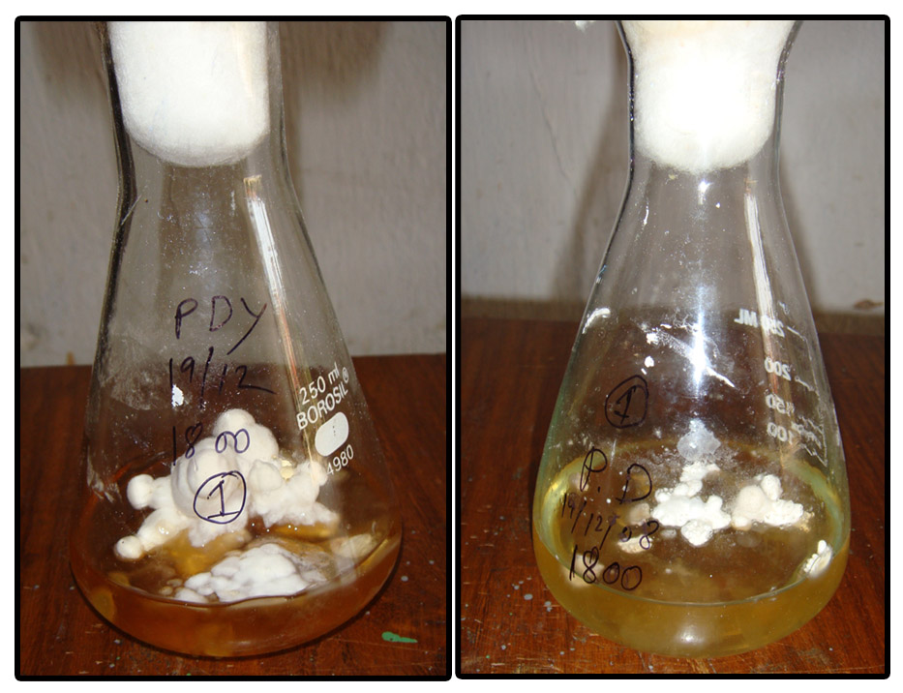
A B

Figure 1. Production of P. fossulatus fruiting bodies in different liquid media A) PDY B) PD

In P. fossulatus, the authors have tried to establish that the submerged fermentations (having PD and PDY medium), maintained in stationary phase, could effectively trigger sporophore developments (Fig.1 and Fig.2). The initiation of primordia had started on the 7th day of growth (in both the media) and even after 32nd day, in liquid culture, there was hardly any development of gill-like structures. Das et al. (2010) had reported that in rice straw (SSF), P. fossulatus had started the initiation of primordia during 21st day of growth. From 50 ml of liquid PD media about 25gms of fresh sporophores were collected after 26th day, where the laccase activity was found to be optimum. As the gill-like structures did not occur in the sporophores, (at least up to 32 days of culture i.e. in 25-day-old sporophore) there was the occurrence of a spore-less stage, showing no signs of allergy. This liquid culture media also formed a sterile but controlled environment to monitor sporophore development inside the laboratory conditions with low-cost PD medium. The protein contents of the fruiting bodies derived from PD and PDY media were found to be 7.0 and 7.5 mg/gm of fresh fruiting body. The data reconfirmed our previous results on SSF-derived fruiting body (2010).

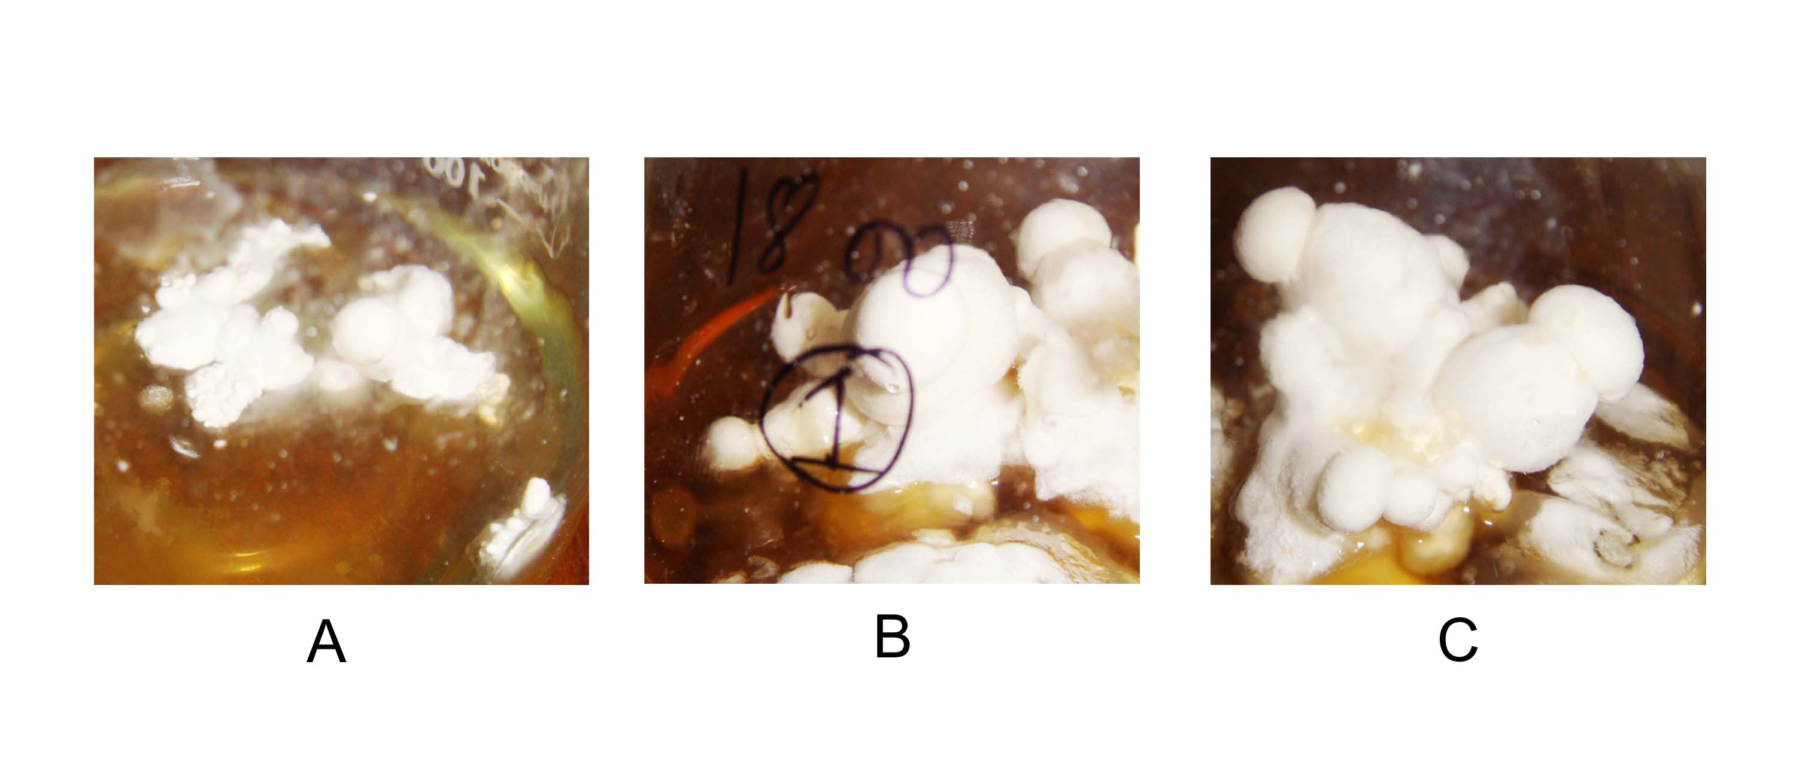
Figure 2. Different stages of fruiting bodies of P. fossulatus after initiation of primordia in liquid PD medium A) 3rd days B) 7th days C) 10th days

Though liquid culture medium has already been found to be an excellent reservoir of active biomolecules (Lee et al. 2004), but reports on the production of mature fruiting body through SMF are still scanty. Kurtzman (1978) had tried to produce fruiting bodies of Pleurotus sapidus on the surface of submerged cultures. Frank and Coffan (2010) had observed the formation of true gills of the basidiomycetous mushroom Psathyrella spp., formed under submerged aquatic conditions. Lomberh et al. (2002) could report that in Agrocybe aegerita fruiting body formation was observed after two weeks in stationary submerged conditions. But the other commercially cultivated mushrooms like Pleurotus flabellatus, Pleurotus HK-37, Pleurotus sp, Ganoderma lucidium, and Laetiporus sulphureus could not produce gilled or gill-less mature sporophore in SMF though enormous mycelial biomass was easily available during cultural practices (Mshandete and Mgonja, 2009)

Figure 3. Day wise laccase production in PD and PDY media in P. fossulatus

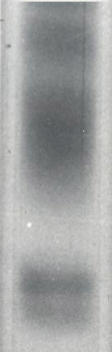

Figure 4. Zymogram of P. fossulatus culture filtrate in PD medium ( stained with o- dianisidine)

There has been good volume of reports about the total protein and laccase turnover by the mycelial culture of Pleurotus (Palmieri et al. 1993; Youn et al. 1995; Das et al. 1997;Téllez-Téllez, 2005; Mukherjee and Das, 2009). In P.florida, there had been a positive relationship between the mycelial growth and one active laccase (Das et al. 1997). In our study, P. fossulatus produced 45.2 U/ml laccase in sold rice straw media. However, 148.42 U/ml laccase was produced in PD media and 137.82 U/ml in PDY media in 26th day (Fig. 3) respectively. The number of laccase isozyme was four in PD medium (Fig. 4). Though yeast extract had demonstrated influencing effect on laccase productions in various Pleurotus spp., (Das et al. 1997) surprisingly, here it had no positive role to play in laccase induction (Fig. 3) even the number of laccase isozyme was found to be four in PDY media also (data not shown).
In the present investigation, authors have tried to advocate that this extracellular laccase present in the liquid culture medium might be a contributing factor for the gill-less fruiting body development in P. fossulatus. Chakraborty et al. (2000) have reported the occurrence and accumulation of a natural substrate of laccase during the gill tissue formation in Pleurotus florida after sporulation in solid rice straw medium. They have found that the predominant presence of this inhibitory compound (regarded as an endogenous laccase substrate) in the mature sporophore (mainly in the gill tissue) was chiefly responsible for spore formation in P. florida. The concentration of this substrate (measured in terms of laccase activity) was very low in immature and non-sporulating sporophores, but with initiation of sporulation there was at least an 8-fold increase in concentration (Chakraborty et al. 2000)). In present study, the liquid culture medium probably provided an ideal environment for this endogenously produced laccase substrate to diffuse out of the developing sporophores in the surroundings. Weaver et al. (1970) had identified a low-moleucular weight, water- soluble, phenolic compound and a low-molecular weight polyphenol oxidase being jointly responsible for sporulation in A. bisporus. Chakraborty et al. (2000) had reported that after coming in contact with oxygen, this endogenous laccase inhibitor got oxidized and thereby failed to impart agonistic action on laccase inhibition. Similar reactions might have been dominant/preponderant in present cultural conditions as well. In this liquid medium, this inhibitor after production, could easily leach out and possibly after oxidation was unable to couple with the active intracellular laccase isoforms, produced de novo, resulting gill- less fruiting bodies.

Corresponding Author:
Dr. Nirmalendu Das
PG Department of Botany
Barasat Government College
Barasat, North 24 Parganas
West Bengal 700124, India
E-mail: nirmalendus@yahoo.co.uk

4. References:
- Bose AK and Majumdar S. Purification, peptide sequencing and study of antiproliferative activity of laccase against liver cancer cell line Hep G2 and human breast cancer cell line MCF 7. Immunity. 2011; 11(4) ( In Press)
- Bose S, Mazumder S, Mukherjee M. Laccase production by the white rot fungus Termitomyces clypeatus. J. Basic Microbiol 2007; 47: 127-131.
- Bradford MM. A rapid and sensitive method for the quantiation of microgram quantities of protein utilizing the principle of protein dye binding. Anal. Biochem 1976 ; 72: 248-254.
- Chakraborty TK, Das N, Sengupta S, Mukherjee M. Accumulation of a natural substrate of laccase in gills of Pleurotus florida during sporulation. Current Microbiol 2000; 41: 167-171.
- Chang ST. World production of cultivated and medicinal mushrooms in 1997 with emphasis on Lentinus edodes (Berk) Sing, China. Int. J. of Med. Mushroom 1999; 1: 291-300.
- Couto SR, Herrera, JLT. Industrial and biotechnological applications of laccases: A review. Biotechnol. Adv 2006; 24: 500–513.
- Das N, Chowdhury P, Pasman B. Cultivation practice of Pleurotus fossulatus on rice straw. J. Life Sci 2010; 4:20-24.
- Das N, Mukherjee M. Cultivation of Pleurotus ostreatus on weed plants. Bioresource Technol 2007; 98: 2723- 2726.
- Das N, Sengupta S, Mukherjee M. Importance of laccase in vegetative growth of Pleurotus florida. Appl. Environ. Microbiol 1997; 63: 4120-4122.
- De Vries OMH, Kooistra WHCF, Wessels JGH. Formation of a extracellular laccase by a Schizophyllum commune dikaryon. J. Gen. Microbiol 1986;132: 2817- 2826.
- Eggert C, Temp U, Eriksson K-EL. Laccase is essential for lignin degradation by the white rot fungus Pycnoporus cinnabarinus. FEBS Lett 1997; 407: 89- 92.
- Frank JL, Coffan RA. Aquatic gilled mushrooms: Psathyrella fruiting in the rogue river in southern oregon. Mycologia 2010; 102:93-107.
- Gomez J, Pajos M, Couto SR, Sanroman MA. Chestnut shell & barley bran as potential substrates for laccase production by Coriolopsis rigida under solidstate condition. J. Food Engg 2005; 68: 315-319.
- Kaul TN. Introduction to Mushroom Science (Systematics). Oxford & IBH Publishing Co. Pvt. Ltd., New Delhi, India. 1999.
- Khanna PK, Bhandari R, Soni GL, Garcha HS. Evaluation of Pleurotus spp. for growth, nutritive value and antifungal activity. Ind. J. Microbiol 1992; 32 :197-200.
- Kurtzman Jr. RH. Production of mushroom fruiting bodies on the surface of submerged cultures. Mycologia 1978; 70:179-184.
- Lomberh ML, Solomko EF, Buchalo AS, Kirchhoff B. Studies of medicinal mushrooms in submerged cultures. In: Sanchez et al. (eds). Mushroom biology and mushroom products. UAEM. 2002.
- Mshandete AM, Mgonja JR. Submerged liquid fermentation of some Tanzanian basidiomycetes for the production of mycelial biomass, exoploysaccharides and mycelium protein using wastes peel media. ARPN J. Agril. Biol. Sci 2009; 4: 1-13.
- Mukherjee M, Das N. Fungal laccase- a biotechnologically potential enzyme. In: Mishra CSK. (eds). Biotechnology Applications. I.K. International, New Delhi, India, 2009 p.70- 108.
- Olsen AJ. Pleurotus spores as allergens. Mushroom J 1978; 172:115-117.
- Palmieri G, Giardina P, Marzullo L, Desiderio B, Nitti B, Cannio R, Sannia G. Stability and activity of phenoloxidase from lignolytic fungus Pleurotus ostreatus . Appl. Microbiol.Biotechnol 1993; 39: 632-636.
- Pathak R, Joshi N, Dwivedi RR. Eco-friendly production of Agaricus bisporus (lange) imbach (white button mushroom). Nat. Sci. 2009; 6: 57-60.
- Sanchez C. Cultivation of Pleurotus ostreatus and other edible mushrooms. Appl. Microbiol. Biotechnol 2010;85: 1321-1337.
- Schulz HK, Hausen BM, Noster U. Allergy to spores of Pleurotus florida. Lancet 1974; 5 :29.
- Staben C. Sexual reproduction in higher fungi. In: Gow, N.A.R.; Gadd G.M. (eds). The Growing Fungus. Chapmann & Hall, London. 1994 p. 383-402.
- Tang Y-J, Zhu L-W, Li HM, Li DS. Submerged culture of mushrooms in bioreactors- challenges, current state-of-the art and future. Food Technol. Biotechnol 2007; 45: 221- 229.
- Téllez-Téllez M, Sánchez C, Loera O, Díaz-Godínez G. Differential patterns of constitutive intracellular laccases of the vegetative phase of Pleurotus species. Biotechnol. Lett 2005; 27: 1391-1394.
- Thurston C F. The structure and function of fungal laccases. Microbiology 1994;140:19- 26.
- Weaver RF, Rajagopalon KV, Handler P, Jeffs P, Byrne WL, Rosenthal D. Isolation of v-L glutaminyl 3,4-benzquinone: a natural sulphohydryl reagent from sporulating gill tissue of the mushroom Agaricus bisporus.Proc. Natl. Acad. Sci USA 1970;67:1050-1056.
- Youn HD, Kim KJ, Maeng JS, Han YH, Jeong IB, Jeong G, Kang SO, Hah,YC. Single electron transfer by an extracellular laccase from the white rot fungus Pleurotus ostreatus. Microbiology 1995; 141: 393-398.
- Zadrazil, F. Cultivation of Pleurotus. In: Chang S. T, Hayes. W. A. (eds.). The Biology and Cultivation of Edible Mushrooms, Academic Press, New York USA , 1978 p. 521-558.

Date- 06/26/2011

