Determination of Bioactive Components of Plectranthus amboinicus Lour by GC–MS Analysis.

M. Uma¹, S.Jothinayaki², S.Kumaravel³, P.Kalaiselvi ⁴

^{1 & 4} Department of Medical Biochemistry, University of Madras, Taramani Campus, Chennai –600 113,
Tamilnadu, India.
² Prince Shri Venkateshwara Arts and Science College, Gowrivakkam,Chennai - 600 073, Tamil Nadu , India.
³ Scientist, Department of Food Quality and Testing, IICPT, Thanjavur - 613 005, Tamil Nadu, India.
E.mail : pkalaiselvi@yahoo.com

Abstract : Plectranthus amboinicus (L.) (Family - Lamiaceae) is traditionally used for asthma, chronic coughs, bronchitis, and a variety of diseases affected by virus, bacteria and other microbes. The present investigation was carried out to determine the chemical constituents from P.amboinicus leaves by GC-MS technique. This analysis revealed the presence of 3-methyl-4- isopropyl phenol (31.70%), Squalene (10.07%), Caryophyllene (2.36%) and phytol (8.44%).The use of this plant to treat many ailments in folk and herbal medicines is justified. [M.Uma., S.Jothinayaki., S.Kumaravel., P.Kalaiselvi, Determination of Bioactive Components of Plectranthus amboinicus Lour by GC-MS Analysis. New York Science Journal 2011; 4(8): 66-69]. (ISSN: 1554-0200). http://www.sciencepub.net/newyork.

Key words : Plectranthus amboinicus L; GC–MS analysis; Bioactivity of phytoconstituents.

1. Introduction
Plants serve as a basis of traditional medicinal systems for thousands of years in India, Nigeria, China, Indonesia, etc. (Hammer, 1999), collectively plants produce a remarkable diverse array of over 5,00,000 low and high molecular mass natural products which are known as secondary metabolites (Fatope, 2001).Distinguished example of these compounds include flavonoids, phenols, saponins and cyanogenic glycosides (Shahidi, 2000 and shahidi et al., 2008).
Plectranthus amboinicus (Lour) belongs to Family lamiaceae and is known as country borage in English (Kirtikar and Basu 1999). It is primarily indicated for cardio vascular diseases including hypertension, congestive heart failure and angina. It is used in the treatment of dyspepsia, impaired digestion, indigestion, asthma, chronic coughs, bronchitis, rheumatism (Prasad et al., 2002). Many pharmacological properties have been reported including urolithiasis (Baskar and Varalakhsmi 1992), antiepileptic (Buznego and Perez–saad 1999), antitumour and anti mutagens (Annapurani and priya 1999),neuro pharmacological (Perez saad et al., 2003), radio protective effect (Rao et al., 2006), antibacterial and antifungal properties (Prudent et al., 1995). The aim of the present study is to determine the organic compounds present in the leaves of Plectranthus amboinicus by GC–MS technique, which may provide an insight in its use in folklore medicine.

2. Materials and Methods
Plant material and extraction procedure
Plectranthus amboinicus was collected from Sembakkam, Gowrivakkam, Tambaram, Chennai, Tamil nadu. Authentication of plant material was done by Prof. P. Jayaraman of Plant Anatomy Research Centre, Tambaram, Chennai. Following identification voucher specimen of the plant was deposited in the herbarium (Parc / 2009 / 288). The powdered leaf material of P.amboinicus (20g) was soaked in 50ml of 80% alcohol for 12 hours and then filtered through whatman filter paper No.41 along with 2g sodium sulphate to remove the sediments and traces of water in the filtrate. Before filtering the filter paper along with sodium sulphate was wetted with absolute alcohol , the filtrate was then concentrated by bubbling nitrogen gas into the solution and concentrated to 1ml.

Gas Chromatography – mass spectrum analysis (GC-MS)
GC-MS analysis was carried out on a GC clarus 500 perkin elmer system and gas chromatograph interfaced to a mass spectrometer (GC-MS) instrument employing the following conditions. Column Elite-1 fused silica capillary column (30mm x 0.25mm ID x 1 μ Mdf, composed of 100% Dimethyl poly siloxane), operating in electron impact mode at 70eV; Helium (99.999%) was used as carrier gas at a constant flow of 1ml / min and an injection volume of 2 ml was employed (split ratio of 10:1); Injector temperature 250ºC; Ion-source temperature 280ºC. the oven temperature was programmed from 110ºC (isothermal for 2 min) with an increase of 10ºC / min, to 200ºC then 5ºC / min, to 280ºC, ending with a 9 min ISO thermal at 280ºC.

Mass spectra was taken at 70eV; a scan interval of 0.5 seconds and fragments from 45 to 450 Da. Total GC running time was 36 min. The relative percentage of each component was calculated by comparing its average peak area to the total area. Software adopted to handle mass spectra and chromatograms was a Turbo Mass Ver5.2.0.

Identification of components
Interpretation of mass spectrum GC-MS was conducted using the database of National Institute Standard and Technique (NIST) having more than 62,000 patterns. The Spectrum of the unknown component was compared with the spectrum of the known components stored in the NIST library. The Name Molecular weight, Structure of the component of the test material was ascertained.

3. Result and Discussion
Nineteen compounds were identified in P.amboinicus leaves extract by GC-MS analysis. The active principle, Molecular weight (MW), Concentration (%), Molecular formula (MF), Retention Time (RT) and their bioactivity are presented in Figure 1, Table 1 and 2 dictates that the predominant compounds are 3- methyl - 4 - isopropyl phenol (31.70%), Squalene (10.07%), Phytol (8.44%), Durohydroquinone (2.73%) and Caryophyllene (2.36%).

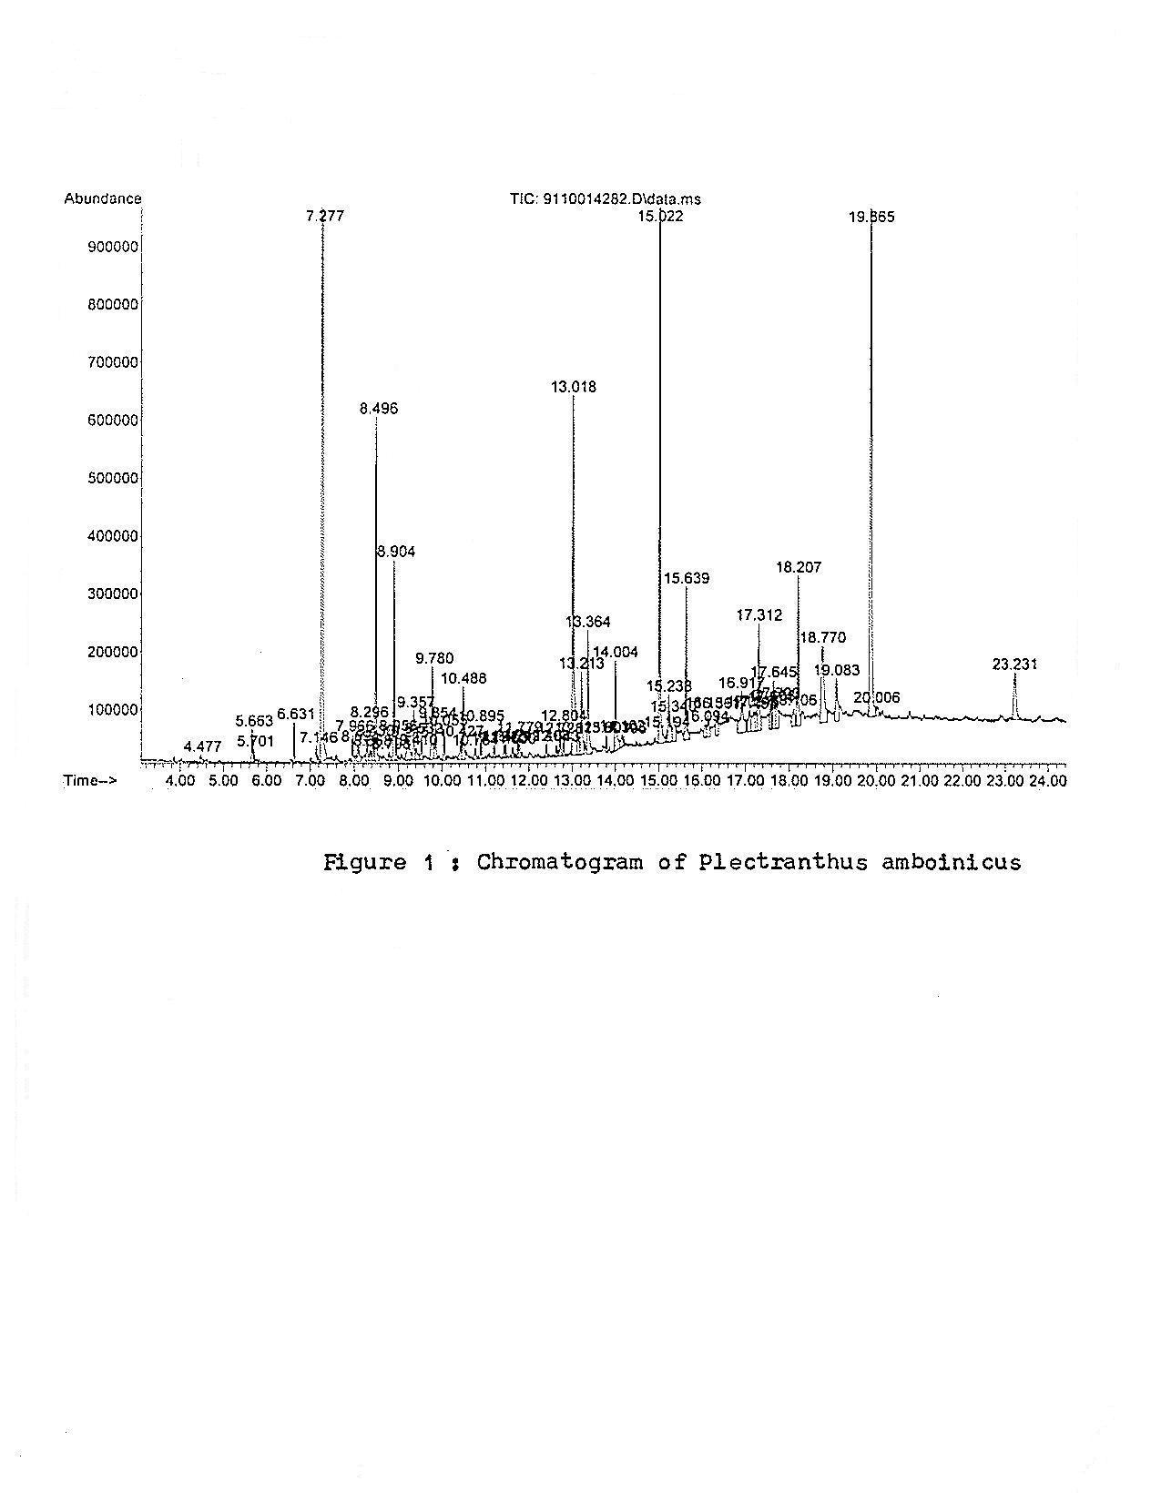

Table1: Total ionic Chromatogram (GC-MS) of Plectranthus amboinicus obtained with 70eV using an Elite-1 fused silica capillary column with He gas as the carrier
No | RT | Name of the Compound | Molecular formula | MW | Peak Area%
 | 13.36 | 3,7,11,15 – Tetramethyl -2- hexadecen -1-ol | C₂₀H₄₀O | 296 | 1.8
 | 15.19 | 9,12 – Octadecadienoic acid (Z,Z) | C₁₈H₃₂O₂ | 280 | 0.14
 | 7.96 | Eugenol | C₁₀H₁₂O₂ | 164 | 0.35
 | 14.00 | n -.Hexadecanoic acid | C₁₆H₃₂O₂ | 256 | 1.39
 | 23.23 | Gamma tocopherol | C₂₈H₄₈O₂ | 416 | 1.42
 | 17.14 | Thymol | C₁₆H₁₄O | 150 | 0.19
 | 12.41 | Tetradecanoic acid | C₁₄H₂₈O₂ | 228 | 0.20
 | 15.02 | Phytol | C₂₀H₄₀O | 296 | 8.44
 | 19.86 | Squalene | C₃₀H₅O | 410 | 10.07
 | 14.19 | Oleic acid | C₁₈H₃₄O₂ | 282 | 0.13
 | 5.66 | Borneol | C₁₀H₁₈O | 154 | 0.13
 | 4.47 | 1-Pentanamine | C₅H₁₃N | 87 | 0.16
 | 10.48 | 1,2-Benzene diol, 4 (1,1 dimethyl ethyl) | C₁₀H₁₄O₂ | 166 | 1.02
 | 13.21 | 1,4 Eicosadiene | C₂₀H₃₈ | 278 | 1.33
 | 31.70 | 3-Methyl- 4 - isopropyl phenol | C₁₀H₁₄O | 150 | 31.70
 | 15.24 | 9,12,15-Octadecatrien -1- ol (Z,Z,Z) | C₁₈H₃₂O | 264 | 1.19
 | 10.89 | Caryophyllene oxide | C₁₅H₂₄O | 220 | 0.43
 | 9.77 | Eudesma - 4 (14), 11-diene | C₁₅H₂₄ | 204 | 1.34
 | 18.77 | Durohydroquinone | C₁₀H₄O₂ | 166 | 2.73

Table 2. Biological activity of phyto components identified in Plectranthus amboinicus
No | Name of the Compound | Molecular formula | Compound | **Activity
 | 3,7,11,15 - Tetramethyl -2- hexadecen - 1 - ol | C₂₀H₄₀O | Terpene alcohol | Antimicrobial, Anti inflammatory.
 | 9,12 - Octadecadienoic acid (Z,Z) | C₁₈H₃₂O₂ | Linoleic acid | Hypocholesterolemic, Antiarthritic, Hepato protective, Anti androgenic, Nematicide, Antihistaminic, Antieczemic
 | Eugenol | C₁₀H₁₂O₂ | Eugenol | Analgesic, Anesthetic, Anti bacterial, Anti inflammatory, Anti oxidant, Anti salmonella, Anti staphylococcus.
 | n.Hexadecanoic acid | C₁₆H₃₂O₂ |  | Antioxidant, Hypocholesterolemic, Nematicide, Anti androgenic, Hemolytic inhibitor.
 | Gamma toco pherol | C₂₈H₄₈O₂ | Tocopherol | Antioxidant, Vasodilator ,Anti tumor, Analgesic, Hepatoprotective, Anticataract, Antidiabetic
 | Thymol | C₁₆H₁₄O | Thyme Camphor | Antimicrobial, Anti inflammatory ,Antiseptic, Antioxidant, Anti carcinogenic, Anti salmonella.
 | Tetradecanoic acid | C₁₄H₂₈O₂ | Myristic acid | Antioxidant, cancerpreventive, Nematicide, Lubricant, Hypocholesterolemic.
 | Phytol | C₂₀H₄₀O | Diterpene | Antimicrobial, diuretic, Anti inflammatory, Anti cancer.
 | Squalene | C₃₀H₅O | Triterpene | Anti cancer, Anti microbial, Anti oxidant, Anti tumor chemo preventive.
 | Oleic acid | C₁₈H₃₄O₂ | Mono unsaturated fatty acid | Anti inflammatory, Anti androgenic, Cancer preventive, Hypocholesterolemic.
 | Borneol | C₁₀H₁₈O | Mono terpene alcohol | Myorelaxant, Antipyretic, Anti inflammatory, Insect repellent, nematicide, Sedative Insectifuge, Tranquilizer, Analgesic, Anti bacterial.
 | 1-Pentanamine | C₅H₁₃N | Amino Compound | Antimicrobial.
 | 1,2-Benzene diol 4-(1,1 dimethyl ethyl) | C₁₀H₁₄O₂ | Phenolic Compound | Antimicrobial, Antioxidant, Analgesic.
 | 1,4 Eicosadiene | C₂₀H₃₈ | Alkene Compound | No activity reported.
 | 3-Methyl-4-isopropyl phenol | C₁₀H₁₄O | Phenolic compound | Antimicrobial, Antioxidant, Analgesic.
 | 9,12,15 - Octadecatrien-1-ol  (Z,Z,Z) | C₁₈H₃₂O | Unsaturated alcoholic compound | Antimicrobial.
 | Caryophyllene oxide | C₁₅H₂₄O | Sesquiterpene oxide | Antitumor, Analgesic, Antibacterial, Sedative, Anti inflammatory
 | Eudesma-4 (14), 11- diene | C₁₅H₂₄ | Sesquiterpene | Antitumor, Sedative Antibacterial, Anti inflammatory, fungicide.
 | Durohydroquinone | C₁₀H₁₄O₂ | Phenolic compound | Antimicrobial,Antioxidant, Analgesic.
**Activity Source: Dr. Duke’s Phytochemical and Ethnobotanical Database.

Acknowledgements
The authors would like to thank Dr. K. Vasudevan, Chairman, Prince Shri Venkateshwara Arts and Science College and Dr. K. Alagusundaram, Director, Indian Institute of Crop Processing Technology for guiding and supporting throughout.

Corresponding Author
Dr. P. Kalaiselvi., M.Sc., Ph.D.,
Department of Medical Biochemistry,
University of Madras, Taramani Campus,
Chennai - 600 113,
Tamil Nadu, India.
E-mail : pkalaiselvi@yahoo.com

References
- Annapurani S, Priya R. Antimutagenic, antitumourogenic and antigen toxic effects of poly phenol extracts of selected medicinal plants. Indian J. Nutr. Diet. 1999;36: 431–435.

- Baskar R, Varalakshmi P, Amsaveni . Changes in tissue enzymes produced by coleus aromaticus experimental urolithiasis – Indian Drugs 1992; 29:254–258.

- Buznego MT, Perez – Saad H . Antiepileptic effect of Plectranthus amboinicus (Lour.) Spreng,Rev. Neurol. 1999;29:229-232.

- Fatope MO. Adowm OA., Takerida Y. Palmitate rimeria Americana Pharmaoeut. Biol. 2001; 38: 391–393.

- Hammer K, Antimicrobial activity of essential oils and other plant extracts J. Appl. Microbiol. 1999; 86:985–990.

- Kritikar KR, Basu BO. Indian Medicinal Plants, Vol 3, Dehradun: International Book Distributors 1999; 1970-1971.

- Perez saad H, Buznego MT, Llanio Villate N, Fernandez perez M, Menindez R. Neuro Pharmacological profile of Plectranthus amboinicus (Lour.) Spreng (Indian borage), Rev. Neurol. 2003;36:98-99.

- Prasad S, Naik P, Vijayalaxmi KK. Efficiency of coleus aromatics extract in modifying cyclophosphamide and mitomycin-C clastogenicity in mouse bone marrow cells . Indian J. of Exp. Biol. 2002; 40:1020-1025.

- Prudent D, Perineau F, Besslere JM, Michael GM, Baccou JC. Analysis of the essential oil of wild Oregans from Martinique (Coleus aromaticus Benth)., evaluation of its bacteriostatic and fungistatic properties J. Esst oil Res 1995;7:165– 173.

- Rao BS, Shanbhoge R, Upadhya D, Jagetia GC, AdigaSK,Kumar P. Antioxidant, anticlastogenic and radioprotective effect of Coleus aromaticus on Chinese hamster fibroblast cells (V79) exposed to gamma radiation. Mutagenesis 2006;21:237-242.

- Shahidi F. "Antioxidant factors in plant foods and Selected oil seeds, Bio factor 2000;13:179–185.

- Shahidi F, Mc Donald J, Chandrasekara H. Zhongy, phytochemicals of foods, beverages and fruit, vinegar, chemistry and health effects, Asia Pacific J. Clin. Nutr. 2008;17:380–382.

13/06/2011

