Potential Biotechnological Application of Lignin Peroxidase Produced by Cunninghamella elegans in the Decolorization and Detoxification of Malachite Green Dye

Roushdy M.M.¹ and Abdel-Shakour E.H.^{2*}

¹Applied medical Sciences Department, College of Community (Unaizah), Qassim University, KSA
²Botany and Microbiology Department, Faculty of Science, Al-Azhar University, Cairo, Egypt
*essam_hussain@hotmail.com

Abstract: Malachite green (50 mg/L) was completely decolorized under static condition within 10 h at pH 6 and 30°C by the fungal strain Cunninghamella elegans; however decolorization was not observed at shaking condition. Induction in the activities of lignin peroxidase was observed during malachite green (MG) decolorization suggesting their involvement in the decolorization process. Toxicity study revealed the degradation of MG into non-toxic products by Cunninghamella elegans. FTIR analysis showed decolorization of MG.
[Roushdy M.M. and Abdel-Shakour E.H. Potential Biotechnological Application of Lignin Peroxidase Produced by Cunninghamella elegans in the Decolorization and Detoxification of Malachite Green Dye. New York Science Journal 2011;4(8):80-88 (ISSN: 1554-0200).

Keywords: Lignin peroxidase; Cunninghamella elegans; Decolorization; Detoxification; Malachite green

1. Introduction
Dyes have been extensively used in a broad range of industries, especially in textiles (Kariminiaae-Hamedaani et al., 2007). Synthetic dyes are used extensively for textile dyeing, paper printing, leather dyeing, colour photography and as additives in petroleum products because of their ease and cost effectiveness in synthesis, firmness, high stability to light, temperature, detergent and microbial attack and variety in color compared with natural dyes (Couto, 2009). This has resulted in the discharge of highly colored effluents that affect water transparency and gas solubility in water bodies (Banat et al.,1996). In addition, many dyes are believed to be toxic, carcinogenic or to be prepared from known carcinogens such as benzidine or other aromatic compounds that might be formed as a result of microbial metabolism (Novotny et al., 2006; Kariminiaae-Hamedaani et al., 2007).
Pollution from the effluents has become increasingly alarming with the usage of a wide variety of dyes in industries (GonCalves et al., 2000 and Singh et al., 2010). Based on the chemical structure of the chromophoric group, the dyes are classified as azo, anthraquinone, triarylmethane and phthalocyanine dyes (Liu et al., 2004).
Dyes are difficult to degrade biologically, so that degradation of dyes has received considerable attention. About 10-15% of all dyes are directly lost to wastewater in the dyeing process (Parshetti et al., 2006).
Malachite green is used extensively for dyeing silk, wool, jute, leather, ceramics, cotton, and used to treat fungal and protozoal infection (Parshetti et al., 2006). Malachite green is highly toxic to mammalian cells; it promotes hepatic tumor formation in rodents and also causes reproductive abnormalities in rabbits and fish (Fernandes et al., 1991).
Malachite green, an N-methylated diaminotriphenylmethane dye, has been widely used as the most efficacious antifungal agent in the fish farming industry (Schnick, 1988).
Malachite green and its reduced form, leucomalachite green, may persist in edible fish tissues for extended periods of time. Therefore, there are both environmental and human health concerns about bioaccumulation of MG and leucomalachite green in terrestrial and aquatic ecosystems (Mitrowska and Posyniak, 2004).
The structural similarity of malachite green to other carcinogenic triphenylmethane dyes also raises suspicion of carcinogenicity. Gentian violet (crystal violet) is a thyroid and liver carcinogen in rodents (Littlefield et al., 1985) and pararosaniline is a bladder carcinogen in humans (Case and Pearson, 1954).
Treatment methodologies of dye containing wastewater fall into three types: physical, chemical and biological. Currently, many physico-chemical methods such as nanofiltration, electrocoagulation and ozonation (Reddy and Kotaiah, 2005; Kashefialasl et al., 2006; Gharbani et al., 2008; Sundrarajan et al., 2007; Hassani et al., 2008) have been applied for removal of dyes from wastewater. Owing to their lower cost and being eco-friendly, biological methods have been proved to be superior over various physico-chemical methods (Banat et al., 1996). Various microorganisms such as bacteria, fungi, yeasts and algae have been reported to remove dyes (Banat et al., 1996; Azmi, 1998; Alhassani et al., 2007; Ncibi et al., 2007; Ghasemi et al., 2010). Generally, removal of dyes by microorganisms takes place through three mechanisms: biosorption, bioaccumulation and biodegradation. Biosorption is defined as binding of solutes to the biomass by processes which do not involve metabolic energy or transport, although such processes may also occur simultaneously where live biomass is used. The process of biosorption can occur in either living or dead biomass (Tobin et al., 1994) whereas bioaccumulation is defined as the accumulation of pollutants by actively growing cells by metabolism- and temperature-independent and metabolism-dependent mechanism steps (Sadettin and Donmez, 2006). Biodegradation is an energy dependent process and involves the breakdown of dye into various by-products through the action of various enzymes. When biodegradation is complete, the process is called mineralization (Bennett and Faison, 1997).
In fungal decolorization of dye waste water, these fungi can be classified into two kinds according to their life state: living cells to biodegrade dyes and dead cells (fungal biomass) to adsorb dyes (Fu and Tiraraghavan, 2001).
For living cells, the major mechanism is biodegradation because they can produce the lignin modifying enzymes, laccase, manganese peroxidase (MnP) and lignin peroxidase (LiP) to mineralize synthetic lignin or dyes (Fu and Tiraraghavan, 2001, and Stolz, 2001).
For dead cells, the mechanism is biosorption, which involves physico-chemical interactions, such as adsorption, deposition, and ion-exchange (Wesenberg et al., 2003).
The aim of present study was to investigate the fastest decolorization of malachite green by the filamentous fungus Cunninghamella elegans and also to study the possible enzymes involved in the decolorization as well as to access the toxicity of MG degradation products. Various conditions for decolorization have been optimized.

2. Material and Methods
2.1. Dyes and chemicals
Malachite green (MG) used in this study was obtained from Sigma-Aldrich Ltd. (Ontario, Canada). Various increasing concentrations of dye (10, 20 and 50 mg/L) were prepared as described below.

2.2. Rice husk preparation
The rice husk was obtained from Mansoura governorate of Egypt. It was homogenized using sterile mortar and pestle and passed through sterile stainless steel sieves of 200 μm and 100 μm in succession, followed by washing with sterile distilled water (D'Souza Ticlo, 2008).

2.3. The test organism
The strain Cunninghamella elegans used in this study was isolated from rice husk and identified at Regional Center of Mycology and Biotechnology (Al-Azhar University, Cairo, Egypt). The identification method was based on the fungal identification as described by Domsch et al. (1993) and Samson et al. (2000). The fungal strain was maintained on PDA slants at 4ºC.

2.4. Enzyme production medium
The pure culture of Cunninghamella elegans was grown (as described by Dayaram and Desgupta, 2008 with some modification) in 250 mL Erlenmeyer flask, containing 100 mL of the production medium; 4.5% (w/v) rice husk, 1.5% yeast extract, 1% glucose, 0.25% NH₄Cl, 0.05% thiamine chloride, 0.2% KH₂PO₄, 0.2% MgSO₄.7H₂O, 0.01% CaCl_{2,} and 0.05% KCl. Tap water was used for preparation of the medium and the pH was adjusted to 6. The medium was inoculated with 1 cm square agar piece (~8x10⁶ spores/ml) from an actively growing fungal isolate on PDA and incubated at 30°C for 14 days.

2.5. Preparation of cell free extract (CFE)
Cunninghamella elegans cells were grown in lignin peroxidase production medium at 30ºC for 14 days. The extraction was carried out according to the method described by Dayaram and Desgupta (2008). Briefly, cultures were harvested after 14 days, filtered and clarified by cooling centrifugation at ~12000 x g for 20 min at 4°C to remove the mycelia and the enzyme activity was assayed.

2.6. Lignin peroxidase activity assay
Lignin peroxidase (LiP) was determined by monitoring the increase in absorbance (A₃₁₀) due to the oxidation of Veratryl alcohol to veratraldehyde at 37°C (Tien and Kirk 1988). The reaction mixture (2.5 ml) contained 500 μl enzyme extract (previously prepared as mentioned above), 500 μl H₂O₂, 500 μl Veratryl alcohol solution and 1.0 ml sodium tartarate buffer, pH 3.0 and LiP activity was calculated from the molar extinction coefficient () of 9300 mM cm⁻¹ (D'Souza Ticlo, 2008). LiP was expressed as enzyme units per liter (U L⁻¹), where one unit of enzyme activity is defined as the amount of enzyme oxidizing 1 μmol of substrate per minute.

2.7. Decolorization of MG by CFE (in vitro)
All decolorization experiments were performed in three sets. The experiment was carried out according to D'Souza Ticlo (2008) with some modification. The dye solution was prepared at concentrations of 10, 20 and 50 mg/1000 ml distilled water. Different volumes of CFE (1, 2, 3, 4, 5ml) containing lignin peroxidase were added to the different concentration of malachite green solutions and incubated at pH 6 and 30°C for 13 h. then three mL were withdrawn at different time intervals (0, 1, 2, 3, 4, 5, 6, 7, 8, 9, 10, 11, 12 and 13 h). Each aliquot was centrifuged at 3000 x g for 15 minutes to clear the supernatants. Decolorization of MG was determined by the ratio of absorbance at 623 nm. Abiotic controls (without microorganism) were always included.

2.8. Decolorization Assay:
This assay was measured in the terms of decolorization (%) using Spectrophotometer. The decolorization percentage in dye concentration (D'Souza Ticlo, 2008) was calculated from the following equation:
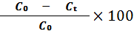
Decolorization (%) =
Where:
C₀: initial concentration of the dye
C_{t}: measured concentration after the end of decolorization test

The effect of pH, incubation time and temperature on the decolorization of the MG dye was studied. In each experiment the optimum conditions deduced from the previous experiments were considered.

2.9. Biodegradation analysis
After complete decolorization (12 h incubation), the decolorized medium was centrifuged at 12,000 x g for 20 minutes and supernatant obtained was analyzed (Husseiny, 2008) using the Fourier Transform Infrared Spectroscopy (Frontier FTIR Spectrometer-spectrum 10, PerkinElmer, Inc., USA) in comparison with control dye in the mid IR region of 400-4000 cm⁻¹. The samples were mixed with spectroscopically pure KBr in the ratio of 5:95, pellets were fixed in sample holder, and the analyses were carried out.

2.10. Microbial toxicity study
Microbial toxicity of control MG and its degradation product (final concentration of 500 and 1000 ppm in 5 ml of ethyl acetate) was also carried out as the method described by Parshetti et al. (2006) in relation to Bacillus subtilis (NCTC 10400), Staphylococcus aureus (NCTC 7447), Escherichia coli (NCTC 10416), Pseudomonas aeruginosa (ATCC 10145) and Candida albicans (IMRU3669) and zone of inhibition (diameter in mm) was recorded after 24 h of incubation at 30°C.

3. Results
3.1. Decolorization at static and shaking conditions
Lignin peroxidase produced by Cunninghamella elegans showed 100% decolorization rate of MG (10 mg/L) after addition of 5 mL of CFE within 12 h at 30°C under static condition whereas there was no decolorization at shaking condition (Fig. 1).
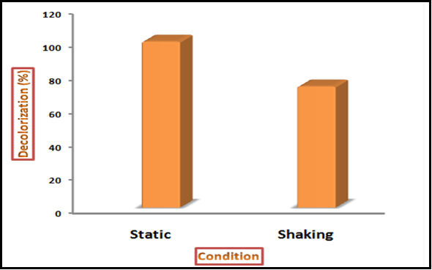

Figure 1. Decolorization of MG within 12 h. at 30°C under static and shaking conditions

3.2. Effect of different MG concentrations on the rate of decolorization
Different concentrations (10, 20 and 50 mg/L) of MG solutions were added to different volumes of CFE (1, 2, 3, 4 and 5 ml) within 12 h at 30°C under static condition. Data recorded in Table (1) showed that the maximum rate (100 %) of MG decolorization was achieved when 5 mL of CFE were added to MG solution at concentration of 50 mg/L.

3.3. Effect of different incubation periods on the decolorization of MG
The cell free Extract (5 ml) was added to MG solution (50 mg/L) at different time intervals (1, 2, 3, 4, 5, 6, 7, 8, 9, 10, 11, 12 and 13 h.). The data, recorded in Fig. 2, revealed that the maximum MG decolorization (100%) was obtained at 10 hours of incubation.

Table 1. Effect of different MG concentrations in relation to different cell free extract (CFE) volumes

CFE volumes  (ml) | MG concentrations  (mg/L) | Decolorization  (%)
1 | 50 | 11
1 | 20 | 30
1 | 10 | 45
2 | 50 | 35
2 | 20 | 46
2 | 10 | 61
3 | 50 | 65
3 | 20 | 83
3 | 10 | 91
4 | 50 | 80
4 | 20 | 92
4 | 10 | 100
5 | 50 | 100
5 | 20 | 100
5 | 10 | 100

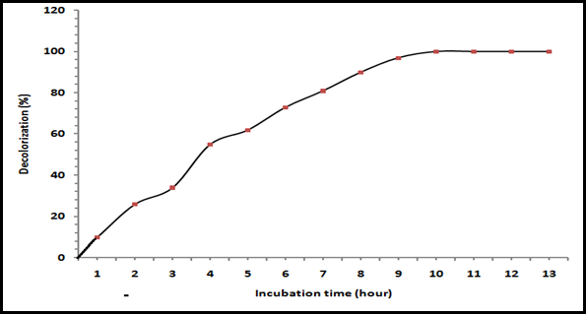

Figure 2. Effect of different incubation periods on the decolorization of MG at 30 °C

3.4. Effect of different pH values on the decolorization of MG
Data, represented graphically in Fig. 3, showed the effect of initial pH on the efficiency of lignin peroxidase to reduce the color intensity of MG solution in the terms of decolorization percentage (%) of the color within the range of pH (3-10). It was clear that, the maximum percentage of decolorization was (100 %) at pH 6.

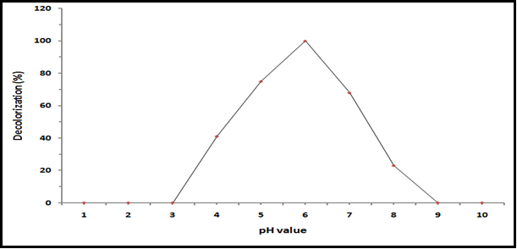

Figure 3. Effect of different pH values on the decolorization of MG at 30°C for 10 h. incubation

3.5. Effect of different temperature degrees (°C) on the decolorization of MG
The effect of temperature was evaluated by incubating the CFE (5 ml) with the solution of MG (50 mg/L) at various temperatures (10, 15, 20, 25, 30, 35 and 40°C). The decolorization rate (100 %) of MG was attained at 30°C on the tenth day of incubation (Fig. 4).

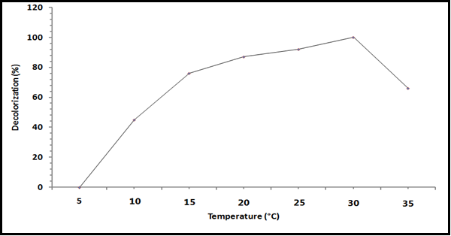

Figure 4. Effect of different temperature degrees on the decolorization of MG at pH 6 and 30°C for 10 h. incubation

3.6. Microbial toxicity and Phytotoxicity study
Zone of inhibition was observed in the case of control MG with all microbial strains studied whereas its decolorization products did not show growth inhibition (Table 2).

Table 2. Microbial Toxicity study of malachite green and its degradation product
Bacteria | Diameter of inhibition zone (mm)
Bacteria | MG conc.  (500 ppm) | Decolorization product  (500 ppm) | MG conc. (1000 ppm) | Decolorization product  (1000 ppm)
Bacillus subtilis (NCTC 10400) | 12 | *NI | 18 | NI
Staphylococcus aureus (NCTC 7447) | 14 | NI | 16 | NI
Escherichia coli  (NCTC 10416) | 10 | NI | 12 | NI
Pseudomonas aeruginosa  (ATCC 10145) | 8 | NI | 10 | NI
Candida albicans (IMRU3669) | 8 | NI | 11 | NI
*NI= No Inhibition

3.7. Analysis of decolorization products
Remarkable variations in the region 2000 to 500 cm⁻¹ of the FTIR (Fig. 5-A) spectroscopy of control malachite green and 10 h extracted metabolites indicate decolorization of MG by lignin peroxidase produced by Cunninghamella elegans.
FTIR spectra of control malachite green showed the specific peaks in region 2000 to 500 cm⁻¹ for the mono- and para- benzene rings which is supporting to the peak at 1584.87 cm⁻¹ for the C=C stretching of the benzene ring. Also the peak at 1170.20 cm⁻¹ for the C-N stretching vibrations gives the perception of the structure of malachite green.
The FTIR spectra of extracted product (Fig. 5-B) showed peak at 1258.89 cm⁻¹ for C-N stretch with supporting peak at 1110.73 cm⁻¹.

4. Discussion
The aim of present study was to investigate the fastest decolorization of MG by lignin peroxidase produced by Cunninghamella elegans and also to study the toxicity of MG degradation product. Our results showed that 100% decolorization of MG was observed at 10, 20 and 50 mg/L concentrations in the presence of 5 ml of the CFE produced from Cunninghamella elegans. The autoclaved CFE of Cunninghamella elegans did not show decolorization of MG, which indicates enzymatic reaction. Cell free extract contains a protein that may be responsible for MG decolorization. CFE of Cunninghamella elegans showed the presence of lignin peroxidase which is responsible for dye decolorization. Various conditions for decolorization have been optimized. Our results showed that MG was degraded and decolorized under ligninolytic conditions. Therefore, the results collectively indicate that the ligninolytic enzymes are essential for the degradation of MG by the fungal strain Cunninghamella elegans. Won et al. (2000) stated that lignin degradation system of the fungi has been directly as well as indirectly linked to the degradation of various compound remains. Other studies reported that malachite green was enzymatically reduced to leucomalachite green and also converted to N-demethylated and N-oxidized metabolites (Cha et al., 2001).
The decolorization of MG was studied at various increasing concentrations of dye i.e. 10, 20 and 50 mg/L. We found that the rate of decolorization was decreased with increasing concentration of dye. Similar observation was also reported during decolorization of reactive violet 5 by newly isolated bacterial consortium (Moosvi et al., 2005).
The present results revealed that static condition was preferable than the shaking one. The reason for no decolorization at shaking condition may be due to the competition of oxygen and dye for the reduced electron carriers under aerobic condition. Similar studies were carried out by Parshetti et al. (2006). They reported that malachite green was completely decolorized under static condition within 5 h by bacteria Kocuria rosea MTCC 1532.

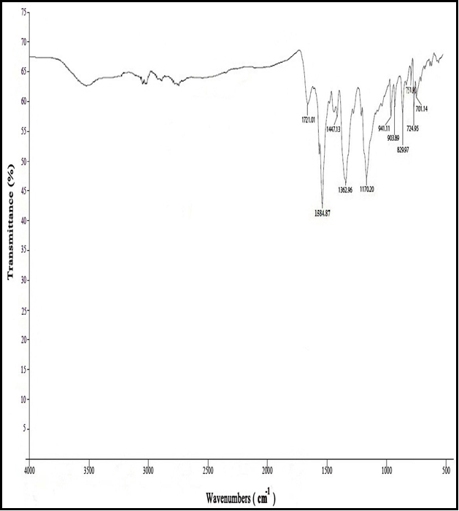
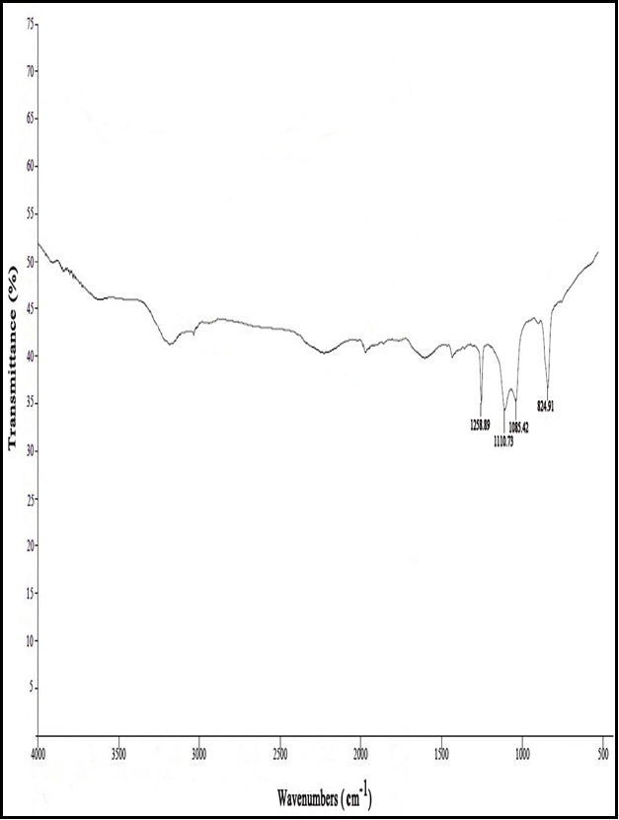
(A)
(B)

Figure 5. A) FTIR spectrum of malachite green dye 0 h (control).

B) FTIR spectrum of malachite green metabolites extracted after 10 h of incubation with lignin peroxidase produced by Cunninghamella elegans.

The maximum decolorization rate (100 %) of MG was attained at 30°C. The lower decolorization at temperatures higher than 30°C may be attributed to the deactivation of the lignin peroxidase. This is in accordance with Zhang et al (2007), since they stated that the decolorization rates (99% and 96%) of crystal violet and malachite green respectively, were attained at 30°C on the second day of incubation than those at other temperature (25, 35 and 40°C).
To confirm whether this decolorization was due to change in pH, the change in pH was recorded where the maximum decolorization was at 6 indicating that an acidic environment is required for a better rate of reaction as well as decolorization. A similar requirement of an acidic pH range for the decolorization of synthetic and commercial dyes by ligninases of P. chrysosporium has also been reported (Singh et al., 2010).
Zone of inhibition was observed with control MG with all microbial strains studied whereas its degradation products did not show growth inhibition. These findings may suggest non-toxic nature of the product formed. Other microbial toxicity studies revealed that zone of inhibition was observed with control Crystal Violet whereas, its metabolites showed comparatively less zone of inhibition (Parshetti et al., 2011).
FTIR spectra of control malachite green showed the specific peaks in region 2000 to 500 cm⁻¹ for the mono- and para- benzene rings which is supporting to the peak at 1584.87 cm⁻¹ for the C=C stretching of the benzene ring. Also the peak at 1170.20 cm⁻¹ for the C-N stretching vibrations gives the perception of the structure of malachite green. The FTIR spectra of extracted product showed peak at 1258.89 cm⁻¹ for C-N stretch with supporting peak at 1110.73 cm⁻¹. Some peaks doesn’t present in spectrum of original dye. This means that the MG dye was degraded by Cunninghamella elegans. Husseiny (2008) stated that the treatment of direct red-81 dye with Aspergillus niger gave a band at 3549.1 cm⁻¹ (when analyzed by FTIR spectroscopy method) that refers to NH group and band at 333.6 cm⁻¹ that refers to OH group. He also mentioned that these resulted peaks doesn’t present in spectrum of original dye, this means that the direct red dye was degraded by Aspergillus niger.

Corresponding Author:
Dr. Abdel-Shakour E.H.
Botany and Microbiology Department
Faculty of Science
Al-Azhar University, Cairo, Egypt.
E-mail: essam_hussain@hotmail.com

References
- Alhassani, H. A., Muhammad, R. A. and Ashraf, S. S. (2007). Efficient Microbial Degradation of toluidine Blue dye by Brevibacillus sp. Dyes Pigments., 755, 395-400.
- Azmi, W., Sani, R. K. and Banerjee, U. C. (1998). Biodegradation of triphenylmethane dyes. Enzyme Microb. Technol., 22, 185–191.
- Banat, I. M., Nigam, P., Singh, D. and Marchant, R. (1996). Microbial decolorization of textiledye- containing effluents: a review, Bioresource Technol., 58, 217–227.
- Benette, J. W. and Faison, B. D. (1997). Use of Fungi in Biodegradation. Manual of Environmental Microbiology, Washington DC, ASM Press. 758-765.
- Case, R. A. M. and Pearson, J. T. (1954). Tumours of the urinary bladder in workmen engaged in the manufacture and the use of certain dyestuff intermediates in the British chemical industry. Br. J. Ind. Med. 11:213–221.
- Cha, C. J., Doerge, R. D. and Cerniglia, C. E. (2001). Biotransformation of malachite green by the fungus Cunninghamella elegans. Applied and Environmental Microbiology, p. 4358–4360.
- Couto, S.R. (2009). Dye removal by immobilised fungi. Biotech Adv., 27, 227-235.
- Dayaram, P. and Dasgupta, D. (2008). Decolorisation of synthetic dyes and textile wastewater using Polyporus rubidus. J. Environ. Biol., 6: 831-836.
- Domsch, K. H., Gams, W. and Anderson, T.H. (1993). Compendium of Soil Fungi. vol.1, IHW-Verlag, Germany.
- D'Souza Ticlo, D. (2008). The Lignin-Degrading Enzyme, Laccase from Marine Fungi; Biochemical and Molecular Approaches. Ph.D. thesis, National institute of oceanography, Dona Paula, Gao University, India.
- Fernandes, C., Lalitha, V. S. and Rao, K. V. K. (1991). Enhancing effect of malachite green on the development of hepatic pre-neoplastic lesions induced by N- nitrosodiethylamine in rats. Carcinogenesis 12:839–845.
- Fu, Y. and Tiraraghavan, Y. (2001). Fungal decolourization of dye waste waters: a review, Bioresource Technology, 79: 251-262.
- Gharbani, P., Tabatabaii, S.M. and Mehrizad, A. (2008). Removal of congo red from textile wastewater by ozonation. Int. J. Environ.Sci.Tech., 5 (4), 495-500.
- Ghasemi, F., Tabandeh, F., Bambai, B. and Sambasiva Rao, K. R. S. (2010). Decolorization of different azo dyes by Phanerochaete chrysosporium RP78 under optimal condition. Int. J. Environ. Sci.Tech., 7 (3), 457-464.
- GonCalves I, Gomes A., Bras R., Ferra M. I. A., Amorim M. T. P. and Porter R. S. (2000). Biological treatment of effluent containing textile dyes. J. Soc. Dyers Colour. 6: 393-397.
- Hassani, A. H., Hassan, A. H., Mirzayee, R., Nasseri, S., Borghei, M., Gholami, M. and Torabifar, B. (2008). Nanofiltration process on dye removal from simulated textile wastewater. Int. J. Environ. Sci. Tech., 5 (3), 401-408.
- Husseiny, S. M. (2008). Biodegradation of the reactive and direct dyes using egyptian isolates. Journal of Applied Sciences Research, 4(6): 599-606, 2008
- Kariminiaae-Hamedaani, H. R., Sakurai, A. and Sakakibara, M. (2007). Decolorization of synthetic dyes by a new manganese peroxidase producing white rot fungus, Dyes Pigments, 72, 157–162.
- Kashefialasl, M., Khosravi, M., Marandi, R. and Seyyedi, K. (2006). Treatment of dye solution containing colored index acid yellow 36 by electrocoagulation using iron electrodes. Int. J. Environ. Sci. Tech., 2 (4), 365-371.
- Littlefield, N. A., Blackwell, B. N., Hewitt, C. C. and Gaylor, D. W. (1985). Chronic toxicity and carcinogenicity studies of gentian violet in mice. Fundam. Appl. Toxicol. 5:902–912.
- Liu W., Chao Y., Yang X., Bao H. and Qian S. (2004). Biodecolourization of azo, anthraquinonic and triphenylmethane dyes by white-rot fungi and a laccase secreting engineered strain. J. Ind. Microbiol. Biotechnol. 31: 127-132.
- Mitrowska, K. and Posyniak, A. (2004). Bulletin of Veterinary. Institute Pulwy., 48, 173–176.
- Moosvi, S., Keharia, H. and Madamwar, D. (2005) W. J. Microbiol. Biotechnol., 21, 667–672.
- Ncibi, M.C., Mahjoub, B. and Seffen, M. (2007). Adsorptive removal of textile reactive dye using Posidonia oceanica (L.). Int. J. Environ. Sci. Tech., 4 (4), 433-440.
- Novotny, C., Dias, N., Kapanen, A., Malachova, K.., Vandrovcova, M., Itavaara, M. and Lima, N. (2006). Comparative use of bacterial, algal and protozoan tests to study toxicity of azo- and anthraquinone dyes. Chemosphere, 63, 1436–1442.
- Parshetti, G., Kalme, S., Saratale, G., and Govindwar, S. (2006). Biodegradation of malachite green by Kocuria rosea MTCC 1532. Acta Chim. Slov. 53, 492–498.
- Parshetti, G. K., Parshetti, S. G., Telke, A. A., Kalyani, D. C., Doong, R. A. and Govindwar, S. P. (2011). Biodegradation of Crystal Violet by Agrobacterium radiobacter. Journal of Environmental Sciences, Vol. (23). DOI: 10.1016/S1001-0742(10)60547-5.
- Reddy, S. S. and Kotaiah, B. (2005). Decolorization of simulated spent reactive dye bath using solar/TiO₂/H₂O₂. Int. J. Environ. Sci. Tech., 2 (3), 245-251.
- Sadettin, S., and Donmez, G. (2006). Bioaccumulation of reactive dyes by thermophilic cyanobacteria. Process Biochem., 41, 836–841.
- Samson, R. A., Hoekstra, E. S. and Frisvad, J. C. (2000). In: Introduction to food- and airborne fungi. 6th ed. Utrecht, Netherlands: Centraalbureau voor Schimmelcultures, Pp. 389
- Schnick, R. A. (1988). The impetus to register new therapeutics for aquaculture. Prog. Fish-Cult. 50:190–196.
- Singh D. A., Sabaratnam V., Abdullah N., Annuar M. S. M. and Ramachandran K. B. (2010). Decolourisation of chemically different dyes by enzymes from spent compost of Pleurotus sajor-caju and their kinetics. African Journal of Biotechnology Vol. 9 (1), pp. 041-054.
- Stolz, A., (2001). Basic and applied aspects in the microbial degradation of azo dyes. Applied Microbiol Biotechnol., 56: 69-80.
- Sundrarajan, M., Vishnu, G. and Joseph, K. (2007). Decolorisation of exhausted reactive bath using ozonator for reuse. Int. J. Environ. Sci. Tech., 4 (2), 263-270.
- Tien M. and Kirk T. K. (1988). Lignin peroxidase of Phanerochaete chrysosporium, Methods Enzymol., 161 238–248.
- Tobin, J. M., White, C. and Gadd, G. M. (1994). Metal accumulation by Fungi: Applications in Environmental Biotechnology. J. Ind. Microbiol., 13, 126-130.
- Wesenberg, D., Kyriakides, I. and Agathos, S. N. (2003). White-rot fungi and their enzymes for the treatment of industrial dye effluents, Biotechnology Advances, 22: 161-187.
- Won, R. R., Seong, H. S., Moon, Y. J., Yeong, J. J., Kwang, K. O. and Moo H. C. (2000). Biodegradation of pentachlorophenol by white rot fungi under ligninolytic and non-ligninolytic conditions. Biotechnol. Bioprocess Eng., 5: 211-214
- Zhang, X., Liu, Y., Yan, K. and Wu, H. (2007). Decolorization of Anthraquinone-type dye by bilirubin oxidase produced by nol-ligninolyti fungus Myrothecium sp. IMR1. J. Biosc. Bioeng., 104 (2): 104–110.

6/22/2011

