The Possible Protective Effect of Mefenamic Acid, Taurine, Soy-Phytoestrogen Extract Against Scopolamine-induced Alzheimer Disease in Rat.

Suzan F.I. El-Sisi

Address: Physiology Department, National Organization for Drug Control and Research (NODCAR), Giza, Egypt

Email: Suzanelsisi@yahoo.com

Abstract: Background: This study was conducted in a trial to counteract the perturbations induced in the rat brain by scopolamine (scop) and may represent risk factors in the progress to Alzheimer’s disease (AD). Mefenamic acid, (a non steroidal anti-inflammatory drug; NSAID), soy-phytoestrogen extract (a plant soy bean), and taurine (tau, a free ß-amino acid and potent endogenous antioxidant) were used either individually or in combination.
Methods: adult rats (6months old) were daily supplemented with tested materials in 8 groups, 3 groups of adult male rats each supplemented individually with mefenamic acid (50mg/kg/B.wt), soy-phytoestrogen (20g/kg/B.wt) and tau (500mg/kg/B.wt) in addition to a 4th one supplemented with a combined treatment of the aforementioned 3 tested materials along with i.p injection of scop (1mg/kg/B.wt) for 5 weeks. To test the effect of sex differences of phytoestrogen, another 2 groups of adult female rats were supplemented with soy-phytoestrogen and the combined treatment respectively. The effects of the tested materials were compared against a +ve control group (treated with scop only) and a –ve one (free diet). Morris water maze was carried out at 6th week from the initiation of the treatment. The levels of malondialdhyde (MDA), nitric oxides (NO as total nitrate), adenosine triphosphate (ATP), acetylcholine (ACh) content, aspartic acid, glutamic acid, glycine and γ-aminobuityric acid (GABA) were determined in hippocampus and thalamus. Results showed that: among all the tested materials administered to rats with scop-induced AD, the combined treatments have the most powerful effect, manifested as decreased prolonged escape latency and improved memory impairment. Mefenamic acid was significantly decreasing Ach and ameliorated oxidative stress. Soy-phytoestrogen extracts significantly increasing ATP levels and revitalized the oxidative defense system; tau was significantly reversing scop-cholinergic and neurotoxicity as well as modulating the excitatory and inhibitory amino acids. Conclusion: It is concluded that the combination of the three treatments was effective in counteracting most of the scop-induced perturbation in the studied brain areas which might be interpreted as having the ability to reduce the prognosis of AD in rats. Soy-phytoestrogen supplementation was beneficial for both female and male rats in reducing the risk of AD development.
[Suzan F.I. El-Sisi. The Possible Protective Effect of Mefenamic Acid, Taurine, Soy-Phytoestrogen Extract Against Scopolamine-induced Alzheimer Disease in Rat. New York Science Journal 2011; 4(8):89-101] (ISSN: 1554-0200). http://www.sciencepub.net/newyork.

Key Words: Alzheimer disease, scopolamine, mefenamic acid, taurine, soy-phytoestrogen, oxidative damage, Acetylcholine, ATP, excitatory and inhibitory amino acids, Estrogen deprivation.

1. Introduction
Alzheimer’s disease (AD) is a neurodegenerative disorder, characterized by a progressive loss of cognitive, language, and behavioral functions (Christopher, 2004). Dementia is one of the age-related mental problems and a characteristic symptom of Alzheimer's disease. Scopolamine is a muscarinic receptor antagonist with amnestic properties that have been used for decades in experimental animals to induce impairment in their performance of a variety of tasks requiring intact working and reference memory (Buccafusco, et al., 2008). The cognitive impairment associated with scopolamine is similar to that in AD. The scop model is not simply a cholinergic model, as it can be reversed by drugs that are non-cholinergic, cognition-enhancing agents (Buccafusco, et al., 2008).
Both oxidative damage and inflammation are elevated in brains of AD patients and are considered the most common risk factors for AD. Oxygen free radical the harmful by-product of oxidative metabolism, are known to cause organic damage to the living system, which may be responsible for the development of AD in the elderly (Jeong et al., 2008). Neuro-inflammation is a complex response to brain injury involving the activation of glial cells, release of inflammatory mediators within the brain, prostaglandins, class of lipid mediators which can have inflammatory actions and impair memory (Hein, 2009).
Acetylcholine esterase (AChEs), are the most extensively risk factor for the AD which decrease synaptic levels of available acetylcholine (ACh) and increasing its degradation, In animals, AChE inhibitors improve learning and memory, reverse scopolamine-induced amnesia, and produce hippocampal theta rhythm (Min et al., 2003).
Nonesteriodal anti-inflammatory drugs (NSAIDs) are widely-used therapeutic agents that have anti-inflammatory, analgesic and antipyretic activities. NSAIDs are involved in the suppression of prostaglandin synthesis by inhibiting cyclooxygenases, enzymes that catalyze the formation of prostaglandin precursors from arachidonic acid (Steven, 2008). In addition NSAIDs have an antioxidant effect and can directly scavenge oxygen radicals. So it was suggested that the neuroprotective effects of NSAIDs were through its anti-inflammatory actions and antioxidant effect. Furthermore, NSAIDs was found to have the ability for inactivation of AChE that induced by their radicals (Muraoka, and Miura 2009). Mefenamic acid is a commonly used NSAID that is a cyclooxygenase-1 and 2, inhibitor with only moderate anti-inflammatory properties, antioxidant and anti-AChE. In this study, the therapeutic potentials of mefenamic acid to counteract the indices of Alzheimer's disease induced by scop were investigated.
Increased release of excitatory amino acids (EAAs) is considered as a common risk factor of AD. Researchers have proposed that over activation of glutamatergic transmission and excitotoxicity is involved in the pathogenesis of dementia of the Alzheimer type and other neurological disorders (Paula-Li ma et al., 2005).
Taurine is a conditionally-essential amino acid which is not utilized in protein synthesis, but rather is found free or in simple peptides (Birdsall, 1998). Tau is found in high concentrations in the CNS and is essential for growth and survival of neurons (Whirley and Einat, 2008). Clinically, tau has been used with varying degrees of success in the treatment of a wide variety of conditions, including: cardiovascular diseases, hypercholesterolemia, seizure disorders, macular degeneration, Alzheimer's disease, hepatic disorders, alcoholism, and cystic fibrosis (Birdsall, 1998). Tau also rescues central neurons from the excitotoxicity induced by high concentrations of extracellular glutamate (Paula-Lima et al., 2005).
Estrogen deprivation is considered another risk factor for the development of AD. In clinical studies, it has been shown that estrogen replacement therapy in menopause is strongly correlated with a reduced risk of the development of AD. In vitro experiments, it was demonstrated that estradiol protects cells against the toxic effects of β-amyloid, the major component of plaques in brains of AD patients. Therefore, estrogens have become interesting candidates for a possible treatment of neurodegeneration (Roth, et al., 1999).
Phytoestrogens, plant-derived non-steroidal estrogens found in high abundance in most soy food products, can influence learning and memory and alter the expression of proteins involved in neural protection and inflammation in rats (Lephart et al., 2002). It was revealed that visual spatial memory is enhanced in female rats (but inhibited in males) by dietary soy phytoestrogens. The difference was attributed to the hormonal influence of estrogen (Lund, et al., 2001). In this paper the effect of soy phytoestrogens diet on both female and male rats in neural protection and reduce the risk of AD were compared.
Overall hypometabolism may be partially caused cognitive impairment in AD. Indeed, AD is characterized by an early region-specific decline in glucose utilization and by mitochondrial dysfunction, which have deleterious consequences for neurons through increased production of reactive oxygen species (ROS), ATP depletion and activation of cell death processes (Ferreira et al., 2010). It is suggested that mitochondrial dysfunction may play a key role in Alzheimer's disease (AD) of the post-menopausal female.
Consequently, the present study was designed to assess the benefits of mefenamic acid, tau and soy-phytoestrogen administered individually or in combination, in protecting the brain against the factors that may result in the development of AD.

2. MATERIALS AND METHODS
Animals
Male and female albino rats (6 months old) weighing 170±10g were used. The animals were brought from laboratory animal breeding of National Organization for Drug Control and Research (NODCAR), Giza, Egypt. Rats were kept under strictly hygienic conditions, fed on a standard basal diet, and allowed free access to drinking water.
Materials
-Scopolamine hydropromide, tau and mefenamic acid were purchased from Sigma Co. USA.
-Soy phytoestrogen was purchased from Egyptian local market.
Tau, mefenamic acid were freshly prepared before administration dissolved in water and given orally, while scopolamine was injected i.p in saline, but soy phytoestrogen was given mixed in diet.
Rats were classified into 8 equal groups each comprises 8 rats and treated daily for 5 weeks, as follow:
G1, -ve control group (C), fed on basal diet and orally administrated with water and injected i.p with saline.
G2, +ve control group (Scop), injected i.p by 1 mg/kg/B.wt of scop-HBr.
G3, Mefenamic treated group (M), orally administrated 50 mg/kg/B.wt (equivalent to human daily dose) of mefenamic acid along with i.p. injection of 1 mg/ kg /B.wt of scop-HBr.
G4, Taurine treated group (Tau), orally administrated 500mg/kg/B.wt of tau along with i.p. injection of 1 mg/ kg / B.wt of scop-HBr.
G5, Male Soy phytoestrogen treated group (Phy-m.), group of male rats received a diet contain 20 g/kg/B.wt of Soy phytoestrogen extract along with i.p. injection of 1 mg/kg/B.wt of scop-HBr.
G6, Female Soy phytoestrogen treated group (Phy-f), group of female rats received a diet contain 20 g/kg/B.wt of Soy phytoestrogen extract along with i.p. injection of 1 mg/kg /B.wt of scop-HBr.
G7, Male Combined treated group (Comb-m), male rats administrated a combined treatment as in G3+4+5
G8, Female Combined treated group (Comb-f), female rats administrated a combined treatment as in G3+4+6.
At the end of the treatment schedule, rat was killed by sudden decapitation. The brain was rapidly and carefully excised and then dissected on dry ice glass plate according to the method of Glowinski and Iversen (1966) to separate hippocampus and the thalamus. Tissues were homogenized in iced 70% methanol, centrifuged and the supernatant was separated. Blood samples were collected, left to coagulate and serum was harvested. The separated serum and supernatant of homogenates tissues were processed for the biochemical analysis which included: oxidative stress (MDA, NO, as total nitrate), ATP, ACh concentration, excitatory & inhibitory amino acids, all were determined by HPLC according to the methods of Karatepe (2004), Everett et al., (1995), Zhang et al., (2000), Jones and Stutte (1985), Heinrikson and Meredith (1984) respectively.

Morris Water Maze Test
The water maze consisted of a white circular galvanized tank (150 cm diameter and 60 cm height) filled with opaque tap water made by adding dry milk powder to water at the temperature of 27 C. Four locations around the edge of the pool were defined as start points, and these divided the pool into four equal quadrants. A circular escape platform 15 cm in diameter was placed 2 cm below the surface of the water in the middle of one of the four quadrants of the pool. A video camera suspended from the bracket above the middle of the tank permitted the observer to monitor the animal’s behavior on a monitor. Animals were tested on three daily trials, each trial separated by 2 min, for three consecutive days. Animals were placed into the tank, facing the wall of the pool, and were allowed to circumnavigate the pool in search of the escape platform for a maximum of 90 seconds (s). On each day, the start points used for each trial varied in a pseudorandom sequence such that no two trials on the same day commenced from the same start point. The time (latency) to reach the escape platform was recorded, and the animals were permitted 30s to rest on the platform before removal from the tank. If an animal failed to locate the platform within 90s, it was guided to the platform by the experimenter, placed on it for 30s and assigned a latency score of 90 s for that trial. A single probe trail was done on the final test days in which the platform was removed and animals were allowed to swim freely for 90s. The number of times the animals spent in where the platform had been located was recorded (Guangqin et al., 2009).
Statistical analysis: Data are expressed as mean ± S.E. of 8 rats values. One-way ANOVA with determination of least significant difference was applied to study the relationship between the different variables. P<0.05 was considered significant.

3. RESULTS
Learning and memory impairment: From the first learning session day, it was observed that all tested materials showed a shorter latency time than Scop-treated group (P<0.05, figure1). The potency effect of the nutrient in a descending order showing that: combined treatment (♂ or ♀) have more improving effect > than individually phy-treatment > then Tau & M treatment. To confirm whether memory impairment, shown in scop-treated rats, was attenuated by the different tested materials, we performed a probe test and recorded average latencies in zone without platform. Both combined treatment stayed significantly (p<0.05 figure.2) longer in that zone more than individually treated materials as compared with scop-treated group. Therefore, rats treated with all tested materials for 5 weeks reversed amnesia induced by scop. Hence oral administration of 500mg/kg/B.wt of tau, 10 mg/kg/B.wt of mefenamic acid and 20 g/kg/B.wt of soy phytoestrogen extract can attenuated (P<0.05) the learning and memory impairment induced by scop-treatment.
MDA and NO content: The result of this study showed that scop-treated rats significantly increases (p<0.05) the levels of MDA (figure 3), while the level of NO was significantly (P<0.05) decreased in the neural cells of hippocampus and thalamic regions of rats brain (figure 4). Treatment with mefenamic acid, tau, soy-phytoestrogen and their combined forms significantly (P<0.05) reduced the ROS generation (by decreasing levels of MDA and increasing level of NO) induced by scop-treatment. This effect was potent with tau administration.
Acetylcholine content: Acetylcholine concentration of hippocampus and thalamus was markedly declined (P<0.05) after i.p injection (1mg/kg) of scop, figure 5). Treatment with all tested materials significantly increased Ach concentration (P<0.05, figure 5), indicating the counteracting actions of these tested materials on the cholinergic system.
Excitatory and inhibitory amino acids content: The data in figure (6&7), showed that i.p injection of scop (1mg/kg/B.wt) significantly increases (P<0.05) the level of excitatory amino acids, (aspartic & glutamic acids) in hippocampus and thalamus, while the level of glycine GABA was decreased. Data in figure (6&7) also showed that administration of tau could decrease (P<0.05) the level of excitatory amino acids (aspartic & glutamic acids) & increase the level of inhibitory amino acids (glycine & GABA) in hippocampus and thalamus. On other hand the mefenamic acid and soy-phytoestrogen treatment failed to ameliorated these levels (P>0.05).
ATP content: The presented study showed that after scop-injection, mitochondrial ATP content of the hippocampus was significantly decreased (P<0.05), figure (8). The data also revealed that only treatment with soy phytoestrogen diet, could recovered (P<0.05) mitochondrial function and the ability of ATP synthesis was enhanced.

4. DESCUSSION
The effect of tested materials on learning and memory impairment:
Scopolamine has been proved to impair memory acquisition and retrieval in human and rats. As cognitive dysfunction is a central feature of Alzheimer's disease, scopolamine induced memory impairment model in rats is considered to be a good model for Alzheimer's disease (Buccafusco, et al., 2008). In this study scopolamine induced Alzheimer's model assesses memory function by the Morris water maze. This test requires the rat to learn the location of a hidden escape platform in a large pool of water. Scopolamine treatment decreased time of latency on first day after training, indicating impairment of memory and amnesia. In agreement with this result is the study of Aaro et al., (2007), which revealed impairment of both learning and memory by scop (0.4 mg/kg i.p.) in rats, this effect was supported by the Saraf et al., (2011), who studied the attenuating effect of Bacopa monniera against scop-induced impairment of spatial memory in mice. On contrast, rats treated with all tested materials for 5 weeks reversed amnesia induced by scop. This result confirmed the previous studies of Joo et al., (2005) in which they estimated that mefenamic acid improves learning and memory impairment in an AB1-42-infuced Alzheimer disease rat model. The improvement effect of soy-phytoestrogen diet on learning and memory impairment induced by scop treatment was in agreement with the study of Sarkaki, et al., (2008) which showed that soy meal diet (with or without isoflavone) in ovariectomized rats with Alzheimer's disease caused improvement of performance across 18 trials of Acquisition. They suggest that soy meal is a potential alternative to estrogen in the prevention and treatment of Alzheimer's disease. Memory performance can be restored in senescent female rats by estradiol, even at an advanced age and after long-term hormone deficiency. Consistent with these behavioral findings, cholinergic pathways involved in memory processes can still be activated by estrogen in the brain of aged female rats (24 months). Data depicted in figure (1) revealed that there is no deference between male and female rats by dietary soy phytoestrogens on learning and memory test, in contrast, the study of Lund et al., (2004), revealed that visual spatial memory is enhanced in female rats (but inhibited in males) by dietary soy phytoestrogens a difference attributed to the hormonal influence of estrogen. On other hand, Zhao and Brinton (2007) revealed that development of an effective phytoestrogen formulation would benefit both women and man to improve neurological health and reduce the risk of Alzheimer's disease. The data depicted in figure (1) showed that oral administration of 500 mg of tau may counteract the learning and memory impairment induced by scop-treatment. These results were in agreement with study of Guangqin, et al., (2009), they showed that in prophylactic supplementation, the combined nutrients (methionine, taurine, zinc, ascorbic acid and glycine) were the effective preventive factors for decreasing prolonged escape latency against lead-induced learning and memory impairment in rats. The effect of tau has been related to its antioxidant potency through overcoming the alteration in SOD, NOS activities and NO levels induced by lead neurotoxicity. In addition, the previous results of Ye et al., (2005) showed that tau effectively improves learning-memory deficits induced by scop injection in mice. The proposed mechanism was related to the improvement of M-cholinergic receptors of brain.

The effect of tested materials on MDA and NO content in scop-induced AD:
Many clinical studies have provided strong evidence that oxidative stress is involved in the pathogenesis of Alzheimer's disease. The oxygen-free radicals are implicated in the process of age related decline in the cognitive performance and may be responsible for the development of Alzheimer's disease in elderly persons (Jeong et al., 2008). Kanwall et al., (2010) reported that memory impairment in the scop-induced animal model is associated with the increased oxidative stress within rat brain. Moreover, strong evidence supporting the involvement of oxidative damage in neurodegenerative disease has been suggested by various clinical studies, in accordance with this line of research, Vandana et al., (2011) revealed that the learning and memory impairment caused by the administration of scop (1 mg/kg, i.p.) in mice was associated with altered brain oxidative status. Nitric oxide (NO) is considered as an intracellular messenger in the CNS, and the NO/sGC/cGMP signal transduction system is considered to be important for modulating synaptic transmission and plasticity in brain regions such as the hippocampus, cerebral cortex, and cerebellum. Thus compounds that inhibit NO synthase, the key synthesizing enzyme, may inhibit cognition, while NO donors may facilitate it (Pitsikas, 2009). The present data showed that 1mg/kg injection of the anti-musccarinic cholinergic receptor, scopolamine could inhibit NO synthase. These results indicate that NO is involved in spatial recognition memory by acting with the cholinergic system on spatial memory. Furthermore, the present results were supported with the recent study of Javadi-Paydar et al., (2011) which showed that administration of atorvastatin could ameliorated the memory acquisition caused by scop-injection, through acting as a donor of NO, which acting on the cholinergic system and ameliorated the spatial recognition memory. The drugs with antioxidant effects and inducer to NO might be beneficial for preserving brain function. Augmentation of endogenous antioxidants by therapeutic substances has recently evoked scientific interest due to their significant improvement in the endogenous defense against oxidative stress (Guangqin et al., 2009). Nutritional supplements should also include the key antioxidant vitamins C and E, as well as β-carotene and the mineral micronutrients found in the oxygen radical-detoxifying enzymes glutathione peroxidase and superoxide dismutase. This result were in agreement with the study of Joo et al., (2005), their vitro results suggest that mefenamic acid exerts a neuroprotective effect against Aβ1–42 treatment or Swe-APP or APP-CTs expression through the inhibitory effects of mefenamic acid on ROS. Moreover, the data of Miquel et al., (2006), revealed that administration of synergistic combinations of some antioxidants in which included soy may help to prevent antioxidant deficiency with resulting protection of mitochondria against premature oxidative damage with loss of ATP synthesis and specialized cellular functions. In addition Shi et al., (2008) support the previous concept of Miquel et al., (2006) that soy phytoestrogen diet may help to prevent antioxidant deficiency, offer protection to mitochondria and preserve ATP levels via enhanced oxidative phosphorylation and lowered oxidative load. Also tau may act as a direct and an indirect antioxidants to scavenge free radicals such as O₁,₂ and OH thus ameliorating NOS activities leading to increased NO levels previously decreased by scop in the hippocampus and thalamic region. The present results showed that tau supplementation, decreased prolonged escape latency, and increased NO levels in the hippocampus and thalamic region. The impairment in learning and memory by scop-neurotoxicity may be the result of interference with NO production. As the possible mechanism for its neuroprotective action, tau was found to counteract the N-methyl-D-aspartate (NMDA) receptor overactivation which inhibited the NMDA receptor-mediated NO synthesis (Wojciech et al, 2003). The actions of tau as an inhibitory neurotransmitter, neuromodulator, and antioxidant were evoked by Rosemberga, et al., (2010) for studying its potential protective role against ethanol-mediated neurotoxicity. In this study, they investigated that acute tau co-treatment or pretreatment (1 h) prevent ethanol-induced changes in oxidative stress parameters in zebrafish brain. This study support the previous study of Guangqin, et al (2009), they suggested that tau could ameliorate learning and memory impairment induced by lead through reversing lead-induced decrease in activities of SOD, NOS and levels of NO.

The effect of tested materials on ACh content in scop-induced AD:
Scopolamine-induced amnesia has been likened to early symptoms of Alzheimer’s disease and is reversed by AChE inhibitors in rats as well as in nonhuman studies. AChE release from hippocampus and thalamus regions of brain and ACh concentration are the central event in AD. In fact, among the multiple transmitter deficits that have been described in AD, is an early and severe degeneration of forebrain cholinergic system, as revealed by the correlation observed between the cholinergic pathology and dementia (Geula and Mesulam 1994). Furthermore, Alreja et al., (2000), suggested that scop can be observed in vitro in a brain slice preparation, originates locally within the medial septum/diagonal band of Broca which is critical for learning and memory. Therefore, the enhancement of brain cholinergic transmission in AD remains a major goal for many putative therapeutic agents that are in use or under development (Kanwall et al., 2010). Treatment with all tested materials significantly increased Ach concentration indicating the counteracting actions of these tested materials on the cholinergic system. The present study suggests that mefenamic acid is a potential anti-cholinesterase. As reported with the study of Muraoka and Miura (2009) indicating that the protective effect of NSAIDs on Alzheimer's disease seems to occur through increasing the concentration of ACh by inactivation of ChE induced by NSAIDs radicals and that ChE may be inactivated through modification of tyrosine residues by mefenamic radicals. The present study revealed that soy-phytoestrogen caused an anti-cholinesterase action in the scop-treated rats. Another study has provided evidence that the ability of estradiol to enhance cholinergic and cognitive functions declines with age in rats (Savonenko and Markowska (2003). Schumacher et al., (2007) demonstrated that, estrogen replacement can reduce memory deficits induced by the muscarinic receptor antagonist scop in young and in middle-aged female rats with irregular cyclicity (12–13 months of age), but not at a more advanced age characterized by consistent estrus (20 months of age). Hence central cholinergic system plays an important role in learning and memory. In human or animal experiments, it has been found that phytoestrogen can block acetylcholine degradation, reduce the release of lactate dehydrogenase and increase the levels of mRNAs of brain-derived neurotrophic factor, choline acetyltransferase and nerve growth factor in the frontal cortex and hippocampus Therefore, phytoestrogens could be a promising substitute for estradiol to prevent amnesia and cognitive deficits in post-menopausal females. The data also showed that tau can significantly raise the level of ACh. Adding tau increases brain levels of ACh, the most critical neurotransmitter involved in memory. As ACh levels fall, memory fails (Larry, 2007). Also it was evident that tau effectively improves learning-memory ability in model mice induced by scop-injection through the improvement of M-cholinergic receptors of brain (Ye et al., 2005). Furthermore, it has been shown that ethanol exposure (1% in volume) during 1 h increased AChE activity, whereas the co treatment with 400 mg·L−1 tau prevented this enhancement. A similar protective effect of 150 and 400 mg·L−1 tau was also observed when the animals were pretreated with this amino acid (Rosemberga, et al., 2010).

The effect of tested materials on the excitatory and inhibitory amino acids content in scop-induced AD:
Excitotoxicity (the neuronal damage caused by overstimulation of excitatory receptors) has been implicated in several neurological disorders, including Alzheimer’s disease (AD). Glutamate is the major excitatory neurotransmitter in the CNS and the overstimulation of glutamate receptors has been clearly implicated in the neuronal injury observed in several neurodegenerative disorders (Louzada et al., 2004). Possible involvement of GABA receptor systems in scop-induced memory deficits was investigated in previous studies. They extended support to the cholinergic concept in cognitive performance and provided an evidence for the influence of GABAergic modulation in scop-induced learning and memory deficits in mice. They showed that GABA showed memory enhancing effects in scopolamine-treated and untreated animals. Also GABAA agonist, muscimol and GABAB agonist, (+/-)baclofen and (-)baclofen also displayed memory enhancing action. Whereas, GABAA antagonist, bicuculline produced hind limb rigidity (Sharma and Kulkarni, 1993). On contrast, scop induced an increment in the level of excitatory amino acids, glutamate and aspartate. Interaction of cholinergic and glutamatergic inputs in influencing learning behavior is a topic of great interest for many studies. Barber and Haggarty (2010) postulated that activation of NMDA receptors by glutamate is particularly important in the initial stages of memory consolidation. In addition, acetylcholine receptor activation has been shown to be a necessary component of memory formation for this task. These results indicate a relationship between glutamate and ACh in memory formation, In addition, the study of Mahmoodi et al., (2011) showed that administration of a nonselective muscarinic acetylcholine antagonist scop (1 and 2 microg/rat) and NMDA receptor antagonist, MK-801 (0.75 and 1microg/rat) immediately after training, impaired consolidation of inhibitory avoidance (IA) memory. They concluded that muscarinic ACh and NMDA glutamate receptors are involved in the mechanism(s) underlying consolidation and retrieval of the IA memory. In the present study, administration of tau decreases the level of the excitatory amino acids aspartic & glutamic acids, whereas it increases the levels of inhibitory amino acids glycine and GABA in hippocampus and thalamus. Tau rescues central neurons from the excitotoxicity induced by high concentrations of extracellular glutamate. louzada et al., (2004) reported that the protective effect of tau is not mediated by interaction with glutamate receptors, but through the activation of GABA receptors and this effect can be blocked by picrotoxin, an antagonist of GABA receptors. These results suggest that activation of GABA receptors decreases neuronal vulnerability to excitotoxic damage and that GABAergic transmission may represent a promising target for the treatment of AD and other neurological disorders in which excitotoxicity plays a relevant role. In this regard, Paula-Lima et al., (2005) pointed out that tau should be investigated as a novel therapeutic tool in the treatment of AD and of other neurological disorders in which excitotoxicity plays a relevant role.

The effect of tested materials on the ATP content, in scop-induced AD:
Altered brain energy metabolism is an early and prominent feature of AD. Increasing evidence suggests that mitochondrial dysfunction is directly responsible for the pathogenesis of energy deficit in AD. Mitochondria are the ‘power house of the cell’ in which the metabolites are converted into ATP through oxidative phosphorylation. Mitochondrial dysfunction systematically leads to decreased ATP production. Therefore, mitochondrial dysfunction may be directly responsible for dysregulation of energy metabolism. The hindered antioxidant functions induced by scop-injection resulted in oxidative stress. The subsequent peroxidation of the lipid in the mitochondrial membrane can further destroy the mitochondrial membrane and impair the functions of respiratory chain enzymes that reduced cellular ATP concentration (Shi et al., 2008). In the present work, the consumption of soy phytoestrogen diet caused the recovery of the mitochondrial function and the ability of ATP synthesis was enhanced. Soy phytoestrogen diet might have acted to counterbalance the antioxidant deficiency, offer protection to mitochondria against premature oxidative damage and preserve ATP levels (Shi et al., 2008). Furthermore, Xu et al., (2008) revealed that ATP content of hippocampal CA1 region after rat ovariectomy declined significantly and estrogen & phytoestrogen could reverse these alterations. In addition, the recent study of Vanize et al., (2011) revealed that phytoestrogen displays strong neuroprotective properties and preserve the energy metabolism in rat striatum. They showed that rats subjected to ovariectomy exhibited a significant increase in the following energy-related parameters; Na+,K+-ATPase, succinate dehydrogenase and complex II activities. The treatment with isoflavones-rich soy diet was able to reverse the increase of Na+,K+-ATPase activity. Taken together, these results revealed that soy phytoestrogen may have a protective role against the neurodegeneration after scop-injection via protecting mitochondrial structure and functions.
The present results indicate that the combination of mefenamic acid, tau and soy-phytoestrogen, posses neuroprotective properties, memory improving activities. These are mediated through variable mechanisms including; neuromodulator, acetyl cholinesterase inhibitor, NO-liberation, inducing estrogen-like activity, revitalization of the antioxidant system. In addition, this combination provided anti-inflammatory, anti-excitotoxicity, mitochondrial function improvement posting effects concomitant with increased in ATP production. All these effects indicate that the use of this combination may be of a significant value use in delaying the onset and reducing the severity of Alzheimer’s disease.

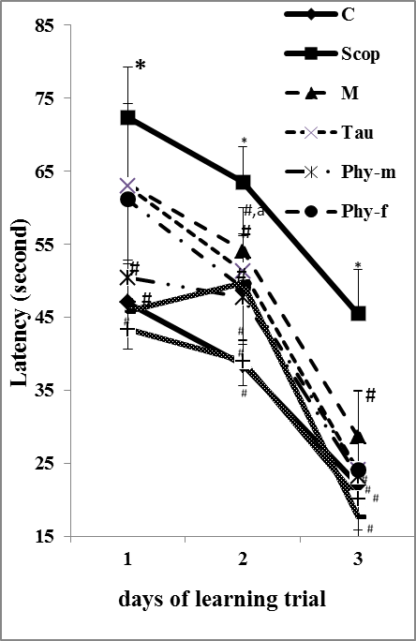

Figure (1): The effect of mefenamic acid, taurine, soy phytoestrogen and their combined treatment on: learning impairment in a scopolamine-induced AD of ♂ & ♀ rats after 5 weeks of treatment.
Data expressed as mean values of 8 rats ± SE.
Significant difference vs. C: *P<0.05
Significant difference vs. Scop: #P<0.05.

From the first learning session day, it was observed that all tested materials showed a shorter latency time than scop-treated group (one-way ANOVA-P<0.05). The potency effect of the nutrient in a descending order showing that: combined treatment (♂ or ♀) have more improving effect > individually phy-treatment > then Tau & M treatment (ªP<0.05 vs. M-treatment). Also the data revealed that there is no deference between male and female rats by dietary soy phytoestrogens on learning and memory test.

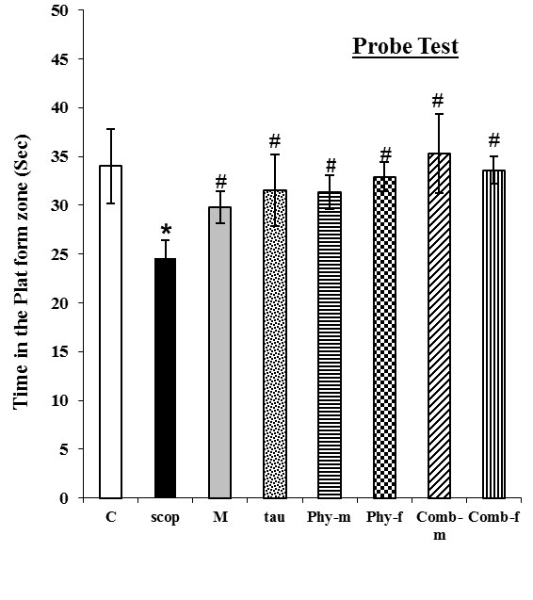

Figure (2): The effect of mefenamic acid, taurine, soy phytoestrogen and their combined treatment on memory impairment in a scopolamine-induced AD of ♂ & ♀ rats after 5 weeks of treatment.
Data expressed as mean values of 8 rats ± SE.
Significant difference vs. C: *P<0.05
Significant difference vs. Scop: #P<0.05.
Probe test was performed and recorded average latencies in zone without platform to show memory impairment in scop-treated rats. The different tested materials attenuated memory impairment induced by scop. Both combined treatment stayed longer in that zone more than individually treated tested materials vs. Scop treatment (One-way ANOVA-P<0.05).

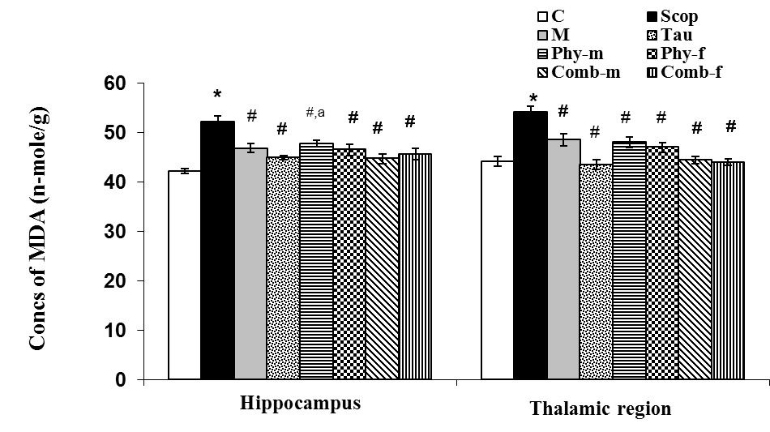

Figure (3): The effect of mefenamic acid, taurine, soy phytoestrogen and their combined treatment on the level of MDA concentration (nmole/g) in hippocampus and thalamic region of ♂ & ♀ brain rats after 5 weeks of treatment.
Data expressed as mean values of 8 rats ± SE.
Significant different vs. C: *P<0.05, vs. Scop: #P<0.05, vs. Comb-m: ªP<0.05.

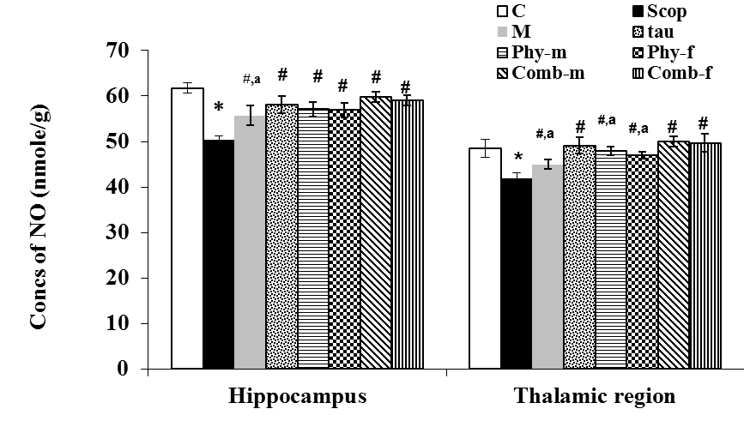

Figure (4): The effect of mefenamic acid, taurine, soy phytoestrogen and their combined treatment on the level of NO concentration (nmole/g) in hippocampus and thalamic region of ♂ & ♀ brain rats after 5 weeks of treatment.
Data expressed as mean values of 8 rats ± SE.
Significant different vs. C: *P<0.05, vs. Scop: #P<0.05, vs. Comb-m: ªP<0.05.

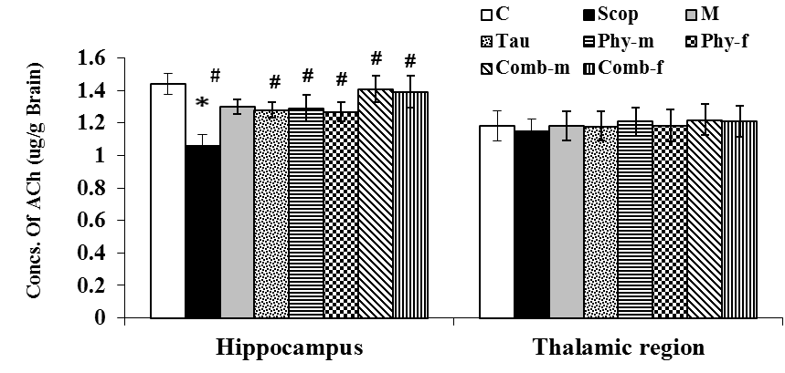

Figure (5): The effect of mefenamic acid, taurine, soy phytoestrogen and their combined treatment on the level of ACh concentration (µg/g) in hippocampus and thalamic region of ♂ & ♀ brain rats after 5 weeks of treatment.
Data expressed as mean values of 8 rats ± SE.
Significant different vs. C: *P<0.05, vs. Scop: #P<0.05, vs. Comb-m: ªP<0.05.
The ACh concentration in thalamic area was not affected by scop-injection while the hippocampus area was significantly affected (P<0.05).

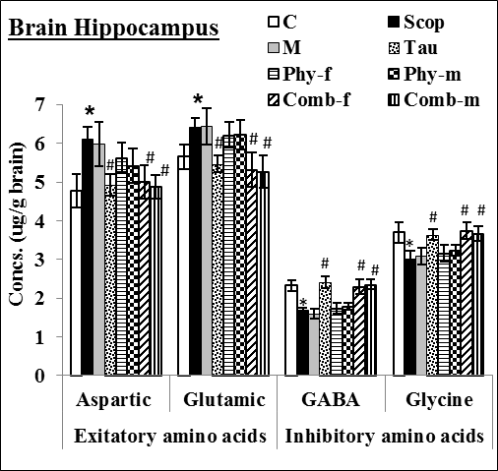
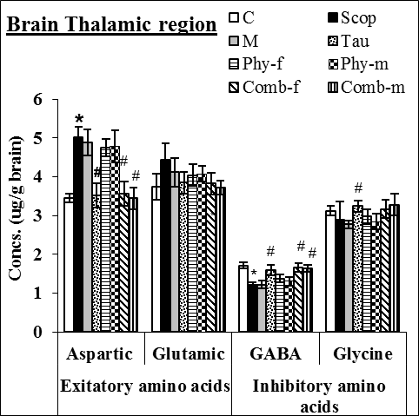

Figure (6, 7): The effect of mefenamic acid, taurine, soy phytoestrogen and their combined treatment on the level of excitatory and inhibitory amino acids concentration (µg/g) in hippocampus (figure 6) and thalamic region (figure7) of ♂ & ♀ brain rats after 5 weeks of treatment.
Data expressed as mean values of 8 rats ± SE.
Significant different vs. C: *P<0.05, vs. Scop: #P<0.05.

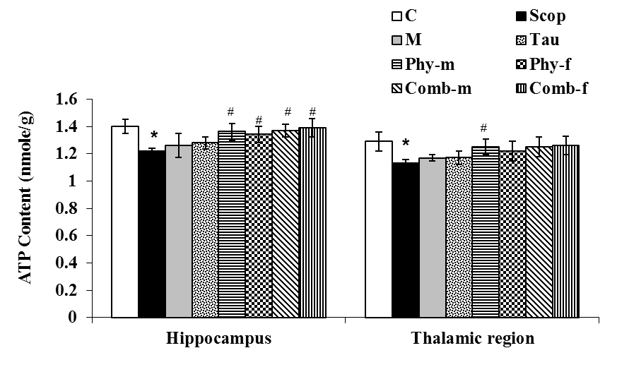
Figure (8): The effect of mefenamic acid, taurine, soy phytoestrogen and their combined treatment on the level of ATP content (nmole/g) in hippocampus and thalamic region of ♂ & ♀ brain rats after 5 weeks of treatment.
Data expressed as mean values of 8 rats ± SE.
Significant different vs. C: *P<0.05, vs. Scop: #P<0.05.

Acknowledgements:

Author is grateful to Professor Dr Ahmed Ezzat, professor of physiology, Department of Zoology, Faculty of Science, Ain Shams University for his valuable final revision.

REFRENCES
- Aaro JJ, Katja AP, Jarkko IV, Veijo S, Anne M, Sirja R, Elina MJ, Erik AAW, Pekka TM: Beneficial Effect of Prolyl Oligopeptidase Inhibition on Spatial Memory in Young but Not in Old Scopolamine-Treated Rats. Basic & Clin Pharm & Tox 2007, 100 (2): 132–138.
- Alreja M, Wu M, Liu W, Atkins JB, Leranth C, Shanabrough M: Muscarinic tone sustains impulse flow in the septohippocampal GABA but not cholinergic pathway: implications for learning and memory. J Neurosci 2000, 20:8103–8110.
- Barber TA, Haggarty MK.: Memantine ameliorates scopolamine-induced amnesia in chicks trained on taste-avoidance learning. Neurobiol Learn Mem 2010, 93(4):540-545.
- Birdsall, TC (1998): Therapeutic applications of taurine, Altern Med Rev 2010, 3(2): 128-36.
- Buccafusco JJ, Terry AV, Webster SJ, Martin D, Hohnadel EJ, Bouchard KA, and Warner SE: The scopolamine-reversal paradigm in rats and monkeys: The importance of computer-assisted operant-conditioning memory tasks for screening drug candidates. Psychopharm, 2008 199:481–494.
- Christopher J: Search strategies used by APP transgenic mice during navigation in the morris water maze. Learn. Mem 2004, 11: 436-446.
- Everett SA, Dennis MF, Tozer GM, Prise VE, Wardman P, Stratford MRL: Nitric oxide in biological fluids” analysis of nitrite and nitrate by high-performance ion chromatography. Journal of Chromatography 1955, (706): 437-442.
- Ferreira IL, Resende R, Ferreiro E, Rego AC, Pereira CF: Multiple defects in energy metabolism in Alzheimer's disease. Curr Drug Targets 2010, 11(10):1193-206.
- Gauthaman KK, Saleem MT, Thanislas PT, Prabhu V, Krishnamoorthy KK, Devaraj NS: Cardioprotective effect of the Hibiscus rosa sinensis flowers in an oxidative stress model of myocardial ischemic reperfusion injury in rat. BMC Complement Altern Med 2006, 6: 32-39.
- Geula C, Mesulam MM: Cholinergic systems and related neuropathological predilection patterns in Alzheimer disease. Terry RD, Katzman R, Bick KL. Alzheimer Disease 1994 pp 263-291 publisher: Raven Press New York.
- Glowinski J, and Iversen , LL: Regional studies of catecholamines in the rat brain. I. The disposition of [3H] dopamine and [3H] dopa in various regions of the brain. J Neurochem1966, 13:655- 669.
- Guangqin F, Chang F, Yu L, Chunhong W, Ji Y, Wei L, Jiangao F, Xianglin S and Yongyi B: Selection of Tested materials for Prevention or Amelioration of Lead-Induced Learning and Memory Impairment in Rats. Ann. Hyg 2009, 53: 341-351.
- Hein AM, O’Banion MK: Neuroinflammation and memory: The Role of Prostaglandins. Mol Neur 2009, (1): 15-32.
- Heinrikson RL, Meredith SC: Amino acid analysis by RP-HPLC: Precolumn derivatization with phenylisothiocyanate. Anal Biochem1984, 136:65-74.
- Javadi-Paydar M, Rayatnia F, Fakhraei N, Zakeri M, Mirazi N, Norouzi A and Dehpour AR: Atorvastatin improved scopolamine-induced impairment in memory acquisition in mice: Involvement of nitric oxide. Brain Res 2011, 1386: 89-99.
- Jeong EU, Lee KY, Kim SH, Sung SH, Kim YC: Cognitive enhancing and anti peoxidant activities of iridoid glycoside from Scrophularia buergeriana in scopolamine treated mice. Eur J Pharmacol 2008, (288): 78- 84.
- Jones RS, Stutte CA: Chromatographic analysis of choline and acetylcholine by u.v. visualization. J. Chromatogr 1985, 319(3), 454-460.
- Joo Y, Kim HS, Woo RS, Park CH, Shin KY, Lee JP, Cang KA, Kim S, Suh YH: Mefenamac acid shows neuroprotective effects and improves cognitive impairment in vitro and vivo Alzheimer's disease models. Mol Pharmacol 2005, (69):76-84.
- Kanwall A, Mehla J, Kunchal M, Naidul VGM, Gupta YK, Sistla R: Anti-Amnesic Activity of Vitex Negundo in scopolamine induced amnesia in rats. Pharmacology & Pharmacy 2010, 1:1-8.
- Karatepe M. Simultaneous: Determination of ascorbic acid and free malonialdehyde in human serum by HPLC-UV. Lcgc North Amerika 2004, 22(4): 362-365.
- Larry MC: Your Brain: A user's Guide, Time Inc., 1271 Avenue of the Americas, New York, NY 10020: The Brain Trust Program, by Larry McCleary M.D. Penguin Group 2007, USA.
- Lephart ED, West TW, Weber KS, Rhees RW, Setchell KD, Adlercreutz H, Lund TD: Neurobehavioral effects of dietary soy phytoestrogens. Neurotoxicol Teratol 2002, 24(1): 5-16.
- Louzada P R, Paula-Lima A C, Mendonça-Silva D L, Noël F, De Mello F G, Ferreir S T:Taurine prevents the neurotoxicity of ß-amyloid and glutamate receptor agonists: activation of GABA receptors and possible implications for Alzheimer’s disease and other neurological disorders. FASEB 2004, (18):511-518.
- Lund TD, West TW, Tian LY, Bu LH, Simmons DL, Setchell KD, Adlercreutz H, Lephart ED: Visual spatial memory is enhanced in female rats (but inhibited in males) by dietary soy phytoestrogens. BMC Neurosciv 2004, (2): 20-32.
- Mahmoodi G, Ahmadi S, Pourmotabbed A, Oryan S, Zarrindast MR: Inhibitory avoidance memory deficit induced by scopolamine: Interaction of cholinergic and glutamatergic systems in the ventral tegmental area. Neurobio Lea Mem 2010, 94(1):83-90.
- Min W, Samuel SN, Joshua BA, Changqing X, Ronald SD, Meenakshi A: Acetylcholin-esterase Inhibitors Activate Septohipp-ocampal GABAergic Neurons via Muscarinic but Not Nicotinic Receptors. JPET 2003, 307, (2): 535–543.
- Miquel J, Ramírez-Boscá A, Ramírez-Bosca JV, Alperi JD: Menopause: A review on the role of oxygen stress and favorable effects of dietary antioxidants. Arch Gerontol Geriatr 2006, 42(3): 289-306.
- Muraoka S, Miura T: Inactivation of cholinesterase induced by non-steroidal anti-inflammatory drugs with horseradish peroxidase: implication for Alzheimer's disease. Life Sci 2009, 84(9-10): 272-277.
Paula-Lima AC, De Felice FG, Brito-Moreira J, Ferreira ST: Activation of GABA (A) receptors by taurine and muscimol blocks the neurotoxicity of beta-amyloid in rat hippocampal and cortical neurons. Neuropharmac 2005, 49(8): 1140-1148.
- Pitsikas N: The nitric oxide (NO) donor molsidomine antagonizes scopolamine and L-NAME-induced performance deficits in a spatial memory task in the rat. Behav Brain Res 2009, 200(1):160-164.
- Rosemberga DB, Rochaa RF, Ricoa EP, Zanotto-Filhoa A, Diasd RD, Bogoe MR, Bonand CD, Moreiraa JCF, Klamta F, Souzaa DO: Taurine prevents enhancement of acetylcholinesterase activity induced by acute ethanol exposure and decreases the level of markers of oxidative stress in zebrafish brain. Cellular and Molecular Neuroscience 2010, 171(15): 683-692.
- Roth A, Schaffner W, Hertel C: Phytoestrogen kaempferol (3,4',5,7-tetrahydr-oxyflavone) protects PC12 and T47D cells from beta-amyloid-induced toxicity. J Neurosci Res 1999, 57(3): 399-404.
- Saraf MK, Prabhakar S, Lal KK, Anand A: Bacopa monniera Attenuates Scopolamine-Induced Impairment of Spatial Memory in Mice. Evid-Based Complem and Altern Med 2011, 2011(236186): 1-10.
- Sarkaki A, Amani R, Badavi M, Moghaddam AZ, Aligholi H, Safahani M, Haghighizadeh MH: Pre-treatment effect of different doses of soy isoflavones on spatial learning and memory in an ovariectomized animal model of Alzheimer's disease. Pak J Biol Sci 2008, 11(8): 1114-1119.
- Savonenko AV, Markowska AL: The cognitive effects of ovariectomy and estrogen replacement are modulated by aging. Neuroscience 2003, (119):821–830.
- Schumacher M, Guennoun R, Ghoumari A, Massaad C, Robert F, El-Etr M, AkwaY, Rajkowski K, Baulieu EE: Novel Perspectives for Progesterone in Hormone Replacement Therapy, with Special Reference to the Nervous System. Endocrine Reviews 2007, (28): 387–439.
- Sharma AC, Kulkarni SK: Baclofen sensitive scopolamine-induced short-term memory deficits in mice. Indian J Exp Biol 1993, 31(4):348-352.
- Shi C, Xu XW, Forster EL, Tang LF, Ge Z, Yew DT, Xu J: Possible role of mitochondrial dysfunction in central neurodegeneration of ovariectomized rats. Cell Biochem Funct 2008, 26(2):172-178.
- Steven CV, Donald RM, Neil WK, David TF: Protective effects of NSAIDs on the development of Alzheimer disease. Neurology 2008, (70): 1672-1677.
- Vandana SN, Sampat VK, Laxman AK, Adhikrao VY: Cognitive enhancing and antioxidant activity of ethyl acetate soluble fraction of the methanol extract of Hibiscus rosa sinensis in scopolamine-induced amnesia. Ind J Pharm 2011, 43(2): 137-142.
- Vanize M, Cristiane M, Luciane F, Clovis W, Angela W: Ovariectomy alters energy metabolism in rat striatum: effect of supplementation with soy diet rich in isoflavones. Metabolic Brain Disease 2011, 26 (2): 97-105.
- Whirley BK, Einat H: Taurine trials in animal models offer no support for anxiolytic, antidepressant or stimulant effects. Isr J Psychiatry Relat Sci 2008, 45(1): 11-18.
- Wojciech H, Elmira A, Simo SO, Pirjo S, Jan A: Taurine reduces ammonia- and N-methyl-D-aspartate-induced accumulation of cyclic GMP and hydroxyl radicals in microdialysates of the rat striatum. Eur. J. Pharm 2003, (468): 21–25.
- Xu XW, Shi C, He ZQ, Ma CM, Chen WH, Shen YP, Guo Q, Shen CJ, Xu J: Effects of phytoestrogen on mitochondrial structure and function of hippocampal CA1 region of ovariectomized rats. Cellular and Molecular Neurobiology 2008, 28(6):875-886.
- YE C, ZHANG L, Li L: Effect of Taurine on learning-memory ability and M-cholinergic receptor in dementia model mice induced by scopolamine. Chin pharm bull 2005, 6-018.
- Zhang YW, Long C, Shi SY: Determination of the adenosine triphosphate in myocardial tissue by ion-pair reversed phase high performance liquid chromatography. Se Pu 2000, 18(4): 322-324.
- Zhao L, Brinton RD: WHI and WHIMS follow-up and human studies of soy isoflavones on cognition. Expert Rev Neurother 2007, 7(11): 1549-1564.

7/2/2011

