Quantification Study of Toxic Heavy Metals Pollutants in Sediment Samples Collected From Kasardi River Flowing Along the Taloja Industrial Area of Mumbai, India

R.S.Lokhande¹, P.U.Singare², D.S.Pimple³

^{1.}Department of Chemistry, University of Mumbai, Santacruz, Vidyanagari, Mumbai 400 098, India ^{2.}Department of Chemistry, Bhavan’s College, Munshi Nagar, Andheri (West), Mumbai 400058, India
^{3.}Department of Chemistry, R.J. College, Ghatkopar, Mumbai 400 086. India
pravinsingare@vsnl.net

Abstract: The present paper deals with quantification study of some toxic heavy metals in the sediment samples of Kasardi River flowing along the Taloja Industrial belt of Mumbai. The results indicates high level of pollution due to toxic heavy metals like chromium (Cr), cadmium (Cd), nickel (Ni), zinc (Zn), copper (Cu), lead (Pb) and iron (Fe). All these heavy metals were found to be much above the acute toxicity level. It is feared that these metals may enter the food chain through bio-magnification there by creating threat to aquatic life and the surrounding population. The results of the present investigation point out the need to implement common objectives, compatible policies and programmes for improvement in the industrial waste water treatment methods.
[R.S.Lokhande, P.U.Singare, D.S.Pimple. Quantification Study of Toxic Heavy Metals Pollutants in Sediment Samples Collected From Kasardi River Flowing Along the Taloja Industrial Area of Mumbai, India. New York Science Journal 2011;4(9):66-71]. (ISSN: 1554-0200). http://www.sciencepub.net/newyork.

Key words: Heavy metals; pollution; sediments; industrial effluent; Kasardi River; Taloja Industrial Area; Mumbai; India

1. Introduction
With the increased use of a wide variety of metals in industries and in our daily life, there is now a greater awareness of toxic metal pollution of the environment. Many of these metals tend to remain in the ecosystem and eventually move from one compartment to the other within the food chain. Food chain contamination by heavy metals has become a burning issue in recent years because of their potential accumulation in biosystems through contaminated water, soil and air (Lokhande and Kelkar, 1999). These toxic metals not only pollute the creek waters but also pose a threat to the aquatic biota (Aghor, 2007; Patil, 2009). The increase in residue levels of heavy metal content in water, sediments and biota, will result in decreased productivity (Lokhande and Kelkar, 1999) and increase in health risk in case of human beings (Kazi et al. 2009, Gbaruko et al., 2008; Ember, 1975; Sunderman, 1959; Cai, 2009; Pokhrel, 2009). For better understanding of heavy metal sources, their accumulation in the sediment and in water seem to be particularly important issues of present day research on risk assessments (Sharma et al., 2004). In hydrosphere, toxic metal concentrations are typically orders of magnitude greater in the sediments as compared to those in overlying waters. The capacity of the soil and sediments to concentrate trace levels of most of the metals make them useful indicators for monitoring purposes and for detecting sources of pollution in the aquatic system. Therefore the analysis of soil and sediment cores may provide a historical record of the heavy metal burdens.
Although some heavy and trace metallic elements are important for proper functioning of biological systems, their deficiency or excess could lead to a number of disorders (Ward, 1995). There is considerable concern about the human health aspects of metal cycling in polluted coastal and inland waters that are in proximity to large population centres. With the ever increasing pace of industrialization in Maharashtra state, the price of industrial development is heavily borne by most of aquatic bodies in the state. A report of the Central Pollution Control Board (CPCB) shows that Maharashtra state has the largest number of polluted river water stretches in the country. According to experts, along with the unchecked industrial pollution, the rapid pace of urbanisation has contributed to the pollution of water in the country (Zingde and Govindan, 2001; Modak et al., 1990; Rajaram and Das, 2008; Khurshid et al., 1998; Pachpande and Ingle, 2004; Prabha and Selvapathy, 1997; Singare et al., 2010a; Singare et al., 2011a; Singare et al., 2011b; Singare et al., 2010b; MPCB, 2004). Among the pollutants entering in the aquatic environment, the toxic heavy metals are creating more serious environmental problem owing to their non bio-degradable nature, accumulative properties and long biological half lives. It is also difficult to remove them completely from the environment once they enter into it. Due to their particle reactivity, metals tend to accumulate in sediments, and, as a result, may persist in the environment long after their primary source has been removed. These toxic metals are not necessarily fixed by the sediments permanently, but may be recycled via biological and chemical agents both within the sedimentary compartment as well as in the water column. Behaviour of these metals in the coastal marine sediments is largely related to their capacity for complexation with organic matter in truly dissolved, colloidal, macro particulate phases. These metals entering the ecosystem may lead to geoaccumulation, bioaccumulation, biomagnification and may have possibilities for environmental transformation into more toxic form. These toxic heavy metals entering in aquatic environment are adsorbed onto particulate matter, although they can form free metal ions and soluble complexes that are available for uptake by biological organisms (Salomons and Forstner, 1984). The metals associated with particulate material are also available for biological uptake (Lee et al., 2000), and are deposited in estuarine sediments (Weston and Maraya, 2002). Once deposited, binding by sulfides and/or iron hydroxides immobilizes trace metals until a change in redox or pH occurs (Adams et al., 1992; Maher et al., 1999). Thus, surfical sediments, particularly the fine fraction, accumulate trace metals and provide a means for evaluating the long term accumulation of heavy metal contaminants (Adams et al., 1992; Kennicutt et al., 1994).
The problem of environmental pollution due to heavy metals has begun to cause concern now in most of the major metropolitan cities in Maharashtra state and Mumbai is not an exception to it. The day by day increasing tremendous industrial pollution (Zingde and Govindan, 2001; Modak et al., 1990; Rajaram and Das, 2008; Khurshid et al., 1998; Pachpande and Ingle, 2004; Prabha and Selvapathy, 1997; Singare et al., 2010a; Singare et al., 2011a; Singare et al., 2011b; Singare et al., 2010b; MPCB, 2004) has prompted us to carry the systematic and detail study of pollution due to toxic heavy metals in soil samples collected from Taloja Industrial estate which is considered as one of the fastest developing industrial belt of Mumbai.

2. Materials and methods
2.1 Area of study
The Kasardi River which is the study area of present investigation receives heavy pollution load from near by Taloja industrial area, which is one of the most rapidly developing and heavily polluted industrial belts of Mumbai. The industrial area is spread over 863.18 hectares of land consisting of about 600 large and medium scale industries like engineering units, steel processing industries, chemical units, paints, pharmaceutical units, textile industries etc. The study area lies between latitude 19°3'39"N longitudes 73°6'57"E. The main water source for the industrial consumption is Maharashtra Industrial Development Corporation. The industrial area utilizes about 45,000 m³/day of fresh water. The effluent discharge, treated and untreated amounts to 28,750 m³/day i.e., 64% of the total industrial effluents. This has created health hazards not only for local population but also resulted in disturbances of aquatic life of the Kasardi River flowing near the industrial area.
2.2 Climatic conditions
The weather of the study area is typical coastal sultry and humid. The average rainfall records from 1,500 mm to 2,000 mm. The place experiences the onset of the monsoon in the month of June and experiences monsoon till the end of September. The average temperature recorded varies from 25 to 42 degrees.
2.3 Requirements
All the glassware, casserole and other pipettes were first cleaned with tape water thoroughly and finally with de-ionized distilled water. The pipettes and burette were rinsed with solution before final use. The chemicals and reagent were used for analysis were of analytical reagent grade. The procedure for calculating the different parameters were conducted in the laboratory.
2.4 Sediment sampling and sample preparation
The study was performed for a period of twenty four months from January 1999 to December 2000. The sediment samples were collected randomly twice in a month in morning, afternoon and evening from downstream (A-1) and upstream (A-2) of the river at different depths. Sediment samples from the top layer (0–15 cm) and sub layer (15–30 cm) were sampled separately. The samples were collected by hand-pushing plastic core tubes (7 cm diameter) as far as possible into the soil. The sediment cores retrieved in the field were sliced on arrival at the lab at 1 cm depth intervals for the first 15 cm, 2 cm depth intervals from 15–25 cm, and then every 5 cm for the deeper sections of the cores. The samples where air dried for eight days, ground using agate mortar and sieved with a 0.5 mm mesh size sieve to remove stones, plant roots and have sample of uniform particle size. Sediment samples from two different layers where mixed thoroughly, packed in polythene bags and kept in a dry place until analyses. Well-mixed samples of 2 g each were taken in 250 mL glass beakers and digested with 8 mL of aqua regia on a sand bath for 2 h. After evaporation to near dryness, the samples where dissolved with 10 mL of 2% nitric acid, filtered through Whatman’s No. 1 filter paper and then diluted with deionised water to give final volumes depending on the suspected level of the metals (Chen and Ma, 2001). The samples were subjected to nitric acid digestion using the microwave-assisted technique, setting pressure at 30 bar and power at 700 watts (Clesceri, 1998; Paar, 1998).

Table 1. Heavy Metal Content in sediment samples of Kasardi River

Year | Months | Heavy Metals
Year | Months | Cr |  | Cd |  | Ni |  | Zn |  | Cu |  | Pb |  | Fe
Year | Months | A-1 | A-2 | A-1 | A-2 | A-1 | A-2 | A-1 | A-2 | A-1 | A-2 | A-1 | A-2 | A-1 | A-2
1999 | January | 31.1 | 37.5 | 34.7 | 39.2 | 73.8 | 85.3 | 679.8 | 713.3 | 102.0 | 127.2 | 11.9 | 23.7 | 18,054.8 | 19,913.2
1999 | February | 31.7 | 43.6 | 34.9 | 41.5 | 76.2 | 85.9 | 685.3 | 729.1 | 107.5 | 130.4 | 13.4 | 24.9 | 18,079.2 | 21,618.7
1999 | March | 39.3 | 52.3 | 35.7 | 44.7 | 77.9 | 89.4 | 692.5 | 733.2 | 109.7 | 132.9 | 14.2 | 25.1 | 18,093.2 | 23,568.3
1999 | April | 43.5 | 58.7 | 35.9 | 47.9 | 79.6 | 91.3 | 703.0 | 749.2 | 119.2 | 137.5 | 14.8 | 27.4 | 18,110.3 | 24,223.6
1999 | May | 57.4 | 68.4 | 47.2 | 57.6 | 81.2 | 97.4 | 712.8 | 754.6 | 124.3 | 141.4 | 15.3 | 31.3 | 18,126.2 | 24,320.4
1999 | June | 46.3 | 61.7 | 43.7 | 50.8 | 73.5 | 89.7 | 697.4 | 744.2 | 116.5 | 131.6 | 14.7 | 29.2 | 18,116.1 | 23,989.2
1999 | July | 38.7 | 56.3 | 40.2 | 43.2 | 62.5 | 81.3 | 681.2 | 731.9 | 104.7 | 124.2 | 13.7 | 23.5 | 18,109.8 | 23,697.9
1999 | August | 29.4 | 50.6 | 33.7 | 37.6 | 57.2 | 75.3 | 665.1 | 719.8 | 98.9 | 117.1 | 13.1 | 18.5 | 18,087.4 | 23,513.7
1999 | September | 23.5 | 47.1 | 30.4 | 32.4 | 51.0 | 67.8 | 661.4 | 713.2 | 96.3 | 110.7 | 12.7 | 18.2 | 18,081.4 | 23,489.8
1999 | October | 27.4 | 52.3 | 32.5 | 36.9 | 55.4 | 73.4 | 672.3 | 722.3 | 107.6 | 121.7 | 13.3 | 20.8 | 18,089.2 | 23,619.3
1999 | November | 29.5 | 55.1 | 33.6 | 37.2 | 59.8 | 79.6 | 678.5 | 723.7 | 115.2 | 126.3 | 13.5 | 21.4 | 18,093.2 | 23,624.7
1999 | December | 30.8 | 56.9 | 33.9 | 38.4 | 64.7 | 83.1 | 682.3 | 724.1 | 116.9 | 128.5 | 13.6 | 23.9 | 18,097.0 | 23,813.4
Average Values |  | 35.7 | 53.4 | 36.4 | 42.3 | 67.7 | 83.3 | 684.3 | 729.9 | 109.9 | 127.5 | 13.7 | 24.0 | 18094.8 | 23282.7
2000 | January | 42.6 | 43.2 | 37.3 | 31.7 | 65.6 | 78.3 | 605.8 | 721.4 | 129.2 | 133.5 | 13.7 | 27.3 | 21,109.8 | 23,218.6
2000 | February | 45.2 | 55.9 | 42.1 | 39.8 | 69.4 | 69.3 | 633.7 | 729.2 | 131.5 | 141.7 | 15.2 | 29.3 | 21,117.2 | 23,007.2
2000 | March | 48.3 | 63.4 | 46.8 | 46.2 | 71.5 | 82.4 | 652.6 | 733.4 | 137.2 | 148.3 | 19.7 | 33.5 | 21,123.4 | 23,102.7
2000 | April | 59.6 | 66.7 | 51.9 | 48.3 | 77.4 | 93.6 | 687.3 | 739.5 | 144.5 | 152.1 | 21.3 | 37.6 | 21,136.5 | 23,187.4
2000 | May | 63.4 | 72.5 | 56.2 | 63.1 | 89.2 | 104.7 | 694.9 | 748.9 | 157.3 | 156.3 | 24.8 | 42.4 | 21,143.2 | 23,237.3
2000 | June | 56.5 | 67.8 | 52.3 | 59.2 | 81.1 | 99.7 | 689.4 | 733.6 | 147.2 | 148.7 | 22.4 | 35.2 | 21,131.7 | 22,989.1
2000 | July | 51.2 | 60.1 | 46.2 | 43.2 | 75.7 | 89.2 | 673.5 | 721.0 | 132.3 | 131.5 | 17.1 | 28.7 | 21,116.3 | 22,807.3
2000 | August | 43.2 | 60.1 | 39.5 | 38.7 | 68.3 | 81.5 | 662.5 | 712.3 | 121.7 | 127.8 | 15.3 | 21.3 | 21,107.4 | 22,519.2
2000 | September | 39.8 | 60.1 | 32.4 | 32.2 | 61.5 | 76.3 | 657.6 | 708.4 | 117.3 | 120.3 | 14.6 | 25.8 | 21,101.2 | 22,478.1
2000 | October | 44.3 | 64.6 | 35.5 | 41.2 | 66.8 | 77.9 | 663.7 | 719.6 | 123.3 | 133.6 | 14.9 | 27.9 | 21,113.3 | 22,503.2
2000 | November | 45.4 | 68.3 | 37.2 | 47.9 | 67.3 | 86.5 | 667.9 | 723.1 | 127.4 | 139.4 | 15.9 | 27.5 | 21,117.6 | 22,614.1
2000 | December | 46.7 | 71.4 | 37.9 | 53.2 | 68.9 | 89.1 | 671.2 | 729.4 | 128.7 | 146.3 | 16.3 | 29.3 | 21,119.4 | 22,921.4
Average Values |  | 48.9 | 62.8 | 42.9 | 45.4 | 71.9 | 85.7 | 663.3 | 726.7 | 133.1 | 140.0 | 17.6 | 30.5 | 21119.8 | 22882.1
A-1- downstream of the River A-2- upstream of the River

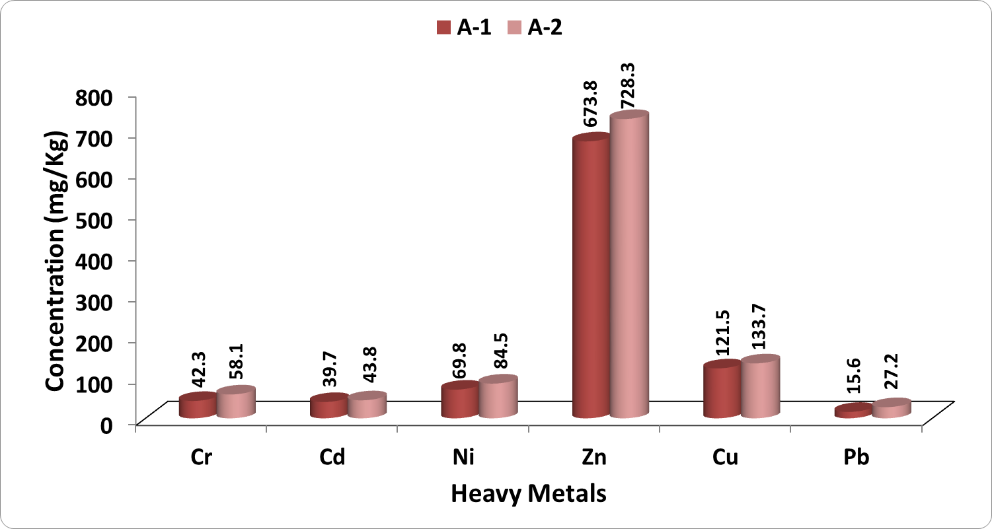
Figure 1. Variation in Average Heavy Metal Content in Sediment Samples of Kasardi River for the Assessment Year 1999-2000

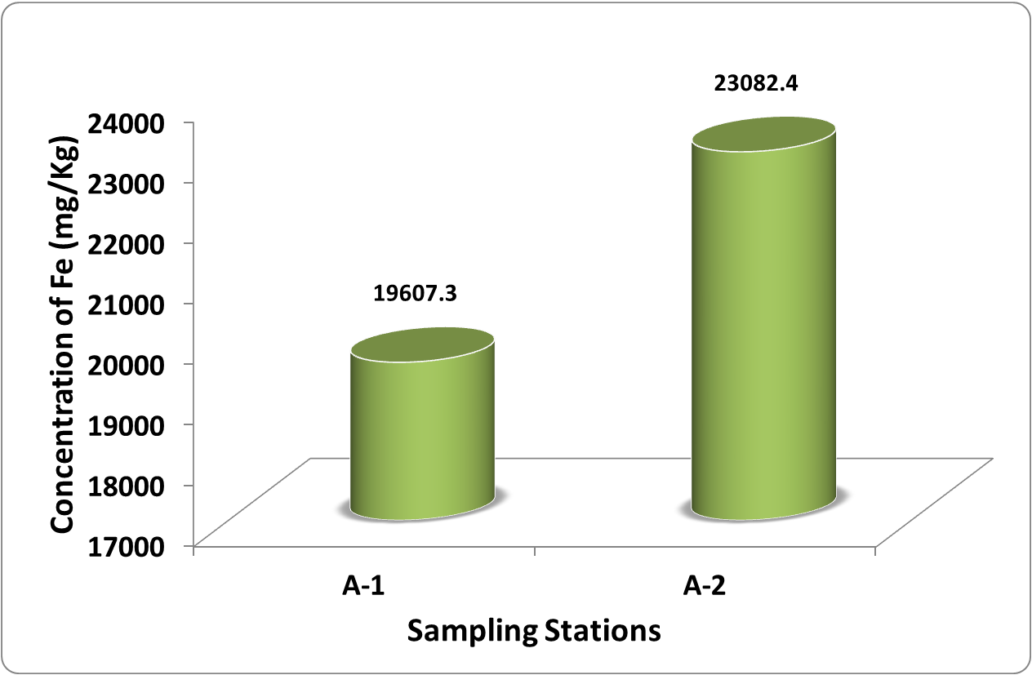
Figure 2. Variation in Average Fe Content in Sediment Samples of Kasardi River for the Assessment Years 1999 and 2000

2.6 Heavy metal analysis by AAS technique
The analysis for the majority of the trace metals like chromium (Cr), cadmium (Cd), nickel (Ni), zinc (Zn), copper (Cu), lead (Pb) and iron (Fe) was done by Perkin Elmer ASS-280 Flame Atomic Absorption Spectrophotometer. The calibration curves were prepared separately for all the metals by running different concentrations of standard solutions. A reagent blank sample was taken through the method, analyzed and subtracted from the samples to correct for reagent impurities and other sources of errors from the environment. Average values of three replicates were taken for each determination.

3. Results and Discussion
The experimental data on heavy metal content in sediment samples collected from Kasardi River flowing along Taloja industrial estate of Mumbai is presented in Table 1.
A number of elements are normally present in relatively low concentrations, usually less than a few mg/L, in conventional irrigation waters and are called trace elements. Heavy metals are a special group of trace elements which have been shown to create definite health hazards when taken up by plants. Under this group are included, Cr, Cd, Ni, Zn, Cu, Pb and Fe. These are called heavy metals because in their metallic form, their densities are greater than 4 g/cc.
The average Cr content in sediment samples for the two assessment years was found to vary between 42.3 mg/Kg in downstream and 58.1 mg/Kg in upstream of the river (Figure 1). Cr compounds are used as pigments, mordents and dyes in the textiles and as the tanning agent in the leather. The sources of emission of Cr in the surface waters are from municipal wastes, laundry chemicals, paints, leather, road run off due to tire wear, corrosion of bushings, brake wires and radiators, etc. The high level of Cr in waste water effluent indicates excessive pollution from textile industries and tanneries (Pachpande and Ingle, 2004). Cr is generally more toxic at higher temperatures and its compounds are known to cause cancer in humans (Ember, 1975). The toxic effect of Cr on plants indicate that the roots remain small and the leaves narrow, exhibit reddish brown discoloration with small necrotic blotches (Centre for Ecological Sciences, 2001).
Cd is contributed to the surface waters through paints, pigments, glass enamel, deterioration of the galvanized pipes etc. The wear of studded tires has been identified as a source of Cd deposited on road surfaces. The average Cd content in water samples was found to vary between 39.7 mg/Kg in downstream and 43.8 mg/Kg in upstream of the river (Figure 1). Higher values of Cd in sediment samples suggest the high level of pollution due to dyes paints and pigments manufacturing industries around. These Cd may enter the food chain through the contaminated fishes or through the vegetation growing along the river. There are a few recorded instances of Cd poisoning in human beings following consumption of contaminated fishes. It is less toxic to plants than Cu, similar in toxicity to Pb and Cr. It is equally toxic to invertebrates and fishes (Moore and Ramamoorthy, 1984).

The average Ni content in the sediment samples was found to vary between 69.8 and 84.5 mg/Kg in downstream and upstream of the river respectively (Figure 1). Ni can accumulate in aquatic life, but its magnification along in food chain is not confirmed. The long-term exposure to Ni can cause decreased body weight, heart, liver damage and skin irritation (Tiwana et al., 2005). Although the previous research works by Sunderman (1959) suggest the carcinogenic effect on rats, the effect of short-term exposure to Ni on human being is not known to cause any health problems.
In the present study the average concentration of Zn in downstream and upstream sediment samples was found to be 673.8 mg/Kg and 728.3 mg/Kg respectively (Figure 1). Excessive concentration of Zn may result in necrosis, chlorosis and inhibited growth of plants.
The average Cu content in sediment samples was found to vary between 121.5 mg/Kg in downstream and 133.7 mg/Kg in upstream of the river (Figure 1). It is important here to note that Cu is highly toxic to most fishes, invertebrates and aquatic plants than any other heavy metal except mercury. It reduces growth and rate of reproduction in plants and animals. The chronic level of Cu is 0.02–0.2 mg/L (Moore and Ramamoorthy, 1984). Aquatic plants absorb three times more Cu than plants on dry lands (Centre for Ecological Sciences, 2001). Excessive Cu content can cause damage to roots, by attacking the cell membrane and destroying the normal membrane structure; inhibited root growth and formation of numerous short, brownish secondary roots. Cu becomes toxic for organisms when the rate of absorption is greater than the rate of excretion, and as Cu is readily accumulated by plants and animals, it is very important to minimize its level in the waterway.
Lead is one of the oldest metals known to man and is discharged in the surface water through paints, solders, pipes, building material, gasoline etc. Lead is a well known metal toxicant and it is gradually being phased out of the materials that human beings regularly use. Combustion of oil and gasoline account for > 50% of all anthropogenic emissions, and thus form a major component of the global cycle of lead. Atmospheric fallout is usually the most important source of lead in the freshwaters (Moore and Ramamoorthy, 1984). The average concentration of Pb in sediment samples was found out to be 15.6 mg/Kg in downstream and 27.2 mg/Kg in upstream of the river (Figure 1). Acute toxicity generally appears in aquatic plants at concentration of 0.1–5.0 mg/L. In plants, it initially results in enhanced growth, but from a concentration of 5 ppm onwards, this is counteracted by severe growth retardation, discoloration and morphological abnormalities. There is an adverse influence on photosynthesis, respiration and other metabolic processes. Acute toxicity of Pb in invertebrates is reported at concentration of 0.1–10 mg/L (Moore and Ramamoorthy, 1984). Higher levels pose eventual threat to fisheries resources.
In the present study, the average concentrations of Fe vary from 19607.3 mg/Kg to 23082.4 mg/Kg respectively in the sediment samples collected from downstream and upstream of the river (Figure 2). The presence of high concentration of Fe may increase the hazard of pathogenic organisms; since most of these organisms need Fe for their growth (Tiwana et al., 2005).

4. Conclusion
Around the world as countries are struggling to arrive at an effective regulatory regime to control the discharge of industrial effluents into their ecosystems, Indian economy holds a double edged sword of economic growth and ecosystem collapse. The present experimental data indicates high level of pollution along Kasardi River of Taloja Industrial estate of Mumbai, India. The experimental data suggests a need to implement common objectives, compatible policies and programmes for improvement in the industrial waste water treatment methods. It also suggests a need of consistent, internationally recognized data driven strategy to assess the quality of waste water effluent and generation of international standards for evaluation of contamination levels. The existing situation if mishandled can cause irreparable ecological harm in the long-term well masked by short term economic prosperity.

Corresponding Author:
Dr. Pravin U. Singare
Department of Chemistry,
Bhavan’s College,
Andheri (West),
Mumbai 400058, India
E-mail:pravinsingare@vsnl.net

References
1. Lokhande RS, Kelkar N. Studies on heavy metals in water of Vasai Creek, Maharashtra. Indian J Environ Protect 1999; 19(03): 664–68.
2. Aghor A. Chemicals make Thane creek the worst polluted waterbody. Daily DNA. August 14, 2007. Mumbai, India. Obtained through the Internet:http://www.dnaindia.com/mumbai/report_chemicals-make-thane-creek-the-worst-polluted-waterbody_1115439 [Accessed 01/03/2010].

3. Patil D. A lot's fishy about our creek and lake fish. Daily Times of India. March 22, 2009. Mumbai, India.

Obtained through the Internet: http://timesofindia.indiatimes.com/city/thane/A-lots- fishy-about-our-creek-and-lake-fish/articleshow/4298566.cms [Accessed 01/03/2010].
4. Kazi TG, Arain MB, Baig JA. The correlation of arsenic levels in drinking water with the biological samples of skin disorders. The Science of the total environment, 2009; 407(3):1019–26.
5. Gbaruko BC, Ana GR, Nwachukwu JK. Ecotoxicology of arsenic in the hydrosphere: implications for public health. African Journal of Biotechnology 2008; 7(25):4737–42.
6. Ember L. The spectra of cancer. Environ Sci Tech 1975; 9(13):1116–21.

7. Sunderman FW. Nickel poisoining carcinogenesis in rats exposed to nickel carbonyl. Arch Ind 1959; 20(1): 36–41.
8. Cai L, Liu G, Rensing C, Wang G. ‘Genes involved in arsenic transformation and resistance associated with different levels of arsenic-contaminated soils. BMC microbiology 2009; 9:4
9. Pokhrel D, Bhandari BS, Viraraghavan T. Arsenic contamination of groundwater in the Terai region of Nepal: an overview of health concerns and treatment options. Environment International 2009; 35(1):157-61.
10. Sharma RK, Agrawal M, Marshall FM. Effects of waste water irrigation on heavy metal accumulation in soil and plants, Paper presented at a National Seminar, Bangalore University, Bangalore, 2004;Abst. no. 7, pp. 8.
11. Ward NI. ‘Environmental analytical chemistry’ In: Fifield FW, Haines PJ.(eds.), Trace Elements, Blackie Academic and Professional, UK, 1995: 320.
12. Zingde MD, Govindan K. Health status of coastal waters of Mumbai and regions around. In: Environmental Problems of Coastal Areas in India (ed. Sharma VK), Bookwell Publishers, New Delhi, 2001:119.
13. Modak DM, Singh KP, Ahmed S, Ray PK. Trace metal ion in Ganga water system. Chemosphere 1990; 21 (1-2):275–87.
14. Rajaram T, Das A. Water pollution by industrial effluents in India: discharge scenarios and case for participatory ecosystem specific local regulation. Futures 2008; 40(1):56–69.
15. Khurshid S, Abdul B, Zaheeruddin A, Usman SM. Effect of waste disposal on water quality in parts of Cochin, Kerala. Indian J Environ Health 1998; 40(1): 45–50.
16. Pachpande BG, Ingle ST. Recovery of the chromium by chemical precipitation from tannery effluent. Orient J Chem 2004; 20(1): 117–23.
17. Prabha S, Selvapathy P. Heavy metal pollution in Indian Rivers. Indian J Environ Prot 1997;17(6):641–49.
18. Singare PU, Lokhande RS, Pathak PP. Study on Physico-Chemical properties and Heavy Metal Content of the Soil Samples from Thane Creek of Maharashtra, India. Interdisciplinary Environmental Review 2010; 11(01): 38-56.
19. Singare PU, Lokhande RS, Jagtap AG. Water pollution by discharge effluents from Gove Industrial Area of Maharashtra, India: Dispersion of heavy metals and their Toxic effects. International Journal of Global Environmental Issues 2011; 11(1): 28–36.
20. Singare PU, Lokhande RS, Bhattacharjee SS. Physico-Chemical Analysis of the Sediment Samples collected from Thane Creek of Maharashtra, India. Interdisciplinary Environmental Review (2011); 12(02), 95-107.
21. Singare PU, Lokhande RS, Jagtap AG. Study of Physico-chemical quality of the Industrial Waste Water Effluent from Gove Industrial Area of Bhiwandi City of Maharashtra, India. Interdisciplinary Environmental Review 2010; 11(4):263-73.
22. Report on Mithi River Water Pollution and Recommendations for Its Control, Survey Conducted By Klean Environmental Consultants Pvt. Ltd., Mumbai, As Submitted To Maharashtra Pollution Control Board, Mumbai. Ref.No.0407/Mpcb Mithi River Survey/ 109, July 10, 2004.
23. Salomons W, Forstner U. Metals in the Hydrocycle. Springer-Verlag, New York (1984).
24. Lee BG, Griscom SB, Lee JS, Choi HJ, Koh CH, Luoma SN, Fisher NS. Influence of dietary uptake and reactive sulfides on metal availability from aquatic sediments. Science 2000; 287(5451): 282-84.
25. Weston DP, Maraya KA. Predicting bioavailability and bioaccumulation with in vitro digestive fluid extraction. Environ Toxicol Chem 2002;21(05):962-71.
26. Adams WJ, Kimerle RA, Barnett JW Jr. Sediment quality: and aquatic life assessment. Environ Sci Technol 1992; 26 (10):1864-75.
27. Maher W, Batley GE, Lawrence I. Assessing the health of sediment ecosystems: use of chemical measurements. Freshwater Biol 1999; 41(2): 361-72.
28. Kennicutt MC, Wade TL, Presley BJ, Requejo AG, Brooks JM, Denoux GJ, Sediment contaminants in Casci Bay, Maine: inventories, sources and potential for biological impacts. Environ Sci Technol 1994; 28(1): 1-15.
29. Chen M, Ma LQ. Comparison of three aqua regia digestion methods for twenty florida soils. Soil Science Society of American Journal 2001; 65(2), 491–99.
30. Clesceri LS. Standard methods for the examination of water and waste water, in E. Arnold, Greenbergy, A.D. Eaton, (Eds.): Collection and Preservation of Samples and Metals, pp.1–27, pp.1–35, pp.3–1, pp.3–21, APHA, AWWA, WEF, Washington DC 1998.
31. Paar A. Microwave Sample Preparation System’ – Instruction Handbook, p.128, Anton Paar GmbH, Austria 1998.
32. Centre for Ecological Sciences, IISc Environmental Hand Book – Documentation on Monitoring and Evaluating Environmental Impacts,Compendium of Environmental Standards, Vol. 3, Indian Institute of Science, Bangalore, (2001).Available at http://wgbis.ces.iisc.ernet.in/energy/HC270799/HDL/ENV/START.HTM (Accessed on 01 March 2010).
33. Moore JW, Ramamoorthy S. Heavy Metals in Natural Waters: Applied Monitoring and Impact Assessment, Springer-Verlag, NewYork, 1984:28.
34. Tiwana NS, Jerath N, Singh G, Ravleen M (Eds.). Heavy metal pollution in Punjab Rivers, in Newsletter Environmental Information System (ENVIS), Punjab State Council for Science and Technology, India, 2005; 3(1):3.

8/24/2011

