Protective Effect of Eclipta Alba Extract, Silymarin and their Combination Against Obesity Induce Insulin Resistance and Hyperglycemia In Rats.

Ghada M. Elhadi; S. A. Ghareib and M. A. Mohamed.

Department of Pharmacology, Faculty of Pharmacy, Zagazig University, Egypt.
ghmelhady@yahoo.com

Abstract: This study was designed to show that, if the causative role of obesity in the peripheral and hepatic insulin resistance, was through the induction of systemic oxidative stress or not and if antioxidants alter the natural history of developing diabetes in a rodent model of obesity?. Therefore silymarin and Eclipta alba extract (natural Flvonoids antioxidant) are used in this study to examine their prophylactic effects against high fat diet-induced obesity involved in the development of type II diabetes mellitus. Fasting blood glucose (BG) and serum insulin (SI) levels, in addition to glucose utilization, insulin resistance (IR) and β-cell function were measured as biochemical markers for diabetes mellitus., free fatty acids (FFA), total cholesterol(T-Ch), triglycerides (TG), LDL-C and HDL-C were used as biochemical markers for obesity. Glutathion content (GSH) and superoxide dismutase activity (SOD) were measured as biochemical markers for redox homeostasis. Adult male albino rats were used in this study and arranged into six groups: The first group was kept on normal standard diet and was served as normal control. The second group was left free on high fat diet for 60 days and represent the obese control group. While G_{3,4&6} were received silymarin (100 mg/kg), Eclipta alba extract (75 mg/kg) and metformin (200 mg/kg) respectively in concurrent with high fat diet for 60 days. While G₅ received silymarin (100 mg/kg) and Eclipta alba extract (75 mg/kg) as combination for 60 days. Obtained results revealed that: 1- The incidence of type II diabetes mellitus by obesity, through hyperglycemia, insulin resistance and elevation in total lipids and FFAs, are associated with a reduction in β-cell function and antioxidant defense mechanisms. 2- The progressive reduction in serum lipids especially FFAs and the increase in antioxidant enzymes may lead to the improvement of the hyperglycemic state after the administration of antioxidants (silymarin and Eclipta alba extract). 3- Silymarin and Eclipta alba extract delayed the incidence of obesity-induced diabetes mellitus in normal and obese rats due to its ability to protect both the liver and the pancreas against free radicals that were produced by the elevated FFAs levels. 4- Silymarin and Eclipta alba extract in combination have more potent protective effect than each one alone and than that of metformin.
[Ghada, M. Elhady Ahmed; Salah, A. Ghareib and M. Abdel-Aal. Mohamed.. Protective Effect of Eclipta Alba Extract, Silymarin and their Combination Against Obesity Induce Insulin Resistance and Hyperglycemia In Rats. New York Science Journal 2011;4(9):86-97]. (ISSN: 1554-0200). http://www.sciencepub.net/newyork.

Keywords: Eclipta Alba; Silymarin; diabetes mellitus; Obesity.

1. Introduction:
Obesity is considered as one of the most common nutritional disorder in affluent societies (Friedman; 2000). Obesity, which affects up to 30% of the adult population in developed countries, is associated with serious mortalities including a high incidence of type II diabetes, cardiovascular diseases as well as an increased risk of many forms of cancer (Furukawa et al., 2004). Obesity development or prevention has focused on high fat diets (Cani et al., 2008), which is an important contributor to obesity in some people (Bray et al., 2004). Obesity is now considered as one of the most important precursor state to NIDDM, however not all obese patients develop NIDDM (Guilherme et al., 2008). This is due to defects in this control system that implicated in the link between obesity and type II diabetes (Schwartz and Porte; 2005). Insulin resistance developed as a result of an imbalance of fat distribution between tissues (Shulman; 2000). Plasma FFAs concentration reflects a balance between their release from the lipolysis of triglycerides and their uptake through re-esterification in adipose tissue and liver (Lewis et al., 2002). The net result of increased lipolysis and diminished re-esterification is diversion of FFAs toward non-adipose tissues (Hegele; 2000), which is linked to the development of insulin resistance at these tissues. The FFAs can induce a state of insulin resistance (Waldhausl and Roden; 2000), impair of pancreatic β-cell function and even may cause β-cell death (Bollheimer et al., 1998), as it can be cytotoxic for normal islet β-cells leading to cell death by both necrosis and apoptosis (Cnop et al., 2001). Another pathway that may be involved in the FFA-induced impairment in glucose metabolism is oxidative stress, FFAs can directly increase reactive oxygen species (ROS) (Bakker et al., 2000). In particular, coincident changes in coupled GSH-Px/GSSG-Red and SOD/CAT activities were found to be most influenced by dietary lipid intake (Yuan et al., 1997), leading to the activation of stress-sensitive signaling pathways, which mediate insulin resistance and impaired insulin secretion (Evans et al., 2002). Furthermore the induction of oxidative stress inhibits insulin-stimulated glucose transport (Tirosh et al., 1999). In addition, oxidative stress has been implicated in β-cell dysfunction, as β-Cells are sensitive to ROS, because they are low in free-radical quenching (antioxidant) enzymes (Hotta et al., 2000).
Silymarin is the major chemical constituents of the fruits, seeds and leaves of Milk thistle which has been used clinically as an anti-hepatotoxic agent (Flora et al., 1998), anti-ulcer effect (Alarcon de la Lastra et al., 1992), anti-inflammatory and anti-arthritic effects (Gupta et al., 2000). Soto et al; (2010) demonstrated that silymarin acts through an anti-oxidative effect by the scavenging of reactive oxygen species, or through increasing the intracellular concentration of glutathion and the antioxidant potential (Soto et al., 2003). Silymarin considered as one of the most effective drugs that can be used in type II diabetes mellitus (Soto et al., 2004) and may be therapeutically beneficial for type I diabetes mellitus (Matsuda et al., 2005). Moreover it has been reported that silymarin causes significant reduction in free fatty acids and triglyceride plasma levels (Skottova et al., 2004).
Eclipta alba, is known to be present in the seeds and leaves of Bhringaraj (Dhar et al., 1986). It posses potent anti-hyperglycemic activity for its antioxidant activities (Ananthi et al., 2003).
Metformin, a biguanide derivative (dimethylbiguanide), is one of the most commonly used drugs for the treatment of type II diabetes (Rodriguez-Moctezuma et al., 2005), through increased insulin-independent glucose uptake in peripheral muscle (Kouki et al., 2005). Moreover, it can also increase glucose uptake in skeletal muscles (Bunck et al., 2009). Furthermore, metformin is able to reverse insulin resistance and hyperglycemia in high-risk subjects for type II diabetes mellitus (Biarnes et al., 2005). Metformin has beneficial effects on lipid levels, so it is the first choice in the treatment of overweight people with type II diabetes (Ramachandran et al., 2004).
This study aimed to revealed the effect of silymarin, Eclipta alba extract and their combination compared to metformin in the protection against high fat diet-induced obesity involved in the development of type II diabetes. As well as to investigate the mechanisms concerned in the incidence of obesity- induced type II diabetes mellitus and the role of ROS and their relation to the increase of FFA levels.

2. Materials and Methods
Animals:
95Adult male albino rats weighing 80-110 gm were used. The animals were supplied from the national research center, Cairo, Egypt. They were kept under strictly hygienic conditions. They were put on a standard basal diet according to AOAC (1988) and allowed free access to drinking water.
Tested drugs:
1-Silymarin was purchased from Sigma pharmaceuticals Egypt.
2-Eclipta alba extract was prepared in the pharmacognosy department, faculty of pharmacy.
3-Metformine was purchased from Cid Pharmaceuticals, Cairo, Egypt.
Drug doses were freshly prepared before administration using Dist. water as solvent and given orally.
Experimental design:
Rats used in this study consist of 95 normal rats, 15 normal rats were kept as a normal control group (G₁). The rest 80 animals were received high fat diet for induction of obesity according to the method described by Lauterio et al. (1994), and were given the drugs and their combination starting from the first day of feeding for 6 weeks. Rats of this group were equally distributed between different groups (n =16) starting by G₂ as follow:
Group 2: Rats received saline for 60 days and represent the obese group. Groups _{3,4,6}: Rats received silymarin (100 mg/kg) , Eclipta alba extract (75 mg/kg) and metformin (200 mg/kg) respectively for 60 days. While G₅ received silymarin (100 mg/kg) and eclipta alba extract (75 mg/kg) as combination for 60 days.
II-Methods:
At the end of the treatment schedule, venous blood samples were collected from the orbital sinus of rats according to the method of Schemer (1967). Livers were excised and sliced; fragments were rapidly used for the determination FFAs. Separated serum were processed for biochemical analysis; glucose and glucose tolerance curve were determined by Tinder (1969), insulin was estimated using Feldman and Rodbard (1971), insulin resistance was measured by the method of Matthews et al. (1985), β-cell function can estimated from the fasting blood glucose and insulin levels (Matthews et al., 1985).
free fatty acids were determined according to the method of Ackman and sipos (1964), T-Ch was determined according to Fasce (1982), TG by the method of Young and Pastaner (1975), HDL-C by Lopez (1977) and LDL-C was calculated using the formula of Friedwald et al. (1972). Glutathion content is determined according to the method of Tietze (1969). SOD activity can be measured by using the method of Minami and Yoshikawa (1979).
All parameters are measured using Randox kit (U.K) by using spectrophotometer model PG-T60 except insulin and FFAs levels were measured using Microplate ELIZA reader model SHX-88 and gas liquid chromatography apparatus, Hewlett Packard model 6890 equipped with flame ionization detector respectively.
Statistical analysis:
Data were analyzed using SPSS version 10. All data are expressed as mean ± standard error. The means of different groups were compared using Student t- test and ANOVA.

3. Results and discussion
Obtained results showed that there is a significant (P<0.05) increase in blood glucose level accompanied by parallel increase (P<0.05) in serum insulin level in obese rats compared with normal control one (table and figure.1) These effects were accompanied by reduction in glucose utilization and glucose disposal rate as shown by the significant (P<0.05) increase in the area under glucose curve of oral glucose tolerance in obese rats in comparison with that of normal control (table and figure.2&3). These findings are in accordance with that reported by Johanson et al. (2003) which observed that obesity induced glucose intolerance indicated by the hyperglycemia and hyperinsulinemia. These effects may be, in part, due to the obesity-induced reduction in insulin sensitivity and increased hepatic glucose production (HGP). This proposal is in accordance with that reported by Ilan et al. (2002) and Winer et al. (2009), who stated that obesity is one of the factors that are responsible for the induction of insulin resistance. The main findings of the present study showed a significant correlation between the induced hyperglycemia, hyperinsulinemia and the induction of obesity. These findings are in agreement with that of Borissova et al. (2004), and Kabir et al. (2005), who reported that obesity plays a key role in the development of type II diabetes mellitus, and probably reflects the development of insulin resistance.
The strong correlation between obesity and insulin resistance suggested that there is a major mediator, that might be a circulating factor secreted by adipocytes (Grundy; 2004). In this regard, several possible candidate molecules have been suggested in which, the strongest evidence is that FFAs are the most likely link between obesity and insulin resistance (Briaud et al., 2002 and Craft; 2009).
In addition, results of the present investigation showed that, high fat diet induced a significant (P<0.05) state of dyslipidaemia as indicated by hyperlipidaemia, hypertriglyceridaemia, increased LDL-C, hypercholesterolaemia and reduced HDL-C serum levels (table and figure.4). These effects were accompanied by a significant (P<0.05) increase in both serum and hepatic levels of free fatty acids in obese rats (table and figure.5). These results confirm the previous studies of Dandona et al. (2003) and Anandh Babu et al. (2006), who reported that dyslipidaemia, which is a feature of obesity and insulin resistance, is associated with an increase in lipoprotein profile. One of the most important effects of obesity is the increase in serum and hepatic levels of FFAs, that has been implicated in the incidence of insulin resistance and type II diabetes mellitus. According to our results, we may suggest that the increased levels of FFAs in both blood and liver may be the critical mediator in the development of insulin resistance, decreased glucose utilization and hyperglycemia in obese rats. Numerous lines of evidence support the notion that the increased circulating FFAs directly cause insulin resistance (Wilson-Fritch et al., 2004). The levels of circulating FFAs are influenced not only by the rate of triglyceride lipolysis but also by the rate of re-esterification and oxidation within the fat cells (Wang et al., 2003). They showed that obesity results in an increased FFAs flux from adipose tissues to non adipose one, which may influence glucose homeostasis and promote insulin resistance.
The elevation of FFAs levels reduced β-cells ability to appropriately increase its secretion in response to the increased blood glucose (Carpentier et al., 2000 and Nilsson et al., 2008). The previous studies support our findings in which there is a significant (P<0.05) increase in serum insulin level in rats fed with high fat diet compared with normal control rats. In addition, fatty acid oxidation may partly mediate the effect of FFAs on the binding of insulin to its specific receptors (Kabir et al., 2005). Oxidative stress is another pathway that may be involved in the FFAs-induced impairment in glucose utilization and metabolism. This assumption is in accordance with that of Keaney et al. (2003), who reported that the increased fat content is correlated with systemic oxidative stress. It has been demonstrated that FFAs can directly increase reactive oxygen species (ROS) via peroxidation reactions (Moisey et al., 2011) and their mitochondrial production (Bakker et al., 2000), or via hexosamine biosynthetic products (Taniguchi et al., 1996). In the present study, ROS production was increased in parallel with fat accumulation. This was proved by the significant (P<0.05) reduction in GSH level and the significant (P<0.05) increase in SOD activity in obese rats in comparison with that of normal control rats (table and figure. 6). These data are in agreement with the studies of Grundy (2004), who found that the production of ROS increased selectively in adipose tissues of obese mice. The decline shown in plasma reduced/oxidized glutathion ratio and in the antioxidant enzymes may be a consequence of the ability of FFAs to increase ROS formation. This suggestion is in consistent with series of studies in which FFAs not only induce a state of oxidative stress, but also impair the endogenous antioxidant defenses by decreasing intracellular glutathion (Toborek et al., 2002). Moreover, Grundy (2004) found that the production of ROS decreased the expression of antioxidant enzymes. Oxidative stress may impair glucose uptake in muscle and adipose tissues and decrease insulin secretion from pancreatic β-cells. This assumption is in agreement with Maddux (2001) and Park et al. (2009), who found that oxidative stress mediated insulin resistance and diabetes mellitus by its effect on glucose utilization and insulin secretion. Interestingly, oxidative stress-induced inhibition of insulin receptor substrate-2 (IRS-2), a key signaling molecule that promotes β-cell growth and survival, contributes to the development of insulin resistance (Rhodes; 2005).
Our results showed that there is a significant (P<0.05) decrease in β-cell function in obese rats when compared with normal control rats (table and figure.1). These findings are supported by the findings of McGarry (2002), who showed that, there is a significant impairment in β-cell function associated with obesity. The negative correlation between the reduced β-cell functions and the elevated levels of FFAs in blood leads to the assumption that β-cells may be particularly susceptible to the damage inflicted by FFAs-induced oxidative stress. Moreover, Cunha et al. (2008) showed that during chronic hyperlipidaemia, increased expression of several antioxidant genes and anti-apoptotic genes appears to be involved in the compensatory response of β-cells, presumably contributing to their ability to survive under conditions of oxidative stress. This indicated that β-cell lipotoxicity may be a late consequence of FFAs-induced hyperglycemia.
Flavonoids are naturally occurring compounds and have a wide range of biological effects, which include anti-hepatotoxic, anti-allergic, anti-inflammatory, anti-osteoporotic, and anti-tumor activities (Di Carlo et al., 1999). Most of these effects may be mediated by their antioxidant and free radical scavenging activities (Jong et al., 2002). This antioxidant effect is one of the most important properties of flavonoids that have been studied extensively. The present study showed that administration of silymarin, a polyphenolic flavonoid induced significant (P<0.05) improvement in obesity-induced hyperglycemia and hyperinsulinemia in rats as a prophylactic therapy when compared with obese rats (table and figure.1). These effects may be, in part, due to the increase of glucose tolerance and utilization in the tissues of these rats. Our results showed that there was a significant (P<0.05) decrease in the area under glucose curves in oral glucose tolerance in rats received silymarin compared with obese rats (table and figure.2&3). These results are in harmony with that reported by Soto et al. (2004) and McCarty (2005), who reported that silymarin has a favorable impact on glycemic control in obesity-induced type II diabetes. Moreover, they added that silymarin restores normoglycemia and reduces both hyperinsulinemia and insulin resistance in obese rats. Its effect on glucose homeostasis may be, in part due to its effect on insulin sensitivity in peripheral tissues.
Obtained resultsalso revealed that, silymarin significantly (P<0.05) reduced insulin resistance in rats. This ability of silymarin to reverse insulin resistance induced by high fat diet in rats may be, in part, due to the reduction of the elevation in lipid profile. This mechanism was documented by significant (P<0.05) reduction in TG, T-Ch, LDL-C levels and the increase in HDL-C level in rats received silymarin when compared with obese rats (table and figure.4). The restoration of normal lipid profile in obese rats means the improvement of diabetic status. These findings are in agreement with the findings of Skottova et al. (2003) and Shaker et al. (2010). Furthermore, results of the present investigation showed that oral administration of silymarin induced a significant (P<0.05) decrease in both blood and liver FFAs levels in rats received high fat diet compared with obese rats (table and figure.5), which are directly correlated to the improvement in insulin resistance and the decrease in blood glucose & serum insulin levels. In addition, our results postulate that silymarin may counteract the effects induced by oxidative stress in rats. This assumption is in harmony with that of Skottova et al. (2004), who reported that silymarin opposed the development of FFAs-induced oxidative stress through ameliorating an antioxidant status in circulation.
Moreover, our results showed that silymarin induced a significant antioxidant property as indicated by the increase in antioxidant enzymes status. These antioxidant activities represented by the significant (P<0.05) increase in GSH level, which almost restore its normal levels. The SOD activity was significantly (P<0.05) increased in rats received silymarin when compared with obese rats (table and figure.6). These findings are in harmony with that of Tumova et al. (2004) and Shaker et al. (2011). There are several proposed mechanisms that may be involved in the effect of silymarin on the obesity-induced insulin resistance. One of these mechanisms may be due to the ability of silymarin for trapping both free radicals and ROS induced by FFAs through its antioxidant activities. This may consequently cause an increase in the intracellular concentrations of GSH level and SOD activity (Soto et al., 2003). Moreover, another mechanism is the direct cytoprotective effect of silymarin on pancreatic β-cells. This effect may result in decreasing the inhibitory effect of free radicals and ROS on glucokinase enzyme (Matsuda et al., (2005). Furthermore, silymarin was reported to have the ability to inhibit peroxidizing enzymes like lipoxygenase, thus blocking the oxidation of fatty acids (Letteron et al., 1990).
Obtained results showed also that silymarin improves β-cell function in obese rats (table and figure.1). This effect may be, in part, due to the increase in the plasma and pancreatic glutathion level, which may be revealed by the direct correlation between the increase in GSH level and the improvement in β-cell function. These findings are in accordance with that of Matsuda et al. (2005).
Results of the present investigation showed that oral administration of Eclipta alba extract, as protective therapy, resulted in a significant (P<0.05) reduction in insulin resistance induced by high fat diet and improved insulin action. These were indicated by the significant (P<0.05) reduction in both blood glucose, serum insulin levels and the improvement of glucose disposal rate (table and figure.1). The later effect was shown by the significant (P<0.05) decrease in the area under glucose curve in oral glucose tolerance of rats received Eclipta alba extract when compared with that of obese rats (table and figure.2&3). Similar results were obtained by many authors (Ananthi et al., 2003 and Chanda et al., 2008).
In the present study, oral administration of Eclipta alba extract induced significant (P<0.05) reduction in TL, TG, TC and LDL-C levels accompanied by a significant (P<0.05) increase in HDL-C level when compared with obese rats (table and figure.4). The hypolipidemic effect of Eclipta alba extract may be attributed to its inhibitory effect on lipolysis through its antioxidant activity, as it induced significant (P<0.05) reduction in both serum and hepatic FFAs levels (table and figure.5). These findings are similar to that of Ananthi et al. (2003). This antilipolytic effect may revealed the direct correlation between the reduction in FFAs level in blood and the reduced blood glucose, serum insulin and insulin resistance in these rats. Eclipta alba resulted in a marked (P<0.05) increase in GSH level and SOD activity (table and figure.6). These results are confirmed by the previous findings that reported the importance of Eclipta alba extract as an antioxidant agent (Siddique et al., 2011), through increasing the free radical scavenging activity in pancreatic islets through its effect on GSH level and SOD activity. These findings may revealed the improvement induced by Eclipta alba extract in the FFAs-induced glucose intolerance and insulin resistance in rats. Moreover, we detect a significant (P<0.05) improvement in β-cell function in rats received the extract when compared with obese rats (table and figure.1). These results are in agreement with that previously reported by Tabassum and Agrawal (2004) , which may primarily due to the modulation and regulation of the activities of GSH and SOD in both blood and pancreatic β-cells (Jayathirtha and Mishra; 2004). Taken together, these studies support our assumption that Eclipta alba may act directly through its inhibitory effect on lipid profile particularly on serum and hepatic levels of FFAs and indirectly through antioxidant activity against FFAs-induced ROS and its effect on pancreatic β-cells.
The results of the present study revealed that, oral administration of silymarin and Eclipta alba extract in combination as protective therapy improve glucose homeostasis in obese rats (table and Figure.1). The obtained effect was much more pronounced than that of silymarin and Eclipta alba extract each alone. This effect may be due to the effects of silymarin and Eclipta alba extract each alone on glucose utilization and glucose tolerance in diabetic rats. This proposal is in harmony with that of McCarty (2005), who mentioned that both silymarin and Eclipta alba extract has a favorable effect on glycemic control. Moreover, we found an improvement in the lipid profile in rats received silymarin and Eclipta alba extract as a combination in comparison with obese rats (table and Figure.4) which may be due to their actions each alone as a potent inhibitory agent on the lipid peroxidation and FFAs levels in rats (Ananthi et al., 2003). The results of the present study showed that the combination of silymarin and Eclipta alba extract restore the redox balance in rats compared with obese rats (table and Figure.6). Based on our results we can propose that silymarin and Eclipta alba combination may induce their effects on glucose homoeostasis and lipid profile through their antioxidant activity. This proposal is in agreement with that of Skottova et al. (2004), who showed that these effects may be attributed to the ability of both silymarin and Eclipta alba extract each alone to increase the antioxidant protection of cells and tissues. Furthermore, silymarin and Eclipta alba combination induce significant (P<0.05) improvement in β-cell function in rats received their combination compared with obese rats (table and figure.1), which may be attributed to their cytoprotective effect on β-cells through increasing the antioxidant enzymes concentration in these cells (Matsuda et al., 2005).
Administration of metformin to adult male rats significantly (P<0.05) decreased blood glucose and improved insulin sensitivity in these rats when compared with obese one (table and figure.1). These effects were accompanied by a significant (P<0.05) reduction in serum insulin and the area under glucose curves of oral glucose tolerance test (table and figure.2&3). This may indicate that metformin increases glucose utilization and glucose tolerance in these rats when compared with obese rats. These findings are in agreement with that reported by Biarnés et al. (2005). Metformin has various mechanisms of action and some of them remain unclear. These actions may be due to inhibiting gluconeogenesis and glycogenolysis in the liver and by increasing insulin-stimulated glucose uptake in muscle and adipocytes (Breen et al., 2008), or through increased insulin-independent glucose uptake in peripheral muscles (Kouki et al., 2005). Bunck et al; (2009) proved its predominant effect in improving insulin sensitivity in the liver, decreasing hepatic glucose production and increasing glucose disposal in skeletal muscle. Metformin may induce these effects on blood glucose through its ability to reduce serum and hepatic FFAs levels. This proposed mechanism supported by our results, where the reduction in serum glucose level in rats received metformin is associated with a parallel reduction in serum and hepatic FFAs levels (table and figure.5). Moreover, as shown from our results metformin corrects the developed hyperinsulinemia in rats may be, in part, by reducing the elevated FFAs level in blood. This assumption corresponded with Cleasby et al. (2004).
Metformin reduced lipid profile in rats when compared with obese rats (table and figure.4), which was presented by the significant (P<0.05) reduction in TG, T-Ch and LDL-C levels and the significant (P<0.05) increase in HDL-C level. These findings are in agreement with that of Ramachandran et al. (2004). The beneficial effect of metformin on lipid profile may be one of the important causes by which metformin may improve glucose homeostasis and insulin secretion.
These effects of metformin may be partially due to its effect on the antioxidant enzymes as it cause significant (P<0.05) increase in SOD activity in rats received metformin when compared with obese rats (table and figure.6). These findings are in agreement with that of Gallo et al. (2005) who showed that metformin has direct antioxidant effect against hyperglycemia in rats. On the other hand we observed that, oral administration of metformin as a protective therapy did not induce these effects on GSH level. This effect may be due to insufficient antioxidant effect of metformin to prevent GSH depletion induced by free radicals.
In the current study, there was a significant (P<0.05) improvement in β-cell function in rats received metformin when compared with obese rats (table and figure.1). These findings are in accordance with that of Defronzo et al; (2010), who reported that metformin restores the normal β-cell function in diabetic rats, which may be due to its ability to protect β-cells against the damage induced by ROS or the free radicals generated from the increased FFAs levels in both blood and liver.
Concisely, from the previous discussion, it could be concluded that obesity per se may induce systemic oxidative stress, which may be considered as one of the underlying causes of type II diabetes mellitus. Increased oxidative stress in accumulated fat, as an early investigator of obesity-associated insulin resistance, should be an important target for the development of new therapies.
In addition, it seems that silymarin and Eclipta alba each alone, or in combination, may be useful as additional or alternative therapy for the protection of obesity-induced insulin resistance and diabetes mellitus in susceptible subjects after complete clinical studies. Interestingly, the effect of the combination of silymarin and Eclipta alba extract is more pronounced than the oral administration of each one alone.

Table.1: Protective effect of silymarin, Eclipta alba extract, their combination and metformin to adult male rats concurrently fed with high fat diet for 60 days on the blood glucose, serum insulin, insulin resistance and β-cell function levels:
Animal  Groups | Parameters under invistigation
Animal  Groups | BG (mg/dl) | SI (μlU/mll) | IR | β-cell function
Norma control | 83.00 ±5.35 | 3.50 ± 0.33 | 0.75 ± 0.05 | 1.30 ± 0.10
Obese control | 181.08 ± 9.95* | 12.30 ± 0.46* | 5.40 ± 0.15* | 0.37± 0.01*
Silymarin | 112.60 ±3.80# | 7.40 ± 0.28# | 2.05 ± 0.08# | 0.80 ± 0.02#
Eclipta alba | 118.00±5.47# | 8.50 ± 0.25 | 2.40 ± 0.11# | 0.78 ± 0.03#
Silymarin+ Eclipta alba | 111.00 ±3.45# | 5.50 ± 0.35# | 1.50 ± 0.13# | 0.97 ± 0.04#
Metformin | 124.80 ± 4.12# | 9.10 ± 0.26 | 2.70 ± 0.07# | 0.71± 0.02#
* Significance difference from normal Control group p < 0.05.
# Significance difference between obese Control and treated groups p < 0.05.

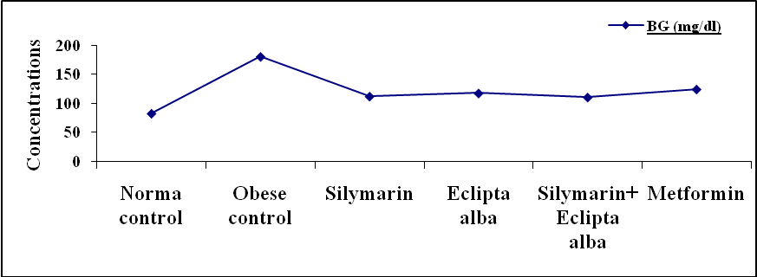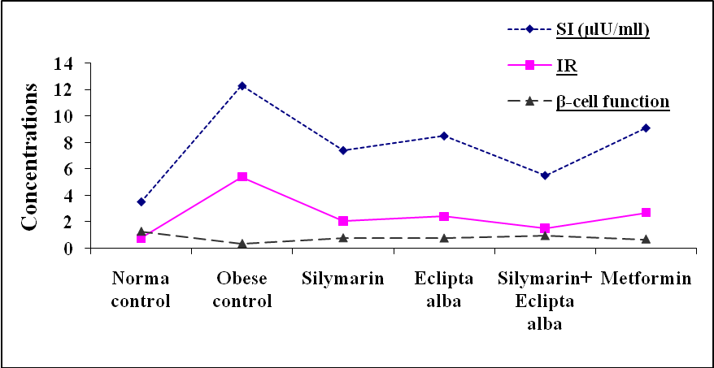

Figure.1: Protective effect of silymarin, Eclipta alba extract, their combination and metformin to adult male rats concurrently fed with high fat diet for 60 days on the blood glucose, serum insulin, insulin resistance and β-cell function levels:

Table.2: Protective effect of silymarin, Eclipta alba extract, their combination and metformin to adult male rats concurrently fed with high fat diet for 60 days on the glucose tolerance curve:
Animal  groups | Time interval in minutes
Animal  groups | 0 | 30 | 60 | 90 | 120 | 150 | 180
Normal control | 80.3±4.35 | 170±6.34 | 214.8±12.5 | 202±12.22 | 219±10.71 | 195.11±13.5 | 133.1±8.68
Obese control | 197.8±7.21* | 303±11.81* | 328±14.22* | 308.5±11.44* | 352.8±13.71* | 347.6±14.11* | 316.3±12.50*
Silymarin | 119.3±5.5# | 214.5±9.3# | 232.5±10.4# | 258.8±9.8# | 233.5±10.3# | 256.3±12.6# | 234.5±12.1#
Eclipta alba | 115.6±6.6# | 212.1±10.2# | 245.6±13.21# | 236.6±12.73# | 251.3±10.6# | 244±11.81# | 229.5±9.63#
Silymarin +  Eclipta alba | 109.1±5.9# | 200.6±9.42# | 240±11.62# | 231.2±9.91# | 242.1±12.09# | 227.8±13.42# | 195.3±10.7
Metformin | 107±4.4# | 205.2±12.11# | 255.3±10.52# | 218.3±11.2# | 258.5±13.11# | 239.8±9.32# | 207.6±10.87#
* Significance difference from normal Control group p < 0.05.
# Significance difference between obese Control and treated groups p < 0.05.

Figure.2: Protective effect of silymarin, Eclipta alba extract, their combination and metformin to adult male rats concurrently fed with high fat diet for 60 days on the glucose tolerance curve.
Table.3: Protective effect of silymarin, Eclipta alba extract, their combination and metformin to adult male rats concurrently fed with high fat diet for 60 days on the area under glucose curve:
Animal groups | AUC (min.mg/dl)
Normal control | 34344 ± 1036
Obese control | 55127.5 ± 2270*
Silymarin | 40262 ± 1603.80#
Eclipta alba | 40174 ± 1514.72#
Silymarin + Eclipta alba | 38510 ± 1981.67#
Metformin | 44844 ± 1829.70#
* Significance difference from normal Control group p < 0.05.
# Significance difference between obese Control and treated groups p < 0.05.

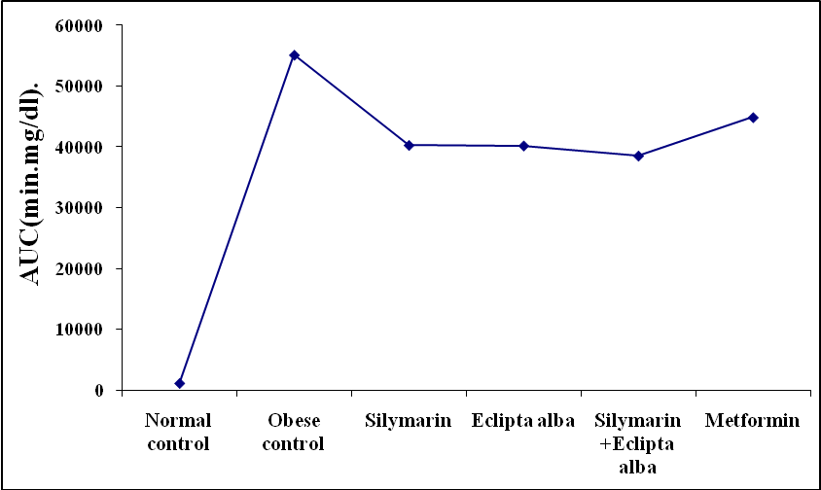
Figure.3: Protective effect of silymarin, Eclipta alba extract, their combination and metformin to adult male rats concurrently fed with high fat diet for 60 days on the area under glucose curve:

Table.4: Protective effect of silymarin, Eclipta alba extract, their combination and metformin to adult male rats concurrently fed with high fat diet for 60 days on the levels of serum total cholesterol, triglycerides, LDL-C & HDL-C:
Animal  groups | Parameters under investigation
Animal  groups | T-Ch | TG | LDL-C | HDL-C
Norma control | 80.30 ± 5.30 | 87.33 ± 6.51 | 61.8 ± 1.3 | 77.4 ± 6.06
Obese control | 136.30 ± 12.00* | 263.31 ± 12.16* | 75.6 ± 2.31* | 56.8 ± 3*
Silymarin | 100.00 ± 4.40# | 136.32 ± 8.29# | 67.2 ± 2.1# | 78.9 ± 4.3#
Eclipta alba | 106.80 ± 8.00# | 137.50 ± 10.11# | 70.3 ± 2.62# | 79.2 ± 3.46#
Silymarin + Eclipta alba | 93.80 ± 6.10# | 114.10 ± 6.48# | 65.8 ± 1.80# | 81.1 ± 4.05#
Metformin | 115.81 ± 5.60# | 165.5 ± 10.20# | 71.00 ± 1.70# | 75.9 ± 3.19#
* Significance difference from normal Control group p < 0.05.
# Significance difference between obese Control and treated groups p < 0.05.

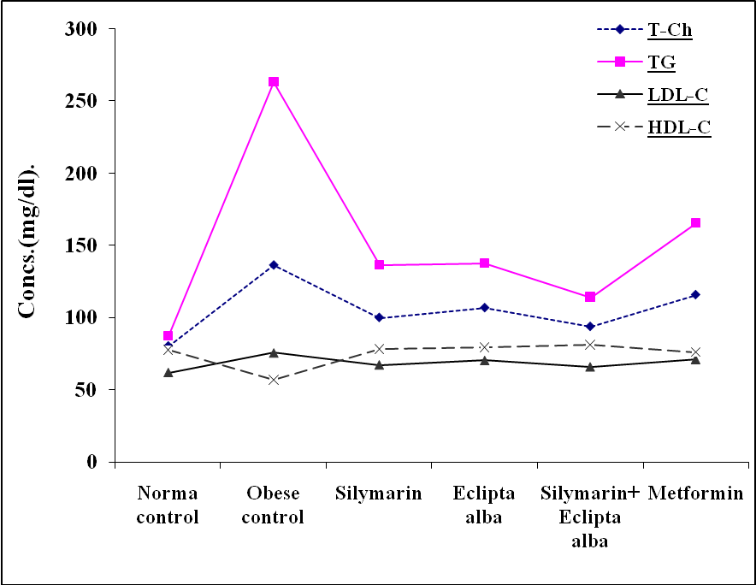
Figure.4: Protective effect of silymarin, Eclipta alba extract, their combination and metformin to adult male rats concurrently fed with high fat diet for 60 days on the levels of serum total cholesterol, triglycerides, LDL-C and HDL-C:
Table.5: Protective effect of silymarin, Eclipta alba extract, their combination and metformin to adult male rats concurrently fed with high fat diet for 60 days on the serum and liver free fatty acids levels:
Animal  groups | Parameters
Animal  groups | Serum FFA (mg/dl) | Liver FFA (mg/g)
Norma control | 102.01 ± 1.77 | 23.04 ± 1.58
Obese control | 157.12 ± 7.36* | 30.67 ± 1.02*
Silymarin | 116.67 ± 5.91# | 24.83 ± 1.48#
Eclipta alba | 113.50 ± 3.04# | 24.17 ± 0.75#
Silymarin+ Eclipta alba | 101.61 ± 2.76# | 15.33 ±1.31#
Metformin | 120.02 ± 2.12# | 27.83 ± 0.38#
* Significance difference from normal Control group p < 0.05.
# Significance difference between obese Control and treated groups p < 0.05.

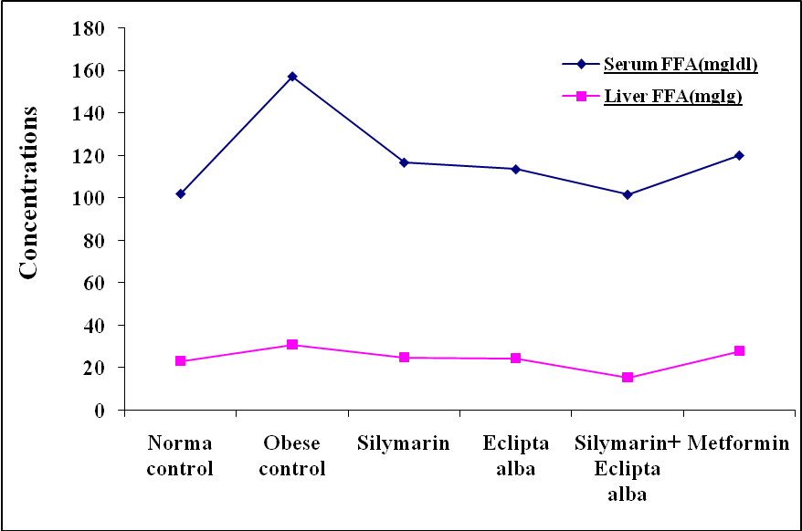
Figure.5: Protective effect of silymarin, Eclipta alba extract, their combination and metformin to adult male rats concurrently fed with high fat diet for 60 days on the serum and liver free fatty acids levels:

Table.6: Protective effect of silymarin, Eclipta alba extract, their combination and metformin to adult male rats concurrently fed with high fat diet for 60 days on the levels of serum GSH and SOD:
Animal  groups | Parameters
Animal  groups | GSH (mglml) | SOD(μg/ml)
Norma control | 44.37 ± 3.37 | 62.76 ± 1.85
Obese control | 25.78 ± 1.88* | 99.40 ± 2.40*
Silymarin | 44.07 ± 3.6# | 73.03 ± 1.64#
Eclipta alba | 44.50 ± 2.67# | 68.44 ± 3.96#
Silymarin+ Eclipta alba | 46.50 ± 2.28# | 89.64 ± 2.29#
Metformin | 23.70 ± 1.74 | 64.86 ± 2.46#
* Significance difference from normal Control group p < 0.05.
# Significance difference between obese Control and treated groups p < 0.05.

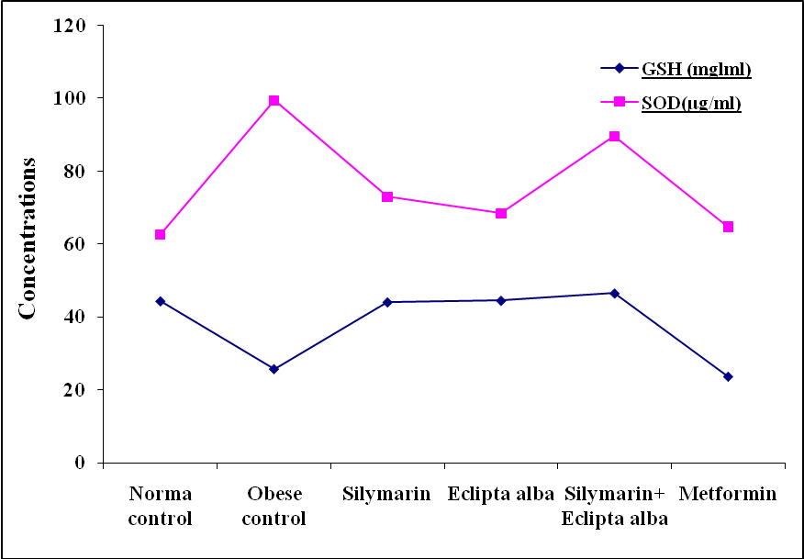
Figure.6: Protective effect of silymarin, Eclipta alba extract, their combination and metformin to adult male rats concurrently fed with high fat diet for 60 days on the levels of serum GSH and SOD:

References:
Ackman, R.G. and Sipos, J.C. (1964). Application of specific response factors in the gas-chromatographic analysis of methyl esters of fatty acids with flame ionization detectors. J Am. Oil Chemists Soc. 41(5): 377-80.
- Alarcon de la Lastra, C.; Martin, M.J. and Marhuenda, E. (1992). Gastric anti-ulcer activity of silymarin, a lipoxygenase inhibitor, in rats.J. Pharm. Pharmacol. 44: 929-31.
- Anandh Babu, P.V.; Sabitha, K.E. and Shyamaladevi, C.S. (2006). Green tea extract impedes dyslipidemia and development of cardiac dysfunction in streptozotocin-diabetic rats. Clinical and Experimental Pharmacology and Physiology. 33(12): 1184-9.
- Ananthi, J.; Prakasam, A. and Pugalendi, K.V. (2003). Antihyperglycemic activity of Eclipta alba leaf on alloxan-induced diabetic rats. Yale J Biol. Med. 1; 76(3): 97-102.
- Association of Official Analysis Chemists (AOAC) (1988). In official Method of analysis, 12th Ed. Benjamin Pranklin Station Washington.
- Bakker, S.J.; IJzerman, R.G.; Teerlink, T.; Westerhoff, H.V.; Gans, R.O. and Heine, R.J. (2000). Cytosolic triglycerides and oxidative stress in central obesity: the missing link between excessive atherosclerosis, endothelial dysfunction, and ß-cell failure?Atherosclerosis. 148: 17–21.
- Biarnés, J.; Fernández-Real, J.M.; Fernández-Castañer, M.; Mar García, D.M. and Ricart, M. (2005). Differential regulation of insulin action and tumor necrosis factor alpha system activity by metformin. Metab. 54: 235-9.
- Bollheimer, L.C.; Skelly, R.H.; Chester, M.W.; McGarry, J.D. and Rhodes, C.J. (1998). Chronic exposure to free fatty acid reduces pancreatic ß-cell insulin content by increasing basal insulin secretion that is not compensated for by a corresponding increase in proinsulin biosynthesis translation.J. Clin. Inves. 10: 1094–101.
- Borissova, A.M.; Tankova, T.I. and Koev, D.J. (2004). Insulin secretion, peripheral insulin sensitivity and insulin-receptor binding in subjects with different degrees of obesity.Diabetes Metab. 30(5): 425-31.
- Bray, G.A.; Paeratakul, S. and Popkin, B.M. (2004). Dietary fat and obesity: a review of animal, clinical and epidemiological studies.Physiol. Behav. 83(4): 549-55.
- Briaud, I.; Kelpe, C.L.; Johnson, L.M.; Tran, P.O. and Poitout, V. (2002). Differential effects of hyperlipidemia on insulin secretion in islets of Langerhans from hyperglycemic versus normoglycemic rats. Diabetes. 51: 662–8.
- Bunck, M.; Diamant, M.; Corner, A.; Eliasson, B.; Malloy, J. et al. (2009). One-year treatment with exenatide improves beta-cell function, compared with insulin glargine in metformin treated type 2 diabetic patients: a randomized, controlled trial.Diabetes Care. 32(5); 762-8.
- Cani, P.D.; Bibiloni, R.; Knauf, C.; Waget, A.; Neyrinck, A.M.; Delzenne, N.M. and Burcelin, R. (2008). Changes in gut microbiota control metabolic endotoxemia-induced inflammation in high-fat diet-induced obesity and diabetes in mice. Diabetes. 57(6): 1470-81.
- Carpentier, A.; Mittelman, S.D.; Bergman, R.N.; Giacca, A. and Lewis, G.F. (2000). Prolonged elevation of plasma free fatty acids impairs pancreatic ß-cell function in obese nondiabetic humans but not in individuals with type 2 diabetes. Diabetes. 49: 399–408.
- Chanda, R.; Ghosh, A.; Mitra, T.; Mohanty, J.P.; Bhuyan, N. and Pawankar, G. (2008). Phytochemical and pharmacological activity of Aegle marmelos as a potential medicinal plant: An overview. The Internet. Journal of Pharmacology. 6(1): 34- 40.
- Cleasby, M.E.; Dzamko, N.; Hegarty, B.D.; Cooney, G.J.; Kraegen, E.W. and Ye, J.M. (2004). Metformin prevents the development of acute lipid-induced insulin resistance in the rat through altered hepatic signaling mechanisms. Diabetes. 53(12): 3258-66.
- Cnop, M.; Hannaert, J.C.; Hoorens, A.; Eizirik, D.L. and Pipeleers, D.L. (2001). Inverse Relationship Between Cytotoxicity of Free Fatty Acids in Pancreatic Islet Cells and Cellular Triglyceride Accumulation. Diabetes. 50: 1771-7.
- Craft, S. (2009). The role of metabolic disorders in Alzheimer disease and vascular dementia: two roads converged. Arch. Neurol. 66(3):300-5.
- Cunha, D.A.; Hekerman, P.; Ladrière, L.; Bazarra-Castro, A.F. et al. (2008). Initiation and execution of lipotoxic ER stress in pancreatic beta-cells. J. Cell Sci. 121: 2308-18.
- Dandona, P.; Aljada, A.; Chaudhuri, A. and Bandyopadhyay, A. (2003). The potential influence of inflammation and insulin resistance on the pathogenesis and treatment of atherosclerosis-related complications in type 2 diabetes.J. Clin. Endocrinol. Metab. 88: 2422–9.
- DeFronzo, R.A.; Triplitt, C.; Qu, Y.; Lewis, M.S.; Maggs, D. and Glass, L.C. (2010). Effects of exenatide plus rosiglitazone on beta-cell function and insulin sensitivity in subjects with type 2 diabetes on metformin.Diabetes Care. 33(5): 951-7.
- Dhar, M.L.; Dhar, M.M.; Dhawan, B.N. et al. (1986). Screening of Indian plants for biological activity. Ind J. Exp. Biol. 6: 232-6.
- Di Carlo, G.; Mascolo, N.; Izzo, A.A. and Capasso, F. (1999). Flavonoids: old and new aspects of a class of natural therapeutic drugs. Life Sci. 65: 337-53.
- Evans, J.L.; Goldfine, I.D.; Maddux, B.A. and Grodsky, G.M. (2002). Oxidative Stress and Stress-Activated Signaling Pathways: A Unifying Hypothesis of Type 2 Diabetes. Endocrine Reviews. 23 (5): 599-622.
- Fasce, C.F. (1982). A model for the study of the molecular genetics of NIDDM.Clin. Chem. 18: 91-4.
- Feldman, H. and Rodbard, D. (1971). Mathematical theory of radioimmunoassay in W.D.odell and Doughaday, W.H.(Ed), principle of competitive protein-binding assays. Philadelphia: J.B. Leppincott Company. 158: 203.
- Flora, K.; Hahn, M.; Rosen, H. and Benner, K. (1998). Milk thistle (Silybum marianum) for the therapy of liver disease. Am. J. Gastroenterol. 93:139 –43.
- Friedman, J.M. (2000). Obesity in the new millennium. Nature. 404: 632-4.
- Friedwald, W.T.; Levy, R.I. and Fredrickson, D.S. (1972). Estimation of the concentration of LDL-C in plasma without use of preparative ultracentrifuge. Clin Chem. 4: 99-102.
- Furukawa, S.; Fujita, T.; Shimabukuro, M.; Iwaki, M.; Yamada, Y.; Nakajima, Y.; Nakayama, O.; Makishima, M.; Matsuda, M. and Shimomura, I. (2004). Increased oxidative stress in obesity and its impact on metabolic syndrome.J. Clin. Invest. 114: 1752-61.
- Gallo, A.; Ceolotto, G.; Pinton, P.; Iori, E.; Murphy, E.; Rutter, G.A.; Rizzuto, R.; Semplicini, A. and Avogaro, A. (2005). Metformin prevents glucose-induced protein kinase C-beta2 activation in human umbilical vein endothelial cells through an antioxidant mechanism.Diabetes. 54(4): 1123-31.
- Grundy, S.M. (2004). Definition of metabolic syndrome: Report of the National Heart, Lung, and Blood Institute/American Heart Association conference on scientific issues related to definition. Circulation. 109: 433-8.
- Guilherme, A.; Virbasius, J.V.; Puri, V. and Czech, M.P. (2008). Adipocyte dysfunctions linking obesity to insulin resistance and type 2 diabetes.Nat. Rev. Mol. Cell Biol. 9(5): 367-77.
- Gupta, O.P.; Sing, S.; Bani, S.; Sharma, N.; Malhotra, S.; Gupta, B.D.; Banerjee, S.K. and Handa, S.S. (2000). Anti-inflammatory and anti-arthritic activities of silymarin acting through inhibition of 5-lipoxygenase. Phytomedicine. 7: 21-4.
- Hegele, R.A. (2000). Familial partial lipodystrophy: a monogenic form of the insulin resistance syndrome.Mol. Genet. Metab. 71: 539–44.
- Hotta, M.; Yamato, E. and Miyazaki, J.I. (2000). Oxidative stress and pancreatic ß-cell destruction in insulin-dependent diabetes mellitus. In: Packer L, Rosen P, Tritschler H, King GL, Azzi A, eds. Antioxidants and diabetes management. New York: Marcel Dekker. 265–74.
- Ilan, G.; Xiao, H.M.; Xiao, M.Y.; Gil, A. and Michael, W. (2002). Removal of Visceral Fat Prevents Insulin Resistance and Glucose Intolerance of Aging. Diabetes. 51: 2951-8.
- Jayathirtha, M.G. and Mishra, S.H. (2004). Preliminary immunomodulatory activities of methanol extracts of Eclipta alba and Centella asiatica.Phytomedicine. 11(4): 361-5.
- Johanson, E.H.; Jansson, P-A.; Lönn, L. et al. (2003). Fat distribution, lipid accumulation in the liver, and exercise capacity do not explain the insulin resistance in males with a family history for type 2 diabetes J. Clin. Endocrinol. Metab. 88: 4232-8.
- Jong, S.K.; Young, J.; Hwan, M.K.; Seung, H. and Kyu-Hwan, Y. (2002). Inhibition of Inducible Nitric-Oxide Synthase Expression by Silymarin in Lipopolysaccharide-Stimulated Macrophages. J. Assoc. Physicians India. 302(1): 138-44.
- Kabir, M.; Catalano, K.J.; Ananthnarayan, S.; Kim, S.P.; Van Citters, G.W.; Dea, M.K. and Bergman, R.N. (2005). Molecular evidence supporting the portal theory: a causative link between visceral adiposity and hepatic insulin resistance.Am. J. Physiol. Endocrinol. Metab. Feb; 288(2): E454-61.
- Keaney, J.F. Jr. et al. (2003). Obesity and systemic oxidative stress: clinical correlates of oxidative stress in the Framingham Study. Arterioscler. Thromb. Vasc. Biol. 23: 434-9.
- Kouki, T.; Takasu, N.; Nakachi, A.; Tamanaha, T.; Komiya, I. and Tawata, M. (2005). Low-dose metformin improves hyperglycaemia related to myotonic dystrophy.Diabet. Med. 22(3): 346-7.
- Lauterio, T.J.; Bond, J.P. and Ulman, E.A. (1994). Development and characterization of a purified diet to identify obesity-susceptible and resistant rat populations. J. Nutr. 124: 2172-8.
- Letteron, P.; Labbe, G.; Degott, C.; Berson, A.; Fromenty, B.; Delaforge, M.; Larrey, D. and Pessayre, D. (1990). Mechanism for the protective effects of silymarin against carbon tetrachloride-induced lipid peroxidation and hepatotoxicity in mice. Evidence that silymarin acts both as an inhibitor of metabolic activation and as a chain-breaking antioxidant.Biochem. Pharmacol. 39: 2027-34.
- Lewis, G.F.; Carpentier, A.; Adeli, K. and Giacca, A. (2002). Disordered fat storage and mobilization in the pathogenesis of insulin resistance and type 2 diabetes. Endocr. Rev. 23: 201-29.
- Maddux, B.A. (2001). Protection against oxidative stress-induced insulin resistance in rat L6 muscle cells by micromolar concentrations of α-lipoic acid. Diabetes. 50: 404-10.
- Matsuda, T.; Ferreri, K.; Todorov, I.; Kuroda, Y.; Smith, C.V.; Kandeel, F. and Mullen, Y. (2005). Silymarin protects pancreatic beta-cells against cytokine-mediated toxicity: implication of c-Jun NH2-terminal kinase and janus kinase/signal transducer and activator of transcription pathways. Endocrinology. 146(1): 175-85.
- Matthews, D.R.; Hosker, J.P.; Rudenski, A.S.; Naylor, B.A.; Treacher, D.F. and Turner, R.C. (1985). Homeostasis model assessment: insulin resistance and beta-cell function from fasting plasma glucose and insulin concentration in man.Diabetologia. 8(7): 412-9.
- McCarty, M.F. (2005). Potential utility of natural polyphenols for reversing fat-induced insulin resistance. Med. Hypotheses. 64(3): 628-35.
- McGarry, J.D. (2002). Banting lecture 2001: dysregulation of fatty acid metabolism in the etiology of type 2 diabetes. Diabetes. 51: 7–18.
- Minami, M. and Yoshikawa, H. (1979). A simplified assay method of superoxide dismutase activity for clinical use. Clin. Chim. Acta. 92(3): 337-42.
- Moisey, L.; Kacker, S.; Bickerton, A.C.; Robinson, L. and Graham, T. (2011). Caffeinated coffee consumption impairs blood glucose homeostasis in response to high and low glycemic index meals in healthy men. Am. J. of Clin. Nutrition. 87(5): 1254-61.
- Nilsson, A.C.; Östman, E.M.; Holst, J.J. and Björck, E.M. (2008). Including indigestible carbohydrates in the evening meal of healthy subjects improves glucose tolerance, lowers inflammatory markers, and increases satiety after a subsequent standardized breakfast. J. Nutr. 138:732-9
- Park, K.; Gross, M.; Lee, D.; Holvoet, P.; Himes, J.H.; Shikany, M. and Jacobs, D.J. (2009). Oxidative stress and insulin resistance: the coronary artery risk development in young adults study.Diabetes Care. 32(7): 1302-7.
- Ramachandran, A.; Snehalatha, C.; Salini, J. and Vijay, V. (2004). Use of glimepiride and insulin sensitizers in the treatment of type 2 diabetes--a study in Indians. J. Assoc. Physicians India. 52: 459-63.
- Rhodes, C.J. (2005). Type 2 diabetes-a matter of beta-cell life and death? Science.Science. 307 (5708): 380-4.
- Rodriguez-Moctezuma, J.R.; Robles-Lopez, G.; Lopez-Carmona, J.M. and Gutierrez-Rosas, M.J. (2005). Effects of metformin on the body composition in subjects with risk factors for type 2 diabetes.Diabetes Obes. Metab. Mar; 7(2): 189-92.
- Schemer, A. (1967). The blood morphology of laboratory animals. 3rd ed. Davis FA company, Philadelphia PP. 42-67.
- Schwartz, M.W. and Porte, D. Jr. (2005). Diabetes, obesity, and the brain. Diabetes Science. 307(5708): 375-9.
- Shaker, E.; Mahmoud, H. and Mnaa, S. (2010). Silymarin, the antioxidant component and Silybum marianum extracts prevent liver damage. Food and Chemical Toxicology. 48(3): 803-6.
- Shaker, M.; Salem, H.A.; Shiha, G.E. and Ibrahim, T.M. (2011). Nilotinib counteracts thioacetamide-induced hepatic oxidative stress and attenuates liver fibrosis progression. Fundamental & Clinical Pharmacology. 25(2): 248–57.
- Shulman, G.I. (2000). Cellular mechanisms of insulin resistance. J. Clin. Invest. 106: 171–6.
- Siddique, Y.H.; Ara, G.; Beg, T.; Faisal, M. and Afzal, M. (2011). ﻿﻿﻿Protective role of Eclipta alba L. extract against ethinylestradiol induced genotoxic damage in cultured human lymphocytesAlternative Medicine Studies. 1(1): 204-9.
- Skottova, N.; Kazdova, L.; Oliyarnyk, O.; Vecera, R.; Sobolova, L. and Ulrichova, J. (2004). Phenolics-rich extracts from Silybum marianum and Prunella vulgaris reduce a high-sucrose diet induced oxidative stress in hereditary hypertriglyceridemic rats.Pharmacol. Res. 50(2): 123-30.
- Skottova, N.; Vecera, R.; Urbanek, K.; Vana, P.; Walterova, D. and Cvak, L. (2003). Effects of polyphenolic fraction of silymarin on lipoprotein profile in rats fed cholesterol-rich diets. Pharmacol. Res. 47(1): 17-26.
- Soto, C.; Mena, R.; Luna, J.; Cerbon, M.; Larrieta, E.; Vital, P.; Uria, E.; Sanchez, M.; Recoba, R.; Barron, H.; Favari, L. and Lara, A. (2004). Silymarin induces recovery of pancreatic function after alloxan damage in rats. Life Sci. 75(18): 2167-80.
- Soto, C.; Pérez, J.; García, V.; Uría, E.; Vadillo, M. and Raya, L. (2010). Effect of silymarin on kidneys of rats suffering from alloxan-induced diabetes mellitus.Phytomedicine.
17(14): 1090-4.
- Soto, C.; Recoba, R.; Barron, H.; Alvarez, C. and Favari, L. (2003). Silymarin increases antioxidant enzymes in alloxan-induced diabetes in rat pancreas. Comp. Biochem. Physiol. & Toxicol. Pharmacol. 136(3): 205-12.
- Tabassum, N. and Agrawal, S.S. (2004). Hepatoprotective activity of Eclipta alba Hassk. against paracetamol induced hepatocellular damage in mice. Experimental Medicine. 11(4): 278-80.
- Taniguchi, N.; Kaneto, H.; Asahi, M.; Takahashi, M.; Wenyi, C.; Higashiyama, S.; Fujii, J.; Suzuki, K. and Kayanoki, Y. (1996). Involvement of glycation and oxidative stress in diabetic macroangiopathy.Diabetes. 45(3): S81–3.
- Tietze, F. (1969). Enzymic method for quantitative determination of nanogram amounts of total and oxidized glutathione: applications to mammalian blood and other tissues. Anal. Biochem. 27: 502-22.
- Tirosh, A.; Potashnik, R.; Bashan, N. and Rudich, A. (1999). Oxidative stress disrupts insulin-induced cellular redistribution of insulin receptor substrate-1 and phosphatidylinositol 3-kinase in 3T3–L1 adipocytes. A putative cellular mechanism for impaired protein kinase B activation and GLUT4 translocation. J. Biol. Chem. 274: 10595–602.
- Toborek, M.; Lee, Y.W.; Garrido, R.; Kaiser, S. and Hennig, B. (2002). Unsaturated fatty acids selectively induce an inflammatory environment in human endothelial cells. Am. J. Clin. Nutrition. 75: 119–25.
- Tinder, P. (1969). Determination of glucose using oxidase with an alternative oxygen acceptor. Ann Clin Biolchem. 6: 24-7.
- Tumova, L.; Gallova, K. and Rimakova, J. (2004). Silybum marianum in vitro. Ceska. Slov. Farm. 53(3): 135-40.
- Waldhausl, W.K. and Roden, M. (2000). The effects of free fatty acids on glucose transport and phosphorylation in human skeletal muscle.Curr. Opin. Endocrinol. Diabetes. 7: 211–6.
- Wang, T.; Zang, Y.; Ling, W.; Corkey, B.E. and Guo, W. (2003). Metabolic partitioning of endogenous fatty acid in adipocytes.Obes. Res. 11: 880-7.
- Wilson-Fritch, L.; Nicoloro, S.; Chouinard, M. and Lazar, M.L. (2004). Mitochondrial remodeling in adipose tissue associated with obesity and treatment with rosiglitazone.Clin. Invest. 114: 1281-9.
- Winer, S.; Chan, Y.; Paltser, G.; Truong, D.; Tsui, H.; Bahrami, J. et al. (2009). Normalization of obesity-associated insulin resistance through immunotherapy. Nature Medicine. 15: 921–9.
- Young, D. and Pestaner, L. (1975). Enzymatic colorimertic determination of triglycerides plasma and serum levels. Clin. Chem. 21: 5-8.
- Yuan, Y.V.; Kitts, D.D. and Godin, D.V. (1997). Influence of dietary cholesterol and fat source on athero-sclerosis in the Japanese quail (Coturnix japonica).Br. J. Nutr. 78: 993-1014.

9/12/2011

