Use of Geophysical Methods in Landfill Site Investigation: A Case Study of Ibadan, Southwestern Nigeria

Oyediran Ibrahim Adewuyi, Adeyemi Gabriel Oladapo

Department of Geology, University of Ibadan, Ibadan, Oyo State, Nigeria
oyediranibrahim@yahoo.com

Abstract: An integrated geophysical investigation of a site in Ibadan southwestern Nigeria was carried out to provide detailed information on the suitability or otherwise of the location for disposal of waste with utmost priority being prevention of groundwater pollution. Sixty six Very Low Frequency-Electromagnetic (VLF-EM) and 36 Vertical Electrical Soundings (VES) were carried out to determine the occurrence of linear structures, layer resistivity, bedrock depth, depth and characteristics of the unsaturated zone, identification of any confined or perched water bearing strata and subsurface features. VLF-EM data indicated the absence of linear features while VES showed the presence of three to four geoelectric layers namely topsoil, dry lateritic soil, clay layer, weathered/fresh bedrock with no evidence of fracture which may promote large scale groundwater pollution. Depths to bedrock and water table varied from 3.80 to 12.20m and 8.00 to 9.30m respectively. The presence of a clay layer with thickness ranging from 3.10m to 12.20m is significant in siting a landfill because of its impermeable nature that makes it qualify as a seal, hence protecting the underlying aquifer from being polluted. It can also serve as attenuating layer that will enable leachate to percolate slowly downwards, simultaneously undergoing attenuation by filtration, sorption and exchange processes with the clays in the unit. Thus the multi method approach has generated information which confirms the suitability of the site.
[Oyediran Ibrahim Adewuyi, Adeyemi Gabriel Oladapo. Use of Geophysical Methods in Landfill Site Investigation: A Case Study of Ibadan, Southwestern Nigeria. New York Science Journal 2011;4(10):1-10]. (ISSN: 1554-0200). http://www.sciencepub.net/newyork.

Keywords: Groundwater; landfill; pollution; leachate; bedrock

1. Introduction
The Earth Summit (1992), held in Rio de Janeiro, Brazil with over 100 countries and leaders present endorsed a global commitment to the preservation of the earth’s natural resources. A consequence of increased population is increased generation of waste and by-products, which must be housed somewhere in the environment or destroyed. No other issue has perhaps dominated the environmental scene in most developing countries as that of management of solid waste.
Geophysical investigations have found useful applications in shallow engineering studies (Olorunfemi and Mesida, 1987; Sharma, 1997). Saksa and Korkealasko (1987) found that geophysical methods can be successfully used both before waste disposal operations for evaluation of site characteristics and for monitoring of possible leachate flow after dumping of waste. Delineating or mapping a landfill has long been a challenge for near-surface geophysicists due to the complexity in the composition of subsurface materials. No single geophysical tool can effectively determine the characteristics of a landfill. Iterative and integrated data collection and interpretation using multiple geophysical methods provides for a more complete interpretation of data, often resulting in a more accurate model of the complex structures and processes of the subsurface (Dawson et al., 2002). According to Sundararajan et al. (2007), an integrated geophysical strategy plays an indispensable role not only in mapping and understanding the nature of aquifers but also ensures a better success rate of exploration. To this end, combined geophysical techniques are expected to give more detailed information of the subsurface.
An integrated geophysical investigation of a site in Ibadan southwestern Nigeria was carried out to delineate the presence of linear structures, depth and characteristics of the unsaturated zone, identification of any confined or perched water bearing strata, layer resistivity, bedrock depth and subsurface features to determine the suitability of the location for disposal of waste with utmost priority being groundwater protection.

2. Material and Methods
The study area Ajibode, a village located within Ibadan lies between longitudes 3º 52’ and 3º 54’ East of the Greenwich meridian and latitudes 7º 27’ and 7º 28’ North of the Equator. The area is easily accessible by a network of roads (Figure 1.). The area is well drained and the pattern is dendritic. The direction of flow is corroborated by direct logging of the water table of hand dug wells and topographic elevations in the study area.
The study area forms part of the area underlain by Basement Complex rocks of southwestern Nigeria (Figure 2.) and they are mainly the metamorphic types of Precambrian age but with few intrusions of granites and porphyries of Jurassic age. The major rock types are quartzites of the metasedimentary series and the migmatites complex comprising banded gneisses, augen gneisses and migmatites. The minor rock types include pegmatite, quartz, aplite, diorites, amphibolites and xenoliths. These rocks occur either exposed or covered by a shallow mantle of superficial deposits. They are loosely categorized into three main subdivisions namely the Migmatite – Gneiss complex, the Schist belt and the Pan- African (ca. 600 Ma) Older Granite series (Elueze, 2000).

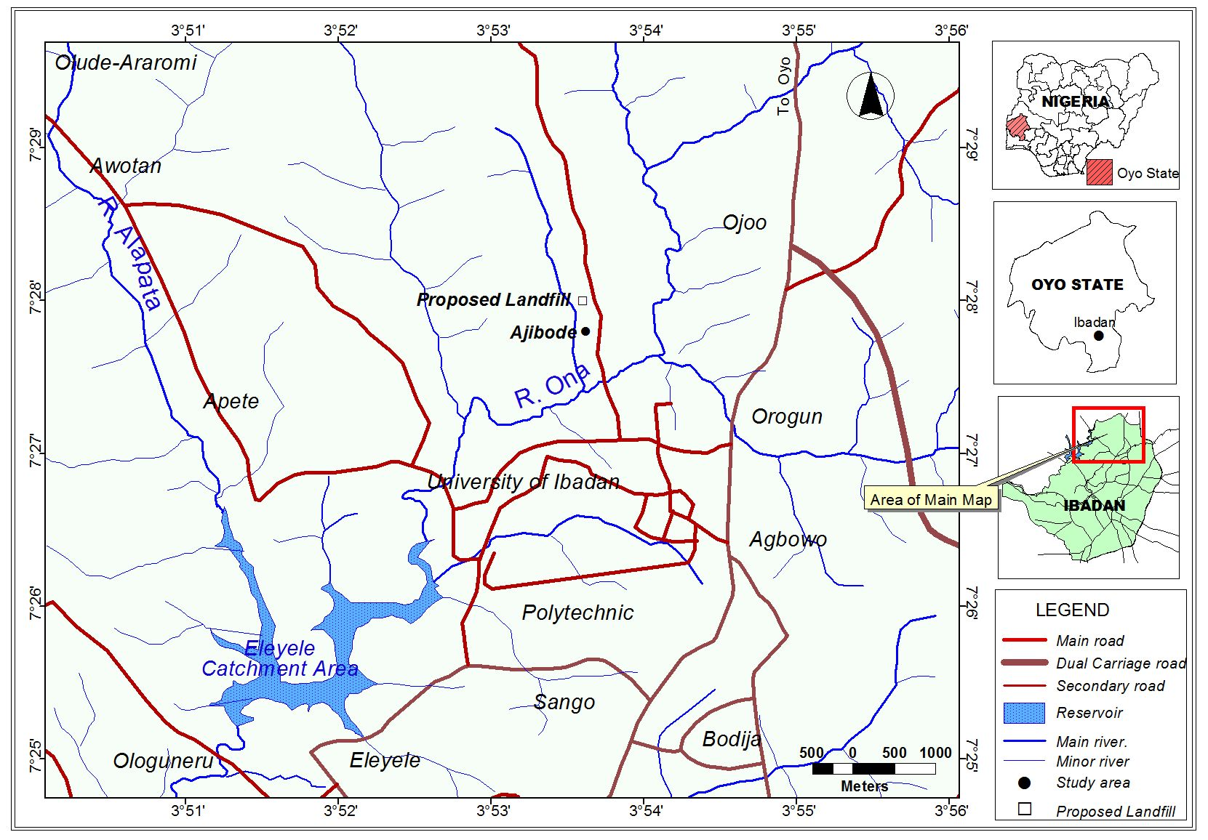
Figure 1. Map showing study area and environs.

Figure 2. Generalized geological map of Nigeria
(Geological Survey of Nigeria, 2004)

Integrated geophysical investigation involving both the Very Low Frequency Electromagnetic (VLF-EM) and Electrical Resistivity (ER) methods was embarked upon along the traverses/profiles established. Very Low Frequency Electromagnetic (VLF-EM), (Benson et al., 1997) and Electrical Resistivity (ER), (Carpenter et al., 1990) methods are very important in obtaining subsurface information. Several workers including Telford et al. (1990) and Benson et al. (1997) have shown that a combination of VLF-EM and ER methods have provided useful results in mapping. The two methods are both responsive to water bearing basement fracture columns due to the relatively high bulk electrical conductivities. Both methods were therefore found relevant and hence were integrated in this investigation. Using the approach adopted by Olorunfemi et al. (2005), the VLF-EM method was adopted as a fast reconnaissance tool to map possible linear features such as faults and fracture zones while the ER method was used to investigate prominent EM anomalies and provide a geoelectric image of the subsurface sequence.
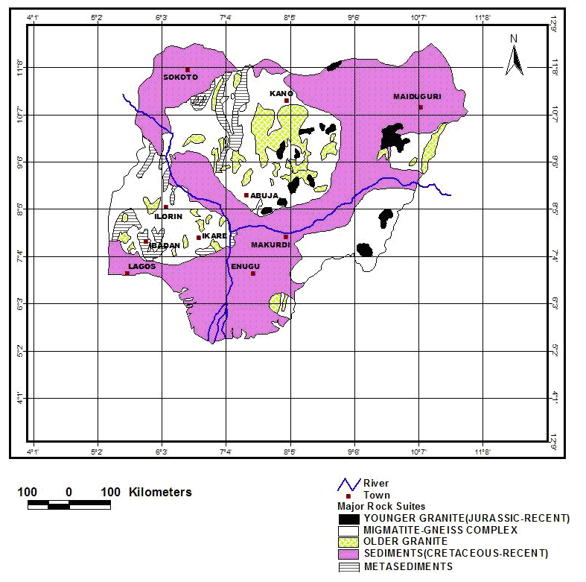
For the purpose of this study Sixty six VLF-EM stations from six NE-SW traverses were occupied at an interval of 10m. The range of each of the traverses was 100m. The VLF-EM measurement was established to map the study area with the object of isolating linear features which can be interpreted as fractured zones likely to serve as conductors’ pathways for groundwater contamination and conductive regions. The equipment measured the real (in phase) and quadrature (out of phase) components of the vertical to horizontal magnetic field ratio. The real component being more diagnostic of linear features were processed for qualitative interpretation. A filter operator [Q_{I.5} = (Q_{I+3} + Q_{I+2}) - (Q_{I} + Q_{I+1}), for n data and I =1 to n-3 where Q are EM data and the subscripts are the station positions] was applied to the real component VLF-EM data to transform the data set to filtered real VLF- EM data (Karous and Hjelt, 1983). The filtered real data transform every genuine crossover or inflection points of the real anomaly to positive peaks while reverse crossovers become negative peaks. The measured raw real and filtered real data were subjected to Fraser (Fraser, 1969) and Karous-Hjelt (Karous and Hjelt, 1983) filtering operations to suppress noise and enhance signal. Filtered traverse data were then subjected to 2D inversion operation and the obtained current density information were used to isolate regions having contrasting conductivity value when compared to the host rock that could be interpreted in terms of fractures or conductive zones within the basement rocks. Furthermore, a double plot of the real and filtered real anomaly curves enabled qualitative identification of the top linear features as point of coincidence of crossovers and positive peaks of real and filtered real anomaly curves.
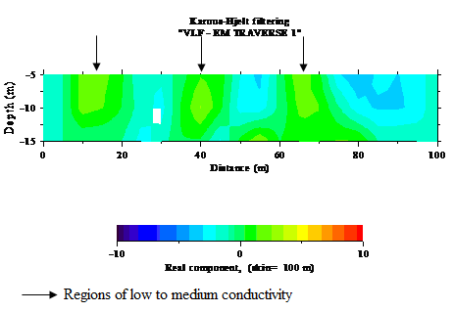
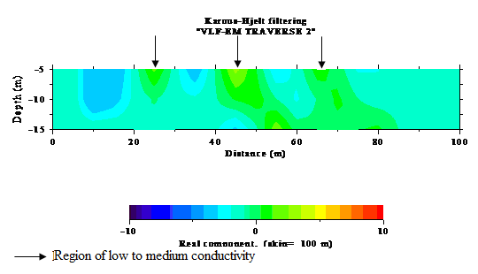
Thirty six Vertical Electrical Sounding (VES) points 20m apart along six traverses using the Schlumberger Array (Figure 3) were established. The maximum AB/2 value in this investigation was 100m. Adequate penetration was however achieved in the soundings. A computer-assisted one-dimensional inversion algorithm of the Schlumberger sounding data was carried out for quantitative interpretation (Zohdy, 1973; 1989) followed by production of geoelectric section of the area to enable an understanding of the subsurface. Thereafter three (3) wells were dug at the sampling site to determine the ground water flow direction and hydraulic gradient.

Figure 3. Distribution of VES points along six traverses

3. Results and Discussions
Very Low Frequency-Electromagnetic (VLF-EM)
The measured raw real and filtered real data extracted from the raw field results were plotted to generate anomaly curves which enabled qualitative identification of linear features. These linear features (suspected geological interfaces) as shown by Olorunfemi et al. (2005), are usually delineated as points of coincident crossovers and positive peaks of the raw real and filtered real anomaly curves.
Figures 4 to 6 display VLF-EM plots (raw real and filtered real) along Traverses1-6 alongside the Fraser filtered and corresponding Karous-Hjelt filtered current density pseudo section. A careful examination of the double plots revealed no linear feature (suspected geological interface) was delineated using the characteristic feature of coincident inflections on real component anomaly curves with positive peaks on filtered real anomaly curves (Olorunfemi et al., 2005). The freshness of the basement rock at the site corroborates the above inference.

Figure 4. VLF-EM plots (raw and filtered real) and corresponding Current density pseudo section for Traverse 1 and 2.

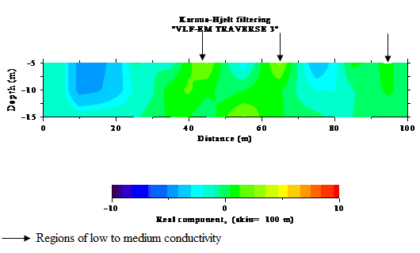
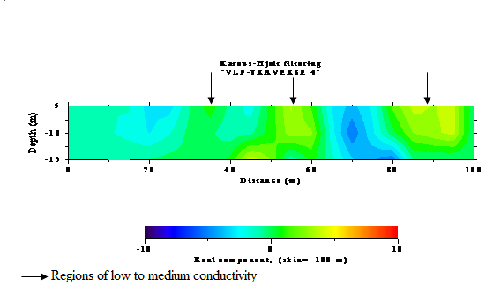

Figure 5. VLF-EM plots (raw and filtered real) and corresponding Current density pseudo section for Traverse 3 and 4

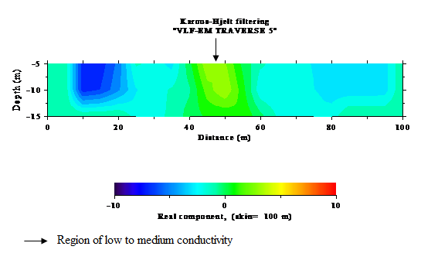
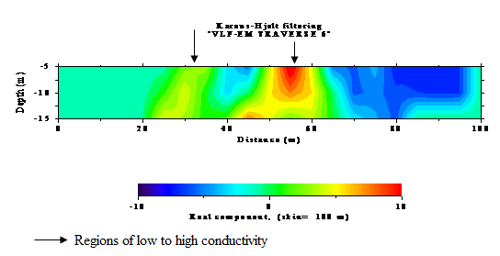

Figure 6. VLF-EM plots (raw and filtered real) and corresponding Current density pseudo section for Traverse 5 and 6

Filtered traverse data subjected to 2D inversion operation, generated current density information used to isolate regions having contrasting conductivity value when compared to the host rock that could be interpreted in terms of conductive zones within the subsurface. Small as well as localized conductors are well resolved in the pseudo sections. Isolated zones of low to medium current density are identified on the representative traverses and these correspond to points of low to medium current density hence are points of low to medium conductivity (indicated by arrows). The isolated regions correspond to points of positive peaks of the filtered real data. However high current density and hence high conductivity zone was noticed on TR 6 between 40 and 60m. Since no linear feature was delineated, the conductive zones could be due to isolated occurrence of clay pockets or loose materials mostly at shallow depth. The current density distribution in the study area (Figure 7.) shows that the major part of the study area falls within the low to medium current density between -10 and 14%.

Figure 7. Current density distribution map of the area

Vertical Electrical Sounding (VES)
Partial curve matching and computer iteration of the results produced a system of three to four geo-electric layers.
The pseudo and geoelectric sections obtained after data inversion and computer iteration for Traverses 1 to 5, VES 1A to VES 5F (Figure 8 to 10) delineates 3 subsurface layers which are the top soil, sandy clayey soil, weathered/fresh bedrock.
The top soil resistivity values and thickness vary from 407 - 1894Ωm, 328 - 1017Ωm, 236 - 1052Ωm, 203 - 732Ωm, 298 - 1044Ωm and 0.70 – 1.30m, 1.00 – 1.60m, 0.90 – 1.40m, 1.00 – 1.90m, 1.10 – 1.70m respectively for Traverses 1 to 5. The variation in the top soil resistivity values is as a result of possible reworked surface or presence of compacted lateritic hard pan. This is characteristic of typical basement complex.
The second layer is the clayey soil layer whose resistivity and thickness vary respectively from 53 - 81Ωm, 19 - 45Ωm, 17 - 25Ωm, 14 - 29Ωm, 23 - 48Ωm and 3.10 – 8.10m, 3.50 – 9.60m, 3.60 – 7.60m, 4.80 – 10.50m, 7.90 – 12.20m for Traverses 1 to 5. This layer plays significant role in siting appropriate location for landfill because of the impermeable nature of clay. The layer serves as a seal and hence protects the underlying aquifer from being polluted by any form of contaminant as such contaminant will be prevented from percolating into the aquifer by the porous but impermeable clay layer.
The third layer is the weathered/fresh bedrock which represents the aquiferous layer in the area. The layer resistivity varies from 154 - 2654Ωm, 212 - 806 Ωm, 353 - 941Ωm, 316 - 993Ωm and 316 - 986Ωm respectively for Traverses 1 to 5. The thickness of this unit was indeterminable because of the limited spread.
The pseudo and geoelectric sections obtained after data inversion and computer iteration for Traverse 6, VES 6A to VES 6F (Figure 10) delineates 4 subsurface layers which are the top soil, dry lateritic soil, clayey soil, weathered/fresh bedrock.
The top soil resistivity values vary from 811 - 4893Ωm while its thickness varies from 0.40 – 1.40 m. The variation in the top soil resistivity values is as a result of reworked soil or presence of compacted lateritic hard pan. This is characteristic of typical basement complex.
The second layer is the dry lateritic soil layer whose resistivity and thickness vary respectively from 181 - 351Ωm and 0.60 – 2.20m. The layer displays characteristics typical of the weathered bedrock but can only be considered as a shallow aquiferous unit which is perched unlike the deep seated aquiferous unit occurring as the fourth layer.
The third layer is the clayey soil with very low resistivity between 11 and 32Ωm. Layer thickness varies from 4.30 – 8.80m. This layer plays significant role in deciding appropriate location for landfill because of the impermeable nature of clay. The layer serves as a seal and hence protects the underlying aquifer from being polluted by any form of contaminant as such contaminant will be prevented from percolating into the aquifer by the porous but impermeable clay layer.

Figure 8. Pseudo section and corresponding Geoelectric section along Traverse 1 and 2

Figure 9. Pseudo section and corresponding Geoelectric section along Traverse 3 and 4

Figure 10. Pseudo section and corresponding Geoelectric section along Traverse 5 and 6
The fourth layer is the weathered/fresh bedrock which also represents the aquiferous layer in the area. The layer resistivity varies from 106 to 768Ωm. The thickness of this unit was indeterminable because of the limited spread.
It was observed that the bedrock is shallow towards the western flank of the study area particularly for the first and second traverses and this accounts for the high resistivity observed at VES 1F and 2F along the profiles. The presence of the clay layer is of great importance to landfill siting as a result of both the attenuation and containment properties of clay (Jones et al. 1995, Comeau et al. 1998).
The overburden thickness varies from 3.80m – 13.60m (Figure 11) indicating different degrees of weathering of the rocks around the study area.

Figure 11. Overburden thickness map of the area

The depth to clay top varies from 0.70m – 2.70m (Figure 12). Resistivity of the clayey layer ranges from 11 - 81Ωm. (Figure 13). The clay layer has thickness range of 3.10 - 12.20m (Figure 14). This result also corroborates information obtained from VLF-EM data. This is because the presence of the clay layer is seen to be responsible for the conductive zones interpreted in the filtered data.

Groundwater hydraulics
Hydrologically the direction of slope of the water table is important because it indicates the direction of the groundwater flow. The knowledge of the direction of the groundwater movement has become increasingly important because of the danger of contaminating groundwater supplies. Groundwater moves in the direction of decreasing total head.

Figure 12. Depth to clay top in the study area

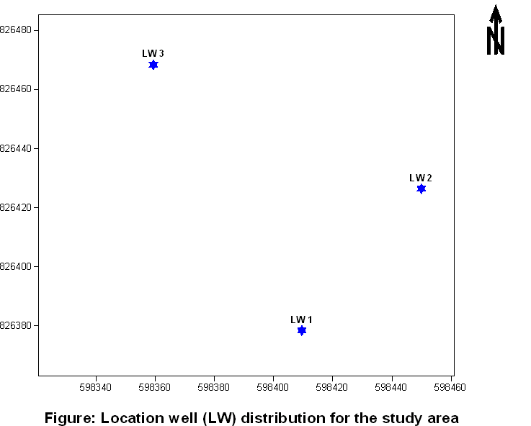

Figure 13. Clay layer resistivity map

Figure 14. Clay layer thickness map

Physical measurements were obtained (Table 1) for wells dug at the sampling locations to help with the determination of the groundwater flow metrics of the study area while the spatial distribution and relative geographic position of the sampling wells at the study area are shown in Figure 15.
The ground water flow direction was found to be in the North - South direction and the hydraulic gradient was calculated to be 17.70 m/km.

Table 1. Physical measurements from location wells
WELL | ELEVATION  Asl (m) | DEPTH TO WATER TABLE  Asl (m) | DEPTH OF WELL  Asl (m)
LW1 | 213 | 205.00 | 202.00
LW2 | 213 | 204.00 | 200.00
LW3 | 213 | 203.75 | 202.55
Asl =Above Sea Level
Figure 15. Locations of dug wells in the study area

Proposed Landfill Model for Study Area
A simplified schematic diagram of the proposed landfill (Figure 16) depicts the presence of a natural geologic attenuation layer of greater than 3.00m as recommended by Clayton and Huie (1973) as the minimum vertical distance between the base of the landfill and the shallowest groundwater. This base/barrier which is a clay-rich geological unit can perform the function of an attenuating layer, enabling leachate to percolate slowly downwards, simultaneously undergoing attenuation by filtration, sorption and exchange processes with the clays in the unit.
Furthermore the absence of fractures interpreted from data acquired during the geophysical survey prevents large scale groundwater pollution. Groundwater in the vicinity of the landfill is expected to be moderately vulnerable to pollution as the bedrock is overlain by 5-10m of clayey till or clay (Geological Survey of Ireland, 2005).
Although not shown on the diagram, continuation of the landfill above the ground surface exists. This will significantly increase the landfilling space.

Fig. 16. Schematic diagram of proposed landfill model for the study area.

4. Conclusions
Comprehensive investigation using integrated geophysical approach in the of the study area have helped in arriving at the following conclusions;
No linear features such as fractures or faults were delineated from the VLF-EM survey while the VES method of electrical resistivity survey indicated the presence of a clay layer with thickness ranging from 3.10m to 12.20m in all the traverses established. The layer is expected to serve as a seal and hence protect the underlying aquifer from being polluted by any form of contaminant. The depth to bedrock in the entire study area is between 3.80m and 13.60m while the depth to water table observed from three wells dug on the site varies from 8.00m to 9.25 m. Furthermore the location possesses acceptable geology as the bedrock is not chemically active.
The realisation of the fact that the present generation must endeavour to take care of the waste it generates and not leave it for the future generations has made the call for proper waste disposal persistent. Also the effect of climate change and pollution on the environment which has affected surface water availability underscores the importance of the protection of groundwater from pollution. Further confirmatory studies on the presence and type of clay in the study area can be undertaken using geotechnical, geochemical and or mineralogical investigations

Acknowledgements:
The Authors acknowledge the efforts of Dr. Michael Oladunjoye of the Department of Geology, University of Ibadan, Mr. Olayanju of the Department of Geophysics, FUTA and Mr. Adiat Nafiu of Malaysia State University in the provision of Geophysical Softwares which assisted in interpretation of the data set. The contributions of the various anonymous reviewers are greatly acknowledged.

Corresponding Author:
Dr. Oyediran Ibrahim Adewuyi
Department of Geology,
University of Ibadan,
Ibadan, Oyo State, Nigeria.
E-mail: oyediranibrahim@yahoo.com

References
- Earth Summit. Environment and sustainable development, Agenda 21. United Nations Conference on Environment and Development (UNCED), Rio de Janeiro, 3-14 June 1992. Retrieved August 5 2006, from http://www.un.org/esa/sustdev/documents/agenda21/index.htm
- Olorunfemi MO, Mesida EA. Engineering geophysics and its application in engineering site investigation – Case study from Ile-Ife area. The Nigerian Engineer 1987; 22:.57- 66.
- Sharma PV. Environmental and engineering geophysics. Cambridge University Press, Cambridge, United Kingdom, 1997.
- Saksa P, Korkealaasko T. Application of geophysical methods in environmental and municipal engineering. Research Report 505. Technical Research centre of Finland, 1987; 124.
- Dawson CB, Lane JW Jr., White EA, Belaval M. Integrated geophysical characterization of the Winthrop landfill southern flow path, Winthrop, Maine: Symposium on the Application of Geophysics to Engineering and Environmental Problems (SAGEEP) 2002 Annual Meeting of EEGS, Las Vegas, Nevada, February 10-14, 2002.
- Sundararajan N, Narasimhachary M, Nandakumar G, Srinivas Y. VES and VLF - an application to ground water exploration, Khammam, India. The Leading Edge 2007; 708–716.
- Elueze AA. Compositional appraisal and petrotectonic significance of the Imelu banded ferruginous rock in the Ilesha schist belt, south western, Nigeria. Journal Min. Geology 2000; 36(1): 9 – 18.
- Geological Survey of Nigeria. Geological map of Nigeria. Published by the Federal Ministry of Solid Minerals Development, 2004.
- Benson AK, Payne KL, Stubben MA. Mapping groundwater contamination using dc resistivity and VLF geophysical methods – A case study. Geophysics 1997; 62(1):80-86.
- Carpenter PJ, Kaufmann RS, Price B. Use of resistivity soundings to determine landfill structure. Groundwater 1990; 28:569-575.
- Telford WM, Geldart LP, Sheriff RA. Applied geophysics. Cambridge University Press, 1990.
- Olorunfemi MO, Fatoba JO, Ademilua LO. Integrated Vlf- Electromagnetic and Electrical resistivity survey for groundwater in a crystalline basement complex terrain of southwest Nigeria. Global Journal of Geological Sciences 2005; 3(1):71-80
- Karous MR, Hjelt SE. Linear filtering of VLF dip angle measurement. Geophysical Prospecting 1983; 31:782-794.
- Fraser DC. Contouring of VLF-EM data. Geophysics 1969; 34: 958-967.
- Zohdy AAR. A computer program for automatic interpretation of Schlumberger sounding curves over horizontally stratified media. National Technical Information Service, PB – 232703, Springfield, Virginia 1973; 25.
- Zohdy AAR. A new method for the automatic interpretation of Schlumberger and Wenner sounding curves. Geophysics 1989; 54: 245-253.
- Jones RM, Murray EJ, Rix DW, Humphrey RD. Selection of clays for use as landfill liners. Waste disposal by Landfill-GREEN’93, Sarsby (ed). Balkema, Rotterdam, 1995.
- Comeau S, Chiasson P, Massiers M, Caissie MA. Liner construction using tills composed of weakly cemented particles. Proceedings of Third International Congress on Environmental Geotechnics, Lisbon, Portugal, 1998.
- Clayton KC, Huie JM. Solid wastes management: the regional approach. Cambridge, Mass., Ballinger Pub. Co. xvii, 1973, 140p.
- Geological Survey of Ireland. Hydrogeological criteria, recommended approach to site selection. Retrieved April 27 2005 from http://www.wexford.ie/wex/Departments/Environment/HydrogeologicalCriteria/bssaonline.org/cgi/content/

3/6/2011

