Bioprocess Development for the Production of Bioactive Compounds from Actinomycetes Isolates from Al-Khurmah Governorate

*¹Atta H.M.; ² El-Sehrawi M.; ¹ Bayoumi R. and ³ Gehan F. Galal

^{1.} Botany and Microbiology Department, Faculty of Science (Boys), Al-Azhar University, Cairo, Egypt. The present address: Biotechnology Department, Faculty of Science and Education- Al-Khurmah, Taif University; KSA.
^{2.} Biology Dept. Faculty of Science - Taif University; KSA. ^{3.} Biotechnology Department, Faculty of Science and Education (Girl)- Al-Khurmah, Taif University; KSA.
houssamatta@yahoo.com and houssamatta@hotmail.com; Tel: 00966506917966

Abstract: This work was carried out for develop a suitable process for extraction of bio-products and improve yields of the bioactive substances that demonstrated inhibitory affects against microbial pathogenic, from Streptomyces rimosus, KH-1223-55. The active metabolite was extracted using Chloroform and ethyl acetate (1:1, v/v) at pH 7.0. The separation of the active ingredient and its purification was performed using both thin layer chromatography and column chromatography techniques. The physico-chemical characteristics of the purified antimicrobial agent have been investigated. This analysis indicates a suggested imperical formula of C₂₈H₄₃NO₆. The minimum inhibition concentrations "MICs" of the purified antimicrobial agent were also determined. The purified antimicrobial agent was suggestive of being belonging to 18 membered polyketide macrolide antibiotic group (Borrelidin or Treponemycin antibiotic) produced by Streptomyces rimosus, KH-1223-55.
[Atta H.M.; El-Sehrawi M.; Bayoumi R. and Gehan F. Galal. Bioprocess Development for the Production of Bioactive Compounds from Actinomycetes Isolates from Al-Khurmah Governorate. New York Science Journal 2011;4(10):11-18]. (ISSN: 1554-0200). http://www.sciencepub.net/newyork.

Keywords: Production; Characterization; bioactive compounds; Streptomyces rimosus; Borrelidin antibiotic

1. Introduction
Borrelidin, 2-(7-cyano-8, 16 dihydroxy-9, 11, 13, 15-tetramethyl-18-oxooxa cyclo o c t a d e c a 4 , 6 - d i e n - 2 y l ) c y c l o pentanecarboxylic acid is first isolated from Streptomyces rochei in 1949 (Vino and Lokesh, 2008). It is crystalline white solid in appearance with molecular weight at 489.6 and molecular formula (C₂₈H₄₃NO₆) (Olano, et al., 2004), which is soluble in organic solvents like Dimethyl Sulfoxide (DMSO) and Ethanol relationship at C4- C10 (ii) a conjugated diene nitrile chromophere unit at C12- C15 and (iii) a cyclo pentane carboxylic acid subunit at C17 (Keller-Schierlein, 1967 and Kuo et al., 1989). (Figure 1) The nitrile, lactone and probably the hydroxyl functions are essential for the borrelidin molecule to show antimicrobial activity (Anderson et al., 1989). The structural features of borrelidin were similar to the antibiotic, Treponemycin (Nagamitsu et al., 2005).

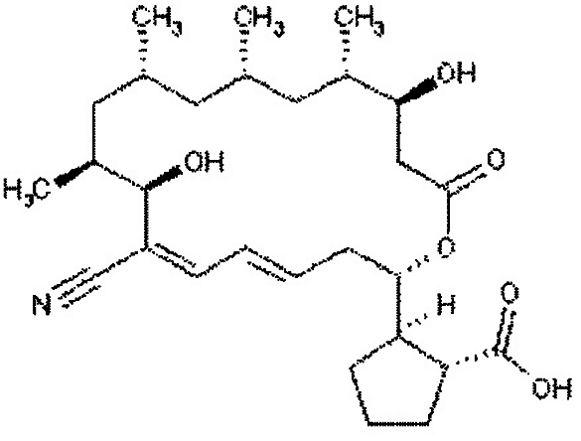
Figure 1 - Chemical structure of Borrelidin

Although, Borrelidin first isolated from a soil sample of Streptomyces rochei subsequently identified from other Streptomyces species such as S. parvulus, S. albovinaceous, S. griseus and an unidentified Streptomyces species C2989 (Vino and Lokesh, 2008). Apart from microbial sources, borrelidin also can be synthesized chemically which has similar structure and functions (Olano, et al., 2004). Novel analogues of borrelidin also can be synthesized by precursor directed biosynthesis (Singh et al., 1989). The biosynthetic pathway of borrelidin falls into four categories based on the genes involved (Maehr and Evans, 1987). They are (i) Biosynthesis of polyketide backbone (ii) starter acid biosynthesis (iii) formation of nitrile group (iv) regulation and resistance (Olano, et al., 2004). The biosynthesis of polyketide backbone occurs by repeated condensation of simple carboxylic acids (3 units of malonyl CoA and 4 units of methyl malonyl CoA). The trans cyclo pentane 1,2 dicarboxylic acid acts as starter molecule and the backbone extended by the addition of carboxylic acid which occurs in seven cycles catalyzed by poly functional type - Poly Ketide Synthase (PKS), also known as modular PKS (Kawamura et al., 2003). Modular PKS are organized into repeating modules, each consisting of a catalytic domain required to perform one round of chain assembly.
In the present study, develop a suitable process for extraction of bio-products and improve yields of the bioactive substances that demonstrated inhibitory affects against microbial pathogenic, from Streptomyces rimosus, KH-1223-55 were reported. The bioactive substance was isolated, purified spectroscopic analysis and biological activities were determined.

2. Material and Methods
2.1. Test organisms
2.1.1. Gram Positive: Staphylococcus aureus, NCTC 7447; Bacillus subtilis, NCTC 1040 ; Bacillus pumilus, NCTC 8214 ; Micrococcus luteus, ATCC 9341.
2.1.2. Gram Negative: Escherichia coli, NCTC 10416; Klebsiella pneumonia, NCIMB 9111; Pseudomonas aeruginosa, ATCC 10145.
2.1.3. Unicellular fungi: Saccharomyces cerevisiae, ATCC 9763, Candida albicans IMRU 3669.
2.1.4. Filamentous fungi: Aspergillus niger, IMI 31276; Fusarium oxysporum, Botrytis fabae, Rhizoctonia solani and P. chrysogenum.

2.2. Scaling up the optimal production of the antimicrobial agents by fermentation.
Streptomyces rimosus, KH-1223-55 was inoculated into 250 ml Erlenmeyer flasks containing 50 ml of liquid starch nitrate medium and incubated at 30ºC and 250 rpm on a rotary shaker. After three day this first- stage was transferred to 500 ml seed medium in a 2L conical flask and incubated under the same conditions for another six days of the production medium and the second stage was used as the inoculum for fermentation in 5L fermentor. The pH was adjusted at 7.0. The temperature was adjusted at 30ºC, the agitation at 250 rpm and aeration rate at 1vvm. Foam was suppressed by sterile sunflower oil (El-Tayeb et al., 2004). Samples were taken every 4 hr.

2.3. Fermentation
Twenty-liter total volume was filtered through Whatman No.1 filter paper, followed by centrifugation at 5000 r.p.m for 20 minutes. The clear filtrates were tested for their activities against the test organisms (Sathi et al., 2001).

2.4. Extraction
The clear filtrate was adjusted at different pH values (4 to 9) and extraction process was carried out using different solvents separately at the level of 1:1 (v/v). The organic phase was concentrated to dryness under vacuum using a rotary evaporator (Atta, 2010).

2.5. Precipitation
The precipitation process of the crude compound dissolved in the least amount of the solvent carried out using petroleum ether (b.p 60-80 °C) followed by centrifugation at 5000 r.p.m for 15 min. The precipitate was tested for its antimicrobial activities (Zhang etal., 2007).

2.6. Separation
Separation of the antimicrobial agent(s) into its individual components was conducted by thin layer chromatography using chloroform and methanol (24:1, v/v) as a solvent system (Atta et al., 2009).

2.7. Purification
The purification of the antimicrobial agent(s) was carried out using silica gel column (2 X 25) chromatography. Chloroform and Methanol 10:2 (v/v), was used as an eluting solvent. The column was left for overnight until the silica gel (Prolabo) was completely settled. One-ml crude precipitate to be fractionated was added on the silica gel column surface and the extract was adsorbed on top of silica gel. Fifty fractions were collected (each of 5 ml) and tested for their antimicrobial activities (Atta et al., 2009).

2.8. Physico-chemical properties of the antimicrobial agent
2.8.1. Elemental analysis
The elemental analysis C, H, O, N, and S was carried out at the micro analytical center, Cairo University, Egypt.

2.8.2. Spectroscopic analysis
The IR, UV and Mass spectrum were determined at the micro analytical center of Cairo University, Egypt.

2.8.3. Biological activity
The minimum inhibitory concentration (MIC) could be determined by the cup assay method (Kavanagh, 1972).

2.8.4. Characterization of the antimicrobial agent
The antimicrobial agent produced by Streptomyces rimosus, KH-1223-55 was identified according to the recommended international references of (Umezawa, 1977; Berdy, 1974; Berdy, 1980a, b & c).

3. Results
3.1. Scaling up of the optimal production of antimicrobial agent using fermentation
The production of the antimicrobial agent from Streptomyces rimosus, KH-1223-55 was carried out in a 5L fermentor. The pH was adjusted at pH 7; temperature was adjusted at 30°C, and agitation at 250 rpm and aeration rate at 1vvm. Samples were taken every 4 hr. The activity of antimicrobial agent produced by Streptomyces rimosus, KH-1223-55 exhibited an increase in comparison to that produced in shake flasks. Results during fed-batch indicated that the dissolved oxygen concentration dropped gradually to about zero after 36 h. Also it was worthy to mention that the pH dropped to about 6.8 and was increased gradually again after 12 h. The activity of the antimicrobial agent production was began after 48 h. and increased until reached the maximum after 120 h incubation.

3.2. Separation of the antimicrobial agent
The clear filtrates containing the active metabolite (20 liters), was adjusted to pH 7.0 then the extraction process was carried out using Chloroform and Ethyl acetate at the level of 1:1 (v/v). The organic phase was collected, and evaporated under reduced pressure using rotary evaporator. The residual material was dissolved in the least amount of DMSO and filtered. The filtrates were test for their antimicrobial activities. The antimicrobial agent was precipitated by petroleum ether (b.p. 60-80°C) and centrifuged at 4000 r.p.m for 15 minute where a brown powdered precipitate could be obtained. Separation of the antimicrobial agent(s) into individual components was carried out by thin-layer chromatography using a solvent system composed of chloroform and methanol (24:1, v/v). Among two bands developed, only one band at R_{f} 0. 65 showed antimicrobial activity. The purification process through column chromatography packed with silica gel. A mixture of chloroform and methanol (10:2 v/v) was used as an eluting solvent. The most active fractions against the tested organisms ranged between 19 to 29 Fig. (1).

3.3. Physicochemical characteristics of the antimicrobial agent
The purified antimicrobial agent produces characteristic odour, their melting point is 95°C. The compound is freely soluble in chloroform, ethyl acetate, n-butanol, acetone, ethyl alcohol, methanol and 10 % isopropyl alcohol, but insoluble in petroleum ether, hexan and benzene.

3.4. Elemental analysis
The elemental analytical data of the antimicrobial agent(s) revealed the following: C=68.68; H=8.85; N= 2.86., O = 19.61 and S=0.0. This analysis indicates a suggested imperical formula of C₂₈H₄₃NO₆

3.5. Spectroscopic characteristics
The infrared (IR) spectrum of the compound reveals the presence of a lactone carbonyl group (1712.0 cm⁻¹), nitrile group (2190.8 cm⁻¹), carboxyl group (3378.2 cm⁻¹) and (1630.0 cm⁻¹) and –OH and CO, respectively (Fig.2). The ultraviolet (UV) absorption spectrum of the antimicrobial agent recorded a maximum absorption peak at 258 nm (Fig. 3). The Mass spectrum revealed that the molecular weight is 489.5 (Fig. 4).

3.6. Biological activities of the antimicrobial agent
Data of the antimicrobial agent spectrum indicated that the agent is active against Gram-positive and Gram-negative bacterial and unicellular fungi. The MIC of antibiotic was determined and the results showed that the minimum inhibitory concentration (MIC) of the antibiotic produced by Streptomyces rimosus, KH-1223-55 against Staph. aureus, NCTC 7447 and Micrococcus lutea, ATCC 9341 was 15.73 µg/ ml; Bacillus subtilis, NCTC 10400, Bacillus pumilus, NCTC 8214, S. cerevisiae, Aspergillus niger IMI 31276 and Fusarium oxysporum was 31.25 µg/ ml, Klebsiella pneumonia, NCIMB 9111, Escherichia coli, NCTC 10416, Candida albicans, IMRU 3669, Rhizoctonia solani and Botrytis fabae was 46.9 µg/ ml, Pseudomonas aeruginosa, ATCC 10145, Asp. flavus, IMI 111023 and Alternaria alternata was 52.7 µg/ ml, Aspergillus fumigatus ATCC 16424 and P. chrysogenum was >100 μg/ml (Table 2).

3.7. Identification of the antimicrobial agent
On the basis of the recommended keys for the identification of antibiotics and in view of the comparative study of the recorded properties of the antimicrobial agent, it could be stated that the antimicrobial agent is suggestive of being belonging to 18 membered polyketide macrolide group (Borrelidin or Treponemycin antibiotic) produced by Streptomyces rimosus, KH-1223-55 (Table 3).

Table 2, Antimicrobial spectrum of the agent by using paper cup assay method.
Test organisms | MIC (ug/ml) concentration
Test organisms | antimicrobial agent produced by Streptomyces rimosus, KH-1223-55
A- Bacteria
a. Gram positive cocci
Staph. aureus, NCTC 7447 | 15.73
Micrococcus luteus, ATCC 9341 | 15.73
b. Gram positive bacilli
Bacillus subtilis, NCTC 10400 | 31.25
Bacillus pumilus, NCTC 8214 | 31.25
c. Gram negative bacteria
Escherichia coli, NCTC 10416 | 46.9
Klebsiella pneumonia, NCIMB 9111 | 46.9
Pseudomonas aeruginosa, ATCC 10145 | 52.7
B- Fungi
a- unicellular fungi
Candida albicans, IMRU 3669 | 46.9
Saccharomyces cervisiae ATCC 9763 | 31.25
b- filamentous fungi
Aspergillus niger IMI 31276 | 31.25
Aspergillus fumigatus ATCC 16424 | 100 <
Aspergillus flavus IMI 111023 | 52.7
Fusarium oxysporum | 31.25
Rhizoctonia solani. | 46.9
Alternaria alternata | 52.7
Botrytis fabae | 46.9
P. chrysogenum | 100 <

Table 3, A comparative study of the characteristic properties of the antimicrobial agent produced by Streptomyces rimosus, KH-1223-55 in relation to Reference antibiotic (Borrelidin or Treponemycin)
Characteristic | purified antimicrobial agent | Borrelidin (or Treponemycin) antibiotic
- Melting point | 95°C | 90°C - 93°C
- Molecular weight | 489.5 | 489.5
Chemical analysis:
C | 68.68 | ND
H | 8.85 | ND
N | 2.86 | ND
O | 19.61 | ND
S | 0.0 | ND
- Ultra violet | 258 nm | 258 nm
- Formula | C₂₈H₄₃NO₆ | C₂₈H₄₃NO₆
- Active against | Active against Gram positive and Gram negative bacteria and unicellular and filamentous fungi. | Active against Gram positive and Gram negative bacteria and unicellular and filamentous fungi.
ND= No data

Figure 1. Antimicrobial activity of fractions obtained using silica gel column chromatography technique for antimicrobial agent produced by Streptomyces rimosus, KH-1223-55.
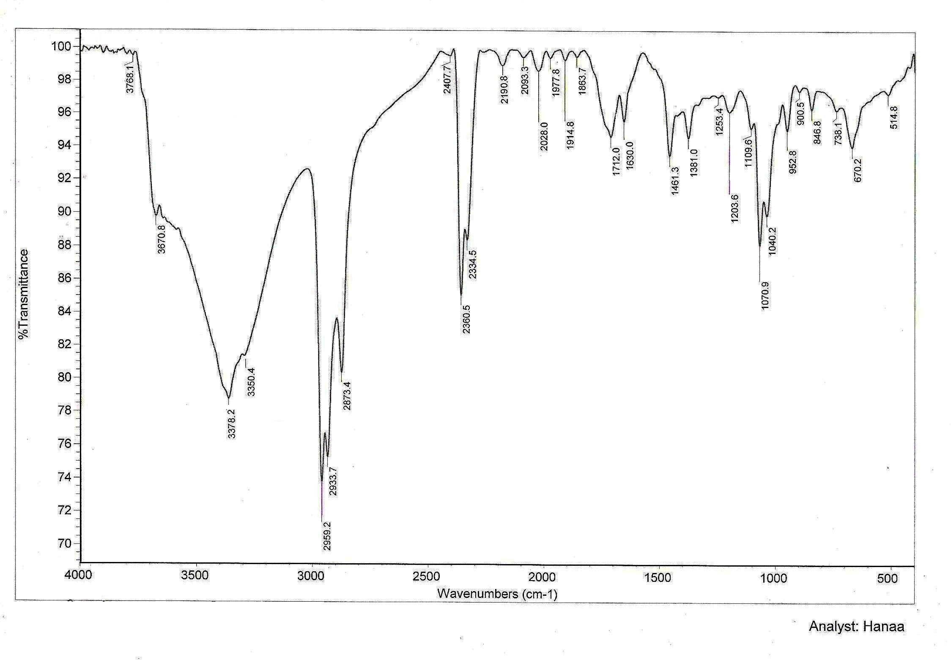
Figure 2. I.R spectrum of antimicrobial agent produced by Streptomyces rimosus, KH-1223-55.

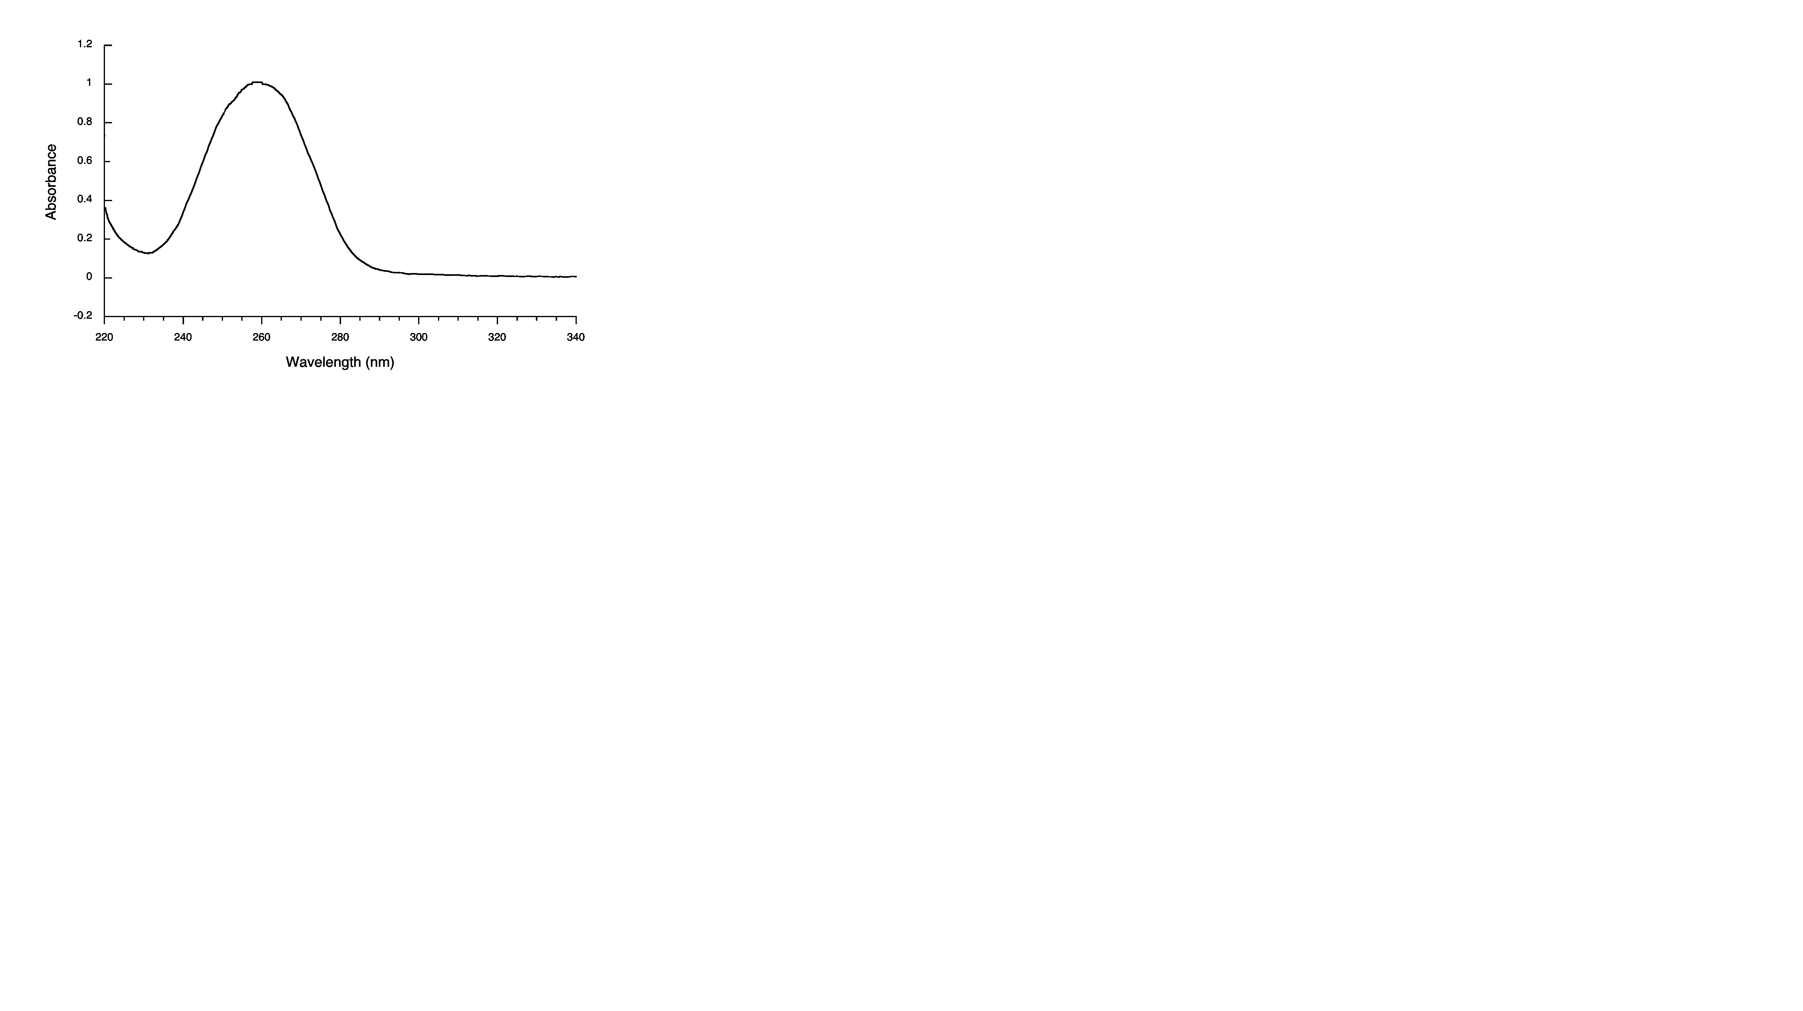
Figure 3. Ultraviolet absorbance of antimicrobial agent produced by Streptomyces rimosus, KH-1223-55.

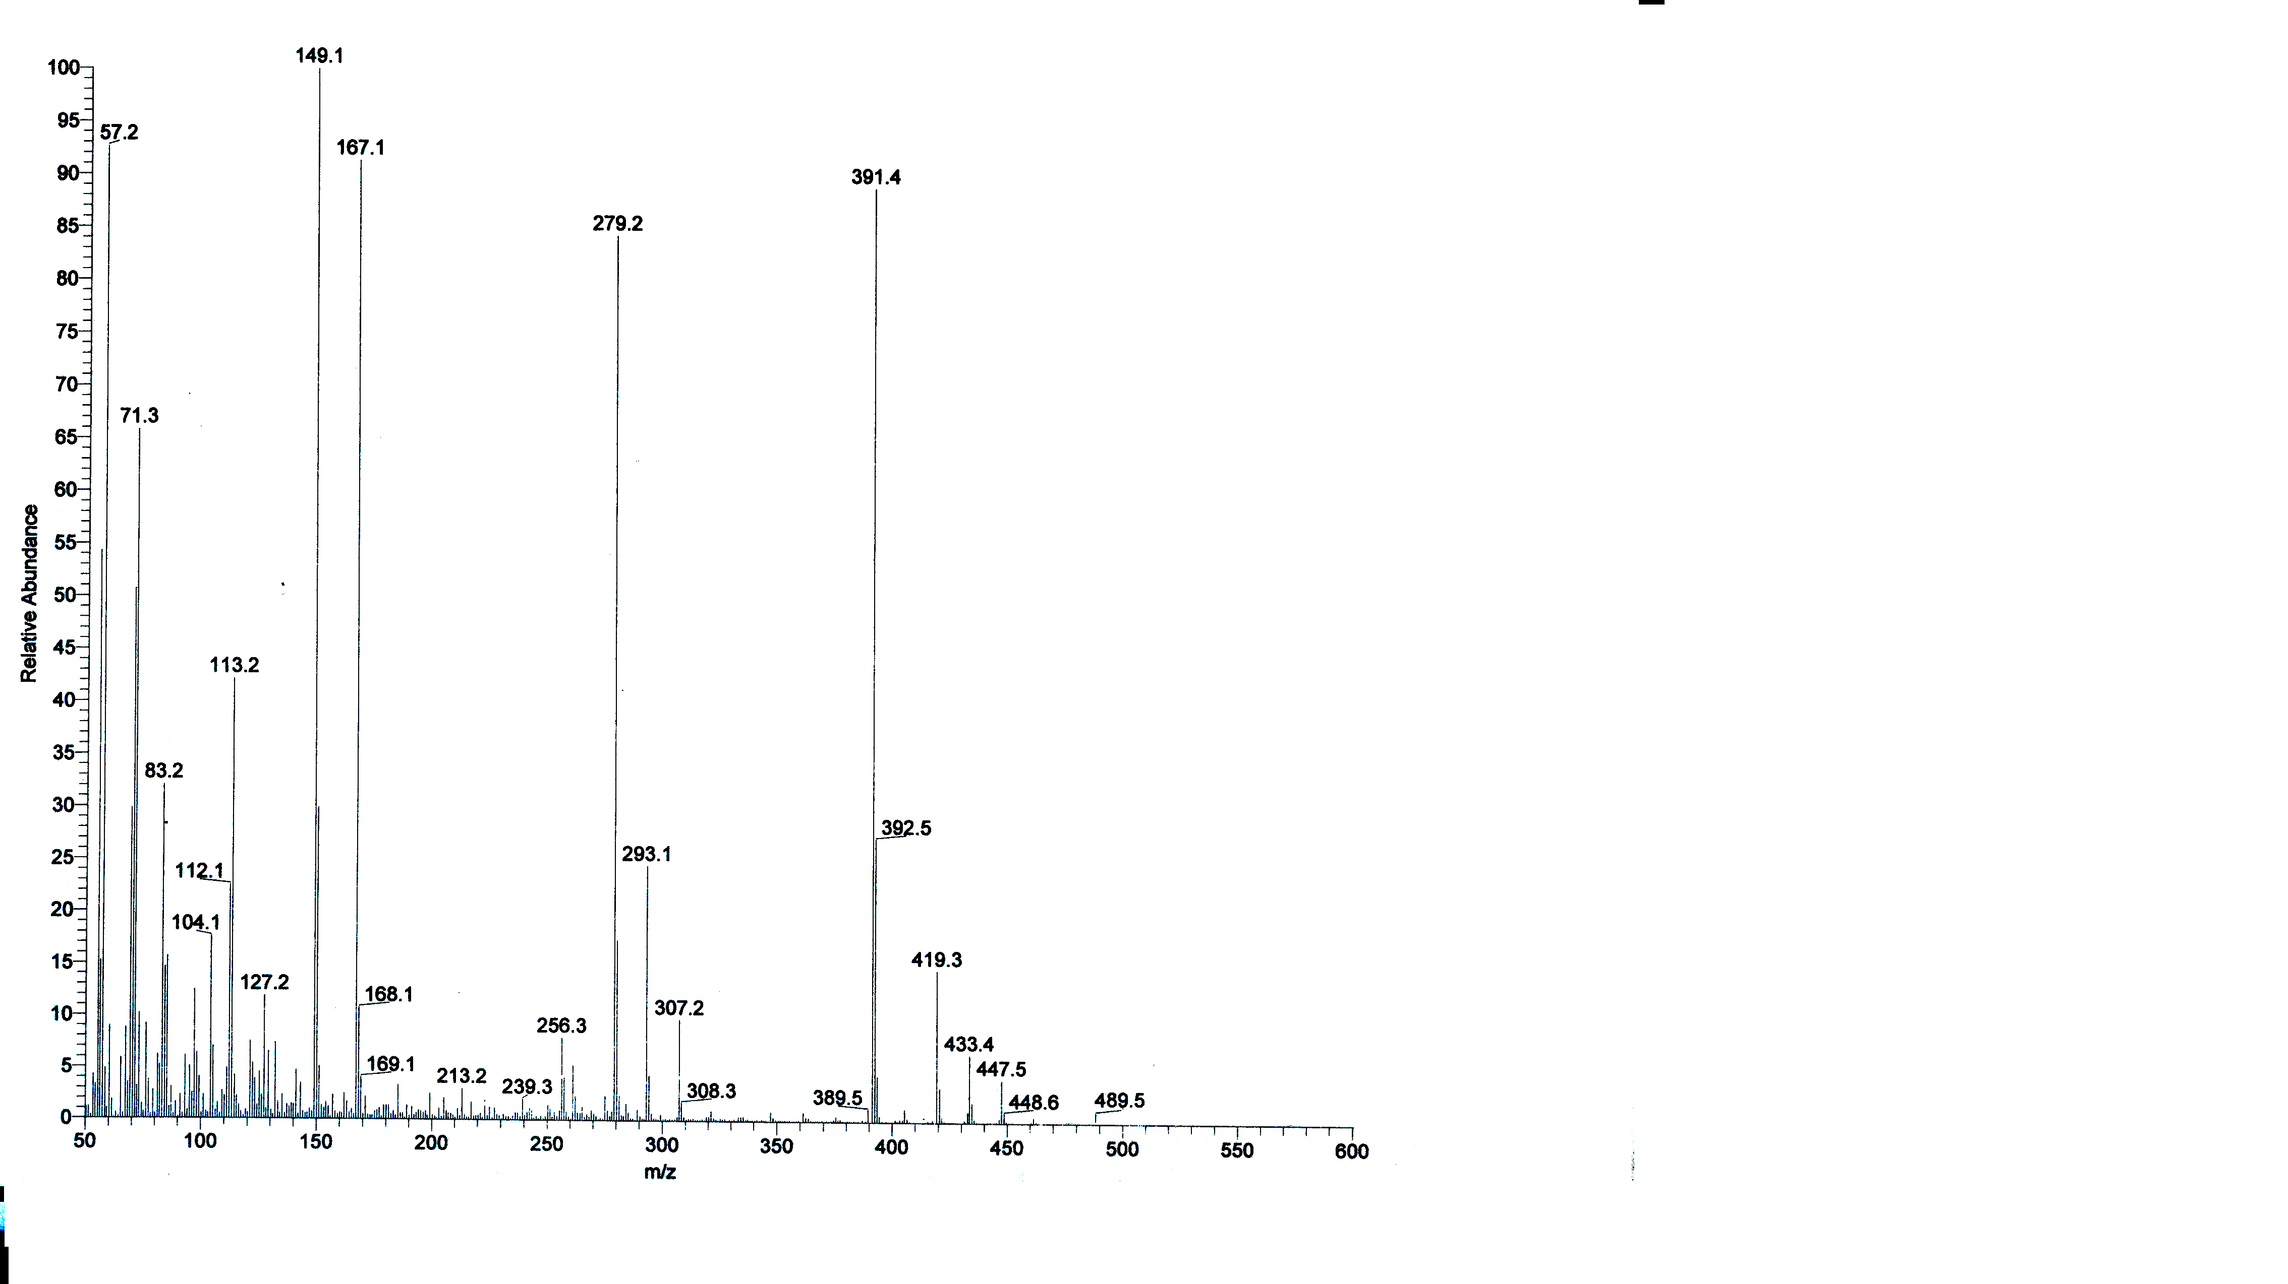
Figure 4. Mass-Spectrum of antimicrobial agent produced by Streptomyces rimosus, KH-1223-55.

4. Discussions
The active metabolites were extracted by Chloroform and Ethyl acetate at pH 7. Similar results were obtained by (Criswell et al., 2006; Sekiguchi et al., 2007 and Vino and Lokesh, 2008). The organic phase was collected and evaporated under reduced pressure using rotary evaporator. The extract was concentrated and treated with petroleum ether (b.p. 60-80°C) for precipitation process, where only one active fraction was obtained in the form of yellowish white powder. The purification process through a column chromatography packed with silica gel and an eluting solvents composed of chloroform and methanol (10:2, v/v), indicated that fractions activities was recorded from fraction Nos. 19 to 29. Similar results were obtained by (Hitchens and Kell, 2003 and Vino and Lokesh, 2008). The physico-chemical characteristics of the purified antibiotic revealed that, their melting point is 95 °C. The compound is freely soluble in chloroform, ethyl acetate, n-butanol, acetone, ethyl alcohol, methanol and 10 % isopropyl alcohol, but insoluble in petroleum ether, hexane and benzene. Similar results were recorded by (Yanai, 2004; Yoram et al., 2006 and Atta, 2009, 2010 & 2011). A study of the elemental analysis of the antibacterial agent lead to an imperical formula of: C₂₈H₄₃NO₆. The spectroscopic characteristics of the antimicrobial agent under study revealed the presence of a maximum absorption peak in UV. at 258 nm, infra-red absorption spectrum of the compound reveals the presence of a lactone carbonyl group (1712.0 cm⁻¹), nitrile group (2190.8 cm⁻¹), carboxyl group (3378.2 cm⁻¹) and (1630.0 cm⁻¹) and –OH and CO, respectively. The Mass spectrum revealed that the molecular weight is 489.5. Similar results were recorded by (Vong et al., 2003 and Vino and Lokesh, 2008).
The MIC of antibiotic was determined and the results showed that the minimum inhibitory concentration (MIC) of the compound against Staph. aureus, NCTC 7447 and Micrococcus lutea, ATCC 9341 was 15.73 µg/ ml; Bacillus subtilis, NCTC 10400, Bacillus pumilus, NCTC 8214, S. cerevisiae, Aspergillus niger IMI 31276 and Fusarium oxysporum was 31.25 µg/ ml, Klebsiella pneumonia, NCIMB 9111, Escherichia coli, NCTC 10416, Candida albicans, IMRU 3669, Rhizoctonia solani and Botrytis fabae was 46.9 µg/ ml, Pseudomonas aeruginosa, ATCC 10145, Asp. flavus, IMI 111023 and Alternaria alternata was 52.7 µg/ ml, Aspergillus fumigatus ATCC 16424 was >100 μg/ml. similar investigations and results were attained by (Khalifa, 2008 and Atta, 2011).
Identification of the antimicrobial agent according to recommended international keys indicated that the antibiotic is suggestive of being likely belonging to 18 membered polyketide macrolide group (Borrelidin or Treponemycin antibiotic) (Umezawa, 1977; Berdy, 1974; Berdy, 1980a, b & c; Vong et al., 2003 and Vino and Lokesh, 2008).

5. Conclusion
It could be concluded that: The Borrelidin or Treponemycin antibiotic produced by Streptomyces rimosus, KH-1223-55 demonstrated obvious inhibitory affects against pathogenic microorganisms (Gram positive and Gram negative bacteria and unicellular fungi).

Corresponding Author:
Prof. Dr. Houssam M. Atta
Botany and Microbiology Department, Faculty of Science (Boys), Al-Azhar University, Cairo, Egypt. The present address: Biotechnology Department. Faculty of Science and Education. Al-Khurmah, Taif University; KSA.
E-mail: houssamatta@yahoo.com
houssamatta@hotmail.com

References
- Anderson, B.F.; Herlt, A.J.; Richards, R.W. and Robertson, G.B. 1989. Crystal and molecular structures of two isomorphous solvates of the macrolide antibiotic borrelidin: absolute configuration determination by incorporation of a chiral solvent in the crystal lattice. Aust. J. Chem., 42, 717730.
- Atta, H. M. 2010. Production, Purification, Physico-Chemical Characteristics and Biological Activities of Antifungal Antibiotic Produced by Streptomyces antibioticus, AZ-Z710. American-Eurasian Journal of Scientific Research. 5 (1): 39-49, 2010.
- Atta, H. M.; A. T. Abul-hamd and H. G. Radwan, 2009. Production of Destomycin-A antibiotic by Streptomyces sp. using rice straw as fermented substrate. Comm. Appl. Biol. Sci, Ghent University, 74 (3) : 879-897, 2009.
- Berdy, J. 1974. Recent development of antibiotic research and classification of antibiotic according to chemical structure. Adv. App. Microbiol., 14: 309-406.
- Berdy, J. 1980a. Recent advances in and prospects of antibiotics research. Proc. Biochem., 15: 28-35.
- Berdy, J. 1980b. CRC Handbook of antibiotic compounds. Vol I. CRC Press, Boca Raton, Florida.
- Berdy, J. 1980c. CRC Handbook of antibiotic compounds. Vol II. CRC Press, Boca Raton , Florida.
- Criswell, D.; V. L. Tobiason; J. S. Lodmell and D. S. Samuels, 2006. Mutations Conferring Aminoglycoside and Spectinomycin Resistance in Borrelia burgdorferi. Antimicrob. Agents Chemother. 50: 445-452.
- El-Tayeb O.M, A. Salama; M. Hussein and H.F. El-Sedawy, 2004. Optimization of industrial production of rifamycin B by Amycolatopsis mediterranei I. The role of colony morphology and nitrogen sources in productivity. Afr. J. Biotechnol. 3: 266-272.
- Hitchens, G.D. and D.B. Kell, 2003. On the effects of thiocyanate and venturicidin on respiration-driven proton translocation in Paracoccus denitrificans. J. Biochim Biophys Acta. Jul 27; 766(1):222-32.
- Kavanagh, F. 1972. Analytical Microbiology. Vol. 2, Acad. Press, New York.
- Kawamura, T.; L i u , D.; Towle, M.J.; Kageyama, R.; Tsukahara, N.; Wakabayashi, T. and Littlefield, B.A. 2003. Antiangiogenesis effects of borrelidin are mediated through distinct pathways: threonyl-tRNA synthetase and caspases are independently involved in suppression of proliferation and induction of apoptosis in endothelial cells. J Antibiot, 56: 709715.
- Keller-Schierlein,W. 1967. Composition of the antibiotic borrelidin., Helv. Chim. Acta., 50: 731753.
- Khalifa, M.A., 2008. Bioprocess Development for the Biosynthesis of Bioactive Compounds from Microbial Origin. M.Sc. Thesis. Faculty of Science, Al-Azhar University, Cairo, Egypt.
- Kuo, M.S.; Yurek, D.A. and Kloosterman, D.A. 1989. Assignment of 1H and 13C NMR signals and the alkene geometry at C-7 in borrelidin. J. Antibiot. (Tokyo). 42, 10061007.
- Maehr, H., and Evans, R.H.1987. Identity of borrelidin with treponemycin., J.Antibiot, 40, 1455-1456.
- Nagamitsu, T.; Harigaya,Y. and Omura, S. 2005. Total synthesis of borrelidin, Proc. Japan Acad.,81, Ser.B, 81(B), 244-256.
- Olano, C.; Moss, J.S.; Brana, A.F.; Sheridan, R.M.; Math, V.; Weston, A.J.; Mendez, C.; Leadley, P.F., Wilkinson, B. and Salas, J.A. 2004. Biosynthesis of angiogenesis inhibitor borrelidin by Streptomyces parvulus TÜ4055: insights into nitrile formation, Molecular Microbiology., 52 (6), 1745-1756.
- Olano, C.; Moss, J.S.; Brana, A.F.; Sheridan, R.M.; Math, V.; Weston, A.J.; Mendez, C.; Leadley, P.F.; Wilkinson, B. and Salas, J.A. 2004. Biosynthesis of the angiogenesis inhibitor borrelidin by Streptomyces parvulus TÜ4055: Cluster analysis and assignment of functions, Chemistry & Biology, 11, 8797.
- Pamboukian, C.R.D. and M.C.R. Facciotti, 2004. Production of the antitumoral retamycin during continuous fermentations of Streptomyces olindensis. Process Biochem. 39, 2249-2255.
- Sekiguchi, M.; N. Shiraish; K. Kobinata; T. Kudo; I. Yamaguchi; H. Osada and K. Isono, 2007. RS-22A and C: new macrolide antibiotics from Streptomyces violaceusniger, Taxonomy, fermentation, isolation and biological activities. Journal of Antibiotics 48(4): 289-292.
- Singh, S. K.; Gurusiddaiah, S. and Whalan, J.W. 1985. Treponemycin, a nitrile antibiotic active against Treponema hyodysenteriae., Antimicrob Agents Chemother, 27, 239-245
- Umezawa, H. 1977. Recent advances in bio-active microbial secondary metabolites. Jap. J. Antibiotic. Suppl., 30: 138-163.
- Vino, S. and Lokesh, K.R. 2008. Borrelidin: A promising anticancer agent from Streptomyces species. Advanced Biotech, 22-26.
- Vong, B.G.; Abraham, S.; Xiang, A.X. and Theodorakis, E.A. 2003. Synthetic Studies on Borrelidin: Enantioselective Synthesis of the C1?C12 Fragment, Organic Letters, 5(10), 1617-1620.
- Yanai, K. 2004. The Kanamycin Biosynthetic Gene Cluster from Streptomyces kanamyceticus. Journal of Antibiotics vol: 57 issue: 5 page: 351-354.
- Yoram, A.; G. Puius; H. Todd; A. Stievater and S. Thamarapu, 2006. Crystal structure, conformation, and absolute configuration of kanamycin A. Volume 341, Issue 17, 11 December 2006, Pages 2871-2875

9/3/2011

