Discovery Potent of Novel Peptide Derivatives Containing Sulfonamide Moiety As Inhibitors of CA Using Structure Based Virtual Screening and Binding Assays

Ahmed A.El-Henawy^{a*}, Shaban I.Mohamed^{b}, Ahmed A.Hassanª, Ahmed H.Halawaª, M A.Elnassagª, Gamil A.Elhageª

a) Chemistry Department, Faculty of Science, Al-Azhar University, Nasr City, Cairo-Egypt.
b) Technology Engineering Institute ,Tamoh,Giza , Egypt.
*elhenawysci@gmail.com

Abstract: Recently, sulfonamides have been reported to show significant antitumor activity in vitro and/or in vivo. There are a variety of mechanisms for the anticancer activity, and the most famous mechanism is through the inhibition of CA isozymes. The structures of these compounds design to comply with the general features of sulfonamide pharmacophore which act as carbonic anhydrase (CA) inhibitors. Virtual screening using molecular docking studies of the synthesized compounds were performed by Virtual Docker (MVD), the molecular docking results indicates that some synthesized compounds more suitable inhibitor against (CA) than original inhibitor (E7070).
[Ahmed A.El-Henawy, Shaban I.Mohamed, Ahmed A.Hassan, Ahmed H.Halawa, M A.Elnassag, Gamil A.Elhage. Discovery Potent of Novel Peptide Derivatives Containing Sulfonamide Moiety As Inhibitors of CA Using Structure Based Virtual Screening and Binding Assays. New York Science Journal 2011;4(10):19-25]. (ISSN: 1554-0200). http://www.sciencepub.net/newyork.

Key words: Peptide, Sulfonamide, Carbonic Anhydrase, DOKING, Lipinski Rule.

1. Introduction
Sulfonamides posses many types of biological activities and representatives of this class of pharmacological agents are widely used in clinic as antibacterial [1], antithyroid [2], diuretic [3,4],hypoglycaemic [5]and anti-carbonic anhydrase [3,6]. From other studies, aryl/heteroaryl sulfonamides may act as antitumor agents through several mechanisms, most famous suggested mechanism by inhibiting carbonic anhydrase isozymes(CA) [7-11]. After widely evaluation, Sulfonamides were found act as carbonic anhydrase (CA) inhibitors [12].
In brief, the CA is a family of metalloenzymes involved in the catalysis of an important physiological reaction: the hydration of CO2 to bicarbonate and a proton. The inhibition mechanism of tumour by sulphonamide CA inhibitors was suggested by Chegwidden and Spencer [12], sulfonamides may be decrease the provision of bicarbonate to synthesis of nucleotides and other cell components such as membrane lipids.
Also, peptide derivatives possess several biological activities such as anti-tumour effect and DNA binding activity [13,14]. Moreover, most natural peptides are composed of L-form α-amino acids, and because of the ubiquitous prevalence of peptidases, they have limited bio-stability, and low bioavailability. To overcome this problems, biologically active pseudo-peptides have been developed, which have highly specificity and non-toxicity pharmaceuticals.
In the light of these facts, and continuation of reported work [13], the present study aimed to identify putative CA inhibitors, used computer docking technique, which plays an important role in the drug design and discovery, by placing a molecule into the binding site of the target macromolecule, to predict the correct binding geometry for each ligand at the active site, which reveals the hydrogen bonds formed with the surrounding amino acids and MVD score values. MVD program enable us to predict favourable protein–ligand complex structures with reasonable accuracy and speed.

2. MATERIALS and METHODS:
2.1. Synthesise:
All synthesized dipeptides (3-19) were achieved according previously reported literature [13].

2.2. Molecular Modelling Study:
2.2.1. Generation of Ligand and Enzyme Structures:
Docking study was carried out for the target compounds into (hCAII) using virtual docker(MVD 08). The crystal structure of the (1G54) complexed with (E7070) was uploaded from protein data bank PDB[23].

2.2.2. Preparation of Small Molecule:
Molecular modeling of the target compounds were built using ChemDraw Ultra version 8.0.3, and minimized their energy through Chem3D Ultra version 8.0.3/MOPAC, Jop Type: Minimum RMS Gradient of 0.010 kcal/mol and RMS distance of 0.1 °A, and saved as MDL MolFile (*.mol)[24]. Our compounds were introduced into the (1G54) binding site accordance the published crystal structures of (E7070) bound to kinase.

2.2.3. Stepwise Docking Method:
Active compounds and hCAII (PDB code 1G54) was uploaded without water molecules. The binding sites of (1G54) were defined close to Zn-Metal ion (volume of approximately 76.8 Å3), The-199, His-119, His-98 and His-96 residues. During docking the grid resolution was set to 0.3 Å, while the binding site radius was set to 9 Å. Scorings Generated by MVD.

3. Results and discussion:
From the analysis of the CA active site[10], and from analysis general features of pharmacophore (Fig. 1) acting as carbonic anhydrase inhibitors, which has been described by Thiry et al. [15].

This pharmacophore includes the structural elements should be present in the compounds to act as CA inhibitors:

(i) Include the presence of a sulfonamide moiety, which coordinates with the zinc ion of the active site of the CA, and attaching to a scaffold which is usually a benzene ring.
(ii) The side chain might possess a hydrophilic link able to interact with the hydrophilic part of the active site, and a hydrophobic moiety which can interact with the hydrophobic part of the CA active site. So that, in this work, these compounds were designed to comply with pharmacophore described earlier [15] (Fig. 2), and comprise substituted moieties in sulfadiazine with E7070 (Fig. 3).
3.1. Chemistry:
The formations of dipeptides (2-16) were achieved according (Scheme 1), and the results of chemical analyses of the synthesized compounds were reported earlier [13].

3.2. In vitro anticancer screening:
The cytotoxic activity of some synthesized compounds was evaluated against human breast cancer cell line (MCF7) were reported previously [13].

3.3. Lipinski rule of five and drug-likeness profile:
Oral bioavailability was considered playing an important role for the development of bioactive molecules as therapeutic agents. Many potential therapeutic agents fail to reach the clinic because of ADME-Tox liabilities. Therefore, a computational study for prediction of ADME properties of the molecules was performed by determination of topological polar surface area (TPSA) and ‘‘rule of five’’, which formulating by Lipinski [16]. Lipinski establishes that, chemical compound could be an orally active drug in humans, if no more than one violation of the following rule: (i) C log P < 5, (ii) number of hydrogen bond donors ≤ 5, (iii) number of hydrogen bond acceptors ≤ 10,(iv) and molecular weight <500. Calculations were performed using Molinspiration calculation toolkit (http://www. molinspiration.com). Our results revealed that (table 1, Fig 4), the lipophilicity of most compounds is smaller than 5.0; the molecular weight (MW> 500) except compound containing methionylthiazole moiety, hydrogen bond acceptors (n-ON= 5–11) and donors (n-OHNH= 2–4) fulfil Lipinski’s rule. These data may suggest that, these compounds act as new potential anticancer agents. In addition the molecular volume and weight of derivatives (295.37 Å³> MV < 426.03 Å³ and 348>MW < 487) are similar to more than 80% of all all Fluka traded drugs (MW < 450 Da), and to that determined by Lipinski ‘‘Rule of 5’’ [17-19].

In order to identify potential drug-score and drug-likeness of these compounds, all compounds (1-16) were submitted into silico ADMET screening (http://www.organic-chemistry.org). There are several approaches to estimate drug-likeness of these compounds based on topological descriptors, ﬁngerprints of molecular drug-like structures keys, or other properties, such as clog P and molecular weight. The Osiris program (www.organic-chemistry .org/prog/peo) determines the frequency of occurrence of each fragment within the collection of treated drugs, and within the supposedly non drug-like collection of (15,000 commercially available chemicals, Fluka) compounds. Positive values (0.1–10) indicate that the molecule predominantly contains the better fragments, which are frequently present in commercial drugs. The drug-score is combining with drug-likeness, clog P, log S, molecular weight, and toxicity risk in one handy value, and may be used to judge the compound overall potential to qualify for a drug. In this work, the Osiris program was used to calculate the fragment based druglikeness and drug-score of the compounds (2-16), The data were compared with those calculated for E7070 (Fig. 1). Interestingly, most derivatives (3,6 and 9-16) have druglikeness values (between 4.11 - 9.33) better than E7070 (2.35). Moreover, we used the Osiris program to predict the overall toxicity of these compounds as it, may point to the presence of some fragments generally responsible for the irritant, mutagenic, tumorigenic, or reproductive effects in these molecules. Interestingly, all Compounds (2-16) presented low toxicity risk profile in silico, similar to E7070, which is a direct indication of these potential drug-score. These theoretical data, pointing to these compounds with low toxicity risk profile.
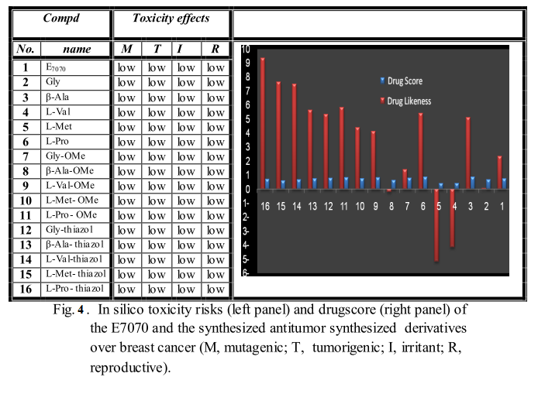
3.4. Molecular Modeling Studies:
3.4.1. Molecular structures:
Abbate et al. stated that [20], the (E7070) potent anti-cancer drug and effective carbonic anhydrase II inhibitor, the interactions between it's drug and the active site of carbonic anydrase II (hCA II), these interactions similar reported earlier [9,15]. These interactions are found to be common for the sulfonamide compounds, which are acting as CA inhibitors and include [9,21]: {(i) The nitrogen atom of the sulfonamide moiety binding with Zn(II) ion in a tetrahedral geometry, which is a stable geometry for the metal ion. (ii) Zn(II) ion of the enzyme is coordinates with The nitrogen atom of the sulfonamide (iii) Thr. 199 amino acid of the enzyme is participates by two hydrogen bonds (First, with the one of the oxygen atom of the SO₂NH₂. Second, with NH moiety}. (Fig. 1)
In order to understand the binding mode of protein-ligand interactions, Docking study was carried out using SYBYL version 7.3. Tripos Inc. with MVD virtual docker version 2008 [22]. The crystal structure of the enzyme (1G54) complexed with (E7070) as inhibitor was downloaded from protein data bank PDB[23]. The MolDock scoring function was applied to evaluate the binding affinities between the (1G54) and selected 15 inhibitors. (E7070) was redocked into the active site of the enzyme, and then replaced it with the tested compounds in order to compare the binding mode of ligand and the tested compounds.
As shown from the (table 2, 3) figures (5and6, show binding modes of compounds 2 and 10 respectively), the following results can be drawn: E7070 (the original ligand) reveals MVD score (-18.76 Kcal/mol) and form 3 hydrogen bonds: two hydrogen bond with Thr-199, and one hydrogen bond with His-119. Compound (2) gives strong binding affinity with MVD score (-37.07 Kcal/mol) and form 16 bonds with active binding site: two important bonds with Zn metal, two other important bonds with Thr-199, Three bonds with His-94, four bonds with His-119, one bond with [Glu-200, His-96, Asn76 , Asn72 and Tyr 7] (Fig. 5). Also, Compound (10) gives binding affinity with MVD score of (-31.43 Kcal/mol) and form important 13 hydrogen bonds with active binding site: one bond with Pro-201, five bonds with Thr-200, Three bonds with Thr-199, one bond with [Gln-92, Asn-67, His-64, and Asn-62] (Fig. 6).
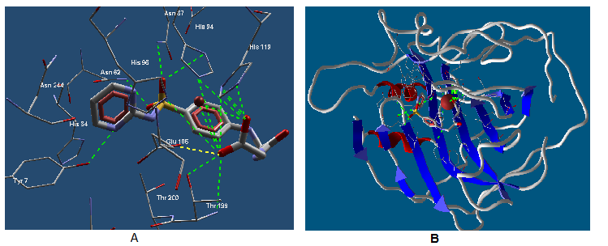

Fig.4: Interaction between ligand (2) and binding site of CA (1G54, PDB code), which green dot lines represented hydrogen bonding interaction of igand (2) with binding site, yellow dot line represented electrostatic interaction of ligand (2) with binding site. B) A plot of docked ligand (2) in active site where the backbone of protein is shown in flat ribbon. Ligand (2) are represented in stick mode. . Ligand (2) are represented in stick mode, which atoms are colored in dark grey, oxygen in red, nitrogen in blue and sulfur in yellow. Hydrogen atoms of the amino acid residues and ligand was removed to improve clarity.

4. Conclusion:
In the present work, led to the development of novel antitumor molecules containing N-substituted sulfonamide pharmacophore. Systematic structure based virtual screening of the synthesized compound library, identified synthesized compounds as putative CA binders most of the synthesized compounds formed strong hydrogen bonding interactions and hydrophobic interactions, with central amino acids of active site of enzyme. In addition, the docking study of the compounds showed that, the most synthesized compounds act as CA inhibitors more than (E7070). Also, further study of these molecules showed that, the studied compounds fulﬁlled Lipinski rule of 5 and present druglikeness similar to antitumor drugs. These results point the N-sulphonamide derivatives as lead compounds for designing new candidates for clinically tumour treatment.
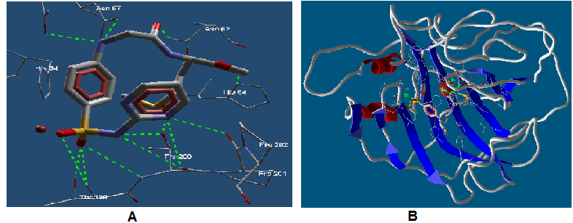
Fig.5: Interaction between ligand (10) and binding site of CA (1G54, PDB code), which green dot lines represented hydrogen bonding interaction of ligand (10) with binding site. B) A plot of docked ligand (10) in active site where the backbone of protein is shown in flat ribbon. Ligand (10) are represented in stick mode. Ligand (10) are represented in stick mode, which atoms are colored in dark grey, oxygen in red, nitrogen in blue and sulfur in yellow. Hydrogen atoms of the amino acid residues and ligand was removed to improve clarity.

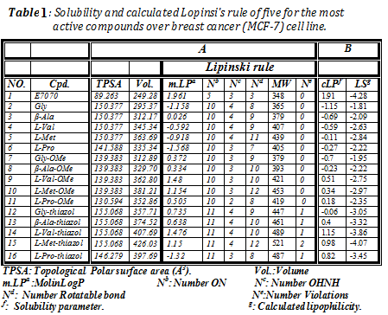

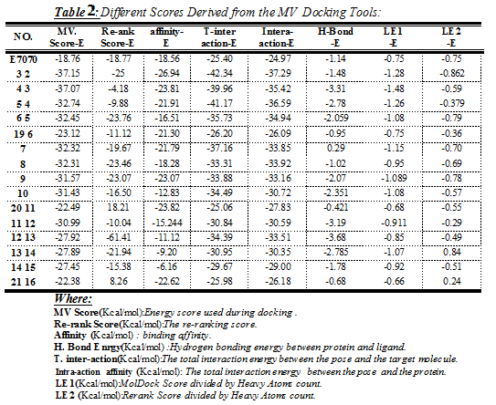

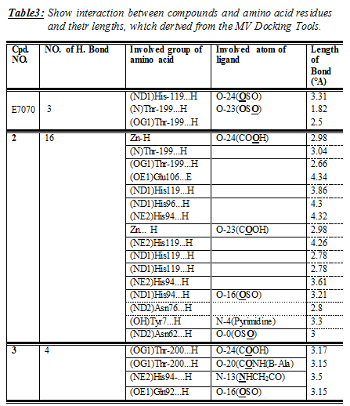

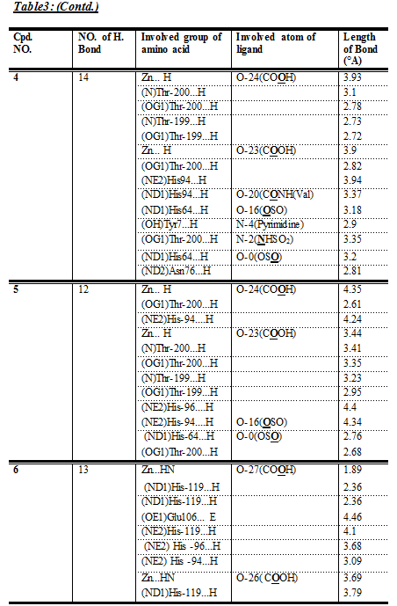

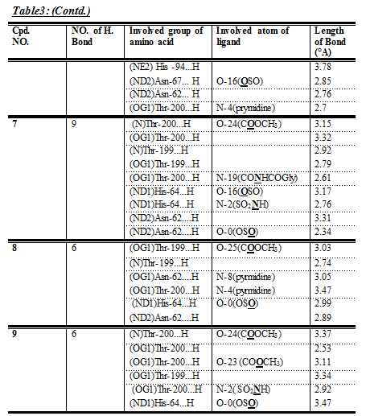

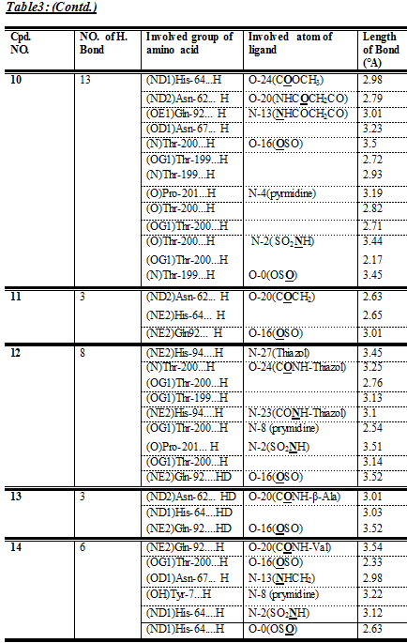

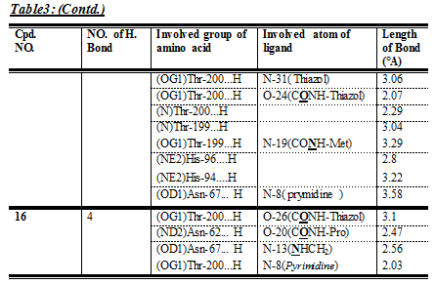

Corresponding Author:
Dr. Ahmed A. El-henawy
Department of Chemistry.
Faculty of Science, Al-Azhar University
Nainital, Uttarakhand 263002, Egypt
E-mail: elhenawysci@gmail.com

5. References:
- J. Drews;” Drug discovery: A historical perspective”; Science; 2000, 287(5460): 1960–1964.
- C.W. Thornber; ” Isosterism and molecular modification in drug design “; Chem. Soc. Rev.; (1979),8:563–580.
- C.T. Supuran and A. Scozzafava;” Carbonic anhydrase inhibitors and their therapeutic potential “; Exp. Opin. Ther. Patents; (2000), 10(26): 575–600.
- T.H. Maren; “Relations between structure and biological activity of sulfonamides“; Annu. Rev. Pharmacol. Toxicol.; (1976),16:309–327.
- A.E. Boyd 3rd; ” Sulfonylurea receptors, ion channels, and fruit flies.”; Diabetes; (1988),37: 847–850.
- C.T. Supuran and A. Scozzafava; ” Carbonic anhydrase inhibitors”; Curr. Med. Chem.-Immunol. Endocr.Metabol. Agents; (2001), 1(37):61–97.
- A.J. Kivela, J. Kivela, J. Saarnio and S. Parkkila; “Loss of heterozygosity: An independent prognostic factor of colorectal.“; World J. Gastroenterol.; (2005), 11:155–163.
- C.T. Supuran; ”Carbonic anhydrases: novel therapeutic applications for inhibitors and activators”; Nat. Rev. Drug Discov.; (2008), 7: 168–181.
- C.T. Supuran and A. Scozzafava; “Carbonic anhydrases as targets for medicinal chemistry”; Bioorg. Med. Chem.; (2007), 15: 4336–4350.
- C.T. Supuran, A. Scozzafava and A. Casini;” Carbonic anhydrase inhibitors”; Med. Res. Rev.; (2003), 23: 146–189.
- A. Casini, A. Scozzafava, A. Mastrolorenzo and L.T. Supuran; ”Sulfonamides and sulfonylated derivatives as anticancer agents”; Curr. Cancer Drug Targets; (2002), 2 : 55–75.
- W.R. Chegwidden, S.J. Dodgson and I.M. Spencer;” The roles of carbonic anhydrase in metabolism, cell growth and cancer in animals.”; EXS; (2000), 90 :343–363.
- A. A. El-Henawy; ”Design Synthesis of New Peptide Derivatives and Evaluated DNA Binding Activity, Anticancer and Antimicrobial Activity.” ; J. of American Science; (2010),6(11):240-249.
- A. A. El-Henawy, Mona S. Kadah and H.S.Nassar; “Design and synthesis of peptide derivatives act as dna binding agent and discovery of potent carbonic anhydrase inhibitors using docking studies.”; Egyptian Journal of Chemistry; (2010), 53(2) : 279-299.
- A. Thiry, M. Ledecq, A. Cecchi, J.M. Dogne, J.Wouters, C.T. Supuran and B. Masereel; “Indanesulfonamides as Carbonic Anhydrase Inhibitors. Toward Structure-Based Design of Selective Inhibitors of the Tumor-Associated Isozyme CA IX”; J. Med. Chem.; (2006), 49:2743–2749.
- C.A. Lipinski, F. Lombardo, B.W. Dominy, P.J. Feeney, "Experimental and computational approaches to estimate solubility and permeability in drug discovery and development settings". Adv.Drug.Delivery Rev. 28, 4-25 (2002).
- D.F. Veber, S.R. Johnson, H.Y. Cheng, B.R. Smith, K.W. Ward, K.D.J. Kopple, J. Med. Chem.; (2002), 45, 2615-2623.
- I.V. Tetko, Drug Discov. Today, (2005); 15, 1497-1500.
- J.M.F. Balanco, E.M. Pral, S. da Silva, A.T. Bijovsky, R.A. Mortara, S.C. Alﬁeri, Parasitology; (1998), 116 ,103-113.
- F. Abbate, A. Casini, T. Owa, A. Scozzafava and C.T. Supuran; “Carbonic anhydrase inhibitors: E7070, a sulfonamide anticancer agent, potently inhibits cytosolic isozymes I and II, and transmembrane, tumor-associated isozyme IX “; Bioorg. Med. Chem.Lett.; (2004), 14: 217–223.
- S. Pastorekova, S. Parkkila, J. Pastorek and C.T. Supuran; “Carbonic anhydrases: current state of the art, therapeutic applications and future prospects “; J. Enzyme. Inhib. Med. Chem. (2004), 19,199-229.
- R. Thomsen and H. Christensen; “A new technique for high-accuracy molecular docking”; J. Med. Chem., (2006), 49(11): 3315-3321.
- C. Kim, J. Chang, J. Doyon, T. Baird, C. Fierke, A. Jain and D. Christianson; “Fluoroaromatic−fluoroaromatic interactions between inhibitors bound in the crystal lattice of human carbonic anhydrase II”; Am.Chem.Soc. (2000), 122:12125-12134.
- ChemDraw Software [Available from: http://www.cambridgesoft.com/ software /ChemDraw/].lliams, Pharm. Biol., (1994) ,32:337–345.

9/1/2011

