PERFORMANCE EVALUATION OF A LOCALLY FABRICATED FRICTION LOSS IN PIPE APPARATUS

Fatukasi Samson Olusegun¹, Ajayeoba Abiola Olufemi² and Olaoye Olusegun Solomon

¹Civil Engineering Department (Mechanical Unit) Osun State Polytechnic, P. M. B. 301, Iree, Nigeria.
²Mechanical Engineering Department, Ladoke Akintola University of Technology,
P.M.B. 4000, Ogbomoso, Nigeria.
aoajayeoba@lautech.edu.ng, samsek2k3@gmail.com, osolaoye@lautech.edu.ng

Abstract: The development and accurate experimental results of friction loss in pipe apparatus allows the detailed study of the fluid friction head losses which occur when an incompressible fluid flows through pipes. But high cost of this imported model of this equipment makes it unaffordable for most Nigerians; hence there is a need for locally fabricated friction loss in pipe apparatus, aiming at economic viability and readily availability of the equipment to Nigerians for quality control. All the materials used in this work were sourced locally and they are readily available. In this work only laminar flow was considered and the t–test analysis at 95% confidence level of experimental results and graphical comparison of both imported and locally fabricated friction loss in pipe apparatus were carried out. It is seen from the results that there is no significant difference between the imported and fabricated apparatus.
[Fatukasi Samson Olusegun, Ajayeoba Abiola Olufemi and Olaoye Olusegun Solomon. PERFORMANCE EVALUATION OF A LOCALLY FABRICATED FRICTION LOSS IN PIPE APPARATUS. New York Science Journal 2011;4(10):50-57]. (ISSN: 1554-0200). http://www.sciencepub.net/newyork.

KEY WORDS; Apparatus, Incompressible fluids, Indigenous materials, Fabrication, Laminar flow, Turbulent flow

- Introduction
The economic development of any nation depends on the level of its industrial development. Industrial development can only be achieved when there is a strong volume of output of locally manufactured goods (Agbetoye et al, 2006). This will ensure conservation of foreign exchange earnings, maintainability and affordability to average Nigerians. Hence the need for locally fabricated equipment for the benefit of students especially in our laboratories is highly essential, considering the high cost of imported equipment. Considering the friction loss in pipe apparatus, the flow of fluid in the pipe is always goes with loss of energy in which the major causes is friction loss (Gardiner and Harrington, 2005).This energy loss is not reversible and hence is not recoverable as useful energy .The water flow in to the apparatus from a supply thank is lead through a flexible hose to the bell mouthed entrance to a straight tube along which the friction loss is measured. The piezometer tapping are connected to an inverted U-tube manometer, which reads the differential pressure directly in millimeter of water. The rate of flow along the pipe is controlled by a needle valve at the pipe exit and is measured by timing the collection of water in a measuring cylinder.
According to Gardiner and Harrington (2005), it was stated that in 1883, Osborne Reynolds recorded a number of experiments to determine the law of resistance in pipes, and concluded that the parameter which determines whether the flow shall be laminar or turbulent in any particular case is
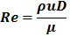
There are widely accepted approaches used by industries, each having a validity which irrespective of procedure- provides identical final answer. As a comparison the friction factor developed in 1893 by an American Engineer John Thomas Fanning (1837-1911) is known as Fanning Friction Factor 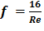 is related to other commonly encountered forms and symbol for the friction factor, where Re is the Reynolds number (Churchill, 1977; Massey. 1987 and White, 1999).
Whither the flow is laminar or turbulent it will depend on the size of Reynolds no. It is laminar when Re ≤ 2100 and turbulent is ≥ 2100. The friction head is related to pressure loss due to friction with the formula
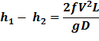
While the hydraulic gradient (i) is related to friction factor as shown in the formula below (White, 1999 and Rajput 1998):
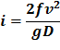

Where h_{f} = friction loss of the pipe
ƒ =fanning friction factor of the pipe
V=.velocity of fluid in pipe
L =Length of the pipe
D=pipe diameter
g=.Acceleration due to gravity
ρ. =Density of fluid
µ =.Coefficient of Viscosity of fluid
i=hydraulic gradient
Considering the importance of this apparatus both in school laboratories and industry using indigenous material for its fabrication, it will provide better knowledge, good understanding and advantage for student and Engineers in the field.
This paper presents performance evaluation of a locally fabricated friction loss in pipe apparatus (Fig. A) for teaching aids and industrial application.

- Material and Methods
2.1 Material Selection
Considering the economic factor, environmental factor and availability of this apparatus to the Nigerian for quality control, all the material used were sourced locally and they were selected based on the following factors; availability, strength ,cost and comfort. The frame work of the apparatus placed on hydraulic bench (as shown in Fig. B). Some parts of the apparatus were purchased (e.g. rubber hose (pipe) of mm, clips, steel meter rule and the bleed screws (Fig. C)) while the others were fabricated (piezometer tappings, base and stand). The body of the apparatus was fabricated by welding the piezometer tappings and the iron pipe to the base and then with the stand. The base is rectangular in shape with dimension 165mm×1153mm and the height is 25mm.The piezometer is cuboid in shape and of dimension 25mm×25mm×170mm, welded to it is a pipe of length 30mm and internal diameter 20mm in which a tap was incorporated in other to control the flow of the fluid flowing into the system. The test pipe has an internal diameter of 0.05mm.The air valve channel is also cuboid in shape and of dimensions 135mm×55mm×20mm and made up of sheet metal incorporated in it is the air valve. The needle valve where the rubber hose is attached is of pipe of external diameter 5mm was welded to the piezometer. The steel meter rule and rubber hose were arranged on the vertical flat iron bar to give the manometer. The air valve, the manometer and the base including the piezometer tappings and test pipe were then arranged as shown in the Figures A and B (in the appendices).

2.2 Experimental Methods
The apparatus was set on the bench and leveled so that the manometers stand vertically. The water manometer is then introduced into the circuit by directing the lever on the tap towards the relevant connecting pipe. The bench supply valve was opened and adjusted until there was a steady flow down the supply tank overflow pipe. With the needle valve partly opened to allow water to flow through the system, any trapped air was removed by manipulation of the flexible pipes. Necessary care was ensured so as to clear the piezometer connection of air. The needle valve was then closed whereupon the levels in the two limbs of the inverted U-tube should settle to the same value. The needle valve was opened fully to obtain a differential head of at least 400mm, and the collection of a suitable quantity of water in the measuring cylinder timed. The values of h₁ (head in downstream manometer) and h₂ (head in upstream manometer) were taken. Further readings were taken at decreasing flows, the needle valve serving to reduce the discharge from each reading to the next.

- Results and Discussion
Tables 1and 2 show the results obtained from both imported and locally fabricated friction loss in pipe apparatus respectively. Also, Fig 1 shows the graphical comparison of experimental result of log of velocity for both imported and fabricated frictional loss in pipe apparatus and Fig 2 shows the graphical comparison of experimental results of log of hydraulic gradient for both imported and fabricated friction loss in pipe apparatus. The deviation of imported and fabricated apparatus result was so negligible, thereby confirming the reliability of the fabricated apparatus as a veritable substitute for the imported one.
The results were further investigated using t-test analysis at 95% confidence level as shown in both Tables 3 and Table 4. It is however seen from Table3 that, there is no significance difference in imported and locally fabricated friction loss in pipe apparatus since T-tabulated (2.073875294) is greater than the T-calculated (0.013489485) and that there is no significance difference in imported and locally fabricated friction loss in pipe apparatus since T-tabulated (2.073875294) is greater than the T-calculated (- 0.090361508).
The cost estimate which is the bill of Engineering Measurement and Evaluation (BEME) of locally fabricated friction loss in pipe apparatus is given in Table 4 as shown.

Table 1; Results obtained from imported friction loss in pipe apparatus
Qty(ml) | t(s) | u(m/s) | h₁(mm) | h₂(mm) | h_{f}(m) | i | Temp ºC | Logi | Log u
400 | 50.8 | 1.11 | 521 | 56 | 0.465 | 0.887 | 25 | -0.0521 | 0.0453
400 | 54 | 1.049 | 500 | 85 | 0.415 | 0.794 | 25 | -0.1002 | 0.208
400 | 58.8 | 0.961 | 476 | 114 | 0.362 | 0.692 | 25 | -0.1599 | -0.0173
400 | 61.8 | 0.915 | 452 | 145 | 0.307 | 0.586 | 25 | -0.2321 | -0.0586
400 | 67.2 | 0.843 | 427.5 | 174 | 0.2535 | 0.483 | 25 | -0.3161 | -0.0742
300 | 57.8 | 0.734 | 390 | 223 | 0.167 | 0.319 | 25 | -0.4962 | -0.1343
300 | 71.9 | 0.592 | 375 | 245 | 0.13 | 0.248 | 25 | -0.6055 | -0.2277
300 | 92.9 | 0.457 | 362 | 263 | 0.099 | 0.189 | 25 | -0.7235 | -0.3401
200 | 92.4 | 0.306 | 349 | 282 | 0.067 | 0.128 | 25 | -0.8928 | -0.5143
150 | 100.8 | 0.22 | 340 | 295.5 | 0.455 | 0.085 | 25 | -1.0771 | -0.6576
85 | 113.6 | 0.106 | 332.5 | 306 | 0.0265 | 0.05 | 25 | -1.2958 | -0.9747
50 | 129.4 | 0.055 | 325 | 316 | 0.009 | 0.017 | 25 | -1.7645 | -1.2596

Table 2; Results obtained from locally fabricated friction loss in pipe apparatus
Qty(ml) | t(s) | u(m/s) | h₁(mm) | h₂(mm) | h_{f}(mm) | i | Temp ºC | Logi | Log u
400 | 51.1 | 1.11 | 521 | 58 | 0.463 | 0.884 | 25 | -0.054 | 0.045
400 | 54.3 | 1.04 | 500 | 86 | 0.414 | 0.79 | 25 | -0.102 | 0.017
400 | 59.1 | 0.96 | 475.5 | 115.5 | 0.36 | 0.687 | 25 | -0.163 | -0.017
400 | 62.1 | 0.91 | 452 | 147 | 0.305 | 0.582 | 25 | -0.235 | -0.041
400 | 67.6 | 0.84 | 427 | 174 | 0.253 | 0.483 | 25 | -0.316 | -0.076
300 | 58.1 | 0.73 | 389.5 | 224.5 | 0.165 | 0.315 | 25 | -0.502 | -0.137
300 | 72.7 | 0.58 | 375 | 244 | 0.131 | 0.25 | 25 | -0.602 | -0.237
300 | 95 | 0.45 | 361.5 | 264.5 | 0.097 | 0.185 | 25 | -0.733 | -0.347
200 | 93.3 | 0.3 | 348 | 283 | 0.065 | 0.124 | 25 | -0.907 | -0.523
150 | 101.2 | 0.2 | 339.5 | 294.5 | 0.045 | 0.086 | 25 | -1.066 | -0.699
85 | 113.9 | 0.11 | 332 | 306 | 0.026 | 0.05 | 25 | -1.301 | -0.959
50 | 129.7 | 0.06 | 325 | 316 | 0.009 | 0.017 | 25 | -1.77 | -1.221

Figure 3; the graphical comparison of experimental result of log of velocity for both imported and fabricated frictional loss in pipe apparatus

Figure 4; the graphical comparison of experimental result of log of hydraulic gradient (i) for both imported and fabricated frictional loss in pipe apparatus

Table 3; T-test comparison results of logarithm of hydraulic gradient (i) and logarithm of velocity (u) between imported and fabricated apparatus
 | Log i |  | Log u
 | Imported | Fabricated | Fabricated | Imported
Mean | -0.642983333 | -0.645916667 | -0.349583333 | -0.333758333
Variance | 0.283370214 | 0.284061174 | 0.173777902 | 0.194267797
Observations | 12 | 12 | 12 | 12
Hypothesized Mean Difference | 0 |  | 0
Df | 22 |  | 22
t Stat | 0.013489485 |  | -0.090361508
P(T<=t) one-tail | 0.49467943 |  | 0.464408802
t Critical one-tail | 1.717144187 |  | 1.717144187
P(T<=t) two-tail | 0.989358859 |  | 0.928817604
t Critical two-tail | 2.073875294 |  | 2.073875294

Table 4; Bill of Enginnering Measurement and Evaluation for the apparatus
S/N | Items | QUANTITY | UNIT COST  (N) | COST  (N)
1 | Iron flat bar 1020mm×185mm×0.05mm | 1 | 1200 | 1200
2 | Iron flat 1153mm×165mm×0.05mm | 1 | 1400 | 1400
3 | Squared pipe 25mm×170mm | 2 | 450 | 900
4 | Rubber hose | 2438.4mm | 400 | 400
5 | Steel meter rule | 2 | 200 | 400
6 | Paint |  | 1000 | 1000
7 | Bolts and nuts | 9 | 120 | 120
8 | Washers | 8 |  | 100
9 | Aluminum clips | 5 | 30 | 150
10 | Miscellaneous |  |  | 2000
11 | Overhead |  |  | 1500
12 | Contingence |  |  | 2200
Total |  |  |  | 11370

- Conclusions
The reliability of the locally fabricated friction loss in pipe apparatus was confirmed based on T-test analysis carried out on the experimental laminar flow test results. It has also been established in this paper that the experimental result carried out using imported friction loss in pipe apparatus and locally fabricated fiction loss in pipe apparatus has no significant difference at 95% confidence level. Considering the cost implication, the locally fabricated apparatus is preferably reliable because many Nigerian institutions and industrial laboratories may not be able to afford the high price of imported friction loss in pipe apparatus. The production cost of the locally fabricated friction loss in pipe apparatus is N11370 as stated in Table 4. The cost is likely to reduce when standard approach is adopted in manufacturing different component on a large scale. It is expected that another group of people or individual will commenced further work from here.

- Recommendations
Having completed this paper work, it is therefore recommended:
- That government should facilitate the manufacturing of this apparatus in large scale so as to reduce the cost of production.
- That government or institutional management should ensure the availability of adequate facilities in the workshop to increase engineering students’ skills in handing engineering equipment.

Corresponding Author:
Ajayeoba Abiola O
Department of Mechanical Engineering
Ladoke Akintola University of Technology,
P. M. B. 4000. Ogbomoso, Nigeria
E-mail: aoajayeoba@lautech.edu.ng

References
- Agbetoye L. A. S., AdemosunO. C., Ogunlowo A. S., Olukunle O. J. Fapetu O. P. and Adesina A. (2006). “Developing Indigenous Machinery for Cassava Processing and Fruit Juice Production in Nigeria. In Advances in Engineering and Technology. Ed. by Mwakali J. A. and Taban-Wani G. Proceedings of the first International Conference on Advances in Engineering and Technology, Entebbe, Uganda.
- Gardiner K. and Harrington J. M. (2005). Occupational Hygiene, 3rd edition, Blackwell Publishing Ltd. USA.
- Churchill, S.W.(1977).Friction Factor equations spans all fluid-flow ranges. Retrieved July 27, 2011, http://en.wikipedia.org/wiki.
- Massey, B. S. (1987). Mechanics of Fluid. Van Nostrand Reinhold, London.
- White, F. M. (1999). Fluid Mechanics Fourth Edition.McGraw-Hill, New York.
- Massey, B . S. (1987). Mechanics of Fluid. Van Nostrand Reinhold, London.

APPENDICES (Figure A, Figure B, Figure C)

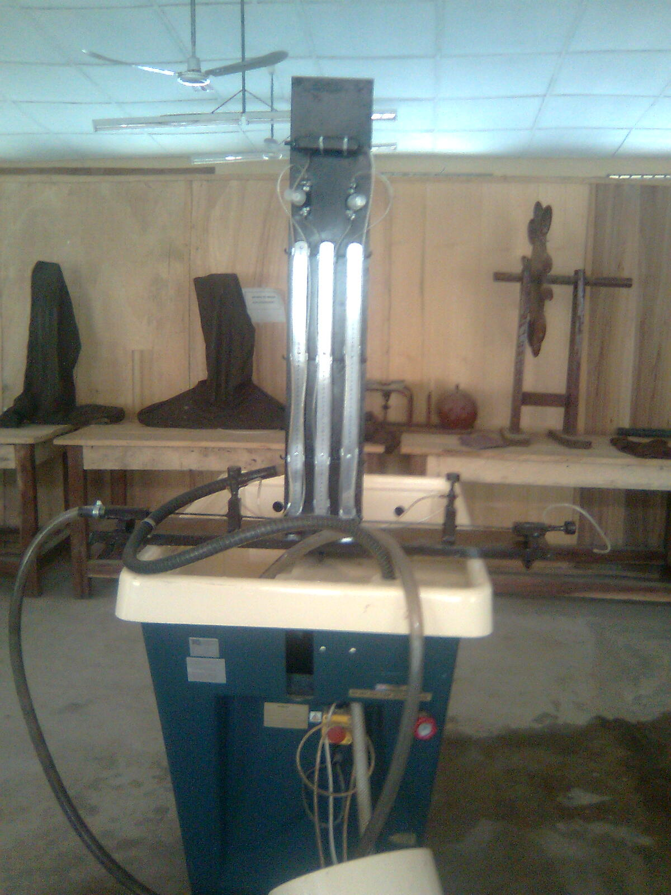
Locally Fabricated Friction Loss in Pipe Apparatus

Hydraulic bench

Figure A: Locally fabricated fiction loss in pipe apparatus on hydraulic bench during testing.

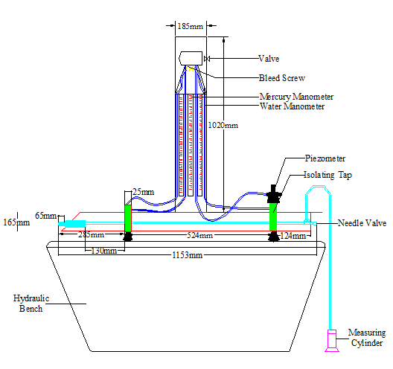
Figure B; Sketch of Friction loss in apparatus placed on hydraulic bench
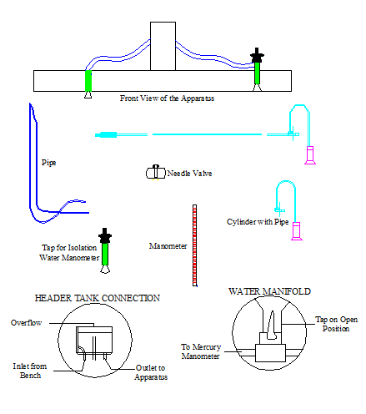
Figure C: Some part of friction loss in pipe apparatus

