Determination of porosity in rocks over some parts of Gwagwalada area, Nigeria.
Alhassan D.Yusuf, Mallam Abu, Abdulsalam N. Nasir

Department of Physics, University of Abuja, Gwagwalada, FCT PMB117, Nigeria
nasnaeem@yahoo.com

Abstract: The determination of porosity of rocks in some part of Gwagwalada Area Council of FCT-Abuja, was carried out to assess the effects of geographical variations on geophysical parameters which include porosity of rocks. This research paper describes a methodological approach using a direct measurement on rock samples in the laboratory. The volume of the rocks and the resulting porosity is then calculated from the computational approach. The results of the experiments and field studies that examined the rock porosity are then compared with the available lithological data (reviewed result). The data presented in this research work were gathered from the experiments conducted in the university of Abuja Physics laboratory and from the field studies observed from about eight locations within the research areas, which include Zuba, Yimi, Giri, Gwako, Paiko, Dobi, Anagada and Gwagwalada. In this investigation we have examined a suite of samples (20 specimens) with porositysity ranging from 14.29% to 51.92%.
[Alhassan D.Yusuf, Mallam Abu, Abdulsalam N. Nasir. Determination of porosity in rocks over some parts of Gwagwalada area, Nigeria. New York Science Journal 2011;4(11):5- 9]. (ISSN: 1554-0200).
Key words: Rocks, porosity, lithology, laboratory, experiment, data

1.0 INTRODUCTION

The use of rocks has had a huge impact on the cultural and technological development of the human race. Rocks have been used by humans and other hominids for more than 2 million years. The mining of rocks and minerals for their metal ore content has been one of the human advancements, which has progressed at different rates in different places including Nigeria because of the kind of metals available from the rocks of a region (Blatt and Robert, 1996).
The solid part of the earth is made up of rocks. Rocks in turn are made up of minerals and minerals are composed of chemical elements (Poldervaart, 1955). Minerals are to rocks as letters are to words. Stone refers to rock used in blocks to construct buildings or crushed to form roadbed. Most stones in buildings are limestone or granite. Marble in particular is a precious rock, often used to decorate floors, mosques, churches and tomb stones (Abegunde and Adegoke, 1998).
This natural body (rock) provides humanity with valuable materials and mineral resources in varying degree of usage depending on both the physical and chemical characteristics of such rocks. The economic value of limestone and their role as storage reservoirs for both petroleum and roundwater have provided incentives for their study (Geze, 1965).
Rocks provide employment opportunities for both skilled and unskilled labour. For example, limestone is used in making cement and also in demand as a soil conditioner as well as the principal ingredient of many chemical products.
The principal factors controlling the strength of solid rocks are density and porosity (Augustinus, 1991). Specific gravity is used in the separations of minerals. Architects and engineers used the knowledge of density in the design of bridge, flyovers and other structure (Abott, 1998). The economic evaluation of a petroleum accumulation demands knowledge of the distribution of porosity and permeability in rocks.
There is an apparent increase in the collapse of buildings, bridges, flyover, roads and as well as other structures in both developed and developing countries including Nigeria. This may be due to the fact that there are several rock types and minerals present in the world and many of them look alike and this makes their identification difficult. The non-diagnostic property of a particular rock type in construction of building or bridge could lead to disaster in form of collapse of the structure.
Many roads linking to villages are not put under construction by the respective local government chairmen, looking at the high cost of acquiring the needed materials for such project which include rocks.
Therefore, this research work is aimed at not only providing the identification properties of the rock and mineral types but also to reveal their various significance to human race.

1.1 LOCATION AND ACCESSIBILITY OF THE RESEARCH AREA
The area is located about 55kilomitres away from the federal capital city. It lies between latitudes 8⁰55' north and 9⁰00' North and longitudes 7⁰00' East and 7⁰05' East.(Gwagwalada Master Plan). The area covers a total of 65 square kilometers located at the centre of very fertile agricultural area with abundant clay deposits. It is located along Kaduna - Lokoja road.
The sunshine of the area ranges between 8 to 10 hours during the period of January to April/May. With regard to temperature, the area records its highest temperature during the dry season months at 38ºc. The start of rain is from March and end around October (Dawam, 2000).
The survey areas are part of the Nigerian basement complex,which occupied mainly hills and dissected terrain (Dawam, 2000). The rocks consists of schists, gneiss and some older granites. The map in fig.1 shows the various locations where the samples were collected.

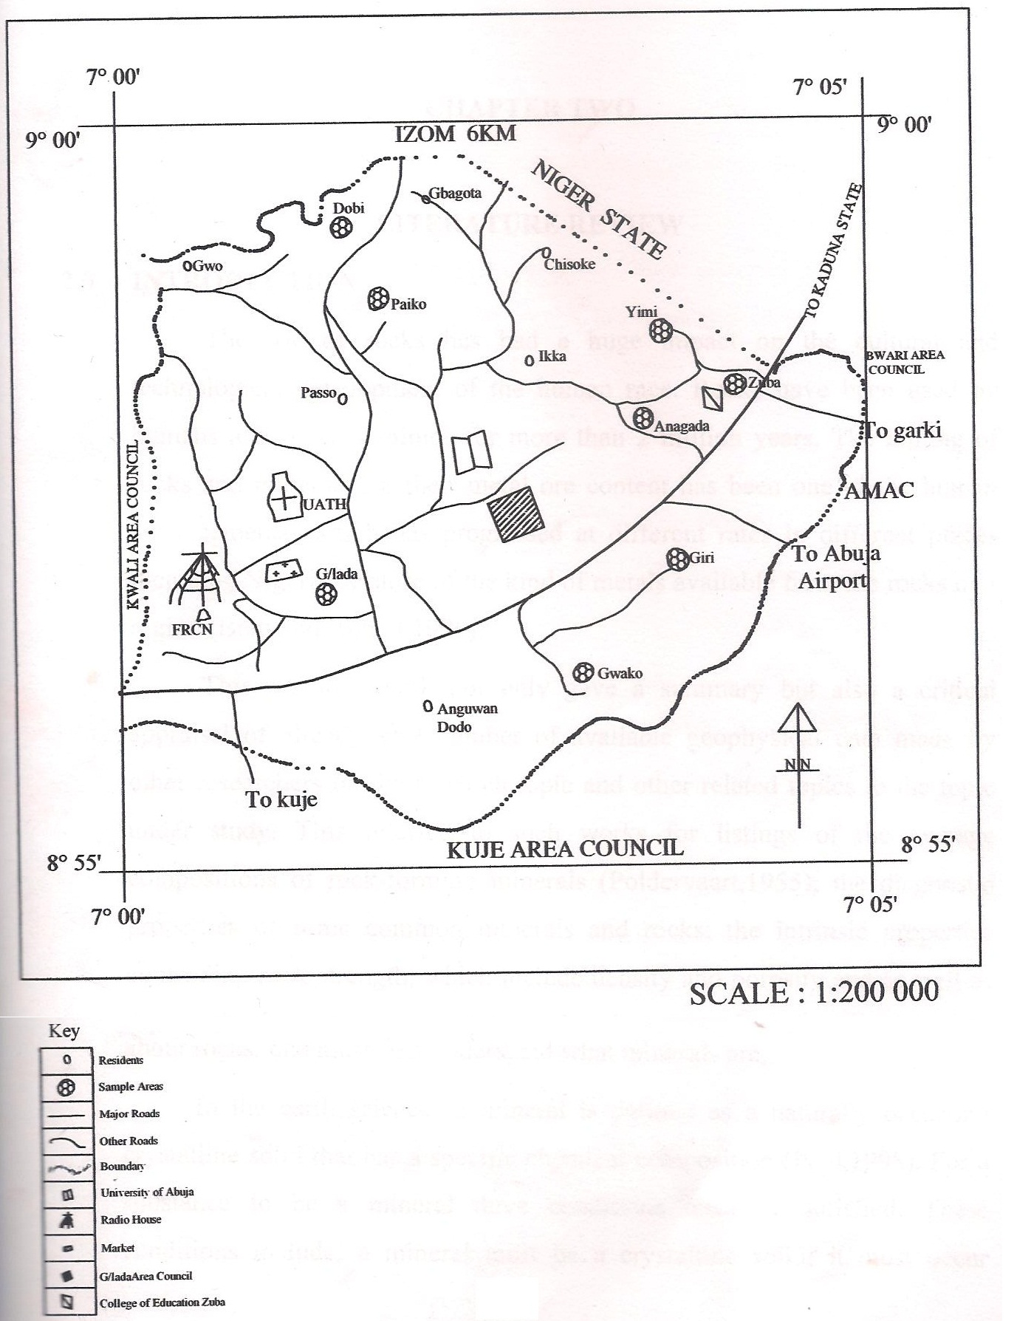
Fig 1: The approximate field location showing the survey areas

2.METHODOLOGY
There are several methods (direct or indirect) of determining the bulk porosity of rocks. For the interest of this research work, the laboratory method was adopted for the investigation of porosity of some surface sample of rocks in some selected locations within the research area. This method can be observed on a small sample of rock in a laboratory (Athy, 1930). The method is well guided by Archimedes’s Principle.
Sampling was done so as to obtain specimen that represent the situation under study. Sampling is therefore a small portion of material representing a large population. Two or more samples were collected each from eight (8) villages within Gwagwalada geographical area; two samples from Gwagwalada; three from Zuba; three from Giri; two from Paiko; three from Anagada; two from Dobi; three from Yimi and two from Gwako, making a total of twenty (20) different samples.
Samples for this study, after the collection, were broke into a measurable size and shape. The samples were then dried properly for six to eight hours so as to remove the moisture contents, before the actual measurement was taken.

2.1POROSITY VERIFICATION
The porosity of rock is defined as the ration of volume of pore space, V_{p} to the bulk volume, V_{b} of rock (Muller, 1967).For a rock of matrix volume, V_{m} the porosity, Ф is derived as follows:-

Ф = V_{p} = V_{b} - V_{m …………….…………….} (i)
V_{b} V_{b}
Where V_{m} = W_{d} - W_{w …………… .} (ii)
P_{f}
V_{b} = W_{s} - V_{w …………………….} (iii)
P_{f}
Putting (ii) and (iii) into (1) to obtained
Ф = W_{s} - W_{d} = W_{s} - W_{d} x 100%..…(iv)
W_{s} - W_{w} W_{s} - W_{w}

Where: W_{d} = dry (air) weight of sample
W_{w} = wet weight of the sample
W_{s} = saturated weight of sample
P_{f} = density of fluid (water)
Spring balance, thread and stand, beaker or cylinder (plastic), bucket of water and rocks were used as the porosity measuring instruments.
The dry weight (W_{d}) of each sample was taken using the spring balance. Followed by respectively taken the reading for the wet weight (W_{w}) after the sample was been submerged in water.
The samples were then soaked for 24 hours (till the samples are allowed to be saturated) in a bucket of water. After which the samples were reweighed as the saturated wet (W_{s}).
The porosity is then computed using the relation given in
equation ( iv).
Table (i): The approximate Lothological porosity for some common rock types (Athy, 1930).
ROCK TYPES | POROSITY (%)
Limestone | 7.00 – 56.00
Sandstone | 5.00 – 30.00
Dolomite | 0.00 – 20.00
Fractured basalt | 5.00 – 50.00
Karst limestone | 5.00 – 50.00
Shale | 0.00 – 10.00
Fractured crystalline rock | 0.00 – 10.00
Dense crystalline rock | 0.00 – 5.00
Weathered granite | 34.00 – 57.00
Weathered gabbro | 42.00 – 35.00
Schist | 4.00 – 49.00
Quartz | 6.00 – 65.00

Table (ii): Typical Compressional wave velocity values and ranges for some common rocks and minerals (Phili et.al, 2002).
ROCK TYPES | Vp (Kms⁻¹)
Sandstones | 2.0 – 6.0
Carboniferous | 4.0 – 4.5
Cambrian quartzite | 5.5 – 6.0
Limestone’s | 2.0 – 6.0
Cretaceous Chalk | 2.0 – 2.5
Carboniferous Limestone | 5.0 – 5.5
Dolomites | 2.5 – 6.5
Salt | 4.5 – 5.0
Anhydrite | 4.5 – 6.5
Gypsum | 2.0 – 3.5
Granite | 5.5 – 6.0
Gabbro | 6.5 – 7.0
Ultramafic Rocks | 7.5 – 8.5
Serpentinite | 5.5 – 6.5

3.RESULTS AND ANALYSIS
All data presented in this work have been subjected to careful computational and statistical analysis and have been shown to be highly significant.
Lithological data and measured values of porosity of rocks are compared using tables (i) and (iii). Virtually all the measured values of porosity are within the lithology range given in table (i) and (ii). This suggests that porosity is controlled by fundamental processes that are common to all rocks. And the close correspondence of the measured and lithology porosities therefore indicates that the computational approach adequately handles these textural and mineralogical variations.
However, great variations are observed in porosity for a particular identical rock types. Gneiss for example varies in porosity from 15.79% to 36.17% for the four samples of gneiss. These may be due to three major important reasons:-
- Measurement errors due to the inherent uncertainties in input and calibration data on the instrument used.

- Geometrical variables. Micro scale variation in texture (the grain size and the degree of sorting ).

- Physicochemical variables are also important. These include temperature, stress, chemistry of the pore water, mineralogy and weathering process.

Table (iii): Porosity Data Presentation.
S/No | Location | Classes of Rock | Rock Type | W_{d} | W_{w} | W_{s} | Porosity
 |  |  |  | (N) | (N) | (N) | (%)
1 | G/lada | Igneous | Quartz | 6.4 | 3.9 | 8.6 | 46.81
2 | G/lada | Metamorphic | Quartzite pebble | 5.4 | 3.4 | 6.1 | 25.93
3 | Zuba | Igneous | Basalt | 8.6 | 5.6 | 9.2 | 16.67
4 | Zuba | Metamorphic | Gneiss | 7.8 | 4.8 | 9.5 | 36.17
5 | Zuba | Metamorphic | Schist | 6.1 | 3.6 | 7.3 | 32.43
6 | Giri | Igneous | Granite | 8.2 | 5.3 | 9.4 | 29.27
7 | Giri | Metamorphic | Marble | 8.7 | 5.5 | 10 | 28.89
8 | Giri | Metamorphic | Quartzite | 5.2 | 3.2 | 6.3 | 35.48
9 | Paiko | Sedimentary | Sandstone | 5.5 | 3 | 8.2 | 51.92
10 | Paiko | Metamorphic | Schist | 9 | 5.7 | 10 | 23.56
11 | Anagada | Igneous | Gabbro | 5.2 | 3.4 | 5.5 | 14.29
12 | Anagada | Sedimentary | Chert | 6.5 | 3.7 | 7.7 | 30
13 | Anagada | Igneous | Weathered Granite | 6.6 | 3.8 | 8 | 33.33
14 | Dobi | Igneous | Pegmatite | 6.3 | 3.6 | 8.7 | 47.06
15 | Dobi | Metamorphic | Gneiss | 7.6 | 4.8 | 9.1 | 34.88
16 | Yimi | Metamorphic | Dolostone | 5.6 | 3.2 | 6.3 | 22.58
17 | Yimi | Metamorphic | Gneiss | 8 | 5 | 9.6 | 34.78
18 | Yimi | Metamorphic | Marble | 8.1 | 4.3 | 9.4 | 25.49
19 | Gwako | Metamorphic | Gneiss | 9.2 | 6 | 9.8 | 15.79
20 | Gwako | Metamorphic | Quartzite | 5.3 | 3.3 | 6.1 | 28.57

4.CONCLUSION
The highest porosity value (51.92%) is represented by sandstone. Porosity and pore-system interconnectivity are therefore two very important controls on sandstone reservoir quality as they determine the rock’s ability to store and to transmit fluids.
The variation in porosity for a particular rock type gives an insight on the need of investigating even the same rock types before using them for a particular project, as some rocks have been subjected to greater pressure, temperature and weather conditions than others due to variations in geographical locations. Gneiss, for example has porosities ranging from 15.79% to 36.17% .
It is apparent from this study to note that there is considerable overlap between different rock types and consequently, identification of a rock type is not possible solely on the basis of porosity data only.

REFERENCES
- Abegunde, M.A and Adegoke, K.A (1998). Geography for senior secondary school. Longmans, Nigeria.

- Abott, H.F (1998). Physics. Bath press, 5th edition. London.

- Alhassan, D.S, Mallam, A. and Abdulsalam, N. N (2011). Verification of rocks density in some parts of Gwagwalada area, Nigeria, 3(9), Journal of Researcher, www.sciencepub.net/researcher.

- Athy, L.F (1930). Density, porosity and compaction of sedimentary rocks. Bull America Assoc. Petrology Geology Vol. 14, p.1-24.

- Augustinus,P.C(1991).Rock Resistance to erosion, www.Journals.uchicago.edu (The Journal of Geology).

- Blatt, H. and Robert, J.T (1996). Petrology. W.H Freeman, 2nd edition, American.

- Dawam, P.D (2000). Geography of Abuja. Federal Capital Territory. Famous/Asanlu publishers, Minna, Niger State, Nigeria.
- Edward, J.T and Frederick, K.L (1996). Earth, and introduction to physical Geology. Prentice Hall, London.
- Eric D.G (2001). Neighborhood Rocks, Names for all our rocks. Salt the sandbox web.
- Geze,B (1965). Les conditions hydrogeologiques des roches calcaires: Bur. Rech. Geology Mining, no 7 PP.9-40.
- Grabau, A.W (1904). On the classification of sedimentary rocks. America Geology Vol.33, PP. 228 – 247.
- Hamblin, W.K (1965). Internal structures of homogeneous Sandstones: Bull. Kansas Geology survey 175, PP. 569 - 582 .
- Hodder and Stoughton (2001), Physics Matters. Division of Hodder Headline Limited, 3rd Edition, London.
- Krynine, P.D (1946). Microscopic morphology of quartz types: Proc, 2nd Pan America congr. Minning Engr. Geology; Vol. 3, PP.35 – 49.
- Margaret S.B., Phyllis G.L. and Richmond L.B. (1969), Focus on Earth Science. Charles E. Merrill Publishing Co., 2nd Edition, U.S.A.
- McGeary D., Plummer C.C. and Carlson D.H. (1992), Physical Geology, Earth Revealed. Mc Graw Hill, 5th ‘Edition, America.
- Muller, G (1967). Methods in sedimentary Petrology: Stuttgart, Schweizerbartsche Verlagsbuchandlung, PP. 283.
- Paul F.S. (1998), Earth Science. Harcort Brace Jovanovich, U.S.A.

- Petti John, F.J. (1984), Sedimentary Rocks. CBS Publishers and Distributors, India.

- Phili K., Michael B. and Ian H. (2002), An Introduction to Geophysical Exploration. Blackwell Science Limited, 3rd Edition, Australia.
- Poldervaart, A (1955). Chemistry of the earth crust. Geology Society, America, paper 62, PP. 119-144.
- Tallman, S.L (1949). Sandstone types, their abundance and cementing agents. Journal Geology: Vol. 57, PP. 582 – 591.
- Telfford, W.M., Geldark L.P, Sheriff R.E. and Keyel D.A. (1996), Applied Geophysics. Cambridge University Press, London.

11/12/2011

