Role of ICT in women’s growth and education

Mini Agarwal, Sumit Choudhary

College of Engineering, Teerthankar Mahaveer University, Moradabad (U.P.).
E-Mail: miniagarwal21@gmail.com

Abstract: All we know that each child has first teacher his/her mother. Educated girl makes the Nation Educated. But if she is illiterate then how child gets or takes the correct education from his/her mother. In recent arena both men and women have equals values in the world. But in villages and in some houses have rigid rules for girls and women’s they don’t believe in women’s education and equal position to men’s. In this paper we represent that with the help of information and communication technology (ICT) e-governance provides the education to women’s in new technologies and in every field like knitting, cooking, paper modeling etc. Through the help of ICT women takes initiative in each field like social and economic development. ICT encourage the women or her families for her education. ICT provides the knowledge of recent technologies like internet, online banking and shopping etc. ICT provide the knowledge of both knowledge sharing means how a woman shares her knowledge to other persons and knowledge gathering means how she gets the knowledge to other persons or resources. We all know that the financial problems are coming time to time if the women are literate then they helps in solving their financial problems.
[Mini Agarwal, Sumit Choudhary. Role of ICT in women’s growth and education. New York Science Journal 2011;4(11):21-22]. (ISSN: 1554-0200).

Keywords: illiterate, literate, gathering, sharing, education, financial.

1. Introduction:
What is e-governance and ICT? E-governance is also known as e-government it is basically an electronically communication between a government and public also said citizens. And ICT is a collection of various things like radio, television, new technologies, etc that provide the knowledge to the citizens. So, The Information and Communication Technologies (ICT) are being increasingly used by the governments to deliver its services at the locations convenient to the citizens. The rural ICT applications attempt to offer the services of central agencies (like district administration, cooperative union, and state and central government departments) to the citizens at their village door steps. These applications utilize the ICT in offering improved and affordable connectivity and processing solutions¹ .We all know that educated person knows the value of education but the illiterate or uneducated person does not know about the education because always they does the work for completing the need of their families. In villages and some houses a persons bounded for some rigid rules like women’s does only work in a kitchen or some financial problems because villagers or some families have not enough money for their daily needs so both men’s and women’s do the hard work for completing their daily needs . So, e-governance with the help of ICT provides the education to these people. ICT opens the evening schools for these women’s and encouraged the women’s for joining these schools. These schools not only provide the education it also provides or teaches the basic work like knitting etc these work help the women’s in doing some new or in improving financial problems. ICT selects the some people for completing these tasks or providing the knowledge to women’s. In this education women’s also knows or teaches to the use of computer, internet and e-governance services how these services are beneficiary for them and how they are using this services and the most important thing they know about the importance of education.

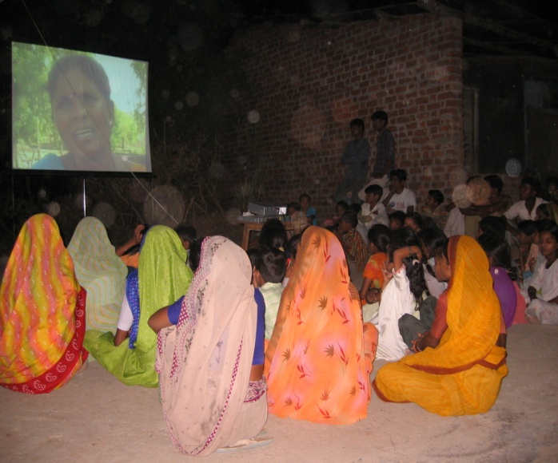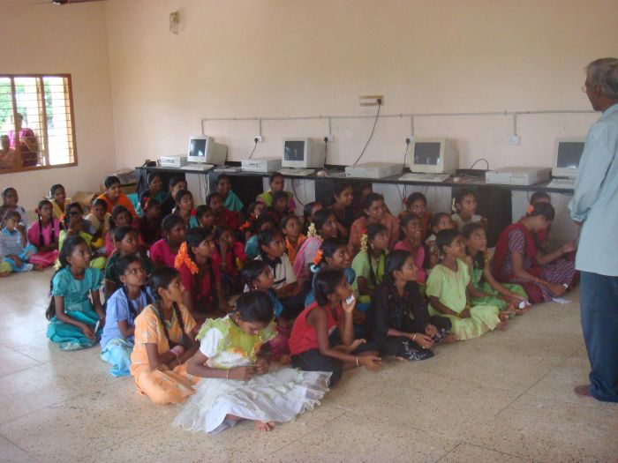
Fig(a) Video education for women’ Fig(b) Computer class for women’s

2. Impacts of ICT education policies in women’s life:
ICT provides the various education policies for women’s ICT want to that no woman is facing the problems due to the uneducation. ICT only not provides the education but it also provides the encouragement to do any thing in their life. They are equal to other women. Some impacts are given below:
- Self confidence: ICT bolds the women’s for taking the suggestion or fighting for their rights in a society. Educations developed or grow the self confidence of women’s. ICT believe them that they do any work without the help of others and in a right manner. If they think that some work is going or any thing is going wrong then they are ready to saying that this is wrong that is not doing in a correct manner they are ready for fighting their rights.
- Gender Gap: ICT removes the guilty felling from the women’s that men have a higher priority than the women’s. Educated women’s remove the genders gap they knowing the persons that they are equal to the men’s. Every right that are given by the society to men’s this same rights are also given to the women’s.
- Access Information: ICT teaches the women’s that how they access or share the new information and technologies. Using this new information or technologies they update their knowledge and if any person no about the new technologies then they are able to get the knowledge.
- Use of E-governance facilities: ICT telling or teaches the women’s that how computer is important for them. And how using the computer they do many works on the any place and any time. ICT provides the information to women’s that about the e-governance facilities that how it is beneficiary for them and how easily completing the work like paying the tax, electricity bill, water bill etc.
- Power and decision making: ICT opens the women’s eyes and knows the women are that they have the special power for putting their rights and knowledge etc in the front of other persons and they also increase the decision making power of women’s.
- Financial help: After education a women are ready for supporting the financial conditions of their family by doing the job. Because ICT not only provide the education but it also learn the extra activities like knitting, painting, drawing etc.

3. Benefits for women education:
- Removes guilty feeling in the women’s that they are not equal to men’s.
- An educated woman provides the right education to her Childs.
- Supporting or helping in the financial problems.
- Make self dependent.
- Helps in the husbands office work.
- They give the nutrition food to her family.

Conclusion:
Through this paper we only want that our nation is educated. Our nation is educated when each person of the nation is educated so that is possible when each woman is educated because the each person first teacher is her mother that is woman. So we only want that no woman is suffering from illiteracy, low confidence, gender gap etc. So we want that ICT not only provides the better education but also provides the self confidence, better life style and different income ways.

References:
- Dr. D.M. Gujarathi,Prof. Rakesh S. Patil “ROLE OF ICTAND E-GOVERNANCE FOR RURAL DEVELOPMENT” International Referred Research Journal ISSN- 0975-3486 VOL, I ISSUE9.
- Fig(a) http://voicingover.wordpress.com/
- Fig(b) http://indiasudar.wordpress.com/category/ap-guthavaripalem-village/
- “INFORMATION AND COMMUNICATION TECHNOLOGIES FOR WOMEN’S SOCIO-ECONOMIC EMPOWERMENT” World bank group working series June 30,2009

11/12/2011

