Expression of drug resistance-related proteins; Survivin and P-glycoprotein in Astrocytic Tumors
and their correlation with Malignant Grade and to each other

Zakaria A. El-Khayat¹; Shadia A. Fathy ²;*Heba K. Nabih ¹; Safinaz E. El-Toukhy ¹'; Azza A. Atef ²; and Marwa A. El-Shaer ³.

¹ Medical Biochemistry Department, National Research Centre (NRC), Cairo, Egypt.
¹' Medical Biochemistry Department, National Research Centre (NRC), Cairo, Egypt and King Abdul-Aziz University, Jeddah, KSA.
² Biochemistry Department, Faculty of Science, Ain Shams University, Cairo, Egypt.
³ Pathology Department, National Research Centre, Cairo, Egypt.
* dr_heba_kamal@hotmail.com

Abstract: The expression of the drug resistance-related proteins; P-glycoprotein (Pgp) and Survivin was analyzed quantitatively in formalin-fixed paraffin embedded tissue samples of forty astrocytic gliomas (8 WHO grade I, 6 WHO grade II, 6 WHO grade III and 20 glioblastomas "WHO grade IV"). In addition, the correlation to each other and with the grade of malignancy was also investigated. Sections of these tumors were immunohistchemically stained with antibody to Pgp (MDR1-gene product) as well as, these sections were subjected to Enzyme Linked ImmunoSorbant Assay (ELISA) for the estimation of survivin protein expression. P-glycoprotein expression was not detected in tumor cells of the majority of low-grade astrocytomas, WHO grade I and II (64%) and the percentage of Pgp stained cells generally increased with tumor grade. However; 4 of the 26 (15.4%) malignant gliomas, while, WHO grade III and IV were negative. While the expression of survivin in non-glioblastomas (grades I, II and III) was not-detectable in 12 cases and detectable in 8 cases with mean of 48.28±14.43 pg/ml. 14 cases of glioblastoma multiform;GBM (grade IV) were detectable for survivin with mean of 135.41±28.34 pg/ml and 6 cases were not detectable for survivin. The distributions of survivin expression included 1 of 8 (12%) grade I; 2 of 6 (33%) grade II; 5 of 6 (83%) grade III and 14 of 20 (70%) grade IV. These results suggest a relation between expression of drug resistance-related proteins and malignant grade of astrocytic tumors. This indicating that, expression of survivin and Pgp may be related to tumor malignant progression in astrocytic tumors. Highly positively significant correlation was found between survivin and P-glycoprotein (r=0.452) at the 0.01 level of signifinance. Expression of drug resistance-related proteins; Survivin and P-glycoprotein in Astrocytic Tumors and their correlation with Malignant Grade and to each other.
[Zakaria A. El-Khayat; Shadia A. Fathy; Heba K. Nabih; Safinaz E. El-Toukhy; Azza A. Atef; and Marwa A. El-Shaer. Expression of drug resistance-related proteins; Survivin and P-glycoprotein in Astrocytic Tumors
and their correlation with Malignant Grade and to each other. New York Science Journal 2011;4(11):49-54].(ISSN: 1554-0200). http://www.sciencepub.net/newyork.

Keywords: Astrocytic tumors; Survivin; P-glycoprotein; Immunohistochemistry; ELISA; Malignant grade; Drug resistance-related proteins.

1. Introduction
Astrocytic tumors, defined by their composition of neoplastic astrocytes, are the most common tumors of the central nervous system. Astrocytic tumors may be categorized into; pilocytic astrocytomas (WHO grade I), diffuse astrocytomas (WHO grade II), anaplastic astrocytomas (WHO grade III) and glioblastomas "GBM" (WHO grade IV). Although all patients receive multidisciplinary treatment, the median survival time for patients with glioblastomas, the most malignant type of astrocytic tumors, is only one year (Baldini et al., 1995).
The resistance of tumor cells to cytotoxic chemotherapeutic drugs is a major problem in the treatment of astrocytic tumors. There are several possible mechanisms of intrinsic drug resistance (Miller et al., 2008). One mechanism that has been a center of attention in most studies is the existence of a 170- to 180-kDa cell membrane protein encoded by MDR1 gene, p-glycoprotein (Pgp); an energy- dependent drug efflux pumps (Longley and Johnston, 2005). Pgp removes a wide range of lipophilic chemotherapeutic drugs from target cells and is a possible mediator of the multidrug resistance phenomenon. Strong PgP expression has been discussed as a negative prognostic marker for chemotherapy as shown in studies of breast and ovarian carcinomas, osteosarcoma, Ewing's sarcoma, neuroblastoma and some haematological malignancies such as, acute myeloid leukemia (Nooter et al., 1995; Kruh et al., 1995). The expression of Pgp in human brain samples was first described in capillaries. Further studies suggested a function of Pgp at the blood-brain barrier in eliminating xenobiotics from brain tissue (Tsuji and Tamai, 1999). Some authors found Pgp expression in neoplastic cells of malignant astrocytic tumors; whereas others did not. Survivin is another protein that has been reported in the most common human cancers; is a bi-functional protein implicated in the regulation of cell division and the suppression of apaptosis (Altieri and Marchisio, 1999). It has proposed roles in tumor formation, tumor cell resistance to anti-cancer agents, and may act as a marker and prognostic indicator for certain types of cancers (Kato et al., 2001). Survivin expression has been investigated by RT-PCR in colorected, gastric, esophageal, pancreatic, and non-small cell lung carcinomas. Expression has also been investigated by immunohistochemistry in colorectal, gastric, breast, bladder, ovarian cancers, neuroblastoma, melanoma and high-grade non-Hodgkin lymphomas. Survivin is considered an important prognostic factor of these cancers. Chakravarti et al., (2002) investigated survivin expression by using western blotting technique and reported that, it has a clear prognostic value in human gliomas included astrocytic tumors. This study aimed at a quantitative investigation of drug resistance-related proteins (PgP and survivin) by immunohistochemistry and ELISA respectively, and its correlation to each other and with the grade of malignancy in series of formalin-fixed paraffin embedded astrocytic brain tumors.

2. Material and Methods
*Clinical data and tumor specimen selection
This prospective study included a total number of 40 formalin-fixed paraffin embedded astrocytic brain tumors: 8 pilocytic astrocytomas, 6 diffuse astrocytomas, 6 anaplastic astrocytomas and 20 GBM, presenting to the El-Kasr El-Aini Hospital-Cairo University, Cairo, Egypt during the years 2009-2011.
All specimens were obtained from the initial surgery. Patients included 15 men and 25 women ranging in age from 23 to 72 years. Histopathological evaluation and grading of tumors were diagnosed according to the World Health Organization (WHO) classification (Louis et al., 2007).
The 40 blocks as well as, 3 normal brain samples; included as controls were subjected to ELISA and immunohistochemical staining.

*Tissue specimens and immunohistochemical staining
Immunohistochemistry was performed on formaldehyde-fixed and paraffin-embedded sections using avidin-biotin-peroxidase kit for mouse biotinylated immunoglobulins (Extra-Avidin kits; Sigma, USA). Mouse Monoclonal Multi-Drug Resistance Marker (P170/P-Glycoptotein/MDR Ab-2"clone F4"); specific for Pgp was purchased from Thermo Scientific; USA.
Primary antibody was diluted in phosphate buffered saline (PBS): anti-Pgp1:50. In brief, 4-µm-thick paraffin sections were dewaxed and treated with 0.3% hydrogen peroxide in methanol followed by incubation in citrate buffer pH 6.0 (Zymed, CA, USA) for antigen retrieval followed by incubation in 10% normal goat serum to inhibit non-specific staining. The sections were then incubated with primary antibody for 60 minutes at room temperature in a humid chamber. After washing with PBS, the sections were incubated with biotinylated anti-IgG of mouse and avidin peroxidase after further rinses. The immunoperoxidase reaction product was visualized with diaminobenzidine (DAB) /hydrogen peroxide. The sections were counterstained with hematoxylin, dehydrated and mounted with Canada balsam. Samples of breast carcinoma were used as positive staining controls.

*Determination of Human Total Survivin
Survivin Extraction:
Formalin- fixed- paraffin-embedded tissue sections were processed according to Chu et al., (2005) for protein extraction.
Briefly; 5-µm tissue sections were deparaffinized and rehydrated (xylene and ethanol), 50 ul of 20 mM-tris Hcl buffer (pH 7.6) containing 2% Sodium dodecyl sulfate (SDS) was then added to the dewaxed tissue; incubate at 100˚c on a heating block for 20 minutes then incubate at 60°C in incubator for 2 hours. The supernatants were transferred to clean fresh tubes after centrifugation.

Enzyme-Linked ImmunoSorbent Assay (ELISA):
Survivin was determined by ELISA assay according to Akhtar et al., (2006). Human total survivin kit was purchased from R&D systems (USA).

*Statistical analysis
Statistical analysis was performed by utilization of the Kruskal-Wallist test in connection with the Nemenyi test, the Mann-Whitney's u-test, and the Chi-square test on SPSS software. Correlation analysis was performed by calculating the person correlation coefficient. Significance level was set at (P<0.05).

3. Results
*Expression of P-glycoprotein in astrocytic tumors studied by IHC:
The immunostaining for Pgp protein was positive in 67.5% (27/40) and negative in 32.5% (13/40).
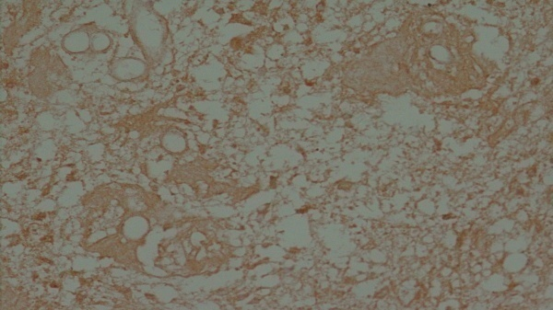
According to the scoring system used, the 27 positive cases were further classified into 3 categories, 48.15% (13/27) were scored 3+ , 29.63 % (8/27) were scored 2+ and 22.2 % (6/27) were scored 1+. Different frequencies for Pgp expression were found in the cell membrane of small anaplastic and gemistocytic tumor cells and in blood vessel walls (endothelium) of some tumors (Figure 1 a,b).

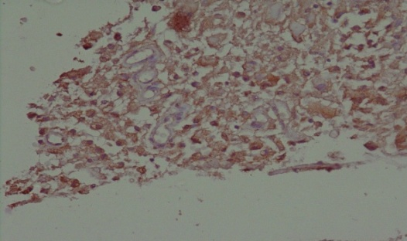
Figure 1a: GBM showing negative Pgp stained blood vessel walls (X 400).

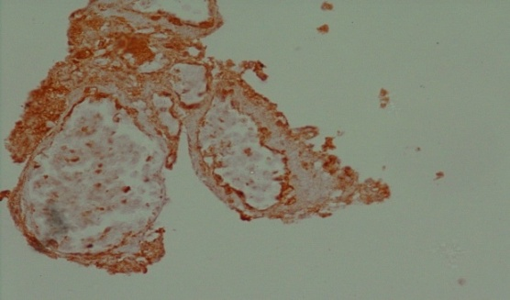
Figure 1b: GBM with strong Pgp immunostained endothelial cells (X 400).

Tumor blood vessels (endothelium) reacted positively for Pgp in 60% of the tumors and in 100% of the three normal control samples. With respect to the frequency of gliomas with Pgp-positive tumor vessels, no difference was found between low grade astrocytomas (GI/II: 62%) and malignant gliomas (GIII/IV: 59%).
The analysis of sections suggested that, there were some neoplastic cells in grade III astrocytomas and glioblastomas showed Pgp reactions. Qualitative evaluation exhibited a high variation in the frequency of immunoreactive tumor cells Pgp in the tumors investigated (Figure 2 a,b). An increase in the grade of anaplasia was accompanied by an increase in the percentage of Pgp-immunoreactive tumor cells, with significant differences between low-grade astrocytomas versus GIII astrocytomas and glioblastomas (P<0.001; Mann-Whitney test).

Figure 2a: Astrocytoma grade I showing weak Pgp expressed glial cells (X 400).

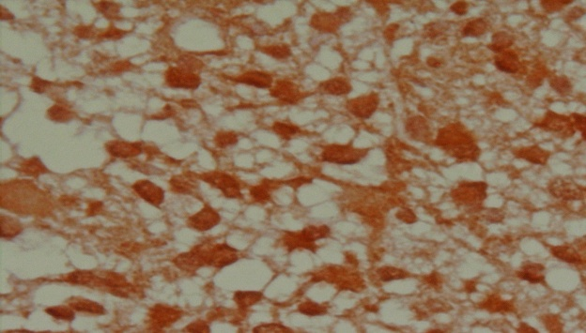
Figure 2b: Astrocytoma grade IV with strong Pgp expressed glial cells (X 400).

The number of Pgp-positive tumors increased with the grade of anaplasia.
Nine of the tumors investigated (5 grade I, 4 grade II) showed no immunoreactions with Pgp. Four of the malignant astrocytic tumors (2 grade III, 2 grade IV) were also Pgp negative (Table: 1).

Table 1: Rate of tumors with expression of Pgp according to histological grade.

Histological grade of the astrocytomas
IV | III | II | I
2/20(10%)  18/20(90%) | 2/6(33.3%)  4/6(66.7%) | 4/6(66.7%)  2/6(33.3%) | 5/8(62.5%)  3/8(37.5%) | Pgp  -ve (n=13/40)  +ve (n=27/40)

*Expression of survivin in astrocytic tumors studied by ELISA:
The expression of survivin in non-GBM (G I, II and III) was not- detectable in 12/20 (60%) cases and detectable in 8/20 cases with mean of: 48.28±64.6 Pg/ml, (ranged from 57.99 to 166.46). (P<0.05).
14/20 (70%) cases of GBM (G IV) were detectable for survivin with mean of 135.41±126.72 Pg/ml, (ranged from 85.11 to 345.85) (P>0.05) and 6/20 (30%) cases were not detectable for survivin (Table: 2). The all three normal control samples were not detectable for survivin expression.

Table 2: Distribution of survivin expression.

Histological grade of the astrocytoma patients
IV | III | II | I
6/20 (30%) | 1/6 (16.7%) | 4/6 (66.7%) | 7/8 (87.5%) | Not-detectable  Survivin (n=18/40)  (45%)
14/20 (70%) | 5/6 (83.3%) | 2/6 (33.3%) | 1/8(12.5%) | Detectable Survivin (n=22/40)  (55%)
* Correlation between Survivin and P-glycoprotein:

The correlation coefficient (pearson's correlation) within the different patient groups showed a highly positively significant correlation in cases of Survivin and Pgp (r=0.452).

4. Discussions
Using immunohistochemistry, the cellular distribution of Pgp expression in forty paraffin-embedded astrocytoma blocks was studied. From the present study it was found that, the percentage of Pgp-immunoreactive tumor cells, as well as, the number of Pgp-positive tumors, increased significantly with increasing grade of anaplasia.

This finding is in contrast to the results of Becker et al., (1991) who observed no such correlation in glial tumors using the monoclonal Ab C219 exhibits only very weak imunostaining according to the comparative investigations performed by Toth et al., (1996) who reported that 5 of 29 (17%) gliomas stained positive for Pgp. John Fruehouf in 2006 found that, immunohistochemically determination of Pgp using MDR1 antibody JSB-1, only 7% of astrocytic tumors expressed the Pgp with no significant differences in biomarker expression were noted between high-grade and low-grade cases, suggesting that, Pgp was not a major contributor to drug resistance for this series.
On the other hand, Von Bossanyi et al., (1997) found that, 31 of 50 (62%) cases showed MDR1 expression using MDR1 antibody JSB-1, with a significant trend toward higher expression levels with increasing grade.
Other authers have described Pgp expression in neoplastic cells in a few glial tumors but not in low-grade tumors. Cardon-cardo et al., (1990) and Tanaka et al., (1994) have reported the presence of strong MDR1 staining on glioma tumor vasculature without reactivity on glioma cells. Pgp immunostaining was evident in endothelial cells in some of the gliomas even when the tumor cells themselves were not immunoreactive to Pgp. In 70% of neuro-axial tumors, Billson et al., (1994) found Pgp expression only in the endothelium of tumor blood vessels.
In this study, quantitation of survivin by ELISA was found to be detectable in 40% of non-GBM (GI; 12.5%, GII; 33%, GIII; 83%) with mean of 48.28±14.43 Pg/ml and in 70% of GBM (GIV) with mean of 135.41±28.34 Pg/ml. The survivin was not detectable in the controls. The expression was increased with the malignant grade of astrocytoma. Qiao, (2011); reported that, survivin was significantly elevated in astrocytoma, and was associated with tumor grade and poorer prognosis.
Liu et al., (2010) used immunohistochemically determination for survivin in a group of astrocytoma patients and found that, 11.1% (2/18 grade I), 40% (8/20 grade II), and 81.5% (22/27 grades III and IV) were positive for survivin. Twelve cases of normal brain tissues used as controls were negative for survivin.
Yoshinori et al., (2002); found that, the expression of survivin in astrocytic tumors by RT-PCR was 37.5% of diffuse astrocytoma (GII), 86.7% of anaplastic astrocytoma (GIII) and 90.0 % of glioblastomas (GIV); suggesting that, expression of survivin was a significant factor for predicting poor prognosis in astrocytic tumors.
Chakravarti et al., (2002); studied 92 glioma cases by western blot analysis and reported that, survivin was found to be expressed in most gliomas (59 [64%] of 92 tumors). Although its expression in GBM tumors (45 [80%] of 56) was significantly higher (P<0.0001) than that in non-GBM tumors (14 [39%] of 36), the observation that it was expressed in some lower grade tumors suggests that, it may play a role in enhancing the malignant behavior of these tumors, survivin expression may carry prognostic significance for patients with both GBM and non-GBM histologies.
Results of Taiichi et al., (2007) indicated that, survivin expression by immunohistochemistry that limited to only the nucleus or cytoplasm doesn't correlate with prognosis of high-grade astrocytoma (GIII and GIV), and also indicated that, simultaneous expression of survivin in both the nucleus and cytoplasm significantly correlates with poor prognosis of high-grade astrocytoma.
In retrospective trials, cancer patients expressing survivin exhibited abbreviated overall survival, associated with unfavorable markers of disease progression, increased rates of recurrences, and increased resistance to therapy.
In the present work there was a significant correlation between survivin and P-glycoprotein (r=0.452). Tao et al., (2005) have studied the relationship between the expression of survivin and clinical MDR in osteosarcoma, and found a positively significant correlation between survivin and P-glycoprotein and suggested that, the survivin overexpression was significantly associated with clinical multidrug resistance (MDR) in osteosarcoma. It could be a potential target for treatment of osteosarcoma. Which in agreement with the present study.

Acknowledgements:
Authors are grateful to the Department of medical biochemistry, Cairo, Egypt for financial support to carry out this work.

Corresponding Author:
Dr. Heba kamal Nabih
Department of Medical Biochemistry
National Research Centre
Cairo, Egypt.
E-mail: dr_heba_kamal@hotmail.com

References
1- Baldini N, Scotlandi K, Barbanti-Brodano G, Manara MC, Maurici D, Bacci G, Bertoni F, Picci P, Sottili S, Campanacci M and Serra M: Expression of P-glycoprotein in high-grade osteosarcomas in relation to clinical outcome. N Engl J Med (1995)333:1380–1385.

2- Miller D S, Bauer B and Hartz A M: "Modulation of P-glycoprotein at the blood-brain barrier: Opportunities to improve central nervous system pharmacotherapy", Pharmacological reviews (2008), vol. 60, no. 2, pp. 196-209.

3-Longley D B and Johnston P G: "Molecular mechanisms of drug resistance", The Journal of pathology (2005), vol. 205, no. 2, pp. 275-292.

4- Nooter K., Westerman AM., Flens MJ., Zaman GJ., Scheper RJ., van Wingerden KE., Burger H., Oostrum R., Boersma T. and Sonneveld P.: Expression of the multidrug resistance- associated protein (MRP) gene in human cancers. Clin Cancer Res (1995) 1: 1301-1310.

5-Kruh GD., Gaughan KT., Godwin A. and Chan A.: Expression pattern of MRP in human tissues and adult solid tumor cell lines. J Natl Cancer Inst (1995)87: 1256-1258.

6-Tsuji A. and Tamai I.: Carrier-mediated or specialized transport of drugs across the bloodbra barrier. Adv Drug Deliv Rev (1999) 36: 277-290.

7- Altieri DC and Marchisio C: Survivin apoptosis: an interloper between cell death and cell proliferation in cancer. Lab Invest (1999) 79(11):1327–1333.

8- Kato J, Kuwabara Y, Mitani M, Shinoda N, Sato A, Toyama T, Mitsui A, Nishiwaki T, Moriyama S, Kudo J and Fujii Y: Expression of survivin in esophageal cancer: correlation with the prognosis and response to chemotherapy. Int J Cancer (2001) 95:92–95, 2001.

9- Chakravarti A, Noll E, Black PM, Finkelstein DF, Finkelstein DM, Dyson NJ and Loeffler JS: Quantitatively Determined Survivin Expression Levels Are of Prognostic Value in Human Gliomas. J Clin. Oncol, (2002). 20, 1063–1068.
10- Louis D N, Ohgaki H, Wiestler O D, Cavenee W K (eds): “WHO Classification of Tumors of the Central Nervous System” (2007), 3rd edition, Lyon, Agency for Research on Cancer (IARC).

11- Chu W-S, Liang Q, Liu J, Wei MQ, Winters M, Liotta L and Sandberg G: A nondestructive molecule extraction method allowing morphological and molecular analyses using a single tissue section. Lab Invest (2005) 85:1416–1428.

12-Akhtar M, Gallagher L and Rohan S: Survivin: role in diagnosis, prognosis, and treatment of bladder cancer. AdvAnat Pathol (2006); 13:122-6.

13- Becker I, Becker KF, Meyermann R and Hollt V: The multidrug- resistance gene MDR1 is expressed in human glial tumors. Acta Neuropathol (1991) 82:516–519.

14-John P. Fruehauf, Brem H, Brem S, Sloan A, Barger G and Parker R: In Vitro Drug Response and Molecular Markers Associated with Drug Resistance in Malignant Gliomas. Clin Can Res 12:4523-32. (2006)

15-Toth K, Vaughan MM, Peress NS, Slocum HK and Rustum YM: MDR1 P-glycoprotein is expressed by endothelial cells of newly formed capillaries in human gliomas but is not expressed the neovasculature of other primary tumors. Am J Pathol (1996) 149(3): 853–858.

16-Von Bossanyi P., Diete S., Dietzmann K.,Warich-Kirches M. and Kirches E.: Immunohistochemical expression of P-glycoprotein and glutathione S-transferases in cerebral gliomas and response to chemotherapy. Acta Neuropatho (1997) l94: 605-611.

17- Cordon C, O’Brien JP, Boccia J, Casals D, Bertino JR and Melamed MR: Expression of the multidrug resistance gene product (P-glycoprotein) in human normal and tumor tissues. J Histochem Cytochem (1990) 38:1277–1287.

18- Tanaka Y, Abe Y, Tsugu A, Takamiya Y, Akatsuka A, Tsuruo T, Yamazaki H, Ueyama Y, Sato O and Tamaoki N: Ultrastructural localization of P-glycoprotein on capillary endothelial cells in human gliomas. Virchows Arch (1994) 425:133–138.

19-Billson AL, Palmer JB, Walker DA and Lowe J: Multidrug resistance gene (MDR1) expression in neuro-axial tumours of children and young adults. Br J Neurosurg (1994) 8:585–591.

20- Qiao Z: Expression and prognostic significance of survivin splice variants in diffusely infiltrating astrocytoma. J of clinical pathology (2011) 66 (15): 5010-32.

21- Liu Y, Xuyu Z, Jun M, Hongxia L, Chunyan T, Lingling Y, Jue W, Zhenhua X, Deliang C and Yuyang J: Pro-oncogene Pokemon promotes breast cancer progression by upregulating survivin expression. Breast Cancer Research (2010), 13:R26.
22- Yoshinori Kajiwara, Fumiyuki Yamasaki, Seiji Hama, Kaita Yahara, Hiroyuki Yoshioka, Kazuhiko Sugiyama, Kazunori Arita and Kaoru Kurisu: Expression of survivin in astrocytic tumors: correlation with malignant grade and prognosis.Cancer (2002); 97(4):1077-83.

23-Taiichi S, Hama S, Izumi H, Yamasaki F, Kajiwara Y, Matsuura S, Morishima K, Hidaka T, Shrestha P, Sugiyama K and Kurisu K: Centrosome amplification induced by survivin suppression enhances both chromosome instability and radiosensitivity in glioma cells. British Journal of Cancer (2007) 98, 345–355.

24-Tao NIE, Min DAI and Shizhang ZONG: Expression of Survivin Gene and Its Relationship with Clinical Multidrug Resistance in Osteosarcoma. The Chinese-German Journal of Clinical Oncology (2005); 4: 164-166.

10/24/2011

