Somaclonal Variation of Three Tolerance Streptomycetes Isolated from Saline Soil

Seham M. Shash

Botany Department, Faculty of Science, Benha University, Egypt
smshash@hotmail.com

Abstract: The present investigation aims to the isolation of Streptomycetes from saline soil. The isolates were varied in color to aerial vegetative mycelia, morphology of conidospore surface, melanin production, utilization of carbon; nitrogen source and fatty acid analysis, as well as physical and chemical characters for their habitat soil. Streptomycetes isolates exhibiting wide range of variability. Analysis of variance for their characters revealed the presence of genotypic differences. The tolerance of sodium chloride indicates that almost the characters were less influenced by the environment. DNA finger print analysis were successfully revealed somaclonal and DNA genetic divesity among three isolates closely related St. catvus; St.canaries and St., nogalater. Randomly amplified polymorphic DNA (RAPD) for identification of three Streptomyces isolates were conducted on the screening of the primers and on the extraction of template DNA. Three out of ten random sequence 10 mer primers were successful in the three isolates ST1, ST2 and ST3 resemble to genus Streptomyces. PCR amplification yielded reproducible PAPD fragments which differentiated the three isolates examined. The difference was also recognized among the RAPD Fragments especially of St. calvus. RAPD-PCR analysis can be used to gain rapid and precise information about genetic similarities and dissimilarities of three Streptomycetes isolates.
[Seham M. Shash. Somaclonal Variation of Three Tolerance Streptomycetes Isolated from Saline Soil. New York Science Journal 2011;4(12):67-73]. (ISSN: 1554-0200).

Keywords: RAPD- PCR; Genetic variability, Saline soil; Actinomycetes; Halotrophic bacteria

1. Introduction
Halotrophic microorganisms can be conveniently grouped according to their requirements for sodium chloride for growth (Larsen, 1986). Slightly halophilic organisms in marine environments can grow in the presence of 2 to 3% Nacl. The moderate halophilic grow over a much wider Nacl concentration range (5to20%w/v).
The extreme halophiles including the well-know halobacteria and halococci are able to grow in saturated NaCl and unable to grow in the presence of NaCl concentrations lower than 12%. The occurrence of Actinomycetes in high saline environments and the tolerance of those organisms to high concentrations of salts have been described by Abbas, (2006); Gottlieb (1973); Rifaat and keera (2011).
Bacterial systematic has undergone revolutionary techniques during the past 3 decades. The application of new and reliable biochemical chemical, genetical numerical and molecular biology techniques have been responsible for rapidly changing views on how bacteria could be classified and identified (Berkeley and Goodfellow, 1981).
Sharma (2003) recorded that the utility of DNA markers as RAPD-PCR in detecting genetic variability is well established for many phytopathogenic fungi and bacteria. Therefore this study was conducted to employ RAPP-PCR as sample molecular marker tool for analysis variation of Halotrophic Streptomycetes isolated from saline soil.
2. Material and Methods
Soil samples were collected from different fresh fields, El-khatateba regions, El-Behera governorate Egypt underlying 10 cm depth. Mean values of some physio-chemical properties of soil were determined according to Jackson (1963).
Steptomycetes were isolated by plating serially diluted soil samples on to nutrient agar media containing (g/L), glucose, 2.0; yeast extract 1.0; malt extract, 1.0; peptone, 2.0; NaCl 100; agar, 15.0 and distilled water (pH,7.2) and incubated at 30˚C for 2 weeks. A visible colony was transferred and subcultured until pure culture. Streptomycetes isolates were growing on starch nitrate agar (g/L), starch, 20.0; K₂HPO4, 1.0; KNO, 20; MgSO₄, 0.5; CaCo₃, 3.0, NaCl 100 and agar, 15.0.
Streptomycetes Cultures were grown on media ISP media for 4 weeks and observation were made at weekly intervals as described by Shirling and Gottlieb (1966). The Cultures were examined for pigmentation and morphological features .The morphological features of colonies, aerial mycelium, cells and spores determined using high and scanning electron microscope (JEM-1200, EX11).
Samples of 15 days old colonial growth on ISP medium supplemented with 10% NaCl were prepared by cutting agar blocks from the growth medium fixing them with glutaroldehyde and dehydrating them by using a graded methoxyethanol series and finally 100% acetone. The dehydrate sections was critical point dried, mounted on aluminium stubs and then suputter coated with gold- palladium (Tresener et al., 1968).
The physiological tested used to determined carbohydrate utilization and melanoid pigments according to Shirling and Gottlieb (1966). The degradation of tyrosine, xylane and urea were determined by the method of Gordon, (1967).
The hydrolysis of starch and cellulose were determined by the method of Goodfellow and Pirouz (1982). Osmotic stress was determined by growing Streptomycetes isolates on glucose nutrient broth supplemented with 0 to 20 % (w/v) NaCl by Osmomat 030 GDNOTEC madel mob030. The susceptibilities of Streptomycetes isolates to various antibiotics were studies on nutrient agar plates containing Chlortetracycline, Neomycin Tetracycline; Penicillin G. and Streptomycin. The plates were incubated at 30˚C for one week.

Genome DNA isolation
Total DNA of three Streptomycetes isolates was extracted from mycelium tissues following the procedure described by Wolff el al. (2002).

RAPD-PCR technique
DNA Fingerprint was performed for Streptomycetes isolates using 10 arbitrary primers (Operon RAPD 10 mer kits). DNA (50ng) of each isolate was amplified by the PCR using 25 µl reaction mixtures under the following conditions: dNTPs (200 mM); MgCl₂ (1.2mM); Tris HCl (10 mM) pH-8.0;KCl (50Mm); Gelatin (0.01%) ; oligonucleotide primer(200ng) and Taq polymerase (2-5unit). Amplification was carried out in DNA thermal cycler programmed according to Weisburg et al. (1991). As follows: One cycle at 92ᴼC for 4 min. and then 40 cycles at 34ᴼC for 20sec., 35ᴼC for 1 min; and 92ᴼC for 2 min and one cycle at 72ᴼC for 72 ᴼC for 5 min then 40ᴼC for 10 min infinitive.
The PCR products were subjected to electrophoresis on 1% agarose in TAE buffer was prepared and a total volume of sample 6 µl (1 µl of miniprep, 4 µl d. H₂O and 1 µl 6x loading dye) of each PCR product and was loaded in each well. The gel was electrophoresed in 65v for 1.5 h and then stained with eithidium bromide solution (10mg/ml) for around 10-15 mins. DNA fractions visualized on a UV Transilluminator these fractions were photographed polaroid camera.

3. Results
Data in table (1) show the soil textures of the tested soil sandy, sandy loam and clay soil with pH values ranged from 7.9 to 8.4. Soil salinity showed considerable variations among tested soils (Lab. of soil analysis Agric.Res.Center, Giza).
The three isolated Streptomycetes out of 20 Streptomycetes colonies were isolated based on cultural growth, morphological and physiological characters (Table 3) The three isolates were appeared variation in growth rate on nutrient agar medium (weak to strong growth rate) and colour colonies whereas showed variable diffusible pigment in experimental medium (Table 2). The preliminary investigation from morphological, pigmentation and chemical analysis. The Streptomycetes isolates can differential into three species isolates;
The first isolate was produced high growth in starch agar medium fortified with 10% (w/v) NaCl concentration at 35ᴼC (tm) and 7.0 pH .it was formed branching vegetative hyphae with white to grey, a diameter 1.0 to 1.5 Mm, which break down into squarish elements. The aerial hyphae are fragment into spores. Spores appear oblong or oval shaped with surface is smooth (Fig. 1). The isolate did not produce melanin pigments when cultured on either peptone yeast iron agar or tyrosine agar (Table 2). It was sensitive to penicillin, tetracycline. But resistant to streptomyces, neomycin and chlorominphicol. The representative isolate is able to utilize glucose, sucrose, starch but did not able to utilize cellobiose as sole carbon source.
The second isolated was produced high growth on yeast extract malt agar, glycerol asparagen agar and inorganic salts starch agar fortified with 10% (w/v) NaCl concentration at 25˚ to 28ᴼC (tm) and 7.8 pH. No diffusible pigments are produced melanin pigments when cultured on either peptone yeast iron agar or tyrosine agar. The isolate was found to be resistance to the inhibitory effect of a wide range of NaCl concentration 0-20%. The isolate produce colonies that consist of extensively branched, non-fragmenting, substrate mycelium that carries rarely branching flexuous to curled straight rarely branching aerial hyphae. The aerial hyphae fragment into spores. The spores appear cylindrical to oblong and unequal length. Spores surface is smooth. The aerial mass color of isolate was white to pale yellow on out meal agar (Table 2). This isolate was sensitive neomycin but resistance to streptomycin, chlortetracycline and penicillin. The isolate able to degrade starch, potassium nitrate, Histidne, glycine, methinine and valine but not to degrade urea. This isolate able to utilize as sole carbon, glucose, sucrose, fructose and sodium acetate, but not able to utilize xylose (Table 3).

The third isolate was produced small round colonies with powdery texture that consist of branched and unfragmented substrate mycelia and monopodially branching aerial mycelia. The aerial hyphae bare, non-motile, spore on short sporophores in characteristic longitudinal pairs (Fig. 1).
The spore was oval and its rough surface. This isolate gave a white aerial mycelia on inorganic salt starch agar, glycerol asparagines agar, oat meal extract agar and yeast melt extract agar, but not diffusible pigment are produced as well as did not produced melanin pigment (Table 2)., when cultured on either peptone yeast iron agar or tyrosine agar, this isolate gave growth at optimum temperature (30˚ to 37˚C) and pH = 7-8 in inorganic salt starch agar fertilitied NaCl 0-14˚ (w/v). The isolate showed positive ability to assimilation glucose, sucrose, D. fructose and starch as carbon source, as well as potassium nitrate, histidine, glycine as a nitrogen source (Table 3). The sensitivity of isolate against antibiotics indicated that it is sensitive against neomycin, streptomycin, chlorotracyclin and penicillin.
Osmatic potential of salt starch agar fertified Nacl 0 to 25(w/v) cultivated with Streptomyces isolates was differed (Table 4) it was found that the medium cultivated with isolate 3 showing high osmatic strength. (2.20 kg) compared with medium cultured isolate 1 (2.00 kg) and isolate 2 (2.10 kg). The three isolates were identified according to cultural growth, morphological and pigments properties as Streptomyces catvus; St. canaries and St. nogatater.

Table 1. Physico-chemical analysis of soils testing.

Soil types | Mechanical analysis |  |  |  |  | Chemical analysis
Soil types | EC | Sandy (%) | Clay (%) | Silt (%) | CaCo5 | Organic  Carbon | Total  Nitrogen | C/N | S1 | Su | Ca | Mg | Na | K | pH
Sandy | 0.95 | 42.75 | 5.12 | 14.12 | 3.33 | 1.9 | 0.14 | 5.72 | 7.0 | 1.5 | 12.5 | 1.2 | 18.20 | 0.75 | 8.21
Sandy  Loam | 1.25 | 32.85 | 18.25 | 5.41 | 25.15 | 1.9 | 0.16 | 2.01 | 25.0 | 9.4 | 21.7 | 1.9 | 70.25 | 1.5 | 7.90
Clay | 0.92 | 57.25 | 51.31 | 3.50 | 10.27 | 0.9 | 0.17 | 3.25 | 9.0 | 2.5 | 4.3 | 2.0 | 19.10 | 0.9 | 8.4

Table 2. Cultural characteristics of Streptomycetes isolates at 14 days old cultural on media.

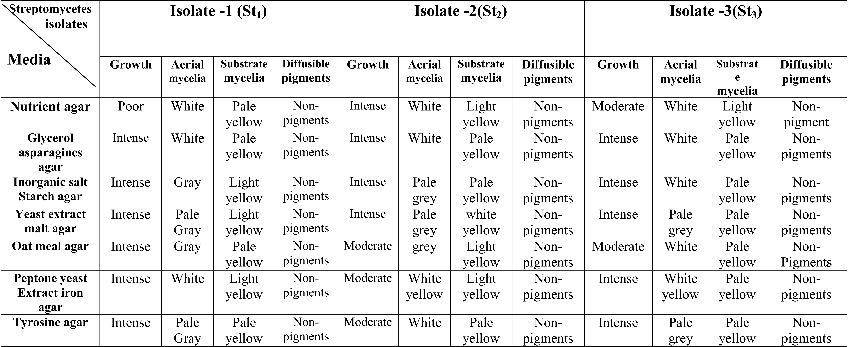

Table 3. Morphological, pigmentation and physiological characters of Streptomyces isolates.

Streptomycetes  Characters | Isolate 1 | Isolate 2 | Isolate 3
Colonies | Forming branching vegetative hyphae break down in into squarish elements | Forming branching non fragmenting substrate mycelium | Forming branching non fragmenting substrate mycelia
Aerial hyphae | Hyphae aerial are white to gray and fragment into spores | Aerial hyphae flexous to curled straight to pale yellow | Aerial hyphae short sporophores in longitudinal pairs-white
Spores | Oblong or oval shape and smooth surface | Cylindrical to oblong smooth surface | Oval smooth surface
Pigmentation | No diffusible pigment and did not produce melanin | No diffusible pigment and  did not produce melanin | No diffusible pigment and  did not melanin pigment
Carbon source
Glucose | + | + | +
Sucrose | + | + | +
D. Fructose | + | + | +
Xylose | + | - | -
Sodium acetate | + | + | -
starch | + | + | +
Nitrogen source
Potassium nitrate | + | + | +
Histidine | + | + | +
Methinine | - | + | -
Glycine | + | + | +
Valine | - | + | -
Urea | - | - | -
Neomycin | + | - | +
Streptomycin | + | + | +
Chlortetracycline | - | + | +
Penicillin | + | + | +
Optimum temperature | 36-37 ᴼC | 25-28 ᴼC | 30-37 ᴼC
Optimum pH | 7-8 | 7-8 | 7-8
NaCl | 0-14% | 0-20% | 0-14%

Table 4. Osmotic strength pressure of salt media cultured with Streptomces isolates using osmomat.

Salt medium NaCl conc. | Isolate 1 |  | Isolate 2 |  | Isolate 3
 | Osmol  (kg) | Count  cfu/ml | Osmol  (kg) | Count  cfu/ml | Osmol  (kg) | Count  cfu/ml
0.0 | -0.05 | 2.5x10⁶ | -0.07 | 3.5x10⁶ | -0.10 | 4.0x10⁶
5.0 | -1.20 | 4.0x10⁵ | -1.30 | 7.0x10⁵ | -1.30 | 2.7x10⁶
10.0 | -1.40 | 2.5x10⁵ | -1.45 | 4.5x10⁵ | -1.50 | 7.0x10⁵
15.0 | -1.80 | 1.5x10⁵ | -1.85 | 2.1x10⁵ | -1.90 | 7.5x10⁵
20.0 | -2.00 | 0.5x10⁵ | -2.10 | 1.2x10⁵ | -2.20 | 2.0x10⁵
Control = Streptomyces culture without salt

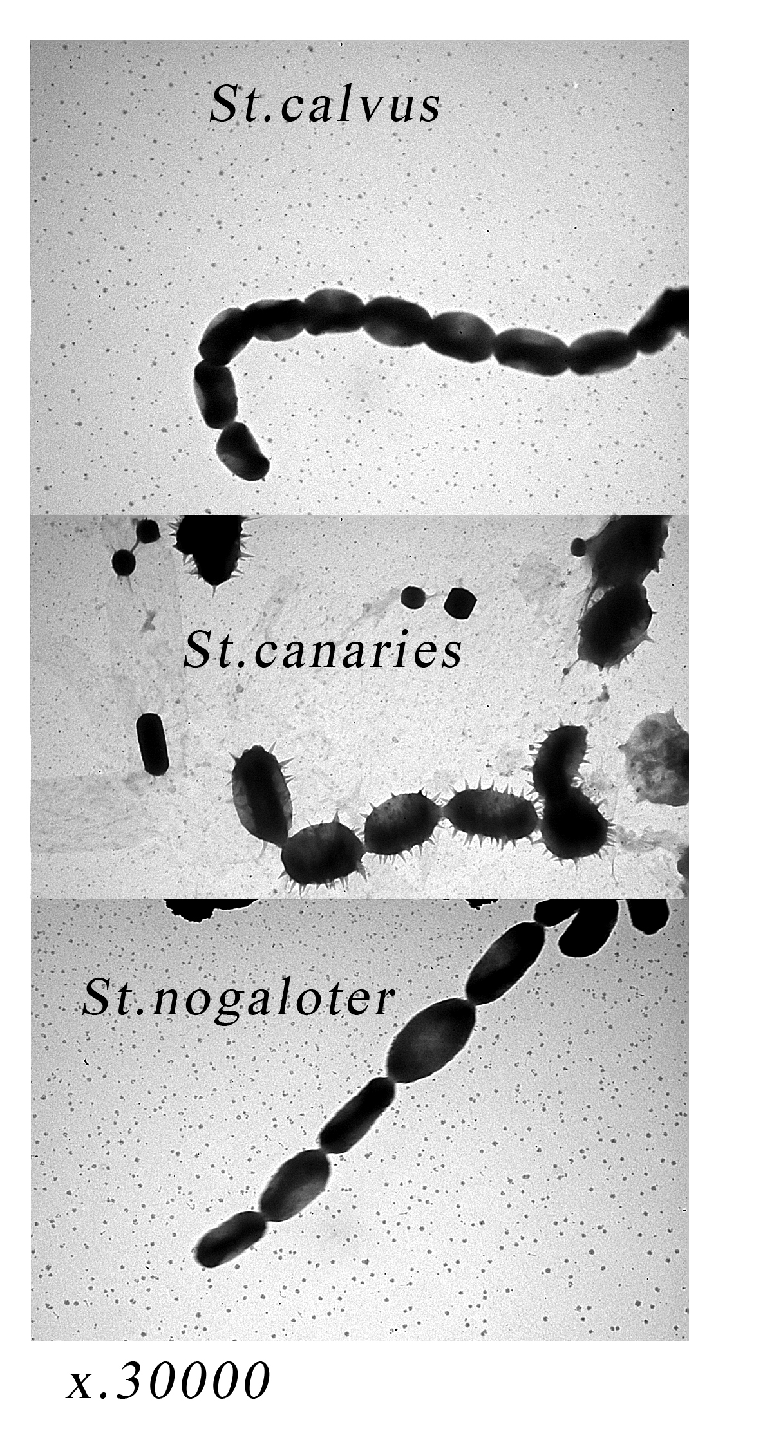

Figure 1. Spores of Streptomyces isolates: St₁ = St. catvus, St₂ = St. canaries and St₃ ₌ St. nogalater.

DNA Fingerprint
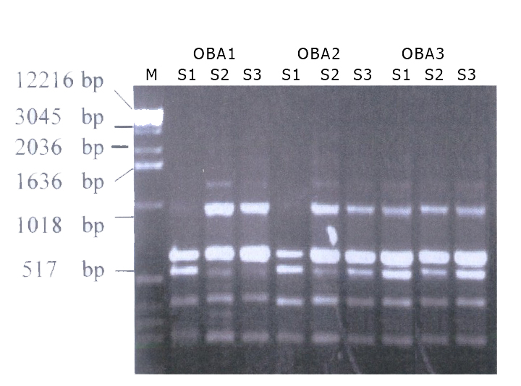
Total DNA is found crucial for RAPD-PCR the DNA yield was determined spectrophotometrically as 6.4 mg/1.0g mycelium tissues. The DNA purity as indicated by 260/280 was 1.7. The polymorphism among 3 Streptomyces isolates were detected using 10 random primers by RAPD-PCR. Out of 10 primers (Operon random primer) 3 primers were screened in RAPD analysis for their ability to produce amplification expressed an overage number of fragments per primer. The three primers (OBA₁, OBA₂ and OBA₃) were more stable and reproducible and gave sufficient polymorphic among 3 isolates. Therefore are focused our efforts on these primers are summarized in Fig. (2) and table (5). The RAPD-PCR analysis of DNA isolated from 3 isolates revealed 68 amplified fragments (23,21and 24) for OBA₁, OBA_{2,} and OBA₃ primers respectively with variation molecular weight ranged from 1500 to 50 bp. The DNA amplified fragments of 3 isolates were different in number, density and molecular weight. The variability analysis among Streptomyces isolates showed some DNA amplified fragments present or/ and absent among isolates (table 5) the polymorphism among isolates revealed 4 polymorphic amplified fragments (Specific fragment) with 28.8; 4 monomorphic fragments (Common fragments) with 28.8 % and 6 unique fragments (genetic markers) with 42.2 %. The genetic markers were 50 (1500, 1000,800 and 650) and (100) bp for streptomyces isolates S₁, S2 and S₃, respectively.

Figure 2. Agarose gel electrophoresis stained with ethidium bromide showing the PCR products of amplified DNA isolated from three Streptomyces isolates. Lane M=DNA molecular weight lanes, St₁, St₂, and St₃ Streptomyces isolates.

4. Discussion
The three isolates of halotoleront Streptomycetes which isolated from saline soil collected from El-Nobaria region of El-Bahora governorate were purified on starch nitrate agar. The three isolates were identified according to cultural growth, morphological and pigments properties. It has been found the isolates can be identified as St.calvrus St.canaries and St.nogatater based on variation of morphological characters growth on media, presence or absence of sporangium, sporongiophere, length spore , aerial hypae mass spore surface spore chairs, spore shape and pigments. These results agreement with Dharmarj et al. (2010) and Abdelah (2010). The morphological variation among 3 Streptomyces isolates due to different physio-chemical characters of soils and different climatic factors of location.
Streptomyces isolates can be conveniently divided according to their requirements for NaCl for growth: slightly halophilic Streptomyces was grown in the presence of 5% NaCl, The moderate halophilic Streptomyces was grown in the presence of 5 to 20 NaCl. The occurrence of Actinomycetes in high saline environments and the tolerance of these organisms to high concentrations of salts have been described by Tresener el al. (1968); Gottlieb (1973) and Abbas (2006). Takashi el al. (2010) reported that, the very obvious diversity in the features and functions of biological membranes, common features between these membranes is the fact that they are

permeable to water. The concentration will move, into or leave from the membrane by osmosis. It is now considered a fact that organisms which are subjected to salt, stress are in danger of dehydration. The increase in external medium salinity leads to cell shrinkage. When this happens, an imbalance in osmotic pressure and the restoration of turgor pressure occurs. The concentrations of the intracellular solutes play vital role in overcoming such problems by attaining growth inhibiting or even toxic levels. This leads to the maintenance of the cytoplasmic water potential near the water potential of the surrounding medium.

Table 5. Polymorphism and genetic markers among tolerant halophilic Streptomyces isolates by DNA fingerprint.

Isolates  M.W  (bp) | OBA₁ |  |  | OBA₂ |  |  | OBA₃ |  |  | Polymorphism
Isolates  M.W  (bp) | S1 | S2 | S3 | S1 | S2 | S3 | S1 | S2 | S3 | Polymorphism
1500 | - | ++ | - | - | - | - | - | - | - | Unique
1000 | - | ++ | - | - | - | - | - | - | - | Unique
900 | +++ | +++ | +++ | +++ | - | +++ | +++ | +++ | +++ | Polymorphic
850 | - | ++ | - | - | - | +++ | +++ | +++ | +++ | Polymorphic
`800 | - | ++ | - | - | - | - | - | - | - | Unique
700 | +++ | +++ | +++ | +++ | +++ | +++ | +++ | +++ | +++ | Monomorphic
650 | - | - | - | - | - | - | - | + | - | Unique
600 | ++ | ++ | ++ | ++ | ++ | ++ | ++ | ++ | ++ | Monomorphic
500 | +++ | +++ | +++ | +++ | +++ | +++ | +++ | +++ | +++ | Monomorphic
450 | - | - | + | + | + | + | + | + | + | Polymorphic
400 | ++ | ++ | ++ | ++ | ++ | +++ | +++ | +++ | + | Monomorphic
200 | - | + | + | + | + | + | - | + | - | Polymorphic
100 | - | - | - | - | - | - | - | - | + | Unique
50 | + | - | - | - | - | - | - | - | - | Unique
S1, S2, and S3: Streptomyces isolates
Fragment density: +++ = strong; ++ = moderate; + = Weak (present); - = absent
Polymorphic: Specific amplified fragments
Monographic: Common amplified fragments
Unique: Genetic marker

This study aims to study the genetic diversity of three halophilic Streptomyces isolates selected on the basis of variation in morphological biochemical and Osmotic potential. The results obtained from RAPP.PCR presented the RAPD profiles generated by random primers fragments genetic markers with MW. 50 bp detected of St. calvus: 1500, 1000, 800 and 650 bp detected of St. canaries and 100 bp detected of St. nogalater which were not seen in the other isolates. Fortunately, the averages of similarities among three isolates were 91.30; 95.83; 87.5 St₁ St₂ and St₃ respectively. This we expect the similarly of genetic back grounds of many Streptomyces isolates.
The introduction of RAPD-PCR technique has amplified the possibilities polymorphisms as it allowed the use of small arbitrary nucleotide segments without the need of a previous knowledge of genes and/ or genomic sequences (Welsh and McClelland, 1990). Also RAPD assay clearly has certain proactivity advantages for deleting DNA variation. It is technically less demanding, cheaper and quicker than other molecular techniques.
The present study demonstrated the utility of RAPD-PCR technique for the differentiation of Streptomyces isolates. The isolates studied were selected on the basis of different habitat; phenotypes, Osmotic pressure upon exposure to Streptomyces isolates.
Reproducible and inheritable stable polymorphic markers for Streptomyces isolates were identified with one out of the ten arbitrary primers tested several of the primers produced monomorphic fragments among the isolates or the polymorphism identified were not reproducible . In previous study genetic diversity among Streptomyces isolates were evaluated either by allozyme or RAPD-PCR fragments length.
Disappearance of some fragments could also for explained on the basis of a mutational event at the regulatory genes which are suppressed at transcription level, meanwhile the appearance of new fragments could be explained on the basis of mutational event at the regulatory system of in expressed gene(s) that activate them (Sharma, 2003). Several factors may be considered as primary determinants of fragments observed on a gel including (1) the number. Of coding genes, (2) their allelic states (homozygous or heterozygous) and (3) the quaternary of the protein products. The simplest case involves a single region of salinity with variant electro morphs (allozymes) observed in different individuals. Because allozymes are usually codominanly inherited, the presence and number of fragments are depending on the number of polypeptide subunit contained in the active enzyme (Kahler and Allard, 1981).

Corresponding Author:
Dr. Seham M. Shash
Botany Department
Faculty of Science
Benha University, Egypt
E-mail: smshash@hotmail.com

References
- Abbas, I.H. (2006). A. biological and Biochemical studies of Actinomycetes isolates from Kuwait saline soil-Kuwait. J. of Applied Science Research, 2(10): 809-815.
- Abdelah, M.A.T. (2010). Biological control of cucumber mosaic virus (cucumo virus) by certain local Streptomycetal isolates. MS.C.fac. Sci. Zogozig Univ.
- Berkeley, R.C.W. and Goodfellow, (1981). The aerobic endospore forming bacteria: Classification and identification. A cad: press. London.
- Dharmarj, S.; A shokkumar, B., and Phevendaran, K., (2010). Isolation of marine Streptomyces and the evaluation of its bioactive potential. African J.of. Microbiology Research, 4(4): 240-248.
- Goodfellow, M. and Pirouz, T. (1982). Numerical classification sporoactinomycetes contaming mesodia minopimilic and in the cell wall .J. Gen. Microbial., 129: 503-527.
- Gordon, R.E. (1967). The taxonomy of soil bacteria In: the biology of soil bacteria.Ed.Liverpool University press pp: 239-321.
- Gottlieb, D. (1973). General consideration and implication of the Actinomycetes (G-Sykos and F.A.Skinner eds) Academic press .pp: 1-10.
- Jackson, D. (1963). Soil chemical analysis. India Prentice Hall.
- Kahler A.E. and Allard, R.W. (1981). Worldwide patherns of genetic variation among four esterase loci in barley (Hordeum) Journal of Tag theoretical and Applied Genetics, 59:101-111.
- Larsen, H. (1986). Halophilic and halotolerent microorganisms: an overview historical perspective. FEMS Microbial Rev., 39:3-7.
- Rifaat, H.M. and Keera, A.A. (2011). Isolation and identification of Streptomycetes from Egyptian soil for thiram degradation, Bull. NRC. Vol. 30.
- Sharma, T.R. (2003). Molecular diagnosis and application of DNA markers in the management of fungal and bacterial plant diseases. Ind. J- Biotechnol., 2:99-109.
- Shirling, E.B. and Gottlieb, D. (1966). Methods of characterization of Streptomyces species. Int. J. Bacterial, 61:313-340.
- Takashi F.; M. Shiro; M. Hiroshi; H. Tasuku and T. Tesuko (2010). Characterization of a novel glycinebetaine/proline transporter gene expressed in the mestome sheath and lateral root cap cells in barley. Biomedical and Life Sciences, 232(1): 133-143.
- Tresener, H.P.; Hayas.J.A.and Backus, E.L (1968). Differential Tolerance of Streptomycetes to sodium chloride as a toxonomes and J-Appl- Microbial. 16: 1134-1136.
- Weisburg, W.G; Barns, S.M.; Pellelier, D.A.; and lane, D.J. (1991). 16s ribosomal DNA amplification for phytogenetic study. J. Bac.173:697-763.
- Welsh, J. and M. McClelland (1990). Fingerprinting genomes using PCR with arbitrary primers. Nat. Acid Res. 19: 303-396.
- Wolff, A.M.; Showed, M.S.; Venegas, M.G.; Barnett, B.L.and Werts, W.C. (2002). Laundry performance of subtilism proteases. In subtilism enzymes: Practical protein engineering Bott. R. and Bezel. C. (eds.) pp.113-120 Netherlands: Kluwer Academic Publishers ISBN 0306451085.

10/10/2011

