Magnetized Water and Saline as a Contrast Agent to Enhance MRI Images

Samir M. Badawi ¹, Wael Abou EL-wafa. Ahmed ², Yasser M. Kadah ³

^{1.} Industrial Electronics and Control Engineering, Faculty of Electronic Engineering, Monoufia University, Egypt
² Biomedical Engineering Department, Faculty of Engineering, Minia University, Egypt
³ Biomedical Engineering Department, Faculty of Engineering, Cairo University, Cairo, Egypt wael@eng.miniauniv.edu.eg

Abstract: MRI image enhancements have been carried out using different contrast agents. This research started with testing the effect of accurately pre-specified magnetized water on MRI received signal, and then considered the magnetized-saline (MS) as a new MRI brain contrast agent (CA).A 40 years old 80kg male injected with 250ml MS. Couple groups of MRI images were performed over the same circumstantial conditions and MRI protocol; before and after the injection. The focused study on MRI showed a significant difference in image intensities after injecting the MS compared to normal MRI images, and water contour of the white matter in T2 WIS is more obvious than before saline injection series. Further quantitative measurements applied using MATLAB genetic algorithm. Leading to the result; magnetized saline injection affect signal intensity and enhance contrast in MRI brain images.
[Samir M. Badawi ¹, Wael Abou EL-wafa. Ahmed ², Yasser M. Kadah. Magnetized Water and Saline as a Contrast Agent to Enhance MRI Images. New York Science Journal 2012;5(1):1-5]. (ISSN: 1554-0200). http://www.sciencepub.net/newyork.

Keywords: Image contrast; MRI; magnetized water; enhancement.

1. Introduction
Magnetic resonance imaging (MRI) is one of the most promising non-invasive diagnostic technique in medicine [1]. For an increasing number of studies of internal organs, magnetic resonance imaging (MRI) reached the highest resolution in images and also the fastest acquisition times. MRI is a special tool in this regard, because of its relatively high spatial resolution (10μ m in high magnetic field scanners) and capacity to scan entire organisms noninvasively, since the quality of the MRI images depends on the three NMR main parameters (proton spin density, nuclear spin–lattice relaxation time T1 and spin–spin relaxation time T2, it is easy to imagine the high interest in development of new natural and safe contrast agents (CA) able to enhance images by increasing (locally) the nuclear relaxation rates [2].Most MRI contrast agents are paramagnetic chemicals that increase parameters called the T1 and T2 relaxation rates of water, as observed in tissue and solution; T1 or T2 relaxation enhancements produce image brightening or darkening, respectively.
Additional classes of contrast agent’s work by a chemical exchange-based mechanism called chemical exchange saturation transfer (CEST) [3], or involve imaging nonstandard nuclei like 19F and 13C. The characteristics and physical mechanisms of different types of contrast agent are discussed at length in a number of book chapters and reviews [4–9],and are summarized in table( II). In general, for any agent to be used in functional imaging, either its ability to influence MRI contrast or its spatial distribution must be sensitized to neural activity in some way. The Toxicity of contrast agents should be considered, where Nephrotoxicity (toxicity to the kidneys) is a major consideration for clinicians when requesting tests which use an iodine-based contrast media. Patients whose renal function is impaired (usually with a creatinine >120 micro mol/liter) should only have contrast media if absolutely necessary. In these circumstances, a special form of contrast media, which is 'kinder' to the kidneys, can be given to prevent contrast-induced nephropathy [10]. Nephrogenic systemic fibrosis (NSF) with MRI contrast agent can appear through the administration of gadolinium for MR contrast enhancement. Although rare and only in renal compromised patients, it produces serious side- effects that may involve fibrosis of skin, joints, eyes, and internal organs. Because of this toxicity, using magnetized water or injecting magnetic saline will be healthier than normal contrast agents in MRI.
Regarding the magnetized water, Magnet researchers Davis and Rawls found that south-pole magnetic force appeared to make water molecules bind to each other more weakly than normal, thus giving it a lower surface tension than normal. When water is magnetized, some of its physical and chemical properties are altered; density, boiling point, electrical conductivity, surface tension, viscosity and increase the pH, making it more alkaline [15]

2. Material and Methods
- Magnetic water phantom Imaging
Two water phantoms used. Each one is constructed of biodegradable latex rubber balloons and filed with 450 ml. one is field with normal tap water to be used as a reference, where the other is field with magnetic water. Both phantoms are scanned using small body coil of 0.2 Tesla MR (IRIS MATE, Hitachi, Japan). The magnetic water phantom scanned after 4 hours of magnetization figure (1) and figure (2)..
The resulted images for both magnetized and non-magnetized water phantoms are quantitatively processed by MATLAP Genetic Algorithms (GAs) as shown in figure(6).We applied the following signal equation for a repeated spin-echo sequence as a function of the repetition time (TR), and the echo time (TE) where it defined as the time between the 90o pulse and the maximum amplitude in the echo
S = k (1 -e-TR/T1 ) e-TE/T2 (1)
This equation is only valid when TR >> TE. In our experiment we used TR= 2700,TE=120, and
k = 8560*10⁻⁷
- MRI brain imaging
Brain imaging experiment executed on a volunteer (40 years old, 80 kg, 173 cm) using a standard head coil of 1.5 T MRI machine (Visart, Toshiba, Tokyo, Japan). The initial MRI examination included axial Fast spin-echo (FSE), T2-weighted [repetition time (TR) 4500 ms, echo time (TE) 120 ms], matrix of 160X256. Two identical image series of MRI brain images acquired. The first image series done at 1.00 PM with no IV saline injection, figure (4). Where at 2.00 PM the volunteer injected with 250ml IV MS; and the second image series acquired, figure (5). The volunteer did not report any complaints during or within 48 h after the injection of MS. The MS was developed using permanent magnetic funnel, where considered as a contrast agent (CA) for application in MRI. Each 100 ml IV saline contains:
- Sodium chloride 0.9 G
- Water for injection Q.S.
- Sodium 150 mEq\L
- Chloride 150 mEq\L

3. Results
As the positive results obtained from our experiments, the expert radiologists recommend that the procedure needs to be applied in real cases like abscesses and tumors, then they recommend performing other MRI fluid sensitive techniques as FLAIR (fluid attenuation inverse recovery), the GA in MATLAB show that T1 is Increased to 1.513 s in magnetized phantom instead of 0.672 s in non-magnetized one and T2 did not changed (0.012 s) and S/N increased from 156.3 to 337.5

- Phantom Imaging analysis
Quantitative analyses performed using MATLAB Genetic algorithms (GAs) as shown in figure (6) to estimate T1 and T2 for both magnetized and non-magnetized water phantoms based on signal to noise ratio for both images. Table (1) shows imaging parameters in addition to S/N ratio, and results of GAs. We used for both magnetized and non-magnetized images the same calculating parameters as: Function tolerance = 1e-100 ,Generation = 10000 The GAs results shows change in T1, where no changes occurred in T2.
- Brain imaging analysis
Qualitative and quantitative analysis considered to insure the research results. The qualitative analyses done by two expert radiologists jointly where they analyzed matched pre-injection and post-injection images. The process carried out based on visual inspection and experience as regular diagnostic and reporting process. Remarkable changes were recorded on post-injection images by the expert radiologists as following:
- Slight increase of the dimensions of the ventricular system & CSF spaces.
- Water contour of the white matter in T2 WIS is more obvious than before saline injection series.
Computer-assisted analysis was performed (quantitative analyses) using the Medical Image Processing, Analyses and Visualization (MIPAV), Center for Information Technology (CIT), National Institutes of Health (NIH), Version: 4.2.1.
As shown in Fig (3) we find a clear changes in the left side figure. the LUT is totally deferent between two images and pixels count is more in magnetized injected images.

4. Conclusions
In conclusion, this study clearly indicated that magnetized injection saline as CA enhances MRI images. We proved that this technique is a clinically healthy and feasible technique for better diagnosis in MRI Imaging because as indicated in many references that Magnetic water is healthy [16-19]

Table 1 Water Phantoms Imaging Parameters And Results Of Matlab GA
Magnetization time | TR | TE | S/N ration | T1 | T2
0 Hours | 2700 | 120 | 156.3 | 672 | 11
4 Hours | 2700 | 120 | 337.5 | 1513 | 12

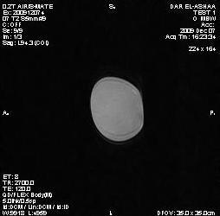
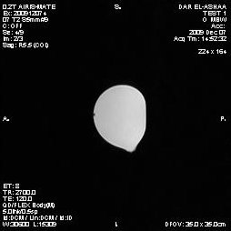
4 Hours Magnetized Water
Non-Magnetized Water

Figure 1. 4 Hours Magnetized Water Figure 2. Non-Magnetized water

MRI with Magnetized MRI without Magnetized
Saline injection Saline injection
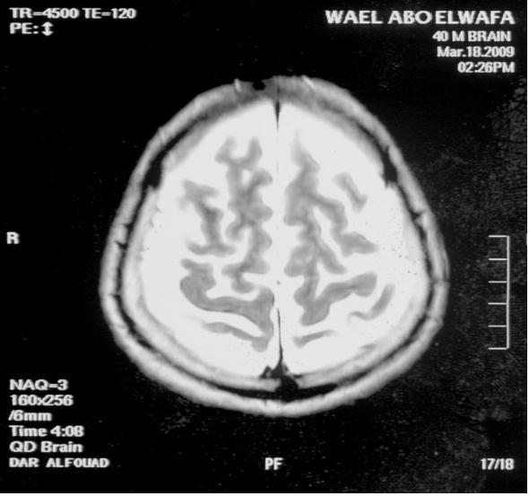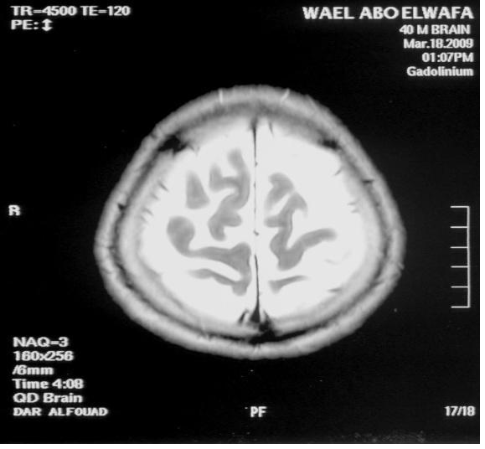

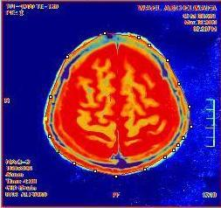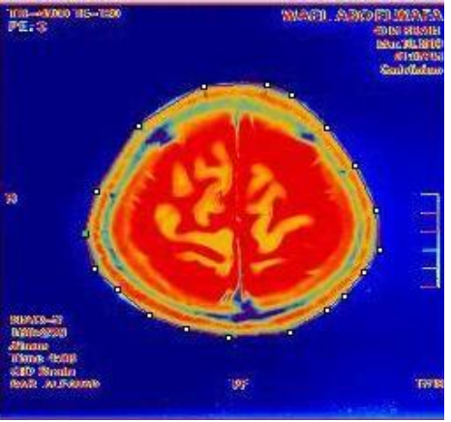

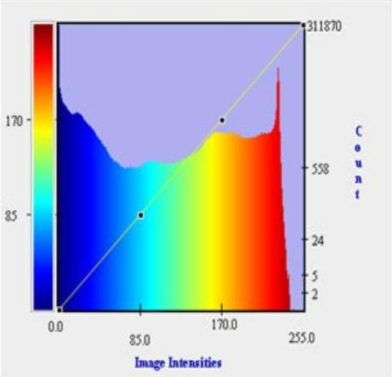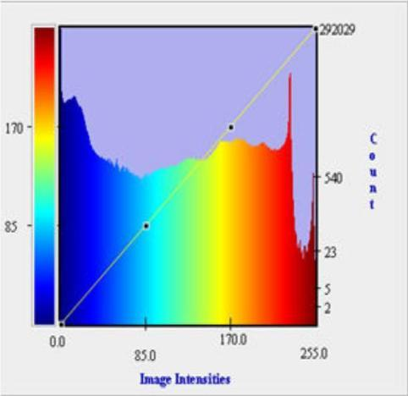
Figure 3. Analysis using medical image processing,
(MIPAV)

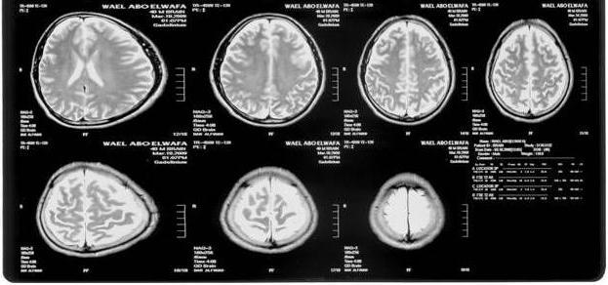

Figure 4. Brain MRI pre-intravenous injection of Magnetized saline

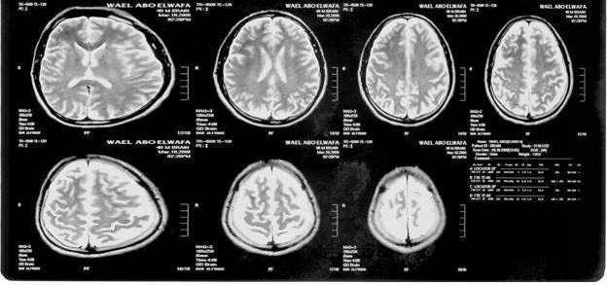

Figure 5 . Brain MRI post-intravenous injection of Magnetized saline

Magnetized Water | Non Magnetized Water
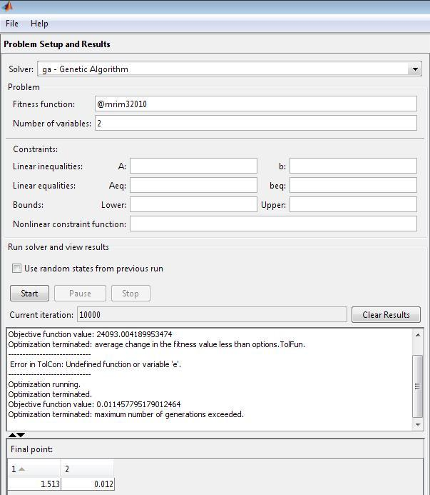 | 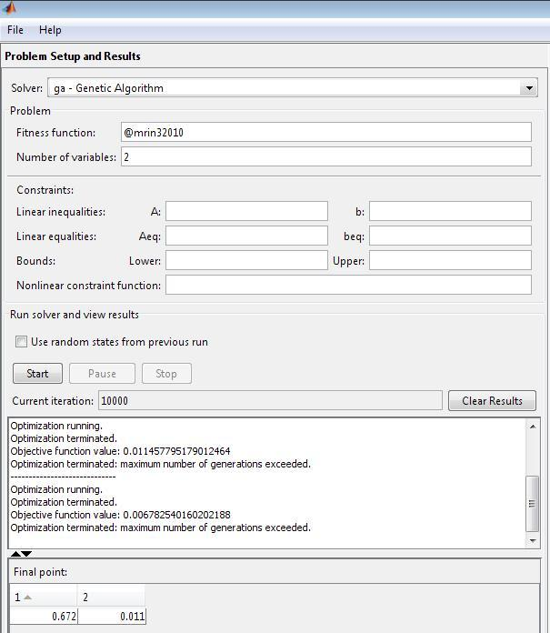

Figure 6 . GUI MATLAB Genetic Algorithm

Acknowledgements:
Authors are grateful to Prof.Ehab Reda and Dar alashaa radiology center, Alexandria, Egypt and Dar Al-Fouad Hospital for help and support by using their MRI machines to made our experiments, and also Mr. Mohamed Ramadan, MRI technologist for his cooperation

Corresponding Author:
Eng.Wael Abou EL-wafa. Ahmed
Department of Biomedical Engineering
Faculty of Engineering, Minia University
Cairo, Egypt
E-mail: wael@eng.miniauniv.edu.eg

References
- Caravan, P.; Ellison, J. J.; McMurry, T. J.; Lauffer, R. B. Chem. Rev. 1999, 99, 2293.
- K.B. Saebo, Degradation, metabolism and relaxation properties of iron oxide particles for magnetic resonance imaging, Ph.D. Thesis, Uppsala University,2004, 146p.
- Ward KM, Aletras AH, Balaban RS: A new class of contrast agents for MRI based on proton chemical exchange dependent saturation transfer (CEST). J Magn Reson 2000,143:79-87.
- Muller RN, Roch A, Colet J-M, Ouakssim A, Gillis P: Particulate magnetic contrast agents. In The Chemistry of Contrast Agents in Medical Magnetic Resonance Imaging. Edited by Merbach AE, Toth E. John Wiley & Sons; 2001.
- Toth E, Helm L, Merbach AE: Relaxivity of gadolinium(III) complexes: theory and mechanism. In The Chemistry of Contrast Agents in Medical Magnetic Resonance Imaging. Edited by Merbach AE, Toth E. John Wiley & Sons; 2001.
- Allen MJ, Meade TJ: Magnetic resonance contrast agents for medical andmolecular imaging. Met Ions Biol Syst 2004, 42:1-38.
- Zhou J, Wilson DA, Sun PZ, Klaus JA, Van Zijl PC: Quantitative description of proton exchange processes between water and endogenous and exogenous agents for WEX, CEST, and APT experiments. Magn Reson Med 2004, 51:945-952.
- Mansson S, Johansson E, Magnusson P, Chai CM, Hansson G,Petersson JS, Stahlberg F, Golman K: 13C imaging—a new diagnostic platform. Eur Radiol 2005, 16:57-67.
- Yu JX, Kodibagkar VD, Cui W, Mason RP: 19F: a versatile reporter for non- invasive physiology and pharmacology using magnetic resonance. Curr Med Chem 2005, 12:819-848.
- http://www.lumrix.net/health/Contrast_medium.htm
- Roch A, Gossuin Y, Muller RN, Gillis P: Superparamagnetic colloid suspensions: water magnetic relaxation and clustering. J Magn Magn Mater 2005, 293:532-539.
- Josephson L, Perez JM, Weissleder R: Magnetic nanosensors for the detection of oligonucleotide sequences. Angew Chem Int Ed Engl 2001, 40:3204-3206.
- Golman K, in ’t Zandt R, Thaning M: Real-time metabolic imaging. Proc Natl Acad Sci U S A 2006, 103:11270-11275. 100:10158- 10163.

- Ardenkjaer-Larsen JH, Fridlund B, Gram A, Hansson G,Hansson L, Lerche MH, Servin R, Thaning M, Golman K: Increase in signal-to-noise ratio of >10,000 times in liquid-state NMR.Proc Natl Acad Sci U S A 2003, 100:10158- 10163.
- http://www.revivenaturally.com/magnetic-therapy/biomagnet-therapy vibrational Medicine for the 21st Century (ã 2000). Ronald Lynch, M.D. Integrative Natural Solutions
- http://searchwarp.com/swa255533.htm
- http://www.ehow.com/facts_4965818_health-benefits-magnetic-water.html
- http://sound-ideas.info/6.html
- http://www.yourhealthbase.com/mag_water.htm
Magnetized water: Universal Source of Health? by Hans R. Larsen, MSc C

hE

1/2/2012

