Study on Home Range of Rhesus Monkey, Macaca mulatta (Zimmermann, 1758) in Saraswati Plantation Wildlife Sanctuary (SPWS) Kurukshetra, Haryana (India)

¹Ajay Kumar and ²Girish Chopra

^{1,2}Department of Zoology (Wild life and animal behaviour laboratory), Kurukshetra University, Kurukshetra-136119, Haryana (India). ¹e-mail - ajayindorakuk@yahoo.com

Abstract: The present study was carried out from February, 2008 to July, 2008 to record home range of rhesus monkey, Macaca mulatta (Zimmermann, 1758) in Saraswati Plantation Wildlife Sanctuary (SPWS), Haryana (India). Three troops (T-I, T-II, T-III) of Rhesus monkey were selected in Saraswati Plantation Wildlife Sanctuary. Troop-I resides nearby the Seonsar forest rest house, troop II was located toward the main gate of the Sanctuary forest and troop III was positioned in between troop I and troop II in Saraswati Plantation Wildlife Sanctuary. To study, home range of rhesus monkey direct contact method (Barwer, 1971) was followed. During periodic fortnightly visits (February, 2008 to July, 2008), each troop was silently followed in the morning active phase (6:00 A.M. to 11:00 A.M.) and later in the evening active phase (3:00 P.M. to 7:00 P.M.) maintaining appropriate distance to avoid their distractions as per standard methodology. Home range of selected three rhesus monkey troops is varied from minimum 0.169 Km² of troop-I to maximum 0.263 Km² of troop-II with an average 0.205 Km².
[Ajay Kumar and Girish Chopra. Study on Home Range of Rhesus Monkey, Macaca mulatta (Zimmermann, 1758) in Saraswati Plantation Wildlife Sanctuary (SPWS) Kurukshetra, Haryana (India). New York Science Journal 2012;5(1):6-12]. (ISSN: 1554-0200). http://www.sciencepub.net/newyork.

Keywords: Rhesus monkey, Saraswati Plantation Wildlife Sanctuary, Home range, Haryana.

1. Introduction
Rhesus monkey (Macaca mulatta) is an old world monkey belongs to family- Cercopithecidae. Rhesus monkey has a major role in biodiversity and in medical biological study such as surrogate mother, immunodeficiency disease, captive breeding, blood grouping and sequence of genome etc. (Zahn et al., 2007). Rhesus monkey is distributed ubiquitously throughout mainland Asia, from Afghanistan to India and Thailand to Southern China, Bangladesh, Bhutan, Nepal and Pakistan (Ferris et al., 1980; Groves, 2001; Smith and Mc Donough, 2005). In India, it is found in good number in peninsular India (Assam, Madhya Pradesh and West Bangal), north India (Jammu and Kashmir, Himachal Pradesh, Punjab, Haryana, Uttar Pradeh, Rajasthan, Gujrat) and central India (Orrisa, Bihar) (Seth et al., 2001). In Haryana, rhesus monkey is found in different habitats including villages, road side forest, towns, temples and near agricultural fields etc. (Hunger, 2004). Rhesus macaques characterized by dusty brown in color with little to no fur on their reddish-pink faces. Male and female are sexually dimorphic. Male have more red color on rump than female resemble with their faces. Average body length for female 207.6 mm and for male 227.9 mm. Average weight for male is 7.70 kg and for female is 5.34 Kg (Fooden, 2000; Singh and Sinha 2004). Seth and Seth (1983) studied, in their brief report on population dynamics of free ranging rhesus monkeys in different ecological condition in India, described that rhesus groups are residing in tropical forests, villages and urban habitats, in both tropical and arid biomes. In India, rhesus monkey is found in flat, cultivated areas, where agricultural fields dominate the landscape and in the plains, foothills and mountains region where habitat includes cultivated fields. Rhesus monkey found in habitats likes average annual rainfall ranges between 420 and 2150 mm, depending on elevation and annual range temperature in between -4° C (25° F) and 48° C (118° F) (Seth and Seth, 1986). During the hottest part of year, groups in the Himalayan region of India migrate to higher elevations where cooler temperatures persist throughout the summer months (Seth et al., 2001). Rhesus monkey is considered as omnivorous in its feeding habitats as it was observed to fed on eggs, termites and moulds in addition to plants (Lindburg, 1971). In human influenced areas, they focus on fruits, flowers, leaves, seeds, gums, buds, clover, roots, bark and they supplement their food diet with termites, grasshopper, ants, beetles and mushrooms (Fooden, 2000; Wolfe, 2002). In some areas, rhesus macaque depends directly as well as indirectly, on parts of their diet from human activities (Richard et al., 1989; Southwick and Siddiqi, 1994). Wolfe (1992), described about food given to the rhesus macaques in temples include bread, bananas, peanuts, seeds, fruits, vegetables, and assorted miscellaneous foods like ice creams and fried bread etc. Rhesus macaque troop are available in abundance in almost all the district of Haryana (Kumar, 1990). However, scanty information is available on different aspects of ecology and behaviour of rhesus macaques in Haryana. Therefore, present research work was planned for study of home range of rhesus monkey, Macaca mulatta (Zimmermann, 1758) in the Saraswati Plantation Wildlife Sanctuary of district Kurukshetra, Haryana (India).

2. Materials and Methods
Study area
To study home range of Rhesus monkey, Macaca mullatta, Saraswati Plantation Wildlife Sanctuary was selected as study site. Saraswati Plantation Wildlife Sanctuary (76° 27' -76° 33' E latitude and 29° 56'- 30° 01' N longitude) is located in between two districts (Kurukshetra and Kaithal) of Haryana, India (fig. 1). It is covering an area of 11,003 acres. The climate of area is subtropical, semi arid type and contains alkali soil. Annual rain fall of this area is 516 mm and average temperature is 32.4°C (Dagar et al., 2001). The vegetation of the Saraswati Plantation Wildlife Sanctuary is categorized as “Sub–group 5B tropical deciduous forest” (Champion and Seth, 1968). The dominant fauna of Saraswati Plantation Wildlife Sanctuary includes avian species (Anas poecilorghyncha, Arcidotheres tristis, Bubulcus ibis, Centrophus sinsnsis, Culumbia livia, corvus splendens, Dinopium savanense, Egretta garzetta, Himantopus himantopus, Meropus orietalis, Passser domesticus, Pristuculla krameri, Phalacrocorax niger, Pycnonotus cafer, Primia gracilis, Streptopelia senegalensis, Sturnus contra, Turdoides caudatus, Upipa epopus), mammalian species (Boselaphus tragocamelus, Sus scrofa, Felis sp., Macaca mulatta, Funambulas pennanti) and dominant flora of both study sites includes Acacia nilotica, Albizza lebbek, Butea monosperma, Eucalyptus sp., Dalbergia sissoo, Prosopus juliflora, Morus alba, Ficus bengalensis, Ficus glomerata, Syzygium cumini and many species of herbs and shrubs (Dagar et al., 2001.)
To study, home range of rhesus monkey direct contact method (Barwer, 1971) was followed. Three troops of Macaca mulatta in Saraswati Plantation Wildlife Sanctuary (T-I, T-II, T-III) were selected (fig. 2). During periodic fortnightly visits (February, 2008 to July, 2008), each individual of selected rhesus macaques troops was monitored. During each visits, each troop was silently followed in the morning active phase (6:00 A.M. to 11:00 A.M.) and later in the evening active phase (3:00 P.M. to 7:00 P.M.) maintaining appropriate distance to avoid their distractions as per standard methodology. Markers were placed at strategic sites to record area covered and popular places of halt during their activity phases to map the route followed by individuals of the troop in each visit. The collected data was later on statically analyzed.

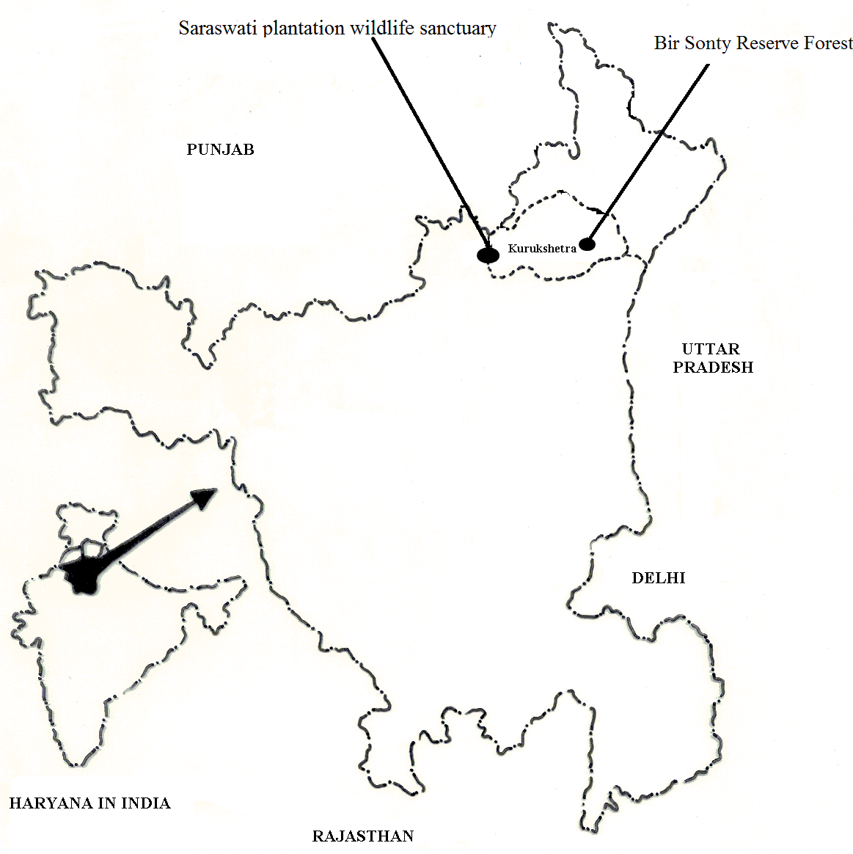
Fig. 1 Saraswati Plantation Wildlife Sanctuary, Haryana (India).

Fig. 2 Selected three troops of rhesus monkey in Saraswati Plantation Wildlife Sanctuary.

3. Results
Free- ranging rhesus monkeys, Macaca mulatta display feeding, breeding and other routine bound mannerisms, in a habitual and ritualistic manner in an area called home range. The home range involves a restricted pattern of movement as well as vicissitudinal cycle within a familiar territory, frequented during the day time, and spanned within the limits of the roosting site, water hole and foraging sites in a zig -zag fashion having alternates routes. During fortnightly periodic visits (from February, 2008 to July, 2008) roosting sites of selected three troops in Saraswati Plantation Wildlife Sanctuary were observed.
Troop I resided nearby the Seonsar forest rest house in Saraswati Plantation Wildlife Sanctuary. This region had prominence of trees like Acasia nilotica, Delbergia sissoo, Albizzia lebbek, Morus alba, Butea monosperna, Cordea dichtoma and Eucalyptus sp. in the forest area. A rest house was located on the northern side about 150 mtrs. away from the roosting place of troop I. On the western side of the roosting place, some 50 mtrs. away, was plantation nursery spread in the north-south direction from near the forest path upto the boundary of the sanctuary on the northern side. Similarly, on the north, northeast and northwest sides joining the boundary of the Saraswati Plantation Wildlife Sanctuary, were the agricultural fields almost 200-250 mtrs. away from the roosting place of this troop. Metallic road (Pehowa-Cheeka road) passed through the forest about 400 mtrs. towards the western side of the roosting sites of rhesus monkeys (fig. 3).
This troop roosted only 150 mtrs. away from the rest house on the trees such as Acasia nilotica, Delbergia sissoo, Albizzia lebbek, Morus alba, Butea monosperna, Cordea dichtoma and Eucalyptus sp. Based on periodic maps, the home range of this troop was recorded to be 0.169 km². In the morning activity phase, this troop moved 250 mtrs. from roosting places in the north direction and 350 mtrs. in the north west and west directions. During this activity phase, the individuals of this troop were found searching the food in the agricultural fields in the north, north-east and north-west directions as well as in the plantation nursery and forest area in the west direction. Troop I of rhesus macaques moved in the southward direction on the main plantation (M P) road passing through the forest as well as on the east side of the road occasionally, in the evening activity phase to feed on natural food as well as food provided by villagers. Macaques covered about 125 mtrs. south from the roosting places and about 100 mtrs. on the east and south-east sides of the roosting places in the evening phase (fig. 3).

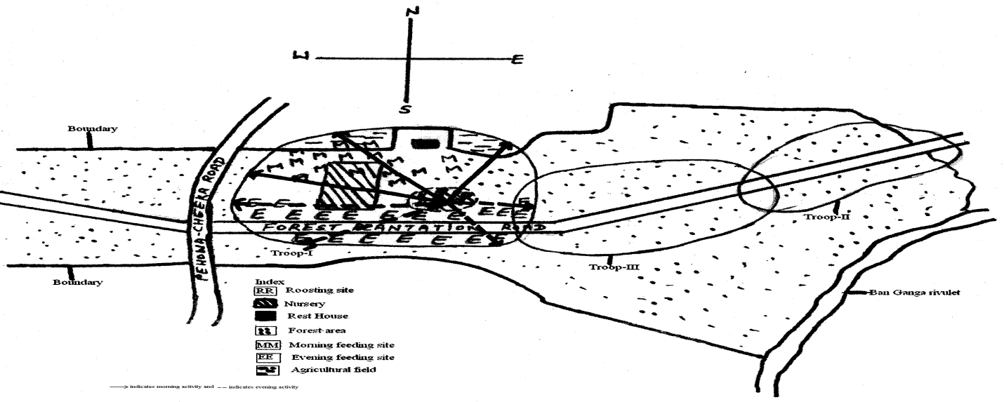
Fig. 3 Home range of selected troop-I in Saraswati Plantation Wildlife Sanctuary

The troop II was located toward the main gate of the Saraswati forest. This region had a Ficus bengalensis tree providing roosting place to the macaques. Nearby this region was a two room-residential complex of the security guard was present. Road side plantation of this area included Acasia nilotica, Delbergia sissoo, Albizzia lebbek, Morus alba and Eucalyptus sp. In the east direction, village Khapra was located 450 mtrs.away from this region. This region was surrounded on the north and east sides by the agricultural fields about 250-300 mtrs. away from the roosting sites. In the south direction, a maszid was located 500 mtes. away from the roosting sites of the rhesus monkey (fig. 4).
This troop also moved for searching the food in the morning upto 100 mtrs. and 350 mtrs. from the roosting sites toward north and northeast directions, respectively to the peripheral agricultural fields and in the east upto forest personnel residence. In the evening phase, the troop moved in the southwest direction upto 400 mtrs. and 250 mtrs. toward south east direction across the forest plantation road. The home range of this troop was found to be 0.263 km². In all periodic visits, this troop was found searching food and performing other activities at the same places both in the morning and evening hours, extending their activities few mtrs. upward or sideways. Like troop I, home range of this troop also overlapped with the home range of troop III upto about 50 mtrs. distance (fig. 4) .
Troop III was positioned in between troop I and troop II in Saraswati Plantation Wildlife Sanctuary. Its home range extended deep in the Saraswati Plantation Wildlife Sanctuary. This region also had plants like Acasia nilotica, Delbergia sissoo, Albizzia lebbek, Morus alba and Eucalyptus sp. in plenty. A water tubewell was present just 500 mtrs. toward southern side from the roosting site of this troop. Two small water holes were also present in this region toward northwestern side from the roosting region some 200 mtrs. away (fig. 5).
Home range of this troop was calculated to be 0.184 km². The data further revealed that the number of popular spots carrying out different diet activities of macaques in morning were 100 mtrs., 250 mtrs. and 400 mtrs. away towards north, northwest and west directions, respectively in thick forest from the roosting place. In the evening time, troop moved upto 250 mtrs., 390 mtrs. and 125 mtrs. towards south, southwest and east sites from the roosting site respectively. Home range of this troop overlapped with home range of troop I and troop II for about 50 mtrs (fig. 5).

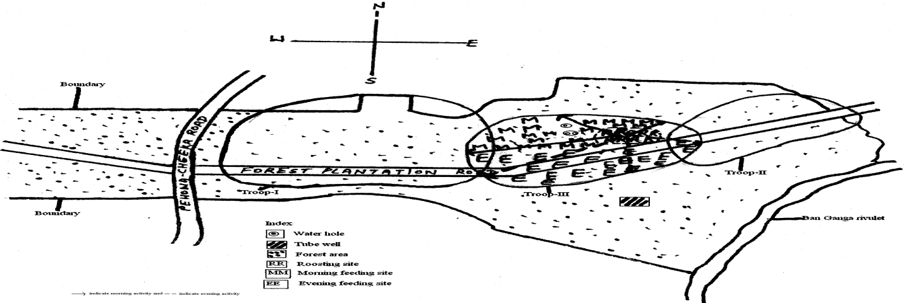
Fig. 4 Home range of selected troop-II in Saraswati Plantation Wildlife Sanctuary

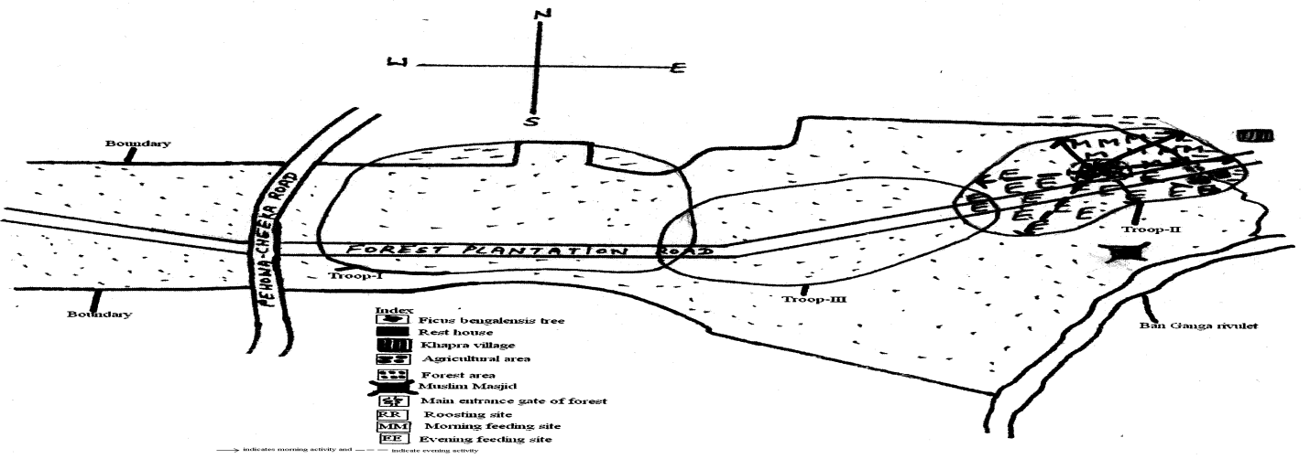

Fig. 5 Home range of selected troop-III in Saraswati Plantation Wildlife Sanctuary

Home range of selected rhesus monkey troops is varied from minimum 0.169/Km² of troop-I to maximum 0.263/Km² of troop-II with an average 0.205/Km² (table 1).

Table 1 Home range rhesus monkey troops in Saraswati Plantation Wildlife Sanctuary.

Troop No. | Home Range/km²
I | 0 .169
II | 0.263
III | 0.184
Average | 0.205

4. Discussion:
Free- ranging rhesus monkeys, Macaca mulatta display feeding, breeding and other routine bound mannerisms, in a habitual and ritualistic manner in an area called home range. The home range involves a restricted pattern of movement as well as vicissitudinal cycle within a familiar territory, frequented during the day time, and spanned within the limits of the roosting site, water hole and foraging sites in a zig -zag fashion having alternates routes. Rhesus monkey is found in different habitats including villages, road side forest, towns, temples, forest areas and near agricultural fields etc (Hunger, 2004). Rhesus monkey, Macaca mulatta are found on such a broad geographical area that it is difficult to concisely summarize the type of habitat of rhesus macaques populate. In the most general terms, they are found in both tropical and temperate habitats including semi desert, dry deciduous, mixed deciduous and mangrove swamps, usually at elevations from sea level to 2000 mtrs., but they have been seen at elevations up to 4000 mtrs. in China and northern India (Seth and Seth, 1986; Srivasta and Mohnot, 2001). Rhesus macaques are also found in area close to human in urban setting or near cultivated fields (Southwick et al., 1996). In India, rhesus monkey is found in flat, cultivated areas, where agricultural fields dominate the landscape and in the plains, foothills and mountains region where habitat includes cultivated fields.
To record home range of Rhesus monkey, Macaca mulatta (Zimmermann, 1758), Saraswati Plantation Wildlife Sanctuary (SPWS), Haryana (India) was selected as study site. Three troops (T-I, T-II, T-III) of Rhesus monkey were selected in Saraswati Plantation Wildlife Sanctuary. Troop-I resided nearby the Seonsar forest rest house, troop II was located toward the main gate of the Saraswati Plantation Wildlife Sanctuary and troop III was positioned in between troop I and troop II in Saraswati Plantation Wildlife Sanctuary.
Home range size and day range length of activity of rhesus monkeys, Macaca mulatta were found dependent on the habitat. Forest dweller rhesus macaques troops restricted their activities with in the forest and thus depicted relatively shorter home range as compared to other troops which were semi dweller or those who extended their activities on the road sides/agricultural fields etc. Earlier also, Seth and Seth (1986) have reported variable home range of troops dwelling in temples, villages and urban areas. According, temples, Villages and urban rhesus macaques have small home range between .01 and 3.0 km (0.04 and 1.16 mt) in size because they derive almost all of their food from human visitors leaving offering (Fooden, 2000). In more forested areas of India, home range size can be up 15 km, but rhesus monkey only move on the average, 1428 m per day (Lindberg, 1971). In China, home range vary in size from .1 to .71 km² near villages, while in mountain areas, home range are much larger and span between 11 and 22 km² but average is 16 km² (Southwick et al., 1996). Daily path lengths in this environment range from 1050 to 3500 m (Makwana, 1978). Mukhrjee (1962) and Pirta and Singh (1978) observed that the home range of rhesus monkeys is affected by searching of food and addition of another troops. Makware (1978) observed variation in home range from 1.3 km to 13.4 km² in rhesus macaques troops in Uttar Pradesh and the home range also overlapped for number of troops.
In present study home range overlapped of troop-I to troop-III and troop-III to troop-II in Saraswati Plantation Wildlife Sanctuary. Home range of selected rhesus monkey troops is varied from minimum 0.169/Km² of troop-I to maximum 0.263/Km² of troop-II with an average 0.205/Km².

Correspondence to:
Ajay Kumar
Department of Zoology, Kurukshetra University,
Kurukshetra-136119, (Haryana) India
Telephone: 01282-320043
Cellular phone: +91-9813077684
E-mail: ajayindorakuk@yahoo.com

Refrences
1.Barwer M. Daily activity pattern study of rhesus monkey, Animal behaviour , 1971, 72(4);165-169.
2. Dagar JC, Singh G, Singh NT. Evalution of forest and fruit tree used for rehabilitation of semiarid alkali-sodic soil, India Journal of Arid land Research and Management, 2001, 15(2);115-133.
3. Ferris SD, Sage RD, Page EM. Classification of living macaques in D.G. Lindburg, education the Macaca mulatta studies in ecology, behaviour and evolution. Van- restern- reinhold, Newyork, 1980, 12(3):1-9.
4. Fooden A. A successful mass translocation on commensal rhesus macaques (Macaca mulatta) in Varindaban, India, 2000, 36(1);87-93.
5. Groves RW. How a developing brains gets itself properly wired for adaptive function. In E. to back, L.R. Aronsone and E. Shaw (Eds.), The biopsychology of development. New York: Academic Press, 2001, 6(4);42-43.
6. Hunger MD. Spontaneous number representation in semi free rhesus monkey. Macaca mulatta, Proceed in royal society of London, 2001, 8(2);267,829-833.
7. Lindburg DG. The rhesus monkey in north India: an ecological and behavioral study; in primate behavior, L.A. Rosenblum (ed.) New York, Academic press, 1971, 2(9);1-106.
8. Makwana SC. Field ecology and behavior of the rhesus macaque (Macaca mulatta): group composition, home range, roosting site and foraging routes in the Asarori forest, Primates, 1978, 19(3);483-492.
9. Mukherjee RP. A field study on the behaviour of two roadsite groups of rhesus monkey, Macaca mulatta in northern U.P., J. Bomb. Nat. Hist. Soc., 1962, 66(1);47-56.
10. Pirta RS and Singh M. Some factor affecting the size and location of home range in natural groups of rhesus monkeys (Macaca mulatta), Proc. Ind. Acad. Sci.(American science), 1978, In Press.
11. Richard AF, Goldstein SJ and Dewa RE. Weed macaques the evolutionary implications of rhesus macaque. Feeding and ecology, Int. J. Primatol, 1989, 10(6);569-594.
12. Seth PK, Pokwal NK. Behaviour and ecology of primates, J. nat. His. Soci., 2001, 14(3);172-180.
13. Seth PK and Seth S. Population dynamics of free ranging rhesus monkey in different ecological condition in India, Am. Journal of Primatology, 1983, 5(2);61-67.
14. Seth PK and Seth S. Ecology and behaviour of rhesus monkey. In: Else, J.G. and Lee, P.C., editors. Primate ecology and conservation. Cambridge (UK), Cambridge University Press, 1986, 2;89-103.
15. Smith and Mc Donough. Habitat, resources, utilization, pattern and determinates of behaviour in rhesus monkey (Macaca mulatta), J. Hum. Eco., 2005, 11(1);1-21.
16. Southwick CH and Siddiqui MF. A successful survey translocation of commensally rhesus monkey in India, American journal of primatology, 1994, 16;187-197.
17. Southwick CH, Zhay Y, Hiang H, Lu Z and Qu W. Population ecology of rhesus macaques in tropical and temperate habitat in China. In evolution of macaques society, Cambridge University press, Cambridge, 1996, 7;95-105.
18. Srivastava A and Mohmot SM. Distribution, conservation status and priorities for primates in northern India. Wild life and protected areas, Dehradun (India): Wildlife Institute India, 2001; 102-108.
19. Wolf LD. Feeding habitats of rhesus macaques (Macaca mulatta) of Jaipur and Gulta, Journal of experimental Zoology, 1992, 7(4);43-54.
20. Wolf LD. Rhesus macaque: a compressive study of two sites, Jaipur in India and Silver springs, Florida. Cambridge (U.K.), Cambridge university Press, Cambridge, 2002, 7(2);310-330.

12/12/2011

