Future Threats to CBD: A Case Study of Bangalore CBD

Javaid Ahmad Tali¹, Mohammad Reza emtehani^{2,} Dr. Krishna Murthy³ and Dr. H. N. Nagendra⁴

Department of Studies in Geography and Institute of Development Studies,
University of Mysore
E-mail: javaid.26.mu@gmail.com, emtehani_mohd75@yahoo.com galimane@yahoo.com, and nagendra@ids.uni-mysore.ac.in

Abstract: Rapid growth of cities has posed a threat to their Central Business District (CBD). This is evident form the growing eagerness of the people to seek accommodation in sub-urban areas. The interaction within the city limits has been studied by a number of scholar. It is very interesting to study the characters of CBD of any city. An attempt has been to analyze the changes in the Central Business District of Bangalore city from 1971-2001. Based on the data it is found that the land use pattern of CBD has shows a tilt towards commercial use which cover a greater portion of the CBD, and this is expected to increase in the next few years if the similar trend continues. The article also reviews the changes in its land use, demography, land value, socio-economic profile and future threats have been analyzed.
[Javaid Ahmad Tali¹, Mohammad Reza emtehani^{2,} Dr. Krishna Murthy³ and Dr. H. N. Nagendra. Future Threats to CBD: A Case Study of Bangalore CBD. New York Science Journal 2012;5(1):22-27]. (ISSN: 1554-0200). http://www.sciencepub.net/newyork.

Key Words: CBD, Land value, Land use, sub-urban, Assimilation, Discard.

Introduction
Central Business District (CBD) is the hub of business and civic life and it exhibits certain distinct physical and human features, which distinguishes it from surrounding areas. The size of the city shows the positive relationship with the size of the city i.e., greater the size of city greater will the size of the CBD vice versa. CBD is always shows dynamic nature in its morphology, structure, shape and size and in social patterns to meet the changing economic conditions. This dynamic nature of the can be seen through the zone of assimilation and the zone of discard at the centre Cities do not grow of themselves but it is the countryside which sets them to do task which must be performed by them (Sidharta and Mukherjee 2009).
The Central Business District is referred to as the heart of the city. Here one finds the greatest concentration of offices and retail stores reflected in the city’s highest land values and its tallest buildings, chief focus of pedestrian and auto-mobile traffic. By way of the transportation net the remainder of the city and an area of decreasing intensity extending far beyond the city's corporate limits are oriented toward the CBD (Raymond and Vance 1954). It has been demonstrated that the CBD is a very special part of a central area complex. The emergence of the CBD has been a long process which has involved large-scale repercussions up on the immediately surrounding areas. That emergence has been conditioned by a number of controlling factors derived from the special development of this city (Carter and Rowley 1966). Downtowns throughout the country are capitalizing on their historic character. Downtowns offer a niche market for those seeking a “sense of place” (Rebecca and Lang 1999).
Central business districts may be a passing phenomenon of the city, for they generally are characterized by a declining centrality influence that results in an encroaching greenbelt. This characteristic, however, may be the result of shifting or changing functions and activities throughout the metropolitan area (Warren and Burton 1966). In any large urban community the central business district (CBD) plays a vital role. It would be impossible to understand the functioning of such a community without analyzing in some detail the ways in which the CBD serves as an integrating mechanism in such vital areas as communication, transportation, trade, finance and government (Donald and Gerald 1951).
Thus it is seen that each central business district has a spatial shape which in detail appears to be unique. No specific district appears quite like any other district. In spite of the great complexity and irregularity of shapes, however, definite geometric patterns are discernable. This arises from the fact that centralized commercial activities by their very nature operate primarily under the same principle-namely, to choose central positions with respect to all internal and external activities of the city (George 1950).

Study area
Bangalore city is the leading city in the state of Karnataka. It has become the hub of Central Business District of Bangalore city is located on the latitude of 12°58′13″N and 77°33′37″E. It is in radial pattern located in the geographical centre and comprising the old part of the city. It had shown a trend of growth towards the south and eastern quadrant and now become slightly acentric. As per the CDP report, Bangalore, 1995, out of the 49 proposed land use planning Districts, CBD falls under planning District No. 11. It covers an area of 640.22 hectares. The CBD is bounded by Kempegowda Road, District Office Road, Part of J.C. Road, N.R. Road, T.C.M. Road and Tank Bund Road. The rest the CBD which developed with the expansion of the city is referred to as peripheral CBD. It comprises of 6 wards, out of which three entirely fall within the CBD (Chikpat, Dharmaraya Temple and Sudhamanagar) and five partly (Gandhinagar, Cottonpet, S.K.R Market, Chamarajpet, Sampangiramanagar) The wards of the CBD are:

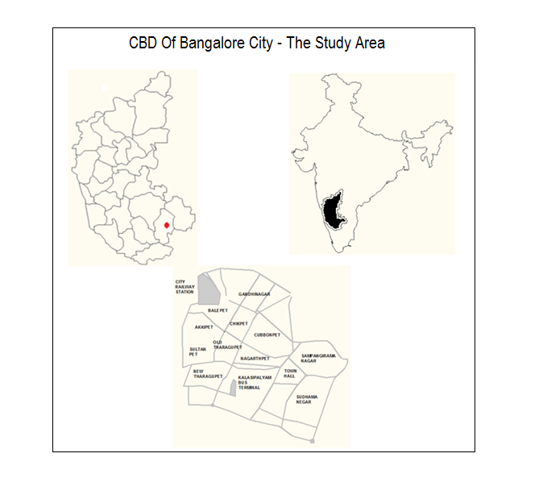
Figure: 1.1, Central Business District of Bangalore – The Study Area
Source: Compiled by Authors

Methodology:
To understand the existing problems of CBD, the data relating to various uses has been analyzed. The study is mainly based on secondary data collected from various offices as Censes of India, Registration Office, and City Development Authority. The collected data has compiled in tabular form to prepare diagrams and it was further statistically analyzed and maps were prepared with the help of collected information, AutoCAD Software has been used to prepare different thematic maps. The analysis of data has been interpreted and future indications have been made based on existing conditions, if similar trend continues.

Demographic profile
The population growth of CBD as shown in table number 1.2 indicates increasing as well as decreasing trend. The trend of growth of population of CBD can be analyzed through two ways, firstly zone of assimilation and secondly the zone of discard. From 1971 to 1981 CBD had shown the 13.30 percent increase in population but later it has shown the decreasing trend. The population in CBD has decreased from 211457 in 1981 to 195593 in 1991 indicating the growth rate of (-16.89%), and has shown further decreasing trend form 195593 in 991 to 149321in 2001 indicating the growth rate of(-15.34%).

Table: 1.2, Ward Wise Population
S No | Ward No | Name of the ward | Population
S No | Ward No | Name of the ward | 1971 | 1981 | 1991 | 2001
1 | 27 | Gandhinagar | 36532 | 41505 | 19304 | 9843
2 | 28 | Chikpat | 57571 | 63075 | 64438 | 31851
3 | 29 | Cottonpet |  |  |  | 6106
4 | 30 | S.K.R Market | 18826 | 17842 | 16790 | 11856
5 | 46 | Chamarajpet | 39537 | 47652 | 31357 | 4073
6 | 47 | Dharmaraya Temple | 34175 | 41383 | 15325 | 32938
7 | 48 | Sudhamanagar |  |  | 28537 | 42919
8 | 77 | Sampangiramanagar |  |  | 19842 | 9735
Total |  |  | 186641 | 211457 | 195593 | 149321
Source: Census of India, 1971, 1981, 1991, 2001.

Table: 1.3, Decadal Growth of Population in CBD
Year | Population | % Increase/Decrease
1971 | 186641 | --
1981 | 211457 | +13.30
1991 | 195593 | -16.89
2001 | 149321 | -15.34

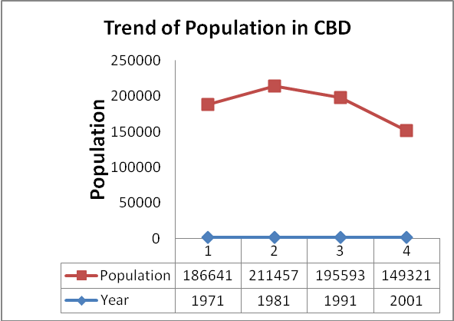
Figure: 1.2, CBD Bangalore - Population Trend
Source: Census of India.

Land use Pattern:
Mixed land use is one of the existing characters of CBD. Since it is the prime land of the city, it needs to act as economic engine for the growth of the city’s economy. The land use pattern of the central part of the city mainly constitutes non-residential use, as mixed land use of residential, commercial, industrial, recreational, public and semi-public and transportation node.
Out of the total area of the CDB (640.25 hectares) residential area in the CBD has shown a declined trend as it has decreased from 190.25 hectares (29.71%) in 1984 to 143.81(22.46%) hectares in 1995 and again to 129.25 hectares (20.20%) in 2003, it has shown a decrease of 61 hectares from 1984 to 2003. The dominance of commercial area is one of the characters of the CBD and Bangalore city has no exception with it. The land area has increased from 148.00 hectares in 1984 to 204.22 in 2003 indicating the increase of 56.22 hectares. The availability of good network of transportation is one of the characters of the CBD and increases with the increase in its functions. The area under transportation node in the CBD of Bangalore has shown an increase of 12 hectares form 1984 to 2003. Some the important commercial establishment mixed with light industries developed almost along all important roads such as, K.G. Road, Belapat Road, O.T.C. Road, Avenue Road, S.J.P. Road and J.C. Road. The land under recreational and administrative has remained constant in the same period.

Table: 1.4, Land Use pattern of CBD Bangalore.
S. No | Land Use | 1985 |  | 1995 |  | 2003
S. No | Land Use | Area in ha. | % | Area in ha. | % | Area in ha. | %
1 | Residential | 190.25 | 29.71 | 143.81 | 22.46 | 129.25 | 20.20
2 | Commercial | 148.00 | 23.12 | 191.66 | 29.94 | 204.22 | 31.90
3 | Industrial, | 28.35 | 04.43 | 20.83 | 3.25 | 20.83 | 3.25
4 | Public and semi-public | 101.00 | 15.78 | 101.00 | 15.78 | 101.00 | 15.78
5 | Parks and open space | 16.25 | 02.54 | 16.25 | 2.54 | 16.25 | 2.54
6 | Traffic and transportation | 156.40 | 24.42 | 166.70 | 26.00 | 168.70 | 26.35
 | Total | 640.25 | 100.00 | 640.25 | 100.00 | 640.25 | 100.00
Source: CDP 1984, 1995 and Draft Report CDP 2015, Bangalore Development Authority Bangalore.
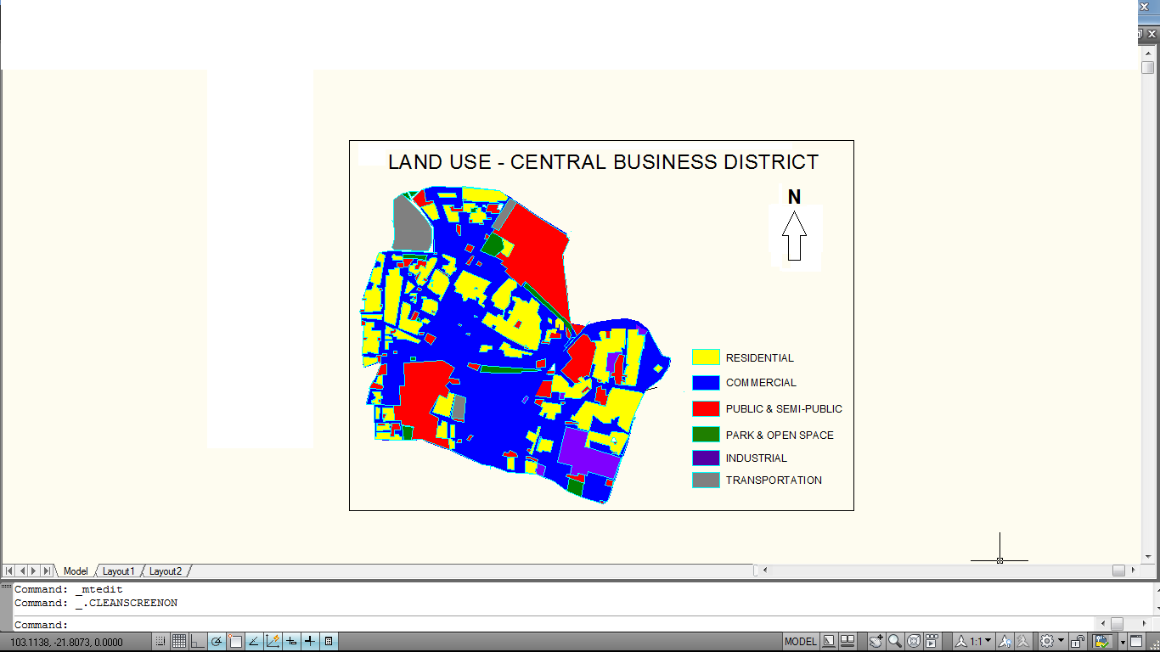
Figure: 1.3, Land Use Map of CBD Bangalore
Source: Bangalore Development Authority Bangalore.

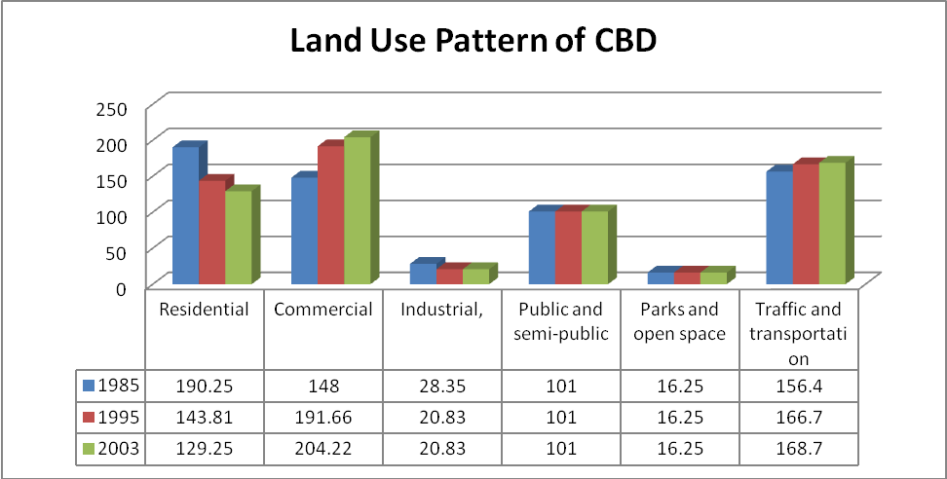
Figure: 1.3, Land Use Pattern of CBD

Socio-Economic scenario
Administration, trade & commerce and industry are the main economic activities of the central part of any city. This is the reason why the core area has more number of people involved in trade and commerce activities and the CBD of Bangalore has no exception with it. The number of workers engaged in trade and commerce decreases towards the peripheral area, where the people are mostly employed in government offices and transportation sector. Due to the unavailability of large parcels of land for Information Techonology (IT) and British Telecom (BT) industries in the CBD, the government has allocated the land for such industries on the strikes of Southern quadrant of Bangalore.
Due to the industrialization, the land under residential use is decreasing and the number of households has shown a major decline in the Chamararjpet, Dharmarayaswami Tempe. The number of hawkers are increasing it is mainly due to unemployment, they mostly come from outside the CBD. It has nearly 10 out of 400 officially declared slums in Bangalore, whereas intermediaryzones adjacent to the CBD has more than 55 per cent.

Land value:
It is the zone of complexities with narrow and discontinuous internal roads. Its central location, easy accessibility and high intensity of development have made the prime land of the city attaining a high land value. Considering the land value in the various wards of the Bangalore city, central business district has high land value, which is one of the important characters of CBD. The increasing trend of land value of Bangalore CBD can be divided in two time periods:

- Gradual Increasing Period (1975-1995) and
- Rapid Increasing Period (1995-2005).
The land value up to the period of 1995 was not too high as the growth of the city was also low. There are several reasons behind it like as lack of Multinational Companies, lack of infrastructure facilities, IT sector was not developed, and so on. But after 1995 the city has shown a rapid growth with multinational companies investing a huge capital, the land value has also got increased. The value of the land depends upon the availability of amenities, location, infrastructure, accessibility, availability of open space etc. in case CBD of Bangalore city the land value of Chamarajpat area is very high as comparable to the well-developed residential neighbourhood, whereas in case of Kalasipalyam and Sudhamanagar have lesser land value even though located within the CBD. It is mainly due to low infrastructure and poor street network.
Road and transportation:
Central Business District is highly accessible area of the city. It is considered as the commercial and trade centre of the city. Roads are considered as the nerves of the development of any area. So for as the CBD of the Bangalore is considered it is surrounded by the Lalbagh Fort Road, K.H. Road, Raj Ran Maohan Road, Nrupatunga Road, Seshadri Road, Gubbi Thotadappa Road, T.M.C Road, Tipu Road and Albert Victora Road. The core area has a complex network of narrow and discontinuous internal roads. These are connected to the main roads in a non-unionized way and run parallel and perpendicular to the main roads.

Analysis of CBD and Findings:
The function in the centre of the city largely influences the urban extent of the city. The city centre and the city have direct inter-relation with other.
- The basic aim of the city dwellers is to enlarge their profits, for this purpose they have utilized their resource in more profitable way. Land under commercial and other non-residential use is more profitable. Due to this reason the land residential use has got decreased form 29.71per cent in 1985 to 20.20 per cent in 2003.

- The population in the CBD has also shown a negative trend in the same period. The population has decreased form 186641 persons in 1971 to 149321 in 2001. The main reason for this decrease in population are lack of open space, high level of noise pollution, frontage to the buildings, high land value etc.

- Though the land value in the central area of the city is always high and the Bangalore CBD has no exception with it. The land value in the CBD has shown an increasing trend but the trend of increasing land value in other parts of the city (IT sector) is much higher. It is mainly due to deteriorated conditions, lack of social and physical infrastructure, slums, poor social index etc. the developmental trend in other parts of the city will grow as per the current requirements whereas in the CBD due to certain constraints like lack of flexibility in planning to accommodate the present requirements will fail to compete with the developments in the other parts of the city which results in the further depreciation of land value.

- It is gradually losing and discarding some of its functions and business by transferring them to the outlying areas.

- Lack of attention to bring in balance between the fast growing demand and required infrastructure may convert these areas into urban blight with social and economic liabilities.

- Though it is considered as the hub of commercial activity and intern generate maximum revenue and its inefficiencies in future will lead to huge loss of revenue.

- The land use under recreational use though is good for health has not shown any increase.

- The core of the city with the conventional administrative, trade and commerce, recreational activity is unable to perform efficiently due to the lack of space, infrastructure and growth of population.

Conclusion:
The focus of development has shifted from CBD to fast developing sub-urban areas, posing a threat to the central part of the city as it has gradually started losing and discarding some of its functions and business by transforming them to the outlying areas. But in a Metropolitan area like Bangalore the core must trend to become more concentrated as it becomes more valuable due to its location, functions and accessibility. Absorption of the increasing requirements of the society in to the core areas needs to be sensitive to certain existing functions and form which have evolved over a period of time. CBD has to thrive by itself by competing with the developments of sub-centres in the outlying areas. To achieve this it has to be more flexible to absorb new activities along with the existing functions for it to sustain.

References:
- Carter, H. and Rowley, G. (1966), The Morphology of the Central Business District of Cardiff, Transactions of the Institute of British Geographers, No. 38, pp. 119-134.
- Donald, L. F. and Gerald, B. (1951), The Standardization of Data Showing Daily Population Movement into Central Business Districts, Land Economics, Vol. 27, No. 4 pp. 348-353
- George, W. H. (1950), The Central Business District - A Study in Urban Geography, Economic Geography, Vol. 26, No. 4, p. 237-244)
- Jefferson, M, (1931), The distribution of world’s city’s folks –A Study in comparative civilization Geographical Review, Vol. 21, pp. 446 – 465.
- Raymond, E. M and Vance, J. E. Jr. (1954) Delimiting the Central Business District , Economic Geography, Vol. 30, No. 3, pp. 189-222.
- Rebecca, S and Lang, R. E. (1999) Life at the Centre: The Rise of Downtown Housing, Housing Facts and Findings. Vol.1, No.1, pp. 3–5.
- Sidharta, K. and Mukherjee, S. (2009) The CBD, Cities Urbanisation and Urban Systems, Kalsalaya Publications Pvt. Limited, pp. 89-94.
- Warren, R. S. and Burton, A. A. (1966), Land Tenure in the Central Business District, Land Economics, Vol. 42, No. 2, pp. 171-178.

12/30/2011

