Extracellular Metabolites Produced by a Novel Strain, Bacillus alvei NRC-14:
1. Some Properties of the Chitinolytic System

Shadia M. Abdel-Aziz^{*1}, Maysa E. Moharam¹, Hoda A. Hamed¹ and Foukia E. Mouafi²

Microbial Chemistry Dept.¹, Microbial Biotechnology Dept.², Genetic Engineering and Biotechnology Division, National Research Center, Dokki, Cairo, Egypt
abdelaziz.sm@gmail.com

Abstract: Bacillus alvei NRC-14, a bacterial soil isolate, constitutively produces chitosanase in presence or absence of the substrate chitosan. The strain was also found to produce a variety of polysaccharide-degrading enzymes into the culture medium. However, when chitin was used as a sole source of carbon, low levels of chitinase was detected in the culture broth. Studies on the chitinase-binding activity to the insoluble polysaccharides revealed that the enzyme adhered strongly to insoluble substrates such as chitin, Avicel and xylan. Dissociation of the bound enzyme was achieved using 0.5 M NaCl at pH 9.6, after which the enzyme was purified to study some of its properties. On other hand, the strain exhibited high levels of chitinase (1.9U/ml) when N-acetylglucosamine, the principle monomeric constituent of chitin, was used as a sole carbon source. When colloidal chitin was used as a carbon source, purification procedures yielded three chitinases, namely ChiA, ChiB, and ChiC. ChiA hydrolyzed N-acetylglucosamine, soluble chitosan, colloidal chitin, and powdered chitin by 178, 100, 77, and 70%, respectively. However, ChiB and ChiC showed specificity for cellulose and its derivatives. The crude enzyme produced by B. alvei NRC-14 showed potentiality against wide range of fungal pathogens, indicating its efficacy as a promising biocontrol agent. A heat-shock treatment trigger the production of an inhibitor substance by strain B. alvei NRC-14 which was found to inhibit the growth of some fungal pathogens.
[Shadia M. Abdel-Aziz, Maysa E. Moharam, Hoda A. Hamed and Foukia E. Mouafi Extracellular Metabolites Produced by a Novel Strain, Bacillus alvei NRC-14: 1. Some Properties of the Chitinolytic System] New York Science Journal 2012;5(1):53-62 ]. (ISSN: 1554-0200). http://www.sciencepub.net/newyork.

Key wards: Chitinase, chitin-binding activity, chitosanase, Bacillus alvei NRC-14, antimicrobial activity.

1. Introduction
Chitin, an insoluble polymer of 1,4-B linked N-acetylglucosamine (NAG) residues, is one of the most abundant and renewable polysaccharide (after cellulose) on Earth. About 10¹¹ metric tons of chitin is produced annually in the aquatic biosphere alone. Fungal cell walls, insect exoskeletons, and shells of crustaceans are the main sources of chitin. The NAG units that generally form intermolecular H-bonds make chitin completely insoluble in water and limit its use. However, several strategies have been developed for converting chitin into small soluble oligomers (chitooligosaccharides), which are more useful for application in the fields of medicine, agriculture, and industry (Stevens, 2005). Chitin oligomers were also examined for their inhibitory effects on human leukemia and have been reported to possess antitumor activity (Wang et al., 2006). Chitinase (EC 3.2.1.14) and N-acetylglucosaminidase (EC 3.2.1.30) are essential enzymes that catalyzing the conversion of insoluble chitin to its monomeric component. These enzymes are found in a wide variety of organisms including bacteria, fungi, insects and plants (Shanmugaiah et al., 2008). Bacterial chitinases are thought to be important in the digestion of chitin for utilization as a carbon and energy source, and, from the ecological point of view, such chitinases serve as an important role in recycling chitin in nature (Watanabe et al., 1994). Invertebrates require chitinases for partial degradation of their old exoskeletons. Microbial chitinases are used in biological control of plant diseases against phytopathogenic fungi whose their cell wall contain chitin. In addition, plant chitinases are defense mechanism against plant fungal pathogens (Kamal, 2011). Interestingly, the presence of chitin in the cyst wall of human pathogen, Entamoeba histolytica and its degradation by chitinase was also demonstrated (Das et al., 2006), therefore, chitinases are gaining much attention worldwide (Mathur et al., 2011).
In the carbohydrate active enzymes database http://www.cazy.org/, carbohydrate hydrolyzing enzymes are first classified as glycosyl hydrolases, glycosyl transferases, polysaccharide lyases, carbohydrate esterases, and carbohydrate binding modules, and then further divided into numbered families. Following this classification, chitinases are commonly listed as glycosyl hydrolases family 18 and 19 (Supansa et al., 2008). Like cellulases, chitinases consist of discrete domains, which can be arranged in different orders in different proteins (Svitil and David, 1998). The chitinases from plants such as tobacco, bean, sugar beet, etc. were reported



Fig. 1. The schematic representation of Bacillus circulans chitinase. Symbols: (□) Signal sequence; (■) Catalytic domain; (■) Serine/Thr rich region;
(■) Chitin-binding domain.

to consist of one catalytic domain only. Watanabe et al. (1990) suggested that an extracellular chitinase from Bacillus circulans Wl-12 contained four domains (Fig. 1), namely a signal sequence, a catalytic domain, a serine/ threonine-rich region and a C-terminal chitin-binding domain (ChBD). An 0-glycosylated Ser/Thr-rich region often separates the two domains and may serve to prevent proteolysis or aid in secretion of the chitinase (Hennrissat and Bairoch, 1993). Perhaps the two most important domains are those involved in catalyzing the hydrolysis of the glycosidic bonds (the catalytic domain) and in mediating the binding of the enzyme to the substrate (the carbohydrate-binding domain). Chitinases belong to either family 18 or 19 of the glycosyl hydrolases based on their amino acid sequence similarities (Henrissat and Bairoch, 1993). Depending on the individual chitinase, the presence of a ChBD can either enhance (Kuranda and Robbins,1991) or inhibit (Hashimoto et al., 2000) chitin hydrolysis by the catalytic domain.
Production of chitinases from different microorganisms, such as fungi and bacteria, has extensively been studied (Shanmugaiah et al., 2008). Although chitinase production was reported in different species of Bacillus such as B. amyloliquefaciens (Liang et al., 2007), B. circulans WL-12 (Watanabe et al., 1990), B. megaterium (Sabry, 1992), B. licheniformis (Waldeck et al., 2006), B. pabuli (Frandberg and Schnurer, 1994), B. subtilis (Wang et al., 2006), B. stearothermophilus (Sakai et al., 1994), B. thuringiensis (Driss et al., 2005), B. laterosporous (Shanmugaiah et al., 2008), our literature survey revealed that no investigations were reported about chitinase production by Bacillus alvei. This study dealt with some factors affecting chitinase production by B. alvei NRC-14. The specific adhesion of the enzyme to the insoluble polysaccharides was also investigated.

2. Materials and methods
Isolation of chitinolytic bacterium
A total of 65 soil samples, collected from different agricultural fields in Egypt, were used for isolation of chitinolytic and chitosanolytic bacteria. Chitin-, and chitosan-degraders were isolated by serial dilutions of soil samples, in a chitin-, or chitosan-containing broth medium. Bacterial isolates were then plated on 0.5% soluble chitosan or colloidal chitin agar medium. After 24 hrs of incubation at 28ºC, isolates capable of degrading chitin and chitosan with distinct zone on agar plates were selected, subcultured on nutrient agar slants, and maintained at 4ºC. The most potent isolate exhibited higher chitosanolytic activity was chosen for determination of chitinolytic activity.

Optimization of culture conditions for chitinase production
To determine cell growth and production of chitinase by B. alvei NRC-14, different carbon and nitrogen sources (at a 1% concentration) were used. Different pH values and temperatures were also tested for maximum production of chitinase by the strain. One-ml of a pre-culture was inoculated into 100 ml medium in a 250-ml flask and incubated at 28ºC under shaking condition (130 rpm) for 5 days. Cell free supernatant, was collected at 1-day intervals by centrifugation at 7000 x g for 20 min at 4ºC, and used for enzyme assay.

Identification of chitinolytic bacterium
The identification of bacterial isolate NRC-14 was carried out according to the methods described in the Bergey’s Manual of Systematic Bacteriology (Juni, 1986).

Preparation of colloidal chitin and soluble chitosan
Colloidal chitin was prepared from chitin flakes (Sigma Chemicals Company, USA) by the method of Monreal and Reese (1969). Chitin flakes were added to 10 N HCl and kept overnight at 4ºC. The suspension was added to a 50% cold ethanol with stirring and then kept overnight at 4ºC. The precipitate was collected by centrifugation at 5000 x g for 20 min, washed with sterile distilled water until the colloidal chitin became neutral (pH 7.0), and stored at 4ºC until further use. Chitosan solution was prepared by the method of Fenton and Eveleigh (1981).

Enzymes assay
Chitinase and chitosanase activities were measured using highly acetylated chitosan as an assay substrate. The standard assay mixture and amount of reducing sugars were performed as described previously (Abdel- Aziz et al., 2008). The release of reducing sugars as detected by A₅₄₀ was converted to molar quantity using a standard calibration curve with NAG or glucosamine for chitinase and chitosanase, respectively. One unit of enzyme activity was defined as the amount of enzyme that released one micromole of reducing sugars per min. Activity of B-1,3 glucanase was measured according to the method of Singh et al. (1999), using laminarine as a substrate. Protease activity was determined as described in a previous work (Abdel-Aziz et al., 2004). Reducing sugars released, by the action of enzymes on the substrates, were detected by using the dinitrosalicylic acid solution (Miller, 1959). Aminosugars released, due to the hydrolysis of chitin and chitosan, were detected as described by Pinto et al. (1997).

Purification of chitinase
All purification steps were carried out at 4ºC unless otherwise noted. Culture broth (500 ml) was centrifuged at 7000 x g for 15 min to remove culture debris. The supernatant was subjected to precipitation by ammonium sulphate (30-80%), and allowed to be kept at 4ºC overnight (Frank et al., 2005). The solution was centrifuged at 7000 x g for 15 min, and the resultant precipitate was dissolved in a minimal volume of Glycine-NaOH buffer (pH 9.6) and dialyzed against the same buffer. The dialyzed sample was loaded onto sephadex G-100 column (50 x 2.5 cm) equiliberated with the same buffer. The enzyme was eluted at a rate of 1ml/2 min. The active fractions (3 ml each) were collected and checked for chitinolytic activity with colloidal chitin as the substrate. Activities of the purified chitinases against chromogenic substrates, i.e. p-nitrophenyl-N-acetyl-B-D-glucosaminide, p-nitrophenyl-B-D-galactosaminide, and p-nitrophenyl-glucopyranoside were also assayed.

Chitin-binding assays
Powdered chitin from crab shells (Sigma), colloidal chitin, chitosan (Sigma), cellulose (Avicel), starch, and xylan (Sigma) were used as polysaccharide substrates. Carbohydrate-binding assays were carried at 0ºC to minimize hydrolysis (Supansa et al., 2008). The standard binding-assay reaction mixture containing 0.2 ml purified chitinase, and 1.0 mg of insoluble polysaccharide in a final volume 1 ml of 50 mM phosphate buffer (pH 7.0). Soluble chitosan was used using citrate-phosphate buffer (pH 6.0) to avoid precipitation of soluble chitosan at high pH values. Samples were placed on ice for 1h with mixing every 5 min and then centrifuged. The supernatant was measured for chitinase activity, and the activity lost from the supernatant was assumed to be the activity bound (Tsujibo et al., 1998). The bound enzyme was calculated from the difference between the initial enzyme activity and the remaining enzyme activity after binding. The binding (%) = [(E_{t} – E_{m}) ÷ E_{t} ] ×100 %, where, E_{t} and E_{m} are the initial and remaining enzyme activities.
For time course, a reaction mixture (set as above) was incubated to a required time of 0, 1.25, 2.5, 5, 10, 15, 20, 25, and 30 min, and then the supernatant was collected by centrifugation (Supansa et al., 2008). Bovine serum albumin was used as the control protein (Chang et al., 2004).

3. Results
Isolation of chitosanolytic and chitinolytic bacteria
Out of 65 soil samples, a total of 62 bacterial isolates were found to possess chitosanolytic activity. Of which 22 isolates exhibited also chitinolytic activity. The bacterial isolates were set as Bacillus sp. according to the Gram-stain method and morphological shape of cells. All of the 22 bacilli isolates exhibited higher chitosanolytic activity and relatively lower chitinolytic activity except for one isolate, Bacillus alvei NRC-14, which showed high levels of chitosanase and only detectable amounts of chitinase .

Identification of bacterium
The isolated strain was identified as Bacillus alvei as described in the Bergey’s Manual of Systematic Bacteriology. Results of Table (1) revealed that, strain B.alvei NRC-14 is Gram- positive, facultative anaerobic, motile, and spore forming. The strain exhibited chitosanase-, cellulose-, CM-cellulase-, xylanase-, and B-glucanase-degrading activities. Chitosanase from B. alvei NRC-14 was constitutively produced, at high levels, in presence or absence of the substrate chitosan (Abdel-Aziz et al., 2008), however, synthesis of chitinase significantly differed when various substrates were used as sole source of carbon.

Optimization of culture conditions for chitinase production
Carbon source in the culture medium, pH, and temperature are key factors for growth as well as metabolites production by microorganisms. B. alvei NRC-14 was tested for chitinase production using various carbon and nitrogen sources as well as different temperatures and pH values.

Table 1. Morphological, physiological and biochemical characteristics of strain B.alvei NRC-14.
Characteristic | Result
Gram-staining | +
Shape | Rods
Spore | +
Motility | Motile
Aerobe/anaerobe | Facultative
Catalase | +
Oxidase | +
MethylRed (MR) | +
Voges-Proskaur(VP) | +
Hydrolysis of:
Casein | +
Gelatin | +
Starch | +
Formation of:
Indole | +
Dihydroxyacetone | +
Optimum growth pH | 6.0
Optimum growth temperature | 28º C
Growth in presence of sodium  Azide (0.02%) | +
Acid from sugars | Mannose, maltose, glucose, galactose, xylose,
Utilization of compounds | Glycerol, manitol, glycine, glutamate
Hydrolysis of:
Xylan | +
Pectin | +
Urea | +
Chitin | +
Chitosan | +
Avecil | +
Carboxymethylcelullose | +

Effect of carbon and nitrogen sources
To inhance chitinase production by strain NRC-14, different carbon sources were tested. Among those, NAG was found to support high levels of chitinase production; approximately 1.9 U/ml was produced as compared with soluble chitosan or fungal mycelium (Fig. 2). It seems that NAG, the monomer of chitin degradation, plays an important role in chitinase formation by this strain, and indicates also that the enzyme is not catabolic repressed by NAG as it does for some other chitinases reported previously (Monreal and Reese, 1969, Leger et al., 1985). Results of Fig. 2 showed also that, chitinase secretion is repressed in presence of insoluble polysaccharides such as powdered chitin, colloidal chitin, Avicel, or xylan. Studies for obtaining maximum chitinase production using differet nitrogen sources revealed that, ammonium sulfate (0.2%, w/v) increased the enzyme production (data not shown).
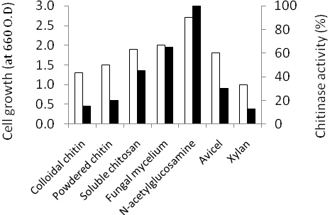
Fig. 2. Effect of carbon source on cell growth (□) and production of chitinase (■) by B.alvei NRC-14.

Effect of pH
The effect of pH greatly differed according to the chitinous substrate used. Using shrimp shells, flaked chitin, or colloidal chitin as carbon and nitrogen sources (at 28ºC) maximum chitinase production reached 1.5, 1.0, and 1.2 U/ml at pH 6.0, 7.0 and 9.5, respectively (Fig. 3). Strain NRC-14 showed higher enzyme production with shrimp chitin rather than flaked or colloidal chitin. Results of Fig. 3 revealed also that, chitinase activity increased by increasing the pH value when colloidal chitin was used as a carbon source.

Effect of temperature
Among different degrees of temperatures used, maximum chitinase production (using flaked chitin and pH 7.0) was observed at 28ºC (data not shown). However, during the growth of strain NRC-14 the temperature was shifted to a value of 40ºC after 24 hrs of growth and then the crude supernatant was assayed for enzymes activity after 48 hrs. Interestingly, the crude supernatant was found to be completely free of enzymes (chitinase, chitosanase, B-glucanases, or protease), but it showed potential antimicrobial activity against some fungal pathogens (Fig. 4).
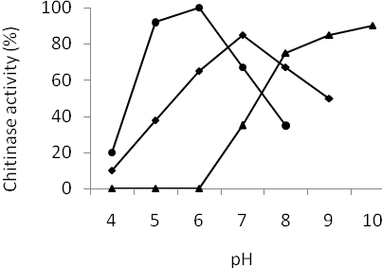
Fig. 3. Effect of pH on production of chitinase by strain NRC-14 using chitinous substrates: (●) shrimp shells, (♦) flaked chitin, or (▲) colloidal chitin.
Chitin-binding activity of chitinase
When colloidal chitin was used as both carbon and nitrogen source for chitinase production, obviously, low levels of chitinase were detected in the culture broth. This feature leads us to study the chitin-binding activity of the enzyme to the insoluble substrates. Results revealed that the enzyme strongly adhered to colloidal chitin as a substrate. To assess whether the binding of the enzyme is specific to colloidal chitin, the capacity of chitinase to bind other insoluble polysaccharides such as soluble chitosan, Avicel, starch, or xylan was evaluated. As shown in Fig. 5, the enzyme strongly bound to powdered chitin, colloidal chitin, Avicel and xylan. However, relatively low extent of binding by the enzyme to the soluble chitosan and starch was observed (Fig. 5). Furthermore, a time course experiment showed that the binding of chitinase to colloidal chitin was completed within 10 min of incubation, and did not change upon extending incubation up to 2 hrs (data not shown). These results indicate that the enzyme bound rapidly to the substrate, and suggest a broad affinity for insoluble polysaccharides.

Dissociation of the chitin-binding enzyme
To release chitinase bound to the substrate, the chitin was treated with Glycine-NaOH buffer (pH values from 8.6-10.6), high-salt buffer containing 1 M NaCl, water, or different concentrations of NaOH (5-40 mM). Of these, complete dissociation of the enzyme was observed in 0.5 M NaCl at pH 9.6 (Fig. 6). Paul et al. (2005) reported that, complete dissociation of chitin-binding chitinase produced by the yeast Kluyveromyces lactis was observed in 20 mM NaOH at pH 12.3, whereas the chitin dissociation of chitinase from Alteromonas sp. O-7 was achieved effectively with 6 M guadinine hydrochloride (Tsujibo et al., 1998).
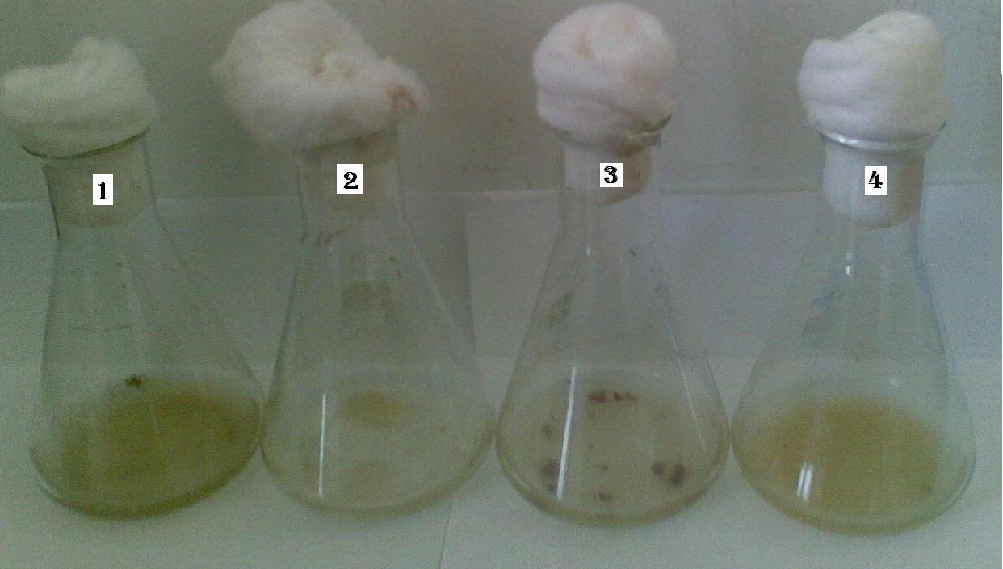
Fig. 4. Inhibitory effect of the antimicrobial substance produced by B. alvei NRC-14 against growth of some fungal pathogens: (1), Aspergillus flavus; (2), Scloratium rolfsii; (3), Fusarium oxysporum; and (4), Mucor sp. Culture media, inoculated with the tested fungi, were supplemented with the crude supernatant (20:1 ml, v/v) and incubated at 28ºC for 72 hrs growth.

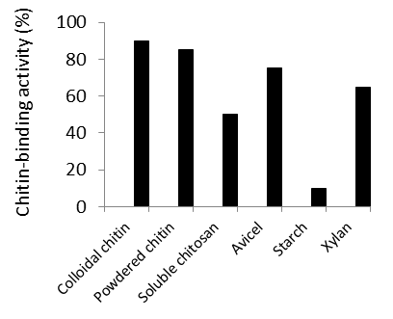
Fig. 5 . Binding specificity of the chitinase produced by strain NRC-14 to different insoluble polysaccharides.
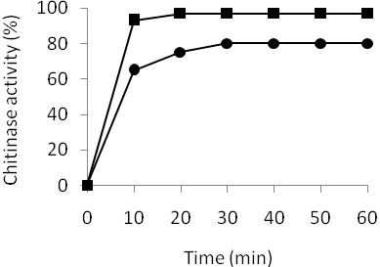
Fig. 6. Dissociation of the bound chitinase from chitin. The bound chitinase was released by controlling the pH value using Glycine-NaOH buffer, pH 9.6 (●) or Glycine-NaOH buffer pH 9.6. with 0.5 M NaCl (■).

Purification of chitinase
Low levels of chitinase was detected in the culture supernatant after 48 hrs of cultivation, probably due to the adhesion of the enzyme to colloidal chitin after secretion by the strain. However, chitin was completely degraded after 5 days, mainly by chitosanases and chitobiase. Therefore, it was found that the suitable time for isolation and purification of the enzyme was 48 hrs of cultivation. After dissociation of the bound enzyme as indicated above, the supernatant was dialyzed several times against Glycine-NaOH buffer (pH 9.6) at 45ºC to renature the proteins. The supernatant of the dializate was applied to sephadex G-100 column. The purification procedure yielded three protein peaks (Fig. 7) corresponding to three chitinases: ChiA, ChiB, and ChiC. The purification scheme of ChiA is represented in Table 2, as shown, the enzyme activity was purified about 10-fold with an overall yield of 23%. The final specific activity was approximately 31 U/mg.

Some of enzymatic properties
Some properties of ChiA, ChiB, and ChiC were studied. Activity of the three enzymes on chromogenic substrates were estimated and the results revealed that ChiA displayed high activities toward pNP-N-acetylglucosaminide and pNP-N-acetylgalactosaminide, whereas ChiB and ChiC exhibited higher activity toward pNP-glucopyranoside and low activity toward pNP-N-acetylglucosaminide (data not shown). The hydrolyzing activities of the three enzymes against a variety of substrates were also determined. As shown in Table 3, ChiA exhibited maximum activity towards NAG, soluble chitosan, colloidal chitin, and powdered chitin. On other hand, ChiB and ChiC showed the highest activities toward cellulose and its derivatives; maximum activity of ChiB and ChiC towards CM-cellulose and cellobiose reached 115, 103 % and 105, 120 %, respectively (Table 3).

Potential role of the crudes enzyme in biocontrol
When strain NRC-14 was grown with fungal chitin (dried mycelium of Aspergillus niger), as both carbon and nitrogen sources, the culture supernatant was found to contain, chitosanase, chitinase, B-1,3 glucanase, protease, and detectable amounts of chitobiosidase. The role of these enzymes in biological control against phytophathogenic fungi has already been established. The crude supernatant of strain NRC-14 was examined against some phytopathogens and, surprisingly, was found to possess a potential antifungal activity as indicated by the release of reducing sugars due to fungal mycelium degradation (Fig. 8 and 9).

Table 2. Purification steps of ChiA produced by Bacillus alvei NRC-14
Step | Total activity  U/ml) | Total protein (mg/ml) | Specific activity (U/mg) | Purification fold | Yield  (%)
Culture broth  Amm. sulfate  Precipitation Sephadex G-100 | 750  580  170 | 240  39  5.5 | 3  15  31 | 1  5  10 | 100  77  23

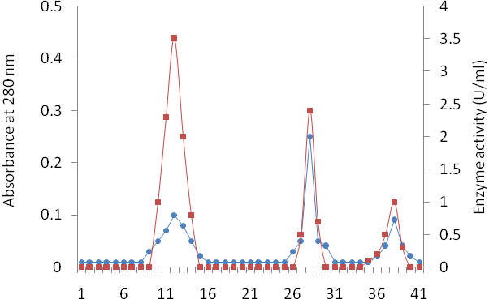
Fig. 7. Sephadex G-100 chromatography of the partially purified enzymes produced by strain NRC-14. Absorbance at 280 nm (●); enzymes activity (■).

Table 3. Substrate specificity of the partially purified ChiA, ChiB, and ChiC to a variety of polysaccharides.
Substrate | Relative activity* (U/ml) ChiA | ChiB | ChiC
Powdered chitin  Colloidal chitin  Soluble chitosan  NAG  Avicel  CM-cellulose  Cellobiose  Starch  Xylan | 70  77  100  178  83  79  62  59  68 | 35  27  42  0  100  115  103  0  ND | 28  27  40  0  100  105  120  0  ND
*Activity of soluble chitosan and Avicel was set as 100%. Glycine-NaOH buffer (pH 9.6) was used for determination of enzyme activity with powdered or colloidal chitin. Acetate buffer (pH 5.6) was used for determination of other enzymes activity. NAG=N-acetylglucosamine. ND = not detected.

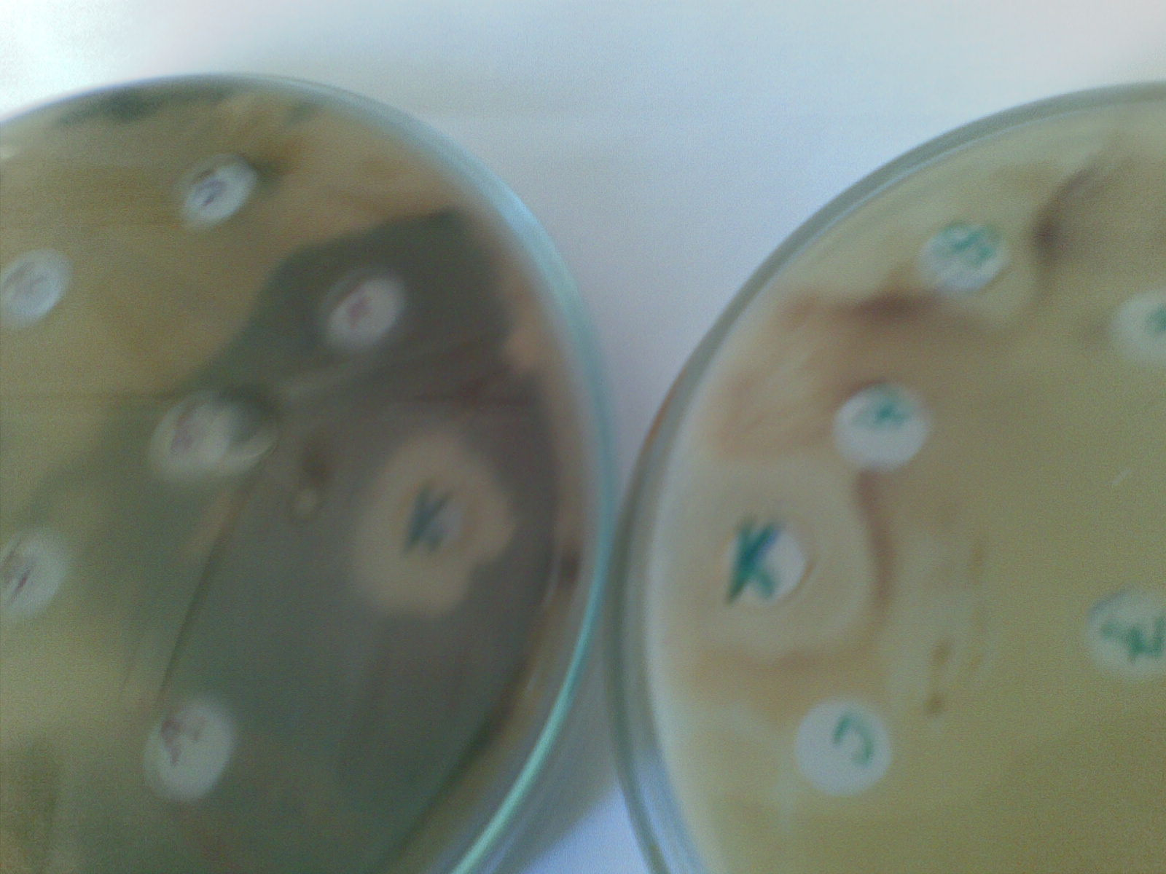
(a) (b)
Fig. 8. Antifungal effect of the crude enzymes (K) produced by B. alvei NRC-14 on lyses of Fusarium oxysporum (a) and Scloratium rolfsii (b) as indicated by the observed zones on potato dextrose agar.

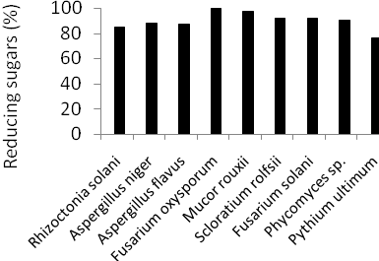
Fig. 9. Influence of the crude enzymes produced by strain B. alvei NRC-14 upon fungal mycelium degradation of the tested fungi shown. Maximum value was set as 100%.

4. Discussion
The genus Bacilli is a special group of Gram-positive bacteria which characterize with a short generation time, can be easily handled, and have metabolic flexibility. These characteristics make them favorite model organisms for examining several metabolic processes. Previous reports have shown that species of bacillus are known to produce chitinolytic enzymes. The present study revealed that only 22 isolates showed chitinolytic activity out of the total 62 chitosanolytic bacillus isolates screened. It means that not all strains of bacillus can be considered as a potential chitinase producers (Aktuganov et al., 2003). B. alvei NRC-14, a potent chitosanase producer, was examined for its chitinolytic activity using different carbon sources. The chitosanolytic and chitinolytic system of strain NRC-14 is wonderful; the strain constitutively produced chitosanase with various carbon sources (Abdel-Aziz et al., 2008), however, the strain frequently exhibited low chitinase activity when colloidal chitin was used as sole carbon source. Our results demonstrated that the most effective inducer for chitinase production is NAG, the principle monomeric constituent of chitin. Induction of chitinase by NAG was reported previously (Monreal and Reese, 1969; Leger et al., 1985; Lopes et al., 2008), however, chitinase from Serratia marcescens was produced at a concentration of 0.2% NAG (Monreal and Reese, 1969), whereas chitinase from Metarhizium anisoplial was highly produced at concentrations less than 0.5% (Leger et al., 1985). In the present study, high levels of chitinase was produced by strain NRC-14 at a concentration of 1.0 % NAG, indicating that no induction-catabolic repression occurred (Pinto et al., 1997). However, at high concentrations, catabolite repression by the monomer is a probability because no chitinase was detected by strain NRC-14 in cultures containing glucose or sucrose as sole carbon source. The hydrolysis of NAG by the purified ChiA may suggest this enzyme to be a type of N-acetylglucosamine deacetylase, which splits the acetyl groups from the polymer to yield glucosamine residues. A large number of polysaccharide deacetylases have been identified in genomes of Gram-positive bacilli bacteria (Emmanuel et al., 2005).
High levels of chitinase activity was detected in the culture broth when shrimp shell was used as carbon source. The reason may be the difference in composition of shrimp chitin. The shell of shrimp is composed mainly of chitin impregnated with protein that has variously modified with lipids and mineral salts such as calcium carbonate, in addition to minor amounts of phosphate, silica, magnesium, and sulfur (Yabuki et al., 1986). The initial pH of culture medium significantly affected chitinase production by strain NRC-14, especially with colloidal chitin as substrate. The enzyme binds very specifically to colloidal chitin at low pH values, and the bound enzyme was found to be liberated at high pH value (9.6) with 0.5 NaCl, resulting in high levels of enzyme activity. On other hand, enzymes production was depressed when the temperature was shifted to 40ºC and the resultant supernatant exhibited potential antifungal activity against some fungal pathogens. It could be suggested that, the heat-shock may trigger the production of an inhibitor substance as a form of self-protection against abiotic stress. Another assumption is that, this degree of temperature may be favorable for production of an antibiotic by this strain. Hecker et al. (1996) have been suggested that the resistance of growing cells of Bacilli to heat stress may, probably, caused by heat-shock proteins which play a major role to form heat resistance spores. Similar results were reported previously ( Shoda 2000, Clery-Barraud et al., 2006) on the special characteristics of the genus Bacillus which include high thermal tolerance, rapid growth in liquid culture, and ready formation of resistant spores under abiotic stress.
Chitinase from strain NRC-14, on other hand, showed strong adhesion to the insoluble polysaccharides, especially for chitin which may suggest the presence of a chitin-binding domain (ChBD) in the structure of the enzyme. Watanabe et al. (1994) found that the ChBD of chitinase from Bacillus circulans WL-12 showed a great affinity only for chitin, whereas, Tsujibo et al. (1998) have reported that, ChBD of the chitinase from a marine bacterium, Alteromonas sp. O-7, bound not only to chitin but also to Avicel. Depending on the individual chitinase, the presence of a ChBD can either enhance (Kuranda and Robbins 1991) or inhibit (Hashimoto et al., 2000) chitinase activity. In our study, binding activity of chitinase from strain NRC-14 to insoluble polysaccharides resulted in pronounced decrease in its hydrolyzing activity. In contrast, intact chitinase from B. circulans WL-12 specifically bound to chitin but not to other insoluble polysaccharides and this binding activity enhance chitin-hydrolyzing activity (Watanabe et al., 1994). Svitil and David (1998) have reported also that, intact chitinase from a marine bacterium, Vibrio harveyi, effectively hydrolyzed colloidal chitin and that loss of the ChBD decreased the effectiveness of the enzyme. The ChBD of a chitinase binds specifically to the insoluble chitin via a hydrophobic interaction, and the bound enzyme can be liberated by controlling the pH value (Watanabe et al., 2000; Supansa et al., 2008), presence of guanidine hydrochloride (Tsujibo et al., 1998), or using NaOH (Paul et al., 2005). These remarkable features of ChBD have made it appealing for versatile applications . Apart from this, the binding matrix, chitin, is the most abundant naturally existing polysaccharide from the cell wall structure of fungi and the exoskeletons of invertebrates. From the perspectives of economics and technology, a useful method of cell immobilization could be explored by exploitation of chitin-binding domain exposed cells (Wang and Chao 2006).
The purification procedure yielded three enzymes, i.e. ChiA, ChiB, and ChiC. The binding properties of ChiA to the insoluble polysaccharides showed great affinity to chitin. Furthermore, ChiA differed in several enzymatic properties such as the optimum temperature (50ºC), optimum pH (9.6), and the substrate specifity. ChiA rapidly hydrolyzed NAG and exhibited a great tendency for hydrolyzing soluble and colloidal chitosan. ChiB and ChiC share some properties, i.e. both enzymes hydrolyzed Avicel, CM-cellulose, and cellobiose. These results most probably reflect the preference of ChiA for hydrolyzing chitin derivatives, whereas ChiB and ChiC were most active on cellulose and its derivatives. However, the hydrolysis of p-nitrophenol N-acetylglucosaminide by ChiA could suggest an involvement of a random, endo-acting hydrolysis of glycosidic bonds, followed by an exo-acting type of enzyme, chitobiosidase (N-acetylglucosaminidase). In nature, such consecutive mechanisms would favor a rapid and complete degradation of chitin microfibrils producing monomers for nutrition and induction of further enzymes synthesis (Orikoshi et al., 2005).
When fungal mycelium was used as sole carbon source, interestingly, chitinase, chitosanase, B-1,3 glucanase, and protease enzymes were detected in the culture broth of strain NRC-14. This feature may confirm the potential impact of the strain as a biocontrol agent. The antifungal activity of the crude supernatant increased about 3-fold over the purified CHiA. The use of crude preparations in biocontrol is an advantage because it must be take into account the effect of other hydrolytic enzymes and low molecular-weight antibiotic or antimicrobial substances likely to be present in such crude preparations (Aktoganov et al., 2003). Most previous investigations on the antifungal activity of chitinase, chitosanase, or B-1,3 glucanase were against phytopathogenic fungi. Our study, however, revealed a potential role of these enzymes against some other pathogens such as Phycomyces, A. niger, A. flavus and Mucor, which are opportunistic invaders of human and animal (Fenton and Evelegh, 1981, Ribes et al., 2000). Cell wall of these fungi contains mainly chitosan, chitosan-glucan complex, chitin, and laminarine. B. alvei NRC-14 was originally isolated from soil and, thus, this bacterium could be an ideal candidate for biological control against plant pathogens. Co-occurrence of enzymes such as chitinase, chitosanase, and chitobiase in the crude preparation of strain NRC-14 may confirm the important role of the strain in natural soil and elucidate its potentiality upon fungal mycelium degradation. Moreover, enzymes such as ChiB and ChiC in the chitinolytic system of strain NRC-14 may contribute to the lyses of Pythium ultimum cell wall (Fig. 9), which mainly contained cellulose. Enzymes produced by the strain could also be used for preparation of wound-healing accelerate products against human opportunistic fungi. Interest in the production of wound-healing products has increased considerably in the pharmaceutical industry. This due to (i) a progressive increase in number of patients with traumas; (ii) the possibility of producing medicinal preparations with predictable medical and biological properties; and (iii) the possibility of using natural biologically active compounds that cause no side effects instead of chemically synthesized products (Feofilova et al., 1999). Further studies are in progress to reveal the potential role of extracellular metabolites produced by the strain in biological control against some phytopathogenic fungi.
Conclusion: Chitinolytic and chitosanolytic system of strain Bacillus alvei NRC-14 greatly differed. Briefly, we could conclude that: (i) the strain, constitutively, produces chitosanase in presence or absence of the substrate chitosan; (ii) production of chitinase was greatly affected by the carbon source used. When colloidal chitin was used as a carbon source, the enzyme was found to bind strongly to the insoluble substrate after secretion by the strain, resulting in a reduction in chitinase activity. Dissociation of the bound enzyme could be achieved by controlling the pH value. Over-production of chitinase by the strain was obtained when N-acetylglucosamine was used as a carbon source. When dried fungal mycelium was used as carbon source, a variety of crude enzymes were produced and showed potentiality in biocontrol against some fungal pathogens, indicating the impact of this strain as an ideal candidate in biological control; and (iii) exposure of the strain to a heat-shock trigger the production of an inhibitor substance and/or an antibiotic which exhibited potent antifungal activity.

Corresponding author
Shadia M. Abdel-Aziz
Microbial Chemistry Dept.,
National Research Center, Dokki, Cairo, Egypt.
abdelaziz.sm@gmail.com

References
Abdel-Aziz, Sh., Gad-Allah, M. and Mouafi, F. (2004). Recovery of chitin from crustacean wastes by proteolytic enzymes. New Egyptian J. Microbiol., 9:137-151.
Abdel-Aziz, Sh., Moustafa, Y. and Mouafi, F. (2008). Partial purification and some properties of the chitosanases produced by Bacillus alvei NRC-14. J. Appl. Sci. Res., 4:1285-1290.
Aktuganov, G., Melent’ev, A., Kuz’mina, L., Galimzyanova, N. and Shirokov, A. (2003). The chitinolytic activity of Bacillus Cohn bacteria antagonistic to phytopathogenic fungi. Microbiology, 72:313-317.
Chang, M., Lai, P. and Wu, M. (2004). Biochemical characterization and site-directed mutational analysis of the double chitin-binding domain from chitinase 92 of Aeromonas hydrophila JP101. FEMS Microbiol. Lett., 232: 61-66.
Clery-Baraud, C., Gaubert, A. Masson, P. and Vidal, D. (2004). Combined effects of high hydrostatic pressure and temperature for inactivation of Bacillus anthracis spores. Appl. Env. Microbiol., 70:635-637.
Das, S., Van Dellen, K., Bulik, D., Magnelli, P., et al. (2006). The cyst wall of Entamoeba invadens contains chitosan (deacetylated chitin). Mol. Bochem. Parasitol., 148:86-92.
Emmanuel, P., Ivo, G., Konstantinos, M., Deli, A., Emma, H., Simon, J., Kjell, M. and Vassilis, B. (2005). Peptidoglycan N-acetylglucosamine deacetylases from Bacillus cereus, highly conserved proteins in Bacillus anthracis. J. Biol. Chem., 280:30856-30863.
Fenton, D. and Evelegh, D. (1981). Purification and mode of action of a chitosanase from Penicillium islandicum. J. Gen. Microbiol., 126:151-165.
Feofilova, E., Tereshina, V., Memorskaya, A., Alekseev, A. et al. (1999). A new field of biotechnology: Polyaminosaccharide-based wound-healing preparations. Mikrobiologiya, 68:834-837.
Fradberg, E. and Schnurer, J. (1994). Chitinolytic properties of Bacillus pabuli K1. J. Appl. Bacteriol., 76:361-367.
Frank, H., Jessica, E. and Rolf, D. (2005). Enrichment of chitinolytic microorganisms: isolation and characterization of a chitinase exhibiting antifungal activity against phytopathogenic fungi from a novel Streptomyces strain. Appl. Microbiol. Biotechnol., 66:434-442.
Hashimoto, M., Ikegami, T., Seino, S., Ohuchi, N., et al. (2000). Expression and characterization of a chitin-binding domain of chitinase A1 from Bacillus circulans WL-12. J. Bacteriol., 182:3045-3054.
Hecker, M., Schumann, W. and Volker, U. (1996). Heat shock and general stress response in Bacillus subtilis. Mol. Microbiol., 19:417-428.
Henrissat, B. and Bairoch, A. (1993). New families in the classification of glycosylhydolases based on amino acid sequence similarities. Biochem. J. 293, 781-788.
Juni, E. (1986). Genus Bacillus, p. 1115-1139, In: J. G. Holt, (ed.), Bergey’s Manual of Systematic Bacteriology, Williams and Wilkins, London.
Kamal, K. and Brian, G. (2006). Biological control of plant pathogens. Plant Health Inst. Doi: 10. 1094/PHI. A. 2006. 1117.02.
Kuranda, M. and Robbins, P. (1991). Chitinase is required for cell separation during growth of Saccharomyces cerevisiae. J. Biol. Chem., 266:19758-19767.
Leger, R., Cooper, R. and Charnely, A. (1985). Cuticle-degrading enzymes of entomopathogen fungi: regulation of production of chitinolytic enzymes. J. Gen. Microbiol., 132:1509-1517.

Liang, T., Chen, Y., Yen, Y. and Wang, S. (2007). The antitumor activity of the hydrolysate of chitinous materials hydrolyzed by crude enzyme from Bacillus amyloliquefaiens V656. Process Biochem., 2:527-534.
Lopes, M., Gomes, D., Koblitz, M., Pirovani, C., et al. (2008). Use of response surface methodology to examine chitinase regulation in the basidiomycete, Moniliophthora perniciosa. Mycol. Res., 112:399-406.
Mathur, A., Anita, R., Gunjan, B., Shikha, B., et al. (2011). Isolation of Bacillus producing chitinase from soil: production and purification of chito-oligosaccharides from chitin extracted from fresh water crustaceans and antimicrobial activity of chitinase. Resent Res. Sci. Technol., 3:1-6.
Miller, G. L. (1959). Use of dinitrosalicylic acid reagent for determination of reducing sugar. Anal. Chem., 31:426-428.
Monreal, J. and Reese, E. (1969). The chitinase from Serratia marcescens. Can. J. Microbiol., 15:689-696.
Orikoshi, H., Nakayama, S., Miyamoto, K., Hanato, C., et al. (2005). Roles of four chitinases in the chitin degradation system of marine bacterium Alteromonas sp. Strain O-7. Appl. Env. Microbiol., 71:1811-1815.
Pinto, A., Barrcto, C., Schrank, A. and Ulhato, C. (1997). Purification and characterization of an extracellular chitinase from the entomopathogen Metahizium anisopliae. Can. J. Microbiol., 43:322-327.
Ribes, J., Carolin, N., Doris, B. (2000). Zygomycetes in human disease. Clinical Microbiol., 13:236-296.
Robertus, J. and Monzingo, A. (1999). The structure and action of chitinases, p. 125-135. In p. .Jolles and R. A. A. Muzzarelli (ed.), Chitin and chitinases. Birkhauser Veriag, Basel, Switzerland.
Sabry, S. A. (1992). Microbial degradation of shrimp-shell waste. J. Basic Microbiol., 32: 107-111.
Sakai, K., Narihara, M., Kasama, Y., Wakayama, M. and Moriguchi, M. (1994). Purification and characterization of thermostable beta-N-acetylhexosaminase of Bacillus stearothermophilus CH-14 isolated from chitin-containing compost. Appl. Env. Microbiol., 60:2911-2915.
Shanmugaiah, V., Mathivanan, N., Balasubramanian, N. and Manoharan, P. (2008). Optimization of cultural conditions for production of chitinase by Bacillus laterosporous isolated from rice rhizosphere soil. Afr. J. Biotech., 7:2562-2568.
Shoda, M. (2000). A review: Bacterial control of plant diseases. J. Biosci. Bioeng., 89: 515-521.
Stevens, W. (2005). Chitin and chitosan: production and application. J. Metals Mater. Min., 15:73-81.
Supansa, P., Chomphunuch, S., Wipa, S. (2008). The effects of the surface-exposed residues on the binding and hydrolytic activities of Vibrio carchariae chitinase A. BMC Biochem., 9: 1-11.
Svitil, A., David, L. (1998). A chitin-binding domain in a marine bacterial chitinase and other microbial chitinases: implications for the ecology and evolution of 1,4-B-glycanases. Microbiology, 144:1299-1308.
Tsujibo, H., Orikoshi, H., Shiotani, H., Hayashi, M., et al. (1998). Characterization of chitinase C from a marine Bacterium, Alteromonas sp. Strain O-7, and its corresponding gene and domain structure. Appl. Env. Microbiol., 64:472-478.
Waldeck, J., Daum, G., Bisping, B., Meinhardt, F. (2006). Isolation and molecular characterization of chitinase from Bacillus licheniformis strains capable of deproteinization of shrimp-shell waste to obtain highly viscous chitin. Appl. Env. Microbiol., 72: 7879-7885.
Wang, J. and Chao, Y. (2006). Immobilization of cells with surface-displayed chitin-binding domain. Appl. Env. Microbiol., 72:927-931.
Wang, S., Lin,T., Yen, Y., Liao, H. and Chen, Y. (2006). Bioconversion of shelfish chitin wastes for the production of Bacillus subtilis W-118 chitinase. Carbohyd. Res., 341: 2507-2515.
Wang, SL. and Hwang, JR. (2001). Microbial reclamation of shellfish wastes for production of chitinases. Enz. Microbial Techn., 28: 376-382.
Watanabe, T., Ito, Y., Tadao, Y., Masayuki, H., Sakari, S. and Tanaka, H. (1994). The roles of the C- terminal domain and type III domains of chitinase A1 from Bacillus circulans WL-12 in chitin degradation. J. Bacteriol., 176:4465-4472.
Watanabe, T., Oyanagi, W., Suzuki, K. and Tanaka, H. (1990). Chitinase system of Bacillus circulans WL-12 and importance of chitinase A1 in chitin degradation. J. Bacteriol., 172:4017-4022.

12/10/2011

