The use of Clay Minerals of the Dead Sea as Drugs

Sana Arab¹ and Asia Alshikh²

¹Kingdom Of Saudi Arabia, Ministry of Higher Education, King Abdulaziz University, Deanship of Scientific Research, Girl’s College of Educational, Jeddah.²Kingdom Of Saudi Arabia, Ministry of Higher Education, Jazan University, Deanship of Scientific Research, Girl’s College of Educational, Jazan.
Ziadahmed1020@hotmail.com

Abstract: This work examines the beneficial effects of clay minerals for human health, describing their use in pharmaceutical formulations, spas and aesthetic medicine. which topical applications (dermatological protectors and cosmetics) is described. Among their uses in spas, clay minerals therapeutic activity, in geotherapy, pelotherapy and paramuds is commented upon. Moreover, the applications of the clay minerals in aesthetic medicine (to clean and moisturize the skin and to combat compact lipodystrophies, acne and cellulite) are also described. The concentration of trace elements in muds of Dead Sea were measured by Polargraph instrumental and Atomic absorption Spectra AAS and descriptive statistics of results was done. Physical properties and chemical analysis of Dead Sea mud samples also studied.
[Sana Arab and Asia Alshikh The use of Clay Minerals of the Dead Sea as Drugs. New York Science Journal 2012;5(1):112-115]. (ISSN: 1554-0200). http://www.sciencepub.net/newyork. 15

Keywords: Clay minerals; Pharmaceutical formulations; Spas; Aesthetic medicine.

1. Introduction
The use of minerals for medicinal purposes is almost as old as mankind itself. Minerals have been used for curative ends since Prehistory. Different types of muds in order to cure wounds, soothe irritations, as a method of cleansing the skin, etc. (Carretero,2002). For over 1500 years the general curative powers and therapeutic advantages of the Dead Sea have been well recognized. Historical figures such as King Herod and Queen Cleopatra utilized the Dead Sea for medicinal and cosmetic purposes. The modern era for treating skin diseases at the Dead Sea began in 1959 with psoriasis being the principal dermatologic disease treated but effective results have also been observed with other skin problems (Veniale,1996 and Khlaifat et al.,2010). Mud therapy reduces the activity of nitrogen monoxide (NO) and myeloperoxidase (MPO) and enhances that of glutathione peroxidase. This suggests that, in osteoarthritis, the therapeutic effect of mud therapy is mediated by a different mechanism (Bender et al., 2007). Spa therapy has been applied to patients with various rheumatic conditions since ancient times. Despite the difficulty to conduct randomized controlled trials, the usefulness of mud packs and thermal baths on selected musculoskeletal disorders has been demonstrated in several open studies (Van Tubergen and Van der Linden, 2002). A limitation of thermal treatment is the possibility that hot applications could induce a disease flare, but beneficial effects of baths and mud packs in patients affected with inflammatory rheumatic diseases, especially ankylosing spondylitis, have been reported (Tishler et al., 1995 and Codish et al., 2005).
Clay minerals are used in aesthetic medicine in cosmetic products, as active principles or excipients, and in geotherapy, pelotherapy and paramuds. Geotherapy is mainly used for facial treatments, generally in the cold direct application on the skin (kaolinite or smectites mixed with water). To treat dermatological diseases as blackheads, spots, acne, seborrhoea, etc., it is recommended that the mixture of clays and water be applied hot as face masks due to the fact that this method promotes perspiration and sebaceous secretions which flow more easily in a fluid state, while it also opens the pylosebaceous orifices. Moreover, during the perspiration sodium, cloro, potassium and urea are eliminated, which activate the metabolic change and the excretion of catabolites (Lotti and Ghersetich, 1999). They are also used in aesthetic medicine to treat compact lipodystrophies in their initial state and which need preventive care but are not treatable by more aggressive treatments due to this early state of evolution. Moreover, it is recommended to retard the development process of cellulite, given the fact that they stimulate venous and lymphatic circulation in the application area and that they act as an anti-inflammatory (Díaz,1998).

2. Materials and Methods.
The apparatus used in the study:
The concentration of trace elements were measured by Polargraph instrumental 746 VA trace analyzer with 747 VA stand (Metrohm company). The information storage is done by a computer, from Toshiba company 757 VA computracy joined with the device.


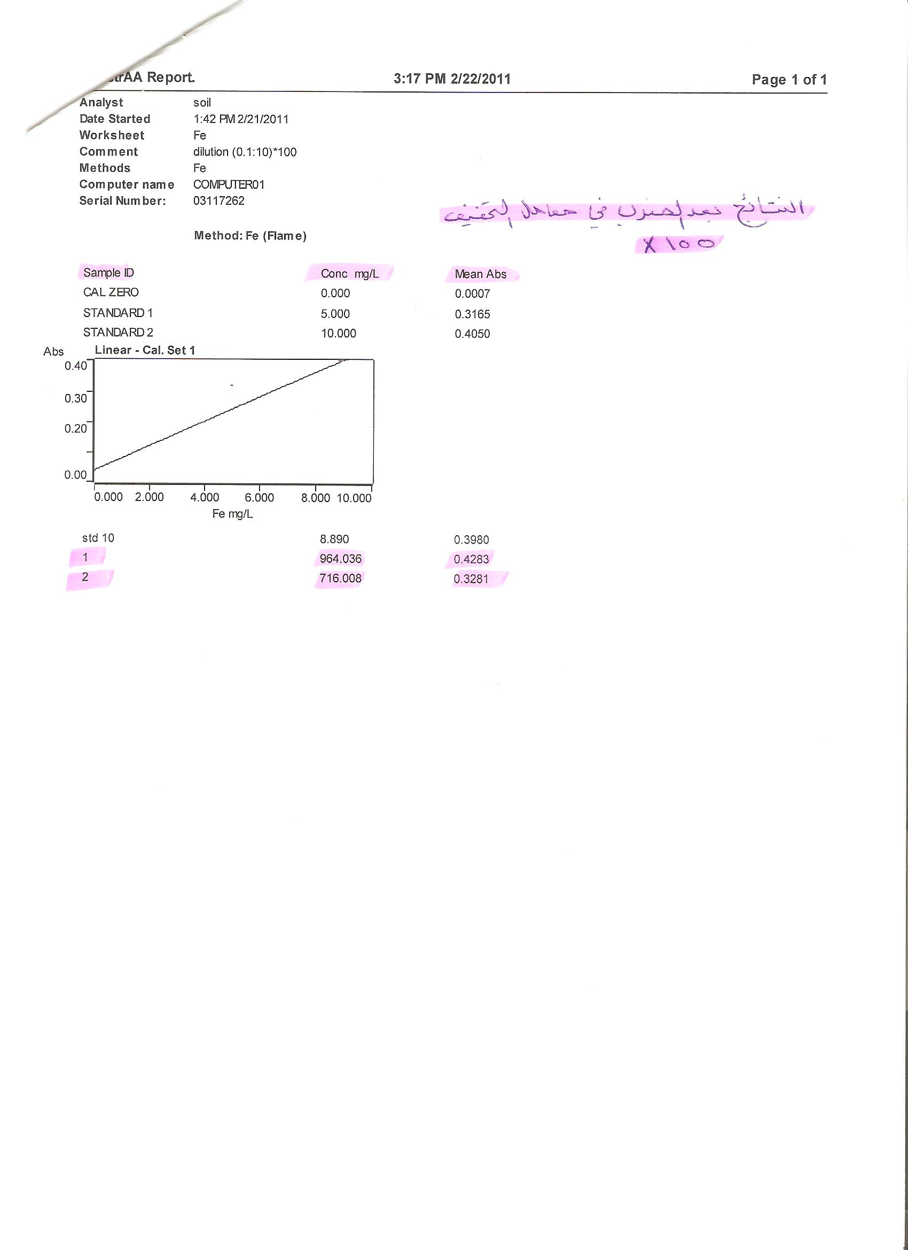



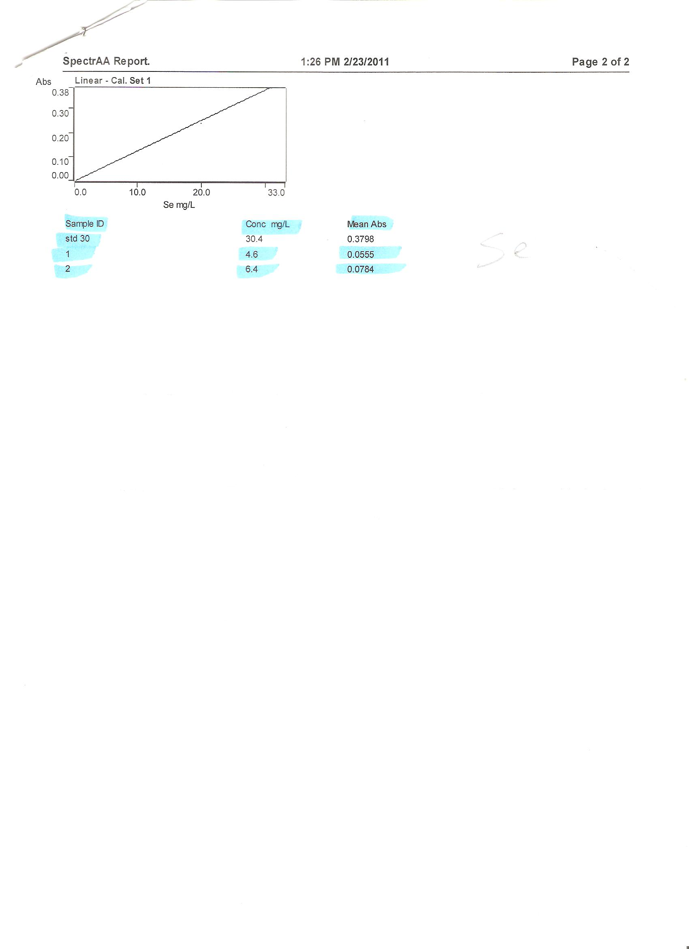

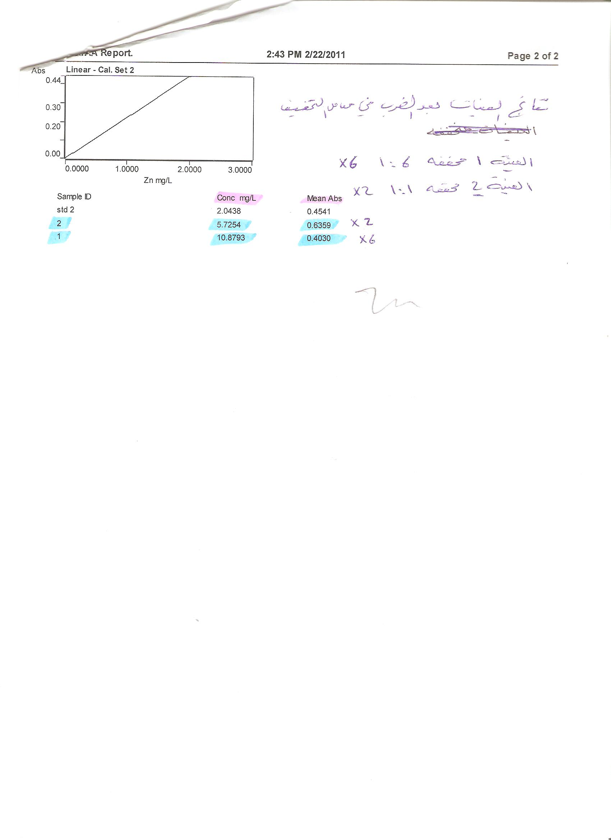



Figure 1. Metalsa influence
The Spectr AA-220 series atomic absorption spectrometers are controlled by varians innovative SpectrAA worksheet software. The software , baswed on a spreadsheet concept which mimics the analysts workbook , combines flame , furnace , zeeman and vapor operation in one integrated package. The spectra software runs under Microsoft windows 98/ME* or windows NT-4 or windows 2000 operating system. Instrument Type was flame, (Air/Acetylene), Wavelength of Fe, Se, Zn, Pb, Cd and Cu elements were 248.3 nm, 196.0 nm, 213.9 nm, 217.0 nm, 228.8 nm, 324.8 nm respectively. The following calibration curve of Cd, Se, Zn, Cu, Fe and Pb elements respectively.
3. Results and Discussion:
The use of clay minerals in aesthetic medicine
Clay minerals are used as active principles in cosmetics, in face masks, due to their high adsorbency level of substances such as greases, toxins, etc. Therefore, they are recommended for inflammatory processes such as boils, acne, ulcers, etc. They are also used in creams, powders, emulsions, etc., as antiperspirants and to give the skin opacity, remove shine and cover blemishes. Clay minerals such as kaolinite, smectites, talc and palygorskite are used, although use of the last two is recommended only in liquid preparations (creams, emulsions, etc.). Geotherapy is the mixture of one or more clay minerals with water and its direct application upon the skin, forming a consistent layer of about 1 cm thick. The applications can take the form of cataplasms or mud baths, depending on the area of the body to be treated. Both are used to treat dermatological diseases (boils, acne, ulcers, abscess, seborrhoea, etc.) and to alleviate the pain caused by chronic rheumatic inflammations and sport traumatism (Benazzo; Mart; Novelli and Torrescani).

Therapeutic advantages
Dead Sea black mud is a homogeneous mixture of Dead Sea minerals and organic materials which may help in decreasing some of skin diseases and rheumatism pains and to rejuvenate skin cells.
The Dead Sea mud is believed to be derived from older sediments or the red-brown soils that are swept into the sea during the winter time. Sediment precipitations in the Dead Sea was investigated for the first time (Neev and Emery, 1967).
Table 1. summarizes the measured range of values for the physical properties (Atterberg limits) of Dead Sea mud samples. Liquid limit (LL) values about 44, plasticity index (PI) about 15 and Plastic limit (PL) values about 29 of the Dead Sea mud samples.

Table 1. Physical properties of Dead Sea mud samples.
Atterberg limits (%)
Liquid limit (LL), % | Plastic limit (PL), % | Plasticity index (PI), %
44 | 29 | 15
Figure 1. Shows chemical analysis of Dead Sea mud samples, the high percentage of total soluble salts (T.S.S), chlorides and sulfates are 10.19 and 4.48 and 0.056, respectively.

Table 2. Shows analytical methods and descriptive statistics .The study approved that the highest concentration of Iron element concentration was (964.036mg/l) then Selenium element concentration (6.4 mg/l), the Zinc element concentration reached to (5.7254 mg/l), then Lead element concentration reached to (3.64 mg/l). after that Copper element concentration where concentration reached to (0.583 mg/l).Finally Cadmium element concentration reached to (0 mg/l).

Table 2. Analytical methods and descriptive statistics.
Analytical method | Element | Unit | x¯ | s
AAS | Pb | mg/L | 3.64 | 0.26
AAS | Cu | mg/L | 0.583 | 0.20
AAS | Cd | mg/L | 0 | 0.23
AAS | Fe | mg/L | 964.036 | 0.21
AAS | Zn | mg/L | 5.7254 | 0.22
AAS | Se | mg/L | 6.4 | 0.25
AAS = Atomic absorption spectrometry.
x¯= average concentration .
s = standard deviation .

Figure 2. Concentrations of elements by Polarographic method, The study approved that:
Fe > Se > Zn > Pb > Cu > Cd.

The general curative powers and therapeutic advantages of the Dead Sea have been well recognized. Spa therapy has been applied to patients with various rheumatic conditions since ancient times. The modern era was used Dead Sea Mud therapy for treating inflammatory rheumatic diseases (low concentration of some trace elements as Fe , Se and Zn in inflammatory rheumatic diseases patients).
This search show mud of Dead Sea rich of some elements like Fe, Se and Zn.
The therapeutic effect of mud therapy is mediated by a different mechanisms may be absorption some trace elements as Iron, Selenium and Zinc. It is beneficial effects of baths and mud packs in patients affected with inflammatory rheumatic diseases, addition no Cd in mud of Dead Sea and it is safe to use.

Conclusions
Clay minerals are used for therapeutic purposes, with a beneficial effect on health, in pharmaceutical formulations, spas and aesthetic medicine. In this researsh The concentration of trace elements in muds of Dead Sea were measured by Polargraph instrumental and Atomic absorption Spectra AAS and descriptive statistics of results was done.By using Atomic absorption Spectra the study approved that the highest concentration of Iron element concentration was (964.036mg/l) then Selenium element concentration (6.4 mg/l), the Zinc element concentration reached to (5.7254mg/l), then Lead element concentration reached to (3.64 mg/l). after that Copper element concentration where concentration reached to (0.583 mg/l). Finally Cadmium element concentration reached to (0 mg/l).
And by using Polargraph instrumental the study shows that the highest concentration of Iron element concentration was (964.088mg/l) then Selenium element concentration (6.3 mg/l), the Zinc element concentration reached to (5.7444mg/l), then Lead element concentration reached to (3.60 mg/l). after that Copper element concentration where concentration reached to (0.581 mg/l). Finally Cadmium element concentration reached to (0 mg/l).
Physical properties(Atterberg limits) of Dead Sea mud samples was studied, Liquid limit (LL) values about 44,plasticity index (PI) about 15 and Plastic limit (PL) values about 29 of the Dead Sea mud samples. Chemical analysis of Dead Sea mud samples also studied, the high percentage of total soluble salts (T.S.S), chlorides and sulfates are 10.19 and 4.48 and 0.056, respectively

Corresponding Author:
Sana T. Arab
Kingdom Of Saudi Arabia, Ministry of Higher Education, King Abdulaziz University, Deanship of Scienctif Research, Girl’s College of Educational, Jeddah.

Asia A. Alshaik
Kingdom Of Saudi Arabia, Ministry of Higher Education, Jizan University, Deanship of Scienctif Research, Girl’s College of Educational, Jizan.
E-mail: Ziadahmed1020@hotmail.com

References

- Carretero IM(2002). Clay minerals and their beneficial effects upon human health. A review. Applied Clay Science ; 21(3-4): 155-163.
- Veniale F(1996)> Argille curative. Antefatti, fattie misfatti. In: F. Veniale, Editor, Atti Convegno “Argille Curative”, Salice Terme/PV. Gruppo Ital. AIPEA;1–11.
- Khlaifat A, Al-Khashman O, Qutob H (2010). Physical and chemical characterization of Dead Sea mud. Materials Characterization. Materials Characterization ; 61(5): 564-568.
- Bender T , Bariska J, Vághy R, Gomez R and Kovács I(2007). Effect of Balneotherapy on the Antioxidant System-A Controlled Pilot Study. Archives of Medical Research; 38(1)86-89.
- Van Tubergen A and Van der Linden S (2002). A brief history of spa therapy, Ann Rheum Dis.; (61) 273–275.
- Tishler M , Brostovski Y and Yaron M (1995). Effect of spa therapy in Tiberias on patients with ankylosing spondylitis, Clin Rheumatol.;(14): 21–25.
- Codish S, Dobrovinsky S, Abu Shakra M, Flusser D and Sukenik S(2005). Spa therapy for ankylosing spondylitis at the Dead Sea. Isr Med Assoc J; (7) 443 – 446.
- Lotti T and Ghersetich I(1999). Peolidi: Trattamento dermato-cosmetologico termale emergente. In: Abstracts Simposio “Argille per fanghi peloidi termali e per trattamenti dermatologici e cosmetici”, Montecatini Terme. Gruppo Ital. AIPEA.
- Díaz ML, Arcillas, peloides y parafangos en medicina estética. Tesis de Máster Universitario de Medicina Estética. Univ. Islas Baleares,1998 ;45.
- Neev D and Emery K (1967). The Dead Sea: depositional processes and environments of evaporates. Geol Survey (Israel) Bull; (41)1.

1/5/2012

