Bioaccumulation and Histopathological Alterations in the Flat Backed Toad, Bufo maculatus Exposed to Sub Lethal Concentrations of Lead.

Lawrence Ikechukwu Ezemonye, Alex Ajeh Enuneku

Department of Animal and Environmental Biology, Faculty of Life Sciences, University of Benin, PMB 1154, Nigeria. lexadena@yahoo.com

Abstract: The toad Bufo maculatus was exposed to 0.25, 0.50, 1.00 and 2.00mg/l lead for 28 days. There was hepatic bioaccumulation of lead at the end of the exposure period. Bioaccumulation of lead increased significantly (p<0.05) with increase in concentration of lead. There was high accumulation of lead in the liver which may cause liver damage. At the end of the study, the liver of control toad showed normal structural pattern. Toad liver exposed to 0.25mg/l lead after 28 days showed normal liver structure. At 0.50 mg/l lead exposure, the histopathological finding was congestion of blood vessel which increased in severity in the 1.00mg/l and 2.00mg/l lead exposures. Haemorrhage was also observed in the liver exposed to the highest concentration of lead (2.00mg/l). The observed changes may be due to the toxic effects of lead on the hepatocytes. The results of this study showed that B. maculatus manifested histopathological changes in the liver when exposed to lead concentrations. The discharge of effluents containing heavy metals like lead into aquatic ecosystems should be discouraged as this may affect the health of amphibians that are exposed in their habitats. This may help in arresting the phenomenon of global declines in amphibian populations.
[Lawrence Ikechukwu Ezemonye, Alex Ajeh Enuneku. Bioaccumulation and Histopathological Alterations in the Flat Backed Toad, Bufo maculatus Exposed to Sub Lethal Concentrations of Lead. New York Science Journal 2012;5(2):15-19]. (ISSN: 1554-0200). http://www.sciencepub.net/newyork. 3

Keywords: Toad; lead; histopathology; liver; Nigeria

1. Introduction
Declines in amphibian populations worldwide have caused concern in the scientific community (Houlahan et al., 2000; Edginton et al., 2004; Ezemonye and Enunueku, 2006) and provided the rationale for this study. Numerous physical and chemical causes have been postulated (Seburn and Seburn, 2000), and in some instances, interaction of multiple causes have been implicated (Wojtaszek et al, 2004). In many cases, heavy metals from industrial and agricultural activities have been implicated (Maheswaran et al, 2008). Lead atomic number 82, atomic mass 207. 4g mol⁻¹ specific gravity 11.34g at 20 is a bluish or silvery-grey soft metal highly malleable, ductile and a relatively poor conductor of electricity. The melting point is 327.5 and the boiling point at atmospheric pressure is 1740. It is rarely found naturally as a metal. Lead is usually found combined with two or more other elements to form lead compounds (Patil et al, 2006). Lead can enter the environment through vehicle and industry exhausts, sewage sludge application in agriculture and the use of lead shot (Volgiatzis, 2001).
Toxicity of lead has been studied extensively in fish, birds and mammals but information related to amphibians is relatively sparse. The most widely studied effects of lead in animals are those on survival, development, reproduction, behaviour, nervous system and haematological system (Chen et al, 2006). In amphibians lead exposure has resulted in a range of effects including decreased erythrocytes and leucocytes, neutrophils and monocytes, sloughing of the skin, excessive bile secretion, hypertrophy of liver, spleen and stomach, decreased muscle tone and loss of normal semi-erect posture, salivation, excitement and muscular twitching; and delayed metamorphosis (Esler, 2000; Sparling et al, 2000).
Bioaccumulation is the building up of a chemical to a toxic level in an organism’s body. It is the net accumulation of a substance by an organism as a result of uptake directly from all environmental sources and from all routes of exposure (ASTM 1998). Primarily, it is the movement of a chemical into the organism from the food or water that is ingested. Bioaccumulative contaminants are rapidly absorbed out of water-borne ambient environments and concentrated in the tissues of living aquatic organisms at concentrations that can range from thousands to millions of times greater than levels in the ambient environment. These absorbed levels are high enough to cause dysfunction in the organisms. Compounds accumulate in living things any time they are taken up and stored faster than they are broken down or excreted (Ogeleka, 2007). Bioaccumulation becomes an environmental problem where chemicals accumulated are toxic, where this will lead to an elevated amount in the organism’s body. Bioaccumulation of chemicals is an important factor in the assessment of environmental hazard. It has been accepted as a trigger factor for decisions of administrative relevance (Heng et al, 2004; Beek, 1991).
The use of histopathological responses as important biomarkers for the possible effects of toxic chemicals on organisms has been reported to be effective (Miller et al, 2007). It is imperative that histological biomarkers are the indicators of pollutants in the overall health of the entire population in the ecosystem (Velkova-Jordanoska and Kostoski, 2005). The exposure of aquatic organisms to sub lethal concentrations of chemical contaminants in their environment may result in various biochemical, physiological and histological alterations in vital tissues. The investigation of histological changes in the organs of amphibians is an accurate way to assess the effects of xenobiotic compounds in experimental studies.

2. Material and Methods
Toads (B. maculatus) were collected from Oghara Community in the Niger Delta ecological zone of Nigeria using handnets in the night. Acclimation to laboratory conditions was done for two weeks prior to experiments (Goulet and Hontella, 2003) in plastic tanks measuring 49cm in length x 29cm in width x 24cm in height with dechlorinated tap water (2 litres at a slant). The toads were fed ad libitum daily with termites. They experienced a natural photoperiod of approximately 10: 14, light/dark period at a laboratory temperature range of 26-27. The initial mean weight of toads was 27.14±0.34g. There was no significant difference (p>0.05) between the mean weights of toads used in the experiments. Since metabolic activity changes with size and affects the parameters to be measured (Canli and Furness, 1993), toads of similar weights and snout-vent-lengths were used. Lead as PbO was used for the sub lethal tests. Stock solutions were prepared by dissolving toxicant in distilled water to a final volume of 1.0 L. Treatment solutions were prepared by serial dilutions. Toads were fed with termites daily during the sub lethal exposure.
At the end of the exposure period, toads were sacrificed for the determination of bioaccumulation and histopathological alterations in the liver. For bioaccumulation, digestion of samples was according to FAO/SIDA (1983). To each sample of liver or kidney (0.1g), 10ml of 10% perchloric acid: conc. HNO₃ (3:2 v/v) was added and heat was applied (60) until a clear solution was formed. The volumes were made up to 50ml using distilled water. The samples were then stored in plastic bottles before analysis with an atomic absorption spectrophotometer to determine the amount of heavy metal bioaccumulated. The heavy metal concentrations were determined with an atomic absorption spectrophotometer (SOLAR 969 UNICAM SERIES) with air acetylene flame according to APHA (1998). The source of radiation is a hollow cathode lamp which contains a cathode constructed of the same material as that being analysed. After analysis using the AAS, the actual concentration of heavy metal in the tissue was determined as;

Actual concentration of heavy metal = PPMR X Dilution factor
Where PPMR = AAS reading
Dilution factor = volume of digest used
Weight of sample digested (Olaifa and Olaifa, 2003)
For the histology, manual tissue processing method was used. The schedule for medium size tissue blocks (Baker et al., 1998) was adopted. After tissue processing, tissues were embedded or blocked out using the Leukhand embedding moulds. The L-pieces were arranged on an aluminium base to form a rectangle. The molten paraffin was then poured into the moulds and the selected surfaces of the tissues embedded with the aid of a pair of blunt end forceps and allowed to set. The embedded tissues were separated into different blocks and then attached to wooden blocks with the aid of an electric spatula. The blocks were then trimmed using a rotary microtome and its knife. At the end of each trimming, the blocks were knicked to show the direction at which trimming was done. The trimmed tissue blocks were arranged on ice trays in order to cut thin sections using the rotary microtome at a thickness of 3µ. Sections were then collected with the help of a camel hair brush and the placed on the slide and then flood picked with 20% alcohol in order to spread out folds on the sections and then floated out on a water bath with a temperature of 5-10 below the melting point of the wax used. The sections were picked and floated on a water bath and then picked with a pre-labelled slide. The slides were dried on a hot plate at a temperature of 5-10 above the melting point of wax used. These were left on the hot plate for 15 minutes.
The staining methods employed in staining the sections were haematoxylin and eosin method to demonstrate general tissue structure and Masson’s trichrome method for the demonstration of connective tissue fibre. Sections were analyzed using the light microscope.
Statistical analysis
Data were analyzed by one-way analysis of variance (ANOVA) followed by Duncan’s Multi sample Range post hoc test using SPSS 15 software (SPSS Inc. Chicago). Statistical significance was considered at p<0.05 level of significance.
Results
Hepatic bioaccumulation of lead was between 0.68±0.04-0.900.03 mg/l (Figure 1).
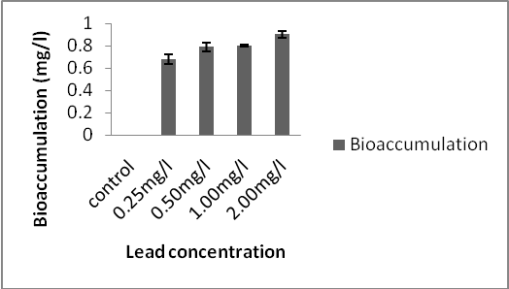
Fig. 1: Bioaccumulation of lead in B. maculatus after 28 days.

Bioaccumulation of lead in the liver of B. maculatus increased as the concentration of heavy metal increased.
Figure 2a shows the liver of control toad after 28 days.
No histological alterations were observed as the toad liver showed normal architecture. Toad liver exposed to 0.25mg/l lead after 28 days still showed normal liver structure. At 0.50 mg/l lead exposure, the histopathological finding was congestion of blood vessel (Figure 2c) with increased severity in the 1.00mg/l and 2.00mg/l lead exposures (Figures 2d and 2e respectively). Haemorrhage was also observed in the liver exposed to the highest concentration of lead (2.00mg/l) after 28 days (Figure 2e).
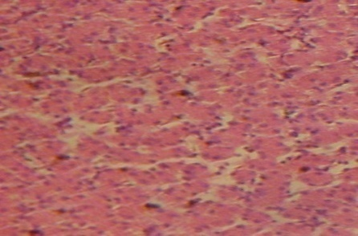

Fig. 2a: Liver of control toad showing The hepatocytes (thin arrowhead) and Sinusoids (thick arrowhead). No visible Lesion observed after 28 days (H & E x160)
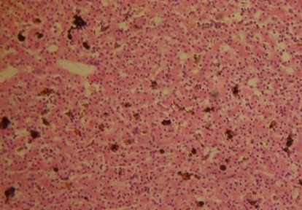

Figure 2b: Liver of toad exposed to 0.25mg/l lead. Normal liver structure observed after 28 days (H & E stain × 160).

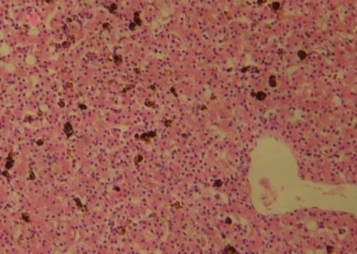
B
Figure 2c: Liver of toad exposed to 0.50mg/l lead. Congestion of blood vessels (B) after 28 days. (H & E stain × 160).

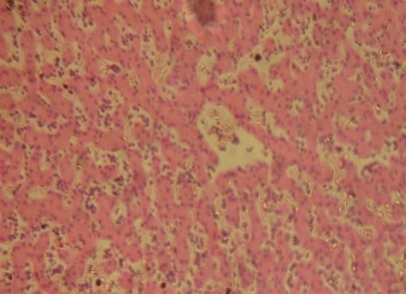
C
Figure 2d: Liver of toad exposed to 1.00mg/l lead. Severe congestion of blood vessels (C) was observed after 28 days. (H & E stain × 160).

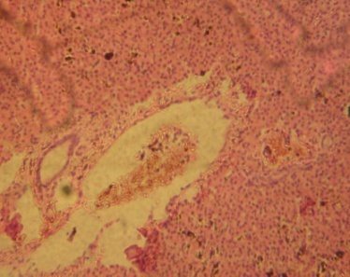
C
A
Figure 2e: Liver of toad exposed to 2.00mg/l lead. Severe congestion of blood vessels (C) and haemorrhage (A) were observed after 28 days. (H & E stain × 160).

Discussion
The toxic effects of lead have been poorly studied in amphibian species. Amphibians are key components of many ecosystems and their disappearance may complicate efforts to manage ecosystems on a sustainable basis.
Findings from this study show that Bufo maculatus bioaccumulated lead in the liver after 28 days exposure. Bioaccumulation of lead increased with increase in the concentration of the heavy metal. The results of this study agreed with those of James et al. (1996) who observed that fish exposed to sub lethal levels of lead produced dose – dependent significant increases in the concentration of lead in the liver and muscle of Oreochromis mossambicus. Vinodini and Narayanan (2008) reported that lead strongly accumulated in the liver and kidneys of the common carp, Cyprinus carpio after 32 days exposure. Mazon et al, (2002) and Ashraf (2005) reported that organs of aquatic animals may accumulate heavy metals when exposed to higher concentrations. Heavy metals accumulated in tissues of aquatic animals catalyze redox reactions that generate reactive oxygen species (ROS) which may lead to oxidative stress and therefore cause biochemical, morphological and histopathological alterations (Varanca et al, 2001; Monteiro et al, 2005).
The results of this study revealed that B. maculatus manifested histopathological changes in the liver and lungs when exposed to lead concentrations. The regulating mechanism of the liver can be impaired by accumulated toxicants which could result in structural damage (Camargo and Martinez, 2006). Congestion of blood vessels was evident in the liver. In a similar study, Ezemonye and Enuneku (2011) reported that excessive bile secretion and dilation of sinusoids were observed in the liver of the crowned bullfrog (Hoplobatrachus occipitalis exposed 0.25, 0.50, 1.00 and 2.00mg/l cadmium for 28 days. Olojo et al, (2005) observed degeneration of hepatocytes and focal necrosis in the liver of C. gariepinus exposed to lead.
The severity of the hepatic alterations observed in this study increased with increase in concentration of lead. These changes may be due to direct toxic effects of lead on hepatocytes since the liver is the site of detoxification of all types of toxins and chemicals (Soufy et al, 2007).

Conclusion
The flat backed toad, Bufo maculatus exposed to sub lethal concentration of lead in this study showed hepatic bioaccumulation of the heavy metal and manifested histopathological maladies. The discharge of effluents containing heavy metals like lead into aquatic ecosystems should be discouraged as this may affect the health of amphibians that are exposed in their habitats. This may help in arresting the phenomenon of global declines in amphibian populations.

Acknowledgements:
Authors are grateful to the Department of Animal and Environmental Biology for providing the laboratory and some of the instruments for the study.

Corresponding Author:
Dr Alex Enuneku, Department of Animal and Environmental Biology, Faculty of Life Sciences, University of Benin, Benin City, PMB 1154, Nigeria. E-mail: lexadena@yahoo.com. Phone: +2348030773314.

References
- Houlahan JE, Findlay CS, Schmidt BR, Kuzmin SL. Quantitative evidence for global amphibian declines. Nature 2000; 404: 752-755.
- Edginton AA, Sheridan PM, Stephensen GR, Thompson DG and Boermans HJ. Comparative effects of pH and vision herbicide on two life stages of four anuran amphibian species. Environ. Toxicol. Chem 2004; 23(4): 815–822
- Ezemonye L, Enuneku A. Stage-dependent acute toxicity of exposure of Bufo maculatus and Ptychadena bibroni tadpoles to cadmium (Cd²⁺). J. Appl. Sci. Technol 2006; 11(1&2): 78-82.
- Seburn D, Seburn C. Conservation priorities for the amphibians and reptiles of Canada. World Wildlife Fund Canada, Toronto ON and the Canadian Amphibian and Reptile Conservation Network, Delta BC. 2000.
- Wojtaszek BE, Staznik B, Chartrand DT, Stephenson GR, Thomson, DG. Effects of vision herbicide on mortality, avoidance, response and growth of amphibian larvae in two forest wetlands. Environ. Toxicol. Chem 2004; 23(4): 832 – 842.
- Maheswaran R, Devapaul A, Muralidharan S, Velmurugan B, Ignacimuthu S. Haematological studies of freshwater fish Clarias batrachus (L) exposed to mercuric chloride. Int. J. Intergr. Biol 2008; 2(1): 49-54.
- Patil AJ, Bhagwat VR, Patil JA, Songre NN, Ambekar JG, Jailkhani R, Das KK. Effect of lead (Pb) exposure on the activity of Superoxide Dismutase and Catalase in Battery Manufacturing Workers (BMW) of Western Maharashtra (India) with Reference to Heme Biosynthesis. Int. J. Environ. Res. Pub Health 2006; 3(4): 329–337.
- Volgiatzis A. Exposure of Rana ridibunda to lead II. Impact of lead on various parameters of liver metabolism of the frog Rana ridibunda. J. Appl. Toxicol 2001; 21: 261-274.
- Chen T, Gross JA, Karasov WH. Sub lethal effects of lead on northern leopard frog (Rana pipiens) tadpoles. Environ. Toxicol. Chem 2006; 25(5): 1383-1389.
- Esler R. Handbook of Chemical Risk Assessment: Health Hazards to Humans, Plants and Animals. Volume 1. Lewis Publishers, CRC Press, Boca Raton FL. 2000.
- Sparling DW, Linder L, Bishop CA. Eds. Ecotoxocology of Amphibians and Reptiles. Society of Environmental Toxicology and Chemistry. SETAC Press, Pensacola, FL. 2000.
- ASTM. American Society for Testing of materials. Standard Practice for Conducting Toxicity Tests With fishes, Macroinvertebrates and Amphibians. ASTM, Philadelphia. 1998: Publication No. E729-80.
- Ogeleka DF. Studies on the toxicity of industrial detergent and corrosion inhibitor on biological organisms. A Ph.D Thesis. University of Benin. 2007.
- Heng LY, Mokhtar MB, Rusin S. The bioaccumulation of Trace Essential Metals by the freshwater Snail Turritella sp. Found in the Rivers of Borneo East Malaysia. J. Biol. Sci 2004; 4(4): 441–444.
- Beek B. Bioaccumulation in aquatic systems. In Bioaccumulation in Aquatic Systems: Contributions to the Assessment, R. Nagel and R. Loskin (Eds), Weinheim, Germany. 1991.
- Miller DH, Jensen KM, Villeneuve DL, Kahl MD, Makyhen EA, Durhan EJ, Ankley G. Linkage of biological response to population level effects. A case study with vitellogenin in the fat heat minnow Pimphales promelas. Env. Toxicol. Chem 2007; 26(3): 521–527.
- Velkova-Jordanoska L, Kostoski G. Histopathological analysis of liver in fish (Barbus meridionalis petenyi heckle) in reservoir Trebenista. Nat. Croat 2005; 14(2): 147-153.
- Goulet NB, Hontella A. Toxicity of Cadmium, Endosulfan and Atrazine in Adrenal Steriodogenic cells of two amphibian species; Xenopus laevis and Rana catesbeiana. Environ. Toxicol. Chem 2003; 22(22): 2106-2113.
- Canli M, Furness RW. Toxicity of heavy metals dissolved in sea water and influences of sex and size on metal accumulation and tissue distribution in the Norway lobster Nephrops norvegicus. Mar. Environ. Res 1993;36:217-236.
- FAO/SIDA. Manual of methods in aquatic environmental research part 9. Analysis of metals and organochlorines in fish. FAO fisheries. 1983. Technical paper 212.
- American Public Health Association (APHA). America Water Works Association, Water Pollution Control Federation. Standard methods for the examination of water and wastewater, 20th edition. American Public Health Association., New York. 1998.
- Olaifa FE, Olaifa OO. Toxic stress of lead on Clarias gariepinus fingerlings. Afr. J. Biomed. Res 2003; 6: 101-104.
- Baker FI, Silverton RE, Pallister CI. Introduction to Medical Laboratory Technology. 7th Ed. Bounty Press Ltd. 1998:448.
- James R, Sampath K, Alagrathinam S. Effects of lead on respiratory enzyme activity, glycogen and blood sugar levels of the teleost Oreochromis mossambicus (Peters) during accumulation and depuration. Asian. Fish. Sci 1996; 9(2): 87–100.
- Vinodhini R, Narayanan M. Bioaccumulation of metals in organs of freshwater fish Cyprinus carpio (common carp). Int. J. Environ. Sci. Technol 2008; 5 (2): 179-182.
- Mazon, A.F, Cerqeira, C.C and Fernandes M.N., 2002. Gill cellular changes induced by copper exposure in the south American tropical freshwater fish Prochilodus scrofa. Environ. Res. 88, 52-63.
- Ashraf W. Accumulation of heavy metals in kidney and heart tissues of Epinephelus microdon fish from the Arabian Gulf. Environ. Monit. Assess 2005; 101: 311.
- Varanka Z, Rojik I, Nemcsok J, Abraham M. Biochemical and morphological changes in Carp (Cyprinus carpio, L) following exposure to copper sulphate and tannic acid. Comp. Biochem. Physiol. C 2001; 128: 467-478.
- Monteiro SM, Mancera JM, Fontainhas-Fernandes A, Sousa M. Copper-induced alterations in biochemical parameters in the gill and plasma of Oreochromis niloticus. Comp. Biochem. Physiol. C 2005; 141: 375-383.
- Camargo, MM, Martinez CB. Biochemical and physiological bio -markers in Prochilodus lineatus submitted to in situ tests in an urban stream in southern Brazil. Environ. Toxicol. Pharmacol 2006; 21: 61-9.
- Ezemonye LI, Enuneku AA. Histopathological alterations in the liver and lungs of Hoplobatrachus occipitalis exposed to sub lethal concentrations of cadmium. Austr. J. Basic Appl. Sci 2011; 5(11): 1062-8.
- Olojo EA, Olurin KB, Mbaka G, Oluwemimo, A. Histopathology of the gill and liver tissues of the African catfish Clarias gariepinus exposed to lead. Afr. J. Biotechnol. 2005; 4: 117-122.
- Soufy H, Soliman M, El-Manakhly E, Gaafa A. Some biochemical and pathological investigations on monosex Tilapia following chronic exposure to carbofuran pesticides. Global Veterinaria 2007; 1: 45-52.

22/01/2012

