Reported Drowning Cases from Various Districts of State Haryana (India)
¹Ajay Kumar, ²Manoj Kumar Malik, ³Anita Kadian, ⁴S. K. Sangwan and ⁵Suresh Kumar
¹Department of Zoology (Wild life and animal behavior laboratory), Kurukshetra University, Kurukshetra-136119, Haryana (India)
^{2, 3,4,5}Forensic Science Laboratory (Biology division), Madhuban, Karnal-132001, Haryana (India)
¹e-mail- ajayindorakuk@yahoo.com
Abstract: In present study (from January, 2011 to December, 2011), 240 drowning cases, have been reported from the various districts of state Haryana (India). Generally, bone sample (clavicle, sternum, ulna, femur etc.) and water sample, where the possible drowning take place sent in Forensic Science Laboratory, Madhuban, Karnal (H) from the various district of Haryana. The “diatom test” is one of the most studied applicable method by which drowning cases can solve. Out of 240 drowning cases, the variation in reported drowning cases (from January, 2011 to December, 2011) may varied from minimum 1 case (in district Fatehabad and Mewat) to maximum 37 cases (in district Sirsa) followed 32 cases in district Hisar, 28 cases in district Rohtak, 19 cases in district Jhajjar, 17 cases in district Bhiwani, 15 cases in district Sonipat, 14 cases in district Jind and Yamuna nagar, 11 cases in district Karnal, 10 cases in district Panipat and Ambala, 8 cases in district Kurukshetra, 6 cases in district Faridabad, 4 cases in district Gurgaon and Karnal, 3 cases in district Panchkula and Rewari, 2 cases in district Mohindergrah and Palwal with an average 11.42±1.16 cases. The percentages of reported of drowning cases from various district varied from minimum 0.41 drowning cases (in district Fatehabad and Mewat) to maximum 15.47 drowning cases (in district Sirsa). The seasonal variation in reported drowning cases also varied from minimum 51 drowning cases (summer season) to maximum 68 drowning cases (monsoon season) with an average 60.00±3.42 drowning cases.
[Ajay Kumar, Manoj Kumar Malik, Anita Kadian, S. K. Sangwan and Suresh Kumar. Reported Drowning Cases from Various Districts of State Haryana (India). New York Science Journal 2012; 5(2):39-44]. (ISSN: 1554-0200). http://www.sciencepub.net/newyork.7
Keywords - Drowning, Diatoms, Bone marrow, Centrifugation, Microscopy, Haryana

1. Introduction:
Drowning can be defined as death due to full or partial submersion in a fluid (Timperman, 1972; Krstic et al., 2002). When a person drowned in water, supply of Oxygen for respiration inhibits. A continued lack of oxygen in the brain (hypoxia), will quickly render a victim towards death. The brain cannot survive long without oxygen and the continued lack of oxygen in the blood combined with the cardiac arrest will lead to the deterioration of brain cells causing first brain damage and eventually brain death from which recovery is generally considered impossible. lack of oxygen in the lungs may cause the heart to stop beating.
Artificial respiration is also much more effective without water in the lungs. At this point the victim stands a good chance of recovery if attended to within minutes. The brain will die after approximately six minutes without oxygen but special conditions may prolong this. Drowning is of two types i.e., deep water drowning (Hypoxia) and shallow water drowning (Hyperventilation).
The fundamental principal of the diatom test, in investigation of drowning is based on the postulation that diatoms are present in the fluid where possible drowning took place and the inhalation of the fluid causes penetration of diatoms into the alveolar system and blood stream, and leading to their deposition into brain, kidneys and other organs (Krstic et al., 2002). If the victim was dead before the body was submerged, the transport of diatom cells to various organs is prevented because lack of circulation and water sample.
Drowning is second cause of death in worldwide after accident death. Due to scanty information available on reported drowning cases in country India and state Haryana, particular. So the present study was planned to summarized the reported drowning cases in Forensic Science Laboratory, Karnal (Haryana) from the various districts.

2. Materials and methods:
Study area:
Haryana (27° 39′ and 30° 55′ N latitude, 74° 27′ and 77° 36′ E longitude) was separated from the Indian state of Punjab on 1st November 1966. It is situated in the Northern part of India and occupies an area of 44,212 km² with Chandigarh as its administrative capital. The state is presently divided into 21 districts, 47 sub-divisions, 67 tehsils, 45 sub-tehsils, 116 blocks, 81 cities and 6759 villages. The climate of Haryana is very hot in summer with temperature touching occasionally 50° Celsius and cold in winters with temperature dropping to 1° Celsius.
The present study was planned in Forensic Science Laboratory, Madhuban, Karnal (29° 40′ 48″ N, 76° 58′ 48″ E), Haryana (fig. 1). Developed nascent state at Rohtak in Haryana (in the year 1973), this laboratory later shifted to Madhuban (Karnal) in 1976. The Forensic Science Laboratory, Karnal (Haryana) has been making consistent strides in the field of scientific activities. Now a day, it is one of the best known laboratories in India. It comprises of eight divisions namely Chemistry, Physics, Biology, Serology, Ballistics, Documents, Instrumentation and Lie-Detection and three sections namely, Photo, General and information. The Scientists of the Laboratory have been assisting the training institutes like National Institute of Criminology and Forensic Science, Delhi, Central Detective Training School, Chandigarh, C.I.D. Training School, Panchkula and P.T.C. Madhuban.

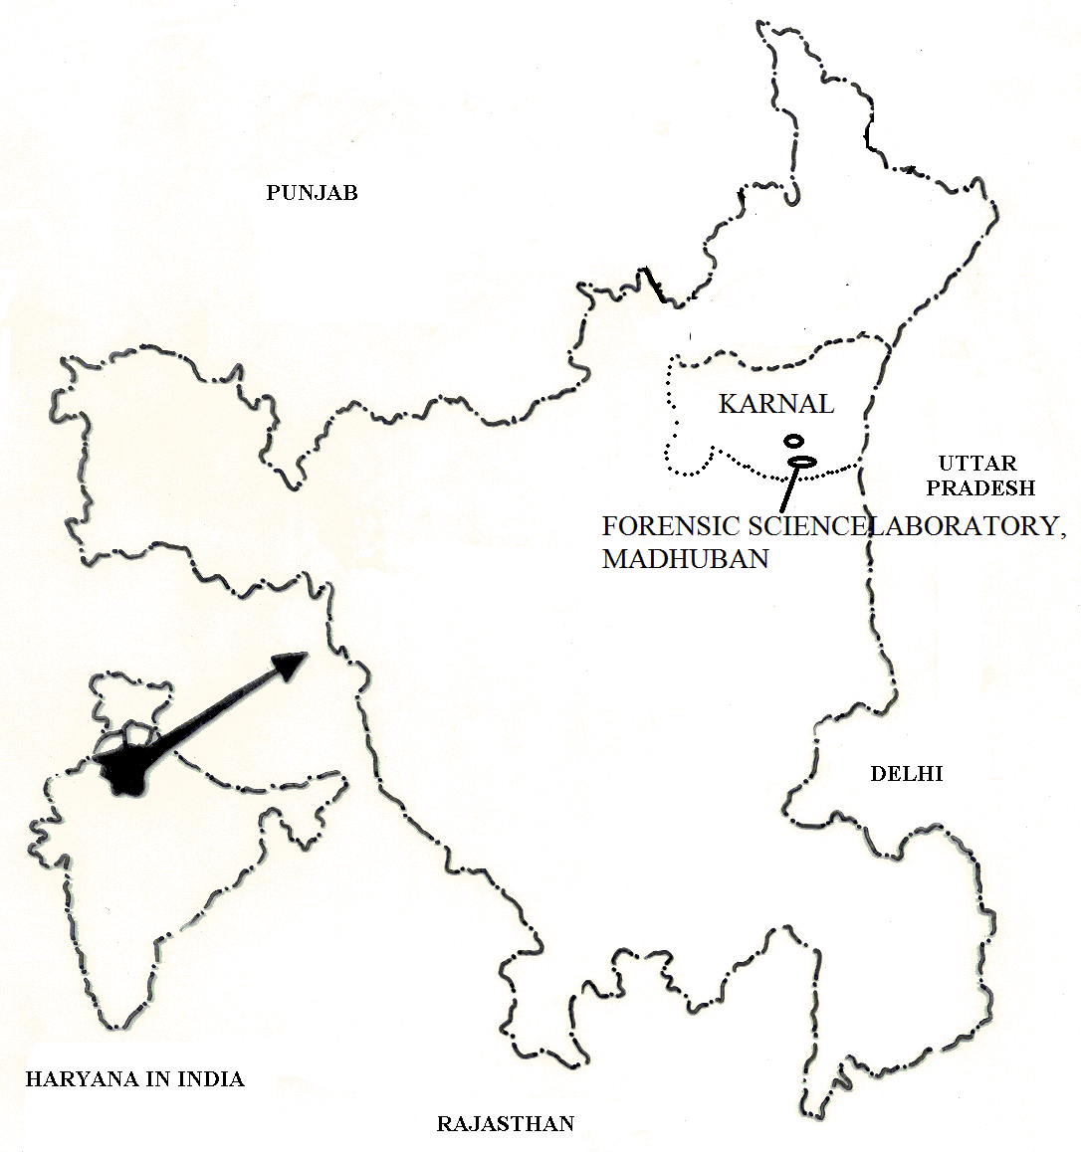
Fig. 1 Forensic Science Laboratory, Madhuban, Karnal (Haryana).

During the drowning death cases, first information report launch in police station of present districts and finally post mortem of dead body has been done by doctors in present districts hospitals. For detection of diatom tests these cases have been brought in biology division of Forensic Science Laboratory, Madhuban, Karnal (H) from various districts of state Haryana. These cases directly observed and data analysed statically.

3. Results and Discussion:
According to the World Health Organization (WHO), drowning is the 3rd leading cause of unintentional injury death worldwide, accounting for 7% of all injury related deaths (estimated 388,000 deaths by drowning in 2004, excluding those due to natural disasters), with 96% of these deaths occurring in low- and middle-income countries (Flegneyer and Pia, 2009). The rate of drowning in populations around the world varies widely according to their access to water, the climate and the national swimming culture (Lindhalm and Lindgren, 2006).
The maximum of drowning cases (16833) have been reported in country Russia while the minimum (3) drowning cases have been reported in country Luxemburg (Galm, 2010). Zeid and Tengku (2010) observed that in year 2008-2009, a total numbers of 284 drowning cases were reported in country of Malaysia (46% drowning cases in sea water, 39% drowning cases in river water and 35 drowning cases in pool water).
In 2000, an estimated 409 272 people drowned, which makes drowning the second leading cause of unintentional injury death globally after road traffic injuries. This total includes only “acciden-tal drowning and submersion”. The problem is even greater. These Global Burden of Disease (GBD) figures are an underestimate of all drowning deaths, since they exclude drowning due to cataclysms (floods), water and other transport accidents, assaults and suicide. Also during 2000, injuries accounted for over 9% of total global mortality. Of these injury-related deaths, 8% were from uninten-tional drowning. Of these unintentional drowning deaths, 97% occurred in low- and middle-income countries.
Roderidues (2006), comprised of 160 drowning cases studied and reported during two year period from March, 2001 to February, 2003 in the Medico Legal Autopsies were conducted at the mortuary of Forensic Medicine Department of Goa Medical College, Bambolim, Goa. The incidence of drowning was predominant in males, with highest deaths in third decade and lowest in extremes of age. Accidental drowning was commonest followed by suicidal, while homicidal cases were rare. Maximum number of deaths due to drowning occurred in rivers in cases of males while it was in wells in cases of females.
During present study (from January, 2011 to December, 2011), approximate 240 drowning cases has been received in Forensic Science Laboratory from various district of state Haryana (India). The variation in drowning cases may varied from minimum 1 case (in district Mewat) to maximum 37 cases (in district Sirsa) followed 32 cases in Hisar, 28 cases in district Rohtak, 19 cases in district Jhajjar, 17 cases in district Bhiwani, 15 cases in district Sonipat, 14 cases in districts Jind and Yamuna nagar, 11 cases in district Karnal, 10 cases in districts Panipat and Ambala, 8 cases in district Kurukshetra, 6 cases in district Faridabad, 4 cases in districts Gurgaon and Karnal, 3 cases in district Panchkula and Rewari, 2 cases in district Mohindergrah and Palwal with an average 11.42±1.16 (fig. 2). The total numbers of drowning cases has been received in Forensic Science Laboratory, Karnal (Haryana) briefly month wise described in table-1.
The minimum drowning cases have been reported from district Mewat because scarcity or deficiency of water sources and small area of present district while the maximum drowning cases have been reported form districts Sirsa, due to large area of present districts. State Haryana has large numbers of canals, when theses canal entered in districts Sirsa, divided in to small numbers of canals. Due to this, drowned body easily found in to small canal, hence maximum numbers of drowning cases have been reported from the districts Sirsa.
The percentages of reported drowning cases from various district varied from minimum 0.41 drowning cases (in district Fatehabad and Mewat) to maximum 15.47 drowning cases (in district Sirsa) (fig. 3). This reason is same reported drowning cases from various districts of state Haryana. The seasonal variation in reported drowning cases varied from minimum 51 drowning cases (summer season, 2011) to maximum 68 drowning cases (monsoon season, 2011) with an average 60.00±3.42 drowning cases (fig. 4). Haryana has variable season in its climate or environment. During rainy season (monsoon season), a heavy rain dropped in present state. Hence, water resources such as pools, canals, ponds, rivers etc. retained maximum water, so the chance o drowning cases increases in particular monsoon or rainy season.
Acknowledgement:
The authors are highly thankful and indebted to Sh. R.S. Dalal (I.P.S.,Director General of Police Haryana) for creating facilities and excellent output in academic field for Research fellows who have been engaged in research work from Universities of India at Forensic Science Laboratory, Madhuban (Haryana). The authors are highly thankful to Dr. Anita Kadian (Assistant Director, Biology Division) of Forensic Science Laboratory, Karnal (H). She gave us permission for published the present problems on the various aspects of drowning cases in Haryana, particular.

Table1 Total numbers of drowning cases has been received in Forensic Science Laboratory, Madhuban, Karnal (Haryana).
Name  of  Dist. | Months in case received (in year 2011)
Name  of  Dist. | Jan. | Feb. | March | April | May | June | July | Aug. | Sept. | Oct. | Nov. | Dec.
AMB | 1 | - | 2 | - | 1 | 1 | 1 | 1 | 1 | - | 2 | -
BWN | 4 | - | 1 | 3 | 1 | 3 | 1 | 3 | 1 | - | - | -
FBD | 1 | - | - | 1 | 1 | 1 | 1 | - | - | - | 1 | -
FTB | - | - | - | - | - | - | - | 1 | - | - | - | -
GGN | 1 | - | - | - | - | - | 2 | 1 | - | - | - | -
HSR | - | 1 | 5 | 2 | - | 5 | 5 | - | 3 | 1 | 6 | 4
JJR | 1 | 1 | 2 | 2 | - | 2 | 2 | 4 | - | 3 | 1 | 1
JND | 1 | - | - | 2 | 4 | 2 | 1 | 2 | 1 | 1 | - | -
KNL | - | 1 | 1 | 5 | - | 1 | - | 1 | - | 1 | - | 1
KTL | - | - | - | - | - | - | 1 | - | - | 2 | 1 | -
KKR | - | - | 1 | 2 | 1 | 1 | - | - | 1 | - | - | 2
MGH | - | - | - | 1 | - | - | - | - | - | - | - | 1
PPT | 1 | - | - | - | - | 1 | 2 | - | - | 1 | 3 | 2
PKL | - | - | - | - | - | - | 2 | - | 1 | - | - | -
RTK | 3 | - | 3 | 1 | 4 | 5 | 1 | 5 | 3 | - | - | 3
RWR | - | - | - | - | - | 1 | 1 | 1 | - | - | - | -
SRS | 4 | 2 | 3 | - | 1 | 5 | 1 | 5 | 3 | 8 | 2 | 3
SPT | - | - | - | - | 1 | - | 3 | 3 | 1 | - | 4 | 3
YNR | - | 1 | 3 | 2 | 2 | - | 1 | 1 | - | 1 | 2 | 1
MWT | - | - | - | 1 | - | - | - | - | - | - | - | -
PWL | - | - | - | - | - | - | - | 2 | - | - | - | -

FTB- Fatehabad,MWT-Mewat,SRS-Sirsa,HSR-Hisar,RTK-Rohtak,JJR-Jhajjar,BWN-Bhiwani, SPT- Sonipat, JND-Jind,YNR-Yamuna nagar,KNL-Karnal,PPT-Panipat,AMB-Ambala, KKR- Kurukshetra, FBD-Faridabad, GGN-Gurgaon, PKL- Panchkula, RWR-Rewari, MGH-Mohindergrah and PWL-Palwal
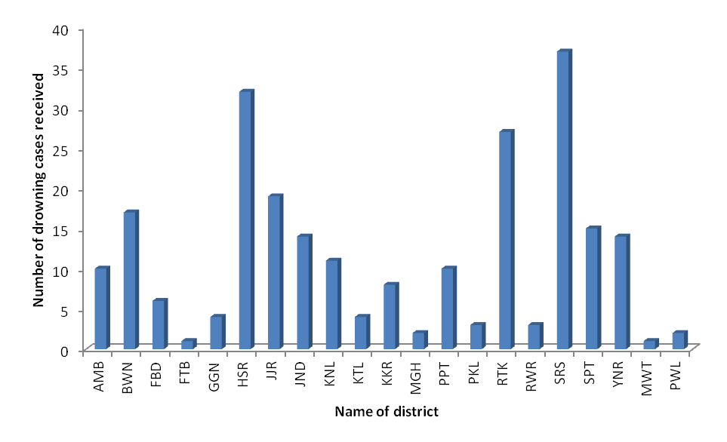
Fig 2. Variation in reported drowning cases Forensic Science Laboratory, Madhuban, Karnal (Haryana).

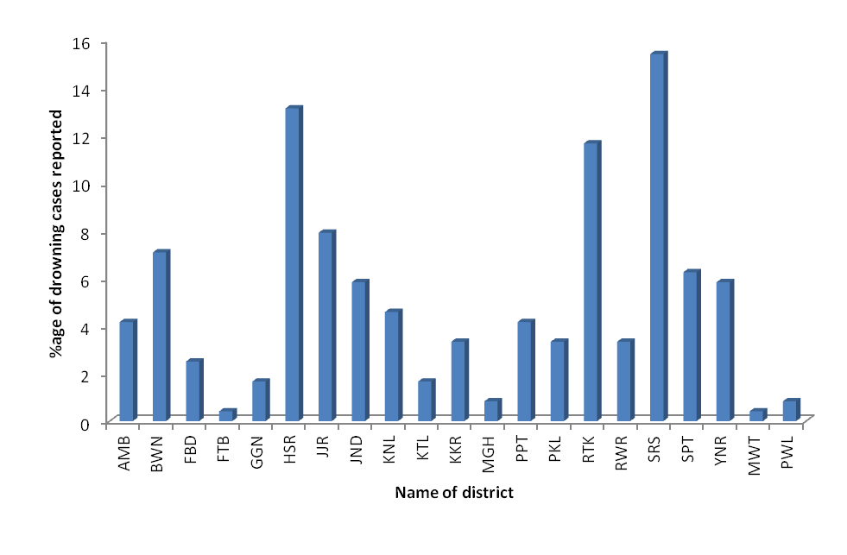
Fig 3. %age of reported drowning cases from various districts of state Haryana.
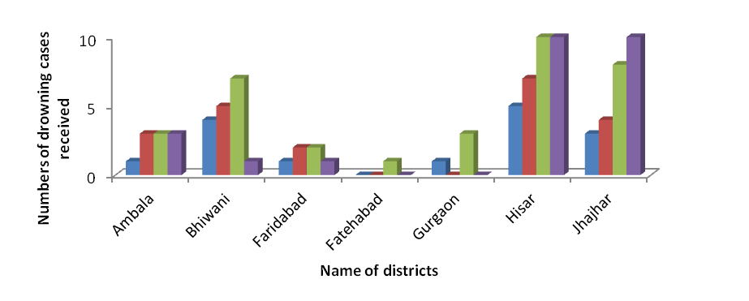
(1)
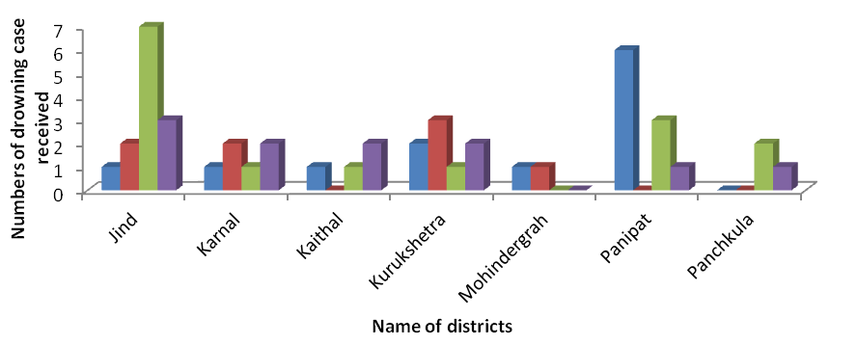
(2)
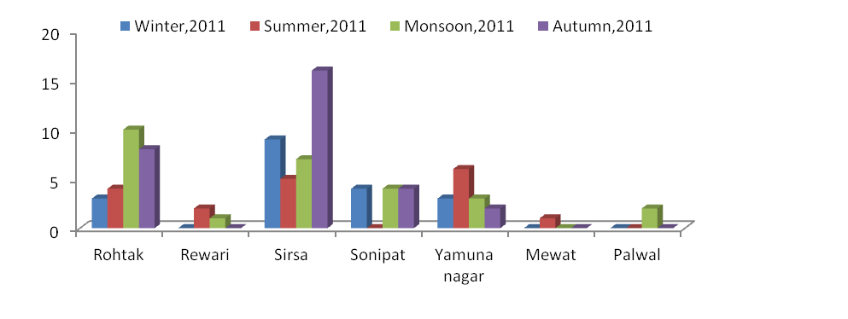
(3)
Fig 4. Seasonal variation in reported drowning cases from various districts of Haryana (India).

Correspondence author:
Ajay Kumar (Research scholar)
Department of Zoology (Wildlife and animal behavior laboratory), Kurukshetra University,
Kurukshetra-136119, Haryana (India)
Mobile no. +91-9813077684
e-mail* - ajayindorakuk@yahoo.com
Refrences:
- Fletemeyer, J and Pia, Y. Owning: new perspectives on intervention and prevention, 1999;1:234.
- Galm. Drowning data at World level, 2010;1-14.
- Global Burden of Disease. Drowning cases statics in World, 2011.
- Krstic SA, Duma B, Janevska Z, Levkov K, Nikolova T and Noveska L. Diatoms in forensic expertise of drowning – a Macedonian experience. Forensic Science International 2002; 12(7):198-203.
- Lindholm P, Lundgren CE. Undersea & Hyperbaric Medicine : Journal of the Undersea and Hyperbaric Medical Society, Inc, 2006;33(6):463–7.
- Roderidues. Medico legal study of drowning cases in Goa medical college hospital, Bambolim, Goa. International Journal of Medical Toxicology & Legal Medicine, 2006;8(2):7-10.
- Timperman, J. The diagnosis of drowning – a review. Forensic Science 1972;1(1):397-409.
- Zaid, CMD and Tengku, F. A survey of hotels in Langkawi island Malasiya, on the need for life gaurds, 2010;1-7.

1/10/2012

