Kinetic and Thermodynamic Study of the Adsorption of Ni (II) using Spent Activated Clay Mineral

N. S. Mahmoud¹, S. T. Atwa², A. K. Sakr¹, M.Abdel Geleel¹

¹National Centre for Nuclear Safety and Radiation Control, Atomic Energy Authority, Nasr City, 11762, Cairo, Egypt
²Chemistry Dept., Faculty of Science, Benha University, Egypt
mnarmine@hotmail.com

Abstract: Storage of spent bleaching clays (SAC) used in refining and processing of vegetable oil is considered a big problem in the purification of vegetable oil company due to self burner. This study will be contributed to solve this problem by recovering residual vegetable oil contained in spent bleaching clay and reuse the bleaching clay as a low cost adsorbent material. This process will reduce the cost of waste treatment and provide alternative sorbent materials. Removing of Ni(II) from aqueous waste solution using this type of clay has been studied. Characterization of SAC, and treated SAC was reported using Fourier Transform Infra Red (FTIR) and Scan Electron Microscopy (SEM). The adsorption of Ni(II) on treated SAC has been studied as a function of pH, adsorbent dosage, contact time, temperature, and initial Ni(II) concentration. The adsorption amount of Ni(II) ions increased with increasing shaking time and temperature. Adsorption equilibrium was achieved in approximately 180 min. The removal was favored at pH 11 and it was about 99.9%. The kinetics and thermodynamics of adsorption process were evaluated and the data followed pseudo kinetic model. The thermodynamic parameters for the present system including Gibbes free energy of adsorption ΔG°, changes in enthalpy of adsorption ΔH°, and changes in entropy of adsorption ΔS° were calculated using van't Hoff equation. Negative value of ΔG° suggests that adsorption is spontaneous. The positive value of ΔH° may suggest endothermic process of adsorption.
[N. S. Mahmoud, S. T. Atwa, A. K. Sakr, M.Abdel Geleel Kinetic and Thermodynamic Study of the Adsorption of Ni (II) using Spent Activated Clay Mineral] New York Science Journal 2012;5(2):62-68]. (ISSN: 1554-0200). http://www.sciencepub.net/newyork. 10

Keywords: Activated clay; Adsorption; Heavy metals; Radioactive wastes disposal.

1. Introduction:
Activated clay (AC) or so-called activated bleaching earth (ABE), layers silicate mineral, mainly consists of montmorillonites (expanding 2:1 layer structure) activated with sulfuric acid. The main constituents of this clay are SiO₂ (65-75%) and Al₂O₃ (15-20%) and it has the capacity to remove colored substances and undesirable residues from edible oil. As such, it was used to bleach the crude oil in the refining process to improve the quality of this oil. This process generates a great amount of spent activated clay (SAC) or spent bleaching earth (SBE). After the bleaching operation, the color of AC would change from white to brownish. Generally, it contains approximately 20-30% of oil [1]. It is noted the SAC not only presents a fire hazard (i.e., spotaneous ignition), but also has unpleasant odor. Consequently, the disposal of SAC may pose a serious problem of management and storage [2]. Edible oil refinery factories produce thousands of tonnes/year of SAC. Generally, the residue was disposed of to landfill without any treatment [1].
On the other hand and because of heavy metals toxicity and non-biodegradable nature, the presence of heavy metals in water is becoming a serious environmental problem that attracted the attention of many scientists at present time. Nickel is one of heavy metals with density 8.91 g.cm^{-3.} It has a major impact on environment and human health [3]. The major use of Nickel is in preparation of alloys used in industry especially in nuclear service for its properties. This leads to generate Ni waste in different forms; radioactive and non-radioactive. Removal of heavy metals from wastewater can be achieved by chemical precipitation, ion exchange, reserve osmosis, adsorption, membrane separation, coagulation, electrodialysis, and evaporation. Adsorption is one of the powerful treatment process for the removal of metal ions from wastewater [4-12]. Commonly, various substances such as activated carbon, natural and synthetic zeolites, resins, and clay minerals (aluminosilicate) have been used as adsorbent.
In this study, different types of organic solvents have been used to de-oil spent activated clay SAC. Treated SAC has been used as a new low cost adsorbent to remove Ni(II) from aqueous solutions. It helps to reduce the cost of waste disposal and provide an alternative sorbent. The adsorption of Ni(II) on treated SAC was studied as a function of solution pH, adsorbent dosage, contact time, temperature, and initial Ni(II) concentration. The kinetics and thermodynamics of adsorption process were evaluated in the light of current known models.

2. Materials and Methods
2.1. Materials
Spent activated clay (SAC) was obtained from Alexandria Company for oils and soap in Alexandria governorate in the northern of Egypt. The commercial virgin activated clay was provided by the edible oil company. This material is montmorillonite activated by sulfuric acid. After the clay was used to remove the color from edible oil, the color of AC would change from white to brownish. It contains 20-30% of oil by weight.

2.2. Treatment of SAC
The experiments were performed by washing SAC with different sorts of organic solvents for the purpose of removing oil content and other residues as follows:
- Prepare a series of polyethylene bottles containing different volumes of Methanol (20 – 30 – 40 – 50 –100 – 150 – 200 – 450 ml)
- Add a weighted amount of 20 g of SAC (W₁) into the organic solvent.
- Shake the mixture by using a magnetic stirrer at 300 rpm for 1 hr at room temperature 25 °C.
- Separate the solution via a 0.45 mm filter paper to collect the Treated-SAC.
- Record the final weight W₂ of Treated SAC.
- The percentage of edible oil extracted was determined as below.
- Amount of oil extracted % = [(W₁- W₂)/(W₁)] x100 %
- Repeat the steps from (1) to (6) by using different organic solvents: Acetone, Benzene, Toluene, Xylene, Carbon tetra chloride.

2.3. Clay mineral characterization
2.3.1. Fourier Transform Infrared Spectrophotometer (FTIR)
Fourier Transform Infrared Spectrophotometer (FTIR) analysis of AC, SAC, and Treated SAC were recorded on FTIR (Nicolet 6700, Thermo Scientific) controlled by OMNIC software by the KBr method; wave numbers in the range of 400-4000 cm⁻¹ with spectral resolution of 8 cm⁻¹.

2.3.2. Scanning Electron Microscope (SEM)
The morphological characteristics of the SAC, Treated SAC, Ni-absorbed Treated SAC were evaluated by using scanning electron microscope (SEM) (Jeol 5600 LV, Joel, Japan). An electron acceleration voltage of 30 kV was applied for SEM observation. All SEM micrographs of samples were taken at 5000 times magnification.

2.4. Adsorption experiments
The Nickel solution was prepared by dissolving a known quantity of AR garde NiCl₂.6H₂O (WinLab, UK) in double distilled water and used as a stock solution (1000 mg/L). Ni(II) in the solution before and after adsorption was measuring using Inductively Coupling Plasma (ICP) (Ultima 2 Jobin Yvon, France).The initial metal ion concentration ranged from 20-100 ppm. All experiments were carried out at room temperature 25° C, pH 3.5, adsorbent dosage of the SAC 1 g, and contact time 10 days except as stated otherwise. Standard base of 0.1 M NaOH and acid of 0.1 M HCl were used for pH adjustment. For the effect of pH on adsorption, the pH of solution was maintained at 3, 4, 8, and 11. For the effect of temperature on adsorption, experiments were conducted under different temperature at 20, 25, 40, and 60 °C. For the effect of contact time, the solution was maintained without separation for contact time for 0.5 hr, 1 hr, 3 hrs, 1 day, 3 days, 1 week, 2 weeks, and 3 weeks. For the effect of adsorbent dosage, the experiments were carried out by adding different amount of the Treated SAC into the solution 0.5, 1, 2, 4, and 6 g. The general experimental procedures were described as follows:
- Prepare a series of 125 mL polyethylene bottles containing 30 ml of Ni(II) concentration (100 mg/L)
- Add a given amount of the Treated SAC (1 g) into the solution.
- The mixture was shaken on a magnetic stirrer at 300 rpm for 15 min at room temperature 25 °C.
- At the end of shaking, record the final pH of the solution.
- The solution was maintained without separation for contact time 10 days.
- Separate the adsorbent through a 0.45 mm filter paper to collect the supernatant.
- Analyze the residual Ni(II) concentration in each of the supernatants using ICP.
- All data were triplicated and the average values were taken in the data analysis.
- The adsorption percentage (D) and adsorption capacity or amount adsorbed per unit mass of Treated SAC (q).

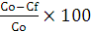
D= %
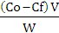
q=

Where D is the adsorption percentage (%), q is the adsorption capacity (mg/g), Co and C_{f} are the initial and final concentration of heavy metal left in solution (mg/L), V is the volume of the aqueous solution (L), and W is the mass of the Treated SAC (g).

3. Results and Discussion
3.1. Properties of SAC
3.1.1. Treatment of SAC
Table 1 outlines the amount of oil removed from SAC by washing it with different organic solvents. The table indicates that the maximum amount of oil removed is 27.08% extracted by using Methanol, while Acetone shows less effectiveness than other solvents. The efficiency of organic solvents used follows the order Methanol < Toluene < Benzene < Xylene < Carbon tetra chloride < Acetone. Consequently, Methanol is much recommended than other organic solvents in the extraction process of oil from the SAC. This is because it gives a higher yield and a better quality of oil than other organic solvents, low cost, less hazardous than other solvents [13]. After the removal of oil, the color of SAC becomes light.

Table 1. Amount of oil extracted
Volume  (ml)/20g | Solvents
Volume  (ml)/20g | Methanol | Acetone | Benzene | Toluene | Xylene | Carbon tetra chloride
20 | 9.17% | 0.79% | 2.33% | 4.78% | 1.14% | 0.02%
30 | 13.64% | 5.22% | 5.79% | 6.72% | 2.42% | 1.02%
40 | 13.92% | 6.98% | 7.73% | 9.25% | 5.99% | 2.93%
50 | 14.39% | 7.21% | 9.68% | 15.15% | 9.01% | 6.18%
100 | 19.21% | 10.81% | 13.03% | 18.19% | 11.52% | 10.59%
150 | 23.17% | 13.58% | 17.90% | 23.69% | 15.37% | 14.73%
200 | 26.23% | 13.92% | 18.12% | 24.41% | 16.01% | 16.37%
450 | 27.08% | 15.53% | 21.98% | 24.99% | 18.46% | 18.37%

3.1.2. Fourier Transform Infrared Spectrophotometer (FTIR)
As seen in Fig. 1, the IR spectrum of SAC mixed with the residue of oily-like materials and other organic materials are completely different from the spectrum of AC as shown on curve b, and the spectrum for Treated SAC is given on curve c. The spectrum shows a strong band at 3410 cm⁻¹ assigned to OH stretching band. Additionally, an intensive band has been seen at 1072 cm⁻¹, which attributed to the Si-O stretching vibration, and two bands of amorphous silica at 790 and 470 cm⁻¹ are observed [14].

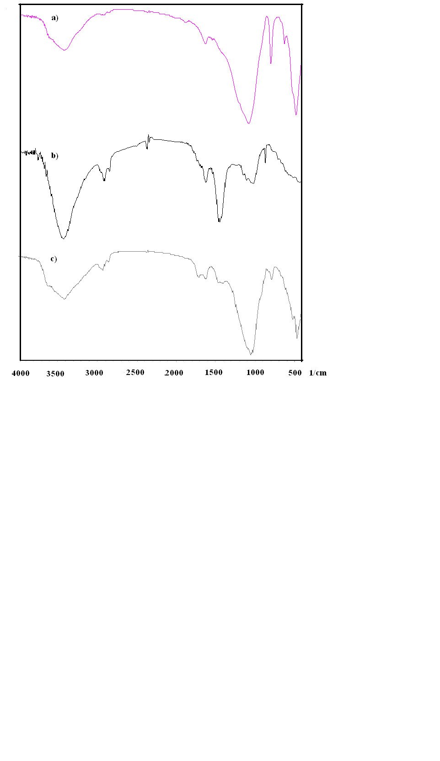
Fig. 1- FTIR spectra of a) AC, b) SAC, and c) Treated SAC

3.1.3. Scanning Electron Microscope (SEM).
The SEM of SAC, Treated SAC, and Treated SAC after adsorption of Ni²⁺ ions were presented in Fig. 2. As shown in Fig. 2a, the surface of SAC particles is covered by oily-like materials and it is almost non-porous [15]. The image Fig. 2b, shows the roughness and irregular layer structure of SAC after treated with methanol, The image Fig.2c. shows the SEM morphology of Treated SAC after adsorption of Ni²⁺ ions. There is a clear indication of adsorbed nickel on Treated SAC as a newly bulky coated layer over the surface via ionic exchange or nonspecific surface adsorption. This phenomenon implied that the structure of the Ni-adsorbed Treated SAC is different from that of SAC.

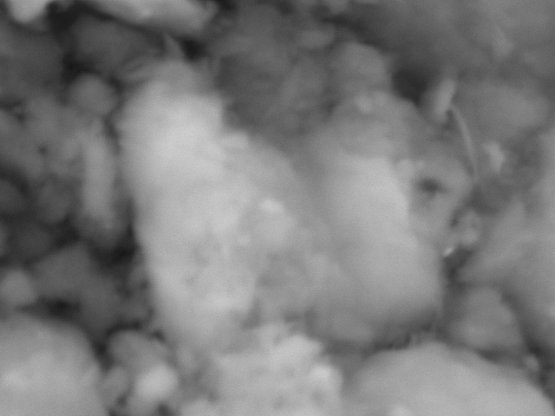
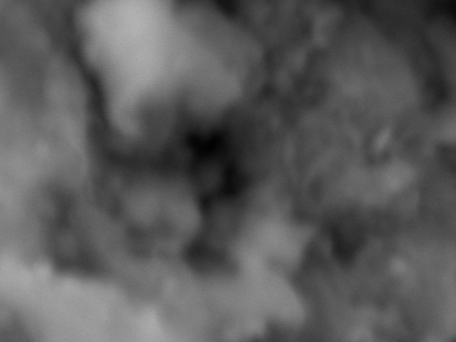
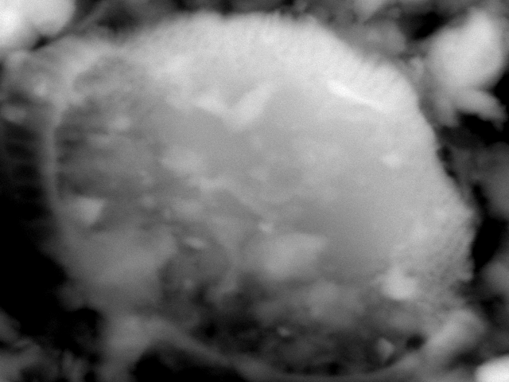

a) b) c)

Fig. 2- SEM images of a) SAC, b) Treated SAC, and c) Ni-adsorbed Treated SAC

3.2. Effect of contact time.
As seen in Fig. 3, the percentage removal of Ni²⁺ ions from aqueous solution increases from 4.75% 18.32% with the increase of contact time from 30 min to 180 min where it reaches equilibrium. With increasing contact time from 30 min to 3 weeks, the percentage removal of Ni²⁺ ions remains the same with no change in value.
Fig. 3- Effect of contact time on the adsorption percentage of Ni²⁺ (V= 30 ml, W= 1 g, Co= 100 mg/L, 25 °C, pH 3.5)

3.3. Effect of pH
The adsorption percentage of Ni²⁺ as a function of pH was presented in Fig. 4. The adsorption percentage of Ni²⁺ on Treated SAC increased with increasing pH from 3 to 11. Hence, heavy metal adsorption on Treated SAC is critically depending on pH. The adsorption of Ni²⁺ increases rapidly in the pH range 3-8. There is no obvious difference in adsorption percentage at pH 8-11. The maximum adsorption percentage of Ni²⁺ on Treated SAC at pH=11 was about 99.9%. The unexpected increase of adsorption of Ni²⁺ may be attributed to its hydroxide precipitation on Treated SAC surface [16].

Fig. 4- Effect of pH on the adsorption percentage of Ni²⁺ (V= 30 ml, W= 1 g, Co= 100 mg/L, 25 °C, t= 10 day)

3.4. Effect of initial metal ion concentration
The effect of initial concentration of Ni²⁺ ions on adsorption percentage was investigated and the results are shown in Fig. 5. The adsorption percentage of removed Ni²⁺ increased from 13.03% to 36.33% with increasing the initial concentration of Ni²⁺ from 20 to 60 mg/L then decreased to 18.32% with increasing the initial concentration to 100 mg/L. This behavior is due to the adsorption sites on the surface of Treated SAC become saturated and reach equilibrium at initial concentration of Ni²⁺ 60 mg/L. The increase in the initial concentration of Ni²⁺ ions remains in the aqueous solution, which raise the final concentration of nickel.

Fig. 5- Effect of initial concentration on the adsorption percentage of Ni²⁺ (V= 30 ml, W= 1 g, pH 3.5, 25° C, t= 10 day)

3.5. Effect of adsorbent dosage

Fig. 6- Effect of adsorbent dosage on the adsorption percentage of Ni²⁺ (V= 30 ml, t= 10 day, Co= 100 mg/L, 25 ° C, pH 3.5)

Fig. 6 depicts the influence of adsorbent dosage on Ni²⁺ sorption. The percentage adsorption of nickel increased from 17.54% to 34.62% with increase of adsorbent dosage from 0.5 to 6 g. This trend is obvious because as adsorbent dose increases the number of adsorbent particles also increase, that makes the greater availability of exchangeable sites for adsorption [17].

3.6. Effect of temperature
The effect of temperature on the adsorption percentage of Ni²⁺ ions was studied within range 20-60 °C and the results are shown in Fig. 7. With increasing the temperature range, the adsorption percentage of Ni²⁺ increases from 16.59% to 27.09%. This result implied that the reaction was closely related to energy and it was an endothermic reaction.
Fig. 7- Effect of temperature on the adsorption percentage of Ni²⁺ (V= 30 ml, t= 10 day, Co= 100 mg/L, W= 1 g, pH 3.5)

3.6. Adsorption kinetics
In order to clarify the adsorption kinetics of Ni²⁺ ions on Treated SAC, Lagergren’s pseudo-first-order and pseudo-second-order kinetics models were applied to the experimental data.
The linearized form of the pseudo-first-order rate equation by Lagergren is given as:
ln(q_{e}-q_{t}) = lnq_{e} ─ k₁t (3)

Where q_{e} and q_{t} (mg/g) are the amounts of metal ions adsorbed at equilibrium (mg/g) and t (min), respectively, and k₁is the rate constants of the equations (min⁻¹). The rate constants k₁can be determined experimentally by plotting of Ln(q_{e}-q_{t}) versus t. The plots of ln(q_{e}-q_{t}) versus t for Lagergren first-order model and the R² value for this model do not fit a pseudo-first-order kinetic model[18]. Experimental data were also applied to the pseudo-second-order kinetic model which is given in the following form:
t/q_{t} = 1/(k₂q_{e}²) + (1/q_{e})t (4)

Where k₂ (min.g/mg) is the rate constant of the second-order equation, q_{t} (mg/g) the amount of adsorption at time t (min), and q_{e} is the amount of adsorption at equilibrium (mg/g).
The model is more likely to predict the kinetic behaviour of adsorption with chemical sorption being the rate controlling step [19]. The linear plots of t/q_{t} versus t for the pseudo-second-order model for the adsorption of Ni²⁺ ions on Treated SAC at 25 ° C are shown in Fig. 8. The rate constants k₂, correlation coefficients of the plots together with the q_{e} value is given in Table 2. It is clear from these results that R² value equals 1. These results suggest the adsorption of Ni²⁺ ions onto Treated SAC follows well the pseudo-second-order kinetics [20].

Fig. 8- Pseudo-second-order adsorption kinetics of Ni²⁺ on Treated SAC.

Table 2. Parameters for adsorption of Ni²⁺ onto Treated SAC derived from pseudo-second-order.
Pseudo-first-order |  | Pseudo-second-order
q_{e} (mg/g) | k₁ (min⁻¹) | q_{e} (mg/g) | k₂ (min.g/mg) | R²
0.50643 | 0.00828 | 0.533918 | 0.021558 | 0.981

3.7. Thermodynamic study
The thermodynamic parameters for the present system including Gibbes free energy of adsorption ΔG°, changes in enthalpy of adsorption ΔH°, and changes in entropy of adsorption ΔS° were calculated using Van't Hoff equation.
ΔG° = ΔH° ─ TΔS° (5)
ΔG° = ─ RT ln k_{d} (6)
lnk_{d} = (ΔS°/R) ─ (ΔH°/RT) (7)

Where R is the ideal gas constant (J/mol.K), and T is temprature (K). The plot of lnk_{d} against 1/T is shown in Fig. 9. ΔH° and ΔS° values can be obtained from the slope and intercept. The values of thermodynamic parameters are given in Table 3. Negative value of ΔG° suggests that adsorption is spontaneous. The positive value of ΔH° may suggest endothermic process of adsorption. The endothermic process has been proved before in the experiments of temperature changes. The positive value of ΔS° shows the feasibility of adsorption and the increased randomness at the sorbent/solution interface during the adsorption of metal ions onto Treated SAC [20-22].
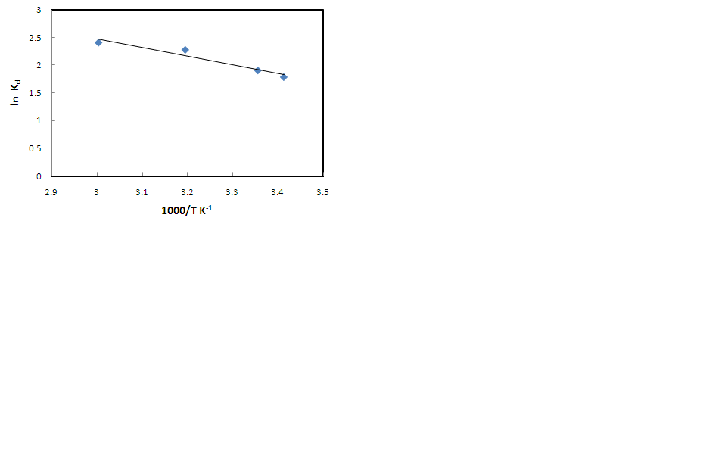
Fig. 9- Van’t Hoff plot for Ni²⁺ adsorption by Treated SAC.

Table 3. Thermodynamic Parameters for the adsorption of Ni²⁺ by Treated SAC.
Temperature (K) | ΔG° (kJ/mol) | ΔS° (J/mol.K) | ΔH° (kJ/mol)
293 | -4.35289 | 21.6176 | 14.550
298 | -4.47896 | 21.6176 | 14.550
313 | -5.93952 | 21.6176 | 14.550
333 | -6.6762 | 21.6176 | 14.550
4. Conclusions
The environmental problems related to SAC disposal could be largely solved by removing the oil and coloring materials adsorbed on SAC. The treatment process has cleared the pores of the SAC and has increased the surface area. Furthermore, Treated SAC can be reactivated and reused as adsorbed material while the recovered oil can be used in soap and poultry feed.
The adsorption amount of Ni(II) ions using this type of clay increased with increasing shaking time and temperature. Adsorption equilibrium was achieved in approximately 180 min. The removal was favored at pH 11 and it was about 99.9%. The kinetics and thermodynamics of adsorption process were evaluated and the data followed pseudo kinetic model. The thermodynamic parameters for the present system including Gibbes free energy of adsorption ΔG°, changes in enthalpy of adsorption ΔH°, and changes in entropy of adsorption ΔS° were calculated using Van't Hoff equation. Negative value of ΔG° suggests that adsorption is spontaneous. The positive value of ΔH° may suggest endothermic process of adsorption.

Corresponding author
N. S. Mahmoud
¹National Centre for Nuclear Safety and Radiation Control, Atomic Energy Authority, Nasr City, 11762, Cairo, Egypt. mnarmine@hotmail.com

References
- Chih-Huang Weng, Cha-Zen Tsai, Sue-Hua Chu, Yogesh C. Sharma, 2007. Adsorption characteristics of copper (II) onto spent activated clay. Sep Purif Technol., 54: 187-197.
- W.T. Tsai, Y.M. Chang, C.W. Lai, C.C. Lo, 2005. Adsorption of ethyl violet dye in aqueous solution by regenerated spent bleaching earth. J. Colloid Interface Sci., 289: 333-338.
- ATSDR, 1997. Toxicological profile for nickel, U.S. Depatrment of health and human services, Public health service, Agency for toxic substances and disease registry, U.S. Government printing office.
- Ibtiseem Ghorbel-Abid, Malika Trabelsi-Ayadi, 2011. Competitive adsorption of heavy metals on local landfill clay. Arabian Journal of Chemistry.
- Ghorbel-Abid, I., Galai, K., Trabelsi-Ayadi, M., 2010. Retention of chromium(III) and cadmium(II) from aqueous solution by illitic clay as a low-cost adsorbent. Desalination, 256:190–195.
- Hoda Omar, Hassan Arida, Abdelhakium Daifullah, 2009. Adsorption of ⁶⁰Co radionuclides from aqueous solution by raw and modified bentonite. Appl Clay Sci., 44: 21-26.
- Guo, Z.J., Xu, J., Shi, K.L., Tang, Y.P., Wu, W.S., Tao Z.Y., 2009. Eu(III) adsorption/desorption on Na-bentonite: experimental and modelling studies. Colloids Surf A: Physicochem Eng Aspects, 339:126-133.
- Oliveira, E. A., Montanher, S. F., Andrade, A. D., Nobrega, J. A., Rollemberg, M. C., 2005. Equilibrum studies for the sorption of chromium and nickel from aqueous solutions using raw rice bran. Process Biochemistry, 40: 3485-3490.
- Jiaojiao Wu, Bing Li, Jiali liao, yue Feng, Dong Zhang, Jun Zhao, Wei Wen, 2009. Behavior and analysis of Cesium adsorption on montmorillonite mineral. J Environ Radioactivity, 100: 914-920.
- J. Anandkumar, B. Mandal, 2009. Removal of Cr(VI) from aqueous solution using Bael fruit shell as an adsorbent. J. Hazard Mater, 168: 633-640.
- C.H. Weng, 2002. Removal of nickel(II) from dilute aqueous solution by sluge ash. J. Environ Eng., 128: 716-722.
- I. Mobasherpour, E. Salahi, M. Pazouki, 2010. Comparative of the removal of Pb²⁺, Cd²⁺, and Ni²⁺ by nano crystallite hydroxyapatite from aqueous solutions: Adsorption isotherm study. Arabian Journal of Chemistry
- A.A. Al-Zahrani, M. A. Daous, 2000. Recycling of spent bleaching clay and oil recovery. Trans I Chem E, Vol 78, Part B:224-228
- J. Madejova, 2002. FTIR tachniques in clay mineral studies. Viberational Spectroscopy, 31: 1-10.
- Chih-Huang Weng, Y.C. Sharma, Sue-Hua Chu, 2008. Adsorption of Cr(VI) from aqueous solutions by spent activated clay. J. Hazard Mater., 155: 65-75.
- Liu Zhi-rong, Zhou Shao-qi, 2010. Adsorption of copper and nickel on Na-bentonite. Process Safety and Environmental Protection, 88: 62-66.
- Christianah Olakitan Ijagbemi, Dong-Su Kim, 2009. Sorbent Characteristics of Montmorillonite for Ni²⁺ Removal from Aqueous Solution. Environ Eng Res., Vol. 14, No. 1: 26-31.
- Reza Fouladi Fard, Gholamreza Nabi Bidhendi and Ali Akbar Azimi, 2011. Biosorption of Nickel from Batch Reactor using the Powder of Waste Activated Sludge. Research Journal of Environmental Sciences, 5: 461-470.
- Ho YS, McKay G, 1999. Pseudo-second-order model for sorption processes. Process Biochem., 34: 451-165.
- Nevenka Rajic, Djordje Stojakovic, Mina Jovanovic, Natasa Zabukovec Logar, Matjaz Mazaj, Venceslav Kaucic, 2010, Removal of nickel(II) ions from aqueous solutions using the natural clinoptilolite and preparation of nano-NiO on the exhausted clinoptilolite. J. Appl Suface Sci., Vol 257, Issue 5: 1524-1532.
- R. Donat, A. Akdogan, E. Erdem, H. Cetisli, 2005.Thermodynamics of Pb²⁺ and Ni²⁺ adsorption onto natural bentonite from aqueous solutions. J. Colloid Interface Sci., 286: 43-52.
- Hui Zhang, Lei Chen, Dechao Zhang, Songsheng Lu, Xianjin Yu, 2010. Impact of environmental conditions on the adsorption behavior of radionuclide ⁶³Ni(II) on γ-Al₂O₃. Colloids Surf A: Physicochem Eng Aspects, Vol 380, Issu 1-3: 16-24.

1/2/2012

