Production of Hygromycin-B antibiotic from Streptomyces crystallinus, AZ-A151: III. Fermentation, Extraction, Physicochemical Analysis and Biological Activities

*Houssam M. Atta ¹; Elshanawany, A. A. ²; Abdoul-raouf, U.M. ²; Afifi, M. M. ² and El-Adly, A.M. ²

^{1.} Botany and Microbiology Department, Faculty of Science (Boys), Al-Azhar University, Cairo, Egypt. The present address: Biotechnology Department. Faculty of Science and Education - Al-Khurmah, Taif University; KSA.
^{2.} Department of Botany and Microbiology, Faculty of Science, Al-Azhar University, Assuit 71524, Egypt.
houssamatta@yahoo.com and houssamatta@hotmail.com; Tel: 00966506917966

Abstract: This work was carried out for the biosynthesis of antimicrobial substance that demonstrated inhibitory effects against microbial pathogenic from Streptomyces crystallinus, AZ-A151. The active metabolite was extracted using ethyl acetate (1:1, v/v) at pH 8.0. The separation of the active ingredient of the antimicrobial agent and its purification was performed using both thin layer chromatography (TLC) and column chromatography (CC) techniques. The physico-chemical characteristics of the purified antibiotic viz. color, melting point, solubility, elemental analysis, spectroscopic characteristics and chemical reactions have been investigated. This analysis indicates a suggested imperical formula of C₁₅H₃₀N₂O₁₀. The minimum inhibition concentrations "MICs" of the purified antimicrobial agent were also determined. The purified antimicrobial agent was suggestive of being belonging to Hygromycin-B, antibiotic produced by Streptomyces crystallinus, AZ-A151.
[Houssam M. Atta; Elshanawany, A. A.; Abdoul-raouf, U.M.; Afifi, M. M. and El-Adly, A.M. Production of Hygromycin-B antibiotic from Streptomyces crystallinus, AZ-A151: III. Fermentation, Extraction, Physicochemical Analysis and Biological Activities. New York Science Journal 2012;5(3):62-69]. (ISSN: 1554-0200). http://www.sciencepub.net/newyork. 7

Keywords: Hygromycin-B; Streptomyces crystallinus; Fermentation; physicochemical analysis; Biological Activities

1. Introduction
Hygromycin B is an antibiotic produced by the bacterium Streptomyces hygroscopicus, a bacterium isolated in 1953 from a soil sample [McGuire, 1953]. The bacterial genus Streptomyces is a high G + C content, Gram-positive filamentous soil bacteria with a complex life cycle that includes morphological differentiation and spore formation [Del-Sol et al., 2007]. Also, it has long been appreciated as a rich source for the production of various secondary metabolites including many pharmaceutically valuable compounds such as antibiotics, anti-cancer agents, immunosuppressant's and enzyme inhibitors [Myles, 2003 and Hindra and Elliot, 2010]. PCR-based methods have provided a rapid and accurate way to identify bacteria [Kohler et al., 1991; Beyazova and Lechevalier, 1993; Telenti et al., 1993; Mehling et al., 1995; Wilson et al., 1998 and Laurent et al., 1999]. In particular, amplified rDNA restriction analysis (ARDRA) has proved to be very useful [Harvey et al., 2001 and Alves et al., 2002]. Moreover, PCR amplification, sequence of 16S rRNA gene, and phylogenetic analyses were performed too [Monciardini et al., 2002].
It is well documented that the biosynthesis Streptomyces secondary metabolites is typically regulated via multiple regulatory pathways operating with several layers of complicated control systems [Lee et al., 2005 and Chen et al., 2010]. The comparison of rDNA sequences is a particularly powerful tool in streptomycete taxonomy. In addition, rDNA sequence comparisons have also been useful for answering questions concerning the horizontal transfer of genes within the genus Streptomyces [Huddleston et al., 1997].
In other report, the crude antibiotic was tested for number of components present by using precoated thin-layer chromatography (TLC) plates using ethanol: water: chloroform (40:40:20) solvent system. Also, purification of the antibiotic was carried out by column chromatography using silica gel [Augustine et al., 2005].
The actinomycins are characterized using a variety of analytical methods including ultraviolet visible spectroscopy system, infrared (IR), electrospray ionization mass spectrometry (ESI–MS) and tandem mass spectrometry (MS–MS) as well as various NMR techniques [Singh and Gurusiddaiah, 1984 and Kurosawa et al., 2006].
The absorption spectrum of active extracts in methanol were recorded in the UV region (210-400 nm) by using a UV-vis spectrophotometer (Cintra 40) and compared with those of known polyenic antifungal antibiotics [Thakur et al., 2007]. The selective production of hygromycin analogs by the Δhyg6 and Δhyg7 mutants has provided an opportunity to probe the importance of a methyl or methylene group on the aminocylitol ring for both in vitro protein synthesis inhibitory activity and antibacterial activity [Palaniappan et al., 2009].
In the present study, the production of the bioactive substances that demonstrated inhibitory affects against microbial pathogenic, from Streptomyces crystallinus, AZ-A151 were reported. The bioactive substance was extraction, purification, elemental and spectroscopic analysis and biological activities were determined.

2. Material and Methods
2.2. Test organisms
2.2.1. Gram Positive: Staphylococcus aureus, NCTC 7447.

2.2.2. Gram Negative: Escherichia coli, NCTC 10416; Klebsiella pneumonia, NCIMB 9111; Salmonella typhi.

2.2.3. Unicellular fungi: Saccharomyces cerevisiae, ATCC 9763.

2.2.4. Filamentous fungi: Aspergillus flavus, IMI 111023 and Alternaria alternata.

2.3. Fermentation
A loopful of the, Streptomyces crystallinus, AZ-A151 from the 6-day culture age was inoculated into 250 ml Erlenmeyer flasks containing 75 ml of liquid starch nitrate medium (seven flasks). The flasks were incubated on a rotary shaker (200 rpm) at 35 ⁰C for 10 days.
Twenty-liter total volume was filtered through Whatman No.1 filter paper, followed by centrifugation at 5000 r.p.m for 20 minutes. The clear filtrates were tested for their activities against the test organisms [Sathi et al., 2001].

2.4. Extraction
The clear filtrate was adjusted at different pH values (4 to 9) and extraction process was carried out using different solvents separately at the level of 1:1 (v/v). The organic phase was concentrated to dryness under vacuum using a rotary evaporator [Atta, 2010].

2.5. Precipitation
The precipitation process of the crude compound dissolved in the least amount of the solvent carried out using petroleum ether (b.p 60-80 °C) followed by centrifugation at 5000 r.p.m for 15 min. The precipitate was tested for its antimicrobial activities [Atta et al., 2009].

2.6. Separation
Separation of the antimicrobial agent(s) into its individual components was conducted by thin layer chromatography using chloroform and methanol (24:1, v/v) as a solvent system [Atta et al., 2009].

2.7. Purification
The purification of the antimicrobial agent(s) was carried out using silica gel column (2 X 25) chromatography. Chloroform and Methanol 10:2 (v/v), was used as an eluting solvent. The column was left for overnight until the silica gel (Prolabo) was completely settled. One-ml crude precipitate to be fractionated was added on the silica gel column surface and the extract was adsorbed on top of silica gel. Fifty fractions were collected (each of 5 ml) and tested for their antimicrobial activities [Atta et al., 2009].

2.8. Physico-chemical properties of the antimicrobial agent
2.8.1. Elemental analysis
The elemental analysis C, H, O, N, and S was carried out at the micro analytical center, Cairo University, Egypt.

2.8.2. Spectroscopic analysis
The IR, UV and Mass spectrum, were determined at the micro analytical center of Cairo University, Egypt.

2.8.4. Biological activity
The minimum inhibitory concentration (MIC) could be determined by the cup assay method [Kavanagh, 1972].

2.8.5. Characterization of the antimicrobial agent
The antimicrobial agent produced by Streptomyces crystallinus, AZ-A151 was identified according to the recommended international references of [Berdy, 1974; Berdy, 1980a b & c; Umezawa, 1977 and Umezawa and Hooper 1982].

3. Results
3.1. Fermentation and Isolation:
The Streptomyces crystallinus, AZ-A151 inoculum was introduced aseptically into each sterile flask containing the following ingredients (g/l): Arabinose, 20; NaNO₃, 2.0; K₂HPO₄, 0.8; MgSO₄.7H₂O, 0.7; vitamin H, p.p.m and KCl, 0.5. The pH was adjusted at 8.0 before sterilization. After 10 days of incubation at 35 ^{O}C filtration was carried out through filter paper Whatman No. 1 and followed by centrifugation at 5000 rpm for 15 minutes. Only clear filtrates were tested for their antimicrobial activities.
The clear filtrates containing the active metabolite, was adjusted to pH 8.0 then extraction process was carried out using Ethyl acetate at the level of 1:1 (v/v). The organic phase was collected, and evaporated under reduced pressure using rotary evaporator. The residual material was dissolved in least amount of DMSO and filtered. The filtrates were test for their antibacterial activities.
The antimicrobial agent was precipitated by petroleum ether (b.p. 60-80°C) and centrifuged at 4000 r.p.m for 15 minute. The fraction was test for antimicrobial activities.
Separation of antimicrobial agent into individual components was carried out by thin-layer chromatography using a solvent system composed of chloroform and methanol (24:1, v/v). Among three bands developed, only one band at R_{f} 0.55 showed antibacterial activity. The purification process through column chromatography packed with silica gel, indicated that maximum activity was at fractions Nos. 14 to 23 (Fig. 1)

3.2. Physicochemical characteristics of the antimicrobial agent:
The purified antimicrobial agent produced by Streptomyces crystallinus, AZ-A151 produces characteristic odour, its melting points is 160 °C. The compound is freely soluble in chloroform, ethyl acetate, n-butanol, acetone, ethyl alcohol, methanol and 10 % isopropyl alcohol, but insoluble in petroleum ether, hexane and benzene.

3.3. Elemental analysis:
The elemental analytical data of the antibacterial agent revealed the following data: C=46.43; H=7.46; N= 6.81; O = 39.43 and S=0.0. This analysis indicates a suggested calculated imperical formula of C₁₅H₃₀N₂O₁₀.

3.4. Spectroscopic characteristics:
The spectroscopic analysis of purified antimicrobial agent produced by Streptomyces crystallinus, AZ-A151, the infrared (IR) spectrum showed characteristic band corresponding to 21 peaks (Fig. 2). The ultraviolet (UV) spectrum recorded a maximum absorption peak at 225 nm (Fig. 3). The Mass spectrum showed that the molecular weight was 432.36 (Fig. 4).

3.5. Biological activities of the antimicrobial agent:
Data recorded in Table (1) indicated that the antimicrobial agent is fairly active against both Gram positive, Gram negative bacteria, unicellular and filamentous fungi. The minimum inhibitory concentration (MIC) of antibiotic produced by Streptomyces crystallinus, AZ-A151 was determined and results showed that MIC (µg/ml) against Staphylococcus aureus, NCTC 7447 (1.73), Klebsiella pneumonia, NCIMB 9111 (3.9), Escherichia coli, NCTC 10416 and Salmonella typhi (7.8), for Aspergillus flavus, IMI 111023 and Alternaria alternata (31.25), and Saccharomyces cerevisiae, ATCC 9763 (62.5).

3.6. Identification of the antimicrobial agent:
On the basis of the recommended keys for the identification of antibiotics and in view of the comparative study of the recorded properties of the antimicrobial agent, it could be stated that the antimicrobial agent is suggestive of being belonging to Hygromycin-B antibiotic (Table 2).

Table 1. Mean diameters of inhibition zones (mm) caused by 100µl of the antimicrobial activities produced by Streptomyces crystallinus, AZ- A151 in the agar plate diffusion assay (The diameter of the used cup assay was 10 mm).
Test organisms | MIC (ug/ml) concentration
Test organisms | Antimicrobial agent produced by AZ-A151
Staphylococcus aureus, NCTC 7447 | 1.73
Escherichia coli | 7.8
Klebsiella pneumonia, NCIMB 9111 | 3.9
Salmonella typhi | 7.8
Saccharomyces cerevisiae | 62.5
Aspergillus flavus | 31.25
Alternaria alternata | 31.25

Table 2. A comparative study of the characteristic properties of AZ- A151 antibiotic in relation to Reference Hygromycin-B antibiotic
Characteristic | purified antimicrobial agent | Hygromycin-B
- Melting point  - Molecular weight  - Chemical analysis:  C  H  N  O  - Ultra violet  - Formula  - Active against | 160°C  432.36  46.43  7.46  6.81  39. 3  225  C₁₅H₃₀N₂O₁₀  Active against Gram positive, Gram negative bacteria, unicellular and filamentous fungi. | 160-180°C  436  46.40  7.48  6.82  39. 3  No characteristic absorbance  C₁₅H₃₀N₂O₁₀  Active against Gram positive, Gram negative bacteria, unicellular and filamentous fungi.

Figure 1. Fractionation pattern produced by Streptomyces crystallinus, AZ-A151.

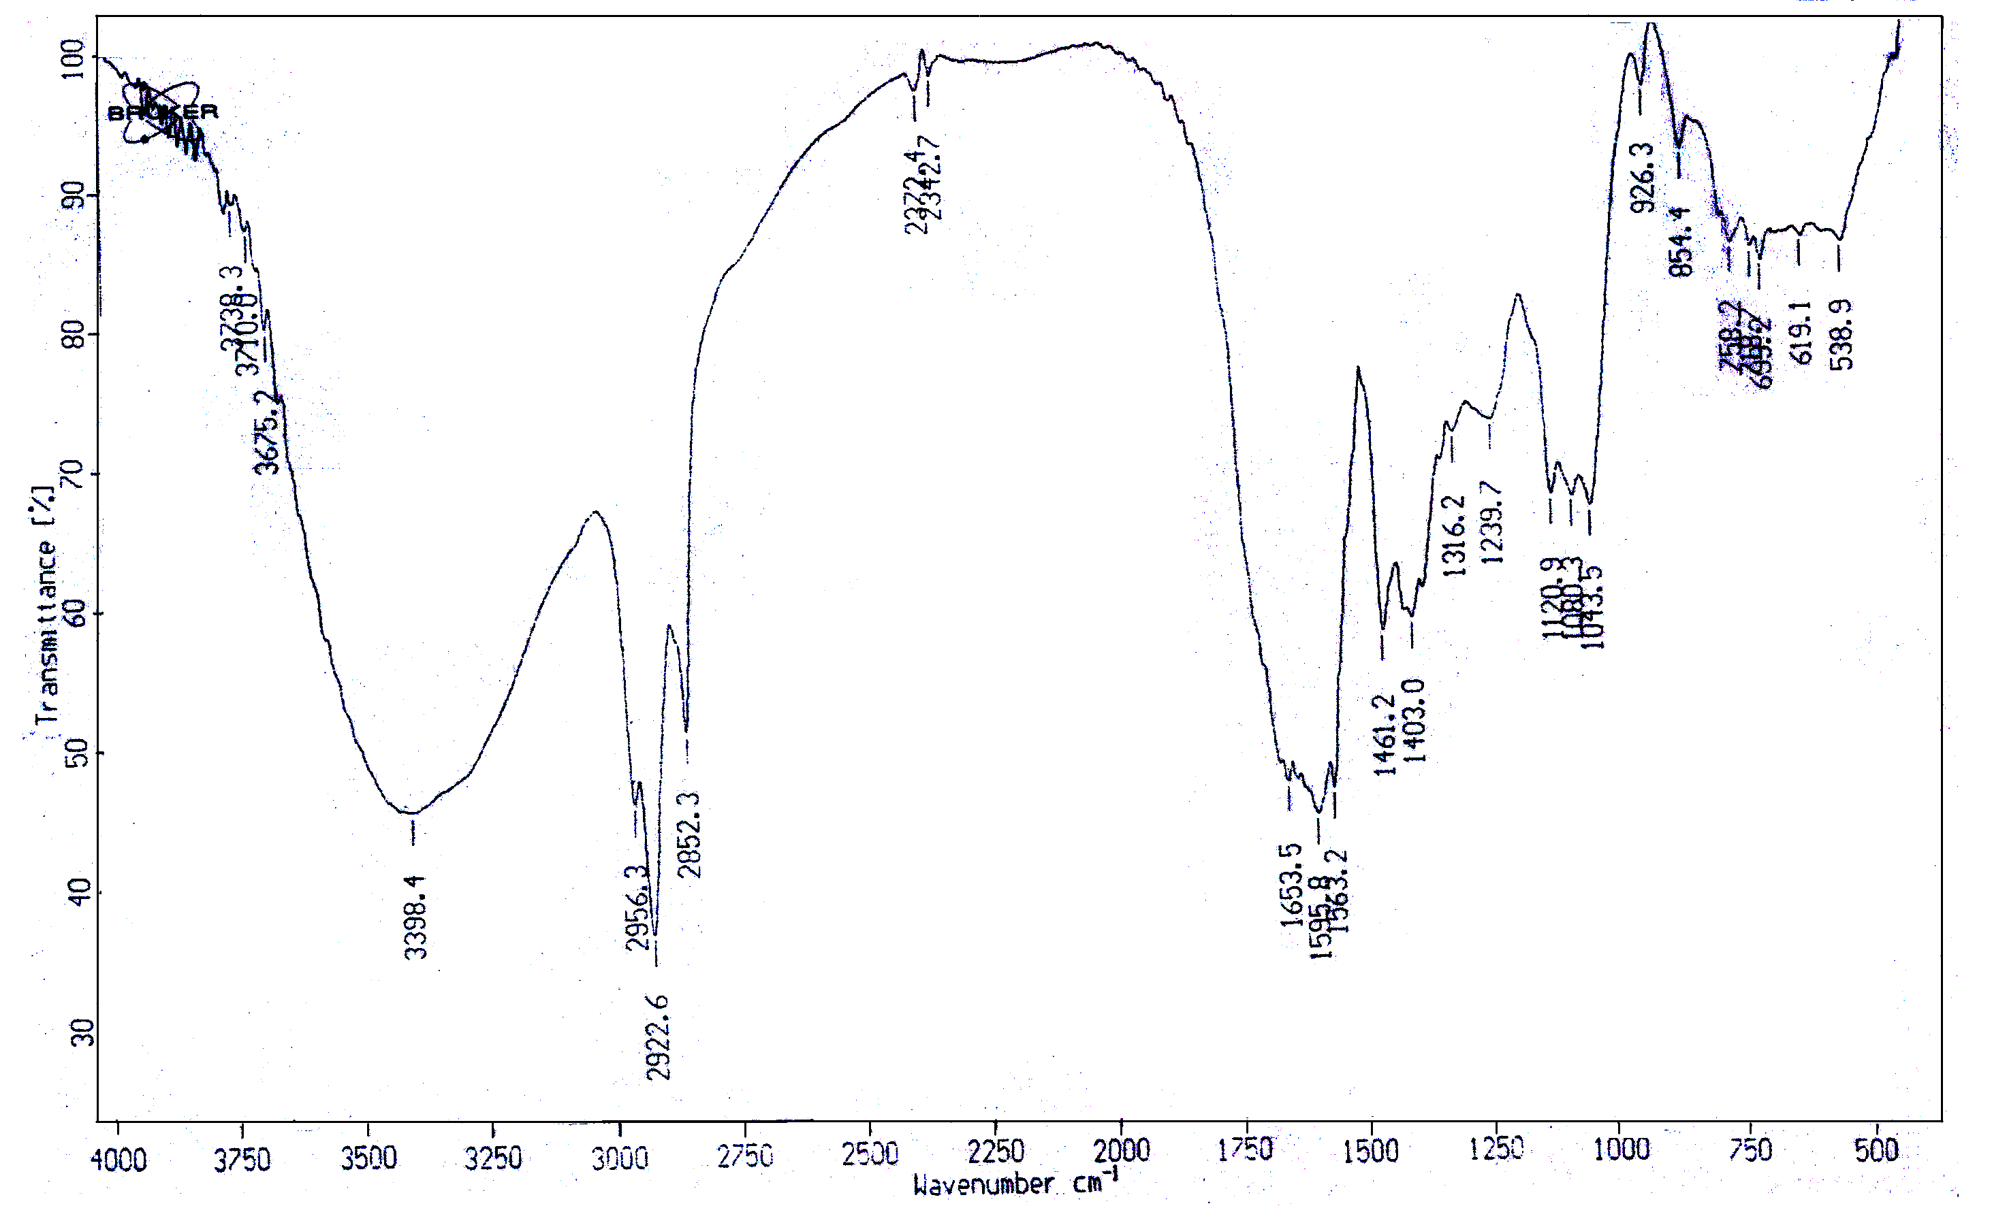
Figure 2: Infrared spectrum of the antimicrobial agent.

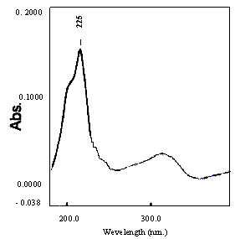
Figure 3. Ultraviolet absorbance of antimicrobial agent

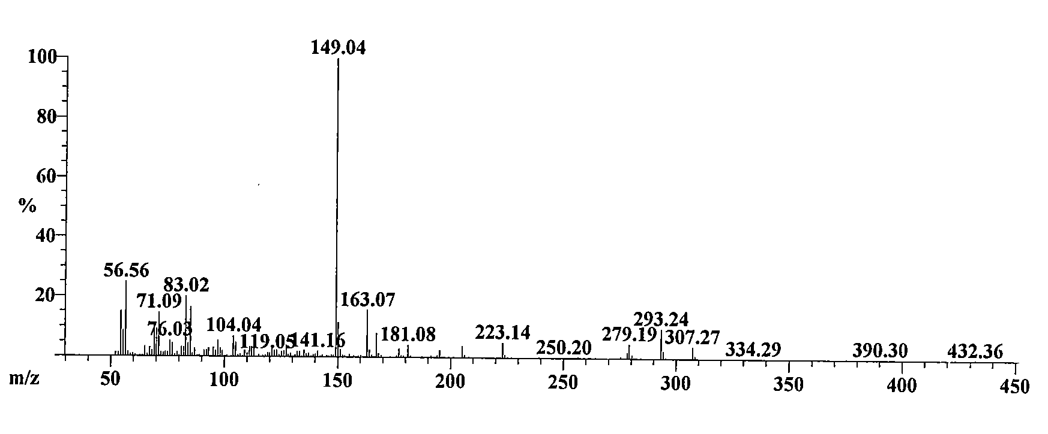
Figure 4: Mass spectrum of antimicrobial agent

4. Discussions
The aminoglycosides such as Hygromycin B are a large and diverse class of antibiotics that characteristically contain two or more aminosugars linked by glycosidic bonds to an aminocyclitol component. The cyclitol is 2-deoxystreptaminestreptomycin, which has a streptidine moiety [Umezawa and Hooper, 1982]. Soil, in particular, is an intensively exploited ecological inhabitant, of which, produce many useful natural products, including clinically important antibiotics [Waksman, 1961 and Waksman, 1975]. Among soil inhabitants, actinomycetes, and more specifically streptomycetes, are of practical importance because they produce most of the useful natural antibiotics for medical use. Nevertheless, selective isolation of soil actinomycetes is important for understanding their ecological properties and for finding novel strains which can produce useful bioactive secondary metabolites. Therefore, various media and techniques have been developed for selective isolation of actinomycetes [Hozzein et al., 2008].
The active metabolites were extracted by ethyl acetate at pH 8. Similar results were obtained by [Yoram, et al. 2006; Criswell et al. 2006; Sekiguchi, et al., 2007 and Atta et al., 2009].
The organic phase was collected and evaporated under reduced pressure using rotary evaporator. The extract was concentrated and treated with petroleum ether (b.p. 60-80°C) for precipitation process, where only one fraction was obtained in the form of viscous syrup, and then tested for antimicrobial activities. The purification process through a column chromatography packed with silica gel and an eluting solvents composed of chloroform and methanol (10:2, v/v), indicated that maximum activity was recorded at fraction Nos. 14 and 23. Many workers used a column chromatography packed with silica gel. Similar results were obtained by [Hitchens and Kell, 2003; Criswell et al. 2006 and Sekiguchi, et al., 2007].
The physico-chemical characteristics of the purified antibiotic revealed that, melting point is 160⁰C; and soluble in chloroform, ethyl acetate, n-butanol, acetone, ethyl alcohol, methanol and 10 % isopropyl alcohol, but insoluble in petroleum ether, hexan and benzene. Similar results were recorded by [Yanai, 2004 and Atta et al., 2011]
A study of the elemental analysis of the antibacterial agent lead to an imperical formula of: C₁₅H₃₀N₂O₁₀. The spectroscopic analysis of purified antimicrobial agent produced by Streptomyces crystallinus, AZ-A151, the infrared (IR) spectrum showed characteristic band corresponding to 21 peaks. The ultraviolet (UV) spectrum recorded a maximum absorption peak at 225 nm. The Mass spectrum showed that the molecular weight was 432.36.
The biological activities (MIC) of the antimicrobial agent are fairly active against both Gram positive, Gram negative bacteria, unicellular and filamentous fungi. The minimum inhibitory concentration (MIC) of antibiotic produced by Streptomyces crystallinus, AZ-A151 was determined and results showed that MIC (µg/ml) against Staphylococcus aureus, NCTC 7447 (1.73), Klebsiella pneumonia, NCIMB 9111 (3.9), Escherichia coli, NCTC 10416 and Salmonella typhi (7.8), for Aspergillus flavus, IMI 111023 and Alternaria alternata (31.25), and Saccharomyces cerevisiae, ATCC 9763 (62.5). Similar studies were conducted by [Criswell et al., 2006 and Sekiguchi, et al., 2007].
Identification of antibiotic according to recommended international keys indicated that the antibiotic is suggestive of being likely belonging to Hygromycin-B antibiotic [Berdy, 1974; Berdy, 1980a b & c; Umezawa, 1977 and Umezawa and Hooper 1982].

5. Conclusion
It could be concluded that: The Hygromycin-B antibiotic produced by Streptomyces crystallinus, AZ-A151 demonstrated obvious inhibitory affects against Gram positive and Gram negative bacteria and unicellular and filamentous fungi.

6. Corresponding Author:
Prof. Dr. Houssam M. Atta
Botany and Microbiology Department, Faculty of Science (Boys), Al-Azhar University, Cairo, Egypt. The present address: Biotechnology Department. Faculty of Science and Education- Al-Khurmah, Taif University; KSA.
E-mail: houssamatta@yahoo.com houssamatta@hotmail.com
Tel : 00966506917966

7. References
- Alves, A.; Santos, O.; Henriques, I. and Correia, A. (2002). Evaluation of methods for molecular typing and identification of members of the genus Brevibacterium and other related species. FEMS Microbiol Lett 213: 205-211.
- Atta H.M.; El-Sehrawi, M.H.; Awny, N.M. and El-Mesady, N.I. (2011). Cirramycin-B Antibiotic Production By Streptomyces Cyaneus-AZ-13Zc: Fermentation, Purification and Biological Activities. New York Science Journal, 2011; 4(2): 35-42.
- Atta, H. M. (2010). Production, Purification, Physico-Chemical Characteristics and Biological Activities of Antifungal Antibiotic Produced by Streptomyces antibioticus, AZ-Z710. American-Eurasian Journal of Scientific Research. 5 (1): 39-49, 2010.
- Atta, H. M.; Abul-hamd A. T. and Radwan, H. G. (2009). Production of Destomycin-A antibiotic by Streptomyces sp. using rice straw as fermented substrate. Comm. Appl. Biol. Sci, Ghent University, 74 (3): 879-897, 2009.
- Augustine, S.K.; Bhavsar, S.P. and Kapadnis, B.P. (2005). A non-polyene antifungal antibiotic from Streptomyces albidoflavus PU 23. J. Biosci. 30: 201-211.
- Berdy, J. (1974). Recent development of antibiotic research and classification of antibiotic according to chemical structure. Adv. App. Microbiol., 14: 309-406.
- Berdy, J. (1980a). Recent advances in and prospects of antibiotics research. Proc. Biochem., 15: 28-35.
- Berdy, J. (1980b). CRC Handbook of antibiotic compounds. Vol I. CRC Press, Boca Raton, Florida.
- Berdy, J. (1980c). CRC Handbook of antibiotic compounds. Vol II. CRC Press, Boca Raton, Florida.
- Beyazova, M. and Lechevalier, M.P. (1993). Taxonomic utility of restriction endonuclease fingerprinting of large DNA fragments from Streptomyces strains. Int. J. Syst. Bacteriol. 43: 674-682.
- Chen, Y.; Yin, M.; Horsman, G.P.; Huang, S. and Shen, B. (2010). Manipulation of pathway regulation in Streptomyces globisporus for overproduction of the enediyne antitumor antibiotic C-1027. J Antibiot (Tokyo). 63(8): 482-485.
- Criswell, D.; Tobiason, V.L.; Lodmell, J.S. and Samuels, D.S. (2006). Mutations conferring aminoglycoside and spectinomycin resistance in borrelia burgdorferi. Antimicrob. Agents Chemother., 50, 445-452.
- Del-Sol, R.; Armstrong, I.; Wright, C.; & Dyson, P. (2007). Characterization of changes to the cell surface during the life cycle of Streptomyces coelicolor: atomic force microscopy of living cells. J Bacteriol. 189: 2219-22125.
- Harvey, I.; Cormier, Y.; Beaulieu, C.; Akimov, V.N.; Meriaux, A. and Duchaine, C. (2001). Random amplified ribosomal DNA restriction analysis for rapid identification of thermophilic actinomycete-like bacteria involved in hypersensitivity pneumonitis. Syst Appl Microbial 24: 277-284.
- Hindra, P., and Elliot, M.A. (2010). Regulation of a novel gene cluster involved in secondary metabolite production in Streptomyces coelicolor. J Bacteriol 2010;192(19): 4973-9482.
- Hozzein, W.N.; Ali, M.I.A. and Rabie, W. (2008). A new preferential medium for enumeration and isolation of desert actinomycetes. J. Microbiol Biotechnol 24: 1547-1552.
- Huddleston, A.S.; Cresswell, N.; Neves, M.C.P.; Beringer, J.E.; Baumberg, S.; Thomas, D.I. and Wellington, E.M.H. (1997). Molecular detection of streptomycin-producing streptomycetes in Brazilian soils. Appl Environ Microbiol 63, 1288-1297. Towards a molecular identification of Streptomyces species in pure culture and in environmental samples. Actinomycetologia 5: 38-44.
- Kavanagh, F. (1972). Analytical Microbiology. Vol. 2, Acad. Press, New York.
- Kohler, G.; Ludwing, W. and Schleifer, K.H. (1991). Differentiation of lactococci by rRNA gene restriction analysis. FEMS Microbiol Lett 84: 307-312.
- Kurosawa, K.; Bui, V.P.; Van-Essendelft, J.; Willis, L.L.B. Lessard, P.A.; Ghiviriga, I.; Sambandan, T.G.; Rha, C.K. and Sinskey, A. J. (2006). Characterization of Streptomyces MITKK-103, a newly isolated actinomycin X2-producer Appl Microbiol Biotechnol 72: 145–154.
- Laurent, F. J.; Provost, F. & Boiron, P. (1999). Rapid identification of clinically relevant Nocardia species to genus level by 16S rRNA gene PCR. J Clin Microbiolo 37: 99-102.
- Lee, E.J.; Karoonuthaisiri, N.; Kim, H.S.; Park, J.H.; Cha, C.J. and Kao, C.M. (2005). A master regulator σB governs osmotic and oxidative response as well as differentiation via a network of sigma factors in Streptomyces coelicolor. Mol Microbiol. 57:1252-1264.
- McGuire, P. (1953). "Hygromycin I. Preliminary studies on the production and biological activity of a new antibiotic. Antibiot. Chemother. 3: 1268-1278
- Mehling, A.; Wehmeier, U. F. and Piepersberg, W. (1995). Nucleotide sequences of Streptomycete 16S ribosomal RNA: toward a specific identification system for streptomycetes using PCR. Microbiology 141:
- Monciardini, P.; Sosio, M.; Cavaletti, L.; Chiocchini, C. and Donadio, S. (2002). New PCR primers for the selective amplification of 16S rDNA from different groups of actinomycetes. FEMS Microbiol Ecol 42: 419–429.
- Myles, D.C. (2003). Novel biologically active natural and unnatural products. Curr Opin Biotechnol 14: 627–33.
- Palaniappan, N., Dhote, V.; Ayers, S.; Starosta, A.L.; Wilson, D.N. and Kevin, A. (2009). Biosynthesis of the Aminocyclitol Subunit of Hygromycin A in Streptomyces hygroscopicus NRRL 2388. Chemistry & Biology 16: 1180-1189.
- Sathi, Z.; Sultana; M.D. Aziz, A. R. and Gafur, M.A. (2001). Identification and In vitro Antimicrobial Activity of a Compound Isolated from Streptomyces Species. Pakistan Journal of Biological Sciences 4 (12): 1523-1525
- Sekiguchi, J.I.; Miyoshi-Akiyama, T.; Augustynowicz-Kopec, E.; Zwolska, Z.; Kirikae, F.; Toyota, E.; Kobayashi, I.; Morita, K., Kudo, K.; Kato, S.; Kuratsuji, T. Mori, T. and Kirikae, T. ( 2007). Detection of multi-drug resistance in Mycobacterium tuberculosis. J. Clin. Microbiol., 45. 179-192.
- Singh S.K. and Gurusiddaiah, S. (1984). Production, Purification, and Characterization of Chandramycin, a Polypeptide Antibiotic from Streptomyces lydicus. American Society for Microbiology, 26(3): 394-400
- Telenti, A.; Marchesi, F.; Balz, M.; Bally, F.; Botteger, E.C. and Bodmer, T. (1993). Rapid identification of mycobacteria to the species level by polymerase chain reaction and restriction enzyme analysis. J. Clin. Microbiol. 31: 175-178.
- Thakur, D.; Yadav, A.; Gogoi, B. and Bora, K.T.C. (2007). Isolation and screening of Streptomyces in soil of protected forest areas from the states of Assam and Tripura, India, for antimicrobial metabolites. Journal de Mycologie Médicale 17: 242-249.
- Umezawa, H. (1977). Recent advances in bio-active microbial secondary metabolites. Jap. J. Antibiotic. Suppl., 30. 138-163.
- Umezawa, H. and Hooper I. R. (1982). Aminoglycoside Anti-biotics, Springer–Verlag, Berlin.
- Waksman, S. A. (1975). The Antibiotic Era, the Waksman Foundation of Japan Inc., Tokyo, 39–53.
- Waksman, S. A. (1961). The Actinomycetes, Classification, Identification and Description of Genera and Species. Baltimore: The Williams and Wilkins Company l2: 61-292.
- Wilson, R. W.; Stiengrube, V. A.; Brown, B. A. and Wallace, R. J. (1998). Clinical application of PCR-restriction enzyme pattern analysis for rapid identification of aerobic actinomycete isolates. J Clin Microbiol. 36: 148-152.
- Yanai, K. (2004). The Kanamycin Biosynthetic Gene Cluster from Streptomyces kanamyceticus. J. of Antibiot. 57(5):351-354.
- Yoram, A.; Puius, G.; Todd, H.; Stievater, A. and Thamarapu, S. (2006). Crystal structure, conformation, and absolute configuration of kanamycin A. Volume 341, Issue 17, 11 December 2006, Pages 2871-2875.

2/12/2012

